**Lab 06**

**Objective: To learn RMI-IIOP**

**Task 1 :----Create RMI IIOP application in which take a sentence at runtime on the client application and let the server return its reverse.  
E.g. input could be: subject is distributed computing   
output should be: computing distributed is subject.**

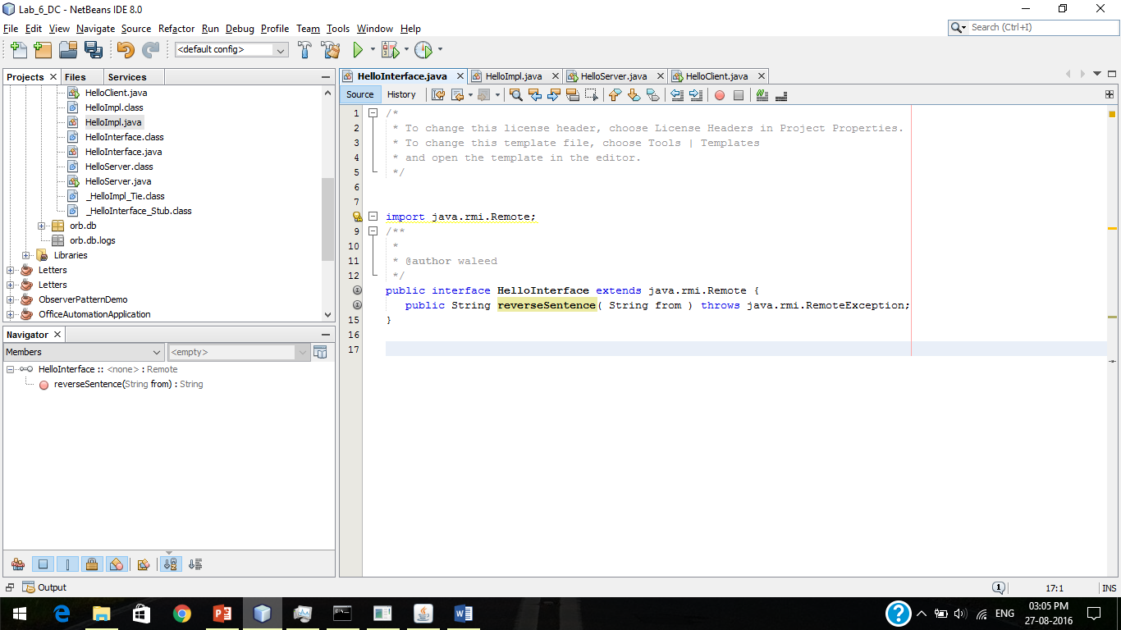

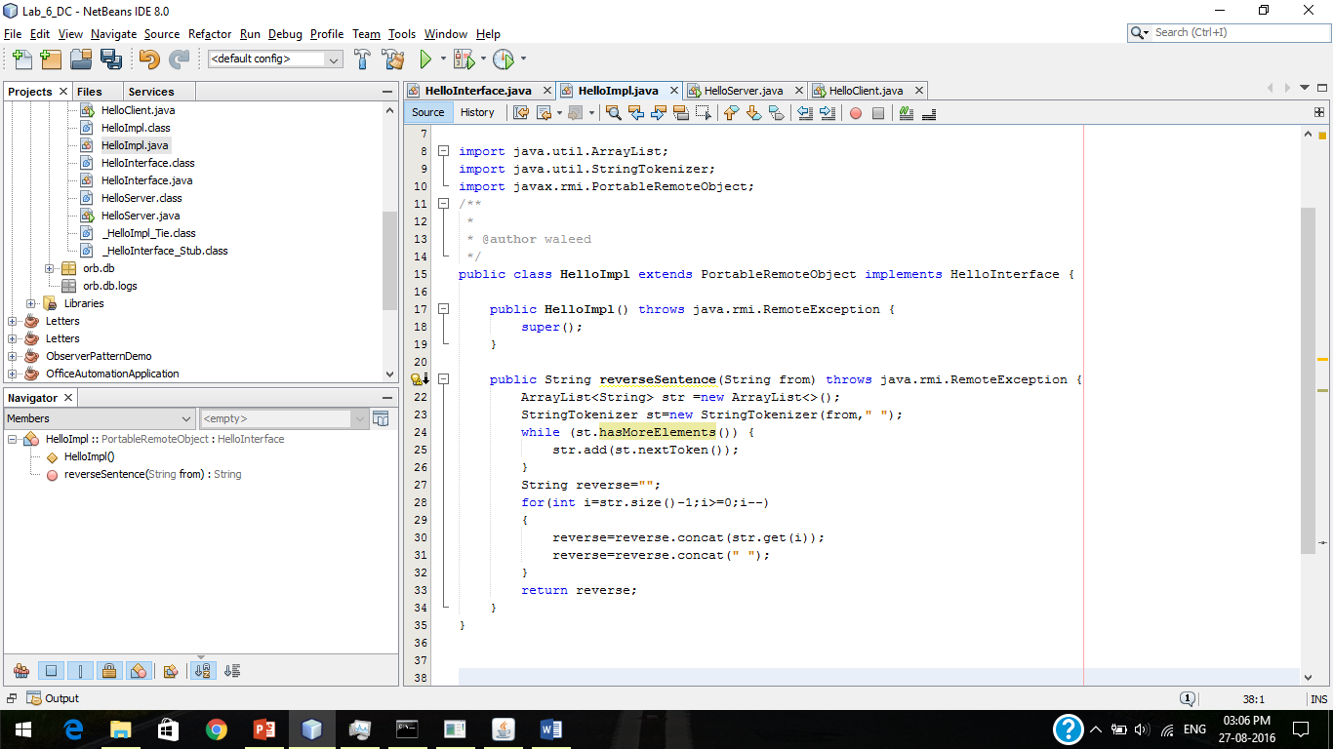

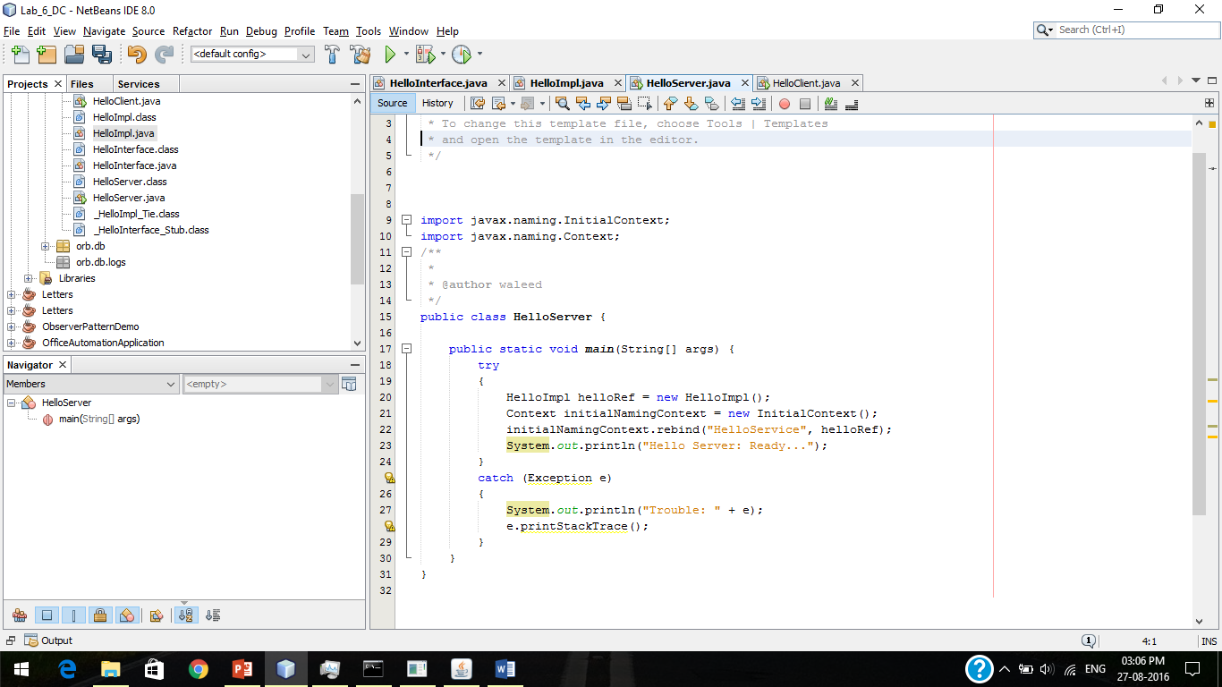



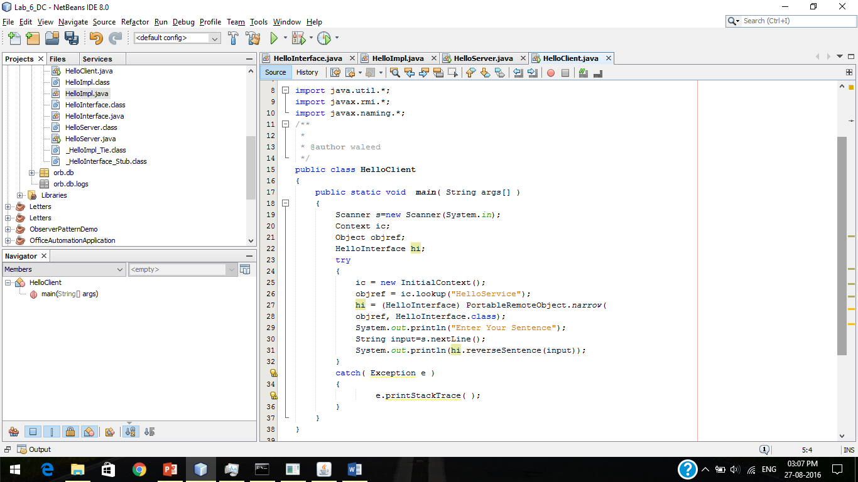

Output :-

