**LAB 5**

**Object: To Become familiar with RMI Object serialization**

**TASK: 1**

* **Develop any simple application to demonstrate object passing in RMI. (Expl: Make a class of your own and use its objects as arguments and return types for RMI)**

**Application for generating Even Numbers series and Odd numbers Series**

* **EvenNumber.java**

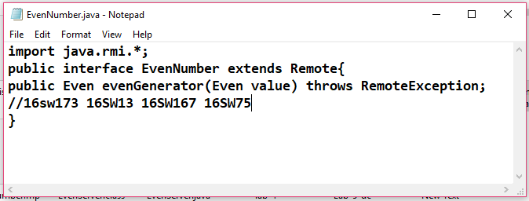

**Even.java**

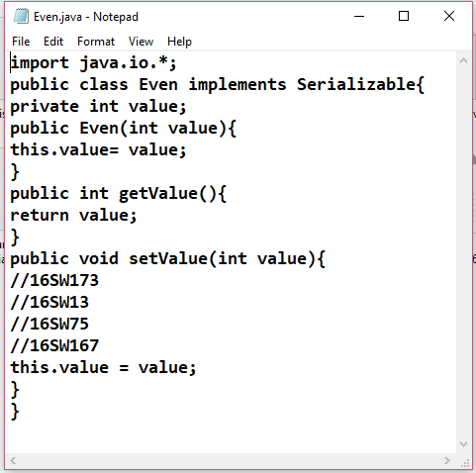

**EvenNumberIMPL.JAVA**

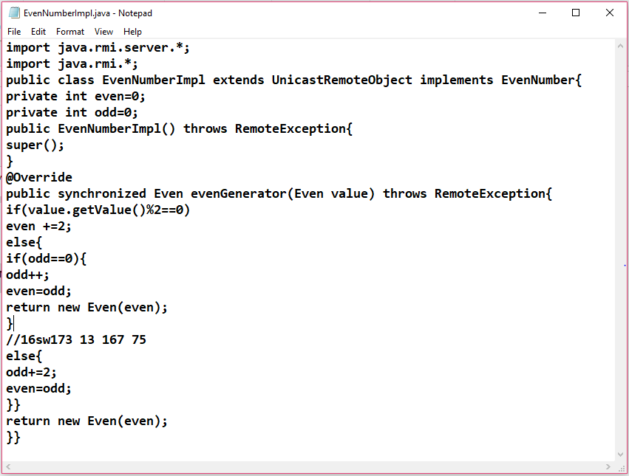

**EvenServer.java**

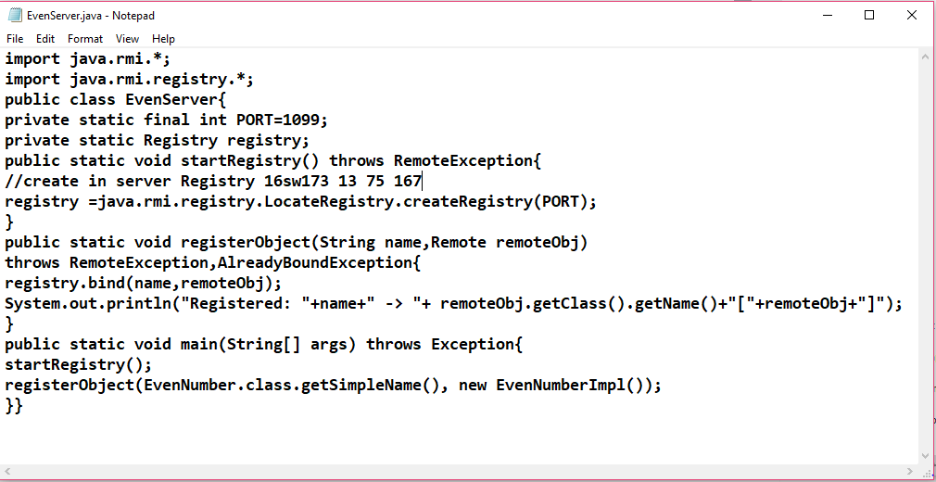

**EvenClient.java**

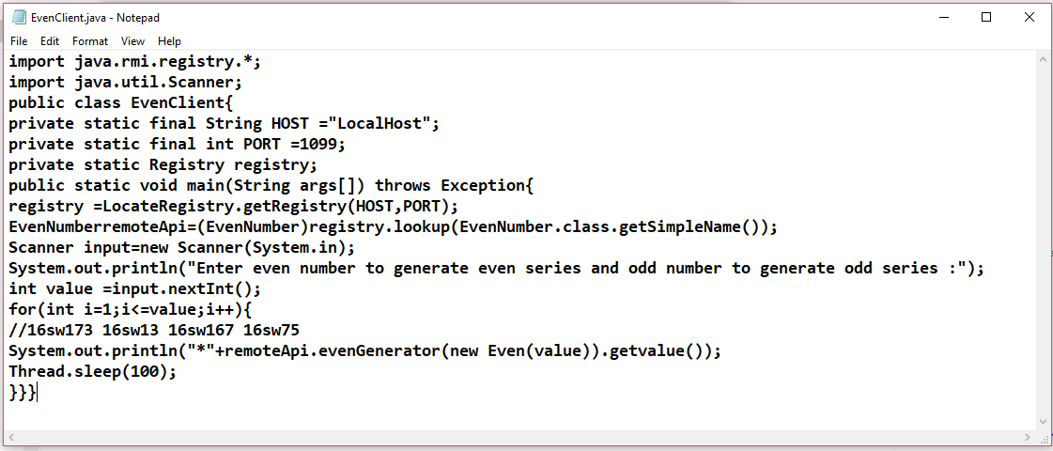

**Output:-**

