



Training framework

EUC Remediation

Document Version / Details: Ver. 2.0/ 15-Sept-23

EUC Training

**Training Framework:**

**Objective:**

**The objective of this training framework is to provide a structured learning path for individuals interested in gaining a comprehensive understanding of functional and technical aspects of EUC. This framework is designed to eqiup participants with the necessary skills and knowledge to effectiviely utilize EUC tools and systems in a professional setting.**

**Target Audience:**

**This trainig framework is suitable for begineers and intermediate learners who want to learn, understand and enchance their understaing of the EUC processess. Business Analyst, developer and Quality engineers can take this training.**

**Duration:**

**4 weeks**

**Table of Contents:**

|  |  |
| --- | --- |
| **Week 1** | **Introduction**  **Functional aspects of EUC**  **Understanding low-code/no-code**  **Flow chart and process walkthrough**  **Assignment of buddy**  **BA detailed process walkthrough - videos**  **Weekly Assessment** |
| **Week 2** | **Development process walkthrough – videos**  **QA process walkthrough – videos**  **QnA session with BA mentor**  **QnA session with Dev mentor**  **QnA session with QA mentor**  **Weekly Assessment** |
| **Week 3** | **Exercise with 1 input file EUC**  **Weekly Assessment** |
| **Week 4** | **Exercise with 3 input file EUC**  **Training Assessment**  **Completion of training** |

Contents

1 Introduction: 5

1.1 Importance and scale of data: 5

1.1.1 Importance of Data: 5

1.1.2 Scale of Data: 6

2 Low-code and no-code tools: 7

2.1 Low-Code Platforms: 7

2.2 No-Code Tools: 7

2.3 Usage and Application: 7

2.3.1 Low-Code Tools: 8

2.3.2 No-Code Tools: 8

**3** **ETL (Extract, Transform and Load)** 9

4 End-User Computing (EUC): 11

5 Application of ETL in EUC process: 11

6 EUC Remediation: 11

7 Scope of EUC Remediation: 12

8 Maker and Checker: 13

9 Different EUC tools which are widely used are: 13

9.1 Appian (https://appian.com/) 13

9.2 ACS 14

9.3 Knime (https://www.knime.com/) 14

9.4 BroadWalkTech - (https://www.boardwalktech.com/) 14

9.5 Xceptor (https://www.xceptor.com/) 14

9.6 Ab Inintio (https://www.abinitio.com/en/) 14

9.7 Tableau (https://www.tableau.com/) 15

9.8 EasyDataTool (https://www.easydatatool.com/) 15

9.9 Comparative Study of Tools: 15

9.9.1 Important tools-Tool study.doc (sharepoint.com) 15

10 Different types of EUC’s: 18

10.1 How EUC’s are categories based on Complexity 18

10.2 Functional aspect of individual EUC 19

10.3 Different Elements of an EUC 21

10.3.1 Hardware Devices: 22

10.3.2 Operating Systems: 22

10.3.3 Software Applications 22

10.3.4 Data and Storage: 22

10.3.5 Networking and Connectivity: 22

10.3.6 Security Measures: 23

10.3.7 User Interfaces: 23

10.3.8 Support and Training: 23

10.3.9 Cloud Services: 23

10.3.10 Mobile and Remote Access: 23

10.3.11 Compliance and Governance 24

10.3.12 Backup and Recovery: 24

10.3.13 Elements of the data model and data flow: 24

10.4 Advanced Excel courses 30

11 Purpose of a particular EUC 33

12 Why we need to remediate this EUC 35

13 Possible errors In EUC 36

14 Types of errors in excels: 38

14.1 Add sample EUC’s – 38

14.2 Add real world examples: 39

15 Flow chart of EUC process: 40

15.1 Stage: Requirement Analysis and FRD creation by BA. 41

15.2 Stage: FRD sign off from the requestor/user by BA. 41

15.3 Stage: implementation by the Development team 41

15.4 Stage: Deployment in UAT by the Development team 42

15.5 Stage: QA Testing in UAT and raise bug/issues. 42

15.6 Stage: Bug/issues fix by Development Team 42

15.7 Stage: Deployment in the live 42

# Introduction:

The banking and financial sector plays a crucial role in the economy by providing a range of financial services. This sector encompasses banks, credit unions, investment firms, insurance companies, and more. Its primary functions include: Intermediation, Depository Services, Lending, Investment Services, Payment Services, Risk Management, Financial Regulation, Capital Allocation and Foreign Exchange.

The banking and financial sector is highly interconnected, impacting the overall economic health of a country. It continually evolves with technological advancements, regulatory changes, and global economic developments, making it a dynamic and critical component of modern economies.

## Importance and scale of data:

The importance and scale of data have grown significantly in recent years, driven by advances in technology and the digital transformation of various industries. Here's an overview of why data is important and the vast scale it has reached:

### Importance of Data:

* Informed Decision-Making: Data provides valuable insights that enable businesses and organizations to make informed decisions. Analyzing data can lead to better strategies, improved operations, and increased efficiency.
* Competitive Advantage: Companies that harness data effectively can gain a competitive edge. They can identify trends, customer preferences, and market opportunities, allowing them to adapt and innovate faster than their competitors.
* Personalization: Data helps businesses personalize products, services, and marketing efforts. This enhances the customer experience and fosters customer loyalty.
* Predictive Analytics: Data-driven predictive models can anticipate future trends, customer behavior, and potential issues. This is invaluable for risk management and forecasting.
* Scientific Research: In fields like healthcare, astronomy, climate science, and more, data plays a crucial role in advancing scientific knowledge and solving complex problems.
* Public Policy and Governance: Governments use data to formulate policies, allocate resources, and improve public services. Data-driven governance can lead to more efficient and responsive public administration.

### Scale of Data:

* Big Data: The scale of data has grown to such an extent that it's often referred to as "big data." This term encompasses massive volumes of structured and unstructured data generated from various sources, including social media, IoT devices, sensors, and more.
* Internet of Things (IoT): The proliferation of IoT devices, such as smart sensors and connected appliances, has led to an explosion in data generation. These devices constantly collect and transmit data for various purposes.
* Social Media: Platforms like Facebook, Twitter, and Instagram generate enormous amounts of data daily through user interactions, posts, and multimedia content.
* E-commerce: Online shopping platforms generate vast datasets related to user behavior, purchase history, and product reviews, which are used for recommendation engines and market analysis.
* Scientific Research: Fields like genomics and particle physics produce massive datasets that require advanced computational and analytical tools to process and extract meaningful insights.
* Machine Learning and AI: These technologies rely heavily on data for training models. Large datasets are essential for building accurate and robust machine learning algorithms.
* Cloud Computing: Cloud platforms have made it easier to store and process data at an unprecedented scale. This scalability has further fueled the growth of data-driven applications and services.

To harness the power of data, organizations invest in data analytics, machine learning, and artificial intelligence to extract valuable knowledge and drive innovation. However, managing and securing data at this scale also poses significant challenges, including data privacy, security, and ethical considerations, making responsible data handling a crucial aspect of its importance and scale.

# Low-code and no-code tools:

Low-code and no-code tools are software development platforms that enable individuals with varying levels of technical expertise to create applications with minimal hand-coding. They are designed to streamline and simplify the application development process, making it more accessible to a broader range of users. Here's a brief overview of both:

## Low-Code Platforms:

Low-code platforms provide a visual development environment where users can design and build applications through a combination of graphical interfaces and minimal coding. These platforms typically involve less manual coding but still offer flexibility for more experienced developers to write custom code when necessary.

* Use Cases: Low-code platforms are often used for developing business applications, workflow automation, and rapid application development.
* Advantages: Faster development, reduced development costs, and the ability to bridge the gap between business needs and IT resources.
* Examples: OutSystems, Mendix, and Microsoft Power Apps.

## No-Code Tools:

No-code platforms take the simplicity of application development a step further by allowing users to create applications entirely without writing code. These platforms rely heavily on visual interfaces, pre-built components, and templates.

* Use Cases: No-code platforms are well-suited for creating simple web and mobile apps, form builders, and automating repetitive tasks.
* Advantages: Extremely accessible, democratizes application development, and empowers business users to solve their own problems.
* Examples: Bubble, Adalo, and Appy Pie.

Key benefits of low-code and no-code tools include increased agility, faster time to market, and reduced reliance on specialized.

## Usage and Application:

Low-code and no-code tools have a wide range of **usage and application** across various industries and business scenarios due to their ability to simplify and accelerate the software development process. Here are some common usage and application areas for these tools:

### Low-Code Tools:

* Enterprise Application Development: Low-code platforms are often used to develop complex enterprise-level applications, such as customer relationship management (CRM) systems, human resources management systems (HRMS), and supply chain management solutions.
* Workflow Automation: They enable organizations to automate manual and repetitive processes, improving efficiency and reducing errors. This includes approval workflows, document routing, and task management.
* Legacy System Integration: Low-code platforms can be used to integrate with existing legacy systems, extending their functionality and bringing them into the modern digital ecosystem.
* Mobile App Development: Developing cross-platform mobile applications is made easier with low-code tools, allowing businesses to reach their customers on smartphones and tablets.
* Custom Reporting and Analytics: Creating customized reports and dashboards for data analysis and decision-making is simplified through low-code platforms.

### No-Code Tools:

* Rapid Prototyping: No-code platforms are ideal for quickly prototyping and validating new app ideas, allowing non-technical users to bring concepts to life without coding.
* Content Management Systems (CMS): No-code tools are often used to build and manage websites and content-heavy applications, enabling users to create and update web content easily.
* Data Collection and Forms: They are useful for creating online forms, surveys, and data collection applications. Users can design forms and workflows without coding.
* E-commerce: No-code platforms are used to set up online stores, manage inventory, and handle payment processing without the need for extensive coding.
* Internal Tools: Businesses use no-code tools to build internal tools and applications, such as employee directories, onboarding systems, and project management solutions.
* Chatbots and AI: Developing chatbots and basic AI-driven applications for customer support and interaction is simplified using no-code platforms.
* Personal Productivity: Individuals use no-code tools for personal productivity, such as building to-do lists, task trackers, and personal websites.

# **ETL (Extract, Transform and Load)**

[ETL Process and tools.doc (sharepoint.com)](https://ltimindtree-my.sharepoint.com/:w:/r/personal/abhidhnya_10729380_ltimindtree_com/_layouts/15/Doc.aspx?sourcedoc=%7B5888A9BA-F48B-49AA-91D3-8ACC7366D1B9%7D&file=ETL%20Process%20and%20tools.doc&action=default&mobileredirect=true)

ETL stands for **extract, transform, load**. ETL tools, in one form or another, have been around for over 20 years, making them the most mature out of all of the data integration technologies. Their history dates back to mainframe data migration, when people would move data from one application to another.

ETL is a data integration process that combines data from multiple data sources into a single, consistent data store that is loaded into a data warehouse or other target system.

The ETL process is comprised of 3 steps that enable data integration from source to destination: data extraction, data transformation, and data loading.

**Step 1: Extraction**

Most businesses manage data from a variety of data sources and use a number of data analysis tools to produce business intelligence. To execute such a complex data strategy, the data must be able to travel freely between systems and apps.

Before data can be moved to a new destination, it must first be extracted from its source — such as a data warehouse or data lake. In this first step of the ETL process, structured and unstructured data is imported and consolidated into a single repository. Volumes of data can be extracted from a wide range of data sources, including:

1. Existing databases and legacy systems
2. Cloud, hybrid, and on-premises environments
3. Sales and marketing applications
4. Mobile devices and apps
5. CRM systems
6. Data storage platforms
7. Data warehouses
8. Analytics tools

**Step 2: Transformation**

During this phase of the ETL process, rules and regulations can be applied that ensure data quality and accessibility. You can also apply rules to help your company meet reporting requirements. The process of data transformation is comprised of several sub-processes:

1. Cleansing — inconsistencies and missing values in the data are resolved.
2. Standardization — formatting rules are applied to the dataset.
3. Deduplication — redundant data is excluded or discarded.
4. Verification — unusable data is removed, and anomalies are flagged.
5. Sorting — data is organized according to type.
6. Other tasks — any additional/optional rules can be applied to improve data quality.

Transformation is generally considered to be the most important part of the ETL process. Data transformation improves data integrity — removing duplicates and ensuring that raw data arrives at its new destination fully compatible and ready to use.

**Step 3: Loading**

The final step in the ETL process is to load the newly transformed data into a new destination (data lake or data warehouse.) Data can be loaded all at once (full load) or at scheduled intervals (incremental load).

**Full loading**- In an ETL full loading scenario, everything that comes from the transformation assembly line goes into new, unique records in the data warehouse or data repository. Though there may be times this is useful for research purposes, full loading produces datasets that grow exponentially and can quickly become difficult to maintain.

**Incremental loading**- A less comprehensive but more manageable approach is incremental loading. Incremental loading compares incoming data with what’s already on hand, and only produces additional records if new and unique information is found. This architecture allows smaller, less expensive data warehouses to maintain and manage business intelligence.

# End-User Computing (EUC):

End-User Computing (EUC) refers to the range of technologies and practices that enable non-technical users, often referred to as "end-users," to interact with computers and software applications to meet their specific business needs or personal tasks. EUC is focused on making computing resources accessible and usable by individuals who may not have advanced technical knowledge or skills.

# Application of ETL in EUC process:

ETL (Extract, Transform, Load) is a common process used in data integration, but its application in an End User Computing (EUC) process can vary depending on the specific needs and context. Here's how ETL can be used in an EUC process:

1. Extract: In the context of EUC, data extraction might involve retrieving data from various sources that end users work with, such as spreadsheets, databases, or external files. ETL tools or scripts can be used to extract this data.

2. Transform: Data transformation is critical in EUC because it helps ensure data consistency and quality. EUC users often work with data in different formats and structures. ETL processes can clean, normalize, and transform this data into a common format that can be used for analysis or reporting.

3. Load: After data extraction and transformation, the data is loaded into a central repository or database. This centralization of data can make it easier for end users to access and analyze the information they need.

In an EUC context, the ETL process might be used to streamline and automate data workflows, reduce errors, and improve data governance. It can help ensure that the data used by end users is accurate and up-to-date, even if it originates from various sources.

The specific ETL tools and techniques used can vary depending on the organization's requirements and the complexity of the EUC processes in place. Popular ETL tools include Apache NiFi, Talend, Apache Spark, and others. These tools can be configured to automate data extraction, transformation, and loading tasks as needed for EUC workflows.

# EUC Remediation:

End-User Computing (EUC) remediation refers to the process of identifying, assessing, and addressing issues, risks, or compliance concerns associated with end-user computing systems and applications within an organization. These systems are typically created and managed by non-IT personnel, such as business analysts, financial professionals, or other end-users, to perform specific tasks or data analysis.

The need for EUC remediation arises due to several reasons:

1. Risk Mitigation: EUC systems may introduce risks related to data accuracy, security, and compliance. Remediation helps mitigate these risks.
2. Compliance Requirements: Many industries and organizations have specific compliance standards (e.g., financial regulations) that EUC systems must adhere to. Remediation ensures compliance with these standards.
3. Data Governance: EUC systems often handle critical data. Remediation ensures proper data governance, including data quality, data lineage, and data security

# Scope of EUC Remediation:

The scope of end-user computing remediation typically involves identifying, addressing, and mitigating issues or risks related to end-user computing environments within an organization. This can include various elements:

1. Hardware and Software Assessment: Assessing the hardware and software used by end-users to ensure they meet security, performance, and compatibility requirements.
2. Security and Compliance: Ensuring that end-user devices and software are compliant with security policies, industry regulations, and best practices. Remediation may involve applying patches, updating antivirus software, and enforcing security configurations.
3. Application Compatibility: Identifying and resolving compatibility issues with applications used by end-users, especially after operating system updates or software changes.
4. User Training and Awareness: Providing training and raising awareness among end-users about best practices for security, data protection, and compliance.
5. Endpoint Management: Implementing endpoint management solutions to monitor and control end-user devices, ensuring they are up to date and compliant.
6. Performance Optimization: Enhancing the performance of end-user devices through hardware upgrades or software optimizations.
7. Remote Work Support: Adapting end-user computing environments to support remote work, including secure remote access and collaboration tools.
8. Risk Assessment: Identifying potential risks associated with end-user computing and implementing mitigation strategies.
9. Documentation and Reporting: Maintaining records of remediation efforts, compliance status, and performance metrics for auditing and reporting purposes.
10. Budgeting and Planning: Developing budgets and long-term plans for maintaining and improving end-user computing environments.
11. Vendor Management: Managing relationships with vendors for hardware, software, and services related to end-user computing.

The scope may vary depending on the organization's size, industry, regulatory requirements, and specific challenges. Effective end-user computing remediation helps ensure that end-users can work efficiently, securely, and in compliance with organizational policies and regulations.

# Maker and Checker:

Maker and checker is one of the central principles of authorization in the information systems of financial organizations. The principle of maker and checker means that for each transaction, there must be at least two individuals necessary for its completion. While one individual may create a transaction, the other individual should be involved in confirmation/authorization of the same. Here the segregation of duties play an important role. In this way, strict control is kept over system software and data, keeping in mind functional division of labour between all classes of employees.

# Different EUC tools which are widely used are:

## Appian (<https://appian.com/>)

1. Building an application in Appian means already building application for all types of device with no extra work or extra cost. This will let the business user access the application and stay connected to his customers on the go. Appian provides an option to connect via mobile, email and web channels.
2. Appian provides cloud infra which is best at capability, scalability, security and reliability.

## ACS

1. This is a custom wrapper built on top of Appian.

## Knime (<https://www.knime.com/>)

1. No coding required to execute workflows, advanced excel knowledge is sufficient.
2. Open source and connected to programming languages like Python and R for customization.
3. Workflow is displayed as connected nodes which makes it easy to troubleshoot and visualize.

## BroadWalkTech - (<https://www.boardwalktech.com/>)

1. It is the plug & play, low code platform to mitigate the excel risk via complete data management strategy with data security, data governance and compliance.
2. It preserves the powerful features of excel and then eliminates the risks using dynamic download upon authentication and wipes the data clean upon closing the file.

## Xceptor (<https://www.xceptor.com/>)

1. Optimize workflows and enable business users to automate complex processes effortlessly.
2. Extract and transform data from any source, delivering trusted data downstream for processing.
3. Solve repetitive interactions and avoid broken processes across your myriad business practices. Solve repetitive interactions and avoid broken processes across your myriad business practices.

## Ab Inintio (<https://www.abinitio.com/en/>)

1. Ab Initio is a software package designed specifically for data processing and analysis. Various sectors use it, but the most popular uses include data warehousing, integration, business intelligence, analytics and reporting.
2. A graphical programming environment for data processing programs, data transfer tool for extracting, manipulating, loading data as well as data analysis tools for analysing results are all part of Ab Initio suite of features.
3. It utilizes programming languages of the fourth generation which enable programs suitable for business use in data processing, integration, and analysis tasks.

## Tableau (<https://www.tableau.com/>)

1. Data visualization tool which helps convert textual and numerical information to beautiful through interactive dashboards.
2. Tableau community is engaging and enthusiastic. It has various comprehensive online resources, guides, training, and online forums.

## EasyDataTool (<https://www.easydatatool.com/>)

1. EasyDataTool is a data management software that offers a set of integrated application features enabling querying, sensitive data detection, anonymization or encryption of data, data governance, data lineage, data migration and generation of data for testing.
2. Queries can be multiple data sources by linking different types of data format : files (Excel, CSV, JSON, XML, TXT, EPUB, PDF, DOC, PPT), databases (MySQL, PostgreSQL, SQLite, MS Access, Oracle, SQL Server, IBM DB2, Teradata, MongoDB).

## Comparative Study of Tools:

### Important tools-[Tool study.doc (sharepoint.com)](https://ltimindtree-my.sharepoint.com/:w:/r/personal/abhidhnya_10729380_ltimindtree_com/_layouts/15/Doc.aspx?sourcedoc=%7B533EAA74-780B-45EA-86AD-872417798673%7D&file=Tool%20study.doc&action=default&mobileredirect=true)

|  |  |  |  |  |  |  |
| --- | --- | --- | --- | --- | --- | --- |
| **Application name** | **Appian** | **Knime** | **BoardWalkTech** | **Xceptor** | **Ab Initio** | **Tableaue** |
| Source | Open Source | Open Source | Open Source | Open Source | Close source | Close source |
| User-friendly | Yes | Yes | No | Yes | No | Yes |
| Coding | Low-code | Low-code | Low-code | No-code | Low-code | Coding required |
| Accessibility | Flexible | Flexible | Flexible | Flexible | Flexible | Flexible/ mobile friendly |
| Cost | High Cost | Moderate Cost | Moderate Cost | Moderate Cost | High Cost | High Cost |
| PDF | Support PDF | Support PDF | Excel only | Support PDF | Support PDF | Support PDF |
| Complex process | Limited Exporting and Data Analysis Capabilities | Python/R scripts are needed for custom needs | Can automate complex process | Can automate complex process | Not support to complex process | Not support to complex process |
| Cons | Steep Learning Curve and Technical Limitations | Graphic needed a lot of machine resources | Excel-based only | Product cannot be deployed without implementation teams | High Maintenance cost | Poor BI capabilities |



# Different types of EUC’s:

## How EUC’s are categories based on Complexity

End-user computing (EUC) categories can be classified based on complexity into several levels, ranging from simple to advanced. Here's a breakdown of these categories:

1. Basic End-User Computing (Low Complexity):

* Basic EUC involves tasks that are simple and straightforward, such as using common office applications like word processors and spreadsheets.
* Users typically perform routine, uncomplicated tasks without the need for specialized knowledge or skills.

1. Intermediate End-User Computing (Moderate Complexity):

* Intermediate EUC tasks involve more complex applications and activities, including data analysis, report generation, and database management.
* Users may need a deeper understanding of software features and functions to accomplish their tasks effectively.

1. Advanced End-User Computing (High Complexity):

* Advanced EUC includes tasks that require a high level of expertise and proficiency in specialized software or tools.
* Examples include programming, complex data modeling, and system administration.
* Users in this category often possess advanced technical skills.

1. Customized End-User Computing (Varied Complexity):

* This category encompasses tasks that are tailored to specific organizational needs.
* Users might work with customized software or workflows designed to meet unique requirements.
* Complexity varies depending on the customization level.

1. Collaborative End-User Computing (Mixed Complexity):

* Collaborative EUC involves tasks that require users to work together using various software and tools.
* Complexity depends on the combination of tools used and the need for coordination among users.

1. Mobile End-User Computing (Device-Specific Complexity):

* In the mobile EUC category, users perform tasks on smartphones, tablets, or other mobile devices.
* Complexity varies based on the device's capabilities and the applications used.

1. Cloud-Based End-User Computing (Dependent on Cloud Services):

* Users in this category rely on cloud-based applications and services, which can range from simple web apps to advanced cloud computing platforms.
* Complexity is often related to the specific cloud services used.

1. Cybersecurity and Compliance-Related End-User Computing (Security Complexity):

* This category focuses on tasks related to cybersecurity, compliance, and data protection.
* Complexity is tied to understanding and implementing security measures and compliance standards.

1. Remote and Virtualized End-User Computing (Network and Infrastructure Complexity):

* Remote and virtualized EUC involves accessing applications and data from remote locations or through virtualized environments.
* Complexity depends on network connectivity, virtualization technologies, and infrastructure setup.

The complexity of EUC tasks can vary widely based on factors such as the user's role, the software and tools they use, and the organization's specific requirements. It's important for organizations to assess the EUC needs of their users and provide appropriate training and support to ensure efficient and secure computing experiences.

## Functional aspect of individual EUC

The functional aspects of individual end-user computing (EUC) refer to the specific tasks, activities, and functions that an individual user performs using computing devices and software to achieve their goals. These functions can vary widely depending on the user's role, responsibilities, and the software applications they use. Here are some common functional aspects of EUC:

1. Word Processing and Document Creation:

* Creating, editing, and formatting documents using word processing software like Microsoft Word or Google Docs.
* Functions may include text formatting, spell-checking, and inserting graphics.

1. Spreadsheet Analysis and Modeling:

* Using spreadsheet software like Microsoft Excel or Google Sheets to perform calculations, analyze data, and create charts.
* Functions may involve formulas, pivot tables, and data validation.

1. Email Communication:

* Sending and receiving emails using email clients like Outlook, Gmail, or Thunderbird.
* Functions include composing messages, managing contacts, and organizing emails into folders.

1. Presentation Design and Delivery:

* Creating multimedia presentations using software like Microsoft PowerPoint or Google Slides.
* Functions include adding slides, graphics, animations, and delivering presentations.

1. Data Entry and Database Management:

* Entering, updating, and retrieving data from databases using software like Microsoft Access or database management systems (DBMS).
* Functions may include data querying, report generation, and database design.

1. Web Browsing and Research:

* Using web browsers like Chrome, Firefox, or Edge to browse the internet, conduct research, and access online resources.
* Functions involve searching, bookmarking, and navigating websites.

1. Content Creation and Editing:

* Creating and editing multimedia content, including images, videos, and audio files, using software like Adobe Creative Cloud tools.
* Functions include image editing, video editing, and audio mixing.

1. Programming and Scripting:

* Writing and debugging code in programming languages such as Python, Java, or JavaScript.
* Functions involve coding, testing, and debugging software applications.

1. Project Management:

* Managing projects and tasks using project management software like Microsoft Project, Trello, or Asana.
* Functions include task allocation, scheduling, and progress tracking.

1. Collaboration and Communication:

* Collaborating with team members and colleagues through collaboration tools like Slack, Microsoft Teams, or Zoom.
* Functions include chat, video conferencing, and document sharing.

1. Cybersecurity and Data Protection:

* Implementing security measures such as password management, encryption, and antivirus software to protect data and systems.
* Functions involve ensuring data privacy and compliance with security policies.

1. Financial and Accounting Tasks:

* Managing finances and accounting using software like QuickBooks or accounting suites.
* Functions include budgeting, invoicing, and financial reporting.

1. Remote Access and Virtualization:

* Accessing work-related applications and data remotely using virtual private networks (VPNs) or remote desktop solutions.
* Functions involve secure remote access and system administration.

1. Cloud-Based Services:

* Using cloud-based services like Google Workspace or Microsoft 365 for document storage, collaboration, and file sharing.
* Functions include cloud storage management and online collaboration.

The specific functional aspects of EUC can vary significantly based on the user's profession, industry, and job responsibilities. Organizations often provide training and support to help users effectively leverage these functions to enhance their productivity and achieve their objectives.

## Different Elements of an EUC

End-user computing (EUC) encompasses a variety of elements that collectively enable individuals to interact with and use computing devices and software to perform their tasks and achieve their goals. These elements include:

### Hardware Devices:

1. Computers: Desktops, laptops, tablets, smartphones, and other computing devices that users interact with.
2. Peripherals: Keyboards, mice, monitors, printers, scanners, and other input/output devices.

### Operating Systems:

The software that manages hardware resources and provides a platform for running applications.

Examples include Windows, macOS, Linux, Android, and iOS.

### Software Applications

1. Productivity Software: Word processors, spreadsheets, presentation software, and email clients.
2. Business Applications: Industry-specific software for tasks like accounting, design, or engineering.
3. Web Browsers: Software for accessing websites and web-based applications.
4. Specialty Software: Tools for graphic design, video editing, programming, and more.

### Data and Storage:

1. Data Files: Documents, spreadsheets, databases, multimedia files, and other user-generated data.
2. Storage Devices: Hard drives, SSDs, cloud storage, and network-attached storage (NAS).

### Networking and Connectivity:

1. Local Area Network (LAN): Wired or wireless networks within a limited geographic area (e.g., office or home).
2. Internet: Connection to the worldwide network, enabling access to remote resources and services.
3. Virtual Private Network (VPN): Securely connect to private networks over the internet.
4. Wi-Fi: Wireless network technology for connecting devices.

### Security Measures:

1. Passwords and Authentication: Usernames, passwords, PINs, and biometric methods to access devices and applications.
2. Antivirus and Antimalware Software: Protects against malicious software and threats.
3. Firewall: Network security tool that monitors and filters incoming and outgoing traffic.
4. Encryption: Protects data in transit and at rest through encryption algorithms.
5. Security Policies: Organizational guidelines for secure computing practices.

### User Interfaces:

1. Graphical User Interface (GUI): Visual representation of software and interactions through windows, icons, menus, and buttons.
2. Command-Line Interface (CLI): Text-based interaction with software through commands.

### Support and Training:

1. User Support: Helpdesk, technical support, and troubleshooting services.
2. Training and Documentation: Resources to educate users on software and best practices.

### Cloud Services:

1. Cloud Storage: Remote data storage services provided by cloud providers like AWS, Google Cloud, or Azure.
2. Software as a Service (SaaS): Cloud-hosted software applications accessible over the internet.
3. Platform as a Service (PaaS): Cloud environments for developing and deploying applications.
4. Infrastructure as a Service (IaaS): Virtualized computing resources, including servers and storage, provided by cloud providers.

### Mobile and Remote Access:

1. Mobile Devices: Smartphones and tablets for remote computing.
2. Remote Desktop and VPN: Tools for accessing work systems and data remotely.
3. Collaboration Apps: Communication and collaboration tools for remote teamwork.

### Compliance and Governance

1. Policies and procedures to ensure compliance with legal, regulatory, and industry-specific requirements.
2. Data governance measures to manage and protect data effectively.

### Backup and Recovery:

1. Data backup solutions to protect against data loss.
2. Disaster recovery plans to restore systems and data in case of emergencies.

These elements collectively form the EUC ecosystem, and organizations must carefully manage and secure these components to ensure effective and secure end-user computing experiences.

### Elements of the data model and data flow:

There are a few more elements which defines the data model and data flow inside the EUC as per the business requirements.

These are as follows:

#### Sheets & Cells:

* Sheets are individual tabs within an Excel workbook that contain different sets of data or information.
* Cells are the individual rectangular boxes in a sheet where you can enter and manipulate data.



#### Macros: -

* Macros are sequences of Excel commands and actions that can be recorded and played back to automate repetitive tasks.
* They are often written in VBA (Visual Basic for Applications) and can save a lot of time by automating complex processes.

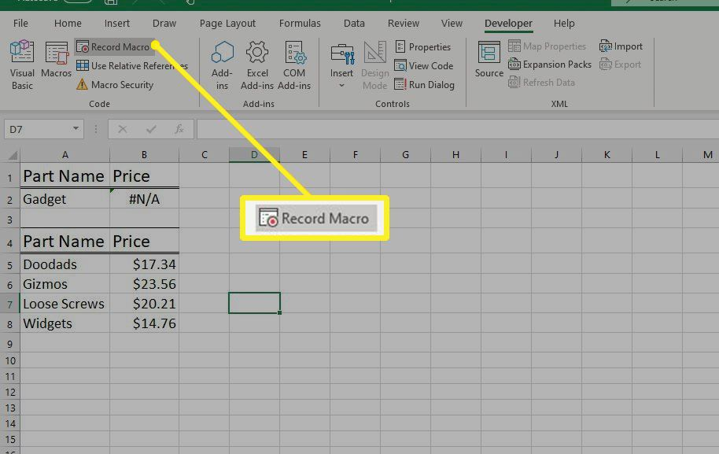

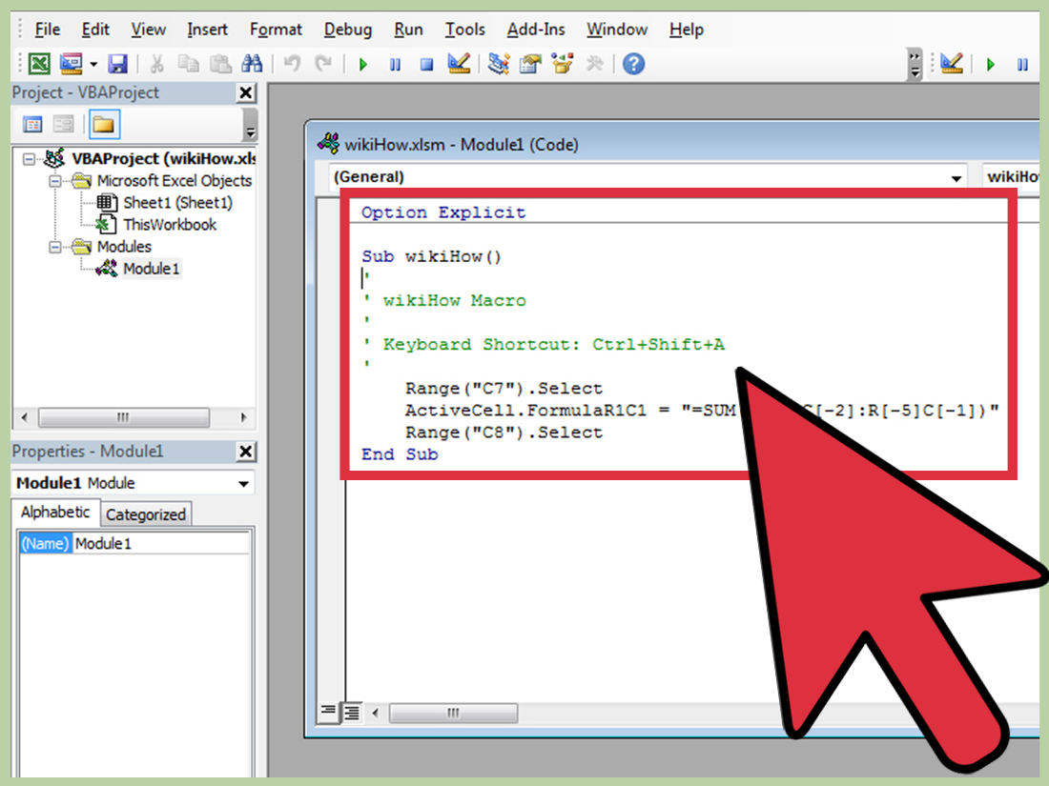

#### Pictures:

* In Excel, you can insert pictures or images into a worksheet to enhance presentations or reports.
* Go to the "Insert" tab and select "Pictures" to insert an image.

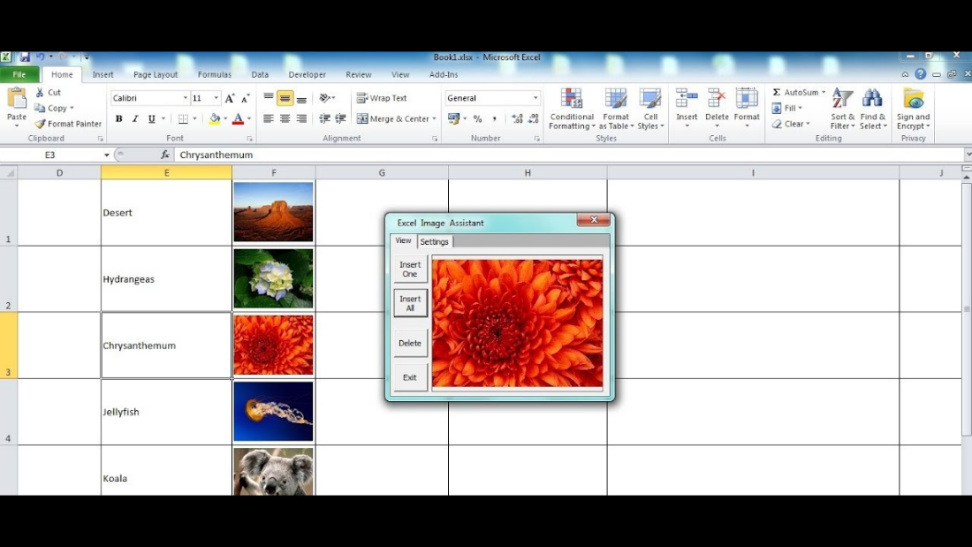

#### Charts:

* Charts in Excel allow you to visualize data using various types like bar charts, line charts, pie charts, etc.
* Select your data and go to the "Insert" tab, then choose the type of chart you want.

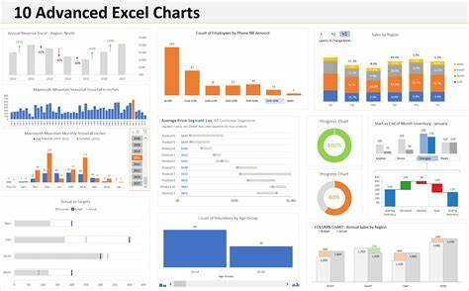

#### Pivot Tables:

* Pivot tables are powerful tools for summarizing and analysing large sets of data.
* They allow you to reorganize and aggregate data quickly to gain insights.

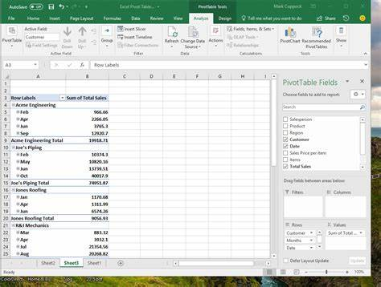

#### User forms:

* User forms are custom dialog boxes that you can create using VBA.
* They enable you to collect input from users in a structured manner within Excel.

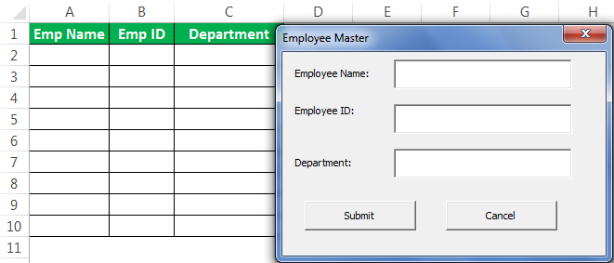

#### Conditional Formatting: -

* Conditional formatting lets you change the appearance of cells based on specific conditions or criteria.
* It's used to highlight important data points or trends.

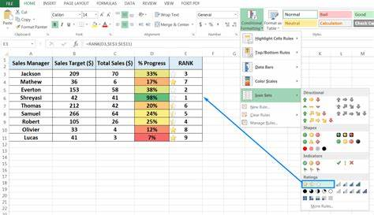

#### Formulas:

* Formulas are expressions you can use to perform calculations in Excel.
* Common functions include SUM, AVERAGE, IF, VLOOKUP, and more.

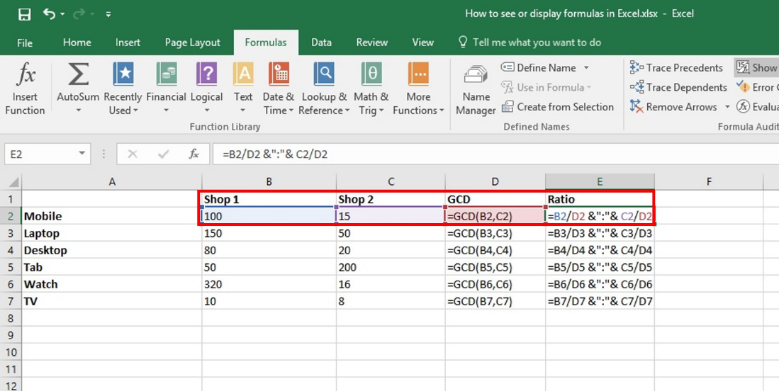

#### Hyperlinks: -

* Hyperlinks in Excel allow you to link to external websites, files, or other locations within your workbook.
* You can insert hyperlinks via the "Insert" tab or by right-clicking on a cell.

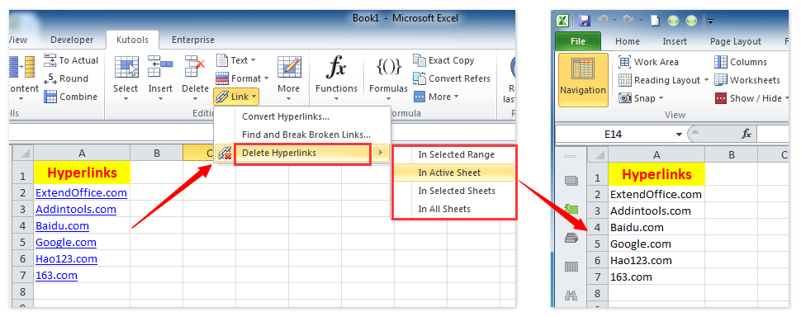

#### References:

* In Excel, references are used to refer to cells, ranges, or data in other worksheets or workbooks.
* You can use absolute ($) or relative references to control how cell references behave when copied or moved.

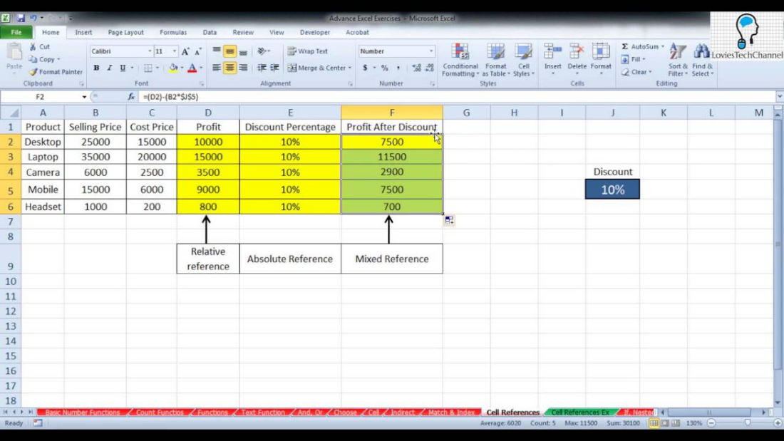

## Advanced Excel courses

We have covered the basic concepts of an excel above. To build further on excel skills, below is the list of courses you can take up from Plural Sight.

#### Excel Course:

#### There is a list of excel courses which will help to cover the below-mentioned topics regarding excel elements and VBA.

|  |  |  |  |  |  |
| --- | --- | --- | --- | --- | --- |
| **Serial No.** | **Course Name** | **Free/Paid** | **Course Duration** | **Course Details** | **Link** |
| 1. | Summarizing and Organizing Data in Excel | Paid after 10-day free trial. | 1h 3m | A practical and pragmatic course exploring the features of Excel that allow you to organize, summarize, analyse, and visualize large amounts of data. Quickly learn how to turn data into insightful and powerful tables and charts. | [Summarizing and Organizing Data in Excel | Pluralsight](https://www.pluralsight.com/courses/summarizing-organizing-data-excel) |
| 2. | Viewing and Manipulating Data in Excel 2016 | Paid | 3h 33m | Learn the most efficient ways of viewing and manipulating data in Excel 2016. | [Viewing and Manipulating Data in Excel 2016 | Pluralsight](https://www.pluralsight.com/courses/excel-2016-data) |
| 3. | Cleansing Data in Excel | Paid | 1h 48m | This course will teach you how to recognize dirty data, minimize its occurrence, and cleanse your data in Excel, working more efficiently, reducing errors, and minimizing cleansing time. | [Cleansing Data in Excel | Pluralsight](https://www.pluralsight.com/courses/cleansing-data-excel) |
| 4. | Excel 365 Essentials | Paid | 1h 55m | In this course, Excel 365 Essentials, you will learn foundational knowledge of the Excel interface and settings. When you’re finished with this course, you will have the skills needed to begin creating your own professional spreadsheets (and begin preparation for the Microsoft Office exams). | [Cleansing Data in Excel | Pluralsight](https://www.pluralsight.com/courses/cleansing-data-excel) |
| 5. | Calculating Cell Values with Formulas | Paid | 1h 22m | In this course, Calculating Cell Values with Formulas, you'll learn to implement various types of functions and formulas, followed by methods to monitor and debug them. | [Calculating Cell Values with Formulas | Pluralsight](https://www.pluralsight.com/courses/calculating-cell-values-formulas) |
| 6. | Developing for Excel with VBA | Paid | 2h 38m | Watch this course and learn how to build custom user applications in Microsoft Excel. | [Developing for Excel with VBA | Pluralsight](https://www.pluralsight.com/courses/developing-excel-vba) |
| 7. | Building Your First VBA Module | Paid | 1h 59m | Visual Basic for Applications and Excel. What a combination! They can do lots of magical things, but just writing VBA code isn’t enough; you need to write efficient code. VBA modules help you do that, and this course will teach you how to use them! | [Building Your First VBA Module | Pluralsight](https://www.pluralsight.com/courses/building-first-vba-module) |
| 8. | Recording and Managing Excel 2016 Macros | Paid | 31m | In this course, Recording and Managing Excel 2016 Macros, we will learn how to develop and edit macros in Excel, which will help us automate a whole host of tedious and time-consuming tasks. | [Recording and Managing Excel 2016 Macros | Pluralsight](https://www.pluralsight.com/courses/recording-managing-excel-macros) |

# Purpose of a particular EUC

The purpose of a particular end-user computing (EUC) setup depends on the specific needs and objectives of the individual or organization using it. EUC serves as a means to enable users to interact with computing devices and software to achieve various goals. Here are some common purposes of EUC:

1. Productivity and Work Tasks: Many individuals and organizations use EUC primarily to enhance productivity and complete work-related tasks efficiently. This includes tasks like document creation, data analysis, and communication.
2. Data Management and Analysis: EUC can be employed to manage, analyze, and visualize data. Users may utilize software like spreadsheets and databases for data-related tasks.
3. Communication and Collaboration: EUC enables users to communicate with colleagues, clients, or peers. Collaboration tools, email clients, and video conferencing software serve this purpose.
4. Content Creation and Editing: Professionals in creative fields, such as graphic designers, video editors, and writers, use EUC to create and edit multimedia content.
5. Information Access and Research: EUC provides access to information and resources on the internet. Users can browse websites, conduct research, and access online databases.
6. Business Operations and Management: Organizations use EUC for managing various aspects of their operations, such as finance, human resources, inventory, and customer relationship management (CRM).
7. Programming and Development: Developers and programmers utilize EUC to write, debug, and test code for software development and application programming.
8. Remote Work and Mobility: EUC facilitates remote work, allowing users to access work-related resources and applications from anywhere, promoting flexibility and work-life balance.
9. Security and Compliance: EUC is essential for implementing security measures, managing user access, and ensuring compliance with data protection and cybersecurity regulations.
10. Entertainment and Personal Use: On a personal level, individuals use EUC for entertainment purposes, such as watching movies, playing games, and engaging in social media.
11. Education and Learning: EUC plays a crucial role in modern education, supporting online learning, course management, and access to educational resources.
12. Healthcare and Research: In the healthcare sector, EUC aids in medical record management, research, and patient care through electronic health records (EHRs) and data analysis tools.
13. Retail and Customer Service: Retail businesses use EUC for inventory management, point-of-sale systems, and customer relationship management, improving customer service.
14. Scientific and Engineering Applications: EUC assists scientists and engineers in data analysis, simulations, and modelling for research and development.

The purpose of EUC can be tailored to the specific needs and objectives of the user or organization. It can range from enhancing daily productivity to supporting complex tasks and industry-specific functions. The choice of hardware, software, and configurations should align with the intended purpose to maximize the benefits of end-user computing.

# Why we need to remediate this EUC

The need to remediate end-user computing (EUC) arises from various situations and challenges that can negatively impact the performance, security, and functionality of EUC environments. Remediation is essential to address these issues and ensure that EUC systems operate effectively. Here are some common reasons why remediation of EUC may be necessary:

1. Outdated Software and Hardware: Aging hardware and software can lead to compatibility issues, performance bottlenecks, and an increased risk of system failures. Remediation may involve upgrading or replacing outdated components to maintain reliability and efficiency.
2. Compliance Requirements: Many industries and organizations are subject to regulatory compliance requirements related to data security and privacy. Remediation may be necessary to ensure that EUC systems align with these regulations and avoid legal consequences.
3. Performance Optimization: Over time, EUC systems may become sluggish or inefficient due to software bloat, configuration issues, or resource constraints. Remediation can involve optimizing system settings, removing unnecessary software, and upgrading hardware components for better performance.
4. User Training and Support: Inadequate user training or lack of support can lead to inefficiencies and user frustration. Remediation may include providing additional training and support resources to help users make the most of their EUC environments.
5. Data Management and Backup: Inadequate data management practices can result in data loss, making data backup and recovery procedures essential. Remediation ensures that data is regularly backed up and can be restored in case of data loss or system failures.
6. Software Licensing and Compliance: Unauthorized software installations or non-compliance with software licensing agreements can lead to legal and financial liabilities. Remediation involves auditing software licenses and ensuring compliance with licensing terms.
7. Network and Connectivity Issues: Network problems, such as slow internet connections or unreliable Wi-Fi, can disrupt EUC operations. Remediation may involve troubleshooting network issues or upgrading network infrastructure.
8. Remote Work Challenges: As remote work becomes more prevalent, addressing challenges related to remote access, security, and collaboration tools is crucial for effective EUC. Remediation can involve implementing solutions to enhance remote work capabilities.
9. Hardware and Software Inventory: Organizations need an up-to-date inventory of hardware and software assets to manage them efficiently. Remediation includes maintaining accurate records of EUC components.
10. Cost Management: Overspending on EUC resources can strain budgets. Remediation may involve cost analysis and optimization to ensure cost-effective EUC solutions.
11. User Experience Enhancement: Improving the user experience can boost productivity and satisfaction. Remediation might include customizing EUC environments to better align with user needs and preferences.

In summary, the need to remediate EUC arises from a variety of factors, including security concerns, compliance requirements, performance issues, and user satisfaction. Addressing these issues through remediation efforts helps maintain the effectiveness and reliability of end-user computing environments.

# Possible errors in EUC

In end-user computing (EUC) environments, various errors can occur that have the potential to impact the integrity, accuracy, and security of data and operations. Here are some possible errors in end-user computing:

1. Data Entry Errors: End-users may make mistakes when manually entering data, leading to inaccuracies in calculations, reports, or analyses.
2. Formula Errors: Users may create or modify formulas incorrectly, resulting in incorrect calculations and data analysis. This includes common Excel formula errors like #DIV/0!, #N/A, #NAME?, and more.
3. Version Control Issues: When multiple users collaborate on EUC applications or documents, version control errors can occur, leading to confusion, data loss, or overwriting of important information.
4. Inconsistent Data Formatting: Users may apply inconsistent formatting to data, making it challenging to work with or analyze datasets effectively.
5. Data Validation Problems: Failing to implement proper data validation rules can result in the input of invalid or inappropriate data, which can cause downstream errors.
6. Access Control Errors: Inadequate access controls can lead to unauthorized users gaining access to sensitive information, potentially compromising data security.
7. Lack of Documentation: A lack of documentation for EUC applications or processes can make it difficult for users to understand how to use them correctly or troubleshoot issues.
8. Security Vulnerabilities: Users may not be aware of or properly address security vulnerabilities in EUC applications, making them susceptible to data breaches or cyberattacks.
9. Improper Backup and Recovery: Neglecting proper backup and recovery procedures can result in data loss and operational disruptions in the event of system failures or data corruption.
10. Misuse of Macros and Scripts: Misconfigured or maliciously designed macros or scripts can introduce errors, security risks, or unwanted automation behaviors.
11. Misinterpretation of Data: Users may misinterpret data or reports generated by EUC applications, leading to incorrect decision-making.
12. Change Management Failures: Making changes or updates to EUC applications without proper change management can result in disruptions, errors, or unintended consequences.
13. Performance Issues: Large or complex EUC applications may suffer from performance problems, causing slow processing or system crashes.
14. Dependency Management: Users may not properly manage dependencies on external data sources or services, resulting in data inconsistencies or errors when those sources change.
15. Compliance and Regulatory Risks: Failure to adhere to industry regulations or compliance standards can lead to legal and financial consequences.

To mitigate these potential errors in end-user computing, organizations should implement strong governance, training, documentation, and quality assurance processes. Regular audits and reviews can also help identify and address issues before they become critical problems.

# Types of errors in excels:

Below are some common types of errors in excel:

|  |  |  |  |
| --- | --- | --- | --- |
| TYPE OF ERROR | MEANING | DETAIL | Formula Errors |
| #N/A | Not available | Can’t find the value you’re looking for | Indicates that a value is not available or not found, often in lookup functions like VLOOKUP. |
| #VALUE! | Invalid value | Wrong arguments in the formula | Occurs when the wrong data type is used in a formula. |
| #REF! | No references | We remove references that are part of the Excel formula | Appears when a cell reference is not valid.  E.g.: referencing a deleted cell. |
| #NAME? | Divided by zero | Excel formula typing error | Appears when excel doesn’t recognize a formula or function name. |
| #DIV/O! | Can’t find the name | The denominator is zero | Occurs when you attempt to divide by zero. |
| ######### | Can’t display value | Can’t display cell content | Appears when the text or number in a cell exceeds the available column width and excel cannot display the entire content. It means the cell content is “overflowing”. |
| #NULL! | Empty value | Can’t determine a range of formula | Occurs when you reference an intersection of two cell ranges that don’t intersect. |
| #NUM! | Invalid number | Invalid numeric values | Indicates an invalid numeric value in a formula. |

## Add sample EUC’s –

1. [Download Sample Excel Data For Analysis - Learning Container](https://www.learningcontainer.com/sample-excel-data-for-analysis/)

## Add real world examples:

1. Excel sample file: <https://www.learningcontainer.com/sample-excel-data-for-analysis/>#
2. CSV Sample file: <https://www.learningcontainer.com/sample-excel-data-for-analysis/>#
3. Excel spreadsheet sample file: <https://www.learningcontainer.com/sample-excel-data-for-analysis/>#
4. Pivot table sample file: [https://www.learningcontainer.com/sample-excel-data-for-analysis/#](https://www.learningcontainer.com/sample-excel-data-for-analysis/)

# Flow chart of EUC process:



Basic understanding of what users are doing:

* Users have a certain input file in excel file and they are doing manual activity by using formula, Pivots, etc to creating a one or more input file.

Basic understanding of EUC automation team is doing:

* EUC team will develop a certain formula, Pivots, etc which is part of the output excel sheet in APIN.
* Input file can be anything. Some EUC is having apart from the excel like notepads, mail conversion, PDF format, etc. This type of scenario handle by different team by using Kinme Tool as per the expected output.
* For example: If user is generating monthly report, last 3-month input we will get from the user and we will put it in our APIN (one-by-one) and we will give 3 set of output to the user. So that user/EUC team can cross verify whether the manual output (working file) created by user is matching with the APIN generated output or not.
* BA will provide the comparison file that is called as normalised file which will be part of FRD to the EUC team.

Above flow chart is explained in detail below:

## Stage: Requirement Analysis and FRD creation by BA.

* BA will review the Business requirement documents (BRD) which is provided by stakeholders, such as clients, users.
* The BA analysis the BRD to ensure that they are clear, complete and the requirement is feasible.
* To gather detailed requirement for the software project from the stakeholders by asking for artifacts from the user (input file, UCC File, output file, sop) based on the BRD provided.
* BA will do the Functional & gaps analysis.
* BA will schedule a call with SME along with Development team and SIT team for gap analysis & Solution mapping.
* The SME to show the process details, how they have creating the EUC manually.
* Multiple calls/meetings need to be schedule with SME depending on complexity.
* BA will create the Functional specification document (FSD/FRD).
* All possible requirements of the system to be developed are captured in this phase.
* The FRD will covers the data flow, who are the approvals, what will be frequency, etc. It will also be including the DM sheet, Blank working file, Blank output file, 3 sets of normalised working file.

## Stage: FRD sign off from the requestor/user by BA.

* BA will share FRD with the stakeholders for review and provide FRD sign off.
* Conducting knowledge transfer session with development and testing teams.
* Co-ordination with internal & external stakeholders.

## Stage: implementation by the Development team

* Once we received FRD sign off then Development team will start developing the requirement.
* Development phase will include entire dev flow, I/O config, parsing, etc.

## Stage: Deployment in UAT by the Development team

* After development, they will deploy the code in SIT/UAT for testing.

## Stage: QA Testing in UAT and raise bug/issues.

* SIT Team start doing testing and they will raise the bug/issue if found.
* Once the bug/issues are fixed by Development team then SIT/UAT team will test again.
* QA team may raise some concerns which need to be taken care by dev team during the development and need to be include in FRD by BA’s.
* BA will provide UAT support and production support.
* Once all the bug/issues are fixed then SIT/UAT team will provide sign off.

## Stage: Bug/issues fix by Development Team

* Development team will fix the bug/issues incase raised by SIT/UAT team.
* Again, Development team will deploy the code in SIT/UAT for testing.
* Post integration the entire system is tested for any faults and failures.

## Stage: Deployment in the live

* Once the functional and non-functional testing is done; the product is deployed in the customer environment or Production released into the market.
* Users will check the code is deployed properly and confirm to the development team.

