Contents

Problem Definition 1

Use Case Diagram 1

Framework 1

Cloud Platform 1

Microservices 2

CI\CD 2

SCCM 2

File Processing 2

Security 2

Testing Strategy 3

Monitoring 3

Logging 3

Compliance 3

Automation 4

Code Analysis 4

Mobile App Dev 4

Service Specs 4

Microservice Patterns: 5

Bounded Context 5

Proposed Solution 5

Database 6

[Company name]  [Company address]

MasterPay design Draft

# Problem Definition

XYZ Corporation would like to create a new bill payment application to act as hub between customers and billers. XYZ Corporation will maintain customer account with balances in it, will maintain biller list along with bill data and will store all transaction data.

# Use Case Diagram

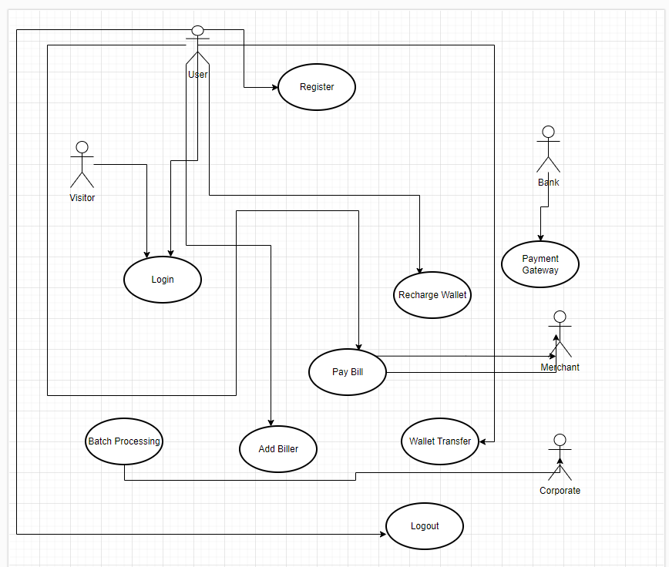

# Assumptions

Batch file from 3rd party system will be placed at regular intervals in Fileshare from where, Master pay will read the file as soon as it is placed.

Format of the file will be specific eg. It will have Biller account number, corporate wallet number, Amount to be transferred, corporate user id.

Those Transactions will be processed which has enough balance in the wallet. Remaining will be unprocessed. Those will be processed in next batch subject to funds availability.

Unprocessed transitions will be notified to corporate with batch, transaction details and error messages through email so they can resolve and send to reprocess.

# Framework

.NET 6.0 LTS

# Cloud Platform

Azure

Azure SQL Database

# Microservices

C#

.NET Framework

Hosting --> Azure App Service ( Auto scaling ) or AKS

# CI\CD

Azure DevOps

# SCCM

**Azure DevOps ( Git )**

**Event Sourcing \ Microservice Communication**

**Saga pattern \ Circuit Breaker \ Retry Pattern**

Azure Service Bus ( message broker )

# File Processing

Azure File share

Trigger based Azure Function

# Security

**Azure APi gateway** ( security , throttling , Load Balancer , reverse proxy )

OpenId Connect User Authentication

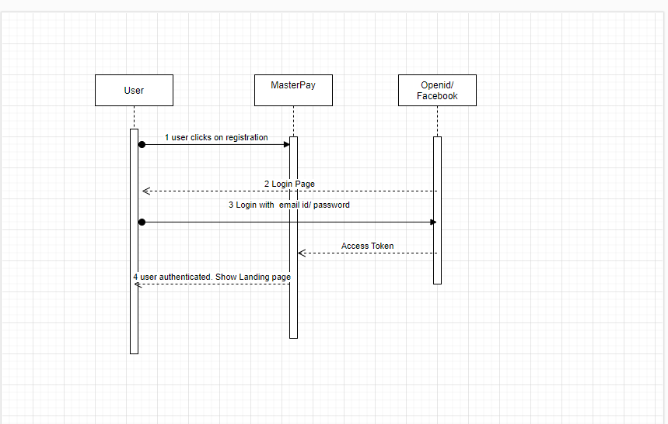

# Testing Strategy

Test Driven Development (TDD using nUNIT)

API testing using RESTAssured \ SoapUI

# Monitoring

Azure App Insight ( correlation logging , alert , threat , monitoring )

# Logging

**log4net**

**serilog ( correlation logging )**

# Compliance

**PII- Do not store any personal identifiable data in DB or log that information.**

**PCI**

# Automation

Selenium# ( UI\Functional Automation )

JMeter and Azure Load Tester

# Code Analysis

SonarQube. Integrate SonarQube with build pipeline.

# Mobile App Dev

React Native

Deploy APK in App Center

Download using Google Playstore

# Service Specs

-User registration through email

Provide authentication using Google, Apple using Oauth .

 Microservices

UserService- Get user details

BillerService

-Get Billers- List of Billers(Electricity, Gas, Water)

-GetBillDetails(Billerid)

Request: BillerAccountnumber

Response: InvoiceId, PaymentAmount

 WalletService

-GetWalletBalance

PaymentService-  Process Payments through payment gateway.

# Microservice Patterns:

-Circuit Breaker for Resiliency

-SAGAs to maintain state.

# Bounded Context

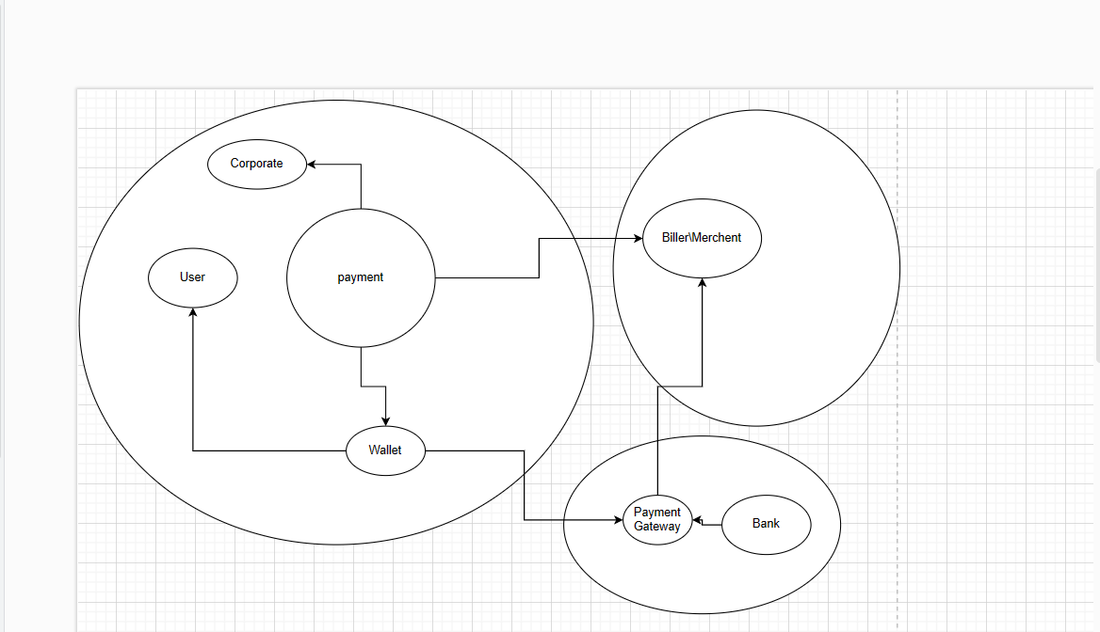

# Proposed Solution

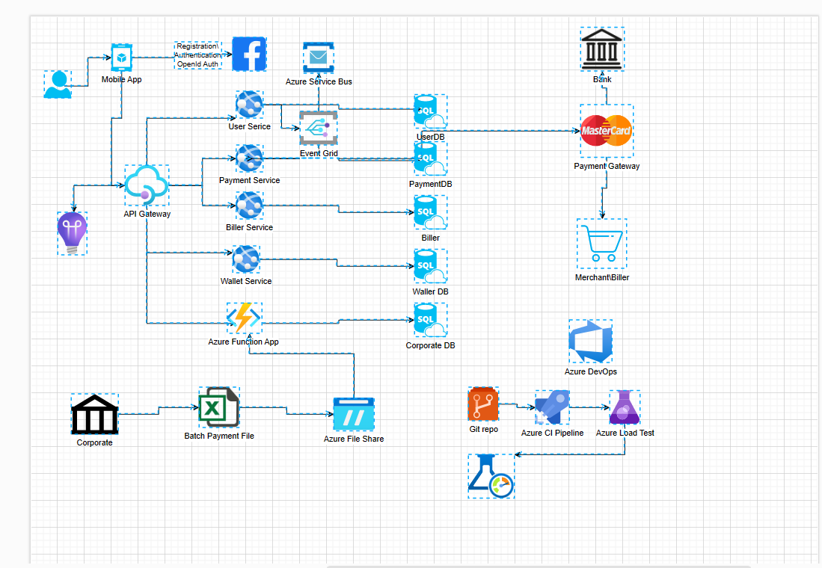

Database: See excel

