**

*Bid-Online System*

*User Requirement*

*Project Code: DUNGNT01*

*Document Code: URD01*

***Ha Noi, 13/5/2014***

*Record of change*

*\*A - Added M - Modified D - Deleted*

|  |  |  |  |  |
| --- | --- | --- | --- | --- |
| ***Effective Date*** | ***Changed Items*** | ***A* M, D*** | ***Change Description*** | ***New Version*** |
|  |  |  |  |  |
|  |  |  |  |  |
|  |  |  |  |  |
|  |  |  |  |  |
|  |  |  |  |  |
|  |  |  |  |  |
|  |  |  |  |  |
|  |  |  |  |  |
|  |  |  |  |  |
|  |  |  |  |  |
|  |  |  |  |  |
|  |  |  |  |  |
|  |  |  |  |  |
|  |  |  |  |  |
|  |  |  |  |  |
|  |  |  |  |  |
|  |  |  |  |  |
|  |  |  |  |  |
|  |  |  |  |  |
|  |  |  |  |  |
|  |  |  |  |  |

*SIGNATURE PAGE*

*ORIGINATOR: QUANBT 13/5/2014*

*Name, Title Date*

*REVIEWERS:*

*Name, Title Date*

*Name, Title Date*

*APPROVAL:*

*Name, Title Date*

*TABLE OF CONTENTS*

*1 INTRODUCTION 3*

*1.1 Purpose 3*

*1.2 Scope 3*

*1.3 Definitions, acronyms and abbreviations 3*

*1.4 References 3*

*1.5 Overview 3*

*2 FUNCTIONALITY 3*

*2.1 <Request number one> 3*

*3 USABILITY 3*

*3.1 <Request number one> 3*

*4 REABILITY 3*

*4.1 <Request number one> 3*

*5 PERFOMANCE 3*

*5.1 <Request number one> 3*

*6 SUPPORTABILITY 3*

*6.1 <Request number one> 3*

*7 BUSINESS RULES AND REGULATIONS 3*

*7.1 <Reference number one> 3*

*8 TECHNOLOGY RULES AND LIMITATIONS 3*

*8.1 <Reference number one> 3*

# *INTRODUCTION*

*Bid-online system executes*

*<This section should provide an overview of the entire document and a description of the scope of the software>*

## *Purpose*

*<This section should:*

*define the purpose of the particular URD*

*specify the intended readership of the URD>*

## *Scope*

*<This section should:*

*identify the software product(s) to be produced by name.*

*explain what the proposed software will do (and will not do, if necessary) and its deliverables*

*describe relevant benefits, objectives, and goals as precisely as possible.*

*Record acceptance criteria and appropriated actions, including concession, when nonconformity is detected>*

## *Definitions, acronyms and abbreviations*

*<This section should provide the definitions of all terms, acronyms, and abbreviations, or refer to other documents where the definitions can be found.>*

## *References*

*<This section should provide a complete list of all the applicable and reference documents, identified by title, author and date. Each document should be marked as applicable or reference. If appropriate, report number, journal name and publishing organization should be included.>*

## *Overview*

*<This section should:*

*describe what the rest of the URD contains*

*explain how the URD is organized>*

# *FUNCTIONALITY*

## *System Manage*

Page’s admin can access the system by logging in and edit bidding items for managing any actions in the system. Such as views and changes in page when someone setups bidding items or someone bids successfully items, deletes a account from members list…

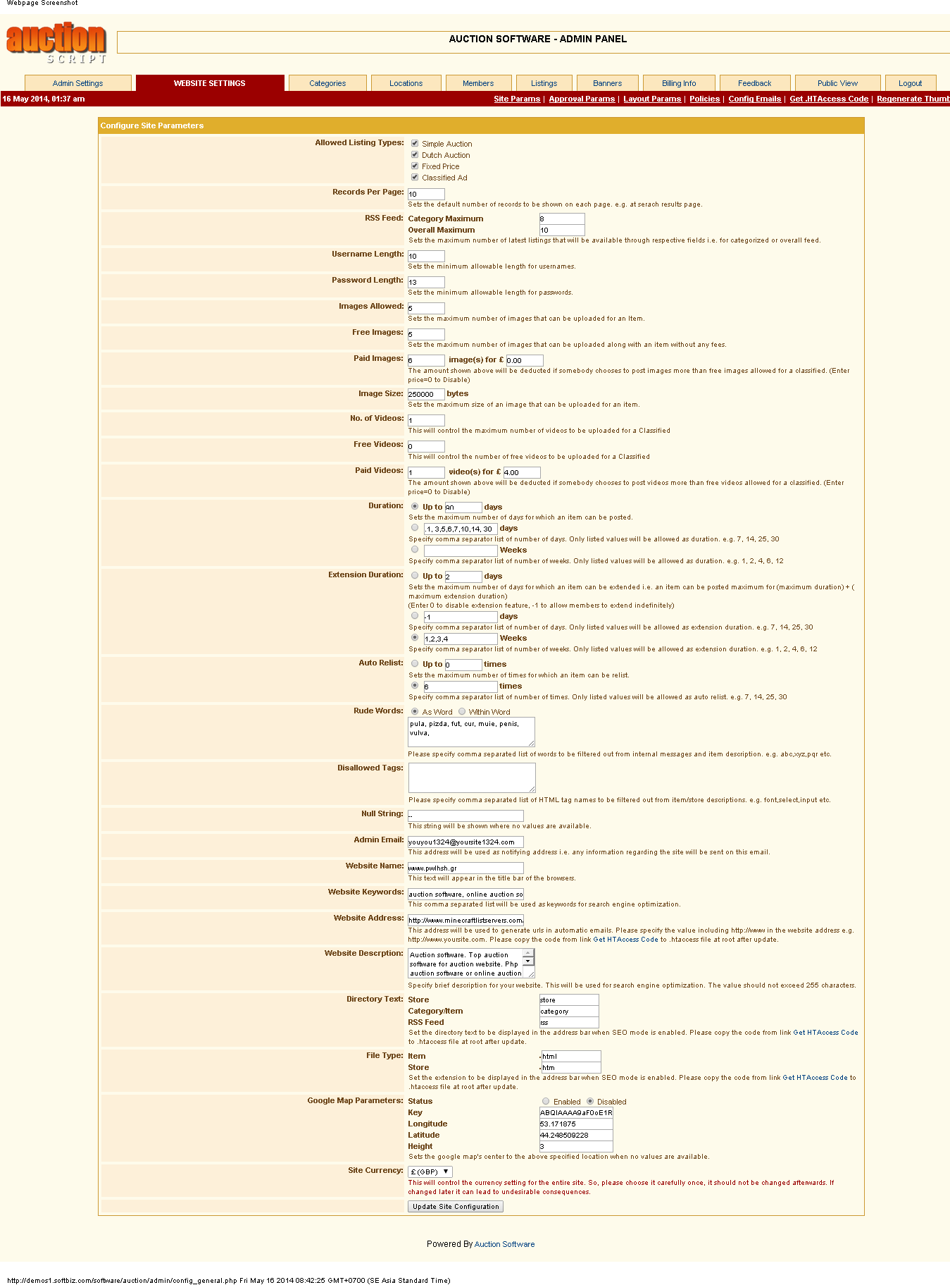

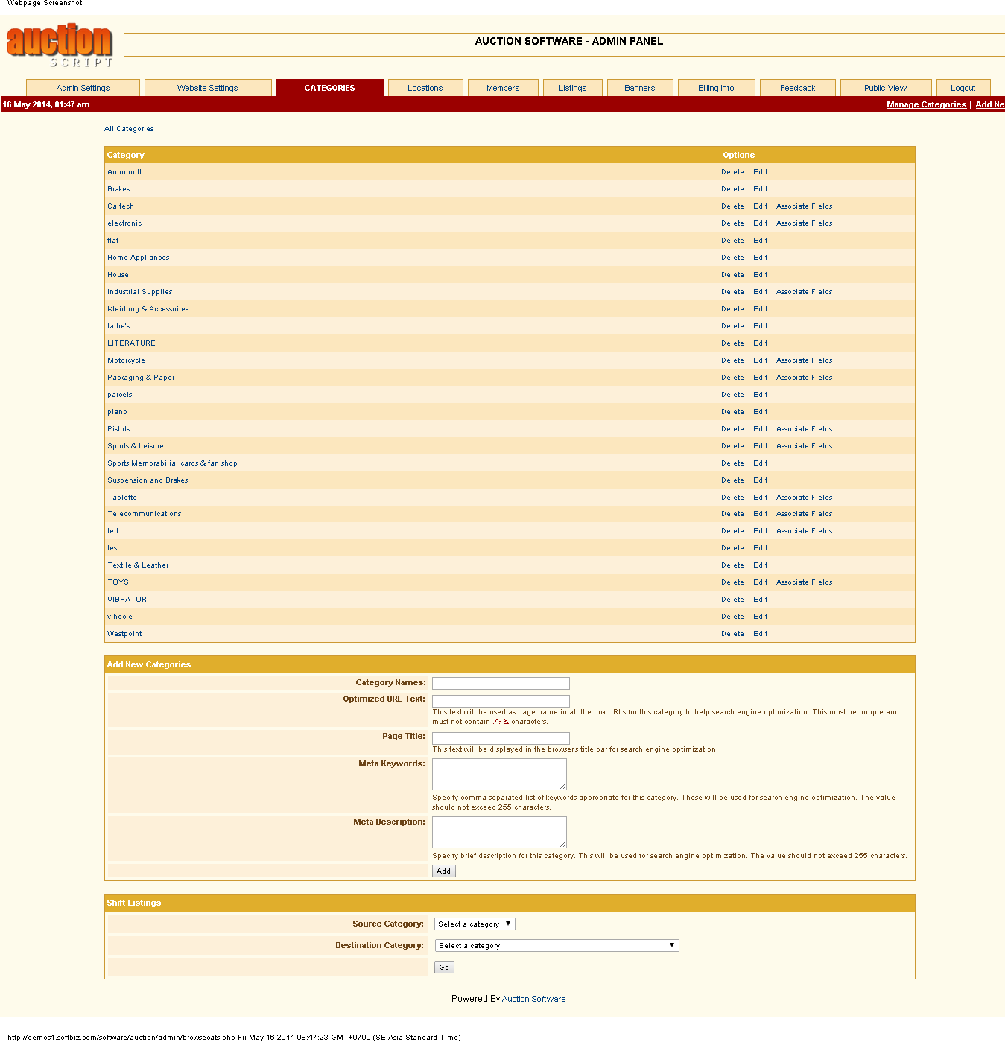

## *Members*

*Anyone must register to view, upload or bid items on bid-online system. They can get some goodwill from the system.*

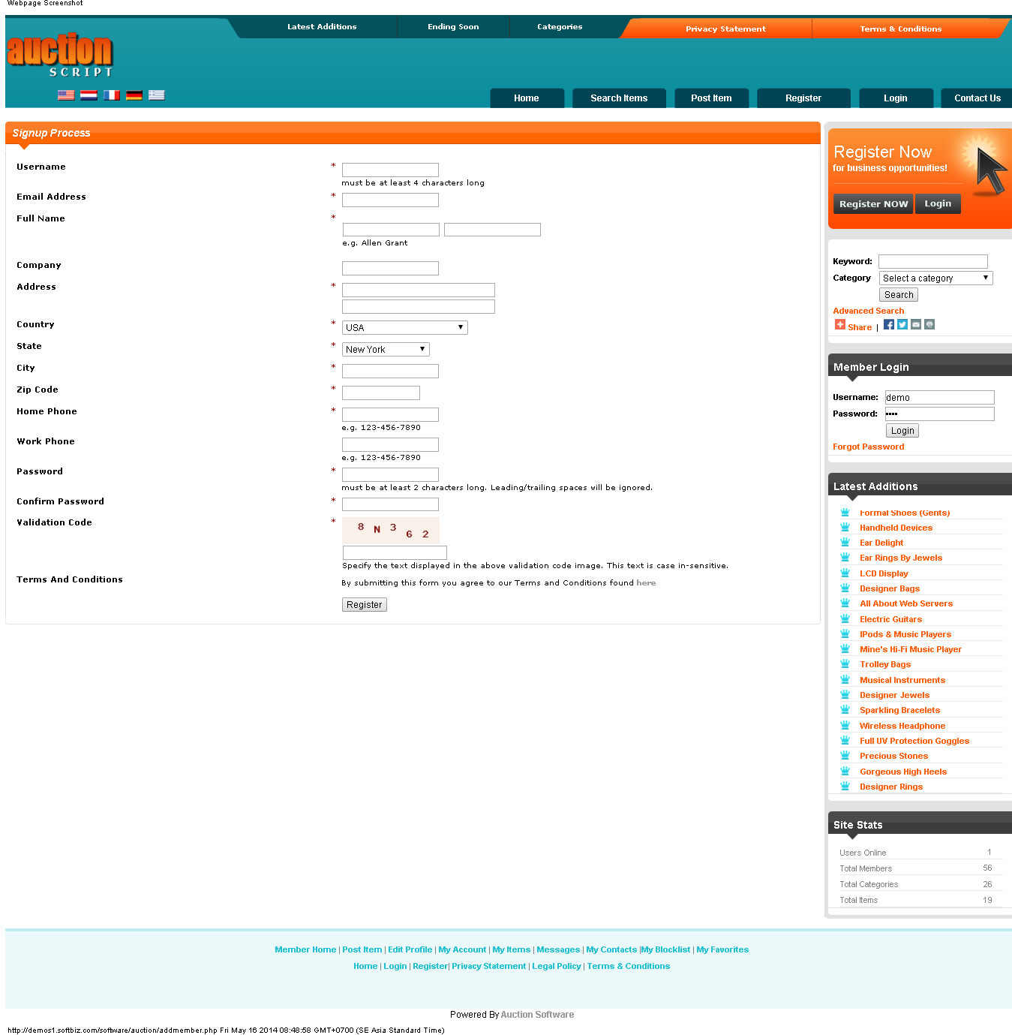

*Log-in*

*When u got an account, u must log-in into the system by input your Username and Password.*

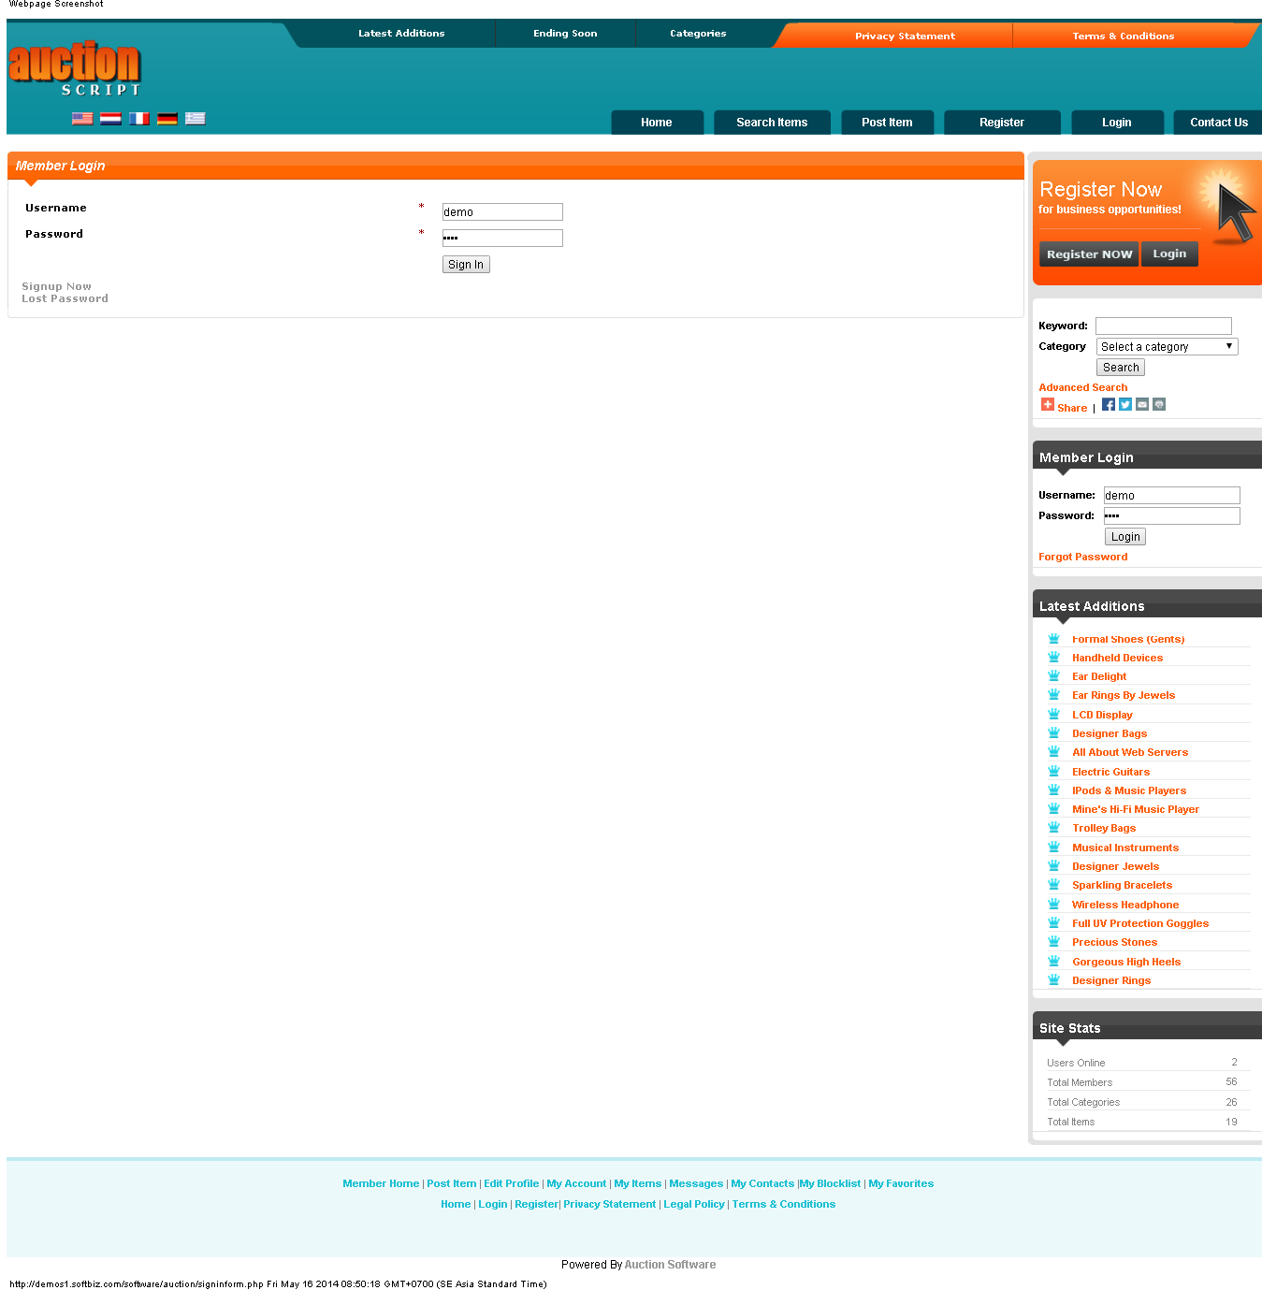

## *Upload items for bidding*

When u want to upload an item for bidding, u must provide all of your information(Name, age, Address, phone, …) and item’s information(situation, image, starting price for bidding, payment method….)

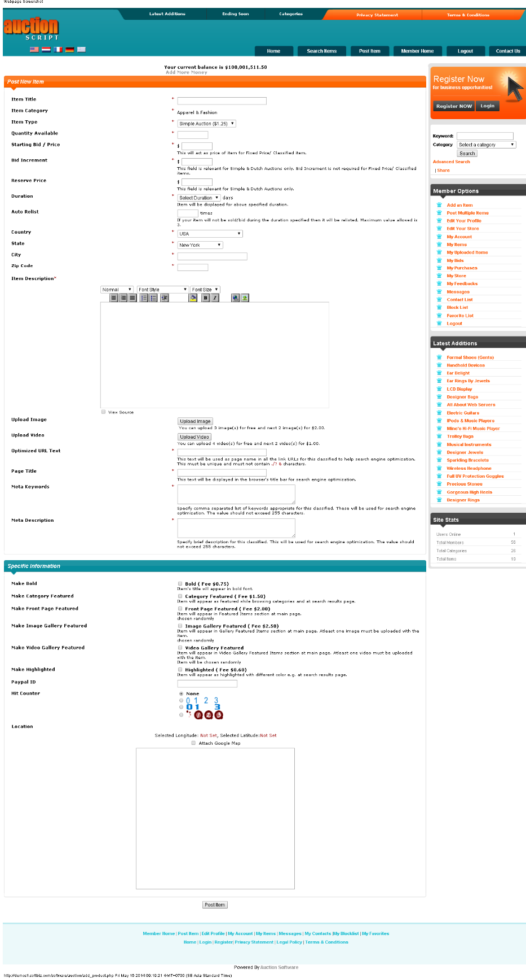

## *Update, change, suspend bid-items*

With items which u had started to bid, u can log-in and change, update or suspend them, anything u want…

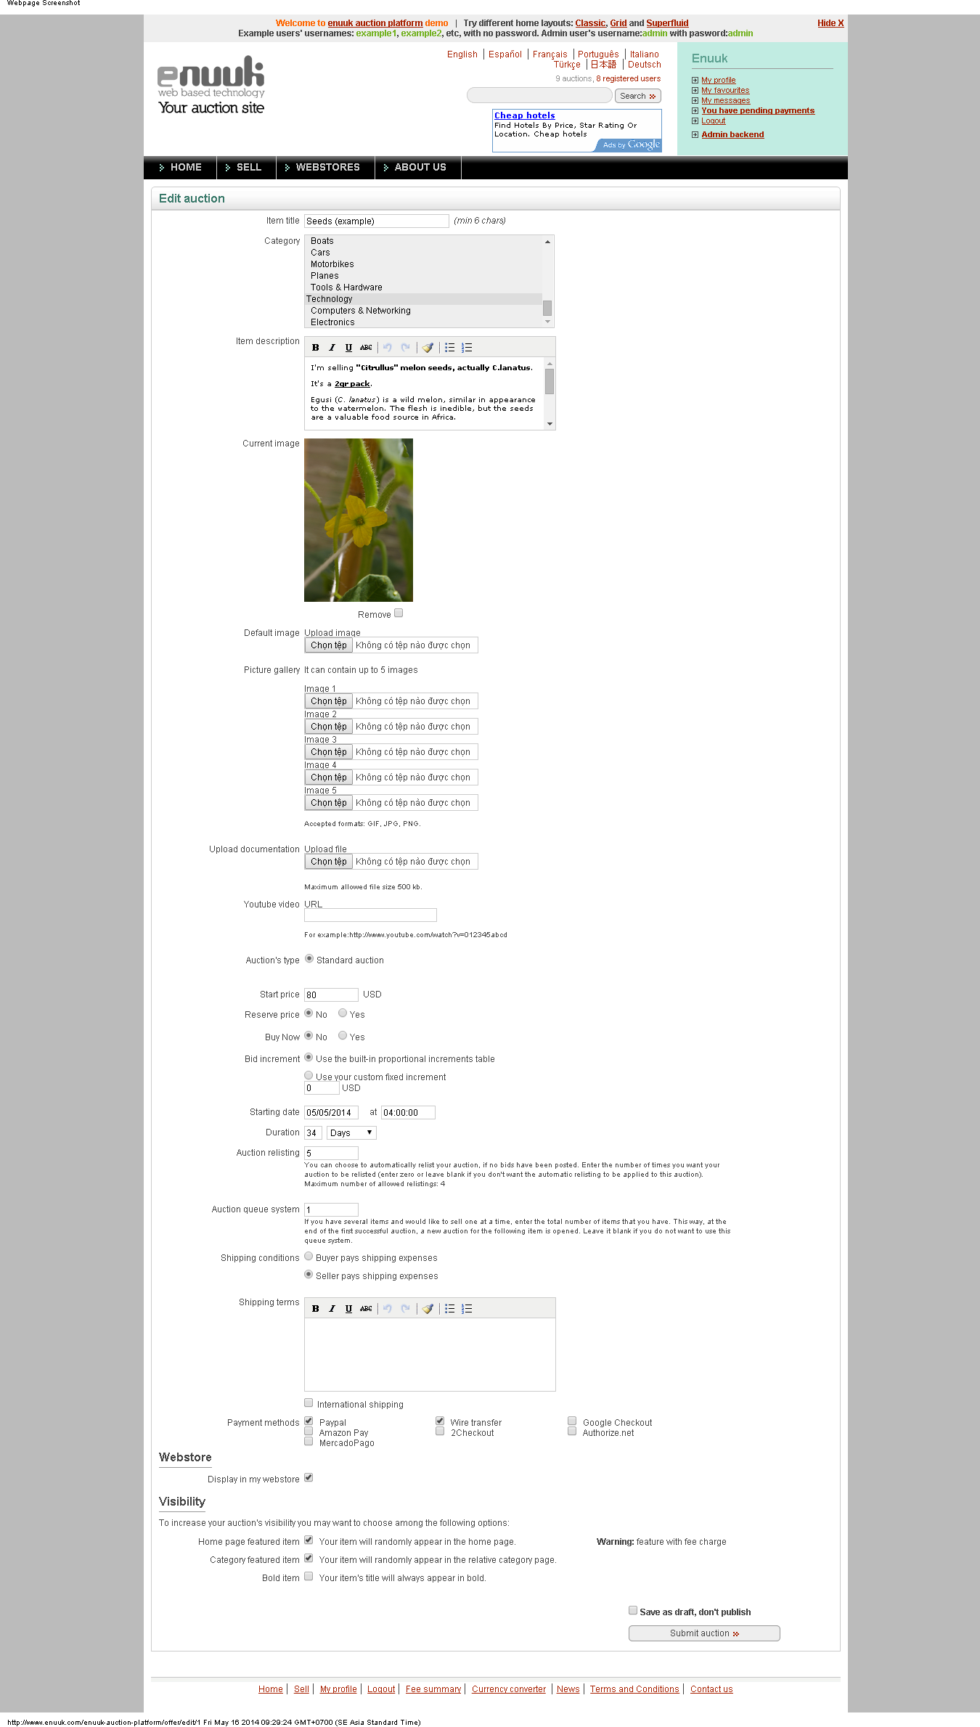

## *Online pay*

System requires you must choose a payment methods(PayPal, credit card, visa…) for your trade, u must provide to system information about your payment method.

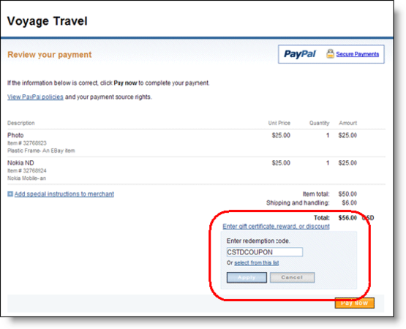

## *Interfaces*

Website has friendly interfaces, help anyone can view, bid easily. U can choose the language which u want

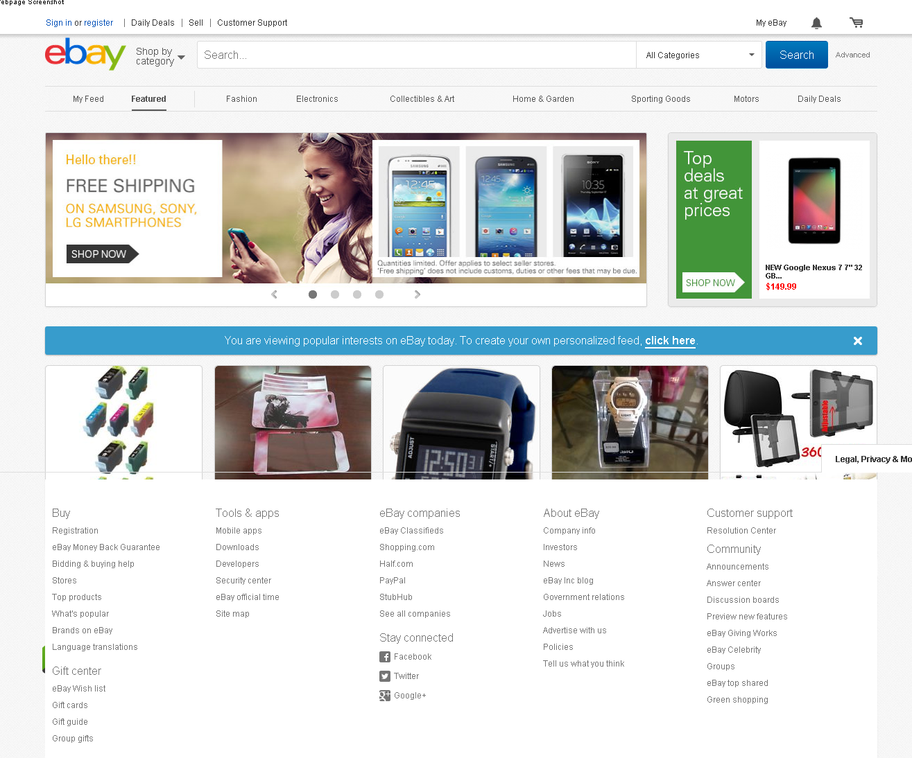

## *Bidding interface*

With any bidding-items, there’s always a page that shows any information about items

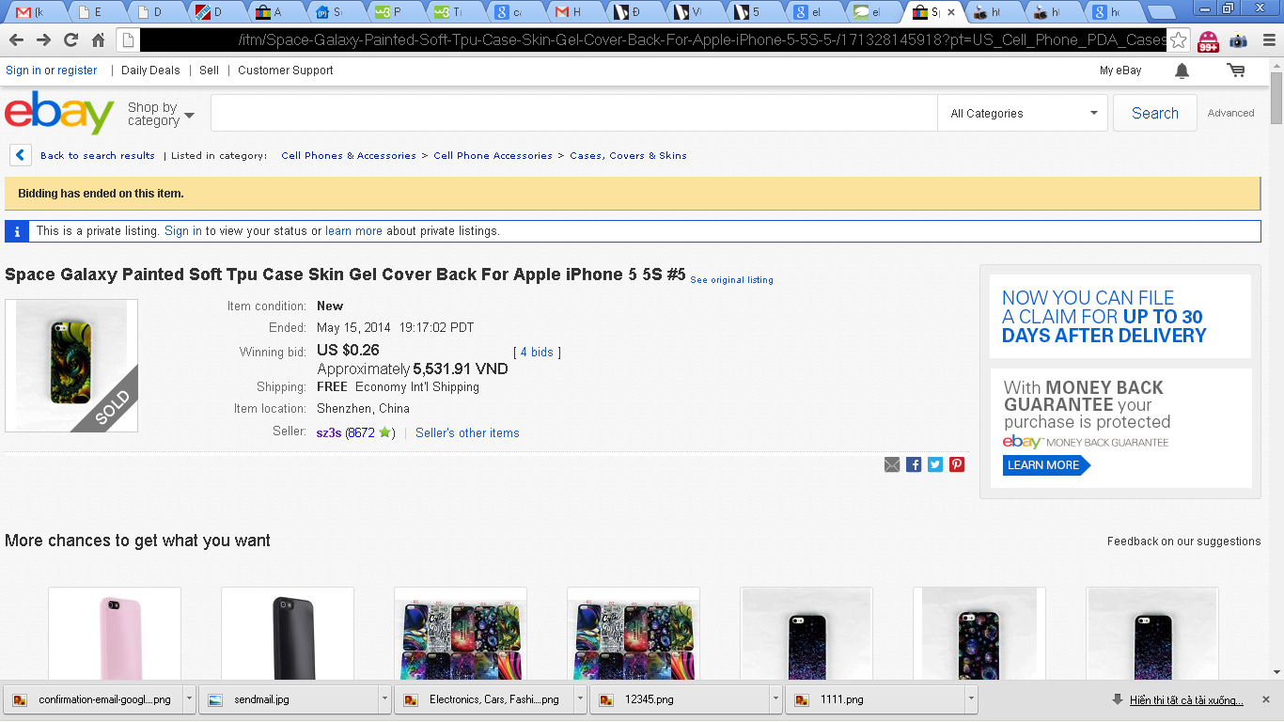

## *Social network*

*U can share items, system, anything u see on the website to your friends across popular social network(Facebook, Skype…)*



# *USABILITY*

## *<Request number one>*

*<A  brief description of the request. Note of what decision has been made on it and how the reques**t will be considered.>*

# *REABILITY*

## *<Request number one>*

*<A brief description of the request. Note of what decision has been made on it and how the request will be considered.>*

# *PERFOMANCE*

## *<Request number one>*

*<A brief description of the request. Note of what decision has been made on it and how the request will be considered.>*

# *SUPPORTABILITY*

## *<Request number one>*

*<A brief description of the request. Note of what decision has been made on it and how the request will be considered.>*

# *BUSINESS RULES AND REGULATIONS*

## Locate the item you want to purchase. Browse the categories for an item you want to buy or use the search feature to find something specific. Scroll through the available listings and click on the one that suits your desires.

## Click on the "Place Bid" button. This initiates the bidding process. If you are not already signed in, system may ask you to sign in now. If you do not have an account, you may need to create one. An account is free to create, and having one allows you to monitor your ongoing bids and orders. Type in your maximum bid. Your maximum bid is the highest amount of money you are willing to pay for an item. Type the amount in the box.

## Review and confirm your bid. Verify that the maximum bid amount is correct and click on the "Confirm Bid" button to approve it.

## Successful bidding strategies. You will win if u have got the highest prices.

# *TECHNOLOGY RULES AND LIMITATIONS*

## *<Reference number one>*

*<A brief description of the reference. Note of what decisions have been made on it and how the reference will be considered. >*