On the working workstation
C:\Windows\System32>odbcad32.exe
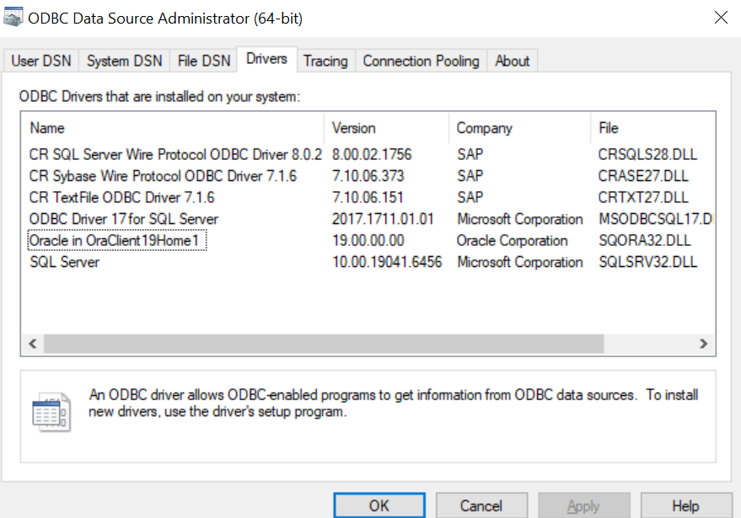

C:\Windows>cd SysWOW64

C:\Windows\SysWOW64>odbcad32.exe

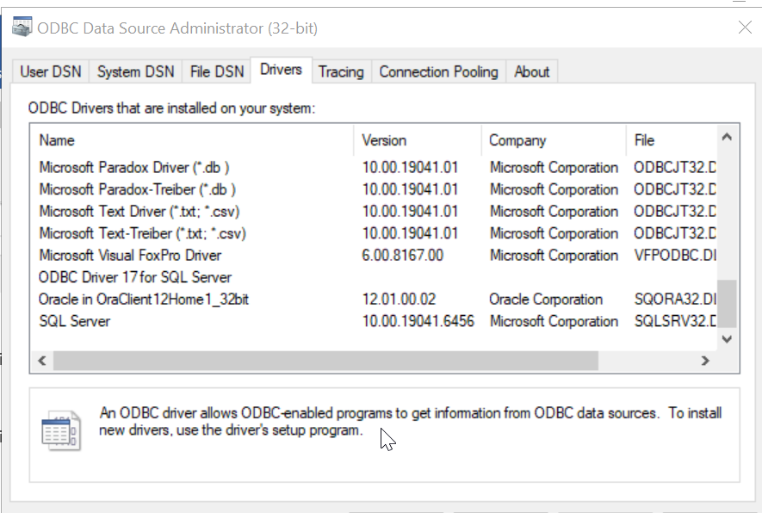
C:\Windows\System32>odbcad32.exe on where it is not working
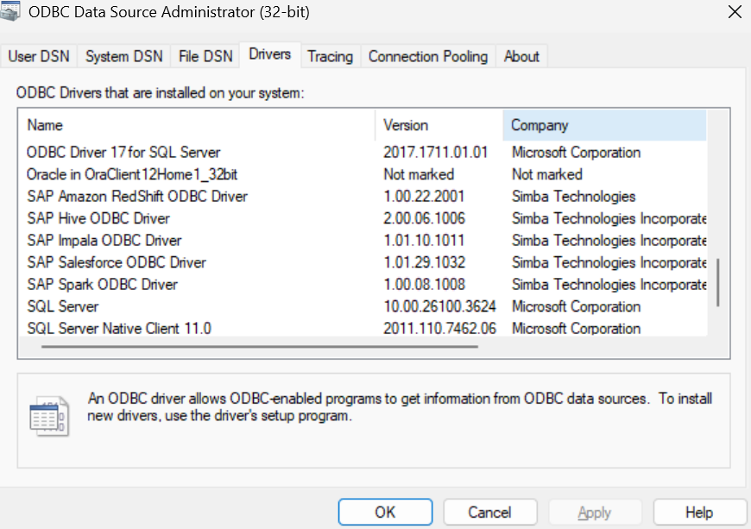
C:\Windows\System32>cd C:\Windows\SysWOW64

C:\Windows\SysWOW64>odbcad32.exe
