How CES connects to BOE 4.3 and generates reports
This document describes how the CES reports module reaches the BOE 4.3 platform through the TTC ReportService, how report parameters travel from the user to BOE, and how the PDF is produced and returned.

1. Architecture overview
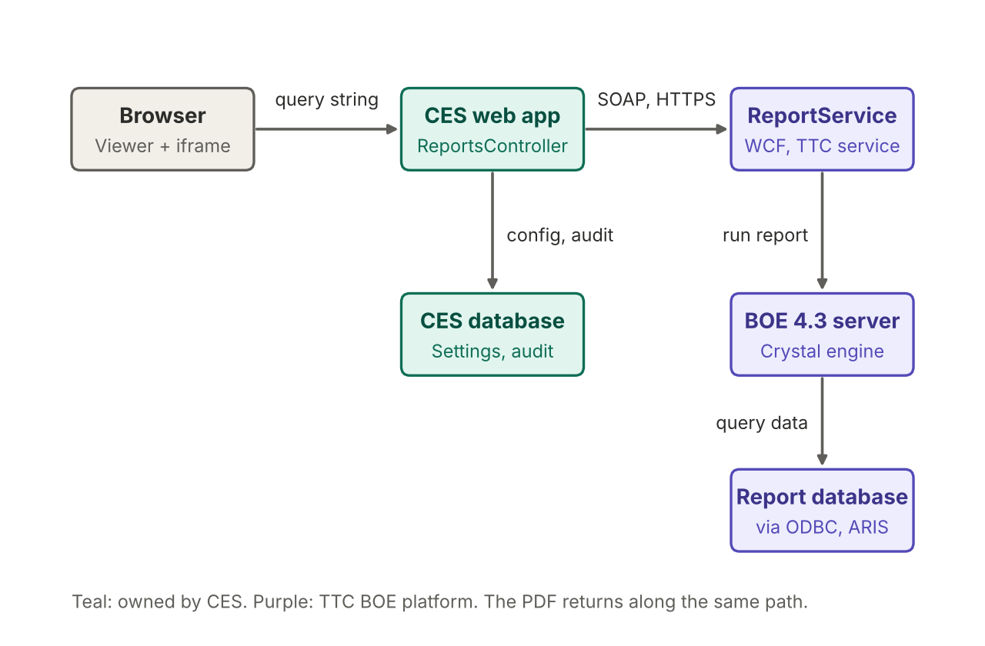
Figure 1. Components and connections. The PDF returns along the same path.
Component | Role
Browser | Shows the Viewer page, collects parameters and displays the PDF in an iframe.
CES web app | ReportsController checks the role, validates parameters, calls the service, writes the audit row and returns the PDF.
CES database | Holds CesSettings (connection values), report mapping, report parameter definitions and the audit table.
ReportService | TTC WCF service (SOAP over HTTPS). Same URL in DEV, UAT and PROD.
BOE 4.3 server | Runs the Crystal report and renders the PDF.
Report database | Data source of the report, reached through the ODBC connection and the credentials stored in ARIS.

2. Request sequence
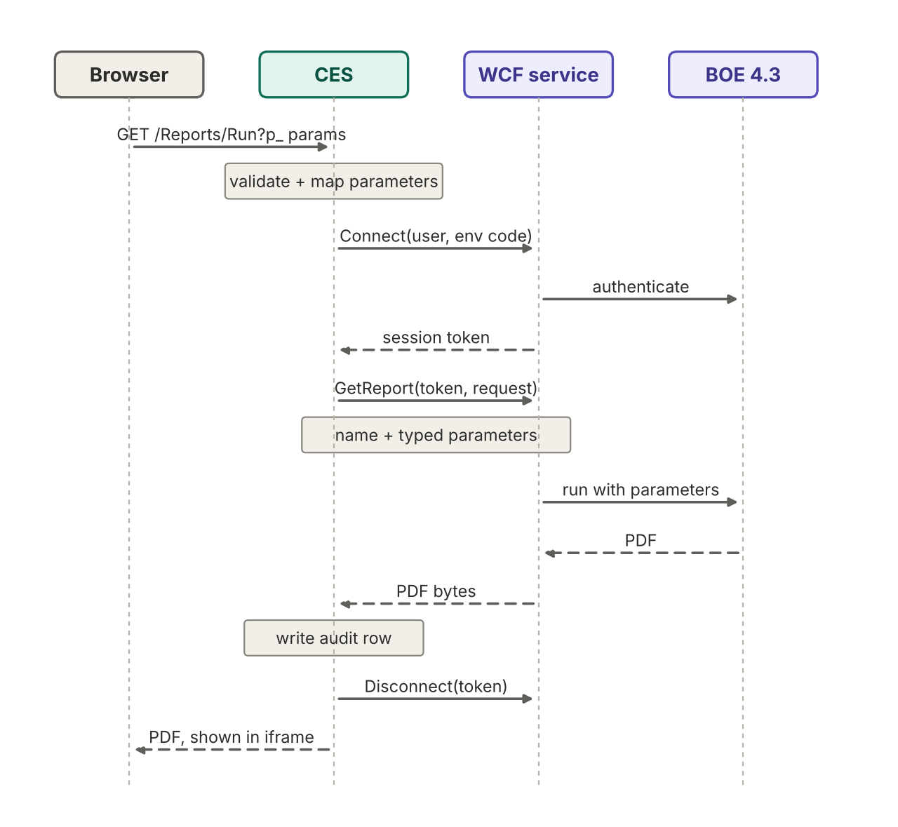
Figure 2. One report run. Solid arrows are requests, dashed arrows are responses.

3. How parameters travel
- Browser to CES. The user enters values such as startDate and endDate on the Viewer page. The page loads /Reports/Run?code=COST_VARIANCE&p_startDate=2026-01-01&p_endDate=2026-03-31 in the iframe. This is the only place a query string is used.
- Inside CES. The controller checks the user's role. It keeps only the parameters defined for that report in BoeReportParameter, rejects missing required ones, checks each value's type and reformats dates.
- CES to the WCF service. The values are not sent as a query string. Each one becomes a typed parameter object carrying the Crystal prompt name and its value. The list goes inside the GetReport request, with the report folder, the report name and PDF as the output format.
- BOE. The service passes the parameters to the Crystal report, which runs against the report database. The prompt names must match the report exactly.
Reports without parameters have no rows in BoeReportParameter. The Viewer skips the form and runs the report immediately.

4. How the PDF is produced and returned
BOE renders the report as a PDF. The service returns the file bytes to CES in the GetReport response. CES records an audit row, calls Disconnect, and sends the bytes to the browser as an inline PDF, which the browser shows in the iframe. The session token stays inside CES and is never put in a URL.

5. What to confirm in DEV
- Environment code. Connect takes the environment through the code stored in CesSettings. The exact values for DEV, UAT and PROD must come from the BOE Administrator.
- Prompt names. The names in BoeReportParameter must match the Crystal report prompts exactly. A prompt called "Start Date" will not match startDate.
- Date format. The default is yyyy-MM-dd and is configurable per parameter. Test it on the first run.
- Range prompts. If a report has one range prompt for the dates, instead of two separate prompts, BOE expects a range parameter with a from and a to value. Check the prompt design in Crystal.

