

**Lasalle Collage**

**Course Name: Computer Tools**

**Teacher Name: Zoe Moeini**

**Student Name: Sandeep Singh**

**Description:** *This report displays the Sales by distinct categories based on Total price.*

Sales of Bars Category

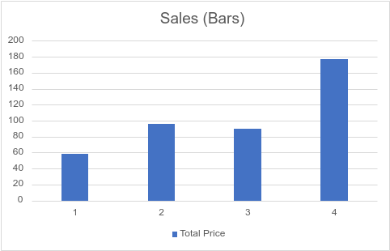

**Summary**: There are 4 transactions. Highest sales are seen in the 4th transaction and the lowest is for 1st transaction. Others are jumping up and down.

Sales of Cookies Category

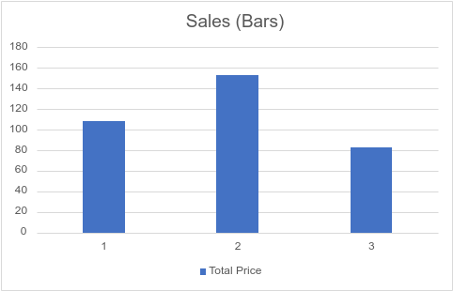

**Summary**: There are 3 transactions. The highest sales are seen in the 2nd transaction and the lowest is for 3rd transaction. 1st transaction is in-between the two.

Sales of Crackers Category

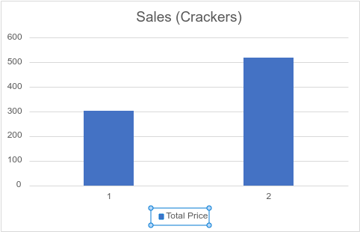

**Summary**: There are 2 transactions. The highest sales are seen in the 2nd transaction and the lowest is for 1st transaction.