Experiment-2

HTML Tables, Forms and Frames:
Write a HTML program, to explain the working of tables. (use tags: <table>, <tr>, <th>,
<td> and attributes: border, rowspan, colspan)
Write a HTML program, to explain the working of tables by preparing a timetable. (Note: Use <caption> tag to set the caption to the table & also use cell spacing, cell padding, border, rowspan, colspan etc.).
Write a HTML program, to explain the working of forms by designing Registration form. (Note: Include text field, password field, number field, date of birth field, checkboxes, radio buttons, list boxes using <select>&<option> tags, <text area> and two buttons ie: submit and reset. Use tables to provide a better view).
Write a HTML program, to explain the working of frames, such that page is to be divided into 3 parts on either direction. (Note: first frame image, second frame paragraph, third frame hyperlink. And also make sure of using “no frame” attribute such that frames to be fixed).

Write a HTML program, to explain the working of tables. (use tags: <table>, <tr>, <th>, <td> and attributes: border, rowspan, colspan)

In HTML, the rowspan attribute specifies how many rows a table cell should span, determining its vertical position. On the other hand, the colspan attribute specifies the number of columns a cell should span, determining its horizontal position.
Table of Content

HTML Table with Colspan HTML Table with Rowspan

HTML Table with Colspan:
HTML Table with Colspan allows you to merge or combine adjacent table cells horizontally, creating a single, wider cell that spans across multiple columns.
Note: The colspan is defined as the <th> element.

Example: The element illustrates the HTML Table with colspan.

<!DOCTYPE html>
<html lang="en">

<head>
<meta charset="UTF-8">
<title>HTML Table with Colspan </title>
<meta name="viewport" content="width=device-width, initial-scale=1.0">
<title>HTML Table</title>

<style> h1,
h3 {
text-align: center; color: green;
}
table {
width: 100%;
border: 1px solid #100808; border-collapse: collapse;
}

th,
td {
padding: 10px;
border: 2px solid black;

}
</style>
</head>
<body>
<h1>GeeksforGeeks</h1>
<h3>Table with Colspan
</h3>

<table>
<thead>
<tr>
<th colspan="2">Name</th>
<th>Class</th>
</tr>
</thead>
<tbody>
<tr>
<td>Mahima</td>
<td>Gupta</td>
<td>1</td>
</tr>
<tr>
<td>Sri</td>
<td>Krishn</td>
<td>3</td>
</tr>
<tr>
<td>Shivika</td>
<td>Goyal</td>
<td>5</td>
</tr>

</tbody>
</table>
</body>
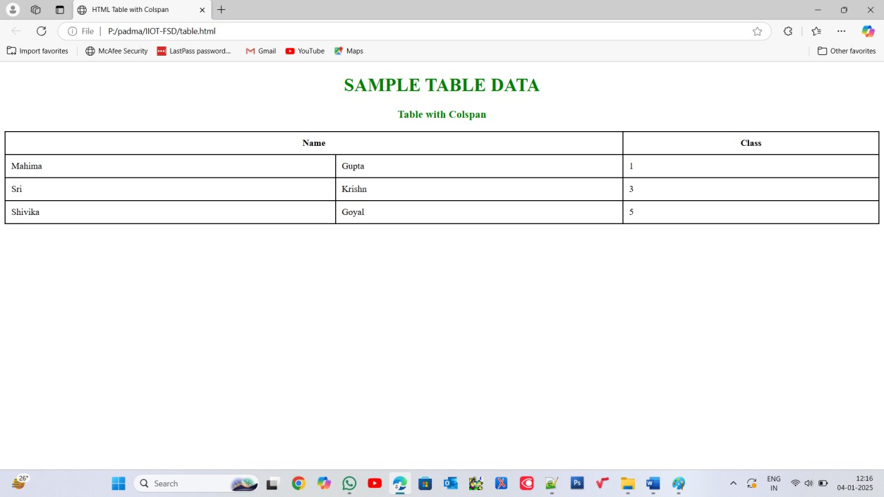
</html> Output:

Write a HTML program, to explain the working of tables by preparing a timetable. (Note: Use <caption> tag to set the caption to the table & also use cell spacing, cell padding, border, rowspan, colspan etc.).

About:

A time table or schedule is essential for organizing tasks, events, or classes. We’ll create a basic time-table layout using HTML.

A Table is an arrangement of rows and columns. Anyone can create a table by knowing the basics of HTML (Hyper Text Markup Language). In HTML we can use the <table> tag.

Approach

HTML Structure: Start with <html> and </html> tags to encapsulate your HTML document
Table Creation: Use <table> and </table> tags to define the table structure
Adding Rows: Insert rows using <tr> and </tr> tags within the table
Inserting Data: Populate cells with data using <td> and </td> tags within each row
Closing Tags: Ensure all opened tags are properly closed for syntactically correct HTML

End HTML Document: Close the <html> tag to signify the end of the HTML document Example: In this example code, we have created a basic timetable in HTML without the usage of font color and background colors with the above-explained approach.

Source Code:
<!DOCTYPE html>
<html>

<head>
<title>Time Table</title>
<style>
body {
font-family: Arial, sans-serif; background-color: #f8f9fa; margin: 0;
padding: 0;
}

h1 {
text-align: center; color: #343a40;
}

table {
border-collapse: collapse; margin: 20px auto; background-color: #fff; border: 2px solid #dee2e6;
box-shadow: 0 2px 4px rgba(0, 0, 0, 0.1);
}

th,
td {
border: 1px solid #dee2e6;

padding: 10px; text-align: center;
}

th {
background-color: #f2f2f2; color: #343a40;
}

.highlight {
background-color: #f8f9fa;
}

.special {
background-color: #f0f0f0;
}
</style>
</head>

<body>
<h1>TIME TABLE</h1>
<table>
<tr>
<th>Day/Period</th>
<th>I<br>9:30-10:20</th>
<th>II<br>10:20-11:10</th>
<th>III<br>11:10-12:00</th>
<th>12:00-12:40</th>
<th>IV<br>12:40-1:30</th>
<th>V<br>1:30-2:20</th>
<th>VI<br>2:20-3:10</th>
<th>VII<br>3:10-4:00</th>
</tr>
<tr>

Full Stack Development Lab Roll Number:

<td class="highlight"><b>Monday</b></td>
<td>OS</td>
<td>CN</td>
<td>P&S</td>
<td rowspan="6" class="special"><b>LUNCH</b></td>
<td colspan="3" class="special">FSD LAB</td>
<td>P&S</td>
</tr>
<tr>
<td class="highlight"><b>Tuesday</b></td>
<td colspan="3" class="special">LAB</td>
<td>CN</td>
<td>OS</td>
<td>P&S</td>
<td class="special">COUNCILLING</td>
</tr>
<tr>
<td class="highlight"><b>Wednesday</b></td>
<td>MPMC</td>
<td>DTI</td>
<td>CN</td>
<td>OS</td>
<td colspan="3">MPMC LAB </td>
</tr>
<tr>
<td class="highlight"><b>Thursday</b></td>
<td>CN</td>
<td>OS</td>
<td>CN</td>
<td colspan="3" class="special"> OS LAB</td>
<td>P&S</td>
</tr>
<tr>
<td class="highlight"><b>Friday</b></td>

Full Stack Development Lab Roll Number:

<td colspan="3" class="special"> CN LAB</td>
<td>MPMC</td>
<td>DTI</td>
<td>CN</td>
<td>OS</td>
</tr>
<tr>
<td class="highlight"><b>Saturday</b></td>
<td>DTI</td>
<td>CN</td>
<td>OS</td>
<td colspan="3">MPMC LAB</td>
<td class="special">LIB</td>
</tr>
</table>
</body>
</html>

Output:

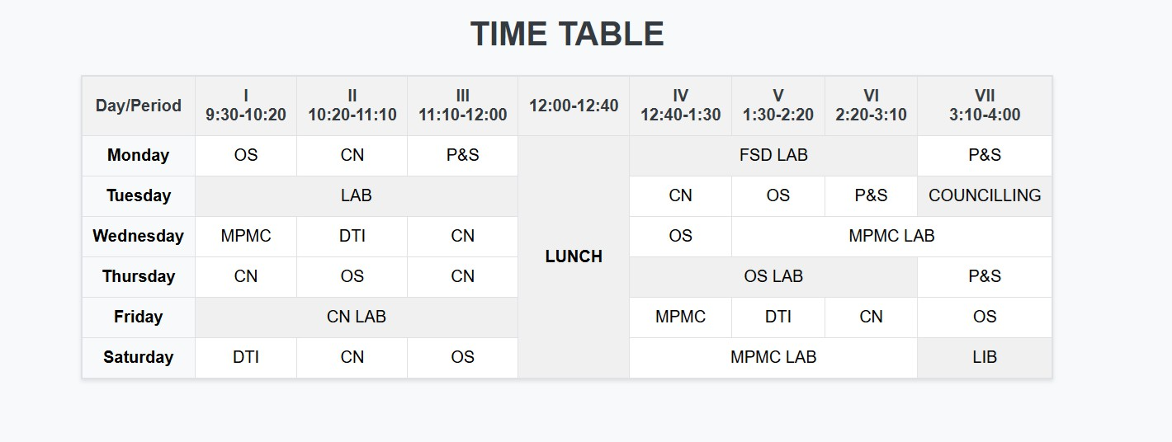

Write a HTML program, to explain the working of forms by designing Registration form. (Note: Include text field, password field, number field, date of birth field, checkboxes, radio buttons, list boxes using <select>&<option> tags, <text area> and two buttons ie: submit and reset. Use tables to provide a better view).

About:

What is HTML Form?
An HTML form is a section of a document that allows users to enter and submit information, which is then sent to a web server for processing. HTML forms are commonly used to collect various types of user data, such as usernames, passwords, contact information, email addresses, and more.

HTML forms contain interactive controls like input boxes, radio buttons, checkboxes, submit buttons, and other elements that allow users to input their information. These controls are crucial for facilitating user interaction and data submission to the server.

The <form> tag is used to create an HTML form. Inside the form, different elements like
<input>, <button>, <select>, and others are used to collect and submit data to the web server.

Source Code:
<!DOCTYPE html>
<html>

<body>
<form>
<label for="username">Username:</label><br>
<input type="text" name="username">
<br><br>

<label for="email_id">Email id:</label><br>
<input type="text" name="email_id">
<br><br>
<input type="submit" value="Submit">
</form>
</body>
</html>

Output:
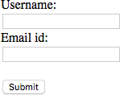

Input Elements in HTML Forms
Input elements are the building blocks of HTML forms, allowing users to enter and submit various types of data. Common input elements include:
Text Field: Allows the user to input single-line text. It is created using the <input> element with type=”text”.
Source Code:
<!DOCTYPE html>
<html>
<body>
<h3>Example of Text Field</h3>
<form>
<label for="email">Email ID:</label><br>
<input type="text" name="email" id="email"><br>
</form>
</body>
</html>

Output:

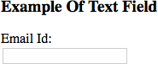
Number Field: This field accepts numeric input. It is created using the <input> element with type=”number”.

Source Code:
<!DOCTYPE html>
<html>
<body>
<h3>Example of Number Field</h3>
<form>
<label for="age">Age:</label><br>
<input type="number" name="age" id="age">
</form>
</body>
</html> Output:
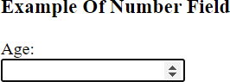

Write a HTML program, to explain the working of frames, such that page is to be divided into 3 parts on either direction. (Note: first frame image, second frame paragraph, third frame hyperlink. And also make sure of using “no frame” attribute such that frames to be fixed).
HTML frames allow authors to present documents in multiple views, which may be independent windows or sub windows. Multiple views offer designers a way to keep certain information visible, while other views are scrolled or replaced.
Program:
<HTML>
<HEAD>
<TITLE>A simple frameset document</TITLE>
</HEAD>
<FRAMESET cols="20%, 80%">
<FRAMESET rows="100, 200">
<FRAME src="contents_of_frame1.html">
<FRAME src="contents_of_frame2.gif">
</FRAMESET>
<FRAME src="contents_of_frame3.html">
<NOFRAMES>
<P>This frameset document contains:
<UL>
<LI><A href="contents_of_frame1.html">Some neat contents</A>
<LI><IMG src="contents_of_frame2.gif" alt="A neat image">
<LI><A href="contents_of_frame3.html">Some other neat contents</A>
</UL>
</NOFRAMES>
</FRAMESET>
</HTML>

Output:

| | |
| | |
| Frame 1 | |
| | |
| | |
| | |  |  | |
| | | Frame 3 |  |  | |
| | |  | |
| | |  | |
| | |  | |
| Frame 2 | |  |  |  | |
| | |  | |
| | |  | |
| | |  | |
| | |  | |

