Local database installation :

<https://www.mongodb.com/try/download/community>

Cloud :

<https://www.mongodb.com/cloud/atlas/register>

Step 1: click on create cluster

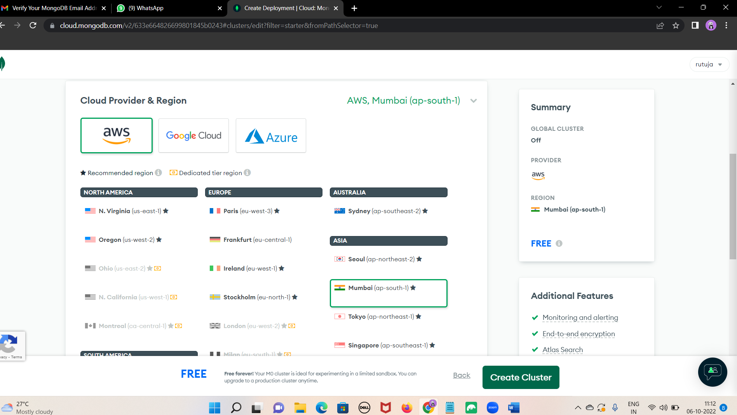

Step 2: put your both username and password (cdac)

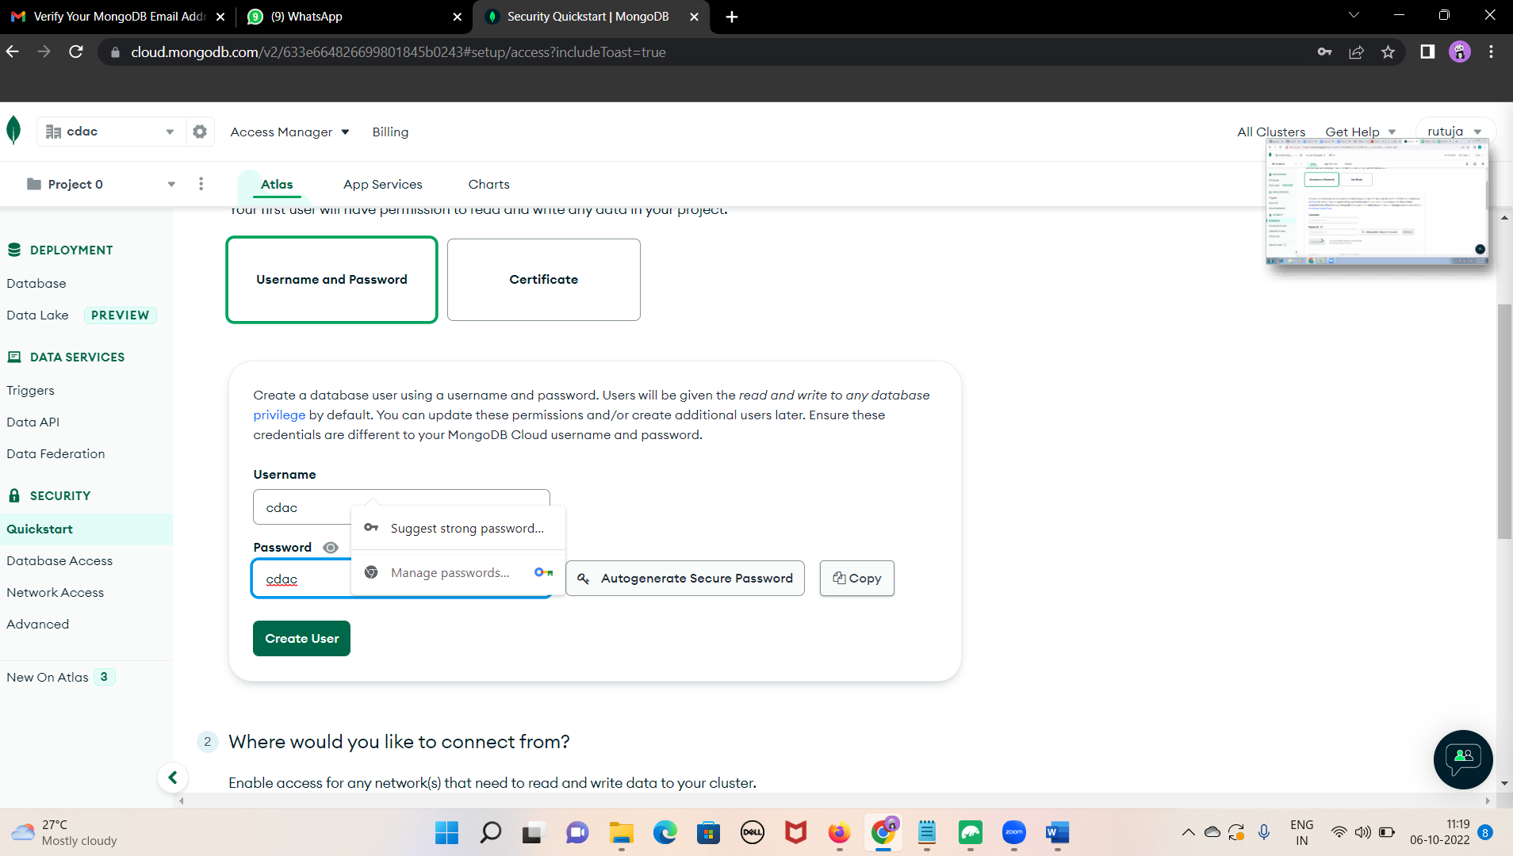

Step 3: click on add my current Ip address

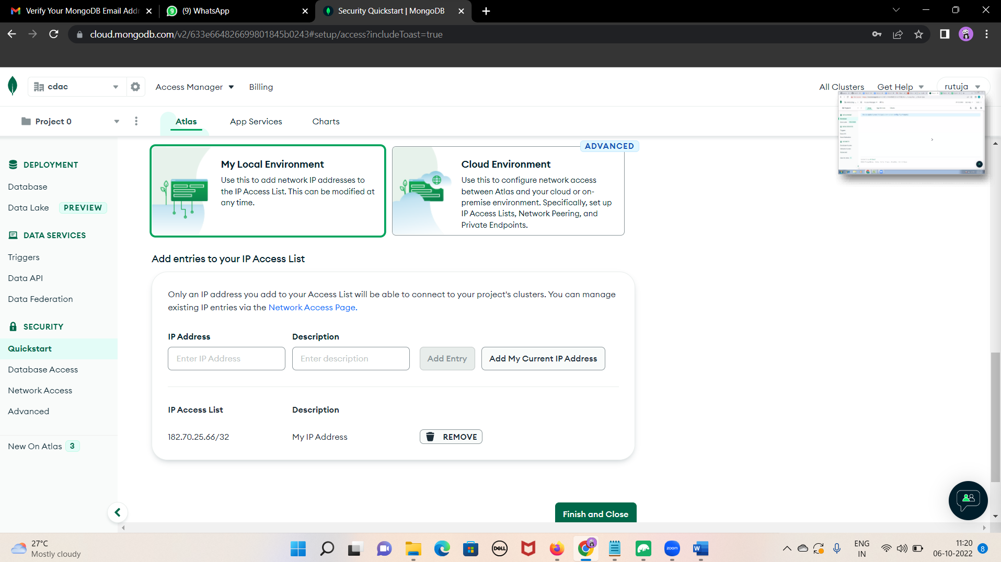

Step 4:ones data base is created go to network access

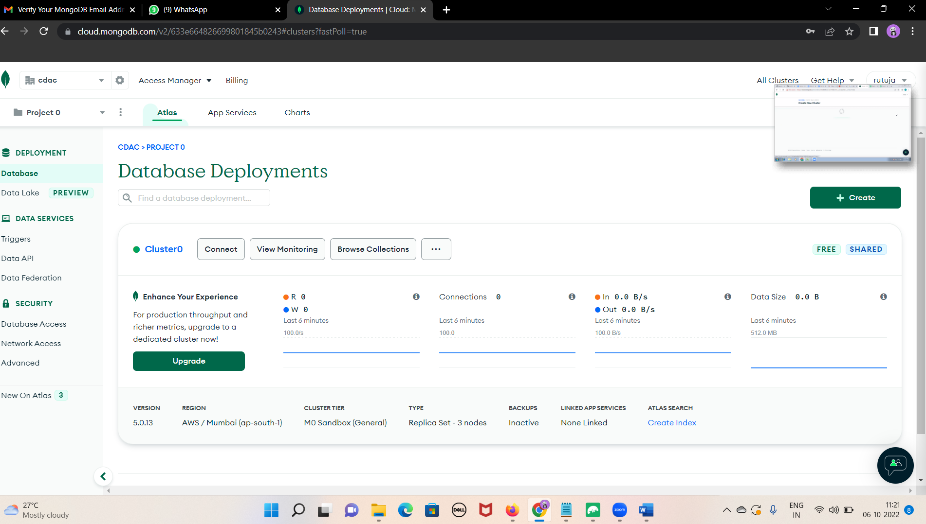

Step 5: click on edit

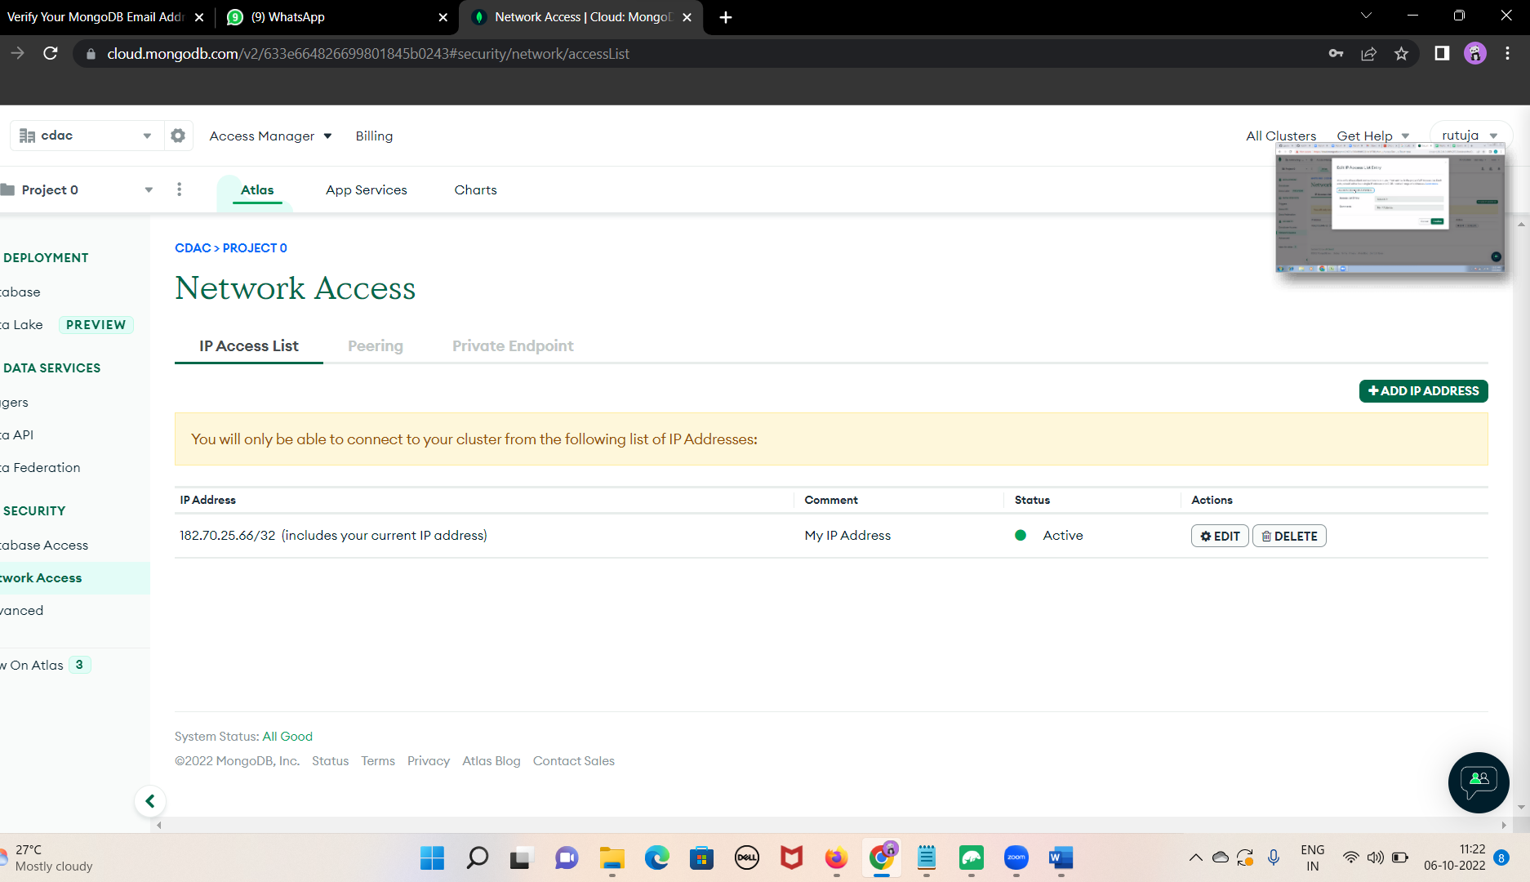

Step 6: click on allow access from anywhere

