**SUPERVISOR : Proff. V NARAYANAN MENTOR : PRASHANT BARNWAL**

**SANDEEP PRASAD GOND (b23ph1019@iitj.ac.in)**

**PONNURU AAKASH (b23ph1015@iitj.ac.in)  
CHIRAG KOTED (b23ph1005@iitj.ac.in)**

Monte Carlo Radiative Transfer Simulation for Photon Scattering in Planetary Atmospheres

# Introduction

The Monte Carlo method is a statistical approach used to model and analyze complex physical systems through random sampling. In our project, we applied this method to simulate photon transport in planetary atmospheres, especially in the context of Titan’s near-infrared radiative transfer. The primary aim was to understand how photons interact with atmospheric particles and surfaces using probabilistic principles.

# Objectives:

* To implement a Monte Carlo radiative transfer model.
* To simulate photon paths as they scatter, absorb, or transmit through the atmosphere.
* To validate the model by comparing the simulation results with known or expected behavior.

# **Methodology**

1. **Photon Initialization**: Each photon is assigned an initial direction and position, typically at the top of the atmosphere.
2. **Step Size and Interaction**: A random path length is calculated using an exponential distribution based on the extinction coefficient. The photon either:

* **Scatters**: Changes direction according to a scattering phase function.
* **Gets Absorbed**: Removed from the simulation.
* **Escapes**: Leaves the top of the atmosphere or hits the surface.

1. **Scattering Angle Determination**: The new direction is calculated using random sampling techniques and the chosen scattering model (e.g., Henyey-Greenstein).
2. **Statistics Collection**: Outcomes like albedo, transmittance, or angular distribution of exiting photons are recorded over many photon histories to produce statistically significant results.

#### **Tools and Implementation**

**Parameters Tuned**:

* Number of photons
* Optical depth
* Surface reflectivity
* Scattering albedo and asymmetry parameter

## 2.3 Algorithm Flow

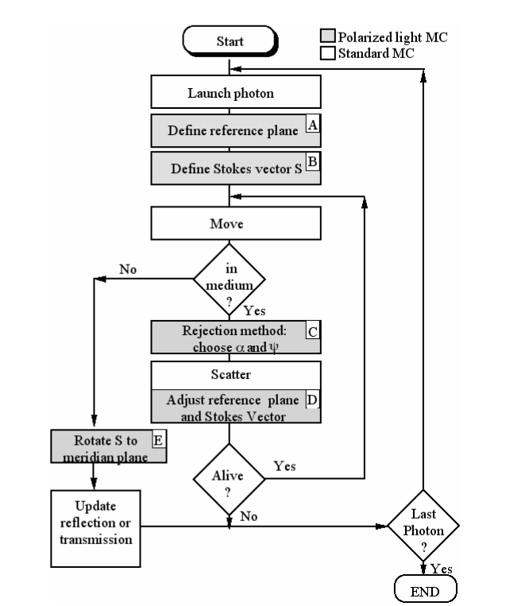

# **Results:**

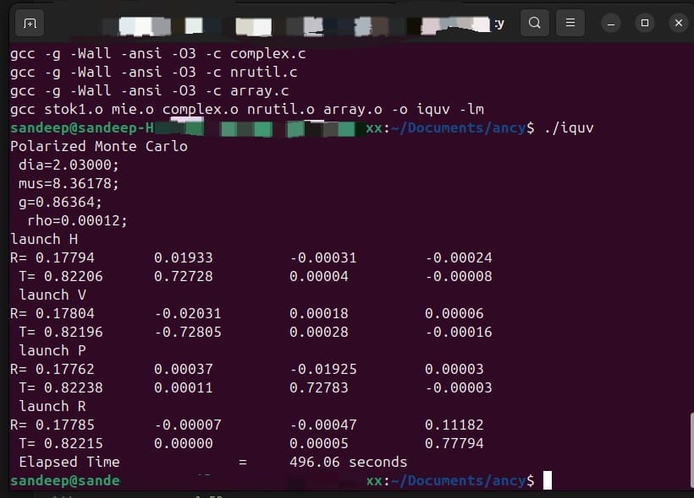

**(Polarized output)**

* As photon counts increase, the simulation converges toward stable reflectance and transmittance values.
* Angular distributions of scattered light follow expected trends, validating the phase function implementation.
* The Monte Carlo model successfully captured complex interactions that are difficult to model analytically.

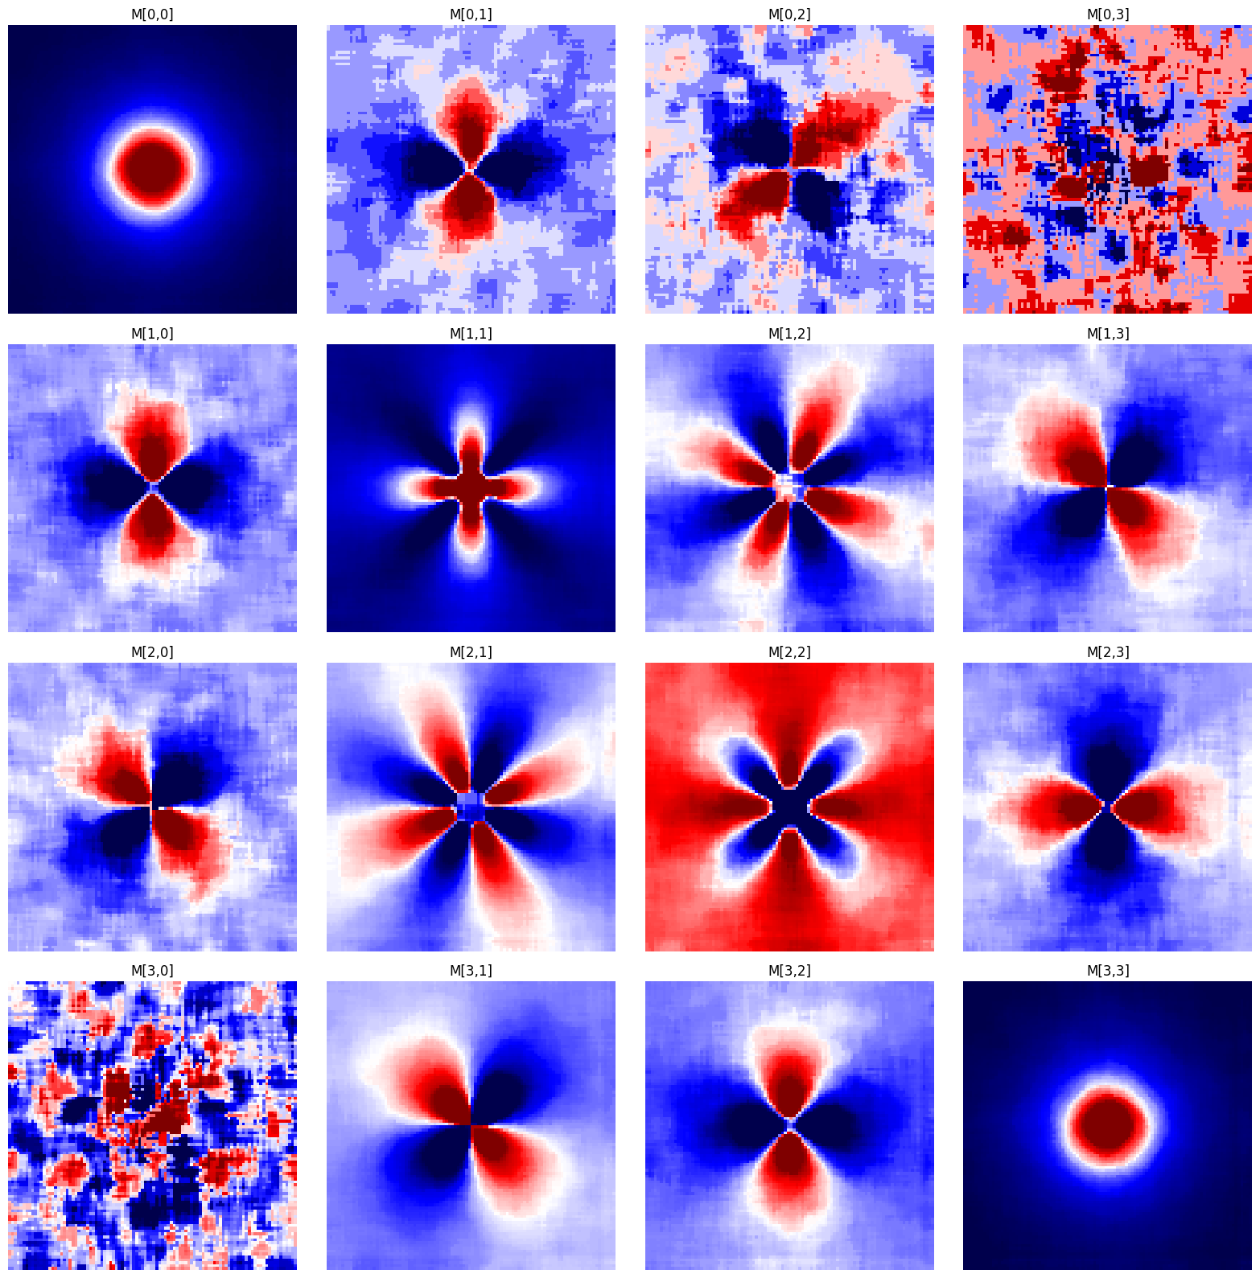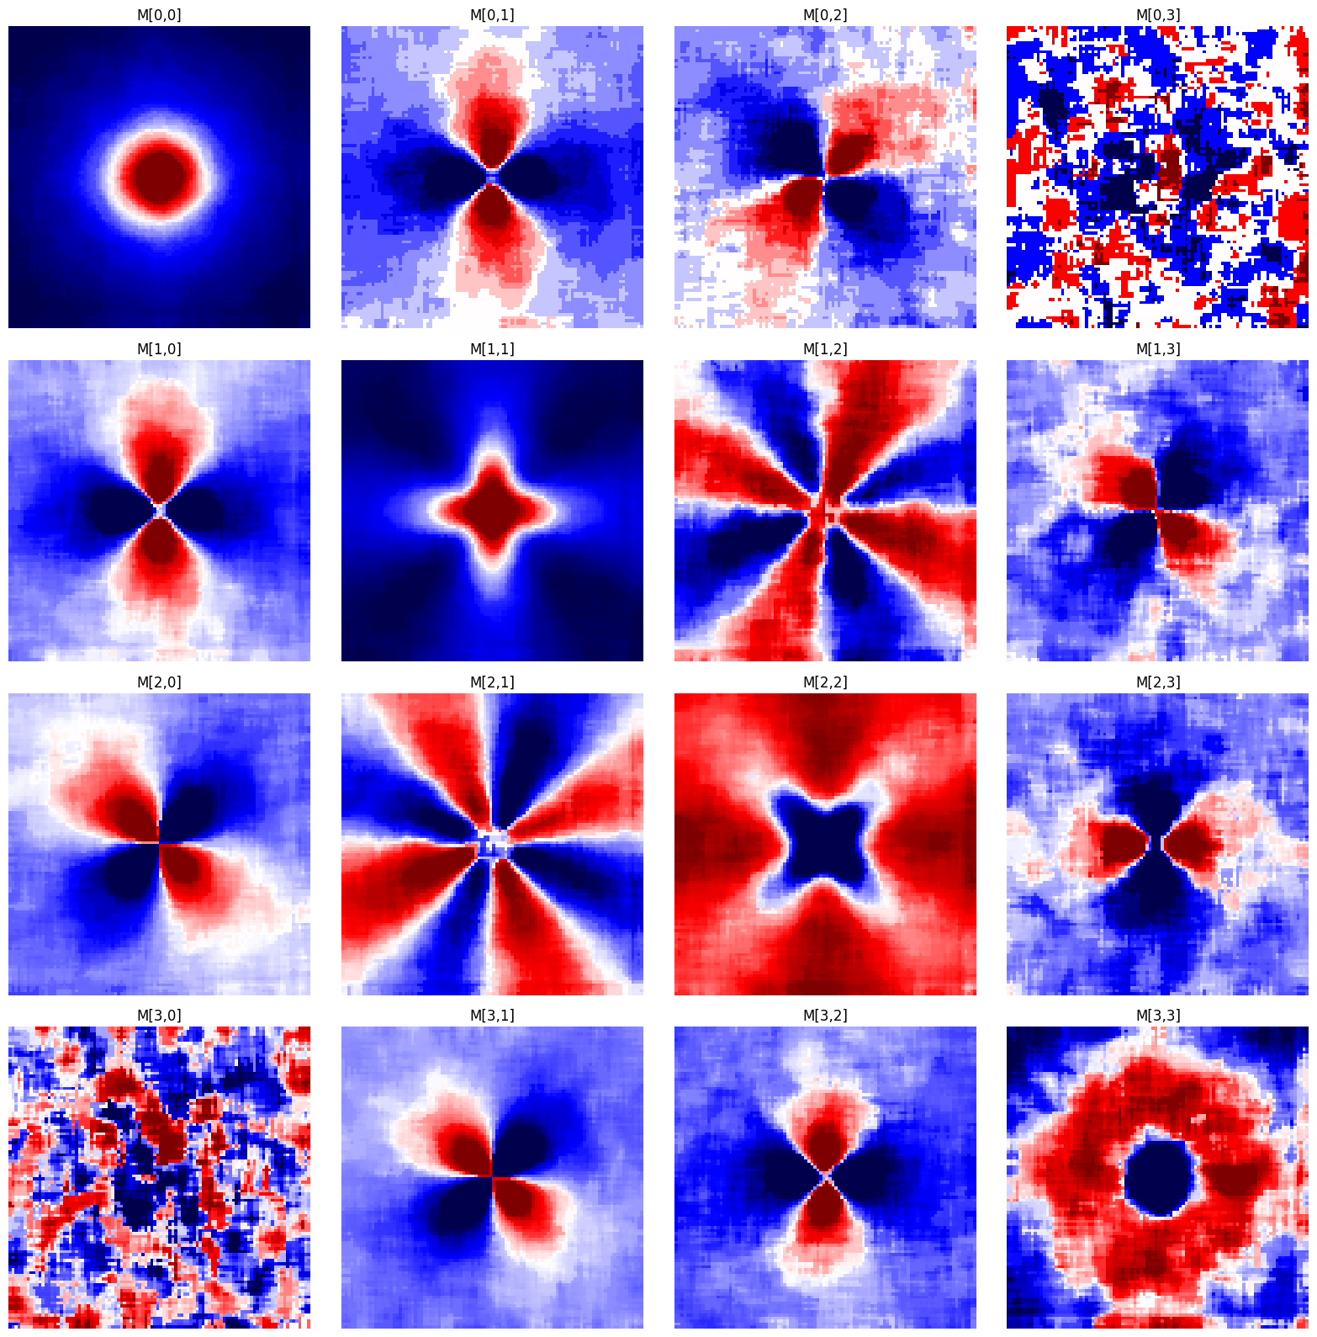

Mueller matrix at UV

Mueller matrix At IR

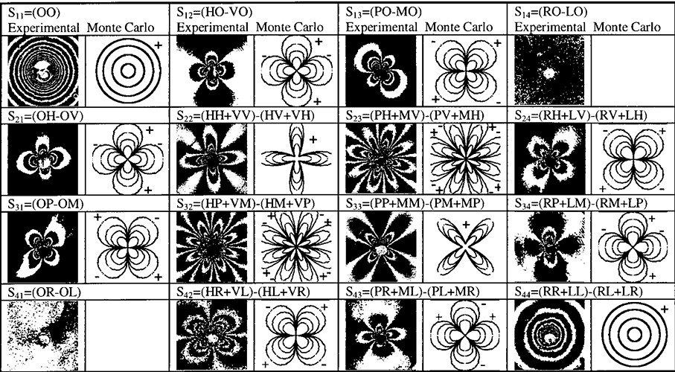

[**Ref. paper**](https://www.researchgate.net/publication/5532217_Light_backscattering_polarization_patterns_from_turbid_media_theory_and_experiment)

**Advantages of the Monte Carlo Method**

* Flexibility in handling arbitrary geometries and boundary conditions.
* Natural inclusion of multiple scattering events.
* Ability to simulate polarized light and spectral features (in future extensions).

#### **Limitations:**

* Computationally expensive for high accuracy due to large photon counts.
* Noise in results unless sufficiently averaged over many photons.

### **Use Cases:**

#### **Radiative Transfer in Atmospheres**

#### **Nuclear Physics**

#### **Financial Modeling**

* + Risk assessment and option pricing in stock markets.
  + Forecasting future asset behavior under uncertainty.

#### **Medical Imaging**

* + Simulation of photon transport in tissues for imaging techniques like PET, SPECT, and optical tomography.
* Machine Learning & AI
* Quantum Mechanics

#### **Conclusion:**

The Monte Carlo method provided a powerful and intuitive way to simulate radiative transfer in Titan’s atmosphere. Its random sampling nature allowed detailed insight into scattering processes that align well with physical expectations. Though computationally intensive, the model lays the foundation for more advanced simulations, including polarization and spectral line treatment.

# Future Work

- Parallelize the simulation for large-scale runs.  
- Include wavelength dependence.  
- Simulate real satellite observation angles.  
- Extend to 3D geometries for planetary limb scattering.

**References:**

* [Monte Carlo programs of polarized light transport into scattering media](https://www.researchgate.net/publication/26265726_Three_Monte_Carlo_programs_of_polarized_light_transport_into_scattering_media_part_I)
* Wikipedia: [monte carlo methods](https://en.wikipedia.org/wiki/Monte_Carlo_method).
* https://www.investopedia.com/terms/m/montecarlosimulation.asp