MINI PROJECT

CLAP CONTROL CIRCUIT USING IC 4017



Department of Electronics and Communication Engineering

National Institute ofTechnology Warangal

Submitted to:

IC APPLICATIONS LAB

Submitted By:-

Manjulatha.D – 21ECB0B12

Abhinay.D – 21ECB0B13

Sandeep.E – 21ECB0B14

**TABLE OF CONTENTS**

●Components Used - 3

●Introduction - 4

●Circuit Diagram - 5

●Components Description - 6-9

●Explanation of Project - 10-11

●Applications - 11-12

●Future Scope - 12-13

●Conclusion - 13-14

●Final circuit - 15

**COMPONENTS USED:**

|  |  |  |  |
| --- | --- | --- | --- |
| **SI.NO** | **Component name** | **Quantity** | **Cost(rs)** |
| 1 | CD4017 IC | 1 | 15 |
| 2 | BC547 NPN transistors | 2 | 20 |
| 3 | DC Condenser Mic | 1 | 10 |
| 4 | 100nf (103) Capacitor | 2 | 5 |
| 5 | 10k Resistors | 2 | 4 |
| 6 | 270k Resistor | 1 | 2 |
| 7 | 1M Resistor | 1 | 2 |
| 8 | 220-ohm Resistors | 1 | 2 |
| 9 | 1N4007 Diode | 4 | 20 |
| 10 | LED 5mm 3volt | 1 | 5 |
| 11 | Bulb 220v/110v | 1 | 92 |
| 12 | 5v DC supply | 1 | 100 |
| 13 | Breadboard or PCB | 1 | 150 |

**INTRODUCTION**

In this project, the 4017 IC is employed to control a bulb by detecting the sound of claps. The circuit consists of a microphone that captures the sound signal, which is then amplified and fed into the input of the IC. The 4017 IC acts as a counter, sequentially activating its output pins in response to each clap detected. Each output pin can be connected to a transistor to control the bulb's power supply.

To implement clap control using the 4017 IC, the circuit follows a specific sequence of steps. First, the microphone or sound sensor captures the sound signal and converts it into an electrical signal. The signal is then amplified to a suitable level for the IC's input. The amplified signal is fed into the 4017 IC's clock input, triggering the counter to advance to the next output pin with each detected clap.

Each output pin of the 4017 IC is connected to a transistor or relay that controls the bulb. When a clap is detected, the IC advances to the next pin, activating the corresponding transistor or relay. This, in turn, switches the power supply to the bulb on or off, depending on the current state. The process repeats with each subsequent clap, causing the bulb to toggle between on and off states.

In summary, the clap control circuit using the 4017 IC allows a bulb to be controlled by clapping sounds. The IC acts as a counter, sequentially activating its output pins in response to each detected clap, which in turn controls the bulb's power supply. This project showcases the versatility of the 4017 IC and its potential for implementing interactive and hands-free control systems.

**CIRCUIT: -**

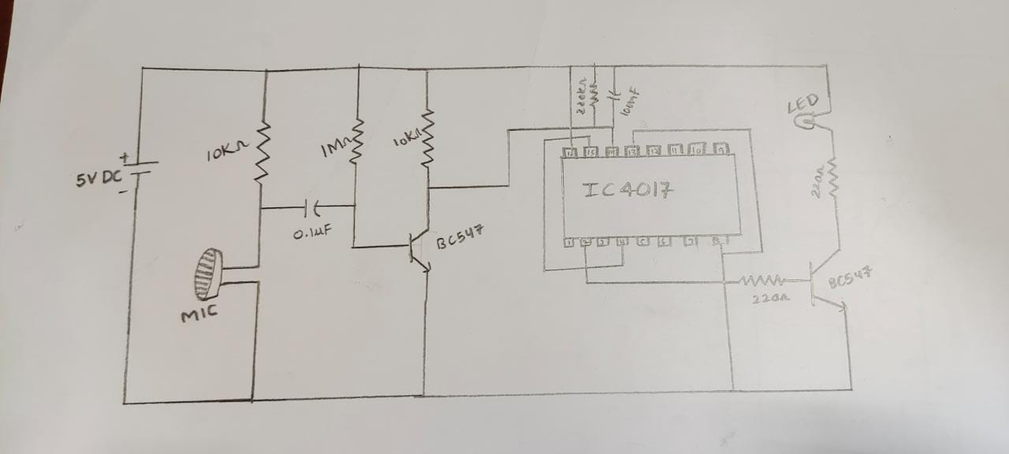

**TRANSFORMER CIRCUIT:** 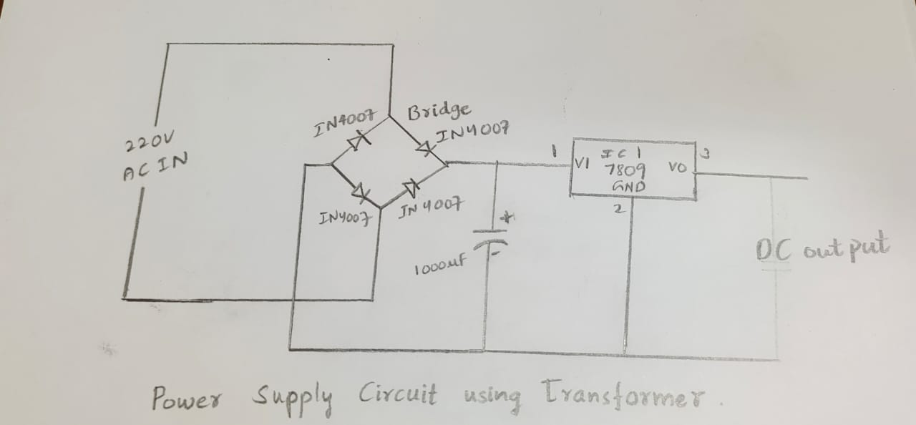

**DESCRIPTION OF COMPONENTS:**

1. **IC 4017**

The IC 4017 is a popular type of CMOS (complementary metal-oxide-semiconductor) integrated circuit used in digital electronics. It is a 16-pin, decade counter/divider chip that can operate at a voltage range of 3V to 18V.

The 4017 IC has a built-in counter that can count up to 10 states and provides output signals on ten separate pins. When a clock pulse is applied to the input of the 4017 IC, it advances to the next state, and the output pin for that state is set high while the other output pins are set low. This makes the IC useful for applications such as frequency division, sequential control, and signal decoding.

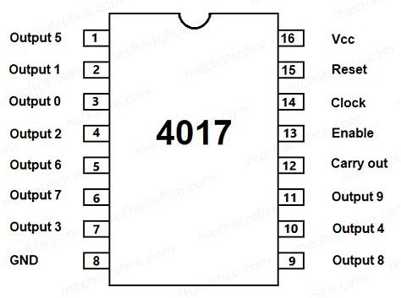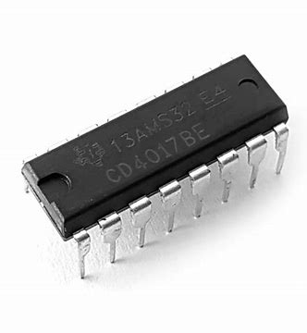In addition to its counter functionality, the 4017 IC also has a carry-out pin that can be used to cascade multiple 4017 ICs together, allowing for the creation of complex counting circuits. It also has a reset pin that can be used to reset the counter to the first state. Overall, the IC 4017 is a versatile and widely used component in digital electronics due to its ease of use, low cost, and flexibility in a variety of applications.

**2.BC547 NPN Transistors**

The BC547 is a commonly used bipolar junction transistor (BJT) in electronics applications. It is a small signal NPN (negative-positive-negative) transistor that can operate at a voltage range of 45V and a current range of 100mA.

The BC547 transistor has three pins: the emitter, base, and collector. It is a versatile transistor that can be used for amplification, switching, and signal processing. When used in amplification circuits, the base current of the transistor is modulated to produce a larger collector current. This allows the BC547 to amplify weak signals and is commonly used in audio amplifiers and small signal amplifiers.

In switching circuits, the BC547 transistor can be used to turn on or off a circuit by controlling the amount of current flowing through the collector-emitter junction. The base current is used to control the collector current, which is used to control the circuit.

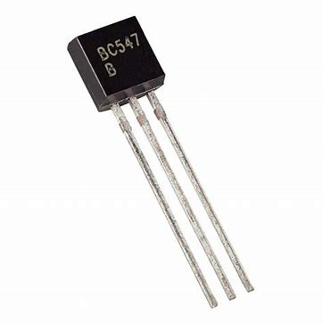The BC547 is a low-cost and widely available transistor that is used in a variety of electronic applications. It is commonly used in hobby projects, educational electronics, and commercial products due to its ease of use, reliability, and low cost.

**3. DC CONDENSER MIC**

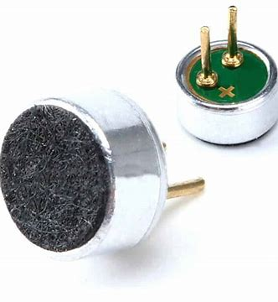A DC condenser microphone, also known as an electret microphone, is a small and lightweight microphone that converts sound waves into an electrical signal using a capacitor. It consists of a diaphragm and a backplate separated by a small air gap, and requires a small amount of power to polarize the diaphragm and maintain the capacitor's charge. DC condenser microphones are known for their sensitivity and wide frequency response, which makes them ideal for recording, broadcasting, and live sound reinforcement. However, they are also more susceptible to handling noise and environmental factors such as humidity and temperature variations.

**4. TRANSFORMER**

A 6V transformer is an essential component in electronics and electrical engineering, stepping down the input voltage to 6V for use in electronic devices and circuits that require a low-voltage power supply. The transformer consists of two coils of wire wrapped around a magnetic core, which generates a magnetic field that induces a voltage in the secondary winding. This voltage depends on the number of turns in the windings and the magnetic properties of the core.

A 6V transformer is commonly used in battery chargers, audio equipment, and other low-voltage applications, providing a reliable and efficient power supply. The output voltage can be regulated using a voltage regulator circuit to maintain a constant output voltage or rectified and filtered to provide a DC voltage for electronic devices that require a DC power supply.

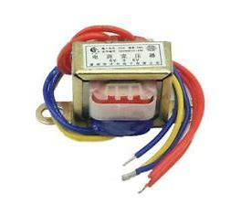Overall, a 6V transformer is a versatile and essential component in electronics, providing a low-voltage power supply for a variety of applications. Its reliability and efficiency make it an essential component in many electronic devices and circuits, from small portable devices to large industrial systems.

**WORKING OF TRASFORMER:**

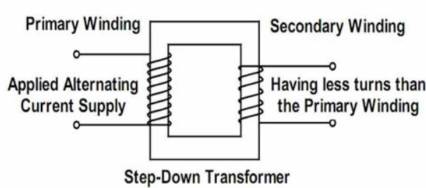

The power supply circuit consists of step down transformer, LM7809, capacitors, full wave rectifier circuit.

An input step down transformer is used for the stepping down of the 230v AC power supply.

Full wave rectifier circuit is used to convert the full cycle of alternating voltage (AC supply) to direct voltage (DC supply).Full wave rectification involves constant current flow across the load throughout the input AC supply cycle.

A capacitor is used to filter the AC ripples from the full wave rectifier and gives to the voltage regulator.

Finally the voltage regulator (LM7809) regulates the voltage to 9V.

**EXPLAINATION OF PROJECT:-**

The clap control bulb project is an electronics project that allows you to control a light bulb using the sound of a clap or sharp noise. The project incorporates a DC condenser microphone as the primary sound input device, replacing the need for a separate microphone sensor.

The project starts with the DC condenser microphone, which converts sound waves into corresponding electrical signals. When you clap your hands or produce a sharp sound near the microphone, it generates an electrical signal proportional to the intensity and frequency of the sound.

Next, the electrical signal from the DC condenser microphone is amplified to a suitable level for processing. An amplifier circuit is used to boost the weak electrical signal, making it easier to work with.

The amplified signal then goes through signal conditioning, which involves adjusting the signal levels and filtering out any unwanted frequencies or noise. This process prepares the signal for accurate detection and analysis.

After signal conditioning, the processed signal is fed into a microcontroller or integrated circuit (IC). The microcontroller or IC is programmed with specific algorithms and logic to analyze the sound patterns and detect claps or sharp sounds.

The microcontroller or IC compares the incoming sound patterns with predefined thresholds or patterns to determine if a clap or sharp sound has been detected. It analyzes factors such as the amplitude, frequency, and duration of the sound signal.

If the circuit is closed, the light bulb receives power and turns on. Conversely, if the circuit is open, the power supply to the bulb is cut off, causing it to turn off. This allows you to control the light bulb simply by clapping your hands or producing a sharp sound.

The project may also include feedback mechanisms, such as an indicator LED, to provide visual feedback when a clap is detected and to indicate the current state of the bulb (on or off).

Overall, the clap control bulb project combines the use of a DC condenser microphone, amplification, signal conditioning, a microcontroller or IC, and a relay to enable you to control a light bulb through sound commands. It offers a hands-free and interactive way to operate the bulb, providing convenience and a touch of innovation to your lighting setup.

**APPLICATIONS: -**

**Hands-Free Lighting Control**: The primary application of the clap control bulb is providing hands-free lighting control. It eliminates the need for physical switches and allows users to turn the light bulb on or off with a simple clap or sharp sound. This feature is particularly useful in situations where your hands are occupied or when you want to control the lighting without reaching for a switch.

**Accessibility**: The clap control bulb can be beneficial for individuals with limited mobility or disabilities. It offers an alternative method of controlling the light bulb that is easy to use and does not require physical dexterity. People with disabilities can benefit from the convenience and independence provided by this hands-free control mechanism.

**Novelty and Entertainment**: The project also serves as an entertaining and novelty lighting solution. The ability to control the light bulb with a clap or sound command adds an element of fun and interactivity to the lighting experience. It can be a unique talking point in parties, gatherings, or as a decorative item in entertainment venues.

**Energy Efficiency**: The clap control bulb can contribute to energy efficiency by allowing users to easily turn off the light when it is not needed. With a simple clap, users can instantly switch off the bulb, preventing unnecessary energy consumption and reducing electricity bills.

**Home Automation Integration**: The clap control bulb can be integrated into a larger home automation system. By connecting the project circuit to a smart home hub or controller, users can incorporate the clap control feature into their existing home automation setup. This integration enables the bulb to be controlled remotely through voice commands or smartphone apps, in addition to the clap control functionality.

**Educational Purposes**: The project serves as an educational tool for learning about electronic circuits, microcontrollers, and sound detection. It provides a hands-on experience for electronics enthusiasts, hobbyists, and students to gain practical knowledge in electronics and programming concepts.

**FUTURE SCOPE:**

The clap control bulb project has several potential future scope and expansion possibilities. Here are some ideas:

**Sensitivity Adjustment**: One potential enhancement is to incorporate a sensitivity adjustment feature. By adding a potentiometer or a switch to the circuit, users can adjust the sensitivity of the sound detection. This allows customization according to individual preferences or to accommodate different noise environments.

**Multiple Control Actions**: Currently, the project turns the light bulb on or off with a clap. However, you can expand its functionality by incorporating multiple sound patterns or commands. For example, you can program the microcontroller to respond to different clapping patterns for different actions, such as dimming the light or changing the light colour.

**Voice Control Integration**: Building on the existing sound control mechanism, you can explore integrating voice control capabilities. This would involve incorporating a speech recognition module or utilizing voice assistants like Amazon Alexa or Google Assistant. By integrating voice control, users can operate the light bulb through voice commands, providing a more intuitive and seamless experience.

**Wireless Communication**: Consider adding wireless communication capabilities to the project. By incorporating modules like Bluetooth or Wi-Fi, you can enable remote control of the light bulb using a smartphone or other smart devices. This expands the accessibility and convenience of the clap control feature.

**Home Automation Integration**: The project can be integrated into a broader home automation system. By connecting the clap control bulb circuit to a smart home hub or controller, you can incorporate it into existing automation routines. For example, you can synchronize the clap control with other smart devices in your home, such as adjusting the lighting scene when the TV is turned on.

**Expandable Lighting System**: Rather than controlling a single light bulb, you can modify the project to control a group of bulbs or an entire lighting system. By incorporating additional relays and circuitry, you can synchronize the clap control across multiple bulbs, creating dynamic lighting effects or controlling different areas of a room.

**Gesture Control**: Explore the integration of gesture control alongside sound control. By incorporating sensors like infrared or motion sensors, you can detect specific hand movements or gestures to controlthe light bulb. This adds an additional interactive dimension to the project.

**CONCLUSION:-**

In conclusion, the clap control bulb project offers an innovative and interactive way to control a light bulb using sound commands. By incorporating a DC condenser microphone and integrating it with amplification, signal conditioning, a microcontroller or IC, the project enables users to turn the light bulb on or off simply by clapping their hands or producing a sharp sound.

The project not only provides a hands-free lighting control solution but also offers opportunities for customization and expansion. With the inclusion of features such as sensitivity adjustment, multiple control actions, voice control integration, wireless communication, home automation integration, expandable lighting systems, and gesture control, the project can be tailored to suit individual preferences and integrated into larger smart home setups.

Furthermore, the clap control bulb project serves as an educational tool, allowing electronics enthusiasts, hobbyists, and students to gain practical knowledge in electronics, circuit design, microcontrollers, and programming concepts. It combines technology, creativity, and problem-solving skills, fostering a deeper understanding of electronic circuits and offering an engaging learning experience.

With its practical applications in hands-free lighting control, accessibility, energy efficiency, novelty, entertainment, and educational purposes, the clap control bulb project exemplifies the fusion of technology and innovation. It showcases the potential for merging electronics, sound detection, and control mechanisms to create unique and interactive solutions that enhance our daily lives.

By embarking on the clap control bulb project, builders can explore the possibilities of sound-based control, expand their knowledge and skills in electronics, and create a functional and enjoyable lighting experience.

FINAL CIRCUIT:-

