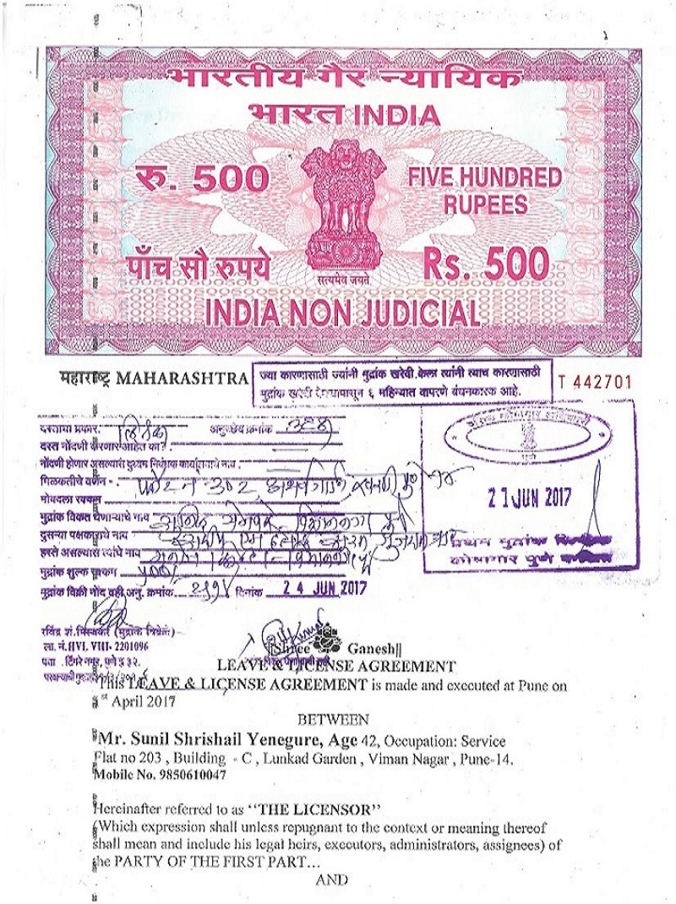

Sandeep Desai, Age about: 29, Occ.: Service

Cont. No. – 8055259515

Hereinafter referred to as “THE LICENSEE”

(Which expression shall unless repugnant to the context or meaning thereof shall mean and include His legal heirs, executors’ administrator’s assignees) of the PARTY OF THE SECOND PART…

And whereas, the Licensor is the absolute owner of premises Bearing Flat No. 302, 2BHK Flat, adm.area 1000 Sq.ft. With the standard fittings & fixtures lying thereon in the building known as “Atharva Garden” situated at Kharadi, Dist-Pune, (hereinafter referred to as “Said Premises”)

And whereas, the licensee being a need of a flat for his residential purpose approached to licensor and requested him to permit to use the said premises on temporally basis for a period of 11 months on a Leave and written License basis and the Licensor has agreed to grant Leave & License to the Licensee to occupy and use the premise property on the following terms & conditions agreed by and between the parties here to.

NOW IT IS AGREED BY AND BETWEEN the parties hereto as follows:

1. The Licensor hereby grants leave and license to the Licensee to occupy and use the said premises for temporally residential use for the period of 11 month, from 1st-April-2017 to 28th-Feb-2018 for the use residential purpose. This writing shall never be construed any other charge, claim or interest in respect Of the said premises in favors of Licensee which is not all the intention but merely A agreement to allow the Licensee to use Fittings on License basis.

2. The Licensee shall pay to the Licensor a sum of Rs. 15,000/- (Fifteen Thousand Rupees Only) (Including maintenances, Society charges) as License fee or Compensation and which is to be paid on or before 5th day of every month. The said amount of monthly license fees shall be payable in advance on or before the 5th day of every English calendar month, failing which, an interest at the rate of 10% p.a. would be payable for the number of days of delay from 5th to the day credit into Licensor’s Account. The Licensee has paid) Rs. 30, 000/- (Thirty Thousand Rupees Only) as security deposit by cheque /cash to the Licensor.

3. All the Municipal Taxes and the other taxes and cesses levies in the respect of the Said premises will be paid by the Licensor as the owner. And also, Electric charge and the other charges as actual of the premises will be paid by the Licensee to the authority concerned same. And while residing in the said

premises, The Licensee shall abide by the rules and regulations of the concerned society (If any).

4. The said premises will be used only for lawful commercial purpose and not for other purpose or illegal business. The said premises have normal electric fitting and fixtures.

5. The said premises is given to the Licensee on personal basis and will not be men titled to transfer the benefit of this agreement to any body else or will not be entitled to allow anybody else to occupy the premises or any part. There of. Nothing in this agreement shall deemed to grant a lease and the Licensee Agrees and undertakes that no such contention shall be taken up by the Licensee At any time.

6. The Licensee shall not be deemed to be in the exclusive occupation of the said Premises and the Licensor will have the rights to enter upon the said premises at any time during working hours to inspect the premises.

7. The Licensee shall maintain the said premises in good condition and will not Cause any damages thereto. If any damage is caused to the premises or any Part thereto by the Licensee or his employees, servants or agents the same will Be made good by the Licensee at the cost of the Licensee either by the rectifying the damages or paying cash compensation. Licensee should handover the premises on same condition in which it is given to him.

8. The Licensee shall not carry out any work of structural repairs or addition or Alteration to the said premises. If the Licensee desires to have any additional fittings and fixtures the Licensee desires to have any additional fittings and Fixtures the Licensee shall obtain written consent from the licensor and do so at his own cost and in compliance with the rules. The Licensee shall remove such fittings and fixtures on the termination of License failing which they shall be deemed to be the property of the Licensor. The Licensee shall not cause any Nuisance or annoyance people to the in neighborhoods or not to store any hazardous goods in the said premises.

9. On expiration of the said terms or period of the License or earlier termination thereof, the Licensee Shall handover the vacant and condition in which the said premises was exist subject to normal wear and tear. After the expiry of the 11 months if both the parties intend to continue this agreement for further 11 months then the Separate agreement should be executed.

10. The licensee has with the execution of this agreement paid to the licensor a sum of Rs. 30,000/-(Thirty Thousand Rupees Only) as mentioned hereinabove, by way on and interest free deposit. The receipt whereof the licensor hereby agreed by and between the parties hereto that the licensor Subject to any deduction of any amount on account any compensation or

damages to the Fixtures and fitting and non-performance of the terms herein contained or on account of any money Otherwise payable by the licensee to the licensor by the virtue of these presents shall be deducted and remaining amount of deposit will be refunded by licensor to licensee without interest by cash on vacation & handing over the key. The said deposit or such lesser Amounts as the case may be to the licensee simultaneously upon the licensee giving the repossession of the said Premises together with the fixtures & fitting and upon the expiry of the period of the Agreement or its sooner determination as herein contained. The licensee shall not do or suffer to be done anything which may Invalidate the Insurance of the said building in which the license premise is situated.

11. That if the licensee fails to pay the said compensation amount for any month to the licensor by the Date provided hereinabove or to fails to perform the conditions of agreement or discontinue his service with the license then the licensor shall have full rights to enter the premises and to terminate This agreement by giving one month notice and on expiry of the notice period the licensee shall remove his belongings and premises use of the said premises and fitting and paraphernalia lying therein.

12. The licensee or the licensor may terminate the agreement by giving one month prior notice to the other even before the expiry of the license period.

13. On the expiry of the said 11 months period of these agreements or in case before the expiry period, the licensee shall forthwith handover vacant and peaceful possession of the licensed premises to the licensor. If the licensee fails to handover vacant and license premises after the expiry of these agreement the Licensor shall take necessary action as available U/s 13-A, 201 Bombay Rent Act (1989) and will pay double License fee per month till the Licensee vacates under section 13-A (2) of Maharashtra Act No.XVII of 1987 action as available U/s 13-A, 201 Bombay Rent Act. 87 as extended the Licensee shall not take any defense before the said competent authority in a proceeding filed against him by the Licensor. If the Licensor fails to return the Deposit on due date, He will be liable to pay the interest @ 24%p.a. to the Licensee.

14. In view of amended provisions of the Bombay Rent Act (as amended) by Maharashtra Act No. XVIII of 1987 the Licensor is giving the said premises on the license basis, and Licensee shall not file a suit against the Licensor for fixation of standard rent or claiming ownership of the said premises.

15. The next agreement of 11 Months is depending upon the consent of the Licensor with an increase of 10% per year in.

IN WITNESSES WHEREOF the parties have signed on the present deed of the 1st day APRIL in the year 2017.
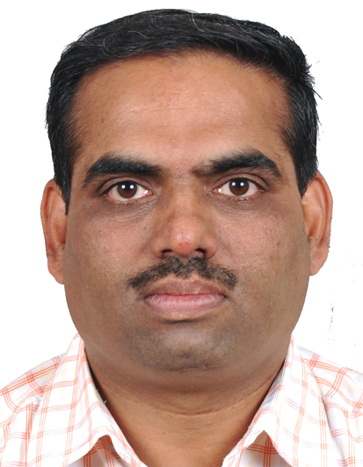
Signed and Delivered:

By the within named “LICENSOR”

Mr. Sunil Shrishail Yenegure
(On behalf of Sanjay Shrishail Yenegure)


Signed Sealed and Delivered:

By the within named “LICENSEE”

Sandeep Desai

In the presence of:-

Witness (1) ……………………………………………

…………………………………………….

Witness (2) …………………………………………….

…………………………………………………..

