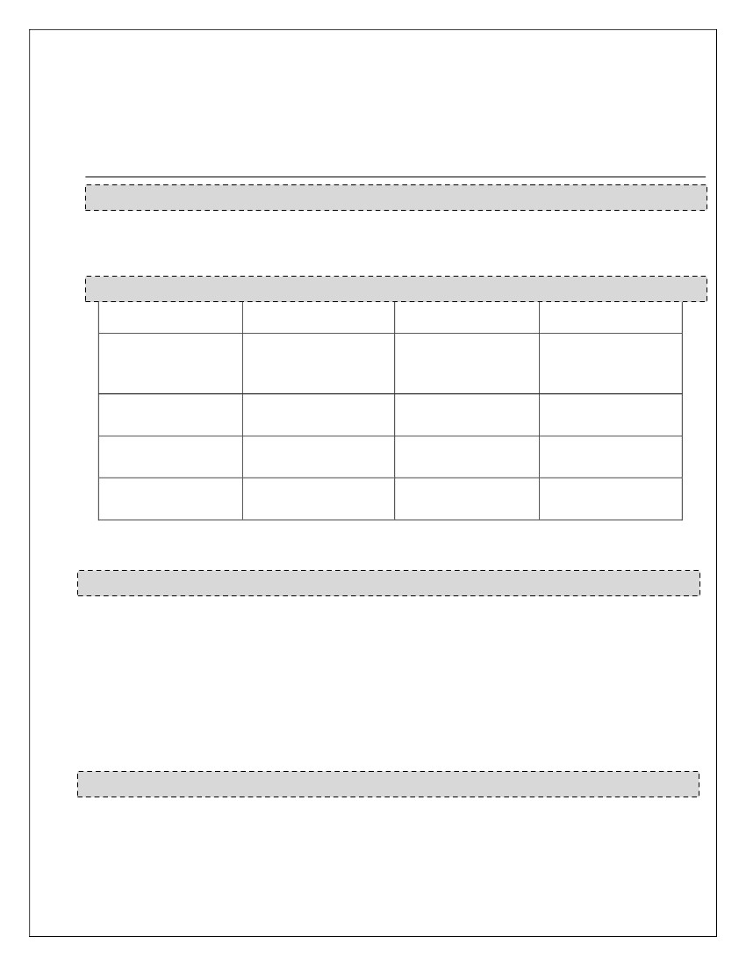RESUME
LISA RUFUS. G.
Address: H.I.G – 19,
Artist Colony,
Near HMDA Zonal Office,
Shamshabad, Hyderabad – 501218.
Ph: 9052461018
Email: lisa.rfs777@gmail.com
OBJECTIVE
Intend to build a career in a firm which can use my abilities and knowledge in the best ways possible to
enhance the growth of the firm, inturn helping me to explore myself fully and realize my potential.
EDUCATION
COURSE
M. Pharmacy
SCHOOL/COLLEGE
G. Pulla Reddy College
of Pharmacy, Osmania
University
Trinity College Of
Pharmacy
Sri Chaitanya Junior
College
St. Pious X Girls High
School
BOARD/
UNIVERSITY
Osmania University,
Hyderabad
Kakatiya University,
Warangal
Narayanaguda,
Hyderabad
Ramnagar, Hyderabad
YEAR OF
PASSING
2013
B. Pharmacy
Intermediate
SSC
2011
2006
2004
SKILLS
●
●
●
●
●
●
●
●
Excellent Writing and Speaking Skills.
Good Computer Skills and handy at various software programs.
Typing Speed of over 50 wpm.
Good command over English Language (Written and Oral).
Excellent Leadership skills and Managing abilities.
Optimistic, Quick learner and a smart worker.
Good Event Managing and anchoring skills.
Content Writer with Good presentation skills.
HOBBIES
●
●
●
●
Singing (Hindustani Vocal)
Poetry & Song Writing
Practicing various performing arts (Dance, Dramatics, Playing Music)
Freelance Writing

WORK EXPERIENCE
➢Working as Medical Writer for Medvarsity Online Ltd.: Feb 2018 – Present.

- Worked as Content and Medical Writer for Happ Tech Pvt. Ltd.: Nov 2016 – Nov 2017.
• Developing overall website content.
• Develop medical content for all the drugs and diagnostic tests provided by the website.
• Maintaining the website’s blog page and contributing unique and creative content in the form
of blog posts.
• Developing creative content to aid to the company’s marketing and advertisement strategies.
• Performing quality check for work done by peers and maintaining a record of the same.
➢ Worked as a Senior Content Writer for Apik Digital Designers: May 2016 – Nov 2016.
• Developing overall website content.
• Editing and proofreading content prepared by peers.
• Sole contributor content to the website’s blog page and managing the same.
• Managing, revising and updating web content from time to time.
• Public Relations: Co-ordinating with print and electronic media to release updates about the
product designed by the company.
➢ Worked as a Faculty for English Language, Digital Media Publisher and Content Creator
and Print Media Designer at Accord School, Tirupati: April 2014 – March 2016. (2 years)
• Played a vital role in developing creative content for various projects besides being responsible
for imparting education to students.
• Hosted two annual functions of the school during my tenure of work which was greatly
applauded.
• Fulfilled my responsibility as a Digital Media Publisher by creating and publishing content on
social sites.
• Designed the school prospectus and other print releases made by the school.
• Played a keen role in organising and managing events at the school.
➢ Worked as a Content Writer for MEdRC (Medical Education Research Center): June 2013 –
Dec 2013. (6 months)
• Was responsible for creating e-content for Medical Students.
• Fulfilled my responsibility of compiling content on various medical topics.
• Performed error-free editing for the work done by peers of the team I handled.
➢ Worked as a Senior Media Analyst-English Language: October 2010 - December2011. (1
year 3 months)
• Handled projects from several renowned International Clients like BOEING, MICHELIN,
JOHNSON CONTROLS, CITROEN UK and others.
• Was responsible for summarising articles, published in various print media publications of the
United Kingdom.
• Was responsible for training new analysts over the process of work and monitoring their
performance.
• Boeing – one of my prime clients, certified my work to be “highly precise and spotless.”
• Quality of work and timely delivery were appreciated and applauded by most of the keen
clients I worked for.
• Was promoted twice in a short span of work tenure, from (Junior Analyst – Media Analyst –
Senior Media Analyst)
• Stood out as the employee receiving highest incentive over the points procured over quality
and time.

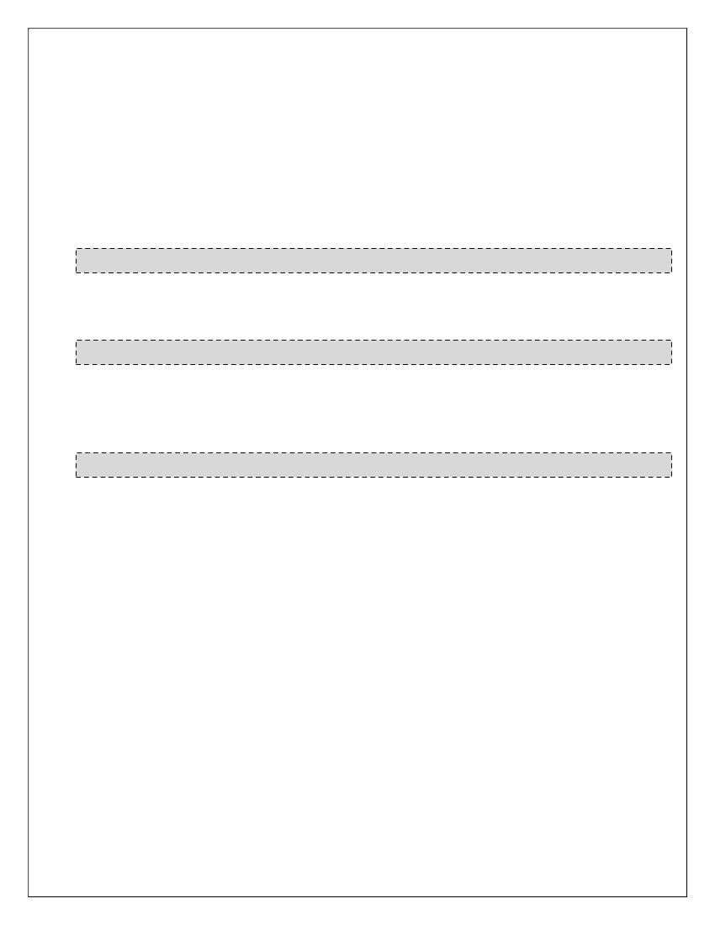➢ Worked for an NGO (Blossoms n Community Albums): February 2012 - February 2015. (3
years)
• Worked as a Secretary for BCA (Blossoms Community Albums) Team.
• Directed Short Films on social causes (mainly those dealing with child issues).
• Worked as a Co-Director for a few Short Films.
• Worked as a Trainer for Music and Media.
• Exposure to Film and Music Editing Software (iMovie and GarageBand).
• Worked as an Editor for Short Films.
FREELANCE WORK EXPERIENCE:
6 years experience of working as a Freelance Content Writer, Content Developer and Content Editor for
several domestic and international projects of various companies (2010 – Present)
DOCUMENTARIES
●
●
●
Directed a Short Film based on the theme “Exams”.
Worked as a Co-Director and Crew Member for several Short Films.
Voiced-over several documentaries.
ACHIEVEMENTS
●
●
●
●
Awarded 1st Prize at State Level for the National IPA Elocution Competition.
Performed as a Lead Vocalist in concerts at International Level.
Achieved Silver Medal in Dramatics in Inter-School Competitions.
Achieved Several Prizes at City and State Level for Essay Writing and Singing.
PERSONAL PROFILE
FATHER’S NAME
DATE OF BIRTH
GENDER
MARITAL STATUS
SPOUSE’S NAME
: G. K. Rufus
: 19 Jul, 1989
: Female
: Married
: Y. Sravan Kumar
LANGUAGES KNOWN : English, Hindi, Telugu.
PERMANENT ADDRESS : Rufus’ Gallery, H. I. G. 19, Artist Colony, Near HMDA Zonal Office,
Shamshabad, Telangana, India. - 501218
I hereby declare that the above given details are true to the best of my knowledge.
Date: 18.04.2018
Place: Hyderabad
LISA RUFUS G.

