Aruna Yadav
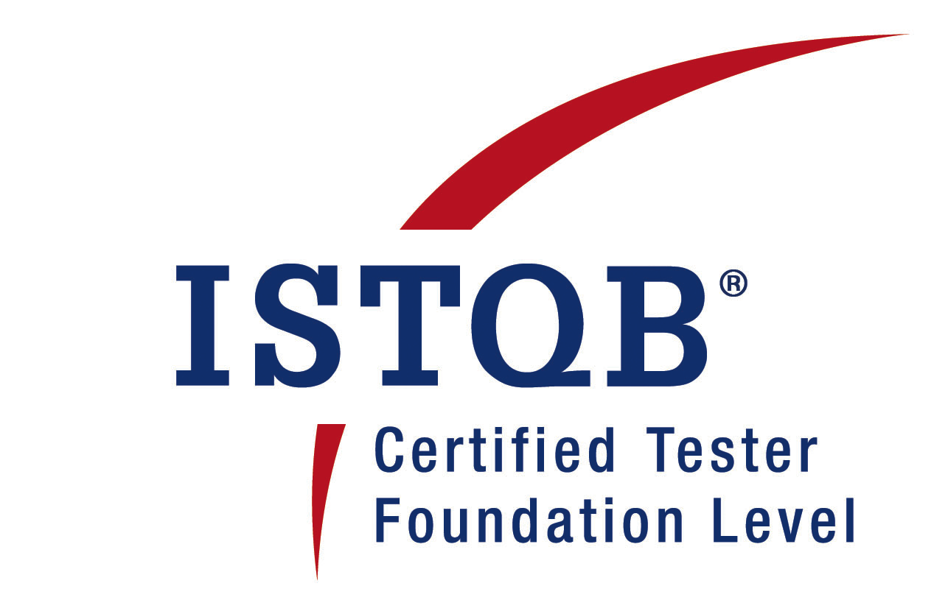
aruna.yadavs@gmail.com

Professional summary:
- 9+ years of Total experience in Testing, having good ability of “Test to Break” Attitude.
- ISTQB Certified Software Quality Test Engineer
- Good knowledge of Manual Testing Concepts
- Proficiency in Agile testing, Database testing
- Proficiency of Selenium
- Lead a team, participates in reviews and handles tasks involving estimation, planning and execution across the product versions
- Works with fellow team members to diagnose bugs and formulate solutions
- Conduct defect triage meetings with onsite project stakeholders
- Communicates effectively both within immediate team and global teams
- Actively involved in other tasks such as DP Anchor, IPM+, RSA soft token Anchor, BG Verification

Organization | Designation | Period | Place
Infosys Technologies  Limited | Test Analyst | Dec 2011-April 2017 | Pune
QA India systems and services Pvt. Ltd. | QA Engineer | Jan 10 – Dec 2011 | Pune
Mindspace Edutech Pvt. Ltd | QA Engineer | Apr 09 – Dec 09 | Aurangabad
Expert Solutions Pvt. Ltd | QA Engineer | Oct 07 – Mar 09 | Aurangabad

Technical Skills:
Testing | Manual Testing, Agile testing, Regression Testing, Functional Testing, Integration Testing, UI Testing, Database testing
Tool | Eventum (Bug tracking tool), Bugzilla, Jira, QC, Selenium
Languages | SQL
Database | Oracle 9.i, MS – Access 7.0
Utility | Toad
Professional Certification | ISTQB Certified

Project Details:

Worked on the following projects at Infosys:
Project 1: Appointment Booking System
Client: Barclays
Duration: 1 year
Tools used: Jira
Description: Appointment Booking system is an Agile project. ABS is used by Bank
employees for booking appointments of its clients
Responsibilities:
- Work with stakeholders to review and understand the business requirements and design specifications. Interact extensively with various onshore / off - site team members to understand application functionality and scope of application.
- Involved in quality outcome of application hence ensure the deliverables meet the business requirements with no serious defects.Work with the development team on defect triage
- Develop and maintain smoke, functional, and regression testing to ensure code is functioning as designed

Project 2: Customer Gateway System
Client: Barclays
Duration: 20 months
Tools used: QC, Blade Logic, Mainframe
Description: Customer gateway system is used by Bank employee to maintain
the details of their customers.
Responsibilities:
- Leading the PR team and involved in the planning, monitoring, and control of the testing activities and tasks.Estimates and negotiate with management to acquire the necessary resources and testing functionality.
- As test execution comes near, ensures the test environment is put into place before test execution and managed during test execution.Schedules the tests for execution and then monitors, measures, controls and prepares report on the test progress.

Project 3: Credit Governance System (CGS): CGS is a decision making Application
whether to provide credit card /loans to the end users. CGS comes under horizontal
pool in Capital One Project. CGS is used by the Systems and Credit Risk
Management organization, which require a list of statistical Decisions.
The application utilizes two major distinct components. These are:
- Base Livelink functionality.
- Data objects in the Oracle RDMS

Project 4: CounterpartCredit Risk Management (CPCRM): CPCRM is Risk Management application, which works on Summit reports. Loans, which are provided by Capital
- One Bnk to different Institutions with specific tenures, are maintained and calculated in CPCRM.
The application utilizes two major distinct components. These are :
- SQL Server 2005 (Database)
- Hyperion Tool (Oracle)
Responsibilities:
- Handled project independently.
- Requirement gathering and analysis, preparing test cases etc..
- DTP (Detailed Test Plan) creation and Test Strategizing (test approach)
- Defect reporting and tracking
- Dynamic role in CGS/ CPCRM and seamless switching between the applications

Worked on the following project with QA India systems and services Pvt. Ltd:
Domain: Healthcare
Designation: Quality Assurance Engineer
Team Size: 12
Project Title:- MEDRIO (Research Logistics): www.medrio.com
Project Description:-
Medrio provides web-based electronic data capture (EDC) and analysis software for clinical research, including study design guard rails, data entry forms, management reports and statistical analyses.
Responsibilities:
- Involved in Preparation and Execution of Test Cases
- Converts test cases into script using Keyword Driven format
- Functionality, Regression, Retesting, User Interface Testing, Bug Reporting
- Handled a team, coordinated and assigning task to team, preparing test plans, taking interviews for the new joinees, providing KT to them

Worked on the following project with Mindspace Edutech:
Designation: Quality Assurance Engineer
Team Size: 18 members approximately.
Project Title: Web Application
Description: This project is the futuristic way of assessment developed after experience garnered from several specialist research. This project is the classroom based, home-based & online assessment service for the students.
Responsibilities:
- Participated in Test Plan. Prepare Test Design and give Testing estimates, define Client acceptance criteria and get clients approval.
- Interacting with the Clients via video and audio conferences, providing Project Demos.

Worked on the following multiple project with Experts Solutions:
Backbone (ERP Product): This product is useful in planning the available resources for small and medium scale enterprises.
MLR: This product allows maintaining ERP of organization. It consists of different types of modules such as Engineering, Material etc. Here the Technology which is being used is Oracle9i Application Server Forms and Reports.
QAMS: This is a Web based project related to the hospitalization facility provided by the company to the patients.
Central Processing System: This is developed as a window-based application. This product allows to maintain the Forbes used.
Secure HealthCare Web Application: This project is an initiative by Secure HealthCare LLC, USA for coming up with a standard Web Application for regulating and monitoring the Rx Transactions and the related Insurance claims.

For all the projects in expert the roles & responsibilities:
Role: Quality Assurance Engineer
Responsibilities:
- Written test cases for - unit level, functional and integration testing.
- Experience using defect management tools on data server.
- Design/Execute requirements-based system & acceptance level tests during project execution
- Identify & investigate defect causes.
- Maintained documents for handling versions for testing.

Educational Qualification:
2008 ISTQB CERTIFICATION of Software Testing
2002-2005 M.Sc. Computer Science, From Dr. Babasaheb
Ambedkar Marathwada University, Aurangabad.
2000-2002 B.Sc. with computer science, Dr. B.A.M.U.
1997-1999 H.S.C Maharashtra State Board, A’ Bad.
1996-1997 S.S.C. Maharashtra State Board, A’ Bad

Personal Details:
Marital Status: Married
Gender: Female
Nationality: Indian
DOB: 10th Nov
Passport: Yes J9041661
Pan Card: AETPY4855J
E-mail: aruna.yadavs@gmail.com
Contact Number: +91 9989433300
Permanent Address: Srinagar Colony, Hyderabad
Language Known: English, Hindi, Telugu, Marathi

Aruna Yadav

