**Assignment 1: Algorithm & Flowchart**

**Course :** Python programming – Module I

**Instructor:** Sandeep Pabbathi

***Note*** : Please refer to appendix material before going to solve the problem.

Write the algorithm and flowchart for solving the following problems

**Problem 1: Find the Simple Interest**

*Given:*

* *P* : Principal amount, *N* : Time in years, *R* : Annual rate of interest (in %) and

*SI* : Simple Interest

*Objective:*  
 Calculate the simple interest using the formula: SI = (P × N × R) / 100

**Problem 2: Find the smallest of two numbers A and B**

*Given:*

* *A*, *B*: Two numbers

*Objective:*  
 Determine and print the smaller of the two numbers.

**Problem 3: Determine if the number A is prime or not**

*Given*:

* *A*: An integer

*Objective*:  
 Check whether *A* is a prime number.

**Problem 4: Find the roots of a quadratic equation**

*Given*:

* Quadratic equation: *Ax² + Bx + C = 0*; where *A*, *B*, *C*: Coefficients

*Objective*:  
 Calculate the roots using the quadratic formula: x = (-B ± √(B² - 4AC)) / (2A)

**Appendix:**

1. Flowchart symbols and its functions

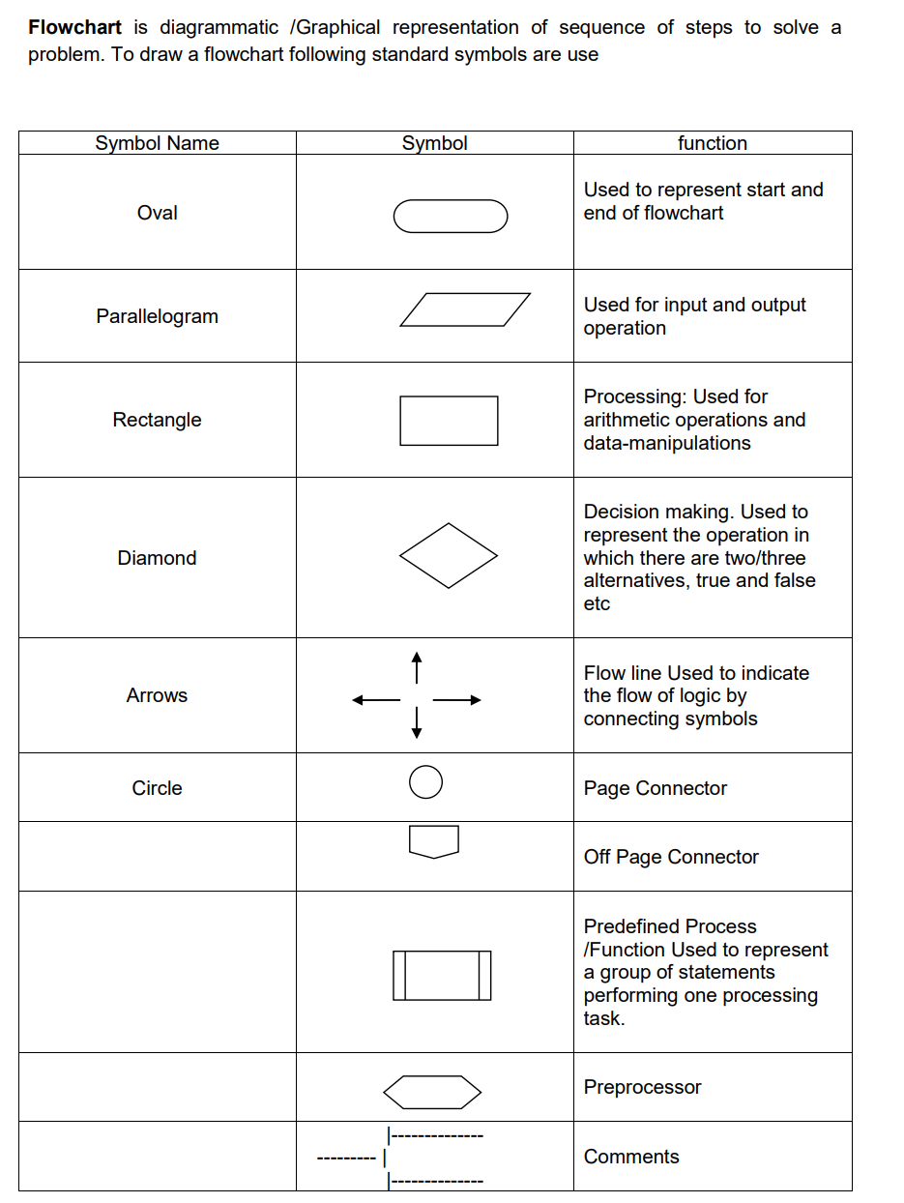

1. Algorithm symbol usages:

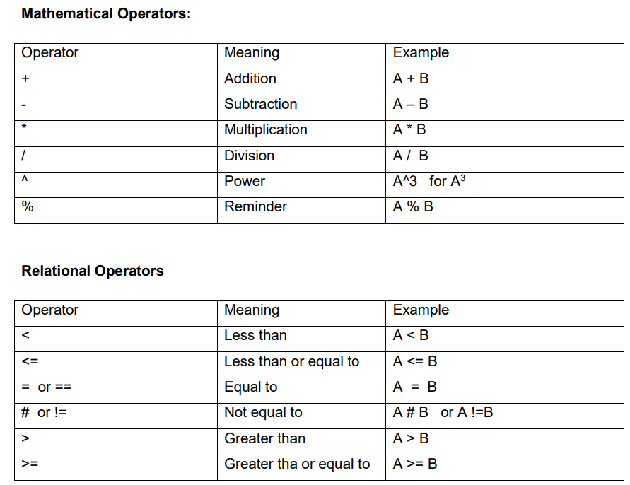

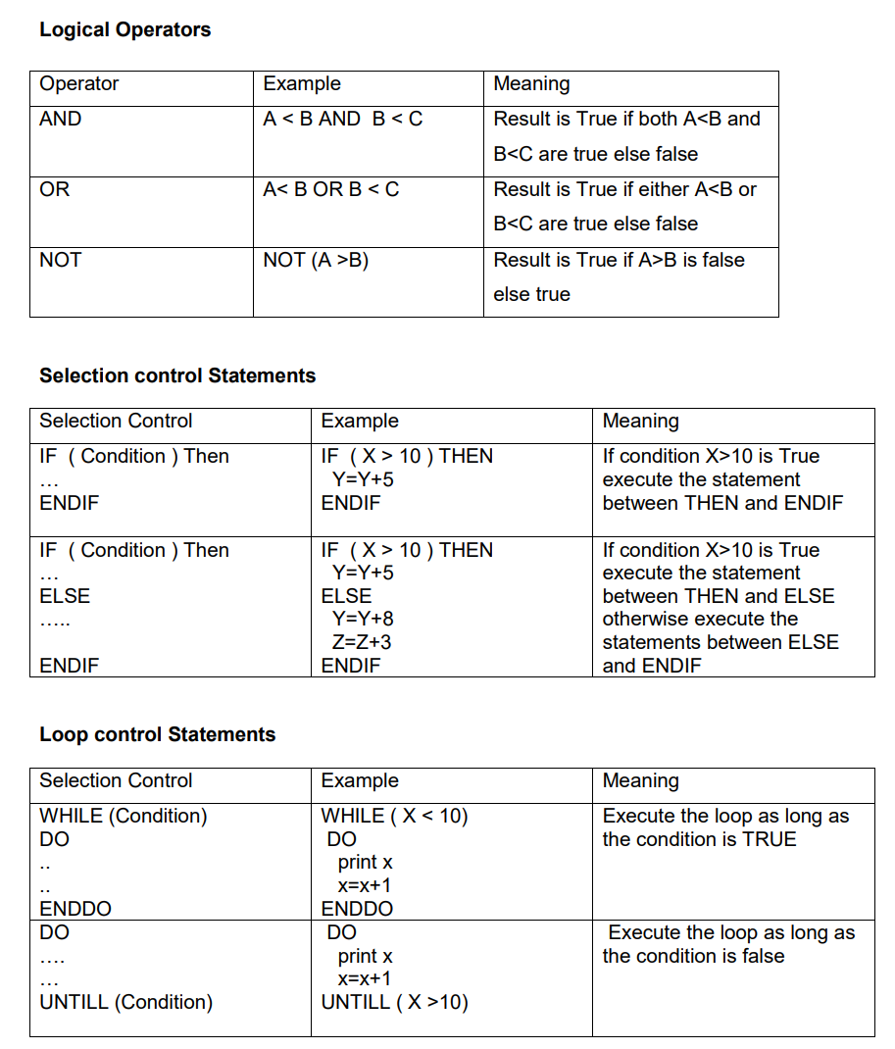

A sample problem, along with its algorithm and flowchart, is mentioned below for your reference.