React & JavaScript Notes

1.What is Hoisting?
Hoisting is a JavaScript behavior where variable and function declarations are moved to the top of their scope before code execution.

Example:
myFirst();
function myFirst() {
console.log("Hello");
}

2.What is useMemo?
useMemo is a React hook used to memorize expensive calculations and re-run them only when dependencies change.

Example:
const price = useMemo(() => {
console.log("calculating...");
return number * number;
}, [number]);

return (
<h2>Pricing No: Number: {price}</h2>
);

3.Pure Function:
A pure function is predictable and always returns the same output for the same input and has no side effects.

Example:
function add(a, b) {
return a + b;
}
4.Impure Function:
A impure function is unpredictable it depends on external state
Example:
let total = 0;
function addToTotal(value) {
total += value;
}
5.Controlled Components:
When Form data is handled by React state called controlled component
Example:
function ControlledForm() {
const [name, setName] = useState("");
return (
<input
type="text"
value={name}
onChange={(e) => setName(e.target.value)}
placeholder="Enter name"
/>
);
}
6.Uncontrolled Components:
When Form data is handled by the DOM itself. Called uncontrolled
7. Currying function
Currying is a functional programming technique where a function takes arguments one by one instead of taking multiple arguments at once, and returns a new function for the next argument
8. closure:
closer function is function which is remember outer scope of variable
Example:
function price(pric){
function discount(dis){
var afterDiscount = pric - (pric * dis / 100);
function texpermonth(texpermon){
return texpermon+afterDiscount;
}
return texpermonth;
}
return discount;
}
const setPrice = price(100);
console.log("______",setPrice(10)(2));
9.collback function:
A callback function is a function that is passed as an argument to another function and is executed later, usually after the completion of some task.
function add(a, b, baadMe) {
let sum = a + b;
baadMe(sum);
}
function collback (result) {console.log("Answer:", result);}

add(5, 6, collback);
10. useCallback:
useCallback is a React hook that memorizes a function and returns the same function reference until its dependencies change

11. useEffect:
useEffect is mechanism of react which Handel side effect of data fetching and updating. It is substitutes of class component lifecycle method such as componentDidMount, componentDidUpdate, componentWillUnmount
12.JavaScript:
JavaScript is an open-source programming language primarily used for web development.
It runs on JavaScript engines like Google’s V8.
13. Lazy Loading:
Lazy loading is technic used for improved performance by loading components when they are needed.
Example:
Const page = React.Lazy(()=>import(“../../page”))
14. Functional Component:
Functional component is using hooks like useSatate, useEffect to manage state and side effect.
15.Class Component: Class component uses ES6 Class syntax and manages state with this.State
16. Lifting state:
Lifting State is common pattern of react when we want pass same data in more then one child component then we should use lifting state pattern.
17. React Fragment:
When I need return multiple elements without adding extra DOM Node
18. useLayoutEffect:
UseLayoutEffect work as useEffect but its synchronous and work before paint. useEffect work as asynchronous non-blocking and work after paint
19. How do you manage global state in a React app without using external libraries?
We can manage global state in react with Context API and useReducer
20. What causes memory leaks in React, and how do you prevent them in components with side effects?
Memory leaks will happen when side effects working after component unmount to prevent cleanup function
21. code splitting in a React project:
22. debounce user input
Debouncing is technique to delay a function execution until a certain time has passed
let timer;
clearTimeout(timer);
timer=setTimeout(()=>{
fn();
},100)
23. Defrance between let,const,var
var-> Re-declare, Re-assign
let-> Re-assign, not Re-declare,
const-> value not update

Node & Express
- What is NodeJS?
NodeJS is open-source JavaScript runtime environment used as backend services which is interact with operating system
- What is runtime envirment
Additional feature to for executing application
- How Node is runtime envirment on server side
Runtime provide necessary infrastructure for code execution
- What is diff b/w runtime env and farmwork

- How NodeJS Work?
NodeJS work on Single thread event driven structure using V8 Engine.
- What is event driven structure?
event driven structure is programing technic where the flow of the application is controlled by event.
- What is Buffer?
- What is NPM?
NPM is stand for node package manager they manage dependency of node project
6.Module?
A Module contains a specific functionality that can be easily reuse
- Global Module: no need import (console,__dir)
- Non-global: need import (fs, bufer)
7. What are 5 bult-in module?
- Fs =>Managing Files , const fs = require(“fs”);
# fs.readFile()
# fs.writeFile()
#fs.appendFile()
#fs.unlink()
#fs.mkdir()
- Path =>path module provided utils for joining parsing path
- Os => os providing interact with operating system
- Event
- http

8.How to pass function as parameter in NodeJS
- What is package JSON File
Package JSON FILE is meta data of project which is kept project details
- Package-lock JSON File
Package -lock JSON File is meta data of package details
- NodeJS is single thread or multi thread?
In Single thread JavaScript executing one task at a time one main thread
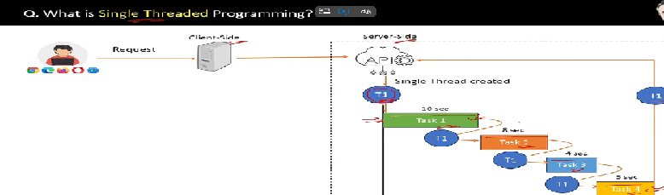
- Nodemon package?
Nodemon is package which is time saving module with the help of nodemon package no need to run project Agen and Agen
- NodeJS Is synch or Asynch Language?
NodeJS is Asynch languages

- Feature of NodeJS
- Single thread
- Asynchronous
- Event driven
- What is Synchronous
In synchronous programing each task is perform one by one in order and program wait for each operation before moving on next one
17 what is Asynchronous
Asynchronous flow can be achieved by its single -thread non-blocking and event driven architecture
18 what are then Event, Event Emitter, Event Queue, Event Loop & Event Driven
Event : Signal that something happened in program
Event Emitter : Source of event emitter
Event Queue: emitted event store in queued called event queue
Event Handler/ listener: Function that responds to specific event called event handler
Event Loop : the process of pickup event from event queue and execute are called event loop
19 . Concurrent Requests ?
Handle multiple request at time called Concurrent Requests

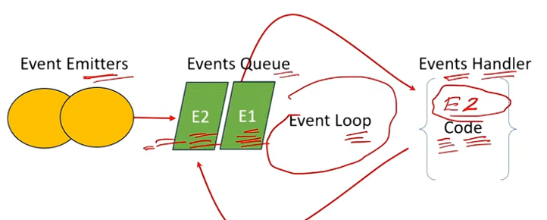

20. d/w function and Event
A function is reusable peace of code and event is signal that somthing happen in application
21 . role of http module in node ?
http module create server that listens to server port and give the response to the client
22. role of createSever() method
Its use for create an HTTP server
// CREATE SERVER USING CREATESERVER METHOD
// const http = require("http");
// const server = http.createServer((req,res)=>{
// res.writeHead(200,{"content-type":"text/plan"});
// res.end("hii");
// });
// const PORT=100;
// server.listen(PORT,()=>{
// console.log(`Server is running at http://localhost:${PORT}`);
// })
// CREATE SERVER USING EXPRESS
const express = require("express");
const app =express();
const PORT=200;
app.listen(PORT,()=>{
console.log(`Server is running at http://localhost:${PORT}`);
});
23. what is CORS?
CORS is browser security mechanism which restricts cross-origin HTTP requests its handle by using the CORS middleware.

24. What is Middleware?
A middleware is function that handles HTTP request perform operation and pass control to next middleware
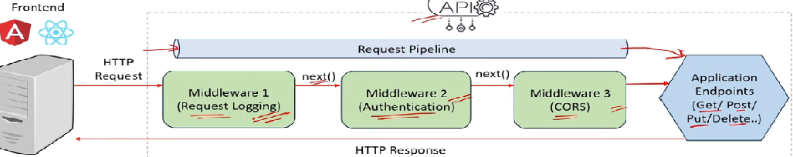
25. what is use app.use()?
app.use() is used to mount middleware functions in Express or register middleware

26. how to implement middleware?
Define middleware function and pass app.use() to mount middleware globally
27. what is use of next();
Next() param is is a callback function which is pass control to the next midelwhare
28. who to use middleware globally for specific root
Use app.use(‘spacefic root’,mymiddelwhare) to use for spacefic root
29.what is request pipeline in express
Request pipeline is series of middleware function that handle http request and pass control to next function
30. type of middleware
# app Laval middleware => its apply globally to incoming all incoming request
# root Laval middleware => its apply specific root not for all incoming request
#error handling middleware => define param err in middleware function
#third party middleware => a function who developed by third party not a part of core express like helmet,bodyParser

