**FUNCTION**

* It is a block of code which will peform a certain task.
* In js function are first-class citizens means they can assigned into variables, passed as an arguments, can be returned from functions.

Advantages of function

* Reusability
* Organize our code into logical units which increase readability and maintainability

**Function Syntax** do not declare variable with let,var,const …..directly write

the variable name only.

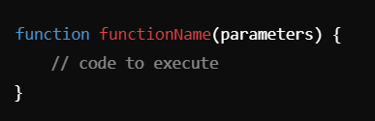

Note – If we do not return anything from function, javascript will return undefined by default.

Function without parameter and return

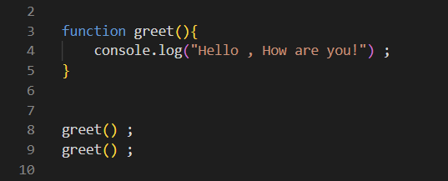

Function with parameter

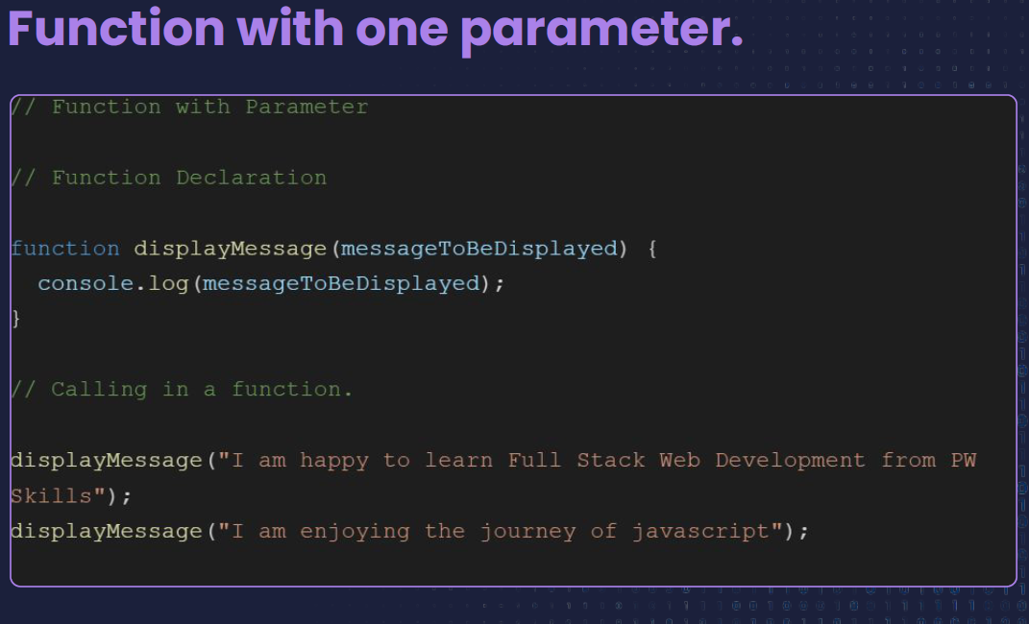

**Function with default parameter**

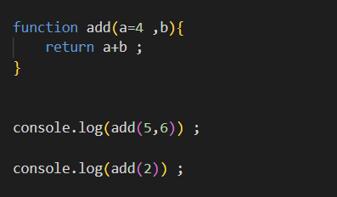

OUTPUT

11

NaN ( Argument Allocation -> first argument goes to first parameter and so on )

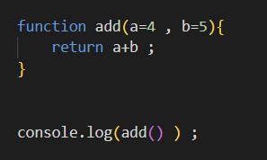

OUTPUT

9

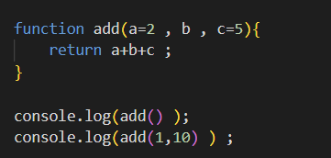

OUTPUT

NaN

16

Note – Do some more tricky question on default parameter

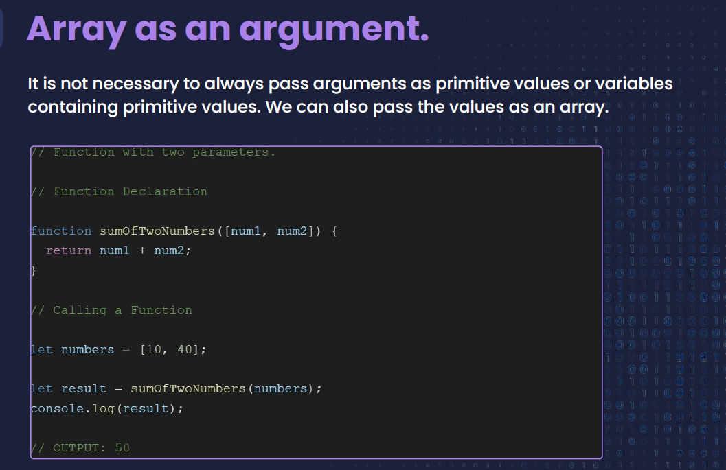

Note 🡪 we can use array elements individually inside function

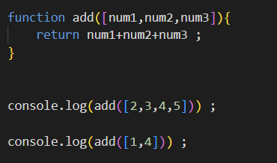

OUTPUT

9

NaN

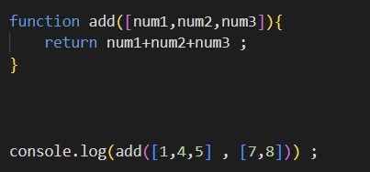

Output

10

**Function with unlimited number of arguments**

**What**

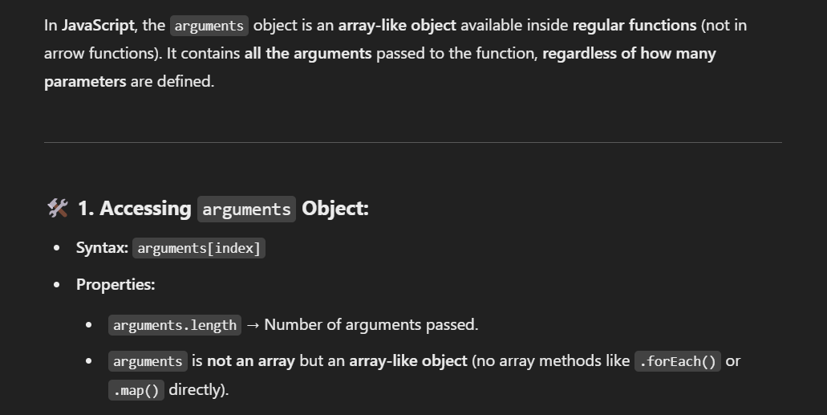

Why

If a developer does not know how many arguments will be passed to this function but he wants to access all arguments which has been passed to this function then in this sitiation he can use arguments object to access all the passed arguments.

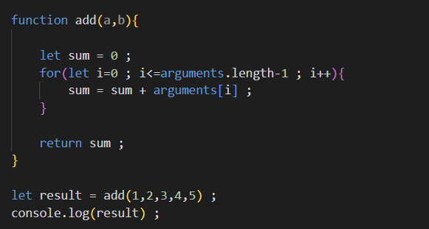

Output

15

Note – But this is not a good practice to use arguments objects.

**ARROW FUNCTION**

**Shorter syntax:** Compared to traditional functions.

**No own this or arguments:** Inherit from surrounding scope.

**Best for:** Callbacks, array methods, concise functions.

Arrrow function are used with method like map(), filter(), reduce() because they make more readable specially when used in a chain of array methods.

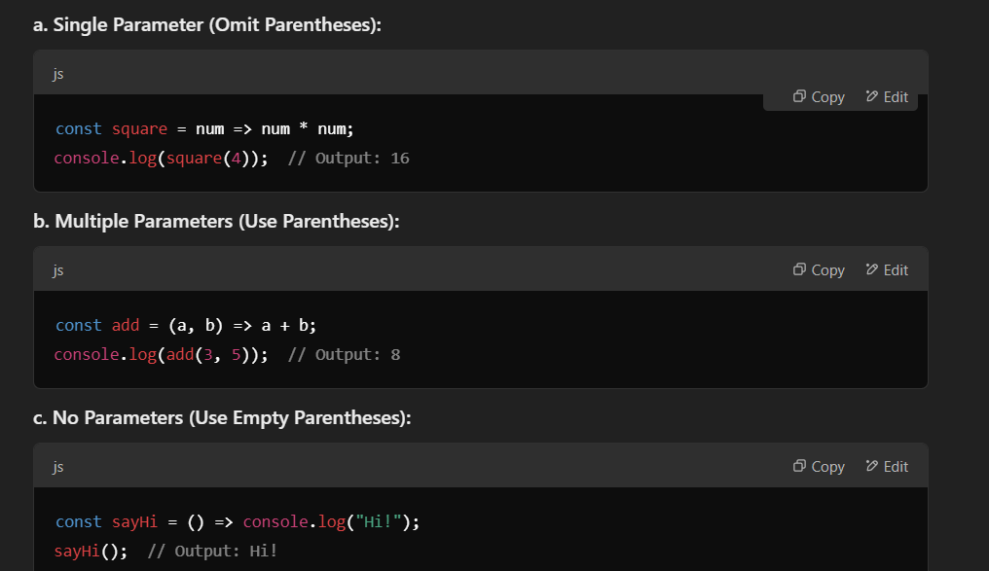

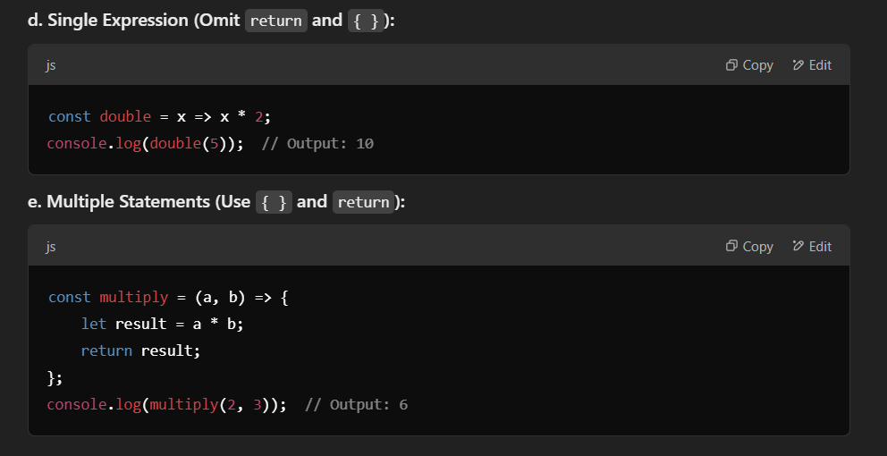

**Anonymous Function**

A function which does not have name is anonymous function.

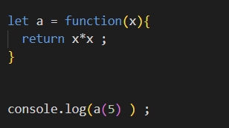

**Immdiately Invoked Function Expression or Self Invoking Function**

It is a function which is executed as soon as it is defined, no need to manually call them and trigger them.

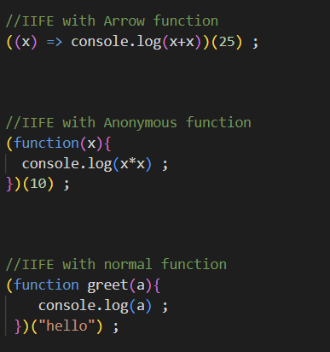

Output

50

100

Hello

**Function Expression**

When we store a function in a variable is called function expression.

It can be named or anonymous or arrow.

Cannot be called before they are defined (Not hoisted)

Named function

