**Object**

* Object is a real world entity.
* Every object has its own states and behaviour
* An Object get new memory everytime, it is created.

Syntax of making object

1. Using curly braces (most preferred way)

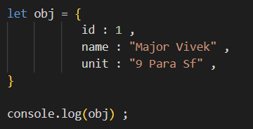

1. Using Object Constructor

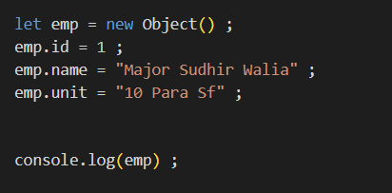

Object is a constructor which we call using new operator and it will return an empty object.

1. Using function

Do it from pw video

How to access a key’s value of an object

objectName.key

objectName[‘key’]

How to update a key of an object

objectName.key = value

(if the key is present it’s value will be updated otherwise this will add a new key value pair to object)

Delete a key Value pair

delete objectName.key

Q- What is Object Class in js ?

The Object class in JavaScript is the root of all objects. Every object in JavaScript is an instance of Object or inherits from it. It provides a set of properties and methods that are essential for creating, manipulating, and interacting with objects.

**Object Method**

These all are static method of Object class, that why we use ClassName to access them

Object.keys(objectName) 🡪 return an array of all keys

Object.values(objectName) 🡪 return an array of all values

Object.entries(ObjectName) 🡪 return an array consist of multiple arrays of length 2

consisting key value pairs

Object.freeze(ObjectName) 🡪 can’t make any changes in object like no updation of value

no addition or removal of key-value pair

Object.seal(ObjectName) 🡪 allow only updation but no addition or deletion of key-

value pair

Object.assign( {} , ObjectName) 🡪 return new Object with all the key-value pair of old object.

emptyObject oldObject

but can give new key-value pair, then new object will have both old object key value pair and given

key value pair.

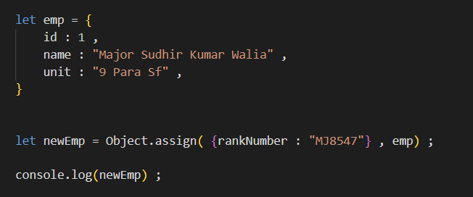

OUTPUT

{

rankNumber: 'MJ8547',

id: 1,

name: 'Major Sudhir Kumar Walia',

unit: '9 Para Sf'

}