Data – Random facts and figures which can be stored is data. For ex- 1 , 1.2 , ‘E’ , “IA”.

Information – Processed data and meaningful data is information.

Database – Place where we store our data or collection of data is called database.

Database is present in our hard-disk.

DBMS – Software which helps us to create and manages database is called DBMS.

DBMS are of different type

1. Relational DataBase Management System. For ex - MYSQL
2. Non relational database management System. For ex- MongoDB

SQL (Structured Query Language)

* It is language which is used by RDBMS to communicate with the Relational databases. Communicate means performing CRUD operation on D.B

(just for understanding)

Analogy:

Think of a **DBMS (MySQL)** as a car and **SQL** as the steering wheel or dashboard controls.

* The **DBMS (car)** provides the underlying functionality to move, turn, and stop.
* **SQL (controls)** lets you interact with and drive the car to perform specific actions.

**RDBMS(Relational Database management System)** relation means table

* RDBMS is a type of DBMS which helps us to create or manage relational databases.
* Relational database means where data is stored in form of table(means row and column)
* Example of RDBMS – MySQL , OracleSQL, PostgresSQL

**Table**

* Logical representation of data that is stored in D.B
* Combination of rows and columns.
* Rows are also called record, tuple.
* Columns are also called attribute, field, properties.
* A Single row is also called record.

while adding and modifying anything column and constraint keyword will not used in command.

**Important points**

* SQL is not case sensitive. But data will be case-sensitive.
* char, varchar, date type of data comes in single(‘ ‘) quotes.

**RELATIONAL OPERATOR**

Relational operators in SQL are used to compare values in queries, typically in WHERE or HAVING clauses. These operators return TRUE or FALSE based on the comparison.

**NOT OPERATOR !**

Not operator will **reverse the result**. If the result is true it will make it false and if the result is false it will make it true.

(just for understanding)

Whenever we write any CONDITION, be it in sql or programming, we always write true condition so if the condition is true that record will be selected, but whenever you are using NOT operator, always write false condition because NOT operator will change it from false to true.



Because if we write true condition, it will make it false which we don’t want, so write false condition NOT operator will make it true.

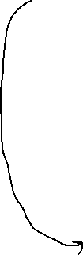

For ex - Select the all emp details, except Martin, Miller



(query without NOT operator)

select *



from emp



where ename!=’MARTIN’ AND ename!=’MILLER’ ;

(query with NOT operator)

select *

from emp

where not( ename=’MARTIN’ or ename=’MILLER’) ;

**IS OPERATOR**

Is operator is used to evaluate null values

For ex

Select details of employee who did not earn any commission

Select *

From emp

Where comm is null ;

Select details of employee who are in some department

Select *

From emp

Where deptno is not null ;

**IN OPERATOR**

* Shorthand property of OR operator.
* IN will group multiple values.
* IN operator works like = operator
* And results are logically combined using OR

Syntax - columnName IN (value1,value2,value3,value4)



Here we should have only one value here we can have n number of values

**NOT IN OPERATOR**

- Shorthand property of AND operator.

-It will group multiple values.

- Not In operator works like != , it rejects the value of specified list.

- The results are logically combined using AND

Syntax - columnName NOT IN (value1,value2,value3,value4)



**TRIM**

Trim function is used to remove a character from starting, ending, or from both places in a string.

Syntax - (leading/trailing/both ‘s’ from ‘sandeep’)



character you want to remove string

**REPLACE**



Replace function is used to replace and remove character from given string.

Syntax - Replace(main string , search string , replace string)

Note – if you don’t pass third argument it will remove the search string.

* It will look for the search string as a whole, in the given string, not character by character . It will replace the search string only when it finds the whole search string as it is, in the original string.

For example -

* 1. SELECT REPLACE('SANDEEP' , 'SA' , 'ZY')

FROM DUAL ;

OUTPUT

REPLACE

----------------

ZYNDEEP

* 1. SELECT REPLACE('SANDEEP' , 'SD' , 'ZY')

FROM DUAL ;

OUTPUT

REPLACE

--------------

SANDEEP

**Translate**

Translate is used to replace character from given string.

Syntax – Translate(main string, search string, replace string)

Note - 3rd argument is compulsory to pass.

* It will look for search string character by character in the given string and replace character by character.
* We can remove the character using Translate but atleast one character we have to replace and other character can be removed, as giving 3rd argument is mandatory in Translate.(see example 2)

For ex

1. SELECT TRANSLATE('SANDEEP' , 'NP' , 'KJ')

FROM DUAL ;

OUTPUT

TRANSLA

-------

SAKDEEJ

1. SELECT TRANSLATE('SANDEEP' , '_DP' , 'Z')

FROM DUAL ;

OUTPUT

TRANSL

------

SKNEE

**INSTR**

Instr returns us the index value, of the character’s occurrence in given string.

**DATE FUNCTION**

Date written like this ’21-MAR-25’ is considered string type not date type. So to convert ’21-MAR-25’ to date type we use TO_DATE(’21-MAR-25’) function.

So we cannot add any number in string type… for ex- ’21-MAR-25’+ 10 …. is error …..so to add any number to the date, we have to convert string type i.e ….’21-MAR-25’ to date type using TO_DATE(’21-MAR-25’).

If I add any number to the date, it will be considered adding days to date. So it will return us new date.

For ex -

* SELECT TO_DATE(’15-JAN-25’) + 8

FROM DUAL ;

OUTPUT

23-JAN-25

1. ADD_MONTHS() FUNCTION

Syntax - ADD_MONTHS(DATE , MONTHS)

* It will add/subtract months in the given date and give us the new date.
* Used when we want to know what will be the date after 3 months or 3years from given date.



by converting years into months

For ex

1. Adding months in the date

SELECT ADD_MONTHS(’15-JAN-25’ , 9))

FROM DUAL ;

1. Adding years in date 🡪 convert year into months and then use add_month() function only

SELECT ADD_MONTHS(CURRENT_DATE , 12*3)

FROM DUAL ;



Converting years into months

1. MONTHS_BETWEEN()

Syntax - MONTHS_BETWEEN( HIGHER_DATE , SMALLER_DATE )

* It will give us number of months exist between two dates.
* And months can be converted to years also by dividing by 12, this means we can also find out no. of years between two dates.

**HANDLING TWO DIGIT YEAR IN SQL**

Whenever we mention YEAR in SQL in two digits, sql will detect century based on RR format instead of YY format.

So YY format means it will detect century based on system date.

But in RR it will detect century based on belowe criteria

00-49 🡪 2000 to 2049

50-99 🡪 1950 to 1999

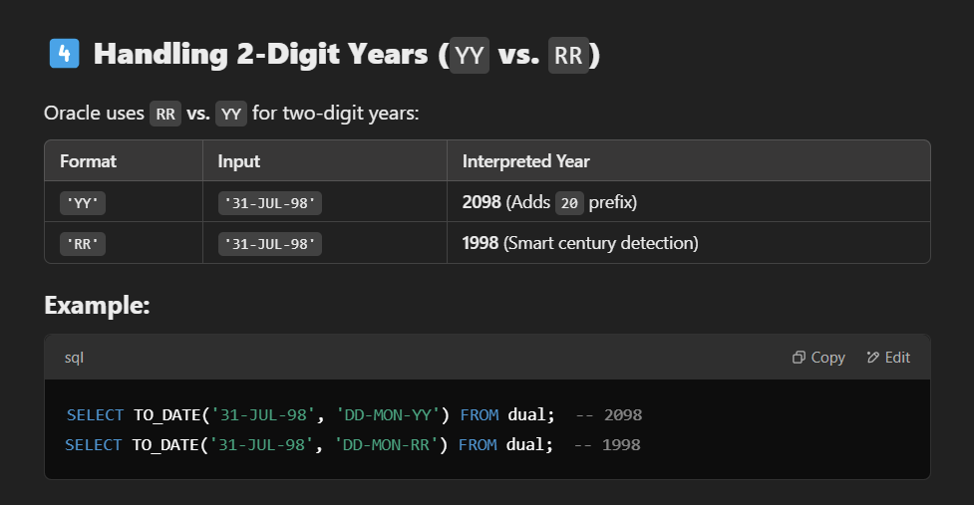

That why it is said always use four digits for mentioning year in sql to avoid any confusion.

**SPECIAL FUNCTION**

CONVERSION FUNCTION

1. **TO_CHAR() FUNCTION**

Syntax TO_CHAR(DATE, DATE_FORMAT)



mention string in which you want to

change like (‘DAY’, ’MON’ etc)

* This function will change date to particular type of string.
* The returned string will have leading and trailing spaces so remove spaces from both side before comparing the returned string to any other string.

1. **TO_DATE() FUNCTION**

whatever string date you have given in 1st argument

mention same date format here. (See example)



Syntax TO_DATE(STRING , DATE FORMAT)

* Convert string type to date type.

For example

1. TO_DATE(’31-JUL-98’ , ‘DD-MON-YY’)

FROM DUAL ;

OUTPUT

31-JUL-98

1. SELECT TO_DATE('31/07/1998' , 'DD/MM/YYYY')

FROM DUAL ;

OUTPUT

31-JUL-98

1. SELECT TO_DATE('2003-27-03' , 'YYYY-DD-MM')

FROM DUAL ;

OUTPUT

27-MAR-03

1. SELECT TO_DATE('2003-27-JUL' , 'YYYY-DD-MON')

FROM DUAL ;

OUTPUT

27-JUL-03

**HOW SET CLAUSE IS EXECUTED IN UPDATE STATEMENT**

Set clause in update statement is updating each row so it expects n value for n rows means one value for each row but , but aggregate function returns one value for n number of rows so database did not know how to map one value with each row…

So directly using aggregate function in set clause is not allowed… solution is to use subquery

Subquery also returns one value only but now it will be considered as constant by database for each row and each row will be updated with that value.

**GROUP BY CLAUSE**

* It will group same values, of a column.

Syntax- GROUP BY COLUMN_NAME1 , COLUMN_NAME_2

Any clause executed after group by clause will be executed group by group.

If we have used Group By clause in our query, then in Select Clause we can write only MRF() function and column written in group by clause.

Order of execution Reason

1. From tableName
2. Where condition(optional)
3. Group by columnName1 , columnName2
4. Select



(just for understanding)



because after group by clause, every clause will be executed group by group, so if we write any other column in select clause, database will not be able to determine which one value to return from that column from each group.

(because that column written in select clause will have multiple values to return)

For ex-

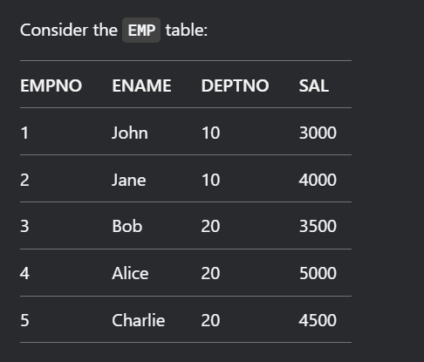

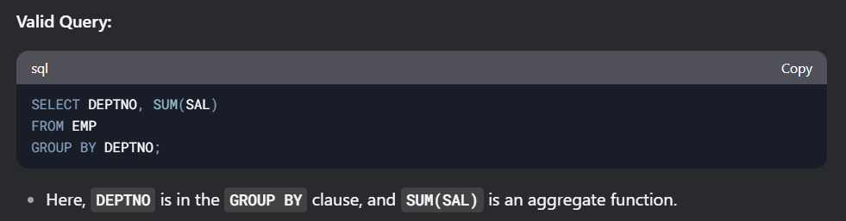

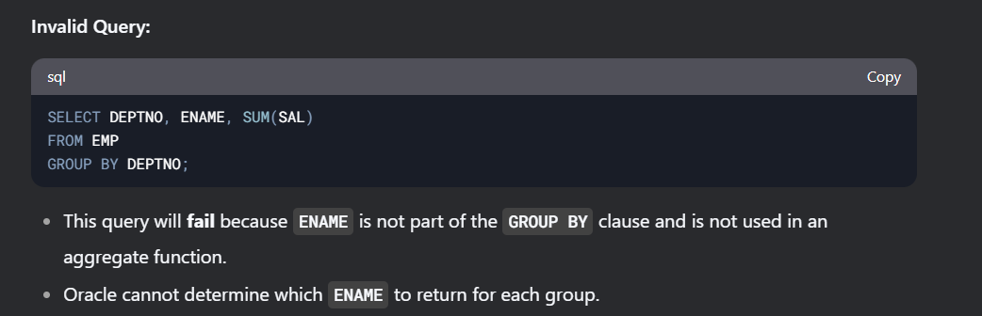

**HAVING CLAUSE**

* Use to filter groups. (By writing a condition)
* Written and executed after group by clause.
* In having clause we can’t use srf function because having executes after group by clause which means having execute group by group means from each group one value should be returned, but srf function can return multiple values from each group, by which database will get confused to select which value for the group, from those multiple values.

Syntax

HAVING CONDITION_1 , CONDITION_2

**Difference between where clause and having clause**

|  |  |
| --- | --- |
| **Where clause** | **Having clause** |
| 1. Use to filter records of columns | * Use to filter records of groups |
| 1. Executes row by row (only srf function can be used here) | * Executes group by group |
| 1. Written and excuted before group by clause | * Written and executed after group by clause |
| 1. Where can be written without group by clause | * Having clause cannot be written without group by clause (because there will be no meaning of having clause withour group by clause) |
| 1. Mrf function cannot be written in where clause. | * Mrf function can be used in having clause. |

**ORDER BY CLAUSE**

Why?

* Used to sort the data in ascending or decending.

How?

Syntax - ORDER BY Column_Name_1 asc/desc , Column_Name_2 asc/desc

* We can use Column_Number also in place of Column_Name(Column_Number will be given on the basis of 🡪on which number that column is present on select clause) and if we don’t mention asc/desc then by default order by sort data in asc.
* If there are two column written in Order by clause, then first priority will be given to first column.
* Srf() and mrf() both can be used in order by clause

Order of execution

1. FROM
2. WHERE
3. GROUP BY
4. HAVING
5. SELECT
6. ORDER BY

Note – we can skip where, grouby , having if not needed

**ANY OPERATOR , ALL OPERATOR**

* **ANY, ALL operator both are used with relational operator**
* ANY operator returns true, if any one condition is satisfied
* ALL operator returns true, if all conditions are satisfied.

**SUBQUERY**

When to use subquery

When we have to fetch the data from one table only but which data to fetch depends on another table output.

We can write subquery in any clause and n number of times

**CO-RELATED SUBQUERY**

When to use

When I want to compare each row of one table with each row of same table or another table then we can use co-related subquery.

WHAT

When inner query is dependent on outer query, and outer query execute(partially) before inner query these types of query are called co-related subquery.

How co-related subquery works, (flow of co-related subquery)

* First outer query will be executed(its FROM clause… then WHERE clause in WHERE clause… inner Query/sub-query will be executed first, outer table each row will be compared with each row of inner table then inner-query/sb-query will give a result then WHERE clause of outer query will compare the result and select or deselect row of outer query. Then for each row of outer query this process will repeat.
* Inner query will be using, value from outer query.

**JOINS**

What?

When we join two or more tables rows, based on related column is called joins

Why?

Because when we have to fetch data from multiple we use join, it helps in avoiding writing multiple queries.

Syntax

SELECT

FROM tableName1 joinName tableName2

ON <join condition> (in ON clause when mentioning column name, use

tablename before columnName as multiple tables exist in query)



Writing join condition is mandatory and join condition is written based on related column(column present in both tables).

We don’t have to write join condition in cross join, natural join.

**SELF JOIN**

What ?

When we join a table with itself is known as self join.

WHY ?

When we have to MERGE row with the row of same table we use self join

Points to remember in self join while writing query

* Name is self join but when we mention self join in query write only join.
* Alias the table name whenever using table name in query, as same table are merging, so for avoiding confusion.
* Join condition will be written on the basis of rows we want to compare.

**EXISTS NOT EXISTS OPERATORS**

What

These two are operators used with corelated subquery.

**EXISTS** operator returns true if inner query returns some row.

When to use

* When we want to check record present in one table is also present in another table.

**NOT EXISTS** operator returns true if inner query do not return any row.

When to use

* When we want to check record present in one table should not present in another table.

**FUNCTIONAL DEPENDENCY**

Notation A 🡪 B



Determinant determine dependent

Value of A can determine, the value of B

It is a relationship between two attribute where value of one attribute determines the value of other attribute.

For ex – In emp table, if you have empid you can determines the emp name, deptno etc

empId 🡪 ename

empId 🡪 deptno

Types of functional dependency

1. Trivial functional dependency

A🡪 B

A can determine B and B is a subset of A. This is called trivial functional dependency

For example

(emp_id, ename) 🡪 ename

(emp_id,ename) can determine (ename), and (ename) is subset of (emp_id, ename)

(emp_id,ename) 🡪 emp_id

(emp_id,ename) can determine (emp_id), and (emp_id) is subset of (emp_id, ename)

1. Non-trivial functional dependency

A 🡪 B

A can determine B but B is not subset of A. This is called non-trivial functional dependency

For example

(emp_id,ename) 🡪 deptno

(emp_id,ename) can determine deptno but deptno is not subset of (emp_id,ename) so this is non- trivial functional dependency.

Rules of Functional dependency (Armstrong’s axioms)

1. Reflexive

If B is a subset of A , this means A 🡪 B is always true.

For example

A= {a,b,c,d,e}

B={a,b,c}

B is a subset of A

So A 🡪 B is always true

1. Augumentation

If A 🡪 B dependency is given, then multiplying a new attribute on both sides, new dependency will be AZ 🡪 BZ, so this new dependency will always be true.

For example

Attributes of table(A,B,Z)

A 🡪 B (given)

THEN

(multiplying Z on both side)

AZ 🡪 BZ …. AZ can determine BZ will be a valid dependency

3 ) Transitivity

If A can determine B, and B can determine C then A 🡪 C is also true.

If A🡪B and B🡪 C then A🡪C also

**Normalisation**

What is normalisation ?

Normalisation is a technique which reduces data redundancy and increases data consistency and data integrity in Database.

Why to remove data redundancy from our D.B ?

* Data redundancy cause anomalies like

1. Insertion Anomalies
2. Deletion Anomalies
3. Updation Anomalies

* Data redundancy also increase the size of database because of which database performance will be low.

How to optimise D.B ?

We breakdown(decompose) tables into multiple tables until one table represents one entity.

Insertion Anomalies

Without the presence of one data we cannot enter the other data.

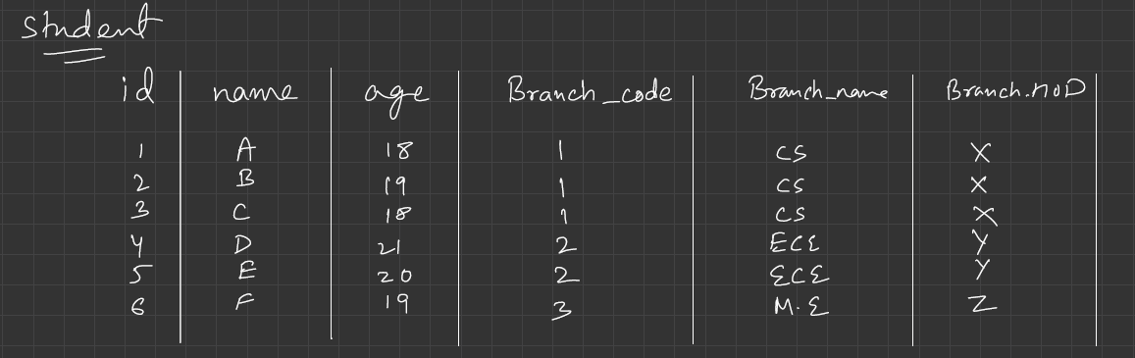



PRIMARY KEY



Suppose college has introduced a new branch and till now no student is enrolled in that branch, but that branch data cannot be inserted into this table because this table Primary key is StudentId+BranchCode, so without StudentID, branch details cannot be added because StudentId is primary key, so it can’t be null.

Vice-versa also without Branch details, Student details cannot be added because BranchId can’t be null.

Deletion Anomalies

Deletion of certain data results in deletion of other data also.

For example

In above table, Suppose All the Students of C.S branch has passed out and now we want to delete the data of those Students from the table but deleting the students, results in deleting the branch, even though the branch exist in the college.

Updation Anomalies

* Change in a single value/data, requires multiple rows to be updated
* so if one forgots to update any one row also, data inconsistency arises.

For example

In above table, C.S (computer science) branch name changed to S.E (software engineering) branch, now change in single value/data requires multiple rows to be updated, so if we forgot to update any one row data inconsistency arises.

Note- While Learning Normal Forms, first imagine table in your mind then explain 1NF,2NF,3NF

UN-NORMALISED TABLE

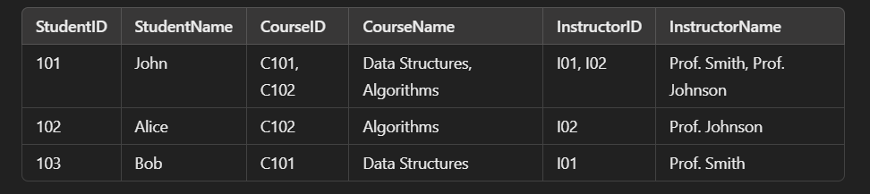 Primary key: **(StudentID, CourseID)** (composite key because a student can enroll in multiple courses).

**TYPES OF NORMAL FORMS**

**1 NF**

* Each cell in table should contain only one value, Table should not have multivalued attribute

Multivalued attribute means attribute which can have more than one value for a single entity.

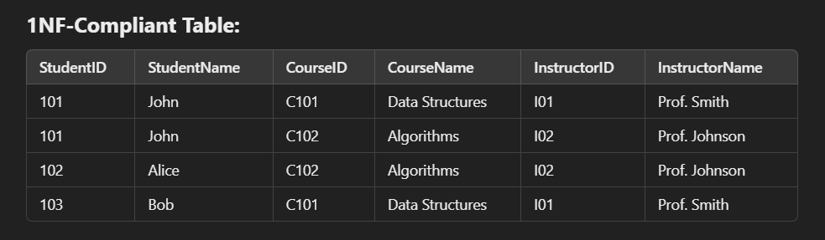

Primary key: **(StudentID, CourseID)** (composite key because a student can enroll in multiple courses).

**Problems in 1NF:**

1. Partial Dependency:
   * StudentName depends only on StudentID, not the full composite key.
   * CourseName and InstructorName depend only on CourseID, not the full composite key.

**2NF**

* Table must be in 1NF
* Remove partial dependency of non-prime attributes on primary key.

Non prime attribute should be dependent on full Primary Key, not on the part of Primary Key.

Prime Attributes are those attribute which are part of primary key.

Non Prime Attributes are those attributes which are not part of primary key.

For example

Four Column of table

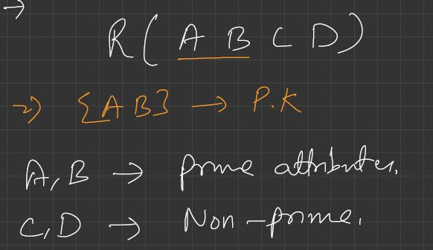



If C(non-prime Attribute) is determinded by A alone( by a part of Primary Key) then it means Non-prime attributes are partially dependent on primary Key.



A 🡪 C

B 🡪 D

So we have to remove this partial dependency and achieve full dependency.

Q- How we achieve full dependency of non-prime attributes on Primary Key?

1. By breaking the tables into multiple tables. Jo bhi non-prime attribute jis attribute pe depend kar rha hai, unn attributes ko utthake, unka ek separate table bna do.

Now this step will ensure full dependency of non-prime attribute on primary key.

**Tables Converted to 2NF**

**Student Table**:

|  |  |  |
| --- | --- | --- |
| **StudentId** | **StudentName** | **CourseId** |
| 101 | John | C101 |
| 102 | Alice | C102 |
| 103 | Bob | C103 |

Primary Key 🡪 StudentId

**Course Table:**

|  |  |  |  |
| --- | --- | --- | --- |
| **CourseId** | **CourseName** | **InstructorId** | **InstructorName** |
| C101 | Data Structure | 101 | Prof. Smith |
| C102 | Algorithms | 102 | Prof. Johnson |

Primary Key 🡪 CourseId

Now non-prime Attributes are dependent on full primary Key.

Problems in 2NF

* + Transitive Dependency ….Non-prime Attribute is finding non-prime attribute CourseID 🡪 InstructorID InstructorId 🡪 InstructorName CourseID 🡪 InstrcutorName

**3NF**

* Relation must in 2NF
* Remove transitive dependency

Means non-prime attributes should not find non-prime attributes

For example

In a table there are three column A,B,C

Primary key 🡪 A

F.D(given)

A🡪B (given)

B🡪C (given)

then A 🡪 C also, so if A 🡪 B and A🡪 C, so why this dependency exist B🡪C, remove it. ‘

Q- How to remove transitive dependency.

Jo bhi attribute jispe depend kar rha unko utthake ek separate table bna do.

**Tables converted to 3NF**

**Student Table**:

|  |  |  |
| --- | --- | --- |
| **StudentId** | **StudentName** | **CourseId** |
| 101 | John | C101 |
| 102 | Alice | C102 |
| 103 | Bob | C103 |

Primary Key is StudentId, Foreign Key is CourseId

**Course Table:**

|  |  |  |
| --- | --- | --- |
| **CourseId** | **CourseName** | **InstructorId** |
| C101 | Data Structure | 101 |
| C102 | Algorithms | 102 |

Primary Key is CourseId, InstructorID is ForeignKey

**Instructor Table:**

|  |  |
| --- | --- |
| **InstructorId** | **InstructorName** |
| 101 | Prof. Smith |
| 102 | Prof. Johnson |

Primary Key 🡪 Instructor Name

No Transitive dependency exist in any table now..

**BCNF (Boyce Codd Normal Form)** ………….. it basically focuses on prime attributes.

* Table should be in 3NF

- X🡪Y , X must be a super key.

- A non-prime attribute should not determine any prime attribute. Kuynki non-prime attribute toh key hi nhi hai, super key toh durr ki baat.

- A prime attribute also, should not determine any other prime attribute. Because prime attribute is a part of super key/primary key, not a super key.

( In other words prime attribute should also depend on full primary key, not on the part of

primary key.)

**Transaction**

* Execution of multiple sql statement considered to be a single task then it is called Transaction.
* Either all the statement must be executed or none of them will be executed.(if any error come in between the transaction will be rollbacked to its starting point)

For example

If Person A has to send 500 rupees to Person B. From user perspective, this is a single task, debit from A account and credit to B account.But In database multiple operation will be done to complete this one task.



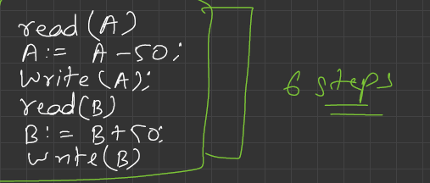

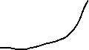

And this transaction if started must be completed fully means if 500 has deducted from account A, so it must be debited to B account, it should not happen that 500 deducted from account A and then never reached to account B due to some error in executing sql statements. So that is why these 6 steps considered single task, either all the statement must execute or none will be executed. If any error come in between all the changes will be rollback to starting point.

Why rollback is important?

Because we want consistency across my database. If money has been debited that means they should be credited to some account, and if they are not credited to some account, that means transaction has not been completed so the account which was debited it must be credited back, so that why we rollback the transaction to its starting point if transaction failed before completion.

**ACID properties**

Why to use ACID properties ?

We use ACID properties in DBMS (Database Management System) to ensure that our database remain consistent even after transaction like it was before the transaction.

What are ACID properties ?

1. Atomicity

Either all the statements will be exceuted or none of the statements will be executed. If any error come in between, the transaction must be roll backed to its starting point.

1. Consistency

Database should remain consistent after the transaction like it was before the transaction.

Note- consistency will be maintained if we maintain atomicity.

For ex- A has 1000 rupees and B has 500 rupess, and A want to send 200 rupees to B. So before starting transaction total money in D.B was 1500. So if A sends 200 rupees to B. A account have 800 and B has 700 which makes total 1500 rupees in D.B after transaction also. So we can say our D.B is consistent after the transaction also.

1. Isolation

Isolation says concurrent transaction happening in our D.B must be executed sequentially, untill T1 gets finished (success or failure), T2 should not be started. This way we have isolated every transactions from each other. This helps in maintain data consistency and integrity.

For example- Customer A has 1000 rupees and is sending 100 rupees to B from two platforms google pay(T1) and phone pay(T2). From each platform 50 rupees.

So if both transaction are executed together it can happen that both T1 and T2 READ 1000 rupees in A account ..

T1 T2

Read(A) 🡪 1000 Read(A) 🡪 100

A = A- 50 A=A-50

Write(A) 🡪 950 Write(A) 🡪 950

This amount will be written in A’s account

B will have 100 rupess, A will have 950 after transaction is completed.

Total Money Before Transaction 🡪 1000 (A 🡪1000 , B🡪0)

Total Money After transaction 🡪 1050 (A 🡪 950 , B 🡪 100)

Consistency is violated

This happened because both are executed together. So that why we should execute all the concurrent transactions sequentially to maintain consistency.

T1

Read(A) 🡪 1000

A = A- 50

Write(A) 🡪 950

First T1 will get success, after that T2 will be executed

T2

Read(A) 🡪 950

A = A-50

Write(A) 🡪 900

Now after transaction A has 900 rupees and B has 100 rupees

Total money before transaction = 1000 (A 🡪1000 , B🡪0)

Total money after transaction = 1000 (A🡪 900 , B 🡪 100)

Consistency maintained.

1. Durability

Durability means even if the system crashes our committed transaction should not be lost.

How durability works ?

1️ **Transaction Starts:** Changes are made in memory (RAM that is temporary storage).  
2️ **Write-Ahead Logging (WAL):** Before applying changes to the database, they are first logged in a **WAL (on disk means permanent storage like hdd, ssd)**.  
3️ **Commit:** Once changes are written in WAL, the transaction is marked **committed**.  
4️ **Flush to Database:** Now the changes will be copied from memory to the database.  
5️ **Crash Recovery:** If a system crash occurs after the commit but before writing to the database, changes in RAM will not be there when system restart. WAL is used to **replay committed transactions** and restore data.

Because of This WAL(Write Ahead Logging), our database is durable because we can recover the committed transaction even if the system crashes before we make changes in Database.

**Transaction States**

Read from Codehelp Pdf ( lec-12AcidProperties&Transaction)

**Indexing**

What is index ?

Index is a data-structure that stores, data of selected column, in a SORTED way with its row number in the acutal table.

Note - Indexing is used only when our database is large.

Original Table

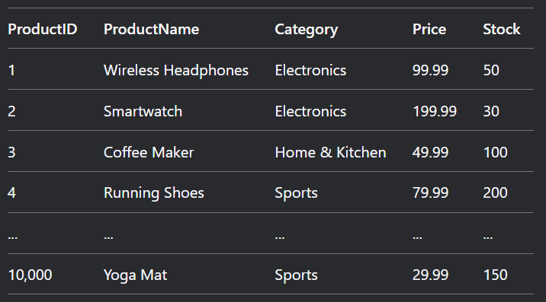

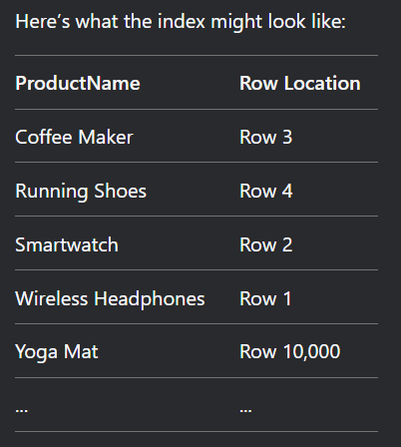

Why to use index ?

To locate the data quickly…….. (To speed up data-retrieval operation)

Because in original table it has to search each row(10,000) …….but in index, data is stored in sorted manner, so database will perform a binary search to find data this will reduce the time complexity from O(n) to O(log n). The moment we find data in index, that data will have its row number (pointing towards the actual row in the original table). Database will go to that row and fetch all the information related to that data.

For example – In above table, if we have to find Yoga Mat Price, if we search in original table we have to search linearly means we have to search each row means O(n) time complexity….. but if we search in index, products are stored in sorted manner alphabetically, so we can perform binary search and find the data(YogaMat) in O(log n) time complexity… And YogaMat will have its row number, pointing towards the actual row in original table, database will go directly to that row number in original table and find all the data related to Yoga Mat.

How to make Index?

Syntax

CREATE INDEX nameOfIndex  
 ON TableName (columnName1, columnName2);

**Types Of Indexing**

* + 1. **Clustered Index**

Clustering index is created on that column which is sorted (which is determining the sequential order of original table)

* Usually Clustering index is created on Primary Key Column, as it is sorted and decides the sequential order of table but we can use any column of the table.
* If use any other column to create clustered index then our original table sequence will change and original table will be sorted according to that column which we use to make clustered index.
* Only one Clustered index per table is allowed.(because table can be sorted on bases of only one column)

Note- In some databases clustered index is automatically created while defining primary key.

If we use a key attribute to make clustered index, How our index table look like?

* No changes in original table because we are using primary key and our table is already sorted according to primary key.
* Key attribute means column have sorted and unique values …. So instead of storing all records of original table in index table, we will store only first record of each block.(Sparse Index)

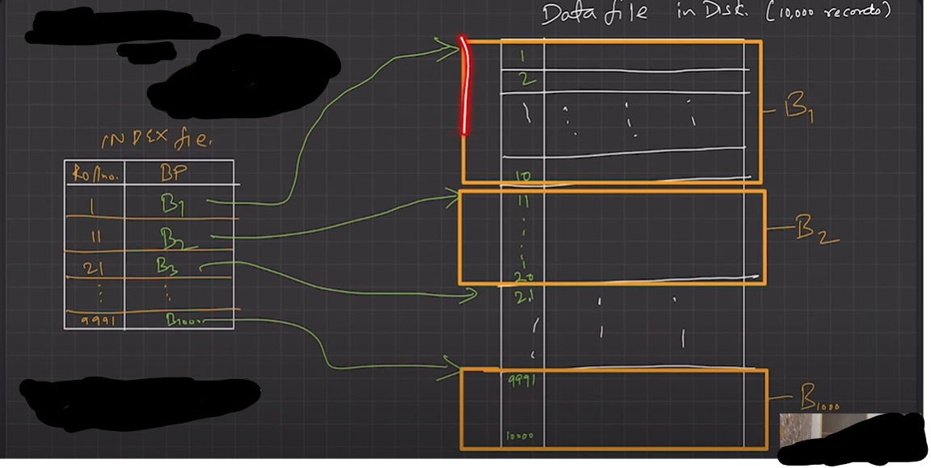

How the Searching works?

* if we have to find data we will first search in index table in which block, data is stored, after that go to particular block in original table and find that particular data.

If we use a non-key attribute to make clustered index, how index table look like?

* So firstly sequence of our original table changes, our original table will be sorted according to the column which we used for clustered index and not primary key.
* Non-key attribute means that column can have repeated values, so our index table will be storing only first record of block, with the block address.
* Here, same values will have one block.

For example

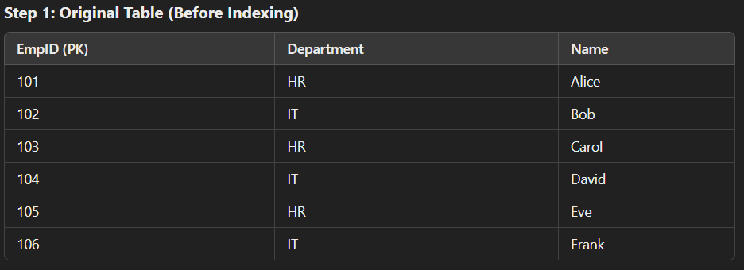

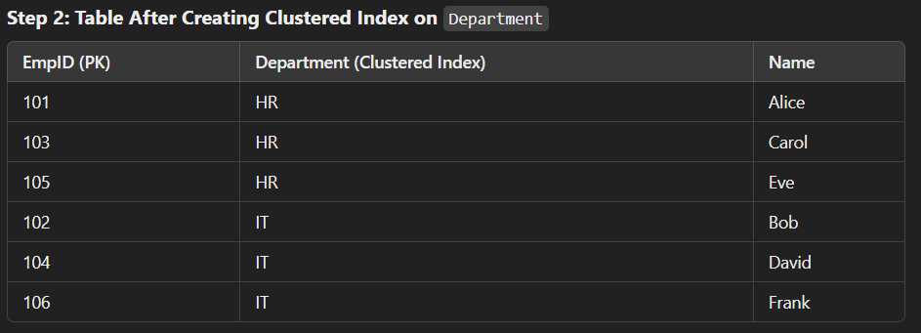

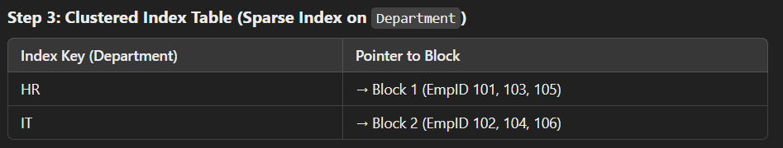

📌 **How Searching Works?**  
🔹 **Searching for employees in HR:**

* Look at the index → HR → Go to **Block 1**.
* Scan **Block 1** to find the exact employee.

**Dense Index**

* Every record of original table is stored in index table then it is Dense Index.

No of records of index table = No of records in original table

Example of dense index Original table



Dense Index

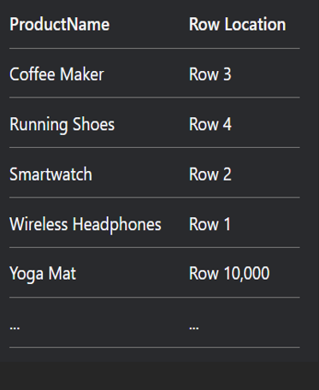

**Sparse Index**

* In this we create block and only first record of each block will be stored in index table.
* Index table will have only first record of each block and the block address.

No of records in index table = no of blocks in original table

Example of sparse Index



In this example each block has 10 records, total 1000 blocks and only first record of each block will be stored in index table with its Block number.



**Multi-level Indexing**