Html

-used to build structure of our web page.

 <meta name="viewport" content="width=device-width, initial-scale=1.0">

Explaination of this tag

**name="viewport"**:

* Specifies that this metadata is for the viewport, which is the user's visible area of a webpage on their device.

**Attributes Inside the Content:**

* **width=device-width**:
  + Sets the width of the viewport to the device's screen width.
  + Ensures the webpage is not scaled beyond the width of the user's device.
* **initial-scale=1.0**:
  + Sets the initial zoom level of the page to 1 (no scaling).
  + A value of 1.0 means 100% zoom, where 1 CSS pixel equals 1 device-independent pixel.

The tag ensures that:

* The webpage fits properly on mobile devices.

Without this tag, many mobile devices would render the page at a default width (e.g., 980px), making the content appear zoomed out and less user-friendly.

**Tags**

* Tags are used to tell web-browser, how to render the content ,which is present inside them, on the webpage.

For ex – content inside <p> tag will be rendered as paragraph and content inside <h1> tag will be rendered as heading.

**Heading**

  <h1>I am Heading 1</h1>

    <h2>I am Heading 2</h2>

    <h3>I am Heading 3</h3>

    <h4>I am Heading 4</h4>

    <h5>I am Heading 5</h5>

    <h6>I am Heading 6</h6>

<h1></h1> this tag is used for page title and should be used only once in your HTML page.

<h2></h2> this tag is used for section level heading and can be used multiple times.

<h3></h3> this tag is used for block level heading and can be used multiple times.

<!-- paragraph tag-->

     <p> </p>

(just for knowledge)

* For comments – use ctrl+slash… to comment any line in HTML

Syntax of comment

    <!-- <h1>India</h1> -->

* All the tags in HTML are written in lowercase.
* And close all the tags, even if you don’t close the tags in HTML, HTML will not give error but in react it will be error, so good practice is closing all the tags.

For ex – <h1> </h1> , <br/>

* Use right semantics tag in HTML page for better search engine optimization and for better readability.

**Semantic tags**

Semantics tag are those tags which will provide information about the content present inside them. For ex- address tag, blockquotes, abbreviation tag.

**Formatting style and global attributes**

<p></p> called paragraph tag used while writing paragraph

<b> </b> called bold tag to make the text bold, but we should use <strong></strong> tag to tell search engine that this information on our web page is important.

<i> </i> - to make the text italic , but if we should give emphasis to any text then use <emp></emp> emphasis tag for better optimisation of your site.

<small> </small> it renders text within it one font-size smaller, such as from small to x-small independent of its styled presentation,for ex-writing copyright and legal text in website.

<sub></sub> called subscript tag used to place word in downscript using smaller text.

<sup></sup> called superscript tag used to place word in upperscript using smaller text.

<del></del> called delete tag used to tell this text has been deleted from document. For ex- Seen in sales website.

<mark></mark> called mark tag used to highlight the text in our web page.

<pre></pre> called preformatted text tag, content inside this will appear exactly same in web browser as it appears in source code.

<blockquote cite=”source-url”></blockquote> tag tells whoever reading the source code that this section of text that is quoted from another website. It is a block level element that why used for long paragraph or text. By default, browsers display blockquote content with indentation without double quotes.

cite is an attribute where we mention the source of the text highly recommended but not mandatory.

Syntax - <blockquote cite="source-url"> Quoted text goes here. </blockquote>

<q cite=”source-url”> </q> tag tells that this section of text is taken from other website. It is an in-line element so used for short lines or text.By default browser will add double quotes both in starting and ending of the text but ot indentation.

For ex    <p>  Indian Army <q cite="www.indianarmy.in">  live a life less ordinary </q> <p>

**Difference Between <q> and <blockquote>**

| **Feature** | **<q> (Quote)** | **<blockquote> (Blockquote)** |
| --- | --- | --- |
| Usage | Used for short quotation (in-line quotes) | Used for long quotations (block-level quotes) |
| Adds Quotes | Quotes are automatically added | No quotes are automatically added |
| HTML Tag Level | Inline-level element | Block-level element |
| Identation | Identation not added | Identation added |

<abbr title=””></abbr> called abbreviation tag used to provide abbreviation for a text. The browser will display the text with dotted underline and when user hover over it, user will get the full form of the text if the programmer has used title attribute with abbr tag. That why it is highly recommended to use title tag with <abbr> tag but not mandatory.

For ex-

<p>The <abbr title="World Health Organization">WHO</abbr> is an agency of the United Nations.</p>

<address></address> this tag tells that contents inside this is contact information.

<cite></cite>

<bdo dir=” “></bdo> called bi-directional tag used to change the direction of text. By default our text start from ltr(left to right) but you change it to rtl(right to left), using dir=”” attribute where you mention the direction as ltr , rtl.

Use-case – when you are making website for muslim countries where text come from right to left for ex- Urdu.

For ex <p> After <bdo dir="rtl">joining google join Indian army </bdo> </p>

**Attributes**

* Attributes gives extra information about the tag
* it will be present in form of key-value pair
* present inside the opening tag.

**Global attribute** means those attributes which are available for all tags. For ex- tiltle, style etc.

For ex-

**style** is a [global attribute](https://developer.mozilla.org/en-US/docs/Web/HTML/Global_attributes) contains [CSS](https://developer.mozilla.org/en-US/docs/Web/CSS) styling declarations by which we can give styling to any text.

Syntax - <p style="text-align:center; background-color: blue;">Indian army is best job in the world</p>

Note – each property of css inside style tag should end with semicolon.

style can be used as a attribute also and tag also in HTML.

**Links**

Anchor tag (inline element)

It defines a hyperlink, which is used to link one page to another.

Attributes

* href In href attribute we can mention link( link should always start with http://link), mail

id(mailto:maiIId) ,telephone number(tel:number) , id or class of different tags(#id

.class) so that you can jump to that section of code when you click, or link of a

resource which you want to download but use download attribute with that.

* target _blank(to open link in new tab) , _self(to open in same tab). And by default browser

use _self

* download it will download the resource of whose path given in href attribute instead of

opening that link on clicking.

For ex-  <a href="./Pictures/IS.png" download> download image </a>

scroll-behaviour:smooth

The scroll-behavior: smooth; property does not apply directly to an <a> tag. Instead, it is meant to be applied to a scrollable container, such as html or body.

When you click an anchor link (<a href="#target">), the browser jumps to the target element, but for smooth scrolling to work, the scroll-behavior must be applied to the container responsible for scrolling.

Note

* when giving link in href attribute, link should start with http://
* When mentioning resource from local system in href attribute, you have to give the relative path of the resource.

Relative path example - ./IS.png

**Image**

img tag (inline-element)

used to put image to our web page.

Atrributes

* src mention source of image here

if copying from web – copy image address, it should start with http://

if image is in local system then give relative path

Relative path example - ./IS.png (Here ./ means in same folder image is

present where the html file is present)

* alt here describe image via text which will appear if image do not load and best to use

when making website for visually impaired people because they use screen reader

which tell what the image is about.

* height mention height of image
* width mention width of image

Images are of two types jpg and png

jpg 🡪 background will not be transparent

png 🡪 background will be transparent

**Relative Path**

./ means you are in the same folder where the html document is present.

../ used to get previous folder (means tum ek level upper aa gye uss folder se jaha html document present tha)

Toh jitne folder se bahar jaana hai utne hi ../../ iss example me tum do folder ke bahar aa gye

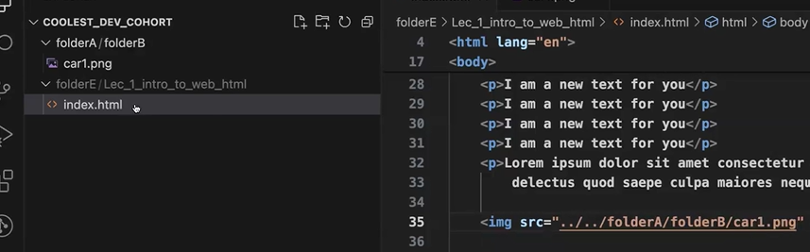

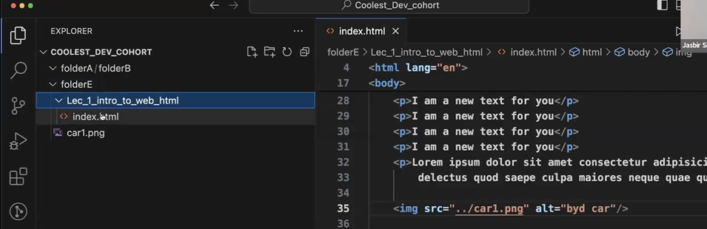

Shortcut to know relative path of the resource …. Right click on the resource and copy its relative path.

(just for knowledge)

* picture stored in local storage should have no space because when you mention picture name with spaces in src attribute, and when all resources given to server, there it would create a problem, locally it will not create a problem.
* When you are giving link of an image in src attribute use height attribute also because if the picture is taking time to come, in the meantime browser will load the rest of the content on website so when the picture comes it will make space for picture agin and shift all content downwards so this take time, so better to use height attribute which will reserve the space for picture so even if picture is taking time to come, browser will leave that much space and load rest of the website and when picture comes it will comes in his reserved space so it does not effect the other content of the webpage. This make you website fast to load

**List**

Read from w3 school

**Table**

For creating row - <tr>

For creating cell, two tag <td> use for creating cell in table body or <th> use for creating cell in table head

Do from algoprep document

**Button (inline element)**

* Syntax

<button>Submit</button>

* Attribute

disabled It will disable the submit button

(Use case – You want to submit the form, so you clicked on submit button, so form will take some time to submit so till that time button should be disabled

**div**

* div is a container inside which we can wrap up multiple HTML elements, for styling purpose or for creating sections for flexbox or grid.
* div is an block level element, it takes whole width of their parent.

Example of block level elements – heading, para , list ,div

**span**

* span is also a container which is used to target a specific part of content inside a tag.
* Span is an inline-element which means it will take width equals to its content.

Example of in-line elements - span, images, buttons, anchor

**id**

* id is an attribute
* It used to target one HTML element because one id can be given to only one HTML element.
* While targeting element using id use #Id

**class**

* It is an attribute
* It is used to target more than one element at a time because same class can be given to multiple HTML element.
* While targeting element using class use .class

**FORMS**

Why to use only label tag?

Because label tag is having for attribute inside which if you mention corresponding input tag id then that label will be associated with that input box.

So in web browser if you click on that label, associated input box will be highlighted which means for that label, you have to enter the data in that input box which was highlighted.

Basic input type

* text
* number
* email
* password
* tel
* url
* date
* time
* file
* search
* submit

Features of <input type=”search”>

* + 1. it will give you clear option to clear entered value at one click.
    2. Sometimes user will give some extra space after entering value, so it will remove that space automatically.

readonly attribute should be used with value attribute. Why?

value – it will provides us the by default value for that tag.

readonly attribute will not let us change the value, so the by default value which we have given will not be changed.

When the values of form will be validated?

Validation of all properties(like maxLength,required,email) happens when we submit the form. At the time of submitting the form, it will give us warning to correct our entered value according to the input tag’s attributes.

Forms study from VSCode (all three files)

**Pattern Attribute**

**What?**

* The pattern attribute allows you to define a custom validation rule using a regular expression.

**Why?**

* The pattern attribute is used when we want user should enter data in a specific format. So to ensure that user enter’s correct data we use pattern attribute. For ex- Mobile numbers (e.g., +91 followed by 10 digits), Credit number(16 digits not alphabets), Vehicle registration numbers.
* So at the time of form submission user data is matched with the pattern attribute, if the user enter right data, form will be submitted else if user enters wrong data form will not be submitted.

Note- You don’t need to learn regular expression( you can take regular expression from chatGpt) but you should now they exist and how to use them.

Use CSS on table

3 ways to add CSS in your project

1. Inline-CSS – directly write inside the HTML tag using style attribute.
2. Internal CSS – write inside head tag of HTML using style tag.
3. External CSS – make a separate CSS file and link it to the HTML page using link tag.

**Colors**

Colors can be given in 3 ways

* Directly give name of the color
* hsl value(hue,saturation,light)
* rgb value(red,green,blue) as every color is made of these color only.

Note- a can be added in hsl and rgb …a means opacity ..its value range from 0 to 1.