PROJECT 1 — AI Fraud Detection Modernization
1. Business Problem
Fraudsters change tactics faster than the bank can update rules.
The current system misses new fraud and generates too many false alarms.
2. Business Objective
Use AI to catch more fraud, reduce false positives, and make decisions faster with a modern, real-time fraud detection system.
3. Business Constraints
- Must meet regulatory & audit requirements
- Real-time decisions (milliseconds)
- Limited data quality & labelled fraud cases
- Must integrate with existing systems
4. Success Criteria (With % Targets)
Business Success
- Reduce fraud losses by 20–40%
- Reduce false positives by 15–30%
- Improve customer approval rate by 5–12%
- Reduce analyst workload by 25–50%
ML Success
- Model accuracy (AUC ≥ 0.90)
- False positive rate improvement of 15–25%
- Model stability: <10% performance drift per quarter
- Explainability coverage: 95–100% of decisions explainable
Economic Success
- ROI ≥ 3–5x
- Payback period: 6–12 months
- Operational cost reduction of 20–35%

5. High-Level AI Solution
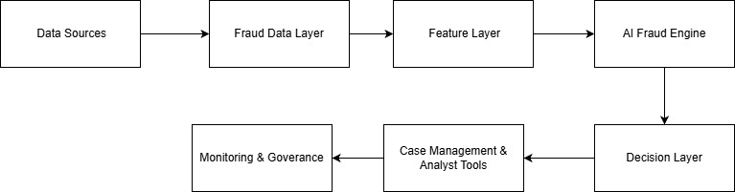

6. AI/ML Models We Can Build
- Supervised ML Model (primary fraud predictor)
- Anomaly Detection (new/unseen fraud)
- Graph Model (detect fraud rings / linked accounts)
- Behavioural Model (velocity, device patterns)

7. Quality Assurance (QA) We Provide
Model QA
- Accuracy testing
- Bias checks
- Back testing with historical data
- Stability/drift testing
System QA
- Latency testing
- Integration testing
- Failover & resilience checks
Governance QA
- Documentation pack
- Explainability reports
- Model audit logs

8. Where We Help (Crisp Consulting Roles)
Area | Our Role
Data | Clean, integrate, prepare fraud data
Features | Build strong fraud features
Modeling | Train & validate high-performing models
MLOps | Deploy models in real time
Governance | Ensure explainability & compliance
Operations | Tune rules & reduce manual reviews

PROJECT 2 — GenAI-Powered Fraud Investigation & Operations Assistant
1. Business Problem
Fraud analysts spend too much time manually reviewing cases, reading long transaction histories, writing investigation notes, and drafting reports.
This slows down investigations and increases operational cost.
2. Business Objective
Use Generative AI to automate repetitive investigation tasks, reduce analyst workload, and speed up fraud case resolution.
3. Business Constraints
- Must ensure no sensitive data leaks outside the bank
- GenAI must not hallucinate facts
- Outputs must be fully auditable
- Must integrate with current case management system

4. Success Criteria
Business Success
- Reduce case investigation time by 40–60%
- Increase analyst throughput by 30–50%
- Improve investigation accuracy/consistency by 20–35%
ML/GenAI Success
- ≥ 95% factual accuracy in summaries
- ≥ 90% correct pattern identification
- Hallucination rate < 5%
Economic Success
- ROI of 3–6x
- Operational cost reduction of 25–45%
- Payback within 6–9 months

5. High-Level AI Solution

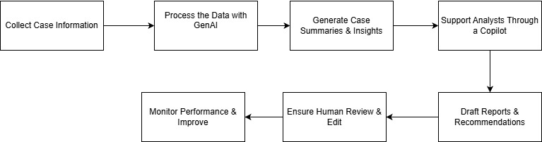

6. AI/ML Models We Can Build
- GenAI Summarization Model
Auto-summarizes fraud cases, transaction histories, and documents.
- Pattern Detection Model
Highlights unusual behaviors and risk indicators.
- GenAI Q&A Model
Lets analysts “chat” with the case to ask questions.
- Document Understanding Model
Extracts data from KYC forms, ID docs, emails, notes.
- SAR/STR Narrative Generator
Drafts regulatory report text for analyst review.

7. Quality Assurance (QA) We Provide
GenAI QA
- Factual accuracy checks
- Hallucination detection
- Toxicity & compliance checks
- Domain grounding with retrieval
System QA
- Response time testing
- Integration reliability
- Data privacy & security validation
Governance QA
- Full audit log of GenAI outputs
- Explainability notes
- Human-in-the-loop validation

8. Where We Help (Crisp Consulting Roles)
Area | Our Role
Use Case Design | Identify automation opportunities & workflows
Data Engineering | Prepare case data for GenAI ingestion
GenAI Development | Build summarization, Q&A, and reporting models
Integration | Connect GenAI to the case management system
UX Design | Build simple analyst-facing copilot tools
Governance | Ensure accuracy, auditability, and compliance
Change Management | Onboard analysts & train teams

PROJECT 3 — AI-Driven Fraud Risk Oversight & Governance Modernization

1. Business Problem
The bank’s fraud models, rules, and decisions are not fully transparent or consistently governed.
Regulators expect explainability, auditability, and proper model monitoring — but current processes are manual and slow.
2. Business Objective
Build a modern AI governance framework for fraud operations that ensures:
- Regulatory compliance
- Transparent AI decisions
- Consistent monitoring
- Faster model updates and reduced risk exposure
3. Business Constraints
- Must follow regulatory guidelines (OCC, FCA, MAS, local regulations)
- Need audit trails for all model decisions
- Multiple teams use different tools and inconsistent processes
- Limited automation for monitoring and documentation
4. Success Criteria
Business Success
- Reduce regulatory/compliance gaps by 50–70%
- Improve model update cycle time by 40–60%
- Reduce operational risk events related to modeling by 25–40%
ML Success
- Explainability provided for 100% of AI decisions
- Model drift detected within hours, not months
- Automated alerts with >95% accuracy
Economic Success
- 3–4x ROI through reduced compliance overhead
- 20–30% lower audit preparation cost
- 30–40% reduction in manual model documentation work

5. High-Level AI Solution (Simple Flow)
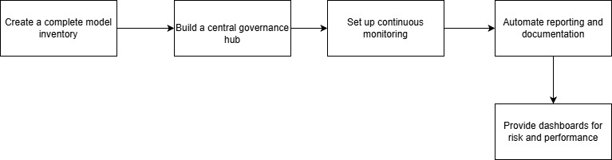

6. AI/ML Models We Can Build
- Drift Detection Model (identifies when performance degrades)
- Bias Detection Model (checks fairness across segments)
- Model Stability & Health Scoring Model
- Anomaly Detection on Inputs (finds unusual data patterns)
- Explainability Engine using SHAP/LIME-style algorithms

7. Quality Assurance (QA) We Provide
Governance QA
- Regulatory compliance checks
- Explainability & audit readiness
- Documentation package (model cards, risk assessments)
Model QA
- Stress testing
- Drift/bias evaluation
- Benchmarking vs. challenger models
Operational QA
- Monitoring dashboards
- Automated alert testing
- Change-management workflow validation

8. Where We Help (Crisp Consulting Roles)
Area | Our Role
Governance Framework | Build AI/ML governance standards, policies & processes
Risk Assessment | Evaluate risks of current fraud models
Monitoring Setup | Build drift, bias, data quality monitoring pipelines
Explainability | Create clear, regulator-ready explanations
Automation | Automate reports, model cards, audit logs
Compliance Support | Prepare for audits & regulatory reviews
Training | Upskill fraud, risk, and compliance teams

PROJECT 4 — AI-Powered Identity & Synthetic Fraud Prevention
1. Business Problem
Synthetic identities and stolen identities are increasingly used to open accounts, apply for credit, or abuse onboarding processes.
Traditional KYC checks and rule-based systems cannot detect fake digital identities or fraudulent behavior patterns.
2. Business Objective
Use AI to detect synthetic identities, identity theft, and high-risk applicants early — before accounts are created or money is lost.
3. Business Constraints
- Limited labeled data for synthetic fraud
- Strict KYC/AML compliance requirements
- Must integrate with onboarding, credit, and fraud systems
- Identity signals come from multiple disconnected sources
4. Success Criteria
Business Success
- Reduce synthetic ID fraud by 40–60%
- Reduce onboarding fraud losses by 25–45%
- Improve identity verification accuracy by 20–35%
ML Success
- High detection rate: ≥85–90% of synthetic identities flagged
- False positive reduction: 15–25%
- Model drift < 10% per quarter
Economic Success
- 3–6x ROI from prevented fraud
- 20–30% reduction in manual KYC review cost
- Payback within 6–12 months

5. High-Level AI Solution
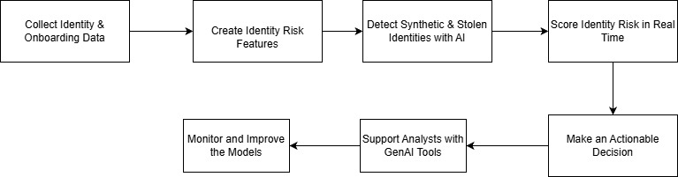
6. AI/ML Models We Can Build
- Synthetic Identity Detection Model
Finds fake IDs using behavior, velocity, inconsistencies.
- Graph ML Model
Detects linked identities, shared devices, fraud rings.
- Behavioral Biometrics Model
Keystrokes, navigation, device patterns.
- Identity Risk Scoring Model
Real-time score for each applicant.
- Document Verification Model
Extracts and validates ID/KYC documents.

7. Quality Assurance (QA) We Provide
Identity QA
- Accuracy checks on identity predictions
- Document extraction validation
- Cross-device and velocity consistency tests
Model QA
- Drift monitoring
- Bias detection
- Backtesting on historical fraud cases
Compliance QA
- KYC/AML audit readiness
- Explainability for every identity decision
- Full traceability logs
8. Where We Help (Crisp Consulting Roles)
Area | Our Role
Identity Strategy | Define how AI strengthens KYC & onboarding
Data Integration | Combine KYC, device, credit, and fraud data
Feature Engineering | Build identity behavior & linkage features
Modeling | Develop synthetic ID & identity-theft detection models
Graph Analytics | Build entity linkage maps & fraud rings
GenAI Tools | Auto-summarize identity risks for analysts
Governance | Ensure compliance with KYC/AML regulations
Training | Train onboarding & fraud teams to use the new tools

PROJECT 5 — Cross-Channel Fraud Intelligence Lake & Entity Resolution
1. Business Problem
Fraud data is spread across multiple systems — cards, payments, digital banking, lending, call center, onboarding.
Because the data is fragmented, the bank cannot see fraud patterns across channels or identify linked entities (accounts, devices, people).
2. Business Objective
Build a central fraud intelligence lake that unifies data across channels and applies AI to detect cross-channel fraud patterns, connected entities, and fraud rings earlier.
3. Business Constraints
- Data exists in disparate systems with different formats
- Need near real-time ingestion
- Strong access control and data privacy required
- Must plug into existing fraud and analytics tools
4. Success Criteria (With %)
Business Success
- Improve fraud detection by 25–40% through cross-channel visibility
- Reduce fraud ring undetected duration by 40–60%
- Improve case investigation speed by 20–35%
ML/Data Success
- ≥ 95% accuracy in entity linking
- ≥ 90% coverage of fraud signals across channels
- Data freshness latency < 5 minutes (streaming)
Economic Success
- 3–5x ROI from improved detection and reduced manual work
- 30–40% reduction in duplicated investigations
- Payback in 9–12 months
5. High-Level AI Solution (Simple Flow)
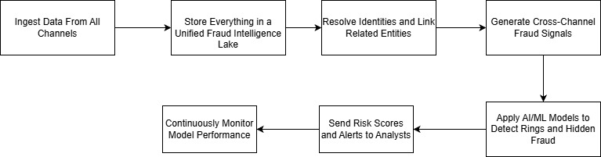
6. AI/ML Models We Can Build
- Entity Resolution Model
Links customers, accounts, devices, merchants.
- Graph ML Model
Detects fraud rings, shared connections, and unusual networks.
- Cross-Channel Behavior Model
Captures movement of fraud across payments, cards, and digital.
- Risk Aggregation Model
Consolidates all signals into a unified fraud risk score.
- Anomaly Detection Model
Flags unusual cross-channel patterns.

7. Quality Assurance (QA) We Provide
Data QA
- Schema consistency checks
- Missing/duplicate data detection
- Multi-source data validation
Model QA
- Entity linking accuracy tests
- Cross-channel signal validation
- Drift detection on new patterns
Platform QA
- Data latency tests
- Access control & privacy checks
- Failover/recovery validation

8. Where We Help (Crisp Consulting Roles)
Area | Our Role
Data Integration | Bring all fraud data sources into one place
Architecture Design | Build the fraud intelligence lake structure
Entity Resolution | Develop ML models to link entities
Graph Analytics | Identify fraud networks and shared connections
Model Development | Create cross-channel risk scoring
Dashboarding | Build fraud analytics & investigator tools
Governance | Implement privacy, access, and audit controls
Enablement | Train fraud teams to use cross-channel insights

