**PROJECT REPORT ON**

## Medicare - Digital OPD Management System

**Carried Out at**



###### CENTRE FOR DEVELOPMENT OF ADVANCED COMPUTING,

###### DELHI

**UNDER THE SUPERVISION OF**

**Mr. Ankit kumar C-DAC Delhi**

**Submitted By**

|  |  |
| --- | --- |
| **Student Name** | **PRN No.** |
| Pol Pranil Sudam | 220910120035 |
| Sandeep Kuraria | 220910120043 |
| Dhanshree Dongre | 220910120019 |
| Sumit Kumar Gupta | 220910120050 |
|  |  |

**TABLE OF CONTENT**

1. Introduction 1

1. Software Requirement Specification 4
   1. Product Perspective 4
   2. Design and Implementation constraints 6
   3. External interface requirements 6
2. Architecture 7
   1. ER Diagram 7
   2. Activity Diagram 8
3. System Design 11
   1. Requirement Analysis and feasibility studies 11
   2. Server and language used 12
   3. Frameworks Used 14
4. Implementation 14
   1. Implementation of system 14
   2. Other aspects 16
5. Conclusion and References 17

# CHAPTER 1 INTRODUCTION

### Introduction

Human Body is a very complex and sophisticated structure and comprises of millions of functions. All these complicated functions have been understood by man, part-by-part through their research and experiments.

As science and technology progressed, medicine became an integral part of the research. Gradually, medical science became an entirely new branch of science. As of today, the Health Sector comprises of medical institutions i.e. Hospitals, research and development institutions and medical colleges.

Thus, the Hospital management system aims at providing the best medical facilities to the common man needs.

**Existing System** :

* The Existing system was paper-based.
* keeping track of all the activities (like records of its patients, doctors and other staff personals) and their records on paper is very cumbersome and error prone.
* It was very inefficient and a time-consuming process Observing the continuous increase in population and number of people visiting the hospital. Recording and maintaining all these records on paper was highly unreliable, inefficient and error-prone.
* It is too slow and cannot provide updated lists of required things within reasonable timeframe.
* It is also not economically & technically feasible to maintain these records on paper.

##### Existing System Drawbacks :

* Chances of data loss and inadequacy.
* Too slow and cannot provide updated lists of patients within reasonable timeframe.
* Also, management of Hospital was cumbersome and error prone .
* Modifying previous mistakes wasn't easy.
* No reliable storage and backup facilities.
* It is also not economically & technically feasible to maintain these records on paper.

##### Proposed System :

Medical Consultant are the essential part of our lives, providing best medical facilities to people suffering from various ailments, which may be due to change in climatic conditions, increased work-load, emotional trauma, stress etc. It is necessary for the hospitals to keep track of its day-to-day activities & records of its patients, doctors that keep the hospital running smoothly & successfully. Our objective is to digitalize all the version of the manual system , and we named it as “Medi Organize”.

The main aim of our project is to provide a paper-less hospital up to 90%. It also aims at providing low-cost reliable digitalization of the existing systems. The proposed system also provides excellent security of data at every level of user-system interaction and also provides robust & reliable storage facility. The purpose of this project is to digitalize, the process of day-to-day activities like Registering New Patient, Assigning a Doctor to new patient, Adding new staff members, and finally compute the bill etc.

As the proposed software product is the providing online medical consultancy. The system will be used in any hospital (only in OPD case), clinic etc.Hospitals (small to medium scale) can used it to to get the information from the patients and then storing that data for future usages. The intention of the system is to reduce over-time pay and increase the number of patients that can be treated accurately. Requirement statements in these documents are both functional and non-functional.

we have tried best to make the complicated process Hospital System as simple as possible using Structured & Modular technique & Menu oriented interface. We have tried to design the software in such a way that doctor may not have any difficulty in using this package & further expansion is possible without much effort. Even though we cannot claim that this work to be entirely exhaustive, the main purpose of us exercise is perform Hospital’s activity in computerized way rather than manually which is time consuming. We are confident that this software package can be readily used by non- programming personal avoiding human handled chance of error.

# CHAPTER 2

**SOFTWARE REQUIREMENT SPECIFICATION**

##### Product Perspective

The main aim of our project is to provide a paper-less hospital up to 90%.

The purpose of this project is to digitalize, the process of day-to-day activities like registering new Patient, assigning a doctor to new patient, adding new staff members, etc. As the proposed software product is the providing online medical consultancy. The system will be used in any hospital (only in OPD case), clinic etc. Hospitals (small to medium scale) can used it to get the information from the patients and then storing that data for future usages. The intention of the system increases the number of patients that can be treated accurately.

**2.1.1Operating Environment**

##### Client Environment: -

Desktop Client: - Browser based clients either in Microsoft Windows or Linux Environment.

##### Server Used:

Spring Boot Server is a popular web container software designed to execute Spring frame works and render web pages that use Java Server page coding. Accessible as either a binary or a source code version. Spring Boot been used to power a wide range of applications and websites across the Internet

##### Design and implementation constraints: -

* + 1. **Server Side:**

WINDOWS 7 OR ABOVE

Web Server: - APACHE TOMCAT 9.0 and Node server and Database: - MySQL

##### Client side:

Desktop Client: - Browser based clients either in Microsoft Windows or Linux Environment.

##### Design and Implementation Constraints

This project requires an application server, MySQL JDK 8.0 or Above, REACT 17.0.2

##### External Interface Requirements

* + 1. **User Interfaces**

The targeted browser Mozilla Firefox 3.6, Google Chrome etc.

##### Hardware Interfaces

Server Side:

Operating System: Windows 7 or above, Processor: Intel i5 3.0 GHz or higher RAM: 4 GB or more

Hard Drive: 50 GB or more

Client side:

Operating System: WINDOWS 7 OR ABOVE

Processor: Intel Atom Processor Z2520 1.2 GHz, or faster processor. RAM: 2 GB or more

##### Software Interfaces

Front End – Html, CSS, Bootstrap Back End – Java, JavaScript, React Js

Server - Tomcat 8.0, node server, MySQL server

# CHAPTER 3 ARCHITECTURE

##### ER Diagram

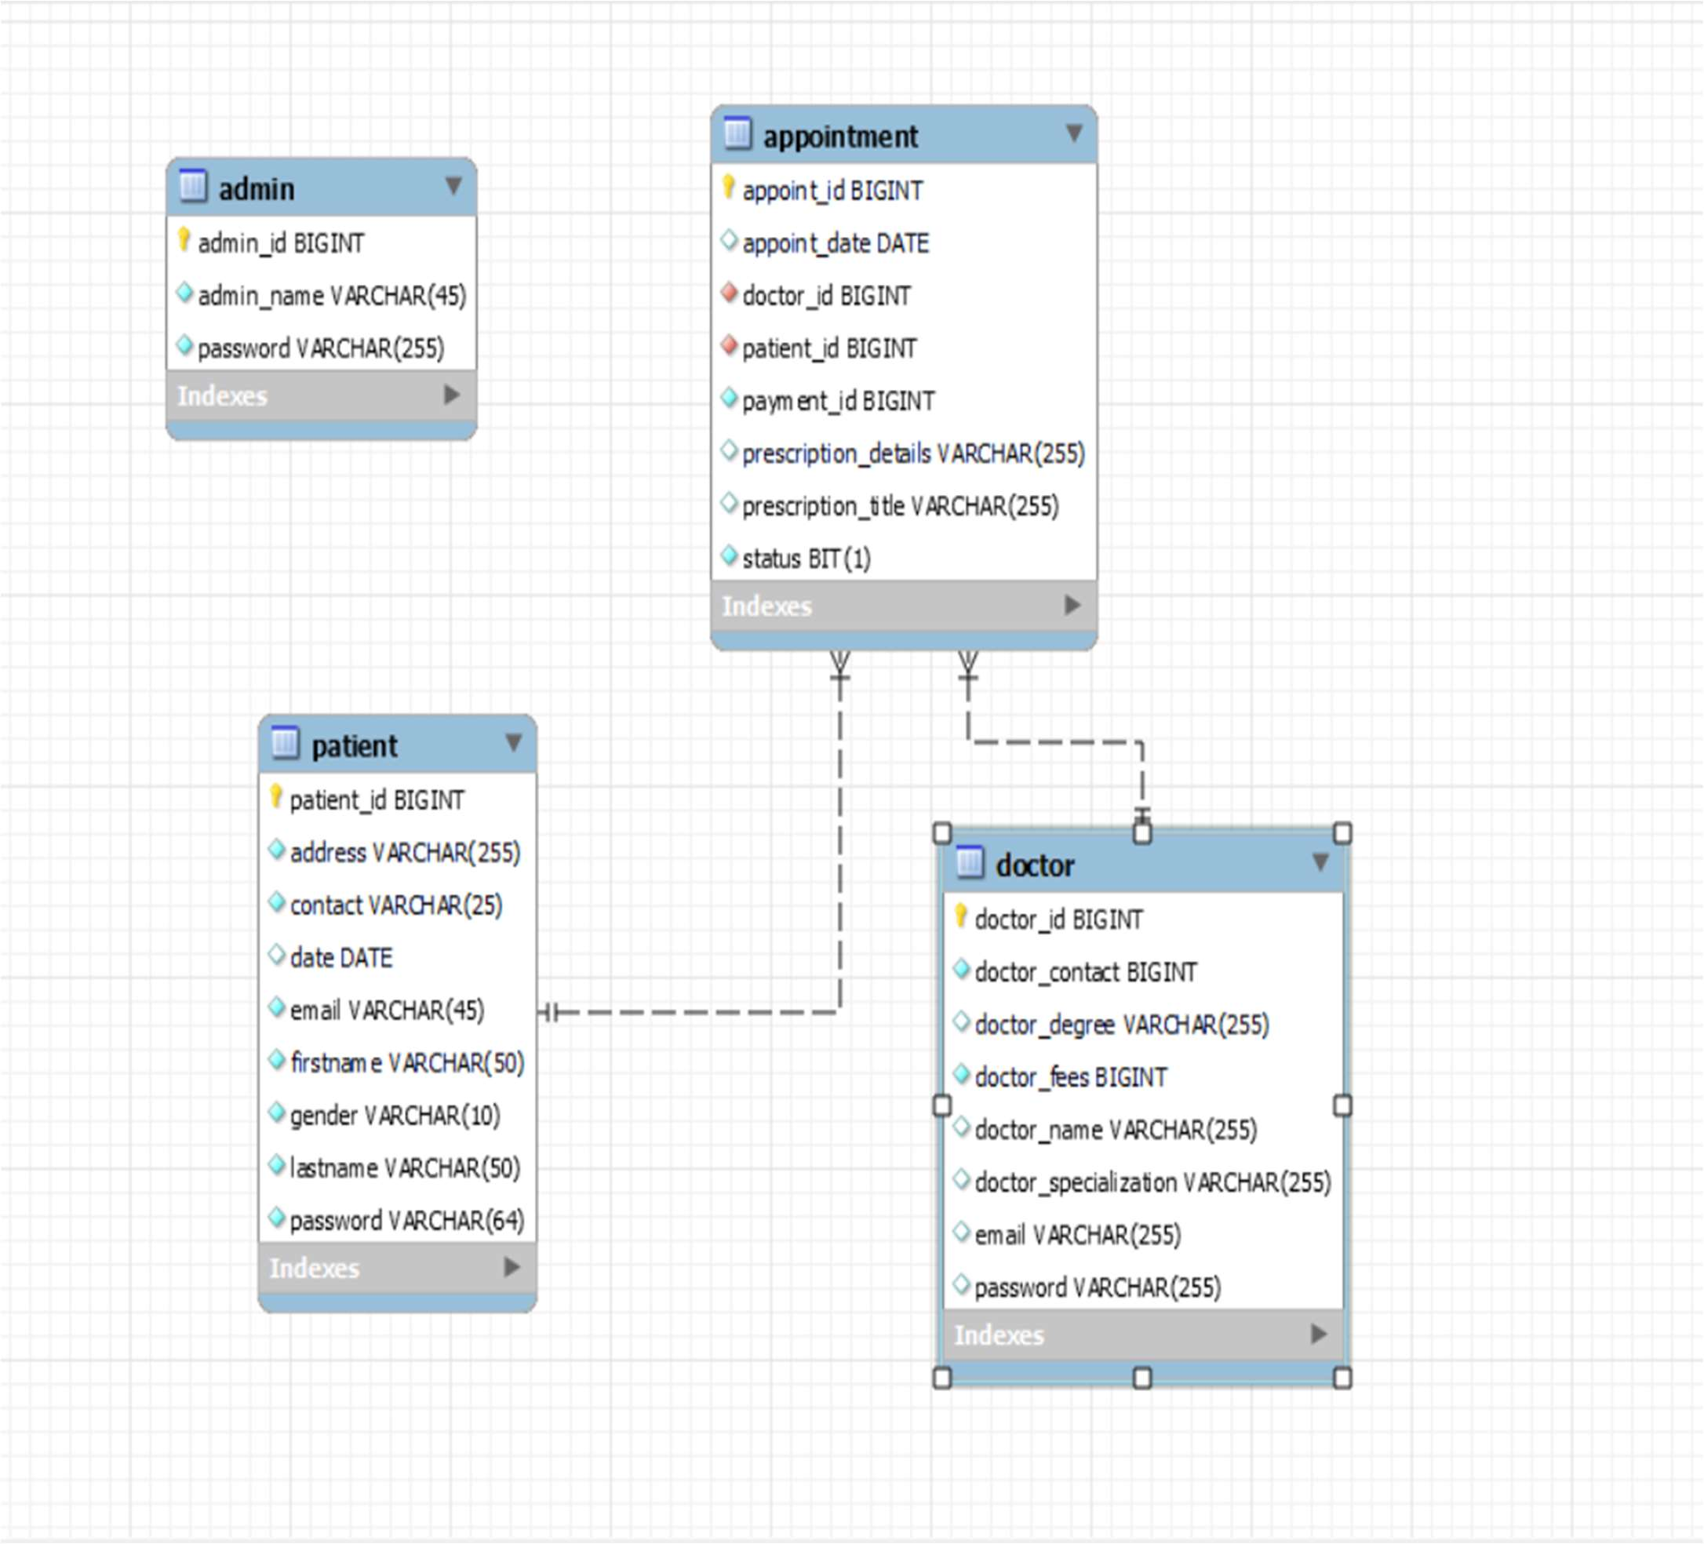

* 1. **Activity Diagram (Admin)**

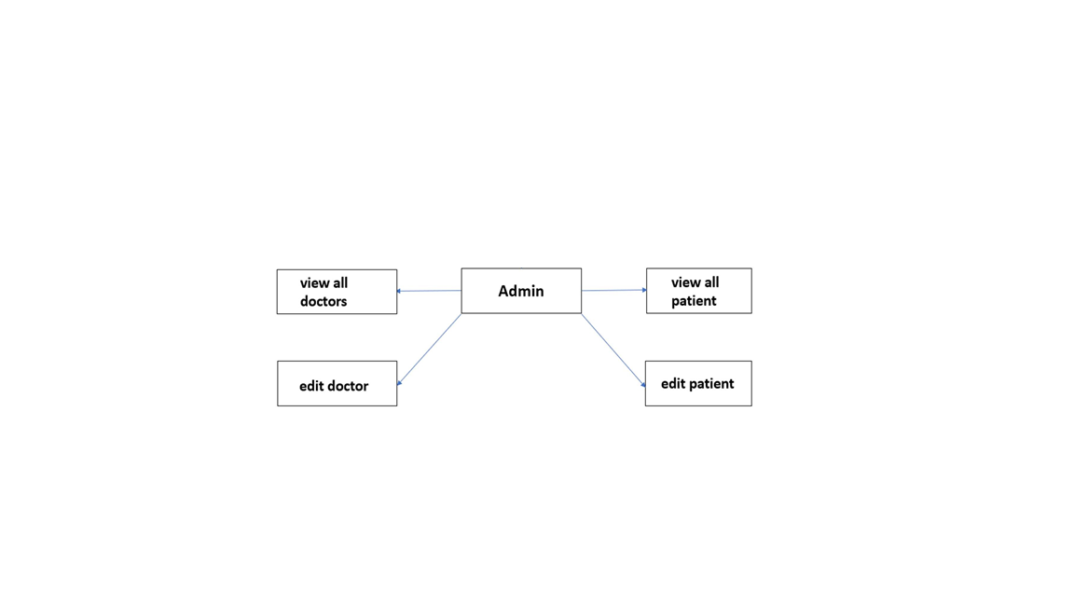

##### Activity Diagram (Doctor): -

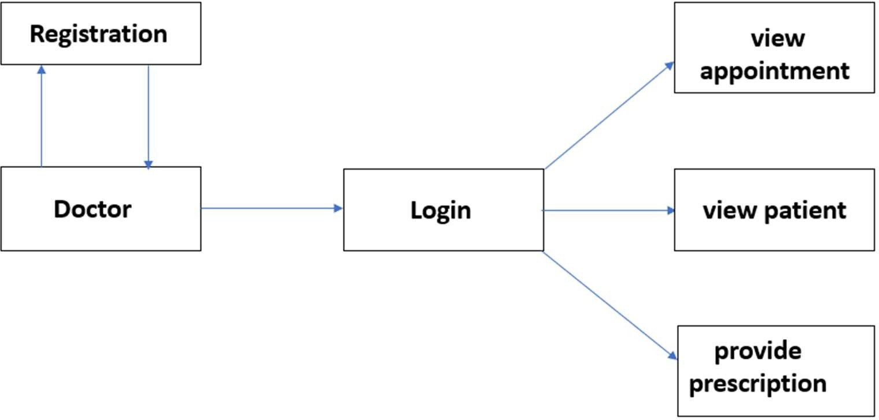

**Doctor:** In this interface the following functionalities are implemented for the administrator :-

1. View Doctor.
2. Add Doctor.
3. Edit Doctor Information.

##### Activity Diagram (Patient): -

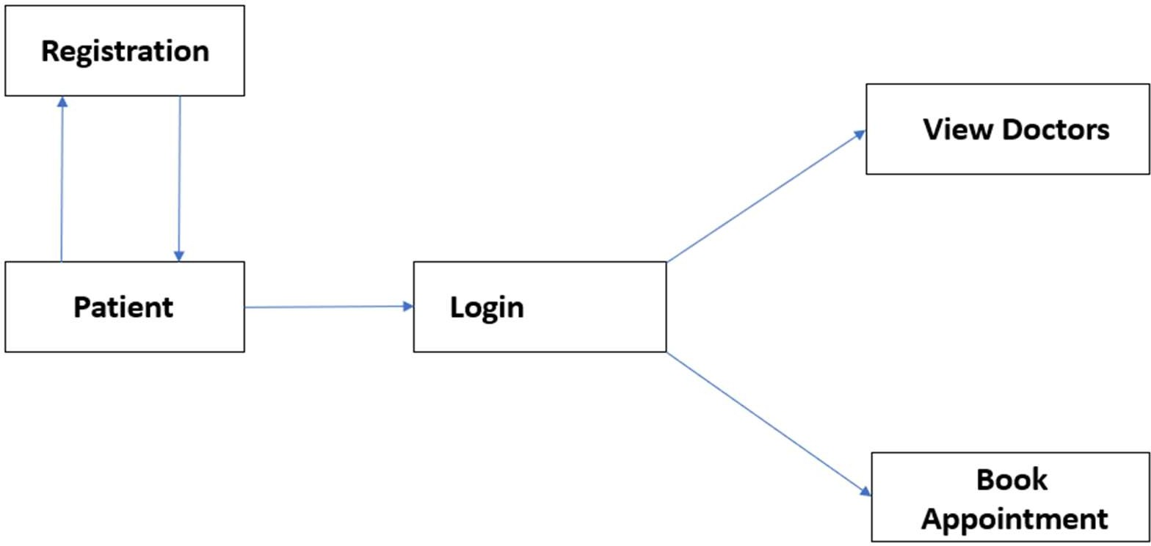

**Patient:** In this interface the following functionalities are implemented for the administrator :-

1. View Patient.
2. Add Patient.
3. Edit Patient Information.

**CHAPTER 4 SYSTEM DESIGN**

### Requirement Analysis & Feasibility Studies.

##### Software Requirement Specification:

The software requirement specification is produced at the culmination of the analysis task. The function and performance allocated to software as part of system engineering are redefined by establishing a complete information description as functional requirement, a representation of system behavior, an indication of performance requirement and design constraints, appropriate validation criteria.

##### IDE Used:-

* + - Eclipse is a widely used IDE primarily for Java development. Eclipse is used for C and C++ development as well as PHP among other programming languages
    - Eclipse IDE is written in Java. It mainly consists of a base ‘Workspace’ and a plug-in system so that we can add more features to it through plugins and extend the functionality of the IDE.
    - Eclipse works on all the major platforms including Windows, Mac OS, Linux, etc. and boasts of powerful features that can be used to develop full-fledged projects.

##### Features Of Eclipse IDE(STS):

* + Almost everything in Eclipse is a plugin.
  + We can extend the functionality of Eclipse IDE(sts) by adding plugins to the IDE, maybe for additional programming language or version control system or UML.
  + Supports various source knowledge tools like folding and hyperlink navigation, grading, macro definition browser, code editing with syntax highlighting.
  + Provides excellent visual code debugging tool to debug the code.
  + Eclipse has a wonderful user interface with drag and drop facility for UI designing.
  + Supports project development and administered framework for different toolchains, classic make framework, and source navigation.
  + Java Eclipse IDE has a JavaDoc facility using which we can automatically create documentation for classes in our application.

##### Development Environment for Eclipse includes:

* Eclipse Java Development Tools (sts) for Java.

##### Server Used:

Spring Boot Server is a popular web container software designed to execute Spring frame works and render web pages that use Java Server page coding. Accessible as either a binary or a source code version. Spring Boot been used to power a wide range of applications and websites across the Internet.

##### Features:

1. **Incredibly Lightweight**: -

Even with Java EE certification, Tomcat is an incredibly lightweight application. If offers only the most basic functionality necessary to run a server, meaning it provides relatively quick load and redeploy times compared to many of its peers, which are bogged down with far too many bells and whistles. This lightweight nature also allows it to enjoy a significantly faster development cycle.

##### Open-Source-

It is an open-source Server which means it is free of cost. Tomcat’s free, and the source code for the server is readily available to anyone who’d care to download it. What this means is that – assuming you’re willing to tinker with the moving parts of your server – you’ve got an incredible degree of freedom insofar as what you want to do with a Tomcat installation.

##### Highly Flexible

Thanks to its lightweight nature and a suite of extensive, built-in customization options, Tomcat is quite flexible. You can run it in virtually any fashion you choose, and it’ll still work as intended. The fact that it’s open-source helps as well, since you can tweak it to fit your needs, provided you’ve the knowledge to do so.

##### Language Used: -

The Java programming language is designed to meet the challenges of application development in the context of heterogeneous, network-wide distributed environments. Paramount among these challenges is secure delivery of applications that consume the minimum of system resources, can run on any hardware and software platform, and can be extended dynamically.

The Java programming language originated as part of a research project to develop advanced software for a wide variety of network devices and embedded systems.

Java has proven ideal for developing secure, distributed, network-based end-user applications in environments ranging from network-embedded devices to the World-Wide Web and the desktop.

##### Frameworks Used: -

1. **Hibernate: -**
   * Hibernate is an open-source Java persistence framework project.
   * It performs powerful Object-relational mapping and query databases using HQL and SQL.
   * Hibernate is a great tool for ORM mappings in Java. It can cut down a lot of complexity and thus defects as well from your application, which may otherwise find a way to exist.
   * This is especially boon for developers with limited knowledge of SQL.

##### Hibernate Architecture

1. Configuration:

In hibernate. Properties or hibernate.cfg.xml files. For Java configuration, you may find class annotated with @Configuration. It is used by Session Factory to work with Java Application and the Database. It represents an entire set of mappings of an application Java Types to an SQL database.

1. Session Factory:

Any user application requests Session Factory for a session object. Session Factory uses configuration information from above listed files, to instantiates the session object appropriately.

1. Session:

This represents the interaction between the application and the database at any point of time. This is represented by the org.hibernate.Session class. The instance of a session can be retrieved from the SessionFactory bean.

1. Query :

It allows applications to query the database for one or more stored objects. Hibernate provides different techniques to query database, including NamedQuery and Criteria API.

1. First-level cache :

It represents the default cache used by Hibernate Session object while interacting with the database. It is also called as session cache and caches objects within the current session. All requests from the Session object to the database must pass through the first-level cache or session cache. One must note that the first-level cache is available with the session object until the Session object is live.

1. Transaction :

Enables you to achieve data consistency, and rollback incase something goes unexpected.

* 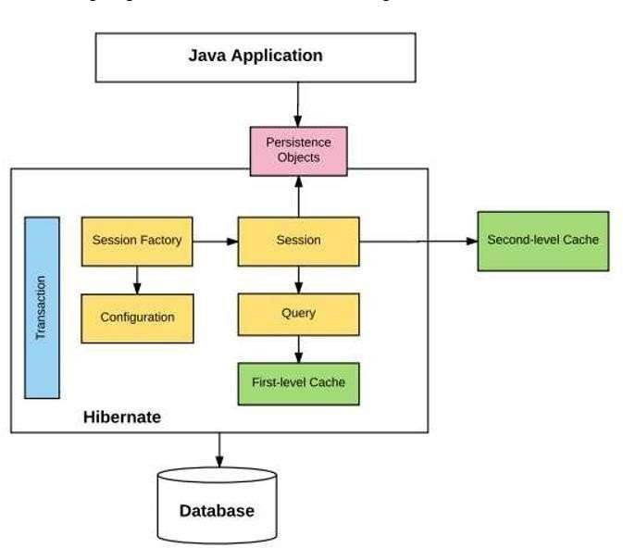The following diagram summarizes the main building blocks in hibernate architecture.

**Fig. Hibernate Architecture**

##### Why to use Hibernate technology –

* + Hibernate supports Inheritance, Associations, Collections.
  + In hibernate if we save the derived class object, then its base class object will also be stored into the database, it means hibernate supporting inheritance
  + Hibernate supports relationships like One-To-Many,One-To-One, Many-To-Many-to Many, Many-To-One
  + This will also supports collections like List,Set,Map (Only new collections)
  + In jdbc all exceptions are checked exceptions, so we must write code in try, catch and throws, but in hibernate we only have Un-checked exceptions, so no need to write try, catch, or no need to write throws. Actually in hibernate we have the translator which converts checked to Un-checked
  + Hibernate has capability to generate primary keys automatically while we are storing the records into database
  + Hibernate has its own query language, i.e. hibernate query language which is database independent
  + Hibernate supports annotations, apart from XML
  + So, if we change the database, then also our application will work as HQL is database independent.

##### Spring MVC:-

A Spring MVC is a Java framework which is used to build web applications. It follows the Model-View-Controller design pattern. It implements all the basic features of a core spring framework like Inversion of Control, Dependency Injection.

A Spring MVC provides an elegant solution to use MVC in spring framework by the help of **DispatcherServlet**. Here, **DispatcherServlet** is a class that receives the incoming request and maps it to the right resource such as controllers, models, and views.

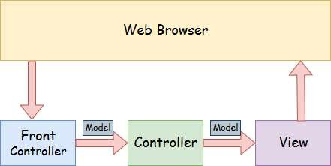

**Fig . Spring Web Model-View-Controller**

##### Model-view-controller:-

1. **Model** :-

A model contains the data of the application. A data can be a single object or a collection of objects.

1. Controller :–

A controller contains the business logic of an application. Here, the @Controller annotation is used to mark the class as the controller.

1. **View** :–

A view represents the provided information in a particular format. Generally, JSP+JSTL is used to create a view page. Although spring also supports other view technologies such as Apache Velocity, Thymeleaf and FreeMarker.

1. Front Controller :–

In Spring Web MVC, the DispatcherServlet class works as the front controller. It is responsible to manage the flow of the Spring MVC application.

##### The Flow of Spring Web MVC:-

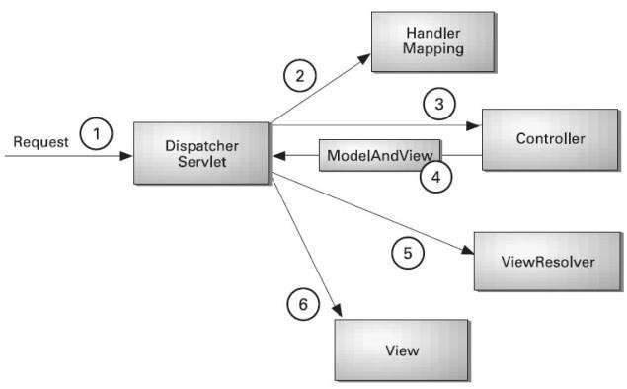

Fig. Flow of Spring Web MVC

1. All the incoming request is intercepted by the DispatcherServlet that works as the front controller.
2. The DispatcherServlet gets an entry of handler mapping from the XML file and forwards the request to the controller.
3. The controller returns an object of ModelAndView.
4. The DispatcherServlet checks the entry of view resolver in the XML file and invokes the specified view component.
   * **Advantages Of Spring MVC Framework: -**
5. **Separate roles** - The Spring MVC separates each role, where the model object, controller, command object, view resolver, DispatcherServlet, validator, etc. can be fulfilled by a specialized object.
6. **Light-weight** - It uses light-weight servlet container to develop and deploy your application.
7. **Powerful Configuration** - It provides a robust configuration for both framework and application classes that includes easy referencing across contexts, such as from web controllers to business objects and validators.
8. **Rapid development** - The Spring MVC facilitates fast and parallel development.
9. **Reusable business code** - Instead of creating new objects, it allows us to use the existing business objects.
10. **Easy to test** - In Spring, generally we create JavaBeans classes that enable you to inject test data using the setter methods.
11. **Flexible Mapping** - It provides the specific annotations that easily redirect the page.

**User module:**

1. Login:

In order for the user (patient & doctor) to login, a username and password needs to be entered and this was implemented in a form that contained fields for name and password, when the form is submitted, the server checks the database if the email is available and the validity of the password, if the password and username is valid the user is redirected to the homepage else an error message is shown informing the user about the error. The login page also had a link that directs users that are not already registered to the registration page.

1. Registration:

In the case of registration the user has to provide personal information like name, email, password , verify password ,date of birth, address, gender, telephone all these information are to be inputted into their respective fields in a form, when the form is submitted the server first checks , if the password field is empty then if the password and verify password are the same, 37 the system checks if the email is already registered if all these are correct, then a new user is created by inserting all these information in the database else an error message is displayed.

1. Home page: This is the default page of the website i.e. the first page you see when you enter the website or after you login or register, this page is the most important it implements some functionalities specified .
2. Doctor:

The doctor page displays the all the doctors available in the database, the doctor’s information are displayed, also there is a book appointment button on each doctor row, when the button is clicked on the user is directed to another page where the patient can book that particular doctor appointments can only be booked if the user is logged in else the user is directed to the log in page after which the user is redirected back to the destined/original page

1. Appointment: The reservation page displays a form with the fields Hospital, Department, date when this form is filled and submitted by the users, the system uses this information to search through the database and displays doctors fitting the users specification, when the user selects a doctor, he is directed to a page to book the doctor, appointments can only be booked if the user is logged in else the user is directed to the log in page after which the user is redirected back to the previous action page. After the user fills all necessary information and books the appointment a confirmation email is sent.

**Admin module**

1. Patient:

In this interface the following functionalities are implemented for the administrator: View patient: A list of all the patients in the database is displayed and when a patient

* + item on the list is clicked, the patient details is displayed in a form Add patient: the administrator can add patients to the database, a form is provided and
  + the patient’s details are entered, when the form is submitted the new patient is created and inserted into the database. Edit patient information: The administrator can also edit patient information,
  + whatever information entered is saved and updated in the database. Delete patient: A delete option is placed beside each patients in the list of patients and
  + when it is clicked that particular patient is deleted.

1. Doctor:

In this interface the following functionalities are implemented for the administrator: View doctor: A list of all the doctors in the database is displayed and when a doctor

* + item on the list is clicked, the doctor details is displayed in a form Add doctor: the administrator can add doctors to the database, a form is provided and
  + the doctor’s details are entered, when the form is submitted the new doctor is created and inserted into the database. Edit doctor information: The administrator can also edit doctor information,
  + whatever information entered is saved and updated in the database.

Delete doctor: A delete option is placed beside each doctor in the list of doctors and

* + when it is clicked that particular doctor is deleted

**CHAPTER 5 IMPLEMENTATION**

#### Implementation:

* + Implementation is the process of having system personal check out and provides new equipment’s into use, train the user to install a new application and construct any files of data needed to use it. There are three types of implementations.
  + Implementation of computer system to replace a manual system. To problem encountered are covering files, training user, creating accurate files and verifying print outs for integrity. Implementation of a new computer system to replace an existing one.
  + This is usually difficult conversion. If not properly planned, there can be many problems. Implementation of a modified application to replace the existing one using the same computer.
  + This type of conversing is relatively easy to handle, usually there are no major change in the file. Our project is yet to be implemented.

###### Database Design

Database design is the process of producing a detailed data model of database. This data model contains all the need logical and physical design choices and physical storage parameters needed to generate a design in a data definition language, which can then be used to create a database. A fully attributed data model contains detailed attributes for each entity.

The term database design can be used to describe many different part of the design of an overall database system. Principally, and most correctly, it can be thought of as the logical design of the base data structure used to store the data. In the relational model these are the tables and views.

###### Database schema of Hospital Management System

* A database schema is the skeleton structure that represents the logical view of the entire database. It defines how the data is organized and how the relations among them are associated. It formulates all the constraints that are to be applied on the data.
* A database schema can be divided broadly into two categories –

1. **Physical Database Schema:** This schema pertains to the actual storage of data and its form of storage like files, indices, etc. It defines how the data will be stored in a secondary storage.
2. **Logical Database Schema:** This schema defines all the logical constraints that

need to be applied on the data stored. It defines tables, views, and integrity constraints.

* List of tables:

1. Admin.
2. Patients
3. Doctor

4.Appointment

###### 5.2 Other Aspects Advantages:

After the customized software is implemented and integrated into the system, patient care and hospital administration becomes an easy job.

1. Makes prescription readable and understandable to patients.
2. Eliminate redundancy in term of data storage. Data will be stored in a computer not heap of files.
3. Reduce the time wasted in retrieving data especially in finding a past health records.
4. Increase Efficiency and Interactivity in any area of specialization in the hospital.
5. Able to quickly collect and edit data, summarize result and adjust as well as collect errors promptly.
6. Uses Bcrypt encoding technique to store passwords hash for secure logins.

###### Limitations of the system:

* 1. Patients don’t have any role.
  2. No Live Queue feature.

## CHAPTER 6

**Conclusion And Reference**

Conclusion:-

This project helps in making paperless activities. It reduces the workload from Doctor and Receptionist. It provides more ease and flexibility to Doctor, Administrator and Receptionist.

This digitalization has reduced costs of Hospital. This work has created a little awareness and promotes the idea that the concept of paperless office is reality.

References :-

* + https://[www.youtube.com/watch?v=BkRZfxznaOo](http://www.youtube.com/watch?v=BkRZfxznaOo)
  + https://[www.youtube.com/watch?v=JR7-EdxDSf0](http://www.youtube.com/watch?v=JR7-EdxDSf0)
  + https://[www.devglan.com/spring-mvc/storing-hashed-password-database-java](http://www.devglan.com/spring-mvc/storing-hashed-password-database-java)
  + https://[www.freestudentprojects.com/studentprojectreport/projectrep](http://www.freestudentprojects.com/studentprojectreport/projectrep) ort/hospital- management-system-project-report/.