CELEBRATING 60 YEARS OF INDIA - JAPAN DIPLOMATIC RELATIONS

‘Noh’ -Traditional Japanese Musical Play by Grand Master of Kanze School, Japan at Bangalore & Violin Recital by Ambi Subramaniam
Venue: RajBhavan on Monday, 27th August 2012, 6:30 PM

An opportunity of this decade !!!

A group of 29 performers led by Mr. Kiyokazu Kanze, the 26th Grand Master of the Kanze School, will perform Noh and Kyogen plays.

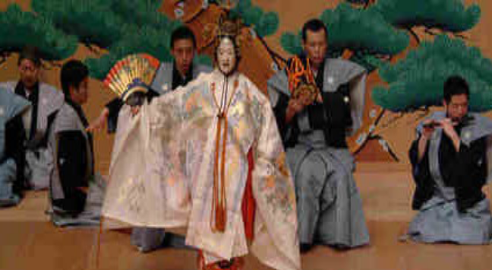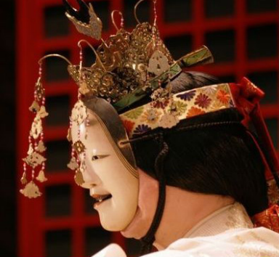

Noh has been highly acclaimed around the world for their great artistic value, and in 2001, UNESCO added to its Intangible Cultural Heritage list as a Masterpiece of Oral and Intangible Heritage of Humanity.

This is considered as "A historical commemoration performance between India-Japan" collaborating with Japan Foundation, Mithila Museum- Japan, Consulate of Japan in Bangalore, Bangalore University with the support of Indo Japanese Chamber of commerce and Industry- Karnataka( IJCCI-K) along with Japanese Chamber of commerce and Industries and Bangalore Japanese Association.

We, IJCCI take great pleasure to be a part of this celebration & it is our delight to introduce this unique art to Bangalore.

Noh will be followed by the Violin Recital from Ambi Subramaniam , an young highly talented artist, son of world renowned violin maestro Dr.L .Subramaniam. (http://www.indianviolin.com/html/ambi.html )

NOH will be performed at Glass House, RajBhavan , The residence of Governor of Karnataka. We are bound to adhere to the strict security rules. We request you to kindly register your Name, Address, Contact number & No. of people accompanying clearly. The entry is only through Invitation. The invitation will be sent to you once we receive your registration. The audience is required to be seated by 6.10 pm.

We request you to display on the notice board and inform about NOH to all the employees of your organization as this is a unique event to be attended by all. (ENTRY FREE)
Registration Details: Email to ijcci@airtelmail.in OR visit www.ijccik.org
Phone: 080 – 26583522, 26580466 Mobile: 9449837370, 9886064822

****************************************************************
A brief History of NOH :
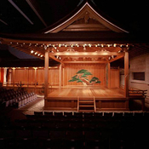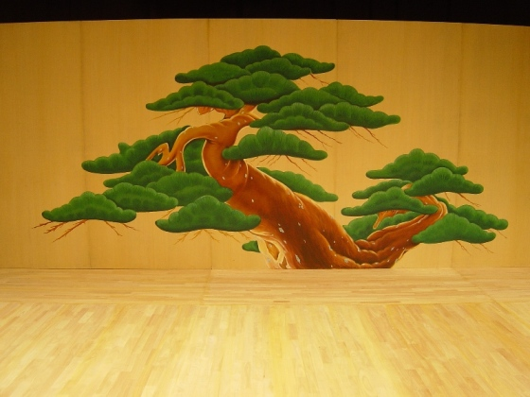
Japanese drama before the Meiji Restoration consists of three main types of performance: the Noh play, Kabuki and the puppet drama or Joruri. Noh, the earliest of three, was certainly in existence six hundred years ago and was itself the result of a long and gradual development.In the middle of the eleventh century an early form in the line which was to give rise to Noh consisted of simple humorous farces based on such characters as immoral priests and nuns and countrymen visiting the capital for the first time. Great Buddhist temples employed professional players to perform at the times of festivals and ceremonies, and largely as a result of this, the humorous plays came to be displaced by others of a more serious nature.

Many of these later plays were designed to explain the significance of religious rites or to depict Buddhist legends for the simple people, and although they came to be more highly regarded than the humorous plays, the latter did not disappear The comedies known as Kyogen, which are still given today as interludes between Noh plays, bear witness to the unbroken existence of this type of play, for many of them are based on the same themes as were used in comedies of the eleventh century. The series of plays soon spread beyond the confines of the temples and thus gained greater freedom in the choice if their material. They came to aim not at religious teaching but at the depiction of artistic beauty by means of song and dance, and it is at this stage that they become Noh. In order to achieve this aim full use was made of the rich store of earlier Japanese literature and of numerous song and dance entertainments current at the time. Themes ware based on incidents in history or literature and the sung parts of the texts richly embellished with appropriate quotations from poetry. Various types of music were blended to form a unique style and dances performed in other types of entertainment were adapted and fitted in with the music and song to make the composite art of Noh.
********************************************************************

