APPEAL FOR SPONSORSHIP
August 03, 2012

CELEBRATING 60 YEARS OF INDIA - JAPAN DIPLOMATIC RELATIONS
‘Noh’ -Traditional Japanese Musical Play by Grand Master of Kanze School, Japan at Bangalore & Violin Recital by Ambi Subramaniam
Venue: RajBhavan on Monday, 27th August 2012, 6:30 PM

A group of 29 performers led by Mr. Kiyokazu Kanze, the 26th Grand Master of the Kanze School, will perform Noh and Kyogen plays.

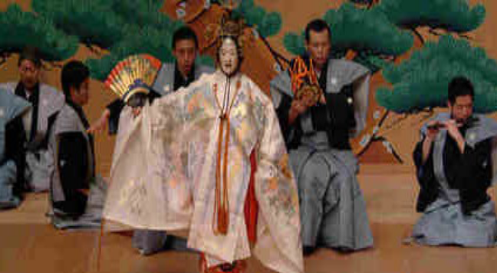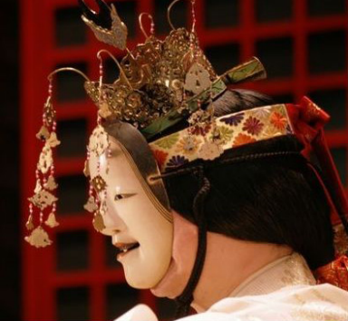

Noh has been highly acclaimed around the world for their great artistic value, and in 2001, UNESCO added to its Intangible Cultural Heritage list as a Masterpiece of Oral and Intangible Heritage of Humanity.

This is considered as "A historical commemoration performance between India-Japan" collaborating with The Embassy of Japan in India, Consulate of Japan in Bangalore, The Chancellor-Bangalore University Organised by Indo Japanese Chamber of commerce and Industry- Karnataka (IJCCI-K) with Japanese Chamber of commerce and Industries-Bangalore(JCCI-B) and Bangalore Japanese Association(BJA).

We, IJCCI take great pleasure to be a part of this celebration & it is our delight to introduce this unique art to Bangalore.
Noh will be followed by the Violin Recital from Ambi Subramaniam , an young highly talented artist, son of world renowned violin maestro Dr.L .Subramaniam.

To organize an event of this magnitude, we request your esteem Organisation to kindly support IJCCI financially, as the organizers’ fund will not be sufficient to meet all the expenses of this big event. We look forward for your positive response towards the success of Japanese Musical Play in Bangalore, an event of Indo Japan 60th year diplomatic relation.

How to sponsor:
- Kindly send in your contribution by cheque along with “Confirmation Form” attached herewith to the address mentioned below before August 15th 2012. If the official formalities are time consuming and tedious, please send us the “Confirmation Form” duly filled in by you, wherein the sponsorship can be made before August 20th 2012. Sponsorships are accepted in units of Rs. 10,000 by corporate offices/ institutions.
Cheque in favor of: Indo Japanese Chamber of Commerce & Industry-Karnataka

Postal address: Indo Japanese chamber of Commerce and Industries- Karnataka
63-B,13th Cross, J.P.Nagar III Phase,
Bangalore - 560 078
Ph: 080 26583522 / 26580466
Email : ijcci@airtelmail.in , anjana_ijcci@airtelmail.in
Privileges to the Sponsors

1. PLATINUM SPONSORSHIP (Rs.1,00,000) A full page Color Ad (A- 4 size) Advertisement will be placed in the Souvenir also the name of the organization will be printed in the Invitation.

- A full page (A-4 size) Advertisement will be placed in the Souvenir. Color Ad can be inserted, provided your sponsorship is more than Rs.40, 000.

- A full page (A-4 size) Advertisement will be placed in the Souvenir. Black/White Ad can be inserted, provided your sponsorship is more than Rs.25, 000.

- A half page (A-4 size) Advertisement will be placed in the Souvenir. Color Ad can be inserted, provided your sponsorship is more than Rs.20, 000.

- A half page (A-4 size) Advertisement will be placed in the Souvenir. Black/White Ad can be inserted, provided your sponsorship is more than Rs.10, 000.

- Please specify the no. of invitations required.

Thanking you,

Warm regards,

P N Karanth,
Hon.Secretary

