

Project Proposal
for
Proposed

Resort Management System
For
Sun & Moon Resort

Name: A.S.D Silva
Index No: R112788


Project Proposal
Academic Year 2014/2015

Candidate Details

Index No: R112788
Name of candidate:
Ambalangodage Sandeepa Dilshan Silva

Address:
“Lathawasa”
Warapitiya,
Dharga Town.
Contact telephone numbers: 0712127275
Email: tosandeepa@gmail.com

Supervisor/Advisor Details
 | Supervisor 1 (IT Related) | Supervisor 2 (Optional)
Name | Dr. Viraj pinto jayawardena | Mr.Sameera Madushanka
Designation | Managing Director | Systems engineer
Workplace address | Matrix Institute of IT (pvt) Ltd No: 279/1,  Galle Road, Colombo 04. | IFS R&D International  501 Galle Road  Colombo 06
Academic/  professional/  qualifications  and memberships | PHD,  MBCS, CITP, MIEEE | BICT (Rajarata),  BCS (Certificate)
Work experience | 18 Years of IT Education training 06+ years of Software Development & Project Management. | 3 ½ Years of Systems Engineer  Oracle DB, Windows Server 2008, PL-SQL
Email: | vpintoj@gmail.com | sameera.ict@gmail.com
Phone number/s | 0714317927 | 0773981773

Project Details
Title of Project:
Resort Management System for Sun & Moon Resort
Name and address of client:
Sun & Moon Resort,
Aluthgama

Motivation for project:
I understand that the Final Individual Project is a key component of the Bachelor of Information Technology degree program of the University of Colombo.

This is an opportunity for me to enhance my skills and also practically applies the knowledge which I have gathered throughout the degree program.
With the rapid changes in technology, each & everyone wish to complete their tasks within a shorter time period with a maximum efficiency.
Sun & Moon Resort, Aluthgama is a fully private Resort & Reception hall focusing for tourism industry & providing servicers for local client needs.
In the Resort, all works are done by manually. Because of that they have to spend more time on their activities.
Overall employees have to put greater effort to complete their tasks.
Problematic areas which make the resort less efficient

• Manual record keeping makes management busier and time consumed to find records quickly
• Very poor client record management
• In busy situations, clients come, but management unable to fulfill their needs.
• Periodical reservation details are not up to date.
• Employee control manually with less efficiency
• Difficulties when making monthly reports of the resort
Because of the above mentioned reasons I have decided to propose a Resort Management System for Sun & Moon to improve employee attraction and efficient way to control resort management with more benefits for employees and the client.
Objectives and scope of proposed project:
Objectives

- Improve management and satisfaction of the Managing level of the Resort & employees of the Business.
- Efficient procedures to provide better service to the customers & through it, improve Customer satisfaction
- Improve Client side information base of the Business.
- Increase efficiency of Business
- Improve Maintainability of the Rooms & Reception hall
- Minimize the time taken to handle paper based documents.
- Accuracy in recording details & work as MIS (Management Information System)
- Generating reports easily

Scope

- Login management
- Database Management
- Room & Reception Hall Booking
- Room & Reception Hall Check In
- Payment Handling
- Report generating
- Daily, monthly, Report Handling
- Give some alerts to the employers when they are working on kitchen, Spa sections etc. TV’s for some targeting things to inform them.

Critical functionalities for project:

- Regular user login - critical
- Security of databases - critical
- Dependencies of databases - critical
- Privacy of information of the resort - critical
- Generating reports - critical
- Efficient of proposed system - essential
- Use simple words for the interfaces - essential
- Produce help documentation - essential
- Flexibility of the system - essential
- Good user interface - necessary
- Color code of web pages - necessary

Itemized list of deliverables of the system:
Note: Deliverables are items that you would deliver to the client at the end of the project.
The entire system consists of several modules.

(Login will decide the Administrator or Normal user)

- Administrator Module
Login
Add New Employee
Update Employee
Booking & Reservation
Payment Handling Module
Reservation Module
Report Generating Module
Availability of Booking
System Documentation
User Manual
System user Training

- Normal User Module
Login
Booking & Reservation
Availability of Booking
Payment Handling Module
Reservation Module
System Documentation
User Manual
System user Training

Work breakdown structure for project (include the work involved in system development as well as writing the dissertation):

1.0 Identify Problem Domain

2.0 Requirement Gathering
2.1 Discuss with Client
2.2 Identify Goal
2.3 User Requirement
2.4 System Requirement
2.5 Validate User Requirement

3.0 Prepare Project Report
3.1 Prepare and Submit Project report
3.2 Prepare Dissertation Template
3.3 Write Chapter 1- Introduction

4.0 Requirement Analysis
4.1 Feasibility Study
4.2 Functional Requirements
4.3 Non-Functional Requirements
4.4 Write Chapter 2- Analysis

5.0 Design the System
5.1 Use case
5.2 Database Design
5.3 Interface Design
5.4 Write Chapter 3- Design

6.0 Develop the System
6.1 Front-end Development
6.2 Back-end Development
6.3 Code Review
6.4 Demo to the User

7.0 Implementation
7.1 Connect Databases
7.2 Configure the system according to client environment
7.3 Host the System
7.4 Write Chapter 4- Implementation

8.0 Testing
8.1 Create test plan
8.2 Unit Testing
8.3 Integration testing
8.4 User acceptance testing
8.5 Write chapter 5 – Evaluation

9.0 Complete Documents
9.1 Write System Documentation
9.2 Write User Documentation
9.3 Write Chapter 6 – Conclusion

10.0 Closing the Project
10.1 Tune the system
10.2 Submit Project Reports
10.3 Face to Interview

11.0 Maintenance

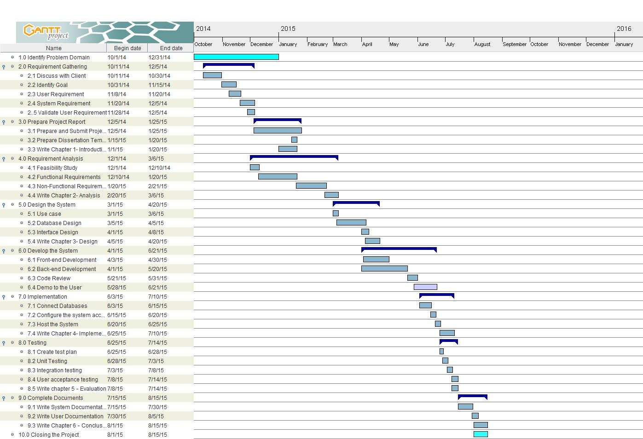

Resource requirements for project (e.g., hardware, software...):

 | Client Side | Developer Side
Hardware | CPU: Intel P IV 2 GHz or Higher Disk Space 20 GB or Higher RAM 1GB or Higher Network Interface Card Printer | CPU: core i5 2.4 GHz Disk Space 500 GB RAM 4GB
Software | Compatible Web browser with Java Script Applet enabled. Compatible Web server with Php 5.0 or Higher My SQL 5.0 or Higher Apache Server Crystal Report | WAMP server 2.0(for testing purposes in local PC only for this project)  Apache HTTP Server 2.2.X (for live testing if the web)  PHP (5.3.6) Apache (2.2.8) MySQL (5.0.51b)  Windows 8.1 pro 64-bit OS  NetBeans IDE 8.0.1  Adobe Photoshop CS3  My SQL Work Bench  Navicat Gantt Project PayPal Sandbox (for implementing virtual PayPal account for testing purpose)  Edraw max Adobe Flash CS3 Crystal Report
Internet | ADSL Internet connection or high speed internet connection
Proposed way of self-evaluating the success of your system:
- Plan to get the feedback according to a schedule from supervisor.
- Planning to get the feedback according to a schedule from management of the Sun & Moon Resort Within specific period check whether system is functioning properly (Checking for security approvals, check details are recording accurately by inserting data set etc…)

Project evaluation plan (test plan- to test the application, supervisor meeting plan –to check the progress, and client meeting plan – to review project activities):

Supervisor meeting plan
Objective | Responsible | TimeLine
Discuss about selecting of a project with supervisor | Developer | Wed 10/1/2014
Discuss about the project scope | Developer | Fri 10/10/2014
Sign the Supervisor agreement | Developer | Thu 10/18/2014
Discuss about the requirement analysis | Developer | Mon 12/8/2014
Discus about the Dissertation | Developer | Thurs 1/15/2015
Discuss about the Design of the application | Developer | Tue 3/3/2015
Discuss about the Implementation of the application | Developer | Wed 6/3/2015
Discuss about the Testing of the application | Developer | Thurs 6/25/2015
Discuss about the system documentation | Developer | Wed 7/15/2015

Client meeting plan
Objective | Responsible | Timeline
Meet the Client to discuss about the project  Discuss about the requirements of the client. | Developer  Developer | Sat 10/11/2014  Sat 10/11/2014 &  Sun 10/12/2014
Visit the customer to discuss about releasing the products | Developer | Sat 11/8/2014
Visit the client to configure the system according to the client requirements. | Developer | Sun 6/21/2015
Meet the client to demonstrate the system | Developer | Tue 6/30/2015
Visit the client to perform the acceptance testing | Developer | Sat 7/11/2015

Testing plan
Objective | Responsible | Timeline
Feasibility Study | Developer | From Sat 12/6/2014 to Wed 12/10/2014
Database testing | Developer | From Fri 4/10/2015 to Fri 5/15/2015
 | Developer | From Mon 7/6/2015 to Sat 7/10/2015
  Interface testing
Unit testing | Developer | From Sun 6/28/2015 to Fri7/3/2015
Integration testing | Developer | From Fri 7/3/2015 to Wed 7/8/2015
User acceptance testing | Developer | From Wen 7/8/2015 to Tue 7/14/2015

