Project Proposal
Academic Year 2014/2015

Candidate Details
Index No: 1127888
Name of candidate: A.S.D.Silva
Address: “Lathawasa” Warapitiya, Dharga Town.
Contact telephone numbers: 0712127275
Email: tosandeepa@gmail.com

Supervisor/Advisor Details
 | Supervisor 1 (IT Related) | Supervisor 2 (Optional)
Name | Dr. Viraj pinto jayawardena
Designation | Managing Director
Workplace address | Matrix Institute of IT (pvt) Ltd No: 279/1,  Galle Road, Colombo 04.
Academic/  professional/  qualifications  and  memberships | PHD,  MBCS, CITP, MIEEE
Work experience | 18 Years of IT Education training 06+ years of Software Development & Project Management.
Email: | vpintoj@gmail.com
Phone number/s | 0714317927

Project Details

Title of Project:
Resort Management System for Sun & Moon Resort
Name and address of client:
Sun & Moon Resort,
Aluthgama

Motivation for project:
With the rapid changes in technology, each & everyone wish to complete their tasks within a shorter time period with a maximum efficiency. Sun & Moon Resort, Aluthgama is a fully private Resort & Reception hall focusing for tourism & local customers. In the Resort, all works are done by manually. Because of that they have to spend more time on their activities .Overall employees have to put greater effort to complete their tasks.

Objectives and scope of proposed project:
Objectives

- Improve management and satisfaction of the Managing level of the Resort & employees of the Business.
- Efficient procedures to provide better service to the customers & through it, improve Customer satisfaction
- Improve Client base of the Business.
- Increase efficiency of Business
- Improve Maintainability of the Rooms & Reception hall
- Minimize the time taken to handle paper based documents.
- Accuracy in recording details & work as MIS (Management Information System)
- Generating reports easily

Scope

- Login management
- Database Management
- Room & Reception Hall Booking, Check In
- Payment Handling
- Report generating
- Daily, monthly, Report Handling
- Seasonal offers reminder

Critical functionalities for project:

- Reservation, booking processing
- Payment Handling
- Report generating
- Backup functionalities
- Security of System

Itemized list of deliverables of the system:
Note: Deliverables are items that you would deliver to the client at the end of the project.
The entire system consists of several modules.

(Login will decide the Administrator or Normal user)

- Administrator Module
Login
Add New Employee
Update Employee
Booking & Reservation
Payment Handling Module
Reservation Module
Report Generating Module
Availability of Booking
System Documentation
User Manual
System user Training

- Normal User Module
Login
Booking & Reservation
Availability of Booking
Payment Handling Module
Reservation Module
System Documentation
User Manual
System user Training

Work breakdown structure for project (include the work involved in system development as well as writing the dissertation):

1.0 Identify Problem Domain

2.0 Requirement Gathering
2.1 Discuss with Client
2.2 Identify Goal
2.3 User Requirement
2.4 System Requirement
2.5 Validate User Requirement

3.0 Prepare Project Report
3.1 Prepare and Submit Project report
3.2 Prepare Dissertation Template
3.3 Write Chapter 1- Introduction

4.0 Requirement Analysis
4.1 Feasibility Study
4.2 Functional Requirements
4.3 Non-Functional Requirements
4.4 Write Chapter 2- Analysis

5.0 Design the System
5.1 Use case
5.2 Database Design
5.3 Interface Design
5.4 Write Chapter 3- Design

6.0 Develop the System
6.1 Front-end Development
6.2 Back-end Development
6.3 Code Review
6.4 Demo to the User

7.0 Implementation
7.1 Connect Databases
7.2 Configure the system according to client environment
7.3 Host the System
7.4 Write Chapter 4- Implementation

8.0 Testing
8.1 Create test plan
8.2 Unit Testing
8.3 Integration testing
8.4 User acceptance testing
8.5 Write chapter 5 – Evaluation

9.0 Complete Documents
9.1 Write System Documentation
9.2 Write User Documentation
9.3 Write Chapter 6 – Conclusion

10.0 Closing the Project
10.1 Tune the system
10.2 Submit Project Reports
10.3 Face to Interview

11.0 Maintenance

A project plan using Gantt chart (include the work involved in system development as well as writing the dissertation):
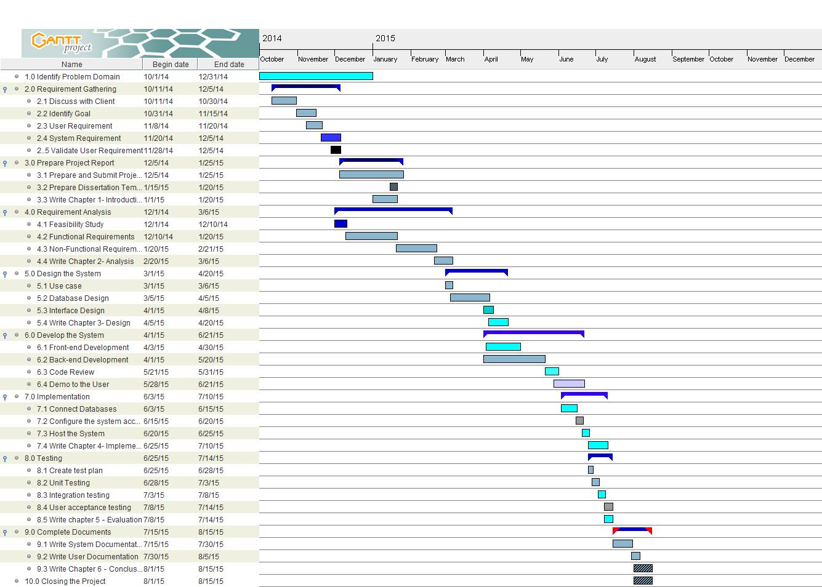

Resource requirements for project (e.g., hardware, software...):

 | Client Side | Developer Side
Hardware | CPU: Intel P IV 2 GHz or Higher Disk Space 20 GB or Higher RAM 1GB or Higher Network Interface Card Printer | CPU: core i5 2.4 GHz Disk Space 500 GB RAM 4GB
Software | Compatible Web browser with Java Script Applet enabled. Compatible Web server with Php 5.0 or Higher My SQL 5.0 or Higher Apache Server Crystal Report | WAMP server 2.0(for testing purposes in local PC only for this project)  Apache HTTP Server 2.2.X (for live testing if the web)  PHP (5.3.6) Apache (2.2.8) MySQL (5.0.51b)  Windows 8.1 pro 64-bit OS Adobe Dreamweaver CS3 Adobe Photoshop CS3  My SQL Work Bench  Navicat Gantt Project PayPal Sandbox (for implementing virtual PayPal account for testing purpose)  Edraw max Adobe Flash CS3 Crystal Report
 | ADSL Internet connection or high speed internet connection

Proposed way of self-evaluating the success of your system:
Asking feedback from the Sun & Moon Resort. Within specific period check whether system is functioning properly (Checking for security approvals, check details are recording accurately by inserting data set etc…) Compare cost of paper based & computer based mechanism Check the growth in number internet based customers quarterly • Measure the time taken to complete a task from inquiry to completion based on internet & manually .

Project evaluation plan (test plan- to test the application, supervisor meeting plan –to check the progress, and client meeting plan – to review project activities):

..............................................................................................................................................................

..............................................................................................................................................................

..............................................................................................................................................................

..............................................................................................................................................................

..............................................................................................................................................................

..............................................................................................................................................................

..............................................................................................................................................................

Note: Any deviation of the final project from the project described in this proposal should
be explained by the candidate in the dissertation.

