**Ex. No: 1** **WEB PAGES USING HTML5**

Date:

Aim:

**Page Design :**

1. **Home Page:**

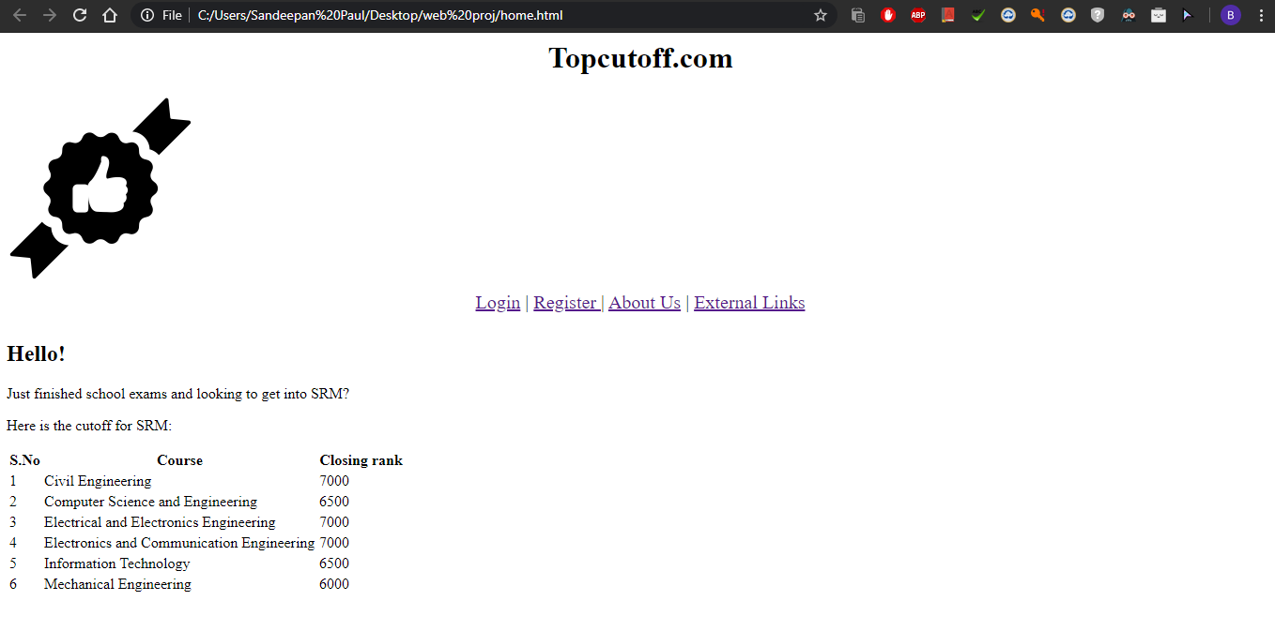

1. **About Us:**

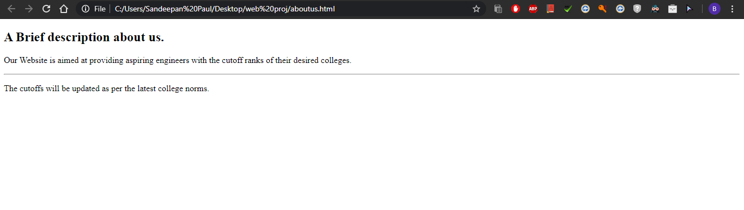

1. **External Link:**

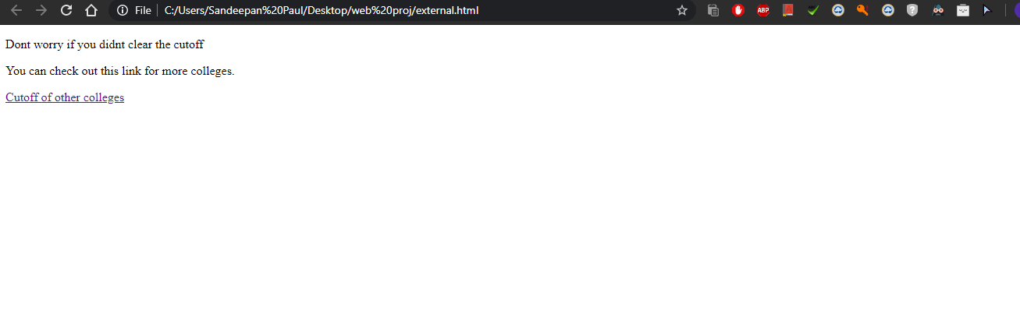

**Code :**

1. **Home Page:**

<html>

<title>Home</title>

<head>

<h1>Topcutoff.com</h1>

<img class="icon" src="C:\Users\Sandeepan Paul\Desktop\web proj\icon.png" alt="">

<nav class="navbar">

<a href="file:///C:/Users/Sandeepan%20Paul/Desktop/web%20proj/login.html">Login</a> |

<a href="file:///C:/Users/Sandeepan%20Paul/Desktop/web%20proj/register.html">Register </a></a>|

<a href="file:///C:/Users/Sandeepan%20Paul/Desktop/web%20proj/aboutus.html">About Us</a> |

<a href="file:///C:/Users/Sandeepan%20Paul/Desktop/web%20proj/external.html">External Links</a>

<link rel="stylesheet" href="css/styles.css">

</nav>

</head>

<body>

<div class="top">

<h2>Hello!</h2>

<p>Just finished school exams and looking to get into SRM?</p>

<p>Here is the cutoff for SRM:</p>

</div>

<div class="bottom">

<table>

<tr>

<th>S.No</th>

<th>Course</th>

<th>Closing rank</th>

</tr>

<tr>

<td>1</td>

<td>Civil Engineering</td>

<td>7000</td>

</tr>

<tr>

<td>2</td>

<td>Computer Science and Engineering</td>

<td>6500</td>

</tr>

<tr>

<td>3</td>

<td>Electrical and Electronics Engineering</td>

<td>7000</td>

</tr>

<tr>

<td>4</td>

<td>Electronics and Communication Engineering</td>

<td>7000</td>

</tr>

<tr>

<td>5</td>

<td>Information Technology</td>

<td>6500</td>

</tr>

<tr>

<td>6</td>

<td>Mechanical Engineering</td>

<td>6000</td>

</tr>

</table>

</div>

</body>

</html>

1. **About us:**

< html>

<head>

<title>About Us</title>

</head>

<body>

<h2>A Brief description about us.</h2>

<p>Our Website is aimed at providing aspiring engineers with the cutoff ranks of their desired colleges.</p>

<hr>

<p>The cutoffs will be updated as per the latest college norms.</p>

</body>

</html>

1. **External :**

<html>

<head>

<meta charset="utf-8">

<title>External Link</title>

<link rel="stylesheet" href="/css/styles.css">

</head>

<body>

<p>Dont worry if you didnt clear the cutoff</p>

<p>You can check out this link for more colleges.</p>

<a href="https://www.sarvgyan.com/articles/tnea-cut-off">Cutoff of other colleges</a>

</body>

</html>