Struts2 IDE - WTP XML Search Engine

1.Struts2 IDE - WTP XML Search Engine 2
2.Struts2 IDE – Struts.xml 4
2.1.Struts2 icons 4
2.2.Syntax coloring for referenced Nodes 4
2.3.Java completion for @class attribute 6
2.4.Java validation for @class attribute 7
2.5.Java hyperlink for @class attribute : 7
2.6.Java Text Hover 8
2.7.Java method completion for action/@method 8
2.8.Java method validation for action/@method 8
2.9.Java hyperlink for action@method attribute : 9
2.10.interceptor-ref completion 10
2.11.interceptor-ref validation 10
2.12.interceptor-ref hyperlink 10
2.13.interceptor-ref Text hover 11
2.14.interceptor/interceptor-statck with Ctrl+Shift+G 12
2.15.result-type features 13
3.Struts2 IDE – JSP Taglib 14
3.1.JSP Taglib @action 14
3.1.1.Ctrl+Shift+G for action 15
3.1.2.Limitation 15
3.2.JSP Taglib @key 16
4.Struts2 IDE – XML XWork validator 17
5.XML Search engine – UI Dialog 18
5.1.Search Xpath manual 18
5.2.Search Xpath automaticly 19

- XML struts.xml
- JSP taglib (s:form,...)

https://bugs.eclipse.org/bugs/show_bug.cgi?id=330576

- org.eclipse.wst.xml.search.core
- org.eclipse.wst.xml.search.ui
- org.eclipse.wst.xml.search.editor
- org.eclipse.jst.jsp.search.editor
- org.eclipse.wst.xml.search.xpath.processorsXPath processor section

- org.apache.struts2.ide.core
- org.apache.struts2.ide.ui
- org.apache.struts2.ide.jsp.core

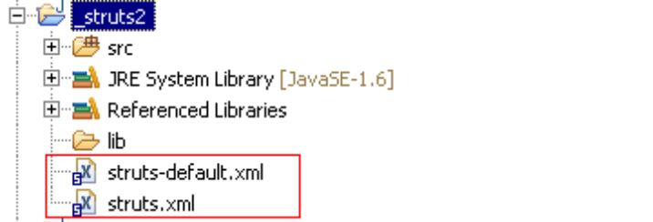

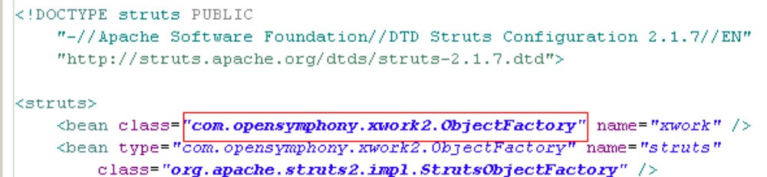

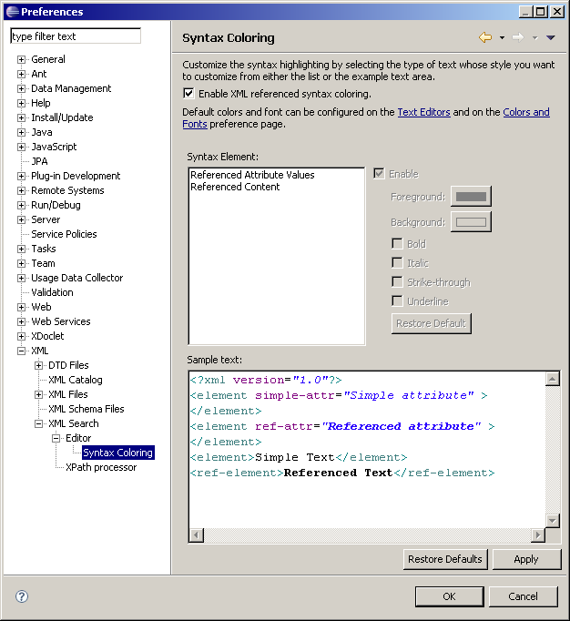

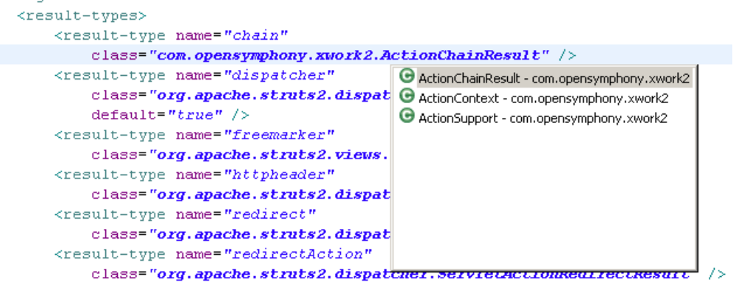

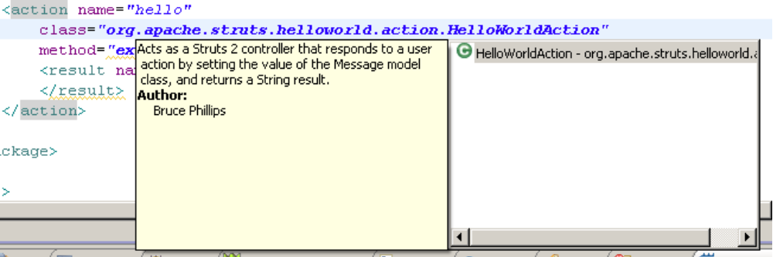

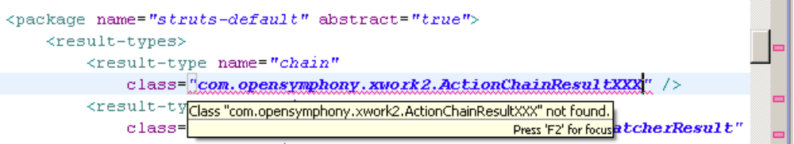

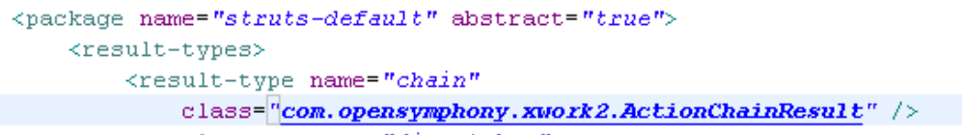

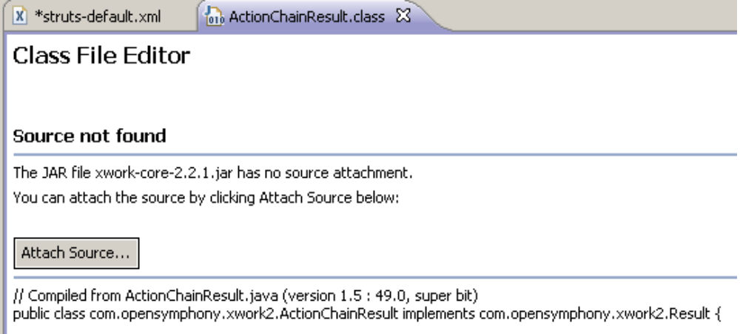

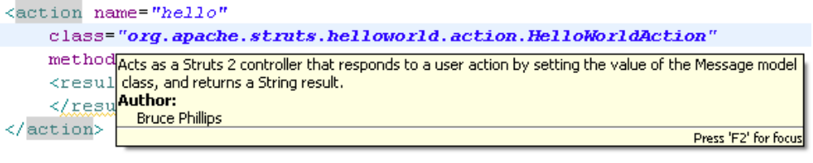
  - action/@method

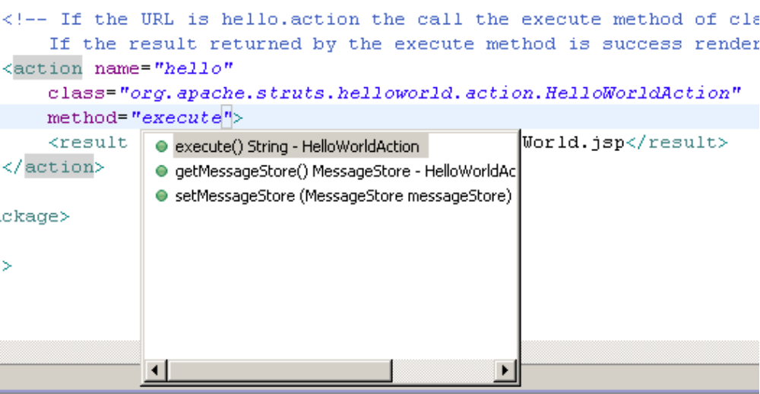
  - action/@method

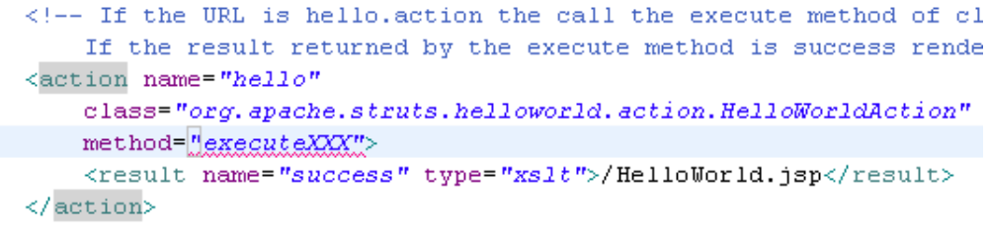

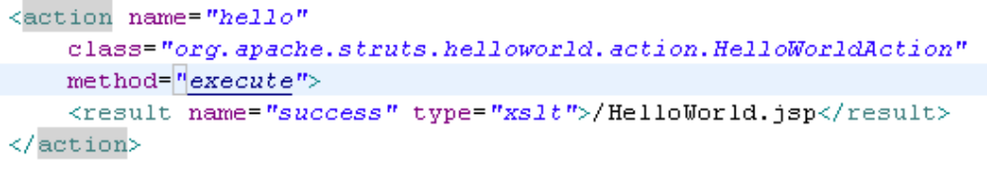

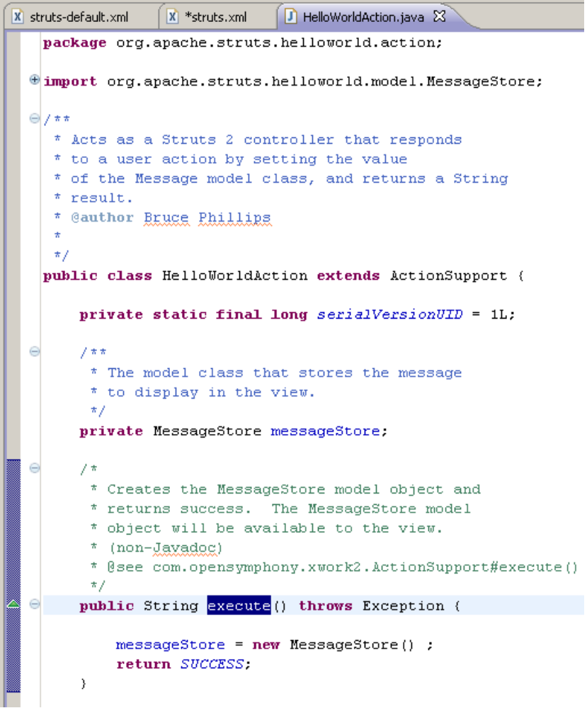

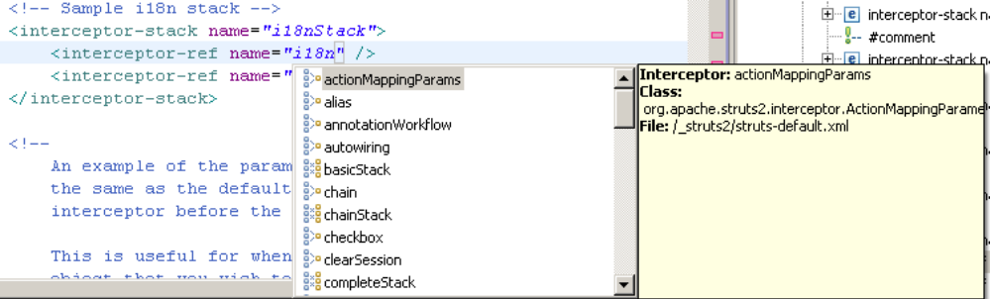

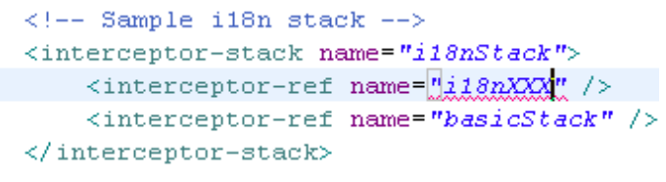

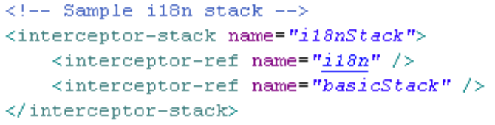

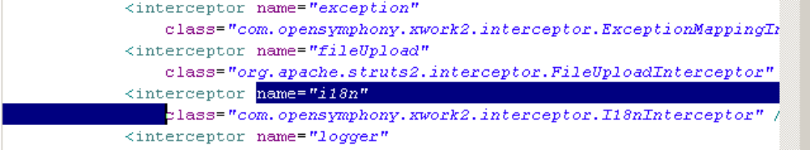

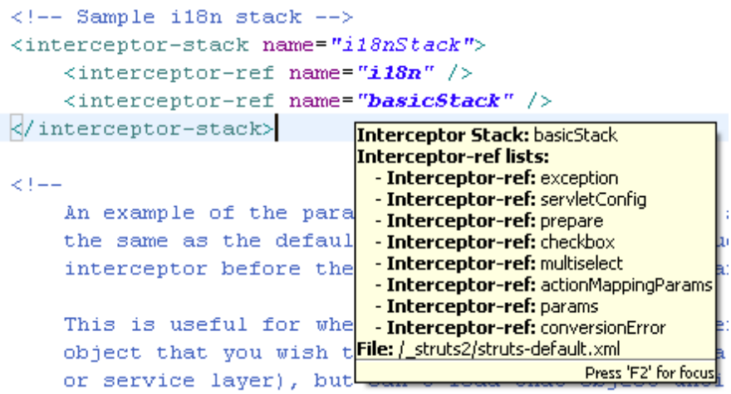

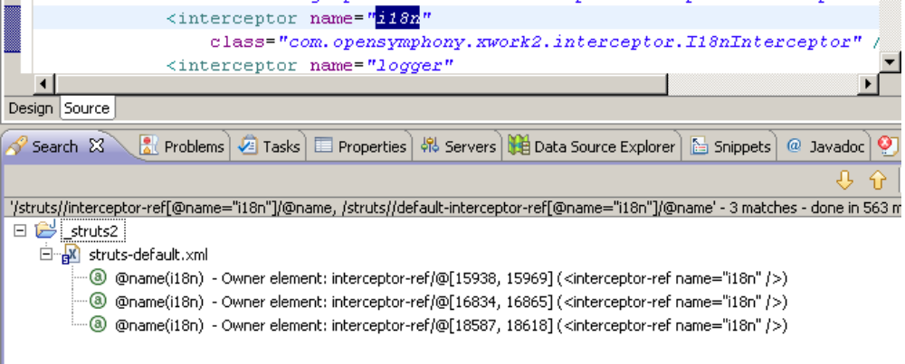

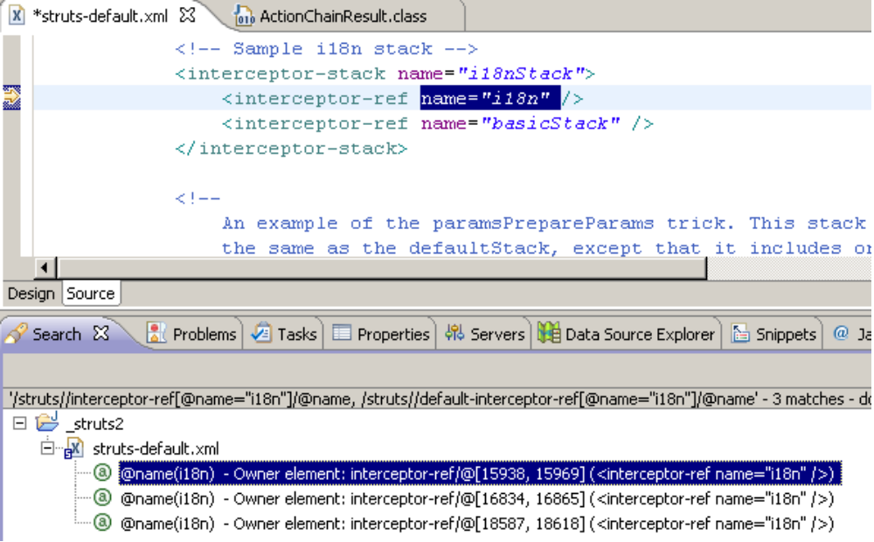

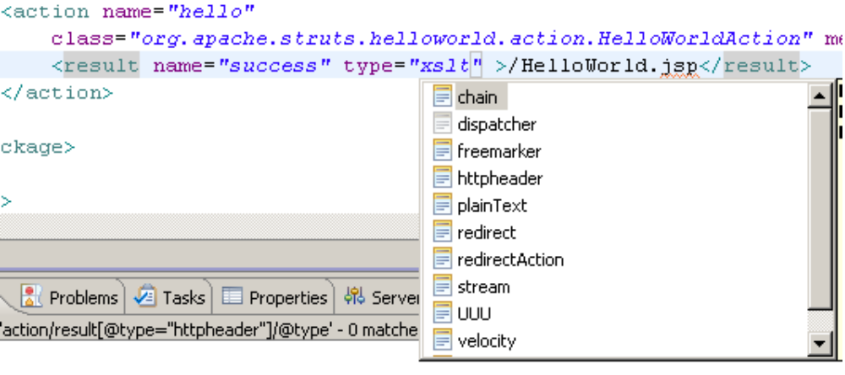

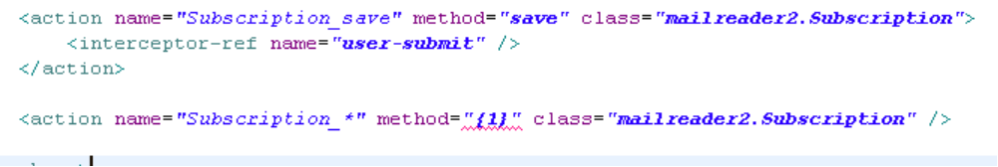

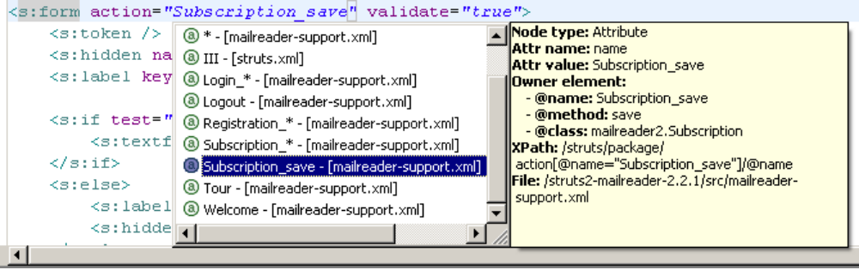

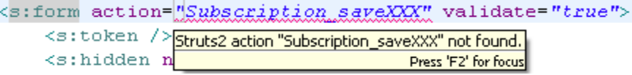

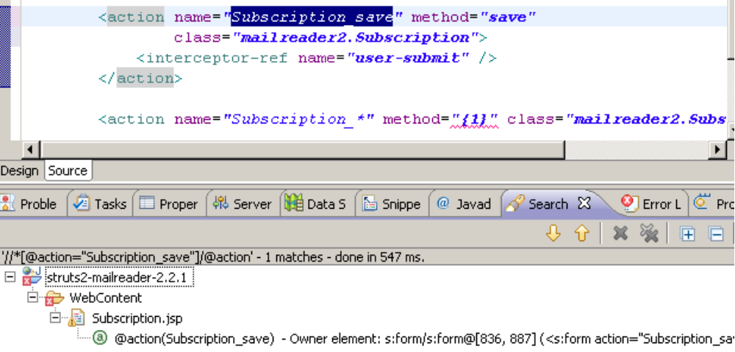

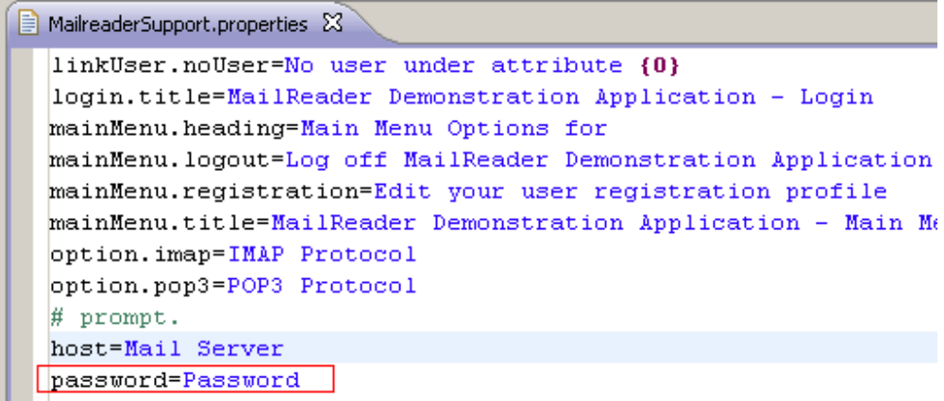

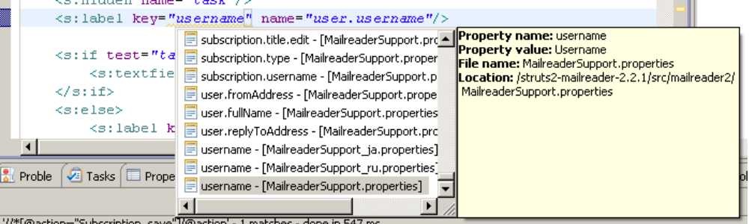

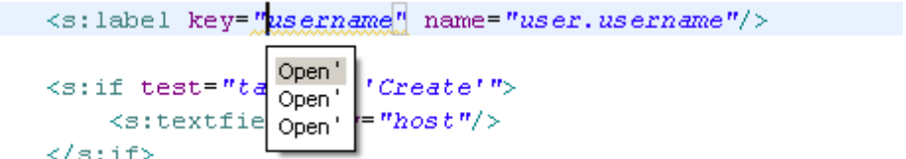

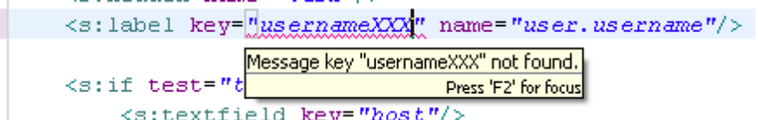

https://bugs.eclipse.org/bugs/show_bug.cgi?id=330576

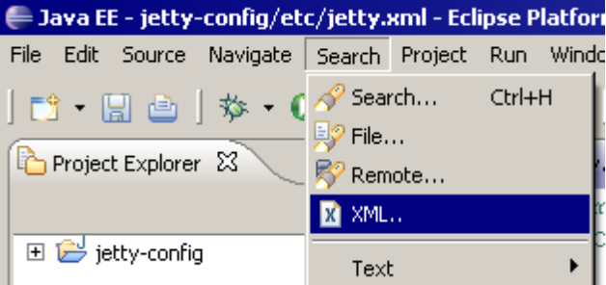

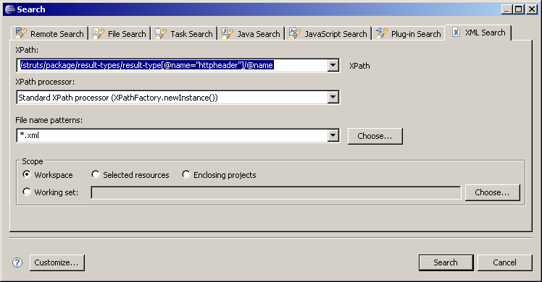

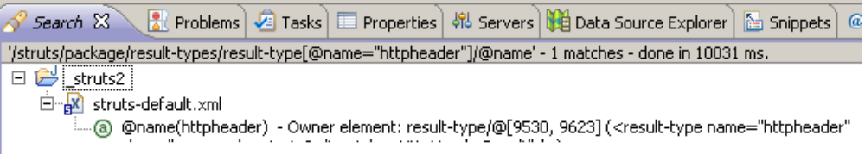

/struts/package/result-types/result-type[@name="chain"]/@name

