Synopsis of the project

Description
Industry:Manufacturing
Theme: Factory Simulation
Title: Supply Chain Prediction
Role: Operations Manager
Objective: Anticipate problems in the supply chain, such as late delivery by suppliers
Outcome: I can make plans to compensate for supply-chain problem

Business Understanding:Supply Chain is the management of a network of interconnected business involved in providing the end product or service to the end customer.

Supply Chain spans across incoming and storage of raw materials ,in progress inventory,stocking the finished goods from point of origin to consumption.

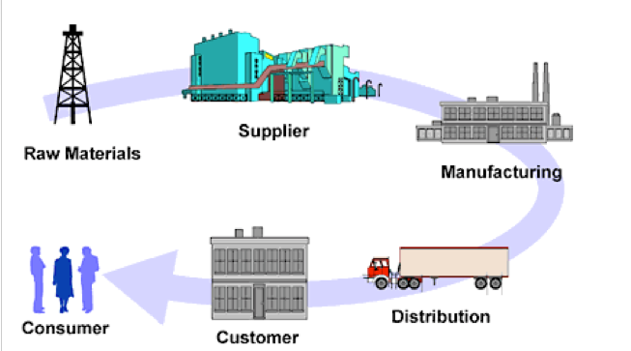

The Benefits of supply chain is as follows
>Lower inventories
>Greater Agility
>Shorter Lead times across the supply chain
>Higher profits and customer satisfaction

Key issues in Supply chain are
>To determine the appropriate level of outsourcing to the vendors
>Managing Procurements
>Managing Supplier
>Managing Customer relationships

As part of this project we are going to focus on Managing Suppliers through analytic s

Dataset collection and overview
I found the below dataset suitable for the analysis and prediction.

Lokad_Items.tsv
This file contains the list of products sold by the retailer along with relevant attributes at the product level.
- Id: the SKU identifier
- Ref: the identifier of the product
- Loc: the identifier of the location
- Name: display name of the product
- Category: top hierarchical level to organize the products
- SubCategory: top hierarchical level to organize the products
- Brand: brand name
- Supplier: primary supplier from whom the product is purchased
- StockOnHand: the number of units readily available
- StockOnOrder: the number of units already ordered from the suppliers but not yet received
- BackOrder: the number of units already ordered by the clients but not yet shipped
- BuyPrice: per-unit purchase price, net of tax
- SellPrice: per-unit selling price, net of tax
- MOQ: the minimal ordering quantity per product when ordering from the supplier
- LotMultiplier the lot multiplier constraint when ordering from the supplier
- Volume: in m3, the volume per unit, typically used to satisfy purchasing constraints
Lokad_Orders.tsv
This file contains the historical sales data disaggregated down to the transaction level as the client identifiers are also provided.
- Id: a foreign key to the “Id” column in the items file, the SKU identifier
- Ref: the identifier of the product
- Loc: the identifier of the location
- Date: ordering date.
- Quantity: quantity ordered in units.
- NetAmount: amount paid for the order line, without taxes.
- OrderId: the identifier of the client order.
- Currency: a 3-letter code for the currency.
- Client: a client identifier, can be used to demo customer loyalty analysis.
Lokad_Suppliers.tsv
This file contains the list of suppliers with their respective properties. On purpose, this file is not indexed by an Id column but by a Supplier column.
- Supplier: the index of the table; acts as a foreign key toward PurchaseOrders.Supplier.
- MOV: the minimal order volume expressed in USD for the given supplier.
- ContainerM3: the target size of the container expressed in m3 - cubic meters.

Data
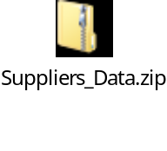

Details of the project
Scope:The problem at the hand is to reduce the lead time so that the production is not affected

Key Variables : %age of supplier lead time variability, %age intransit lead time variability,
%age demand variability

Solution Analysis
Problem:To predict the delay and make plans to compensate or find an alternative
Techniques: To anticipate the problems in supply chain(such as late delivery) EDA will be used to understand the nature of the issue and also the potential causes. Time Series to understand the trend of suppliers to make a better judgment.

There are ways in which we can have an alternative to the delay by a supplier
>Higher inventory levels
>Source from Multiple Vendors

Tools: tableau for visualization and R programming for analysis.

