CORE JAVA
With
SCJP/OCJP
By
Mr.K.Veerendranath _{M.Tech}

CoreJava-Basiscs
Internet:
Why C/C++ are not opted for a network and why java is a language suited for a network, especially internet.
Internet: Interconnection of computers is called network. A network may contain two or more computers connected with or without a cable, you can connect a computer in Delhi to one placed in Hyderabad with the help of a satellite and data can be sent or received via satellite in the form of electromagnetic waves. So a network may or may not have a cable.
The primary purpose of a network is a resource sharing, which means a computer can share its resources, like data, memory, software, hardware, CPU, etc. with other computers on the network. In the network, one computer may ask the other computer some service. The computer, which requests for some service is called client and the other computer, which is provide that service to the client is called server.
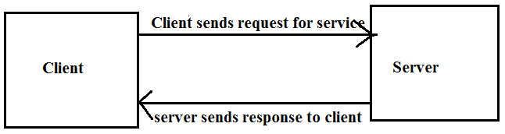
How we can connect one computer to another?
Hardware: Computer systems, Network Interface cards, cables, modems, hubs, satellites, etc.
Software: Any software, which supports networking features, like Unix, Linux, windows, etc.. So that data can be sent or receive.
Protocols: protocols could be defined as a standard procedure for regulating data transmission between computers. It specifies a way to identify the destination and source computers and establish a connection between them to receive or send data. Ex TCP/IP or UDP
Protocols help to divide data into small packets of several bytes, insert the packets into frames, and then send those frames to the destination computer over the network.
Intranet:
A network of computers within an organization is called Intranet.
Extranet:
An external network connecting an organization’s network with that of another organization is called Extranet.
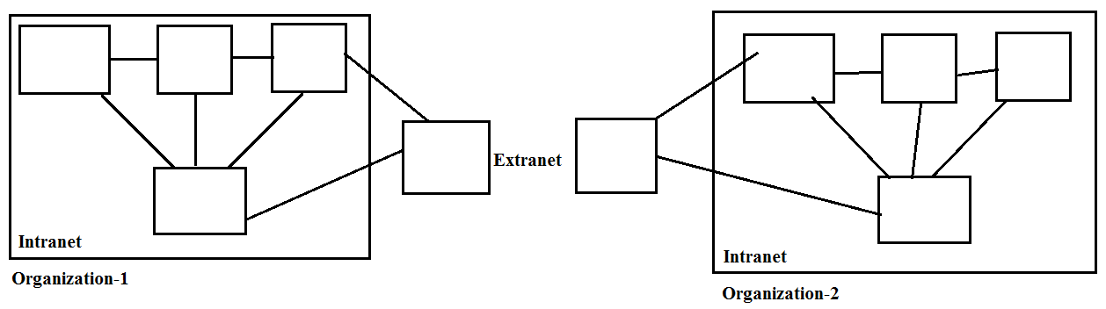
How does internet function?
Like any network, internet also requires certain hardware, software, and protocols to perform its functions. Ex: Computer systems, Network Interface cards, cables, modems, hubs, satellites, etc. are need to connect different computers with each other.
The computer, which is connected to Internet Service Provider (ISP) computer is called client and the ISP’s computer called server.
Application servers: focus on single area like employee attendance, company scheduling.
Some servers provide services purely related to internet (maintain the website and communicating with clients on internet) called web servers.
Some imp topics about.
Web browser
Protocols
Software Development for internet:
Software:
As per the industrial standard a “digitalized (GUI) automated system” is called software.
Digitalized: When the software where is providing graphically user interface then it is called digitalized.
Automated system: Without human interaction if the process is completed then it called automated system.
Software is nothing but a collection of programs. A program is a set of instructions which is designed for particular task.
A number of programs combining together like a single unit it is called software tool of software component.
Software are classified into two types:
1. System software
2. Application software.

1. System software:
The software design for general purpose & does not having any limitations it is called system software.
Note: System software manages the computer resources. It provides the interface between the hardware and the users but does nothing to directly serve the user’s needs.
System software are classified into 3-types:
1. Operating systems: Dos, windows, Linux, UNIX…
2. Translators: Compilers, interpreters, assemblers…
3. Packages: linkers, loaders, editors…
2. Application software:
This software is designed for specific task only it is application software.
Note: Application software is directly responsible for helping users solve their problems.
Ex: application software are classified into 2-types:
1. Application packages: MS office, Oracle…
2. Specific purpose software: Tally..
- Ms Office is a Microsoft product which maintains the information in document format.
- Oracle is a database which maintains the information in document format.
- By using Tally we can maintain the information of accounts.
Computer:
A computer is an electronic device which accepts instructions from user and according to user sended instruction it produces result.
Computer is an electronic device which operates under the control of instructions stored in its own memory. A computer can take data from the user through input devices (Input), process the user given data (Processing), produces the result to the user through output devices (Output)and stores data (Information) for future use.
Note: Computer knows only one language i.e binary language.
How does Computer works?
When a user wants to communicate with the computer, the user interacts with an application.
The application interacts with the operating system, and the operating system makes hardware components to work according to the user given instructions.
The hardware components sends the result back to the operating system, then the operating system forwards the same to the application and the application shows the result to the user.
By using input devices, the user interacts with the application and the application uses output devices to show the result.
All input and output devices work according to the instructions given by the operating system.
The working process of a computer is shown in the following figure...

Computer Languages
What is Computer Language?
Generally, we use languages like english, hindi, telugu etc., to make communication between two persons. That means, when we want to make communication between two persons we need a language through which persons can express their feelings.
As a programmer when we required interacting with a computer we need a communication channel called programming language.
Similarly, when we want to make communication between user and computer or between two or more computers we need a language through which user can give information to computer and vice-versa.
When user wants to give any instruction to the computer the user needs a specific language and that language is known as computer language.
User interacts with the computer using programs and that programs are created using computer programming languages like C, C++, Java etc.,
A programming language is a special kind of instructions which is used to communicate with computer.
As a programmer if we knows the programming language then it is not possible to interact with computer because computer can understand binary code only.
In the above case, recommended to use translator. As a programmer if the instruction came from the programming language, translator will converts programming language code into binary format and according to even binary instructions we will get application software.
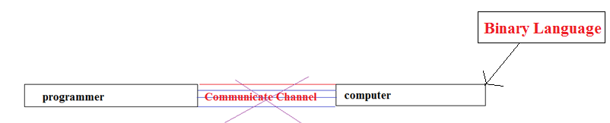
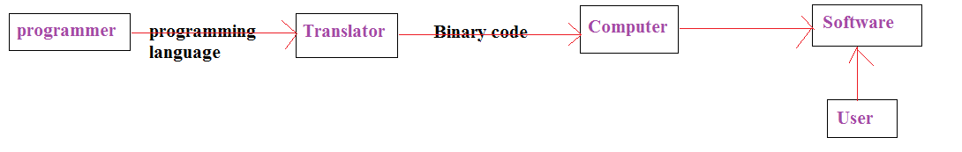
Note: Computer languages are the languages through which user can communicate with the computer by writing program instructions.
Translators:
A translator is system software which can convert programming language code into binary format.
Translators are classified into 3-types:
- Compiler
- Interpreter.
- Assembler.
1. Compiler:
It is system software which can converts programming language code into binary language format in a single step except those lines are having error.
2. Interpreter:
It is system software which converts programming language code into binary format step by step i.e line by line combination takes place.
Note: when in it error occurs it stops the compilation process.
3. Assembler:
By using assembler we can convert assembly language instructions into binary formats.
Note: As per the performance wise recommended to use compiler and as per the development wise recommended to use an interpreter.
Programming language
A programming language is a special kind of instructions which is used to communicate with computer.
Every computer programming language contains a set of predefined words and a set of rules (syntax) that are used to create instructions of a program.
Computer Languages Classification
Over the years, computer languages have been evolved from Low Level to High Level Languages. In the earliest days of computers, only Binary Language was used to write programs.
The computer languages are classified as follows...
Programming language is classified into 2-types:
1. Low level programming language.
2. Middle Level Programming language.
3. High level programming language.
1. Low level programming language.
Low Level language is the only language which can be understood by the computer. Binary Language is an example of low level language. Low level language is also known as Machine Language.
The binary language contains only two symbols 1 & 0. All the instructions of binary language are written in the form of binary numbers 1's & 0's.
A computer can directly understand the binary language. Machine language is also known as Machine Code.
As the CPU directly understands the binary language instructions, it does not requires any translater. CPU directly starts executing the binary language instructions, and takes very less time to execute the instructions
Note: Low level language is specific to one machine i.e. machine dependent. It is machine dependent, fast to run. But it is not easy to understand.

Advantages
- A computer can easily understand the low level language.
- Low level language instructions are executed directly without any translation.
- Low level language instructions require very less time for thier execution.
Disadvantages
- Low level language instructions are very difficult to use and understand.
- Low level language instructions are machine dependent, that means a program written for a particular machine does not executes on other machine.
- In low level language, there is more chance for errors and it is very difficult to find errors, debug and modify.
Middle Level Language (Assembly Language):
Middle level language is a computer language in which the instructions are created using symbols such as letters, digits and special characters. Assembly language is an example of middle level language. In assembly language, we use predefined words called mnemonics.
Binary code instructions in low level language are replaced with mnemonics and operands in middle level language. But computer cannot understand mnemonics, so we use a translator called Assembler to translate mnemonics into binary language. Assembler is a translator which takes assembly code as input and produces machine code as output. That means, computer cannot understand middle level language, so it needs to be translated into low level language to make it understandable by the computer. Assembler is used to translate middle level language to low level language.

Advantages
- Writing instructions in middle level language is easier than writing instructions in low level language.
- Middle level language is more readable compared to low level language.
- Easy to understand, find errors and modify.
Disadvantages
- Middle level language is specific to a particular machine architecture that means it is machine dependent.
- Middle level language needs to be translated into low level language.
- Middle level language executes slower compared to low level language.
High level programming language
High level language is a computer language which can be understood by the users. programming language is syntactically similar to English and easy to understand it is called high level programming language.
Every high level language has a set of predefined words known as Keywords and a set of rules known as Syntax to create instructions. High level language is easier to understand for the users but the computer cannot understand it. High level language needs to be converted into low level language to make it understandable by the computer. We use Compiler or interpretor to convert high level language to low level language.
By using high level programming language we are developing user interface applications.
Ex: C, C++, Vc++, java, C#, Swift, Objective C, D-language, COBOL, FORTRAN, BASIC are the examples of high level languages. All these programming languages use human understandable language like english to write program instructions. These instructions are converted to low level language by the compiler so that it can be understood by the computer.
Note: High Level language is not specific to one machine i.e. machine independent. It is easy to understand.
Advantages
- Writing instructions in high level language is more easier.
- High level language is more readable and understandable.
- The programs created using high level language runs on different machines with little change or no change.
- Easy to understand, create programs, find errors and modify.
Disadvantages
- High level language needs to be translated to low level language.
- High level language executes slower compared to middle and low level languages.
Understanding Computer Languages
The follwing figure provides few key points related to the computer languages.
From the above figure, we can observe the following key points...
- The programming languages like C, C++, Java etc., are written in High level language which is more comfortable for the developers.
- High level language is more closer to the users.
- Low level language is more closer to the computer. Computer hardware can understand only the low level language (Machine Language).
- The program written in high level language needs to be converted to low level language to make communication between the user and the computer.
- Middle level language is not closer to both user and computer. We can consider it as a combination of both high level language and low level language.
Program Development Life Cycle
Waterfall approach was first SDLC Model to be used widely in Software Engineering to ensure success of the project. In "The Waterfall" approach, the whole process of software development is divided into separate phases. In Waterfall model, typically, the outcome of one phase acts as the input for the next phase sequentially.
Following is a diagrammatic representation of different phases of waterfall model.
The sequential phases in Waterfall model are:
Requirement Gathering and analysis: All possible requirements of the system to be developed are captured in this phase and documented in a requirement specification doc.
System Design: The requirement specifications from first phase are studied in this phase and system design is prepared. System Design helps in specifying hardware and system requirements and also helps in defining overall system architecture.
Implementation: With inputs from system design, the system is first developed in small programs called units, which are integrated in the next phase. Each unit is developed and tested for its functionality which is referred to as Unit Testing.
Integration and Testing: All the units developed in the implementation phase are integrated into a system after testing of each unit. Post integration the entire system is tested for any faults and failures.
Deployment of system: Once the functional and non functional testing is done, the product is deployed in the customer environment or released into the market.
Maintenance: There are some issues which come up in the client environment. To fix those issues patches are released. Also to enhance the product some better versions are released. Maintenance is done to deliver these changes in the customer environment.
One more angle…
Generally, program development life cycle contains 6 phases, they are as follows….
- Problem Definition
- Problem Analysis
- Algorithm Development
- Coding & Documentation
- Testing & Debugging
- Maintenance

1. Problem Definition
In this phase, we define the problem statement and we decide the boundaries of the problem. In this phase we need to understand the problem statement, what is our requirment, what should be the output of the problem solution. These are defined in this first phase of the program development life cycle.
2. Problem Analysis
In phase 2, we determine the requirements like variables, functions, etc. to solve the problem.
That means we gather the required resources to solve the problem defined in the problem definition phase. We also determine the bounds of the solution.
3. Algorithm Development
During this phase, we develop a step by step procedure to solve the problem using the specification given in the previous phase. This phase is very important for program development.
That means we write the solution in step by step statements.
4. Coding & Documentation
This phase uses a programming language to write or implement actual programming instructions for the steps defined in the previous phase. In this phase, we construct actual program. That means we write the program to solve the given problem using programming languages like C,
C++, Java etc.,
5. Testing & Debugging
During this phase, we check whether the code written in previous step is solving the specified problem or not. That means we test the program whether it is solving the problem for various input data values or not. We also test that whether it is providing the desired output or not.
6. Maintenance
During this phase, the program is actively used by the users. If any enhancements found in this phase, all the phases are to be repeated again to make the enhancements. That means in this phase, the solution (program) is used by the end user. If the user encounters any problem or wants any enhancement,then we need to repeat all the phases from the starting, so that the encountered problem is solved or enhancement is added.
Java Programming Language
Java is a high level, robust, secured and object-oriented programming language and a platform. Java, developed by Sun Microsystems and released to market in 1995.It can be used to develop standalone applications, web applications (applets and servlets), e-commerce applications, enterprise applications (like banking) and mobile applications. Very strong in LAN based as well as Client-Server programming with predefined methods.
Java is a high level, robust, secured and object-oriented programming language.
Platform: Any hardware or software environment in which a program runs is known as a platform. Since Java has its own runtime environment (JRE) and API, it is called platform.
Like C++ and Smalltalk, Java Language is object-oriented with a good support of standard class libraries, known as Java API (Application Programming Interface). Java API supports graphics, graphical user interface (GUI), mathematical and threaded operations, applets and applications etc. With its rich API, architecture neutral support and Java Virtual Machine, Java sometimes referred as a platform itself called Java Platform.
Java looks familiar to a novice as much of the syntax is borrowed from C/C++. The major variation is that Java does not support pointers. The compilation of Java application results in a .class file containing bytecode. The byte code file can run on any operating system and hardware irrespective of the operating system on which it was compiled.
Why we should go for Java?
Java is one of the best programming language created ever, and I am not saying this because I am a passionate Java developer, but Java has proved it in last 25 years. Two decades is a big time for any Programming language, and Java has gained strength every passing day. Though there are times, when Java development slows down, but Java has responded well. Earlier with groundbreaking changes in the form of Enum, Generics, and Autoboxing in Java 5, performance improvement with Java 6, and Google's choice of language for Android apps development keeps Java as a front-line programming language.
1) Java is Easy to learn
Java has fluent English like syntax with minimum magic characters e.g. Generics angle brackets, which makes it easy to read Java program and learn quickly.
4. Java is open source
We love free and open source software, don’t we? OpenJDLK is a free and open source implementation of Java programming language. Being an open source programming language, it’s platform independent across OS environments. Also, you don’t need to pay a penny to write applications on Java.

2. Java is popular.
Java continues to be one of the most popular programming languages in the world. There's an infinite number of ways to use Java.
3. Pay matters.
Recent reports confirm Java programmers are among the highest paid programmers in the industry.
4. Java programmers are employable.
Java programming skills remain in high demand with employers. It's a widely used language with a large installed base.
5) Java is everywhere.
Yes, Java is everywhere, it's on the desktop, it's on mobile, it's on the card, almost everywhere and so is Java programmers.
- Desktop Applications such as acrobat reader, media player, antivirus etc.
- Web Applications such as irctc.co.in, veerendras.com etc.
- Enterprise Applications such as banking applications.
- Mobile
- Embedded System
- Smart Card
- Robotics
- Games etc.
Java is estimated to be running on over 3 billion devices worldwide. No other language runs on as many devices. Java lets you create programs that work almost anywhere, including smartphones, servers, ATMs, point of sale (POS) terminals, Blu-ray players, televisions, set top boxes, Internet of Things gateways, medical devices, Kindle E -readers, automobiles and more.
Java is used in real world applications.
You may be wondering where Java is used. Here are a few examples:
- Java is used in many of the world's most prominent web sites, including eBay.com, Linkedin.com, Amazon.com, and Facebook.com.
- Java is excellent for developing enterprise applications in virtually any industry, including financial services, healthcare and manufacturing.
1) Android Apps:
If you want to see where Java is used, you are not too far away. Open your Android phone and any app, they are actually written in Java programming language, with Google's Android API, which is similar to JDK. Couple of years back Android has provided much needed boost and today many Java programmer are Android App developer.
2) Server Apps at Financial Services Industry
Java is very big in Financial Services. Lots of global Investment banks like Goldman Sachs, Citigroup, Barclays, Standard Charted and other banks use Java for writing front and back office electronic trading system, writing settlement and confirmation systems, data processing projects and several others. Java is mostly used to write server side application, mostly without any front end, which receives data form one server (upstream), process it and sends it other process (downstream). Java Swing was also popular for creating thick client GUIs for traders, but now C# is quickly gaining market share on that space and Swing is out of its breath.

3) Java Web applications
Java is also big on E commerce and web application space. You have a lot of RESTfull services being created using Spring MVC, Struts 2.0 and similar frameworks. Even simple Servlet, JSP and Struts based web applications are quite popular on various government projects. Many of government, healthcare, insurance, education, defense and several other department have their web application built in Java.
4) Software Tools
Many useful software and development tools are written and developed in Java e.g. Eclipse, InetelliJ Idea and Netbans IDE. I think they are also most used desktop applications written in Java. Though there was time when Swing was very popular to write thick client, mostly in financial service sector and Investment banks. Now days, Java FX is gaining popularity but still it is not a replacement of Swing and C# has almost replaced Swing in Finance domain.
6) J2ME Apps
Though advent of iOS and Android almost killed J2ME market, but still there is large market of low end Nokia and Samsung handset which uses J2ME. There was time when almost all games, application, which is available in Android are written using MIDP and CLDC, part of J2ME platform. J2ME is still popular on products like Blu-ray, Cards, Set top boxes etc. One of the reason of WhatsApp being so popular is because it is also available in J2ME for all those Nokia handset which is still quite big.
7) Embedded Space
Java is also big in the embedded space. It shows how capable the platform is, you only need 130 KB to be able to use Java technology (on a smart card or sensor). Originally Java was designed for embedded devices. In fact, this is the one area, which was part of Java's initial campaign of "write once, run anywhere" and looks like it is paying up now.
8) Big Data technologies
Hadoop and other big data technologies are also using Java in one way or other e.g. Apache's Java-based HBase and Accumulo (open source), and ElasticSearch as well. By the Java is not dominating this space, as there are technologies like MongoDB which is written in C++. Java has potential to get major share on this growing space if Hadoop or ElasticSearch goes big.
9) High Frequency Trading Space
Java platform has improved its performance characteristics a lot and with modern JITs, its capable of delivering performance at C++ level. Due to this reason, Java is also popular on writing high performance systems, because Though performance is little less compared to native language, but you can compromise safety, portability and maintainability for more speed and it only takes one inexperienced C++ programmer to make an application slow and unreliable.
6) Java has staying power.
Java recently celebrated its 20th birthday, proving its staying power in the industry
7) Excellent Java tools are available to help you be productive.
An important factor in choosing a language is the availability of good developer tools to ensure productivity. Many tools are free or open source.
8) The Java community is passionate.
With about 10 million Java developers spread across the world, Java community continues to grow. Just like other open source technologies, Java promotes the philosophy of giving back to the society.

9) Java has a strong roadmap.
Oracle remains committed to Java with a strong development roadmap. In Java 10, which is scheduled for a March 2018 release, Oracle plans to modularize the platform while improving security and performance. This will enable Java to easily scale from large software systems to small devices, including embedded Internet of Things processors.
10) Java has the world's leading developer certifications.
Many technical training institutions, colleges and universities offer courses in java programming.
Types of Java Applications
There are mainly 4 types of applications that can be created using java programming:
1) Standalone Application
Standalone applications are also known as desktop applications or window-based applications.
These are traditional software that we need to install on every machine. Example of standalone applications are:
Media player, antivirus etc. AWT and Swing are used in java for creating standalone applications.
2) Web Application
An application that runs on the server side and creates dynamic page, is called web application. Currently, servlet, jsp, struts, spring, hibernate, jsf etc. technologies are used for creating web applications in java.

3) Enterprise Application
An application that is distributed in nature, such as banking applications etc. is called enterprise application. It has the advantage of high level security, load balancing and clustering. In java, EJB, Web services, spring are used for creating enterprise applications.
4) Mobile Application
An application that is created for mobile devices. Currently Android and Java ME are used for creating mobile applications.
History of Java Language – Evolution
The history of Java is very interesting. Java was originally designed for interactive television, but it was too advanced technology for the digital cable television industry at the time.
The history of java starts from Green Team. Java team members (also known as Green Team), initiated this project to develop a language for digital devices such as set-top boxes, televisions etc. But, it was suited for internet programming. Later, Java technology was incorporated by Netscape.
Set-top box is a unit that connects a television set to an external signal. The signal is converted into content and displayed on television screen to the viewers; a visualization to network the digital devices with computers finally.
Currently, Java is used in internet programming, mobile devices, games, e-business solutions etc.
1) James Gosling, Mike Sheridan, and Patrick Naughton initiated the Java language project in June 1991. The small team of sun engineers called Green Team.
2) Originally designed for small, embedded systems in electronic appliances like set-top boxes.
3) Firstly, it was called "Greentalk" by James Gosling and file extension was .gt.
4) After that, it was called Oak and was developed as a part of the Green project.
5) Manager in the team of James Gosling and the discussion came when they were in a coffee-shop (other names stood for final selection were DNA and Silk). Java (Jawa, in Indonesian language) is an island in Indonesia famous for coffee plantations and volcanic mountains.
6) Java is an island of Indonesia where first coffee was produced (called java coffee).
Note: Notice that Java is just a name not an acronym.
Gosling’s aim was to develop a virtual machine that can “write Once, Run Anywhere“, meaning compile once and run on any system. Another aim was to make Java as simple as possible avoiding many confusing concepts of other languages so that the programmer should feel comfortable to learn and practice.
Originally developed by James Gosling at Sun Microsystems (which is now a subsidiary of Oracle Corporation) and released in 1995.
In 1995, Time magazine called Java one of the Ten Best Products of 1995.
JDK 1.0 released in(January 23, 1996).

Java Versions
Version Name | Code Name | Release Date
JDK 1.0 | Oak | January 1996
JDK 1.1 | (none) | February 1997
J2SE 1.2 | Playground | December 1998
J2SE 1.3 | Kestrel | May 2000
J2SE 1.4 | Merlin | February 2002
J2SE 5.0 | Tiger | September 2004
Java SE 6 | Mustang | December 2006
Java SE 7 | Dolphin | July 2011
Java SE 8 |  | March 2014
Java SE 9 |  | September, 21st 2017
Java SE 10 |  | March, 20th 2018

Note: The major changes to Java came with Java 2 (JDK 1.2) version, released in 1998, that included three components – J2ME (Java 2 Micro Edition), J2SE (Java 2 Standard Edition), J2EE (Java 2 Enterprise Edition).
Note: Android, the mobile operating system developed by Google, is based on Java. The Android programming is done in Java.

Overview of Java
Java is one of the programming language or technology used for developing web applications. Java language developed at SUN Micro Systems in the year 1995 under the guidance of James Gosling and there team. Originally SUN Micro Systems is one of the Academic university (Standford University Network)
Whatever the software developed in the year 1990, SUN Micro Systems has released on the name of oak, which is original name of java (scientifically oak is one of the tree name). The OAK has taken 18 months to develop.
The oak is unable to fulfill all requirements of the industry. So James Gosling again reviews this oak and released with the name of java in the year 1995. Scientifically java is one of the coffee seed name.
Java divided into three categories, they are
- J2SE (Java 2 Standard Edition)
- J2EE (Java 2 Enterprise Edition)
- J2ME (Java 2 Micro or Mobile Edition)
J2SE
J2SE is used for developing client side applications.
J2EE
J2EE is used for developing server side applications.
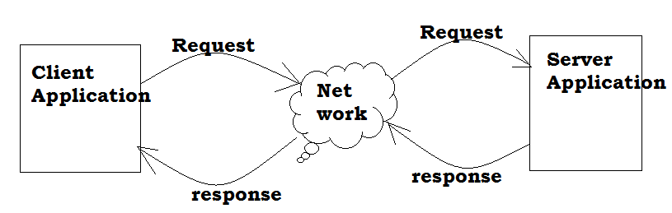
J2ME
J2ME is used for developing mobile or wireless application by making use of a predefined protocol called WAP(wireless Access / Application protocol).
Difference between C/C++ and Java:
1. C and C++ are the static programming language but java is the dynamic programming language?
If a program allows static memory allocation then that programming language is called as static programming language. That means memory allocation done at compile time.
Ex: C and C++
In C and C++ programming languages allocating memory for primitive data types at time of compile time.
If program allows dynamic memory allocation then that programming language is called as dynamic programming language. That means for primitive data type allocating memory at runtime time.
Ex: Java
In java programming language memory allocated for primitive data types at time of runtime and object is created at time of runtime.

2. Pre-processor is required in C- programming language but not required in Java programming language?
App.c:
#include<stdio.h>
#include<conio.h>
void main()
{
printf (“hello”)
}
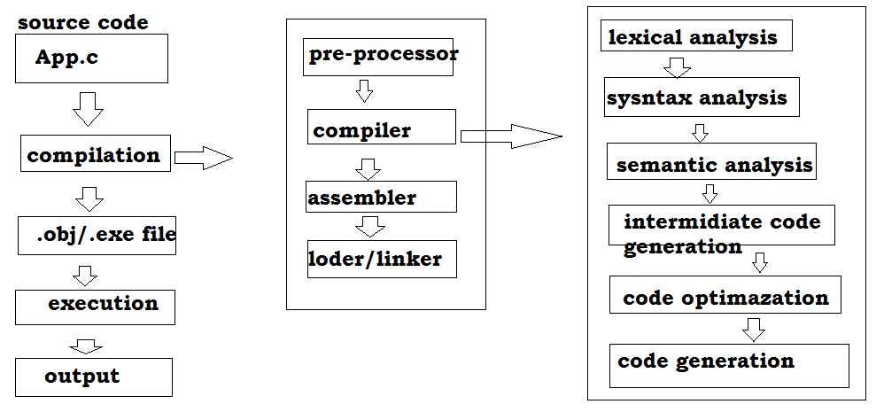
In c-programming language pre-defined libraries provided in form of header files.So in C /C++ we require #include statements
Ex:
#include<stdio.h>
#include<conio.h>
In C programming language pre-processor requires the #include statements that’s why pre-processors are required in c/C++.
In java:
import java.lang.*;
class App
{
public static void main(String[] args)
{
System.out.println(“Hello”);
}
}
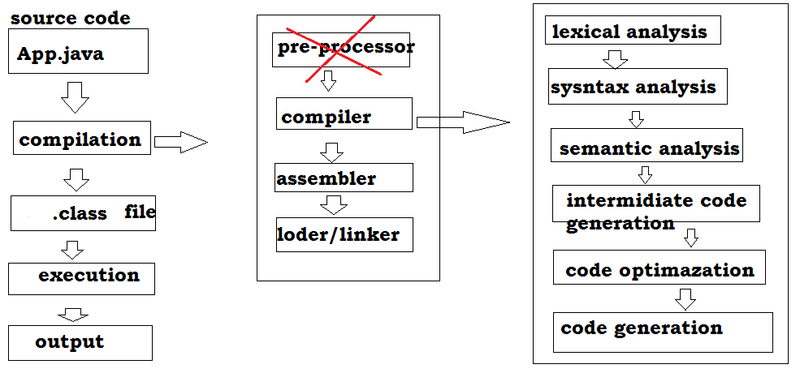In java programming completely pre-defined libraries are provided in the form of packages . in java we need to include packages into our application instead of #include statements.

Ex:
Java.lang.io.*;
Java.lang.*;
If compile our java application java compiler will recognize the import statements but not #include(not pre-processor) statements due to this in C/C++ pre-processor is required but not required in java.
3. Destructors are required in C++ but not required in Java.
In every object oriented programming language it is convention to create an object to store the data in the form of objects and destroy the object after usage.
Generally in object oriented programming languages we can create objects by using constructors and we can destroy the object by using the destructors.
In C++, developers are using constructors to create objects and using the destructors for destroys the objects.
In java, developers will take responsibility only for creating objects by using constructors they are not taking responsibility for destroy the objects why because in java in built Garbage collector is available which automatically destroy the objects.
In java due to availability of Garbage collector it is not required to destroy the object explicitly by the developers.

Features of Java
The main objective of Java programming language creation was to make it portable, simple and secure programming language. Apart from this, there are also some awesome features which play important role in the polularity of this language. The features of Java are also known as java buzzwords.
- Simple
- Object-Oriented
- Portable
- Platform independent
- Secured
- Robust
- Architecture neutral
- Dynamic
- Interpreted
- High Performance
- Multithreaded
- Distributed
1. Simple and Familiar
The main motto of Java designers is to take out the language very simple to practice and develop the code. Many confusing concepts of C++ are simply deleted from Java and right now Java proved that a language can exist without these concepts. Following list gives a few concepts not supported by Java but supported by other object-oriented languages like C++.
1. No support for pointers.
2. No "goto" keyword. The minus point of "goto" is that you loose the command on control flow of the code and thereby debugging becomes a nightmare.
3. No support for unsigned data types.
4. No operator overloading.
5. No preprocessor directives (# define).
6. No multiple inheritance.
7. No garbage values for unassigned data types.
8. No explicit memory management by the developer. Memory management is taken care implicitly.
9. No structures, no templates and no unions.
10. No need to remove unreferenced objects because there is Automatic Garbage Collection in java.
Java looks as if it is a known language, familiar earlier, as much of the syntax is borrowed from C/C++. The control structures, functions, arrays and data types etc. looks the same of C/C++. Even though it is a derivative of C++, Java is fully an independent language where the execution entity is a class.
2. Object-Oriented
Java is Object-oriented programming language. Everything in Java is an object. Object-oriented means we organize our software as a combination of different types of objects that incorporates both data and behaviour.
Object-oriented programming(OOPs) is a methodology that simplifies software development and maintenance by providing some rules.
Basic concepts of OOPs are:
- Object
- Class
- Inheritance
- Polymorphism
- Abstraction
- Encapsulation
Benefits of OOPs
OOPS comes with many advantages over procedure-oriented languages useful for product architects and programmers. The main and foremost advantage is productivity with low-maintenance cost. Following list illustrates a few important.
1. With Java design patterns, the product architects can develop modules that can be integrated later to evolve as a big reusable component.
2. Using objects, a programmer can divide his work into a number entities (units) and coding each entity separately.
3. Data hiding helps to hide the data of one entity (unit or object) from another. This helps to write secured programs that cannot be accessed by other parts of the code.
4. With encapsulation, the same data (variables) can co-exist with different objects but without overlapping and ambiguity.
5. Due to encapsulation, software complexity can be reduced.
6. Inheritance helps reusability of code by avoiding redundancy.
7. Object-oriented systems can be scaled up easily from small to medium or medium to large business systems.
8. Using objects, message servicing systems can be developed easily to integrate modules of a business process.
Platform Independent
Java is platform independent because it is different from other languages like C, C++ etc. which are compiled into platform specific machines while Java is a write once, run anywhere language(WORA)
"Java compiled file known as .class file can be executed on any OS without bothering on which platform (OS) the source code was compiled". That is, a Java source file can be compiled on any OS and executed on the same or any other OS. This is quiet contradictory to other languages like C/C++ where these languages should be executed on the same OS where they were compiled earlier.
Java's Magic of Bytecode:
Bytecode is a new term to the programming world introduced by Java. The compilation product of Java source file is a .class file consisting of bytecode. This bytecode makes Java platform-independent where as the binary code of C/C++ makes C/C++ platform-dependent.
The bytecode is not an ultimate format that is readily understood by the microprocessor. It must be converted into binary code format that can be processed by the microprocessor directly. This conversion is taken care by the JVM. The format conversion takes some time and thereby Java executes slower. Incase of C/C++, they contain binary code directly.
Note: The slow nature is overcome to some extent with the introduction of JIT (Just-In-Time) compiler.
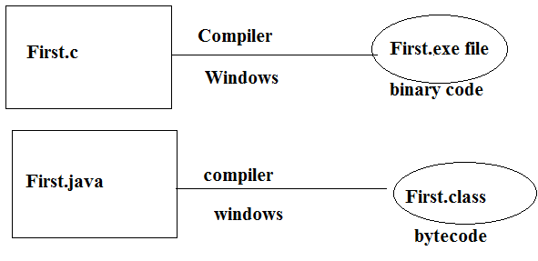
Java Compiler – Is Platform-Independent?
A compiler job is to compile the source code into an executable file. An executable file, as the name indicates, gives output when executed.
The compilers are different for different operating systems. For example, a C/C++ compiler developed for UNIX understands the functions of UNIX but not that of Windows.
Every OS comes with its own set of functions and for every OS operation, the OS makes a function call to do the job. The functions may relate to the resource management like file system, memory and thread operations. Every OS comes with its own functions written in proprietory code. The compiler should thoroughly understand these functions.
Ex: a C/C++ compiler developed for UNIX understands the functions of UNIX but not that of Windows.
For the above rule, Java compiler is not an exception. A Java compiler developed and executed on UNIX does not work on Macintosh etc. That is, Java compiler, like any other compiler, is platform-dependent. The difference with Java compiler is it produces a platform-independent executable file known as .class file.
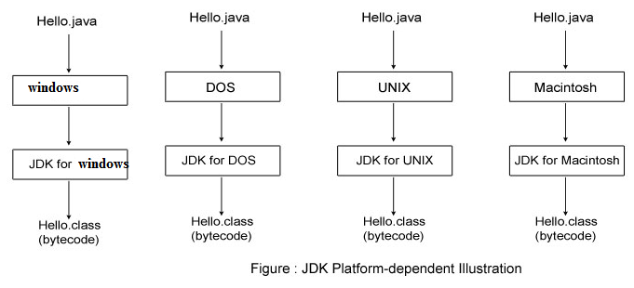
Note: The .class file is not really an executable file because it must be converted in binary code specific to the OS at execution time.
Conclusion:
Note: java is platform independence due to availability of JVM. Java is also called as WORA (Write Once Run Anywhere).
But JVM is platform dependency.
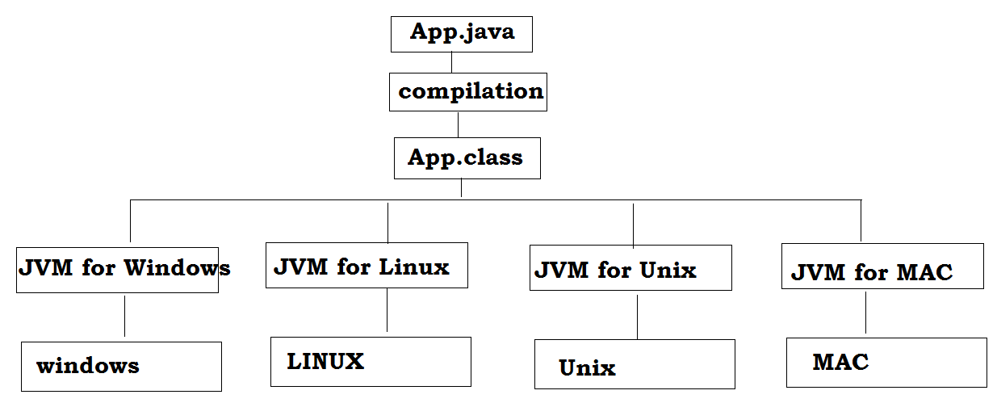

Secured
Java is best known for its security. With Java, we can develop virus-free systems. Java is secured because:
- No explicit pointer.
- Java Programs run inside virtual machine sandbox.
- Classloader: Classloader in Java is a part of the Java Runtime Environment(JRE) which is used to dynamically load Java classes into the Java Virtual Machine. It adds security by separating the package for the classes of the local file system from those that are imported from network sources.
- Bytecode Verifier: It checks the code fragments for illegal code that can violate access right to objects.
- Security Manager: It determines what resources a class can access such as reading and writing to the local disk.
These securities are provided by java language. Some security can also be provided by application developer through SSL, JAAS, Cryptography etc.
Robust
Robust simply means strong. Java is robust because:
- It uses strong memory management.
- There are lack of pointers that avoids security problem.
- There is automatic garbage collection in java.(no need to delete unused object by the programmer )
- There is exception handling and type checking mechanism in java. which takes care of user's mistakes at runtime.
- Java includes a strong type checking for objects and data types both at compile time and runtime.
- Variables must be assigned before they are used.
- Array size should not be given in initialization.
- All these points makes java robust.
Architecture-neutral
Java is architecture neutral because there is no implementation dependent features. The binary code conversion is effected by the JVM. The bytecode is OS architecture neutral. Any OS can execute the bytecode without bothering its architecture.e.g. size of primitive types is fixed.
In C programming, int data type occupies 2 bytes of memory for 32-bit architecture and 4 bytes of memory for 64-bit architecture. But in java, it occupies 4 bytes of memory for both 32 and 64 bit architectures.
Portable
Portability for Java comes from its bytecode. A Java .class file, obtained from the compilation on one platform can be ported or carried, for execution, to a different platform. The necessity is to have a compatible JVM (specific to the platform). JDKs are different for different platforms.

High-performance
Java is faster than traditional interpretation since bytecode is "close" to native code still somewhat slower than a compiled language (e.g., C++). Java is an interpreted language, so it is also a reason that why it is slower than compiled language C, C++.
The designers took utmost care in designing the API libraries like introducing StringBuffer in place of String, StringBuilder in place of StringBuffer, lightweight Swing GUI components in place of AWT heavyweight components. ArrayList (methods are not synchronized) can be used for Vector(methods are synchronized).
Distributed
No language can parallel Java in networking support. Java supports both LAN programming (TCP/IP and UDP) and distributed programming. In distributed computing, the systems in communication are spread across the globe. Again this is of two types – Internet-based and non internet-based. Java includes sockets and server sockets to support socket (LAN) programming (with java.net package), servlets and JSP (with javax.servlet.http package) for Internet-based programming and RMI/EJB (with java.rmi and javax.ejb packages) to support distributed non Internet-based communication. Java wisely knows the utilization of HTTP, SMTP, POP3 and FTP protocols etc. to communicate between systems.
We may access files by calling the methods from any machine on the internet.
Multi-threaded
A thread is like a separate program, executing concurrently. We can write Java programs that deal with many tasks at once by defining multiple threads. The main advantage of multi-threading is that it doesn't occupy memory for each thread. It shares a common memory area. Threads are important for multi-media, Web applications etc.
Dynamic
Generally in coding, one class may require the functionality of another class. At runtime, JRE can search, hook and load the necessary classes required for the smooth execution of the program. Do not bother where the files are, may be on your own local disk or in a server at a far off place, JRE knows well how to play the game dynamically. Java has got built-in support for many protocols like HTTP and FTP using which the JRE can download the classes, files and libraries required for the execution of a program.
Interpreted
Generally, a language like C/C++ is compiled or a HTML is parsed or VBScript is interpreted; but Java is both compiled and interpreted. At compilation stage, the Java source code is converted into a bytecode file. As bytecode cannot be executed by a microprocessor, at runtime, the JVM converts the bytecode into binary code. This platform-specific binary code is executed and generates output. That is, in Java, from source code to the output, two stages exist – compilation and interpretation.
Implicit Memory Management
We know earlier, one of the striking features of Java is its implicit memory management. It avoids much of the tedious code of memory management by the programmer. If a programmer does not manage the memory robustly with utmost care, as in C/C++, the system may crash sometimes while executing the program. The programmer is relieved of the usage of destructors and many functions like malloc(), calloc(), sizeof(), free() and delete() etc.
When Java software starts, it spawns a garbage collector (gc) thread that takes cares of the garbage of a process. The objects not required in further process of a program are treated as garbage. Keeping the memory for unwanted objects is a wastage. The garbage collector removes these garbage objects while execution is going on; even without a message or warning to the programmer.
C++ vs Java:
Comparison Index | C++ | Java
Platform-independent | C++ is platform-dependent. | Java is platform-independent.
Mainly used for | C++ is mainly used for system programming. | Java is mainly used for application programming. It is widely used in window, web-based, enterprise and mobile applications.
Goto | C++ supports goto statement. | Java doesn't support goto statement.
Multiple inheritance | C++ supports multiple inheritance. | Java doesn't support multiple inheritance through class. It can be achieved by interfaces in java.
Operator Overloading | C++ supports operator overloading. | Java doesn't support operator overloading.
Pointers | C++ supports pointers. You can write pointer program in C++. | Java supports pointer internally. But you can't write the pointer program in java. It means java has restricted pointer support in java.
Compiler and Interpreter | C++ uses compiler only. | Java uses compiler and interpreter both.
Call by Value and Call by reference | C++ supports both call by value and call by reference. | Java supports call by value only. There is no call by reference in java.
Structure and Union | C++ supports structures and unions. | Java doesn't support structures and unions.
Thread Support | C++ doesn't have built-in support for threads. It relies on third-party libraries for thread support. | Java has built-in thread support.
Documentation comment | C++ doesn't support documentation comment. | Java supports documentation comment (/** ... */) to create documentation for java source code.
Virtual Keyword | C++ supports virtual keyword so that we can decide whether or not override a function. | Java has no virtual keyword. We can override all non-static methods by default. In other words, non-static methods are virtual by default.
unsigned right shift >>> | C++ doesn't support >>> operator. | Java supports unsigned right shift >>> operator that fills zero at the top for the negative numbers. For positive numbers, it works same like >> operator.
Inheritance Tree | C++ creates a new inheritance tree always. | Java uses single inheritance tree always because all classes are the child of Object class in java. Object class is the root of inheritance tree in java.

Interview question: why pointers are eliminated from java?
1. Pointers lead to confusion for a programmer.
2. Pointers are may crash a program easily, for example, when we add two pointers, the program crashes immediately. The same thing could also happen when we forget to free memory allotted it to some other variable.
3. Pointers break the security. Using pointers, harmful program like virus andother hacking program can be developed.
Structure of the java programming
When we are writing any program in any language we need to follow a standard structure for writing the program which is recommended by the language experts. A java program may contain many classes of which only one class will have a main method. Class will contain data members and methods that operate on the data members of the class. To write a Java program, we first need to define classes and then put them together. Generally a standard java program consists of following blocks as shown in below figure.
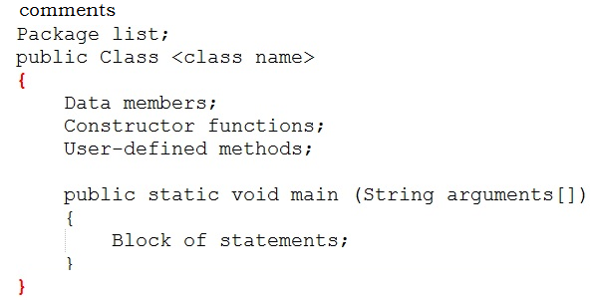
Explanation:
Java Comments
Whenever we want to write a program, we should first think about writing comments. Comments are described about the features of a program. This means that whatever we write in a program should be described using comments.
Note: The java comments are statements that are not executed by the compiler and interpreter. The comments can be used to provide information or explanation about the variable, method, class or any statement. It can also be used to hide program code for specific time.
Why we should write comments?
When we write comments, we can understand what the program is doing as well as it helps others to easily follow our code.
This means readability and understandability of a program will be more. If a program is understandable, then only can it be usable in software. If other members of the software development team cannot understand our program, then they may not be able to use it in project and will reject it.

Types of Java Comments
There are 3 types of comments in java.
- Single Line Comment
- Multi Line Comment
- Documentation Comment
Single Line Comment: These comments are for marking a single line as a comment. These comments starts with double slash (//) and after this, whatever is written till the end of the line is taken as a comment.
Ex: //this is my single line comment
Multi Line Comment: These comments are used for representing several lines as comments. These comments start with (/*) and with (*/) in between /* and*/ whatever is written is treated as a comment.
Ex:
/* this is multi line comment.
This is line-1
This is line-2
This is line-3 */
Documentation Comment: These comments are start with /** and end with */. These comments are used to provide description for every feature in java program. This description proves helpful in the creation of a .html file called API (Application Programming Interface) document.
Note: he documentation comment is used to create documentation API. To create documentation API, you need to use javadoc tool.
/** description about class */
Class Code
---
/** description about method */
method Code
Package:
Package is a collection of classes, interfaces and sub packages. In a java program if we are using any pre-defined classes and interfaces then it is the responsibility of the java programmer to import that particular package containing such specific classes and interface. In java by default java.lang.* package is imported by every program.
Class:
Class is a keyword used for developing user defined data types. Every java program must starts with a prototype of class. The class has been declared public, means all classes can access the class from all packages. Generally, however, we will declare classes in java without specifying a modifier.
Class name:
Class name is the name given to that class. Every class name is treated as one kind of user defined data type.
Data Members:
Data Members represents either instance members or static members.
Constructor:
Constructor function is called when an object of the class is created. It is a block of code that initializes the newly created object. The constructor simply has the same name as the name of the class name. A constructor does not have a return type. A constructor is called automatically when a new instance of an object is created. In the following code, the constructor bird() prints a message.
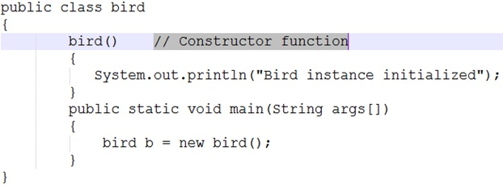
When we create the object of the bird class as shown above:
bird b = new bird();
The new keyword here creates the object of class bird and invokes the constructor to initialize this newly created object.
Constructor and method are different because the constructor is used to initialize the object of a class while the method is used to perform a task by implementing java code. Constructors cannot be declared as abstract, final, static and synchronised while methods can be declared. Constructors do not have return types while methods do.
User-defined methods:
User-defined methods represents either instance (or) static and they will be selected depends on the class name and these methods are used for performing the operations either once (or) repeatedly. All the user-defined methods of a class contain logic for a specific problem. These methods are known as Business logic methods.
Starting a java Program:
Requirement for Hello Java Example
For executing any java program, you need to
- install the JDK if you don't have installed it, download the JDK and install it.
- set path of the jdk/bin directory.
- create the java program
- compile and run the java program
Creating First java example
import java.lang.System;
import java.lang.String;

public class FirstApp {

public static void main(String[] args) {

System.out.println("welcome to java language");
}
}
save this file as FirstApp.java
To compile: | javac FirstApp.java
To execute: | java FirstApp
Parameters used in first java program
Let's see what is the meaning of class, public, static, void, main, String[], System.out.println().

- class keyword is used to declare a class in java.
How to create class?
After importing the classes in to the program, the next step is to write class. Java is a purely object oriented programming language, we cannot write a java program without having at least one class or object.
We can write class by using class keyword then we write the class name.
Class FirstApp
{
//Statements
}
Note: class contain variables and methods
- public keyword is an access modifier which represents visibility, it means it is visible to all.
- static is a keyword, if we declare any method as static, it is known as static method. The core advantage of static method is that there is no need to create object to invoke the static method. The main method is executed by the JVM, so it doesn't require to create object to invoke the main method. So it saves memory.
- void is the return type of the method, it means it doesn't return any value.
- main represents the starting point of the program.
If main() method is not written in a java program JVM will not execute it. main() is the starting point for JVM to start execution of a java program.

- String[] args is used for command line argument.
It simply means that you can pass the run-time command line arguments of type String to the main method. In Java args contains the supplied command-line arguments as an array of String objects.
- System.out.println() is used print statement.
In java print() method is used to display something on monitor.
Print(“welcome to java language”)
But it is not correct way of calling method in java.A method should be called by object.methodname().
To call print() method, we should create an object to the class to which print() belongs. Print method belongs to PrintStream class. So we should call print method by creating an object to PrintStream class
PrintStream obj.println(“welcome to java language”)
But it is not possible to create the object to PrintStream class directly, an alternate is given to us i.e System.out., here system is the class name and out isis static variable name of System class.out is called a field in System class. When we call this field, a PrintStream class object will be created internally. So we call print() method like
System.out.println(“welcome to java language”);
Note: System.out gives the PrintStream class object. This object, by default represents the standard out put device. i.e monitor.
Importing classes:
Suppose we are stating a C/C++ program, the first line of theprogram would generally be:
#include <stdio.h>
This means: a request is made to the C/C++ compiler to include the header file<stdio.h>.
Header file: A header file is a file, which contains the code of functions that will be needed in a program. In other words, to able to use any function in a program, we must first include the heard file containing that function’s code in our program.
Ex: <stdio.h> is the header file that contains functions, like printf(), scanf(), puts(), gets(), etc. so if we want to use any of these functions, we should include this header file in our C/C++ program.
What happens when we include the header file?
The C/C++ compiler goes to the standard library (tc/lib) and searches for the header file there. When it find the header file, it copies the entire header file content into the program where the #include statement is written. Thus, if we write a program of 10lines, then after copying code from the header file, the program size may become 510 lines. These 500 lines are copied physically into program from the header file.
Note: by adding header file our program size increases unnecessarily, wasting memory and processor time.
Similarly, a more efficient mechanism, available in java that is importing classes. First, we should decide which classes are needed in our program. Programmers are interested in two way things
1. Using the classes by creating objects in them.
2. Using the methods (functions) of the classes.
In java methods are available in classes or interfaces.
Interface: It is similar to classes that contain some methods.
A group of classes and interfaces are contains methods and these are contained in a package. A package is kind of directory that contains a group of classes and interfaces.
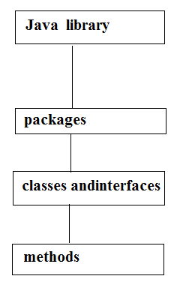
Note: if a programmer wants to use class, then that class should be imported into his program. If he wants to use a method, then that corresponding class or interface should be imported into his program.
In our program we are using two classes namely, System and String. These classes belong to a package called java.lang. So these two classes must be imported into our program
import java.lang.System
import java.lang.String
In import statement, the package name that we have written acts like a reference to the JVM to search for the classes there. JVM will not copy any code from the classes or packages. On the other hand, when a calss name or a method name is used, JVM goes to the java library, execute the code there, comes back, and substitutes the result in that place of the program. Thus , the java program size will not increased.

Q) What is difference b/w #include and import statement?
#include directive makes the compiler go to the C/C++ standard library and copy from the header files in to the program. As a result, the program size increases, thus wasting of memory and processor’s time.
import statement makes the JVM go to the java standard library, execute the code there, and substitute the result in to the program. Here no code copied and hence no waste of memory or processor’s time.
So import statement is an efficient mechanism than #include
Main Method:
Whether the class contains main() method or not, and whether it is properly declared or not, these checking's are not responsibilities of the compiler, at runtime JVM is responsible for this.
If JVM unable to find the required main() method then we will get runtime exception. saying NoSuchMethodError: main.
How many ways can we write a java program?
There are many ways to write a java program. The modifications that can be done in a java program are given below:
1) By changing sequence of the modifiers, method prototype is not changed.
static public void main(String args[])
2) subscript notation in java array can be used after type, before variable or after variable.
public static void main(String[] args)
public static void main(String []args)
public static void main(String args[])
3) You can provide var-args support to main method by passing 3 ellipses (dots)
public static void main(String... args)
5) Instead of args we can use any valid java identifier.
public static void main(String... veeru)
6) main() method can be declared with the following modifiers.
final, synchronized, strictfp.
class FristApp{
static final syncronized strictfp public void main(String... veeru){
System.out.println("hello java");
}
}
4) Having semicolon at the end of class in java is optional.
class FristApp{
static public void main(String... args){
System.out.println("hello java");
}
};

Valid java main method signature
- public static void main(String[] args)
- public static void main(String []args)
- public static void main(String args[])
- public static void main(String... args)
- static public void main(String[] args)
- public static final void main(String[] args)
- final public static void main(String[] args)
- final strictfp public static void main(String[] args)
Invalid java main method signature
- public void main(String[] args)
- static void main(String[] args)
- public void static main(String[] args)
- abstract public static void main(String[] args)
Internal Details of Hello Java Program
At compile time
At compile time, java file is compiled by Java Compiler (It does not interact with OS) and converts the java code into bytecode.
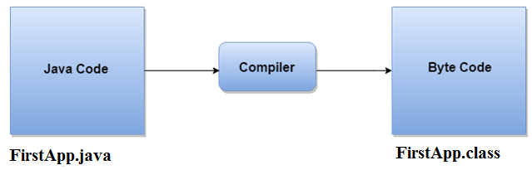
At runtime:
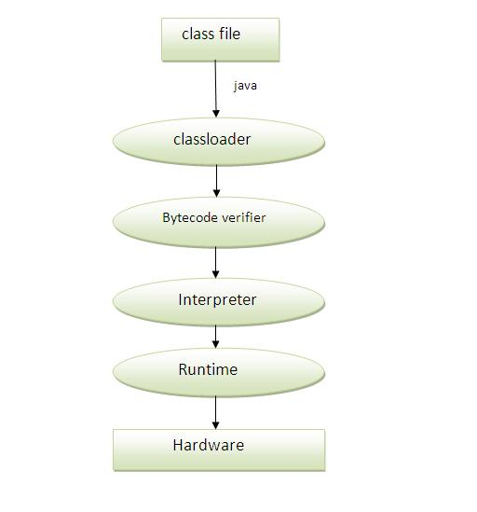
Classloader: is the subsystem of JVM that is used to load class files.
Bytecode Verifier: checks the code fragments for illegal code that can violate access right to objects.
Interpreter: read bytecode stream then execute the instructions.
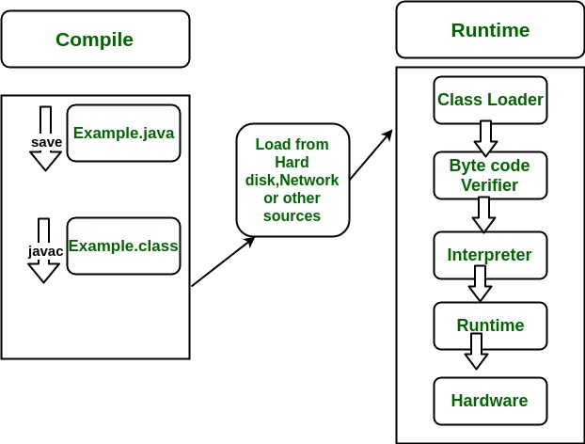
Q) Can you save a java source file by other name than the class name?
Yes, if the class is not public.
class FristApp{
static public void main(String... args){
System.out.println("hello java");
}
}
Save: Veeru.java
Compile: javac Veeru.java
Run: java Firstapp
Q) What is difference b/w print() and println()?
Both methods are used to display the results on the monitor.
Print() method displays the result and then retains the cursor in the same line, next to the end of the result.
Println() method displays the result and then throws the cursor to next line.
Java Fundamentals
Communicating with a computer involves speaking the language the computer understands, which immediately rules out English as the language of communication with computer. However, there is a close analogy between learning English language and learning java language. The classical method of learning English is to first learn the alphabets used in the language, then learn to combine these alphabets to form words, which in turn are combined to form sentences and sentences are combined to form paragraphs.
Learning Java is similar and easier. Instead of straight-away learning how to write programs, we must first know what alphabets, numbers and special symbols are used in Java, then how using them constants, variables and keywords are constructed, and finally how are these combined to form an instruction. A group of instructions would be combined later on to form a program.
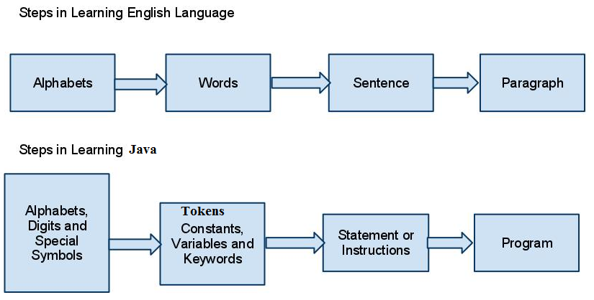
Java Tokens
A java Program is made up of Classes and Methods and in the Methods are the Container of the various Statements And a Statement is made up of Variables, Constants, operators etc.
Tokens are the various Java program elements which are identified by the compiler. A token is the smallest element of a program that is meaningful to the compiler. Tokens supported in Java include keywords, variables, constants, special characters, operations etc.
When you compile a program, the compiler scans the text in your source code and extracts individual tokens. While tokenizing the source file, the compiler recognizes and subsequently removes whitespaces (spaces, tabs, newline and form feeds) and the text enclosed within comments.
public class Tokens {

public static void main(String[] args) {

System.out.println(" Hello java");
}
}
The source code contains tokens such as public, class, Tokens, {, public, static, void, main, (, String, [], args, {, System, out, println, (, "Hello Java", }, }. The resulting tokens are compiled into Java bytecodes that is capable of being run from within an interpreted java environment. Token are useful for compiler to detect errors. When tokens are not arranged in a particular sequence, the compiler generates an error message.
Tokens are the smallest unit of Program There is Five Types of Tokens
1) Identifier
2) Reserve Word or Keywords
3) Literals
4) Operators
5) Separators

IDENTIFIER
In programming languages, identifiers are used for identification purpose.
A name in java program is called identifier. It may be class name, method name, variable name and label name.
- Test : class name.
- main : method name.
- String : predefined class name.
- args : variable name.
- x : variable name.
Rules to define java identifiers
There are certain rules for defining a valid java identifiers. These rules must be followed; otherwise we get compile-time error. These rules are also valid for other languages like C,C++.
Rule 1: The only allowed characters in java identifiers are:
1) a to z
2) A to Z
3) 0 to 9
4) _ (underscore)
5) $
Rule 2: If we are using any other character we will get compile time error.
Example:
1) total_number-------valid
2) Total#------------------invalid
Ex:
class Identifer
{
public static void main(String[] args)
{
int total_number;//valid
int Total#;//invalid -illegal character
}
}
Rule 3: identifiers are not allowed to starts with digit.
Example:
1) ABC123---------valid
2) 123ABC---------invalid

Ex:
class Identifer
{
public static void main(String[] args)
{
int marks2;//valid
int 123marks;//invalid-compiletime error
}
}
Rule 4: java identifiers are case sensitive up course java language itself treated as case sensitive language.
Example:
class Identifer {
int number=10;
int Number=20;
int NUMBER=20; we can differentiate with case.
int NuMbEr=30;
}
Rule 5: There is no length limit for java identifiers but it is not recommended to take more than 15 lengths.
Rule 6: We can't use reserved words as identifiers.
Example:
int if=10; --------------invalid
class Identifer
{
public static void main(String[] args)
{
int if=10; //invalid-compiletime error
}
}
Rule 7: All predefined java class names and interface names we use as identifiers.
Example 1:
class Test
{
public static void main(String[] args){
int String=10;
System.out.println(String);
}
}
Output:
10
Example 2:
class Test
{
public static void main(String[] args){
int Runnable=10;
System.out.println(Runnable);
}
}
Output:
10
Even though it is legal to use class names and interface names as identifiers but it is not a good programming practice.
Which of the following are valid java identifiers?
Reserved words
In java some identifiers are reserved to associate some functionality or meaning such type of reserved identifiers are called reserved words.
Diagram:
Reserved words for data types: (8)
1) byte
2) short
3) int
4) long
5) float
6) double
7) char
8) boolean

Reserved words for flow control:(11)
1) if
2) else
3) switch
4) case
5) default
6) for
7) do
8) while
9) break
10) continue
11) return
Keywords for modifiers:(11)
1) public
2) private
3) protected
4) static
5) final
6) abstract
7) synchronized
8) native
9) strictfp(1.2 version)
10) transient
11) volatile
Keywords for exception handling:(6)
1) try
2) catch
3) finally
4) throw
5) throws
6) assert(1.4 version)
Class related keywords :(6)
1) class
2) package
3) import
4) extends
5) implements
6) interface
Object related keywords:(4)
1) new
2) instanceof
3) super
4) this
Void return type keyword:
If a method won't return anything compulsory that method should be declared with the void return type in java but it is optional in C++.
1) void
Unused keywords:
goto: Create several problems in old languages and hence it is banned in java.
Const: Use final instead of this.
By mistake if we are using these keywords in our program we will get compile time error.
Reserved literals
1) true values for boolean data type.
2) false
3) null----------------- default value for object reference.
Enum:
This keyword introduced in 1.5v to define a group of named constants
Example:
enum Beer
{
KF, RC, KO, FO;
}
Conclusions :
1. All reserved words in java contain only lowercase alphabet symbols.
2. New keywords in java are:
3. strictfp-----------1.2v
4. assert-------------1.4v
5. enum--------------1.5v
Note: In java we have only new keyword but not delete because destruction of useless objects is the responsibility of Garbage Collection.
Confusion keywords:
instanceof but not instanceOf
strictfp but not strictFp
const but not Constant
syncronized but not syncronize
extends but not extend
implements but not implement
import but not imports
int but not Int
Which of the following list contains only java reserved words ?
1. final, finally, finalize (invalid) //here finalize is a method in Object class.
2. throw, throws, thrown(invalid) //thrown is not available in java
3. break, continue, return, exit(invalid) //exit is not reserved keyword
4. goto, constant(invalid) //here constant is not reserved keyword
5. byte, short, Integer, long(invalid) //here Integer is a wrapper class
6. extends, implements, imports(invalid) //imports keyword is not available in java
7. finalize, synchronized(invalid) //finalize is a method in Object class
8. instanceof, sizeOf(invalid) //sizeOf is not reserved keyword
9. new, delete(invalid) //delete is not a keyword
10. None of the above (valid)
Which of the following are valid java keywords?
1. public(valid)
2. static(valid)
3. void(valid)
4. main(invalid)
5. String(invalid)
6. args(invalid)

Data Types in Java
A data type is a classification of data, which can store a specific type of information.
Ex:
class DataType1
{
public static void main(String[] args)
{
//x=10;
//System.out.println(x);//cannot find symbol
int x=10;
System.out.println(x);
//int y=10.9;//10.9--double
//System.out.println(x);// possible loss of precision
//c=a+b;// cannot find symbol
int a=0,b=0;
int c=a+b;
}
}
Data types represent the different values to be stored in the variable.
Data type declaration should be done when the variable is declared. It is required in Java as Java is a strongly typed language. The data type indicates what possible values that can be assigned to variable and possible operations that can be performed. The language system allocates memory to the variable on the type of data it can hold like an integer or double etc.
In java, there are two types of data types:
- Primitive data types
- Non-primitive data types
Primitive data types
Primitive data types are predefined by the language and named by a keyword.
It means:
Primitive types are the most basic data types available within the Java language. There are 8: boolean , byte , char , short , int , long , float and double .
Note:String in Java is not a data type. String is a class from java.lang package. String is not a keyword; for that matter no class is a keyword. Strings are used very often in coding like data types.
Non-primitive data types
Non-primitive data types are not defined by the programming language, but are instead created by the programmer. They are sometimes called "reference variables," or "object references," since they reference a memory location, which stores the data.
In the Java programming language, non-primitive data types are simply called "objects" because they are created, rather than predefined. While an object may contain any type of data, the information referenced by the object may still be stored as a primitive data type.
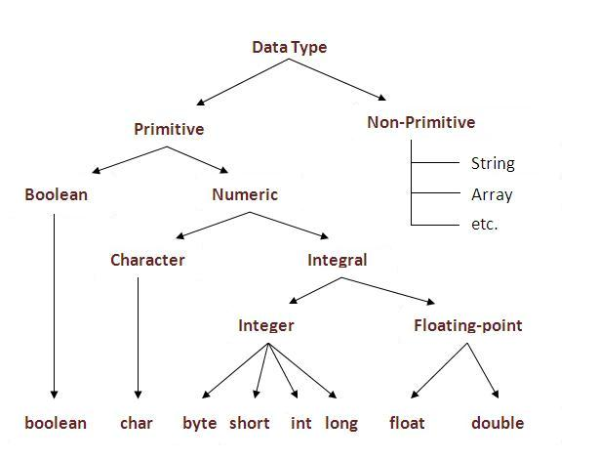
Note: In java Every variable has a type, every expression has a type and all types are strictly define more over every assignment should be checked by the compiler by the type compatibility hence java language is considered as strongly typed programming language.
Note: Except Boolean and char all remaining data types are considered as signed data types because we can represent both "+ve" and"-ve" numbers.
Integral data types:
byte:
- Byte data type is an 8-bit signed two's complement integer
- Minimum value is -128 (-2^7)
- Maximum value is 127 (2^7 -1)
- Default value is 0
- Byte data type is used to save space in large arrays, mainly in place of integers, since a byte is four times smaller than an integer.
- Example: byte a = 100, byte b = -50
The most significant bit acts as sign bit. "0" means "+ve" number and "1" means "–ve" number. "+ve" numbers will be represented directly in the memory whereas "–ve" numbers will be represented in 2's complement form.
Examples on byte:
class ByteExample
{
public static void main(String[] args)
{
byte b1=10;
byte b2=127;
byte b3=-128;
System.out.println(b1);//10
System.out.println(b2);//127
System.out.println(b3);//-128
}
}

Ex-2:
class ByteExample
{
public static void main(String[] args)
{
byte b1=10.5; //double is bigger than byte
System.out.println(b1);
}
}
Java 1.8: Compile time error: incompatible types: possible lossy conversion from double to byte
In java 1.7:
C.E:possible loss of precision
found : double
required : byte
Ex-3:
class ByteExample
{
public static void main(String[] args)
{
byte b1=128; //its integer type
System.out.println(b1);
}
}
Compile time error: incompatible types: possible lossy conversion from double to byte
In java 1.7:
C.E:possible loss of precision
found : int
required : byte
Ex-4
class ByteExample
{
public static void main(String[] args)
{
byte b1="Veeru";//its String type so mis match
System.out.println(b1);
}
}
Compile time: error: incompatible types: String cannot be converted to byte
In java 1.7:
C.E:incompatible types
found : java.lang.String
required : byte
Ex-5:
class ByteExample
{
public static void main(String[] args)
{
byte b1=true;//its Boolean data type
System.out.println(b1);
}
}
Compile time: error: incompatible types: boolean cannot be converted to byte

Ex-6:
class ByteExample
{
public static void main(String[] args)
{
byte b1=veeru;//its not any data type
System.out.println(b1);
}
}
Compile time: error: cannot find symbol
symbol: variable veeru
location: class ByteExample
Ex-7:
class ByteExample
{
public static void main(String[] args)
{
byte b1=’a’;
System.out.println(b1);
}
}
Output :97
Usage of Byte:
Byte data type is best suitable if we are handling data in terms of streams either from the file or from the network.
Short:
The most rarely used data type in java is short.
- Short data type is a 16-bit signed two's complement integer
- Minimum value is -32,768 (-2^15)
- Maximum value is 32,767 (inclusive) (2^15 -1)
- Short data type can also be used to save memory as byte data type. A short is 2 times smaller than an integer
- Default value is 0.
- Example: short s = 10000, short r = -20000
Ex :
class ShortExample
{
public static void main(String[] args)
{
short s1=10;
short s2=32767;
short s3=-32768;

System.out.println(s1);//10
System.out.println(s2);//32767
System.out.println(s3);//-32768
}
}
Ex-2:
class ShortExample
{
public static void main(String[] args)
{
short s1=32768;
System.out.println(s1);

}
}
Java 1.7: Compile time error:: possible loss of precision
required: short
found: int
java 1.8: error: incompatible types: possible lossy conversion from int to short
Ex-3:
class ShortExample
{
public static void main(String[] args)
{
short s1=true;
System.out.println(s1);
}
}
Java 1.7: Compile time error: incompatible types
required: short
found: boolean
java 1.8: error: incompatible types: boolean cannot be converted to short
Ex-4:
class ShortExample
{
public static void main(String[] args)
{
short s1="String";
System.out.println(s1);
}
}
Compile time: java 1.8: incompatible types: String cannot be converted to short
Java 1.7: error: incompatible types
required: short
found: String
Ex-4:
class ShortExample
{
public static void main(String[] args)
{
short s1=John;
System.out.println(s1);
}
}
Compile time: error: cannot find symbol
symbol: variable John
location: class ShortExample
Note: Short data type is best suitable for 16 bit processors like 8086 but these processors are completely outdated and hence the corresponding short data type is also out data type.
Int:
This is most commonly used data type in java.
- Int data type is a 32-bit signed two's complement integer.
- Minimum value is - 2,147,483,648 (-2^31)
- Maximum value is 2,147,483,647(inclusive) (2^31 -1)
- Integer is generally used as the default data type for integral values unless there is a concern about memory.
- The default value is 0
- Example: int a = 100000, int b = -200000
Ex-1:
class IntExample
{
public static void main(String[] args)
{
int i1=-2147483648;
int i2=2147483647;
System.out.println(i1);// -2147483648
System.out.println(i2);// 2147483647
}
}
Ex-2:
class IntExample
{
public static void main(String[] args)
{
int i1=2147483648;
System.out.println(i1);
}
}
Compile time: error: integer number too large: 2147483648

Ex-3:
class IntExample
{
public static void main(String[] args)
{
int i1=true;
System.out.println(i1);
}
}
Compile time: IntExample.java:5: error: incompatible types
required: int
found: Boolean
java 1.8: IntExample.java:5: error: incompatible types: boolean cannot be converted to int
Ex-4:
class IntExample
{
public static void main(String[] args)
{
int i1=True;
System.out.println(i1);
}
}
Compile time:error: cannot find symbol
symbol: variable True
location: class IntExample
Ex-5:
class IntExample
{
public static void main(String[] args)
{
int i1=10.5;
System.out.println(i1);
}
}
Compile time: error: possible loss of precision
required: int
found: double
Ex-5:
class IntExample
{
public static void main(String[] args)
{
int i1='a';
System.out.println(i1);
}
}
Note: In Java SE 8 and later, we can use the int data type to represent an unsigned 32-bit integer, which has value in range [0, 2³²-1]. Use the Integer class to use int data type as an unsigned integer.

Ex-6:
class IntExample
{
public static void main(String[] args)
{
int i=-2;
long ui = Integer.toUnsignedLong(i);
System.out.println(ui);// 4294967294
}
}
long:
Whenever int is not enough to hold big values then we should go for long data type.
Ex:
To hold the no. Of characters present in a big file int may not enough hence the return type of length() method is long.
long l=f.length();//f is a file
- Long data type is a 64-bit signed two's complement integer
- Minimum value is -9,223,372,036,854,775,808(-2^63)
- Maximum value is 9,223,372,036,854,775,807 (inclusive)(2^63 -1)
- This type is used when a wider range than int is needed
- Default value is 0L
- Example: long a = 100000L, long b = -200000L

float
- Float data type is a single-precision 32-bit IEEE 754 floating point
- Float is mainly used to save memory in large arrays of floating point numbers
- Default value is 0.0f
- Float data type is never used for precise values such as currency
- Example: float f1 = 234.5f
Ex-1:
class FloatExample
{
public static void main(String[] args)
{
float f=10;//valid
System.out.println(f);//10.0

float f2=10.5;
System.out.println(f2);

float f3=10.5f;
System.out.println(f3);//10.5
}
}
Compile time : error: possible loss of precision
required: float
found: double

Ex-2:
class FloatExample
{
public static void main(String[] args)
{
float f=true;
System.out.println(f);
}
}
Compile timr: error: incompatible types
required: float
found: Boolean
java 1.8: incompatible types: boolean cannot be converted to float
Ex-3:
class FloatExample
{
public static void main(String[] args)
{
float f=True;
System.out.println(f);
}
}
Compile timr: error: cannot find symbol
symbol: variable True
location: class FloatExample

Ex-4
class FloatExample
{
public static void main(String[] args)
{
float f="True";
System.out.println(f);
}
}
Compile timr: error: incompatible types
required: float
found: String
java 1.8: incompatible types: String cannot be converted to float
Ex-4 :
class FloatExample
{
public static void main(String[] args)
{
float f='b';
System.out.println(f);//980.
}
}
Note: In Java SE 8 and later, you can use the long data type to represent an unsigned 64-bit long, which has a minimum value of 0 and a maximum value of 2⁶⁴-1. The Long class also contains methods like compareUnsigned, divideUnsigned etc to support arithmetic operations for unsigned long.

double
- double data type is a double-precision 64-bit IEEE 754 floating point
- This data type is generally used as the default data type for decimal values, generally the default choice
- Double data type should never be used for precise values such as currency
- Default value is 0.0d
- Example: double d1 = 123.4
Floating Point Data types:
Float | double
If we want to 5 to 6 decimal places of  accuracy then we should go for float. | If we want to 14 to 15 decimal places of accuracy then we should go for double.
Size:4 bytes. | Size:8 bytes
Range:-3.4e38 to 3.4e38. | -1.7e308 to1.7e308.
float follows single precision. | double follows double precision.

boolean
- boolean data type represents one bit of information
- There are only two possible values: true and false
- Size: Not applicable (virtual machine dependent)
- This data type is used for simple flags that track true/false conditions
- Default value is false
- Example: boolean one = true
class BooleanExample
{
public static void main(String[] args)
{
boolean b=true;
System.out.println(b);//true
}
}
Ex-2:
class BooleanExample
{
public static void main(String[] args)
{
boolean b=True;
System.out.println(b);
}
}

Compile timr:error: cannot find symbol
symbol: variable True
location: class BooleanExample
Ex-3:
class BooleanExample
{
public static void main(String[] args)
{
boolean b="True";
System.out.println(b);
}
}
Compile timr:error:incompatible types
required: boolean
found: String
Ex:
class BooleanExample
{
public static void main(String[] args)
{
boolean b=10;
System.out.println(b);
}
}
Compile timr:error:incompatible types
required: boolean
found: int

Why Boolean data types take zero byte of memory ?
Boolean data type takes zero bytes of main memory space because Boolean data type of java implemented by Sun Micro System with a concept of flip - flop. A flip - flop is a general purpose register which stores one bit of information (one true and zero false).
Note: In C, C++ (Turbo) Boolean data type is not available for representing true false values but a true value can be treated as non-zero value and false values can be represented by zero
char
- char data type is a single 16-bit Unicode character
- Minimum value is '\u0000' (or 0)
- Maximum value is '\uffff' (or 65,535 inclusive)
- Char data type is used to store any character
- Example: char letterA = 'A'
In old languages like C & C++ are ASCII code based the no.Of ASCII code characters are < 256 to represent these 256 characters 8 - bits enough hence char size in old languages 1 byte.
In java we are allowed to use any worldwide alphabets character and java is Unicode based and no.Of unicode characters are > 256 and <= 65536 to represent all these characters one byte is not enough compulsory we should go for 2 bytes.
Why Java take 2 byte of memory for store character ?
Java support more than 18 international languages so java take 2 byte for characters, because for 18 international language 1 byte of memory is not sufficient for storing all characters and symbols present in 18 languages. Java supports Unicode but c support ascii code. In ascii code only English language are present, so for storing all English latter and symbols 1 byte is sufficient. Unicode character set is one which contains all the characters which are available in 18 international languages and it contains 65536 characters
Ex-1:
class CharExample
{
public static void main(String[] args)
{
char c='a';
System.out.println(c);//a
}
}
Ex-2:
class CharExample
{
public static void main(String[] args)
{
char c=100;
System.out.println(c);//d
}
}
Ex-:
class CharExample
{
public static void main(String[] args)
{
char c=65536;
System.out.println(c);
}
}

Compile timr:error:possible loss of precision
required: char
found: int
Summary of java primitive data type:

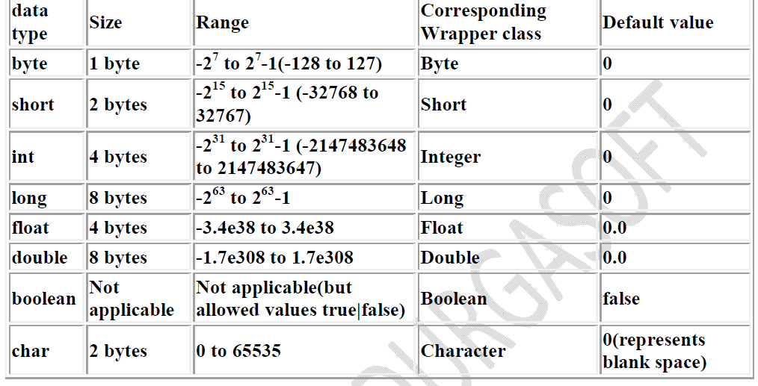
The default value for the object references is "null".

Literals
Any constant value which can be assigned to the variable is called literal.
Example:
Java Constants is a most fundamental and essential part of Java programming language.
It is an identifier whose value cannot be changed at the execution time of program. In general constant can be used to represent as fixed values in a Java program.
Java Constants are also like normal variables. But, only difference is, their values cannot be modified by the program once they are defined.
Constants refer to fixed values. They are also called as literals
Constants may be belonging to any of the data type.
TYPES OF C CONSTANT:
Integral Literals:
For the integral data types (byte, short, int and long) we can specify literal value in the following ways.
- An integer constant must have at least one digit.
- An integer constant refers to a sequence of digits without a decimal point.
- It can either be positive or negative.
- No commas or blanks are allowed within an integer constant.
- If no sign precedes an integer constant, it is assumed to be positive.
- The allowable range for integer constants is -2147483648 to 21474847.
Ex: 426
+782
-8000
-7605
There are three types of integer constants namely,
a) Decimal integer constant
b) Octal integer constant
c) Hexadecimal integer constant
Ex:
class Literals
{
public static void main(String[] args)
{
int num=786;
int marks=-89;
int num2=0777;
int num3=0xface;
System.out.println(num+"--"+marks+"--"+num2+"--"+num3);
}
}
Output: 786---89--511--64206
1) Decimal literals:
Allowed digits are 0 to 9.
Example: int x=10;
The base value of decimal number system is 10,
- It consists of any combinations of digits taken from the set 0 through 9, preceded by an optional – or + sign.
- The first digit must be other than 0.
- Embedded spaces, commas, and non-digit characters are not permitted between digits.
Valid: 0 32767 -9999 -23
Invalid:
12,245 - Illegal character (,)
10 20 30 - Illegal character (blank space)
2) Octal literals:
Allowed digits are 0 to 7. Literal value should be prefixed with zero.
Example: int x=010;
- It consists of any combinations of digits taken from the set 0 through 7.
- If a constant contains two or more digits, the first digit must be 0.
- In programming, octal numbers are used.
Valid: 037 0 0435
Invalid:
0786 - Illegal digit 8
123 - Does not begin with zero
01.2 - Illegal character (.)
Ex:
class Literals
{
public static void main(String[] args)
{
int num2=0777;//valid
int num3=0786;//invalid-integer number too large: 0786
System.out.println(num2+"--"+num3);
}
}
3) Hexa Decimal literals:
• The allowed digits are 0 to 9, A to Z.
• For the extra digits we can use both upper case and lower case characters.
• This is one of very few areas where java is not case sensitive.
• Literal value should be prefixed with ox(or)oX.
Example: int x=0x10;
These are the only possible ways to specify integral literal.
Ex:
class Literals
{
public static void main(String[] args)
{
int x=0777; //(valid)
int x=0786; //C.E:integer number too large: 0786(invalid)
int x=0xFACE; //(valid)
int x=0xbeef; //(valid)
int x=0xBeer; //C.E:';' expected(invalid) //:int x=0xBeer; ^// ^
int x=0xabb2cd;(valid)
}
}
Which of the following are valid declarations?
1. int x=0777; //(valid)
2. int x=0786; //C.E:integer number too large: 0786(invalid)
3. int x=0xFACE; (valid)
4. int x=0xbeef; (valid)
5. int x=0xBeer; //C.E:';' expected(invalid) //:int x=0xBeer; ^// ^
6. int x=0xabb2cd;(valid)

Interview:
class Literals
{
public static void main(String[] args)
{
int x=10;
int y=010;
int z=0x10;
System.out.println(x+"----"+y+"----"+z); //10----8----16
}
}
Note: By default every integral literal is int type but we can specify explicitly as long type by suffixing with small "l" (or) capital "L".
Example:
class Literals
{
public static void main(String[] args)
{
int x=10;(valid)
long l=10L;(valid)
long l=10;(valid)
int x=10l;//C.E:possible loss of precision(invalid)
//found : long
//required : int
}
}
Note: There is no direct way to specify byte and short literals explicitly. But whenever we are assigning integral literal to the byte variables and its value within the range of byte compiler automatically treats as byte literal. Similarly short literal also.
Example:
class Literals
{
public static void main(String[] args)
{
byte b=127;//(valid)
byte b=130;//C.E:possible loss of precision(invalid)
short s=32767;//(valid)
short s=32768;//C.E:possible loss of precision(invalid)
}
}

Floating Point Literals:
Constants in Java are fixed value that does not change during the execution of a program. A real constant is combination of a whole number followed by a decimal point and the fractional part.
Example: 0.0083 -0.75 .95 215.
- A real constant must have at least one digit
- It must have a decimal point
- It could be either positive or negative
- If no sign precedes an integer constant, it is assumed to be positive.
- No commas or blanks are allowed within a real constant.
Use of Real or Floating-point constants
Integer numbers are inadequate to represent quantities that vary continuously, such as distances, heights, temperatures, prices and so on. These quantities are represented by numbers containing fractional part. Such numbers are called real or floating point constants.
The Real or Floating-point constants can be written in two forms:
1. Fractional or Normal form
2. Exponential or Scientific form
Express a Real constant in fractional form
A real constant consists for a series of digits representing the whole part of the number, followed by a decimal point, followed by a series of representing the fractional part. The whole part or the fractional part can be omitted, but both cannot be omitted. The decimal cannot be omitted. That is, it is possible that the number may not have digits before the decimal point or after the decimal point.
Valid Real constants (Fractional): 0.0 -0.1 +123.456 .2 2.
Invalid Real constant: - 1 - a decimal point is missing
1, 2.3 - Illegal character (.)
Rules for Constructing Real Constants in Fractional Form
1. A real constant must have at least one digit.
2. It must have a decimal point.
3. It could be either positive or negative.
4. Default sign is positive.
5. Commas or blanks are not allowed within a real constant.
Express a real constant in Exponential form
A real constant is combination of a whole number followed by a decimal point and the fractional part. If the value of a constant is either too small or too large, exponential form of representation of real constants is usually used.
In exponential form, the real constant is represented in two parts.
Mantissa
The part appearing before e, the mantissa is either a real number expressed in decimal notation or an integer.
Exponent -
The part following e, the exponent is an integer with an optional plus or minus sign followed by a series of digits. The letter e separating the mantissa and the exponent can be written in either lowercase or uppercase.
Example:
0.000342 can be represented in exponential form as 3.42e-4
7500000000 can be represented in exponential form as 7.5e9 or 75E8
Note: Floating point literal is by default double type but we can specify explicitly as float type by suffixing with f or F.
Example:
class Literals
{
public static void main(String[] args)
{
float f=123.456;//C.E:possible loss of precision(invalid)
float f=123.456f;//(valid)
double d=123.456;//(valid)
}
}
We can specify explicitly floating point literal as double type by suffixing with d or D.
Example:
double d=123.456D;
We can specify floating point literal only in decimal form and we can't specify in octal and hexadecimal forms.

Example:
class Literals
{
public static void main(String[] args)
{
double d=123.456;//(valid)
double d=0123.456;//(valid) //it is treated as decimal value but not octal
double d=0x123.456;//C.E:malformed floating point literal(invalid)
}
}
Which of the following floating point declarations are valid?
1. float f=123.456; //C.E:possible loss of precision(invalid)
2. float f=123.456D; //C.E:possible loss of precision(invalid)
3. double d=0x123.456; //C.E:malformed floating point literal(invalid)
4. double d=0xFace; (valid)
5. double d=0xBeef; (valid)
Note: We can assign integral literal directly to the floating point data types and that integral literal can be specified in decimal , octal and Hexa decimal form also.

Example:
class Literals
{
public static void main(String[] args)
{
double d=0xBeef;
System.out.println(d);//48879.0
}
}
But we can't assign floating point literal directly to the integral types.
Example:
int x=10.0;//C.E:possible loss of precision
We can specify floating point literal even in exponential form also(significant notation).
Example:
class Literals
{
public static void main(String[] args)
{
double d=10e2;//==>10*102(valid)
System.out.println(d);//1000.0
float f=10e2;//C.E:possible loss of precision(invalid)
float f=10e2F;//(valid)
}
}
Boolean literals:
The only allowed values for the boolean type are true (or) false where case is important. i.e., lower case
Example:
class Literals
{
public static void main(String[] args)
{
boolean b=true;//(valid)
boolean b=0;//C.E:incompatible types(invalid)
boolean b=True;//C.E:cannot find symbol(invalid)
boolean b="true";//C.E:incompatible types(invalid)

}
}
Char literals:
1) A char literal can be represented as single character within single quotes.
Example:
class Literals
{
public static void main(String[] args)
{
char ch='a';(valid)
char ch=a;//C.E:cannot find symbol(invalid)
char ch="a";//C.E:incompatible types(invalid)
char ch='ab';//C.E:unclosed character literal(invalid)
}
}
2) We can specify a char literal as integral literal which represents Unicode of that character.
We can specify that integral literal either in decimal or octal or hexadecimal form but allowed values range is 0 to 65535.
Example:
class Literals
{
public static void main(String[] args)
{
char ch=97;/// (valid)
char ch=0xFace;// (valid)
System.out.println(ch); //?
char ch=65536; //C.E: possible loss of precision(invalid)
}
}
3) We can represent a char literal by Unicode representation which is nothing but
‘\uxxxx' (4 digit hexa-decimal number) .
Example:
class Literals
{
public static void main(String[] args)
{
char ch='\ubeef';
char ch1='\u0061';
System.out.println(ch1); //a
char ch2=\u0062; //C.E:cannot find symbol
char ch3='\iface'; //C.E:illegal escape character
//note:Every escape character in java acts as a char literal.
}
}
Example:
1) char ch='\n'; //(valid)
2) char ch='\l'; //C.E:illegal escape character(invalid)
Escape Character:
Which of the following char declarations are valid?
1. char ch=a; //C.E:cannot find symbol(invalid)
2. char ch='ab'; //C.E:unclosed character literal(invalid)
3. char ch=65536; //C.E:possible loss of precision(invalid)
4. char ch=\uface; //C.E:illegal character: \64206(invalid)
5. char ch='/n'; //C.E:unclosed character literal(invalid)
6. none of the above. (valid)

String literals:
Any sequence of characters with in double quotes is treated as String literal.
Example:
String s="Veeru"; (valid)
1.7 Version enhansements with respect to Literals:
The following 2 are enhansements
1. Binary Literals
2. Usage of '_' in Numeric Literals
Binary Literals :
For the integral data types untill 1.6v we can specified literal value in the following ways
1. Decimal
2. Octal
3. Hexa decimal
But from 1.7v onwards we can specified literal value in binary form also.
The allowed digits are 0 to 1.
Lit:eral value should be prefixed with Ob or OB.
Ex:
class Literals
{
public static void main(String[] args)
{
int x = 0b111;
System.out.println(x); // 7
}
}
Usage of _ symbol in numeric literals :
From 1.7v onwards we can use underscore(_) symbol in numeric literals.
double d = 123456.789; //valid
double d = 1_23_456.7_8_9; //valid
double d = 123_456.7_8_9; //valid
The main advantage of this approach is readability of the code will be improved At the time of compilation ' _ ' symbols will be removed automatically , hence after compilation the above lines will become double d = 123456.789
We can use more than one underscore symbol also between the digits.
Ex : double d = 1_23_ _456.789;
We should use underscore symbol only between the digits
double d=_1_23_456.7_8_9; //invalid
double d=1_23_456.7_8_9_; //invalid
double d=1_23_456_.7_8_9; //invalid

We can convert :
class Literals
{
public static void main(String[] args)
{
double d='a';
System.out.println(d); //97 integral data types
float f=10L;
System.out.println(f); //10.0 floating-point data types
}
}
Diagram:

Java Variables
A variable is a container which holds the value while the java program is executed. A variable is assigned with a datatype.
Variable is a name of memory location.
Variable is name of reserved area allocated in memory.
In other words, it is a name of memory location. It is a combination of "vary + able" that means its value can be changed.
Scenario: Consider real time example , suppose we need to store water then we can store water in glass if quantity of water is small and Bucket is the quantity of water is large. And big can to store water having quantity larger than bucket similarly Variable (i.e Value container) may have different size for storing different verities of values.

How variable occupy the space in memory:
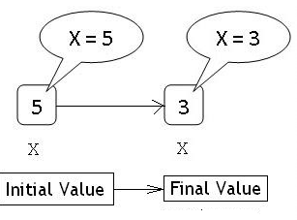
- Initially 5 is Stored in memory location and name x is given to it
- After We are assigning the new value (3) to the same memory location
- This would Overwrite the earlier value 5 since memory location can hold only one value at a time
- Since the location ‘x’ can hold Different values at different time so it is refered as ‘Variable‘
- In short Variable is name given to Specific memory location or Group.
Syntax:
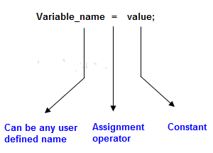
Step 1: Memory before Variable Declaration
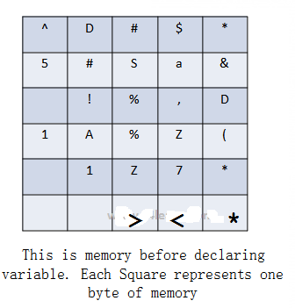
Initially before declaring variable ,We have Only memory. Memory is block of bytes. Each byte is filled with random or garbage data.

Step 2: Declaring Variable
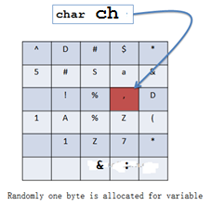
- Now we have declared a variable.
- Compiler Checks data type . Depending on data type it will allocate appropriate bytes of memory. (in this case Compile will allocate 1 byte because we have declared Character data type)
- It’s only declaration so, garbage value inside that address remains the same.
Step 3: Initialize Variable
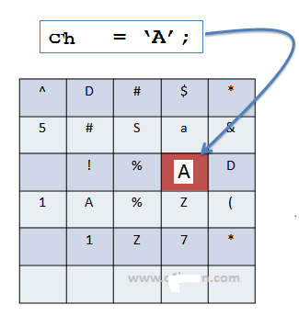
- We have Initialize character variable now.
After initializing value inside that memory block gets overwritten
C variable naming rules:
- Characters Allowed :
  - Underscore(_) and dollar ($)
  - Capital Letters ( A – Z )
  - Small Letters ( a – z )
  - Digits ( 0 – 9 )
Ex: 1. num
2. Num
3. Num1
4. _NUM
5. NUM_temp2
2. Blanks are not allowed
Ex: number 1
num 1
Addition of program
3. No Special Symbols other than underscore(_) and Doller($) are allowed
Ex:
num_1
number_of_values
status_flag

Note: First Character should be alphabet or Underscore
_num1
Invalid Identifier
1num
1_num
365_days
4.Variable name Should not be Reserved Word
- C is case sensitive.
- However if we capitalize any Letter from Reserve word then it will become legal variable name.
Valid Identifier
iNt
Char
Continue
CONTINUE
Invalid Identifier
int
char
continue

7. Name of identifier cannot be exactly same as of name of another identifier.
int num = 15;
int num = 20;
class Variable
{
public static void main(String[] args)
{
int num = 15;
int num = 20;//error-num is already defined in main
}
}
Invalid Example: We cannot declare same variable twice within same scope
Conclusion:
- Do not Create unnecessarily long variable name
- Do not use underscore as first character to avoid confusion.
- Variable names are case-Sensitive. i.e sum, Sum, SUM these all three are different variable names.
- Reserve words with one/more Capital letters allowed eg. Int, Float, chAr are allowed but try to skip them.

class Variable
{
public static void main(String[] args)
{
//int char = 15;//invalid
int Char = 20;//valid
}
}
variable declaration in Java programming:
This is the process of allocating sufficient memory space for the data in term of variable.
- To Declare is nothing but to represent a variable.
- Only Variable name and its Data type is Represented in Declaration.
- We cannot use variable inside program expression or in program statements without declaring.
- Declaring a variable just give rough idea to compiler that there is something which is of type “<Data Type Specified>” and will be used in the program.
- Memory is neither allocated to Variable nor space is Reserved after declaration.
- Declaration is just used for Identification of Data Type.
Syntax
Datatype variable_name;
int a; //4-bytes
float b; //4-bytes
char c; //2 byte
Here, a, b, c are variables and int,float,char are data types.
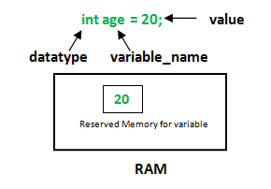
datatype: Type of data that can be stored in this variable.
variable_name: Name given to the variable.
value: It is the initial value stored in the variable.
Examples:
float simpleInterest; //Declaring float variable
int time = 10, speed = 20; //Declaring and Initializing integer variable
char var = 'h'; // Declaring and Initializing character variable
Variable initialization in C programming:
It is the process of allocating sufficient memory space with user defined values.
Syntax
Datatype nariable_name=value;
Example
int b = 20;

Variable assignment in C programming:
It is a process of assigning a value to a variable.
Syntax
Variable_Name = value
Example
int a= 20;
int b;
b = 25; // --> direct assigned variable
b = a; // --> assigned value in term of variable
b = a+15; // --> assigned value as term of expression
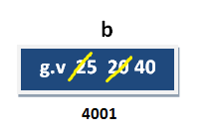
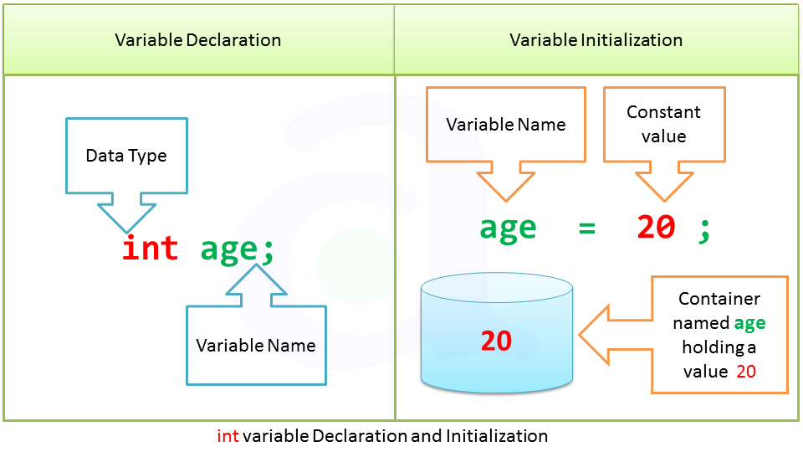
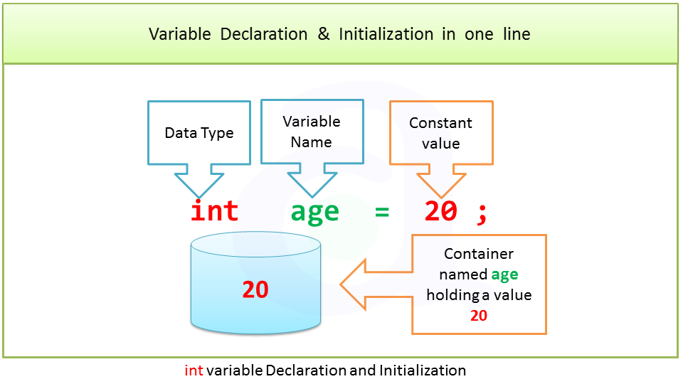
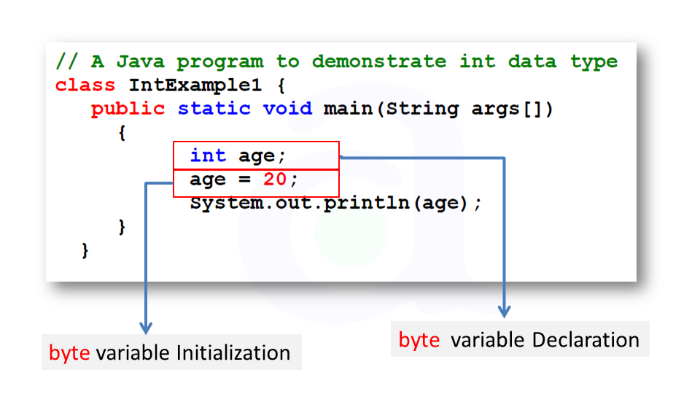
Object and Class in Java
Class in Java
A class is a group of objects which have common properties. It is a template or blueprint from which objects are created. It is a logical entity. It can't be physical.
A class in Java can contain:
- fields
- methods
- constructors
- blocks
- nested class and interface
Syntax to declare a class:
class <class_name>{
field;
method;
}
Method in Java:
In java, a method is like function i.e. used to expose behavior of an object.
A Java method is a collection of statements that are grouped together to perform an operation. When you call the System.out.println() method, for example, the system actually executes several statements in order to display a message on the console.
Object in Java
Object is the physical as well as logical entity whereas class is the logical entity only.
Object is the physical as well as logical entity whereas class is the logical entity only.
An entity that has state and behavior is known as an object e.g. chair, bike, marker, pen, table, car etc. It can be physical or logical (tangible and intangible). The example of intangible object is banking system.

An object has three characteristics:
- state: represents data (value) of an object.
- behavior: represents the behavior (functionality) of an object such as deposit, withdraw etc.
- identity: Object identity is typically implemented via a unique ID. The value of the ID is not visible to the external user. But, it is used internally by the JVM to identify each object uniquely.
Example:
Pen is an object. Its name is Reynolds, color is white etc. known as its state. It is used to write, so writing is its behavior.
Object is an instance of a class. Class is a template or blueprint from which objects are created. So object is the instance(result) of a class.
Object Definitions:
- Object is a real world entity.
- Object is a run time entity.
- Object is an entity which has state and behavior.
- Object is an instance of a class.
new keyword in Java
The new keyword is used to allocate memory at run time. All objects get memory in Heap memory area.

Object and Class Example: main within class
We have created a Student class that has two data members’ id and name. We are creating the object of the Student class by new keyword and printing the objects value.
Here, we are creating main() method inside the class.
File: Student.java
class Student
{
//field or data member or instance variable
int id;
String name;

public static void main(String args[])
{
//creating an object of Student
Student s1=new Student();
//accessing member through reference variable
System.out.println(s1.id);
System.out.println(s1.name);
}
}
Output:
0
null
Object and Class Example: main outside class:
In real time development, we create classes and use it from another class. It is a better approach than previous one. Let's see a simple example, where we are having main() method in another class.
We can have multiple classes in different java files or single java file. If you define multiple classes in a single java source file, it is a good idea to save the file name with the class name which has main() method.
File: TestStudent1.java
class Student{
int id;
String name;
}
class TestStudent1{
public static void main(String args[]){
Student s1=new Student();
System.out.println(s1.id);
System.out.println(s1.name);
}
}
Output:
0
null
3 Ways to initialize object:
There are 3 ways to initialize object in java.
- By reference variable
- By method
- By constructor
1) Object and Class Example: Initialization through reference
Initializing object simply means storing data into object. Let's see a simple example where we are going to initialize object through reference variable.
File: TestStudent2.java
class Student{
int id;
String name;
}
class TestStudent2{
public static void main(String args[]){
Student s1=new Student();
s1.id=101;
s1.name="Veerendra";
System.out.println(s1.id+" "+s1.name);//printing members with a white space
}
}
Output:
101 Veerendra
We can also create multiple objects and store information in it through reference variable.
File: TestStudent3.java
class Student{
int id;
String name;
}
class TestStudent3{
public static void main(String args[]){
//Creating objects
Student s1=new Student();
Student s2=new Student();
//Initializing objects
s1.id=101;
s1.name="Veerendra";
s2.id=102;
s2.name="Pawankalyan";
//Printing data
System.out.println(s1.id+" "+s1.name);
System.out.println(s2.id+" "+s2.name);
}
}
Output:
101 veerendra
102 Pawankalyan
2) Object and Class Example: Initialization through method
In this example, we are creating the two objects of Student class and initializing the value to these objects by invoking the insertRecord method. Here, we are displaying the state (data) of the objects by invoking the displayInformation() method.
File: TestStudent4.java
class Student{
int rollno;
String name;
//Method
void insertRecord(int r, String n){
rollno=r;
name=n;
}
void displayInformation(){
System.out.println(rollno+" "+name);
}
}
class TestStudent4{
public static void main(String args[]){
Student s1=new Student();
Student s2=new Student();
s1.insertRecord(333,"kajal");
s2.insertRecord(222,"veerendra");
s1.displayInformation();
s2.displayInformation();
}
}
Output:
222 veerendra
333 kajal
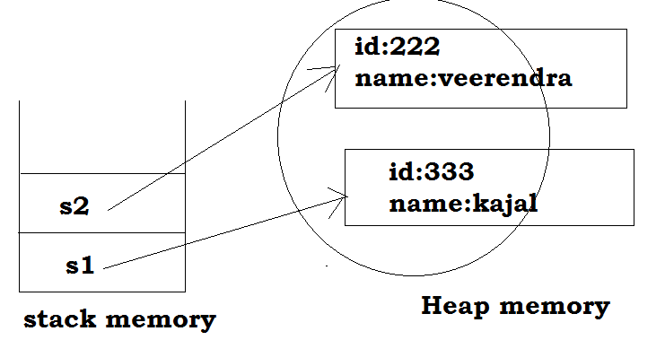
Method in Java:
In java, a method is like function i.e. used to expose behavior of an object.
A Java method is a collection of statements that are grouped together to perform an operation. When you call the System.out.println() method, for example, the system actually executes several statements in order to display a message on the console.
Types of Java methods
Depending on whether a method is defined by the user, or available in standard library, there are two types of methods:
- Standard Library Methods
- User-defined Methods
Standard Library Methods
The standard library methods are built-in methods in Java that are readily available for use. These standard libraries come along with the Java Class Library (JCL) in a Java archive (*.jar) file with JVM and JRE.
For example,
- print() is a method of java.io.PrintSteam. The print("...") prints the string inside quotation marks.
- sqrt() is a method of Math class. It returns square root of a number.
Ex:
public class Numbers
{
public static void main(String[] args)
{
System.out.print("Square root of 4 is: " + Math.sqrt(4));
}
}
Output:
Square root of 4 is: 2.0
User-defined Method
You can also define methods inside a class as per your wish. Such methods are called user-defined methods.
How to create a user-defined method?
Syntax
public static int methodName(int a, int b)
{
// body
}
Here,
- public static − modifier
- int − return type
- methodName − name of the method
- a, b − formal parameters
- int a, int b − list of parameters
One more level:
Syntax
modifier returnType nameOfMethod (Parameter List)
{
// method body
}
The syntax shown above includes −
- modifier − It defines the access type of the method and it is optional to use.
- returnType − Method may return a value.
- nameOfMethod − This is the method name. The method signature consists of the method name and the parameter list.
- Parameter List − The list of parameters, it is the type, order, and number of parameters of a method. These are optional, method may contain zero parameters.
- method body − The method body defines what the method does with the statements.
One more level:
modifier static returnType nameOfMethod (Parameter List) {
// method body
}
Here,
- modifier - defines access type whether the method is public, private and so on.
- static - If you use static keyword in a method then it becomes a static method. Static methods can be called without creating an instance of a class.
For example, the sqrt() method of standard Math class is static. Hence, we can directly call Math.sqrt() without creating an instance of Math class.
- returnType - A method can return a value.
It can return native data types (int, float, double etc.), native objects (String, Map, List etc.), or any other built-in and user defined objects.
If the method does not return a value, its return type is void.
- nameOfMethod - The name of the method is an identifier.
You can give any name to a method. However, it is more conventional to name it after the tasks it performs. For example, calculateInterest, calculateArea, and so on.
- Parameters (arguments) - Parameters are the values passed to a method. You can pass any number of arguments to a method.
- Method body - It defines what the method actually does, how the parameters are manipulated with programming statements and what values are returned. The codes inside curly braces { } is the body of the method.
Ex:
public static void myMethod()
{
System.out.println(“My Function called”);
}
How to call a Java Method?
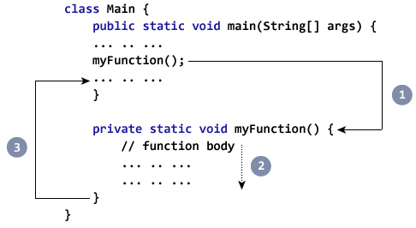
- While Java is executing the program code, it encounters myMethod(); in the code.
- The execution then branches to the myFunction() method, and executes code inside the body of the method.
- After the codes execution inside the method body is completed, the program returns to the original state and executes the next statement
Example: Complete Program of Java Method
class Main {
public static void main(String[] args)
{
System.out.println("About to encounter a method.");
// method call
myMethod();
System.out.println("Method was executed successfully!");
}
// method definition
private static void myMethod()
{
System.out.println("Printing from inside myMethod()!");
}
}
Output:
About to encounter a method.
Printing from inside myMethod().
Method was executed successfully!
Note:
The method myMethod() in the above program doesn't accept any arguments. Also, the method doesn't return any value (return type is void).
Note that, we called the method without creating object of the class. It was possible because myMethod() is static.
Ex:
In this example, our method is non-static and is inside another class
class Main {
public static void main(String[] args) {
Output obj = new Output();
System.out.println("About to encounter a method.");
// calling myMethod() of Output class
obj.myMethod();
System.out.println("Method was executed successfully!");
}
}
class Output {
// public: this method can be called from outside the class
public void myMethod() {
System.out.println("Printing from inside myMethod().");
}
}
Java Methods with Arguments and Return Value
A Java method can have zero or more parameters. And, they may return a value.
Example: Return Value from Method
class SquareMain {
public static void main(String[] args) {
int result;
result = square();
System.out.println("Squared value of 10 is: " + result);
}
public static int square() {
// return statement
return 10 * 10;
}
}
Output:
Squared value of 10 is: 100
Note: the return type of square() method is int. Meaning, the method returns an integer value.
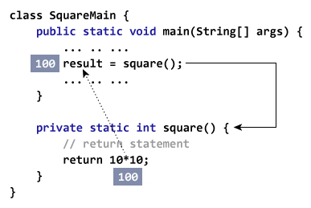
Example: Method Accepting Arguments and Returning Value
public class SquareMain {
public static void main(String[] args) {
int result, n;
n = 3
result = square(n);
System.out.println("Square of 3 is: " + result);
n = 4
result = square(n);
System.out.println("Square of 4 is: " + result);
}
static int square(int i) {
return i * i;
}
}
Output:
Squared value of 3 is: 9
Squared value of 4 is: 16
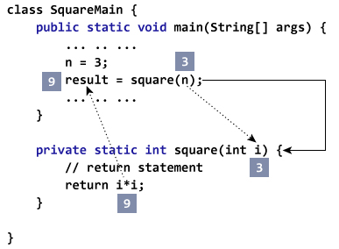
You can pass more than one argument to the Java method by using commas. For example,
public class ArithematicMain {
public static int getIntegerSum (int i, int j) {
return i + j;
}
public static int multiplyInteger (int x, int y) {
return x * y;
}
public static void main(String[] args) {
System.out.println("10 + 20 = " + getIntegerSum(10, 20));
System.out.println("20 x 40 = " + multiplyInteger(20, 40));
}
}
Output:
10 + 20 = 30
20 x 40 = 800
Example: Get Squared Value Of Numbers from 1 to 5
public class JMethods {
// method defined
private static int getSquare(int x){
return x * x;
}
public static void main(String[] args) {
for (int i = 1; i <= 5; i++) {
// method call
result = getSquare(i)
System.out.println("Square of " + i + " is : " + result); }
}
}

output :
Square of 1 is : 1
Square of 2 is : 4
Square of 3 is : 9
Square of 4 is : 16
Square of 5 is : 25
Ex: swapping two numbers
public class swappingExample {
public static void main(String[] args) {
int a = 30;
int b = 45;
System.out.println("Before swapping, a = " + a + " and b = " + b);

// Invoke the swap method
swapFunction(a, b);
System.out.println("\n**Now, Before and After swapping values will be same here**:");
System.out.println("After swapping, a = " + a + " and b is " + b);
}
public static void swapFunction(int a, int b) {
System.out.println("Before swapping(Inside), a = " + a + " b = " + b);

// Swap n1 with n2
int c = a;
a = b;
b = c;
System.out.println("After swapping(Inside), a = " + a + " b = " + b);
}
}
This will produce the following result −
Output
Before swapping, a = 30 and b = 45
Before swapping(Inside), a = 30 b = 45
After swapping(Inside), a = 45 b = 30

**Now, Before and After swapping values will be same here**:
After swapping, a = 30 and b is 45
Advantage of Method
- Code Reusability
- Code Optimization

3) Object and Class Example: Initialization through constructor
In Java, constructor is a block of codes similar to method. It is called when an instance of object is created and memory is allocated for the object.
It is a special type of method which is used to initialize the object.
Note: It is called constructor because it constructs the values at the time of object creation. It is not necessary to write a constructor for a class. It is because java compiler creates a default constructor if your class doesn't have any.
Example of default constructor that displays the default values
class Student3{
int id;
String name;
void display(){System.out.println(id+" "+name);}
public static void main(String args[]){
Student3 s1=new Student3();
Student3 s2=new Student3();
s1.display();
s2.display();
}
}
Output:
0 null
0 null
Explanation:
In the above class,you are not creating any constructor so compiler provides you a default constructor.Here 0 and null values are provided by default constructor.
Java parameterized constructor:
A constructor which has a specific number of parameters is called parameterized constructor.
Why use parameterized constructor?
Parameterized constructor is used to provide different values to the distinct objects.
Example of parameterized constructor
In this example, we have created the constructor of Student class that have two parameters. We can have any number of parameters in the constructor.
class Student4{
int id;
String name;
Student4(int i,String n){
id = i;
name = n;
}
void display(){System.out.println(id+" "+name);
}
public static void main(String args[]){
Student4 s1 = new Student4(111,"Karan");
Student4 s2 = new Student4(222,"Aryan");
s1.display();
s2.display();
}
}
Output:
111 Karan
222 Aryan
Types of Variables
Division 1 : Based on the type of value represented by a variable all variables are divided into 2 types. They are:
1. Primitive variables
2. Reference variables
Primitive variables:
Primitive variables can be used to represent primitive values.
Example: int x=10;
Reference variables:
Reference variables can be used to refer objects.
Example: Student s=new Student();

Diagram:
Division 2: Based on the behavior and position of declaration all variables are divided into the following 3 types.
1. Instance variables
2. Static variables
3. Local variables

Instance variables:
- If the value of a variable is varied from object to object such type of variables are called instance variables.
Ex:
class Instance1
{
//instance variable
int x;
public static void main(String[] args)
{
Instance1 i1=new Instance1();
i1.x=10;
System.out.println(i1.x);//10

Instance1 i2=new Instance1();
i2.x=100;
System.out.println(i2.x);//100
}
}

- For every object a separate copy of instance variables will be created.
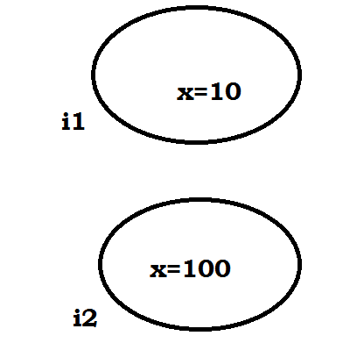
- Instance variables will be created at the time of object creation and destroyed at the time of object destruction hence the scope of instance variables is exactly same as scope of objects.
- Instance variables will be stored on the heap as the part of object.
- Instance variables should be declared with in the class directly but outside of any method or block or constructor.
- Instance variables can be accessed directly from Instance area. But cannot be accessed directly from static area.
Ex:
class Instance1
{
//instance variable
int x;

public static void main(String[] args)
{
//directly accesing
System.out.println(x);//non-static variable x cannot be referenced from a static context
}
}
Ex-2:
class Instance1
{
//instance variable
int x=10;
public static void main(String[] args)
{
//directly accesing
//System.out.println(x);//non-static variable x cannot be referenced from a static conte
//create object
Instance1 i=new Instance1();
//accessing throgh obj referenced
System.out.println(i.x);
}
}
- But by using object reference we can access instance variables from static area.

Ex:
class Instance1
{
//instance variable
int x=10;
//accersssing from instance area
public void print()
{
System.out.println(x);
}
public static void main(String[] args)
{
//create object
Instance1 i=new Instance1();
//call method
i.print();
}
}
- For the instance variables it is not required to perform initialization JVM will always provide default values.

Example:
class Instance1
{
//instance variable
int x;
//accersssing from instance area
public void print()
{
System.out.println(x);
}
public static void main(String[] args)
{
//create object
Instance1 i=new Instance1();
//call method
i.print();
System.out.println(i.x);
}
}

Ex:2
class Test
{
boolean b;
public static void main(String[] args)
{
Test t=new Test();
System.out.println(t.b);//false
}
}
Note: Instance variables also known as object level variables or attributes.
Static variables:
- If the value of a variable is not varied from object to object such type of variables is not recommended to declare as instance variables. We have to declare such type of variables at class level by using static modifier.
Ex:
class StaticStudent
{
//instance variable
int id;
String name;
String collegeName;
//main
public static void main(String[] args)
{
//object1
StaticStudent s1=new StaticStudent();
s1.id=101;
s1.name="veeru";
s1.collegeName="CBIT";
System.out.println(s1.id+"\t"+s1.name+"\t"+s1.collegeName);
StaticStudent s2=new StaticStudent();
s2.id=102;
s2.name="pawan";
s2.collegeName="CBIT";
System.out.println(s2.id+"\t"+s2.name+"\t"+s2.collegeName);
}
}
Ex:
class StaticStudent
{
//instance variable
int id;
String name;
//static var
static String collegeName="CBIT";
//constructor
StaticStudent(int i,String n)
{
id=i;
name=n;
}
//main
public static void main(String[] args)
{
//object1
StaticStudent s1=new StaticStudent(101,"veeru");
System.out.println(s1.id+"\t"+s1.name+"\t"+s1.collegeName);
StaticStudent s2=new StaticStudent(102,"kajal");
System.out.println(s2.id+"\t"+s2.name+"\t"+s2.collegeName);
}
}

Ex:
//without static
class Static
{
int x;
//constructor
Static()
{
x++;
System.out.println(x);
}
//main()
public static void main(String[] args)
{
Static s1=new Static();
Static s2=new Static();
Static s3=new Static();
}
}

Ex-2:
//with static
class Static
{
static int x;
//constructor
Static()
{
x++;
System.out.println(x);
}
//main()
public static void main(String[] args)
{
Static s1=new Static();
Static s2=new Static();
Static s3=new Static();
}
}
- In the case of instance variables for every object a separate copy will be created but in the case of static variables for entire class only one copy will be created and shared by every object of that class.

- Static variables will be crated at the time of class loading and destroyed at the time of class unloading hence the scope of the static variable is exactly same as the scope of the .class file.
- Static variables will be stored in method area. Static variables should be declared with in the class directly but outside of any method or block or constructor.
- Static variables can be accessed from both instance and static areas directly.
Ex:
//with static
class Static
{
//static
static int x=10;
public static void main(String[] args)
{
//accessing directly
System.out.println(x);
}
}
Ex:
//with static
class Static
{
//static
static int x=10;
public void print()
{
System.out.println(x);
}
public static void main(String[] args)
{
//accessing directly
System.out.println(x);
//calling metyhod
Static s=new Static();
s.print();
}
}
- We can access static variables either by class name or by object reference but usage of class name is recommended.
Ex:
//with static
class Static
{
//static
static int x=10;
public void print()
{
System.out.println(x);
}
public static void main(String[] args)
{
//accessing directly
System.out.println(x);
//calling metyhod
Static s=new Static();
s.print();//by ref
System.out.println(s.x);//by ref
System.out.println(Static.x);//by class name
}
}
- But within the same class it is not required to use class name we can access directly.
Example:
class Test
{
static int i=10;
public static void main(String[] args)
{
Test t=new Test();
System.out.println(t.i);//10
System.out.println(Test.i);//10
System.out.println(i);//10
}
}
java TEST
- 1. Start JVM.
- 2. Create and start Main Thread by JVM.
- 3. Locate(find) Test.class by main Thread.
- 4. Load Test.class by main Thread. // static variable creation
- 5. Execution of main() method.
- 6. Unload Test.class // static variable destruction
- 7. Terminate main Thread.
- 8. Shutdown JVM.
For the static variables it is not required to perform initialization explicitly, JVM will always provide default values.

//with static
class Static
{
//static
static int x;
public static void main(String[] args)
{
//accessing directly
System.out.println(x);
}
}
Note: Static variables also known as class level variables or fields.
Example:
class Test
{
int x=10;
static int y=20;
public static void main(String[] args)
{
Test t1=new Test();
t1.x=888;
t1.y=999;
Test t2=new Test();
System.out.println(t2.x+"----"+t2.y);//10----999
}
}
Diagram:
Local variables:
- Some times to meet temporary requirements of the programmer we can declare variables inside a method or block or constructors such type of variables are called local variables or automatic variables or temporary variables or stack variables.
- Local variables will be stored inside stack.
- The local variables will be created as part of the block execution in which it is declared and destroyed once that block execution completes. Hence the scope of the local variables is exactly same as scope of the block in which we declared.
Example:
class Local
{
public static void main(String[] args)
{
int i=0;
for(int j=0;j<3;j++)
{
i=i+j;
System.out.println("j value: "+j);
}
//System.out.println(i+"--"+j);
System.out.println("i value: "+i);
}
}
Ex:
class Local
{
public static void main(String[] args)
{
int i=0;
for(int j=0;j<3;j++)
{
i=i+j;
System.out.println("j value: "+j);
}
System.out.println(i+"--"+j);//cannot find symbol
}
}
Example 2:
class Test
{
public static void main(String[] args)
{
try
{
int i=Integer.parseInt("ten");
}
catch(NullPointerException e)
{
System.out.println(i);
}
}
}
- The local variables will be stored on the stack.
- For the local variables JVM won't provide any default values compulsory we should perform initialization explicitly before using that variable.

Example:

- It is never recommended to perform initialization for the local variables inside logical blocks because there is no guarantee of executing that block always at runtime.

Example:
class Test
{
public static void main(String[] args)
{
int x;
if(args.length>0)
{
x=10;
}
System.out.println(x);
//C.E:variable x might not have been initialized
}
}

Example:
class Test
{
public static void main(String[] args)
{
int x;
if(args.length>0)
{
x=10;
}
else
{
x=20;
}
System.out.println(x);
}
}
Output:
java Test x
10
java Test x y
10
java Test
20
- It is highly recommended to perform initialization for the local variables at the time of declaration at least with default values.
Note: The only applicable modifier for local variables is final. If we are using any other modifier we will get compile time error.
class Test
{
public static void main(String[] args)
{
public int x=10; //(invalid)
private int x=10; //(invalid)
protected int x=10; //(invalid) C.E: illegal start of
expression
static int x=10; //(invalid)
volatile int x=10; //(invalid)
transient int x=10; //(invalid)
final int x=10;//(valid)
}
}
Conclusions:
1. for the static and instance variables it is not required to perform initialization explicitly JVM will provide default values. But for the local variables JVM won't provide any default values compulsory we should perform initialization explicitly before using that variable.
2. For every object a separate copy of instance variable will be created whereas for entire class a single copy of static variable will be created. For every Thread a separate copy of local variable will be created.
3. Instance and static variables can be accessed by multiple Threads simultaneously and hence these are not Thread safe but local variables can be accessed by only one Thread at a time and hence local variables are Thread safe.
4. If we are not declaring any modifier explicitly then it means default modifier but this rule is applicable only for static and instance variables but not local variable.
UnInitialized arrays
Example:
class Test
{
int[] a;
public static void main(String[] args)
{
Test t1=new Test();
System.out.println(t1.a);//null
System.out.println(t1.a[0]);//R.E:NullPointerException
}
}

Instance level:
Example 1:
int[] a;
System.out.println(obj.a);//null
System.out.println(obj.a[0]);//R.E:NullPointerException
Example 2:
int[] a=new int[3];
System.out.println(obj.a);//[I@3e25a5
System.out.println(obj.a[0]);//0
Static level:
Example 1:
static int[] a;
System.out.println(a);//null
System.out.println(a[0]);//R.E:NullPointerException
Example 2:
static int[] a=new int[3];
System.out.println(a);//[I@3e25a5
System.out.println(a[0]);//0
Local level:
Example 1:
int[] a;
System.out.println(a); //C.E: variable a might not have been initialized
System.out.println(a[0]);
Example 2:
int[] a=new int[3];
System.out.println(a);//[I@3e25a5
System.out.println(a[0]);//0
Once we created an array every element is always initialized with default values irrespective of whether it is static or instance or local array.
Every variable in java should be either instance or static or local.
Every variable in java should be either primitive or reference
Hence the following are the various possible combinations for variables.
Var- arg methods (variable no of argument methods) (1.5):
- Until 1.4v we can't declared a method with variable no. Of arguments.
- If there is a change in no of arguments compulsory we have to define a new method.
- This approach increases length of the code and reduces readability.
- But from 1.5 version onwards we can declare a method with variable no. Of arguments such type of methods are called var-arg methods.
We can declare a var-arg method as follows.
Example without var-arg method:
//without var-arg method
class Test
{
//for static no need to create obj
public static void m1()
{
System.out.println("0-arg method");
}
public static void m1(int x)
{
System.out.println("1-arg method");
}
public static void m1(int x,int y)
{
System.out.println("2-arg method");
}
public static void main(String[] args)
{
m1();
m1(10);
m1(10,20);
m1(10,20,30);//cannot find symbol
}
}
//with var-arg method
class Test
{
//for static no need to create obj
public static void m1()
{
System.out.println("0-arg method");
}
public static void m1(int...x)
{
System.out.println("var-arg method");
}
public static void m1(int x)
{
System.out.println("1-arg method");
}
public static void m1(int x,int y)
{
System.out.println("2-arg method");
}
public static void main(String[] args)
{
m1();
m1(10);
m1(10,20);
m1(10,20,30);//cannot find symbol
}
}
Example:
class Test
{
public static void m1(int... x)
{
System.out.println("var-arg method");
}
public static void main(String[] args)
{
m1();
m1(10);
m1(10,20,30);
}
}
Output:
var-arg method
var-arg method
var-arg method
Internally var-arg parameter implemented by using single dimensional array hence within the var-arg method we can differentiate arguments by using index.
Example:
class Test
{
public static void sum(int... x)
{
int total=0;
for(int i=0;i<x.length;i++)
{
total=total+x[i];
}
System.out.println("The sum :"+total);
}
public static void main(String[] args)
{
sum();
sum(10);
sum(10,20);
sum(10,20,30,40);
}
}
Output:
The sum: 0
The sum: 10
The sum: 30
The sum: 100

Example:
class Test
{
public static void sum(int... x)
{
int total=0;
for(int x1 : x)
{
total=total+x1;
}
System.out.println("The sum :"+total);
}
public static void main(String[] args)
{
sum();
sum(10);
sum(10,20);
sum(10,20,30,40);
}
}

Output:
The sum: 0
The sum: 10
The sum: 30
The sum: 100
Case 1:
Which of the following var-arg method declarations are valid?
1. m1(int... x) (valid)
2. m1(int ...x) (valid)
3. m1(int...x) (valid)
4. m1(int x...) (invalid)
5. m1(int. ..x) (invalid)
6. m1(int .x..) (invalid)
Case 2:
We can mix var-arg parameter with general parameters also.
Example:
m1(int a,int... b) //valid
m2(String s,int... x) //valid

Ex:
class Test
{
public static void sum(int a,int...x)
{
System.out.println("var-arg mixed with general params");
}
public static void main(String[] args)
{
System.out.println("hi im main()");
sum(10,20);
}
}
Case 3:
If we mix var-arg parameter with general parameter then var-arg parameter should be the last parameter.
Example:
m1(int a,int... b) //valid
m1(int... a,int b) //(invalid)

Ex:
class Test
{
public static void sum(int...x,int a)
{
System.out.println("var-arg mixed with general params");
}
public static void main(String[] args)
{
System.out.println("hi im main()");
sum(10,20);
}
}
Case 4:
Within the var-arg method we can take only one var-arg parameter. i.e., if we are trying to more than one var-arg parameter we will get CE.
Example:
m1(int... a,int... b) //(invalid)

Ex:
class Test
{
public static void sum(int...x,int...a)
{
System.out.println("var-arg mixed with general params");
}
public static void main(String[] args)
{
System.out.println("hi im main()");
sum(10,20);
}
}
Case 5:
class Test
{
public static void m1(int i)
{
System.out.println("general method");
}
public static void m1(int... i)
{
System.out.println("var-arg method");
}
public static void main(String[] args)
{
m1();//var-arg method
m1(10,20);//var-arg method
m1(10);//general method
}
}
In general var-arg method will get least priority that is if no other method matched then only var-arg method will get the chance this is exactly same as default case inside a switch.
Case 6:
For the var-arg methods we can provide the corresponding type array as argument.
Example:
class Test
{
public static void m1(int… x)
{
System.out.println("var-arg method");
}
public static void main(String[] args)
{
m1(new int[]{10,20,30});//var-arg method
}
}
Case 7:
class Test
{
public void m1(int[] i){
}
public void m1(int... i){
}
}
Output:
Compile time error.
Cannot declare both methodOne(int...) and methodOne(int[]) in Test
Single Dimensional Array Vs Var-Arg Method:
Case 1:
Wherever single dimensional array present we can replace with var-arg parameter.
Example:
class Test
{
public static void main(String... args)
{
System.out.println("var-arg main method");//var-arg main method
}
}
Case 2:
Wherever var-arg parameter present we can't replace with single dimensional array.
Note:
1. m1(int... x)
We can call this method by passing a group of int values and x will become 1D
array. (i.e., int[] x)
2. m1(int[]... x)
We can call this method by passing a group of 1D int[] and x will become 2D array. ( i.e., int[][] x)
Above reasons this case 2 is invalid.
Example:
class Test
{
public static void m1(int[]... x)
{
for(int[] a:x)
{
System.out.println(a[0]);
}
}
public static void main(String[] args)
{
int[] l={10,20,30};
int[] m={40,50};
m1(l,m);
}
}

Output:
10
40
Analysis:
Main Method
Whether the class contains main() method or not,and whether it is properly declared or not, these checking's are not responsibilities of the compiler, at runtime JVM is responsible for this.
If JVM unable to find the required main() method then we will get runtime exception saying NoSuchMethodError: main.
Example:
class Test
{
}

Output:
javac Test.java
java Test R.E: NoSuchMethodError: main
At runtime JVM always searches for the main() method with the following prototype.
If we are performing any changes to the above syntax then the code won't run and will get Runtime exception saying NoSuchMethodError.
Even though above syntax is very strict but the following changes are acceptable to main() method.
1. The order of modifiers is not important that is instead of public static we can take static public.
2. We can declare string[] in any acceptable form
- String[] args
- String []args
- String args[]
3. Instead of args we can use any valid java identifier.
4. We can replace string[] with var-arg parameter.
Example: main(String... args)
- main() method can be declared with the following modifiers. final, synchronized, strictfp.
Ex:
class Test {
static final syncronized strictfp public void main(String... veeru){
System.out.println("valid main method");
}
}
output :
valid main method
Which of the following main() method declarations are valid ?
1.public static void main(String args){} (invalid)
2. public synchronized final strictfp void main(String[] args){} (invalid)
3. public static void Main(String... args){} (invalid)
4. public static int main(String[] args){} //int return type we can't take //(invalid)
5. public static synchronized final strictfp void main(String... args){}(valid)
6. public static void main(String... args){}(valid)
7. public void main(String[] args){}(invalid)
In which of the above cases we will get compile time error?
No case, in all the cases we will get runtime exception.
Case 1:
Overloading of the main() method is possible but JVM always calls string[] argument main() method only.
Example:
class Test
{
public static void main(String[] args)
{
System.out.println("String[] array main method"); //overloaded methods
}
public static void main(int[] args)
{
System.out.println("int[] array main method");
}
}
Output:
String[] array main method
The other overloaded method we have to call explicitly then only it will be executed.

Case 2:
Inheritance concept is applicable for static methods including main() method hence while executing child class if the child class doesn't contain main() method then the parent class main() method will be executed.

Ex: without Extends:
class Parent
{
public static void main(String[] args)
{
System.out.println("String[] array main method"); //overloaded methods
}
}
class Child
{

}// NoSuchMethodError: main

Example 1:
class Parent
{
public static void main(String[] args)
{
System.out.println("parent main"); //Parent.java
}
}
class Child extends Parent
{
}
Analysis:

Example 2:
Method hiding.
class Parent
{
public static void main(String[] args)
{
System.out.println("parent main"); // Parent.java
}
}
class Child extends Parent
{
public static void main(String[] args)
{
System.out.println("Child main");
}
}
It seems to be overriding concept is applicable for static methods but it is not overriding it is method hiding.
1.7 Version Enhansements with respect to main() :
Case 1:
- Untill 1.6v if our class doesn't contain main() method then at runtime we will get Runtime Exception saying NosuchMethodError:main
- But from 1.7 version onwards instead of NoSuchMethodError we will get more meaning full description
class Test {
}
1.6 version :
javac Test.java
java Test
RE: NoSuchMethodError:main
1.7 version :
javac Test.java
java Test
Error: main method not found in class Test, please define the main method as public static void main(String[] args)
Case 2:
From 1.7 version onwards to start program execution compulsory main method should be required, hence even though the class contains static block if main method not available then won't be executed
class Test {
static {
//static block(java 1.6)
System.out.println("im without main() method by static block");
}
}
1.6 version :
javac Test.java
java Test
output :
im without main() method by static block
RE: NoSuchMethodError:main
1.7 version :
javac Test.java
java Test
Error: main method not found in class Test, please define the main method as public static void main(String[] args)
Case 3:
class Test {
static {
System.out.println("static block");
System.exit(0);
}
}
1.6 version :
javac Test.java
java Test
output :
static block
1.7 version :
javac Test.java
java Test
Error: main method not found in class Test, please define the main method
as
public static void main(String[] args)
Case 4 :
class Test {
static {
System.out.println("static block");
}
public static void main(String[] args) {
System.out.println("main method");
}
}
1.6 version :
javac Test.java
java Test
output :
static block
main method
1.7 version :
javac Test.java
java Test
output :
static block
main method

Java Array
When we work with large number of data values we need that many number of different variables. As the number of variables increases, the complexity of the program also increases and so the programmers get confused with the variable names. There may be situations where we need to work with large number of similar data values. To make this work more easy, C programming language provides a concept called "Array".
An array is a special type of variable used to store multiple values of same data type at a time.
An array can also be defined as follows...
An array is a collection of similar data items stored in continuous memory locations with single name.

An array is an indexed collection of fixed number of homogeneous data elements.
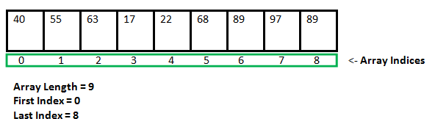
The main advantage of arrays is we can represent multiple values with the same name so that readability of the code will be improved.
Normally, array is a collection of similar type of elements that have contiguous memory location.
Due to contiguous memory location the performance becomes fast.
Java array is an object the contains elements of similar data type. It is a data structure where we store similar elements. We can store only fixed set of elements in a java array.
Array in java is index based, first element of the array is stored at 0 index.
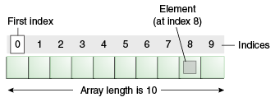
Why we need Array in C Programming?
Ex: Java array is beneficial if you have to store similar elements. Suppose you have to store marks of 50 students, one way to do this is allotting 50 variables. So it will be typical and hard to manage. For example we can not access the value of these variables with only 1 or 2 lines of code.
Another way to do this is array. By using array, we can access the elements easily. Only few lines of code is required to access the elements of array.
- Array might be belonging to any of the data types
- Array size must be a constant value.
- Always, Contiguous (adjacent) memory locations are used to store array elements in memory.
- It is a best practice to initialize an array to zero or null while declaring, if we don’t assign any values to array.

Drawback of ordinary variables
Ex:
class Test
{

public static void main(String[] args)
{
int rollno=5;
rollno=10;
System.out.println(rollno);
//rollno=110;
System.out.println(rollno);
System.out.println("finally rollno is"+rollno);
}
}
No doubt, this program will print the value of x as 10. Why so? Because, when a value 10 is assigned to x, the earlier value of x, i.e. 5, is lost. Thus, ordinary variables are capable of holding only one value at a time.
Advantage of Java Array
- Code Optimization: It makes the code optimized, we can retrieve or sort the data easily.
- Random access: We can get any data located at any index position.
- Array reduces the program size. For example if we want to
store roll number of 100 students then we have to create 100 variables. It will make the program very large and difficult to handle. This problem can be solved easily by using an array of size 100.
Disadvantage of Java Array:
- Size Limit: We can store only fixed size of elements in the array. It doesn't grow its size at runtime. To solve this problem, collection framework is used in java.
- Fixed in size that is once we created an array there is no chance of increasing or decreasing the size based on our requirement that is to use arrays concept compulsory we should know the size in advance which may not possible always.
- We can resolve this problem by using collections.
In Java Array is a container objects that holds a collection of similar type of elements (type may be integer, float, long etc).
It means, we can’t store multiple data type values. For example, an integer array will store all the integer elements, if you try to insert a float or char value then it will throw an error.
Array in Java can also be used as a static field, a local variable, and a method parameter.
In Java, array primitive datatype, as well as objects, can be stored when a primitive datatype is stored than the actual values are stored at the memory locations while when objects are stored than actual objects are stored in heap segments.

Types of Java Array
There are two types of array.
- Single Dimensional Array
- Multidimensional Array
Array declarations:
Single dimensional array declaration:
Example:
int[] a;//recommended to use because name is clearly separated from the type
int []a;
int a[];

At the time of declaration we can't specify the size otherwise we will get compile time error.
Example:
int[] a;//valid
int[5] a;//invalid
Ex:
class Array1
{
public static void main(String[] args)
{
int[] a;//valid
int[5] a;//invalid
}
}
Two dimensional array declaration:
int[][] a;
int [][]a;
int a[][];
int[] []a;
int[] a[];
int []a[];
All are valid.(6 ways)
Three dimensional array declaration:
int[][][] a;
int [][][]a;
int a[][][];
int[] [][]a;
int[] a[][];
int[] []a[];
int[][] []a;
int[][] a[];
int []a[][];
int [][]a[];
All are valid.(10 ways)
Which of the following declarations are valid?
1) int[] a1,b1; //a-1,b-1 (valid)
2) int[] a2[],b2; //a-2,b-1 (valid)
3) int[] []a3,b3; //a-2,b-2 (valid)
4) int[] a,[]b; //C.E: expected (invalid)
class Array11
{
public static void main(String[] args)
{
int[] a,[]b; //invalid
}
}
Note:
If we want to specify the dimension before the variable that rule is applicable only for the 1st variable.
Second variable onwards we can't apply in the same declaration.
Array construction:
Every array in java is an object hence we can create by using new operator.
Example:
int[] a=new int[3];
Diagram:
For every array type corresponding classes are available but these classes are part of java language and not available to the programmer level.
Ex:
class Array1
{
public static void main(String[] args)
{
int[] a=new int[3];
System.out.println(a);
System.out.println(a.getClass().getName());//[I
}
}
Array Type corresponding class name
int[] [I
int[][] [[I
double[] [D
What is the class name of java array?
In java, array is an object. For array object, an proxy class is created whose name can be obtained by getClass().getName() method on the object.
EX:
class Testarray4{
public static void main(String args[]){
int arr[]={4,4,5};
Class c=arr.getClass();
String name=c.getName();
System.out.println(name);
}
}
Rule 1:
At the time of array creation compulsory we should specify the size otherwise we will get compile time error.
Example:
int[] a=new int[3];//valid
int[] a=new int[];//C.E:array dimension missing
class Array2
{
public static void main(String[] args)
{
int[] a=new int[3];
int[] a=new int[];//C.E:array dimension missing
}
}
Rule 2:
It is legal to have an array with size zero in java.
Example:
int[] a=new int[0];
class Array3
{
public static void main(String[] args)
{
int[] a=new int[0];
System.out.println(a.length);//0
}
}
Rule 3:
If we are taking array size with -ve int value then we will get runtime exception saying NegativeArraySizeException.
Example:
int[] a=new int[-3];//R.E:NegativeArraySizeException
class Array4
{
public static void main(String[] args)
{
int[] a=new int[-3];//R.E:NegativeArraySizeException
}
}
Rule 4:
The allowed data types to specify array size is byte, short, char, int. By mistake if we are using any other type we will get compile time error.
class Array5
{
public static void main(String[] args)
{
int[] a=new int['a'];//(valid)
byte b=10;
int[] a1=new int[b];//(valid)
short s=20;
int[] a2=new int[s];//(valid)
int[] a3=new int[10l];//C.E:possible loss of precision//(invalid)
int[] a4=new int[10.5];//C.E:possible loss of precision//(invalid)
double[] f=new double[10.9];//C.E:possible loss of precision//(invalid)
}
}
Rule 5:
The maximum allowed array size in java is maximum value of int size [2147483647].
Example:
int[] a1=new int[2147483647];(valid)
int[] a2=new int[2147483648];
//C.E:integer number too large: 2147483648(invalid)
In the first case we may get RE : OutOfMemoryError.
class Array6
{
public static void main(String[] args)
{
int[] a1=new int[2147483647];//(valid) but RE:.OutOfMemoryError
//int[] a2=new int[2147483648];//(invalid)integer number too large: 2147483648
}
}
Multi dimensional array creation:
In java multidimensional arrays are implemented as array of arrays approach but not matrix form.
The main advantage of this approach is to improve memory utilization.
Example 1:
int[][] a=new int[2][];
a[0]=new int[3];
a[1]=new int[2];

Diagram:

Example 2:
int[][][] a=new int[2][][];//here base size is 2
a[0]=new int[3][];
a[0][0]=new int[1];
a[0][1]=new int[2];
a[0][2]=new int[3];
a[1]=new int[2][2];

Which of the following declarations are valid?
1) int[] a=new int[]//C.E: array dimension missing(invalid)
2) int[][] a=new int[3][4];(valid)
3) int[][] a=new int[3][];(valid)
4) int[][] a=new int[][4];//C.E:']' expected(invalid)
5) int[][][] a=new int[3][4][5];(valid)
6) int[][][] a=new int[3][4][];(valid)
7) int[][][] a=new int[3][][5];//C.E:']' expected(invalid)
Ex:
class Array1
{
public static void main(String[] args)
{
int[] a=new int[]//C.E: array dimension missing(invalid)
int[][] a=new int[3][4];(valid)
int[][] a=new int[3][];(valid)
int[][] a=new int[][4];//C.E:']' expected(invalid)
int[][][] a=new int[3][4][5];(valid)
int[][][] a=new int[3][4][];(valid)
int[][][] a=new int[3][][5];//C.E:']' expected(invalid): 2147483648
}
}
Array Initialization:
Whenever we are creating an array every element is initialized with default value automatically.

Example 1:
class Array1
{
public static void main(String[] args)
{
int[] a=new int[3];
System.out.println(a);//[I@15db9742
System.out.println(a[0]);//0
System.out.println(a[1]);//0
System.out.println(a[2]);//0
}
}
Note: Whenever we are trying to print any object reference internally toString() method will be executed which is implemented by default to return the following.
classname@hexadecimal stringrepresentation of hashcode.

Example 2:

class Array1
{
public static void main(String[] args)
{
int[][] a=new int[2][3];
System.out.println(a);//[[I@15db9742
System.out.println(a[0]);//[I@6d06d69c
System.out.println(a[0]);//[I@6d06d69c
System.out.println(a[0][0]);//0
System.out.println(a[1][2]);//0
}
}
Example 3:
class Array1
{
public static void main(String[] args)
{
int[][] a=new int[2][];
System.out.println(a);//[[I@15db9742
System.out.println(a[0]);//null
System.out.println(a[0][0]);//R.E:NullPointerException
}
}
Diagram:
Once we created an array all its elements by default initialized with default values.
If we are not satisfied with those default values then we can replays with our customized values.
Example:
int[] a=new int[4];
a[0]=10;
a[1]=20;
a[2]=30;
a[3]=40;
a[4]=50;//R.E:ArrayIndexOutOfBoundsException: 4
a[-4]=60;//R.E:ArrayIndexOutOfBoundsException: -4
class Array1
{
public static void main(String[] args)
{
int[] a=new int[4];
a[0]=10;
a[1]=20;
a[2]=30;
a[3]=40;
a[4]=50;//R.E:ArrayIndexOutOfBoundsException: 4
a[-4]=60;//R.E:ArrayIndexOutOfBoundsException: -4
}
}

Diagram:
Note: if we are trying to access array element with out of range index we will get Runtime Exception saying ArrayIndexOutOfBoundsException.
Declaration, construction and initialization of an array in a single line:
We can perform declaration, construction and initialization of an array in a single line.
Example:
char[] ch={'a','e','i','o','u'};(valid)
String[] s={"balayya","venki","nag","chiru"};(valid)

Accessing the elements from the array:
Ex-1:
class Test
{
public static void main(String[] args)
{
int a[]={33,3,4,5};//declaration, instantiation and initialization
//printing array
//for(int i=0;i<a.length;i++)//length is the property of array
System.out.println(a[0]);
System.out.println(a[1]);
System.out.println(a[2]);
System.out.println(a[3]);
System.out.println(a[4]);
}
}
But this is not recommended to use
Ex:
class Testarray1{
public static void main(String args[]){
int a[]={33,3,4,5};//declaration, instantiation and initialization
//printing array
for(int i=0;i<a.length;i++)//length is the property of array
System.out.println(a[i]);
}
}
Ex:
class Test
{
public static void main(String[] args)
{
int a[]={33,3,4,5};//declaration, instantiation and initialization
//printing array
for(int i:a)//length is the property of array
{
System.out.println(i);
}
}
}
Ex:
public class TestArray {
public static void main(String[] args) {
double[] myList = {1.9, 2.9, 3.4, 3.5};
// Print all the array elements
for (int i = 0; i < myList.length; i++) {
System.out.println(myList[i] + " ");
}
// Summing all elements
double total = 0;
for (int i = 0; i < myList.length; i++) {
total += myList[i];
}
System.out.println("Total is " + total);
// Finding the largest element
double max = myList[0];
for (int i = 1; i < myList.length; i++) {
if (myList[i] > max)
max = myList[i];
}
System.out.println("Max is " + max);
}
}
Output
1.9
2.9
3.4
3.5
Total is 11.7
Max is 3.5
We can extend this short cut even for multi dimensional arrays also.
Example:
int[][] a={{10,20,30},{40,50}};
Diagram:
Example:
Example:
int[][][] a={{{10,20,30},{40,50}},{{60},{70,80},{90,100,110}}};

Diagram:
class Array1
{
public static void main(String[] args)
{
int[][][] a={{{10,20,30},{40,50}},{{60},{70,80},{90,100,110}}};
System.out.println(a[0][1][1]);//50(valid)
System.out.println(a[1][0][2]);//R.E:ArrayIndexOutOfBoundsException: 2(invalid)
System.out.println(a[1][2][1]);//100(valid)
System.out.println(a[1][2][2]);//110(valid)
System.out.println(a[2][1][0]);//R.E:ArrayIndexOutOfBoundsException:
System.out.println(a[1][1][1]);//80(valid)
}
}
If we want to use this short cut compulsory we should perform declaration, construction and initialization in a single line.
If we are trying to divide into multiple lines then we will get compile time error.
Example:

length Vs length():
length:
1. It is the final variable applicable only for arrays.
2. It represents the size of the array.
Example:
class Array1
{
public static void main(String[] args)
{
int[] x=new int[3];
System.out.println(x.length());//C.E: cannot find symbol
System.out.println(x.length);//3
}
}
length() method:
1. It is a final method applicable for String objects.
2. It returns the no of characters present in the String.
Example:
class Array1
{
public static void main(String[] args)
{
String s="veerendra";
System.out.println(s.length);//C.E:cannot find symbol
System.out.println(s.length());//9
}
}
In multidimensional arrays length variable represents only base size but not total size.

Example:
class Array1
{
public static void main(String[] args)
{
int[][] a=new int[6][3];
System.out.println(a.length);//6
System.out.println(a[0].length);//3
}
}
Diagram:
Note: length variable applicable only for arrays where as length()method is applicable for String objects.
Ex:
class Array1
{
public static void main(String[] args)
{
String[] a={"veeru","shirisha","shiva","swathi"};
System.out.println(a.length);//4
//System.out.println(a[0].length);//invalid
System.out.println(a[0].length());
}
}
There is no direct way to find total size of multi dimentional array but indirectly we can find as follows
x[o].length +x[1].length + x[2].length + .......
Ex:
class Array1
{
public static void main(String[] args)
{
int[][] a=new int[6][3];
System.out.println(a.length);//6
System.out.println(a[0].length);//3
System.out.println(a[0].length+a[1].length+a[2].length);
}
}

Example of single dimensional java array:
class Array1
{
public static void main(String[] args)
{
// declares an Array of integers.
int[] arr;
// allocating memory for 5 integers.
arr = new int[5];
// initialize the first element of the array
arr[0] = 10;
// initialize the second element of the array
arr[1] = 20;
//so on...
arr[2] = 30;
arr[3] = 40;
arr[4] = 50;
// accessing the elements of the specified array
for (int i = 0; i < arr.length; i++)
System.out.println("Element at index " + i + " : "+ arr[i]);
}
}
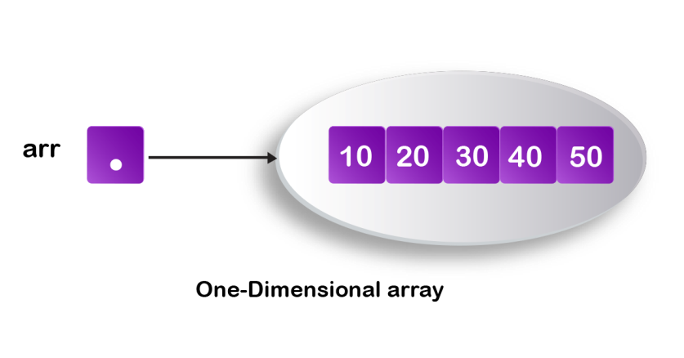
For-each loop (Advanced or Enhanced For loop):
The for-each loop introduced in Java5. It is mainly used to traverse array or collection elements. The advantage of for-each loop is that it eliminates the possibility of bugs and makes the code more readable.
Advantage of for-each loop:
It makes the code more readable.
It elimnates the possibility of programming errors.
Syntax of for-each loop:
for(data_type variable : array | collection)
{
}
Ex:
class ForEachExample1{
public static void main(String args[]){
int arr[]={12,13,14,44};
for(int i:arr){
System.out.println(i);
}
}
}
Output:
12
13
14
44
Ex:
public class TestArray {
public static void main(String[] args) {
double[] myList = {1.9, 2.9, 3.4, 3.5};

// Print all the array elements
for (double element: myList) {
System.out.println(element);
}
}
}
Array of Objects:
An array of objects is created just like an array of a datatype in Java.
Student.java
// Java program to illustrate creating an array of objects
class Student
{
public int roll_no;
public String name;
Student(int roll_no, String name)
{
this.roll_no = roll_no;
this.name = name;
}
}
Test.java
public class Test
{
public static void main (String[] args)
{
Student[] arr;
arr = new Student[5];
arr[0] = new Student(1,"ayushi");
arr[1] = new Student(2,"nainsih");
arr[2] = new Student(3,"mohnish");
arr[3] = new Student(4,"anshul");
arr[4] = new Student(5,"Aparna");
for (int i = 0; i < arr.length; i++)
System.out.println("Element at " + i + " : " +
arr[i].roll_no +" "+ arr[i].name);
}
}
Passing Array to method in java:
We can pass the java array to method so that we can reuse the same logic on any array.
class Testarray2{
static void min(int arr[]){
int min=arr[0];
for(int i=1;i<arr.length;i++)
if(min>arr[i])
min=arr[i];
System.out.println(min);
}
public static void main(String args[]){
int a[]={33,3,4,5};
min(a);//passing array to method
}
}
Example to instantiate Multidimensional Array in java
int[][] arr=new int[3][3];//3 row and 3 column
Example to initialize Multidimensional Array in java
arr[0][0]=1;
arr[0][1]=2;
arr[0][2]=3;
arr[1][0]=4;
arr[1][1]=5;
arr[1][2]=6;
arr[2][0]=7;
arr[2][1]=8;
arr[2][2]=9;
Ex:
class Testarray3{
public static void main(String args[]){
//declaring and initializing 2D array
int arr[][]={{1,2,3},{2,4,5},{4,4,5}};
//printing 2D array
for(int i=0;i<3;i++){
for(int j=0;j<3;j++){
System.out.print(arr[i][j]+" ");
}
System.out.println();
}
}
}
Output:
1 2 3
2 4 5
4 4 5

Addition of 2 matrices in java
class Testarray5{
public static void main(String args[]){
//creating two matrices
int a[][]={{1,3,4},{3,4,5}};
int b[][]={{1,3,4},{3,4,5}};
//creating another matrix to store the sum of two matrices
int c[][]=new int[2][3];
//adding and printing addition of 2 matrices
for(int i=0;i<2;i++){
for(int j=0;j<3;j++){
c[i][j]=a[i][j]+b[i][j];
System.out.print(c[i][j]+" ");
}
System.out.println();//new line
}
}
}
Anonymous Arrays:
Sometimes we can create an array without name such type of nameless arrays are called anonymous arrays.
The main objective of anonymous arrays is "just for instant use".
We can create anonymous array as follows.
- new int[]{10,20,30,40};(valid)
- new int[][]{{10,20},{30,40}};(valid)

At the time of anonymous array creation we can't specify the size otherwise we will get compile time error.
Example:
new int[3]{10,20,30,40};//C.E:';' expected(invalid)
new int[]{10,20,30,40};(valid)
Based on our programming requirement we can give the name for anonymous array then it is no longer anonymous.
Example:
int[] a=new int[]{10,20,30,40};(valid)
Example:
class Test
{
public static void main(String[] args)
{
System.out.println(sum(new int[]{10,20,30,40}));//100
}
public static int sum(int[] x)
{
int total=0;
for(int x1:x)
{
total=total+x1;
}
return total;
}
}
In the above program just to call sum() , we required an array but after completing sum() call we are not using that array any more, ananimous array is best suitable.
Array element assignments:
Case 1:
In the case of primitive array as array element any type is allowed which can be promoted to declared type.
Example 1:
For the int type arrays the allowed array element types are byte, short, char, int.
int[] a=new int[10];
a[0]=97;//(valid)
a[1]='a';//(valid)
byte b=10;
a[2]=b;//(valid)
short s=20;
a[3]=s;//(valid)
a[4]=10l;//C.E:possible loss of precision

Example 2:
For float type arrays the allowed element types are byte, short, char, int, long, float.
Case 2:
In the case of Object type arrays as array elements we can provide either declared type objects or its child class objects.
Diagram:
Example 1:
Object[] a=new Object[10];
a[0]=new Integer(10);//(valid)
a[1]=new Object();//(valid)
a[2]=new String("veerendra");//(valid)
Ex:
class Array1
{
public static void main(String[] args)
{
Object[] a=new Object[10];
a[0]=new Integer(10);//(valid)
a[1]=new Object();//(valid)
a[2]=new String("veerendra");//(valid)
}
}
Example 2:
Number[] n=new Number[10];
n[0]=new Integer(10);//(valid)
n[1]=new Double(10.5);//(valid)
n[2]=new String("veerendra");//C.E:incompatible types//(invalid)

Ex:
class Array1
{
public static void main(String[] args)
{
Number[] n=new Number[10];
n[0]=new Integer(10);//(valid)
n[1]=new Double(10.5);//(valid)
n[2]=new String("veerendra");//C.E:incompatible types//(invalid)

}
}
Case 3:
In the case of interface type arrays as array elements we can provide its implemented class objects.
Example:
Runnable[] r=new Runnable[10];
r[0]=new Thread();
r[1]=new String("bhaskar");//C.E: incompatible types

Array Type Allowed Element Type
1) Primitive arrays. 1) Any type which can be promoted to declared type.
2) Object type arrays. 2) Either declared type or its child class objects allowed.
3) Interface type arrays. 3) Its implemented class objects allowed.
4) Abstract class type arrays. 4) Its child class objects are allowed.
Array variable assignments:
Case 1:
Element level promotions are not applicable at array object level.
Ex : A char value can be promoted to int type but char array cannot be promoted to int array.
Example:
int[] a={10,20,30};
char[] ch={'a','b','c'};
int[] b=a;//(valid)
int[] c=ch;//C.E:incompatible types(invalid)
Ex:
class Array1
{
public static void main(String[] args)
{
int[] a={10,20,30};
char[] ch={'a','b','c'};
int[] b=a;//(valid)
int[] c=ch;//C.E:incompatible types(invalid)
}
}
Which of the following promotions are valid?
Note: In the case of object type arrays child type array can be assign to parent type array variable.
Example:
String[] s={"A","B"};
Object[] o=s;

Ex:
class Array1
{
public static void main(String[] args)
{
String[] s={"A","B"};
Object[] o=s;
}
}
Case 2:
Whenever we are assigning one array to another array internal elements won't be copy just reference variables will be reassigned hence sizes are not important but types must be matched.
Example:
int[] a={10,20,30,40,50,60,70};
int[] b={80,90};
a=b;//(valid)
b=a;//(valid)

Diagram:
Case 3:
Whenever we are assigning one array to another array dimensions must be matched that is in the place of one dimensional array we should provide the same type only otherwise we will get compile time error.
Example:
class Array1
{
public static void main(String[] args)
{
int[][] a=new int[3][];
a[0]=new int[4][5];//C.E:incompatible types(invalid)
a[0]=10;//C.E:incompatible types(invalid)
a[0]=new int[4];//(valid);
}
}
Note: Whenever we are performing array assignments the types and dimensions must be matched but sizes are not important.
Example 1:
int[][] a=new int[3][2];
a[0]=new int[3];
a[1]=new int[4];
a=new int[4][3];
Diagram:
Total how many objects created?
Ans: 11
How many objects eligible for GC: 6

Example 2:
class Test
{
public static void main(String[] args)
{
String[] argh={"A","B"};
args=argh;
System.out.println(args.length);//2
for(int i=0;i<=args.length;i++)
{
System.out.println(args[i]);
}
}
}
Output:
java Test x y
R.E: ArrayIndexOutOfBoundsException: 2
java Test x
R.E: ArrayIndexOutOfBoundsException: 2
java Test
R.E: ArrayIndexOutOfBoundsException: 2
Note: Replace with i<args.length
Example 3:
class Test
{
public static void main(String[] args)
{
String[] argh={"A","B"};
args=argh;
System.out.println(args.length);//2
for(int i=0;i<args.length;i++)
{
System.out.println(args[i]);
}
}
}
Output:
2
A
B

Example 4:
class Test
{
public static void main(String[] args)
{
String[] argh={"A","B"};
args=argh;
for(String s : args) {
System.out.println(s);
}
}
Output:
A
B

Command line arguments
The arguments which are passing from command prompt are called command line arguments.
The main objective of command line arguments are we can customize the behavior of the main() method.
Example 1:
class Test
{
public static void main(String[] args)
{
for(int i=0;i<=args.length;i++)
{
System.out.println(args[i]);
}
}
}

Output:
java Test x y z
ArrayIndexOutOfBoundsException: 3
Replace i<=args.length with i<args.length then it will run successfully.
class Test
{
public static void main(String[] args)
{
for(int i=0;i<args.length;i++)
{
System.out.println(args[i]);
}
}
}
Output:
10
20
30

Example 2:
class Test
{
public static void main(String[] args)
{
String[] argh={"X","Y","Z"};
args=argh;
for(String s : args)
{
System.out.println(s);
}
}
}
Output:
java Test A B C
X
Y
Z
java Test A B
X
Y
Z
java Test
X
Y
Z
Within the main() method command line arguments are available in the form of String
hence "+" operator acts as string concatenation but not arithmetic addition.
Example 3:
class Test
{
public static void main(String[] args)
{
System.out.println(args[0]+args[1]);
}
}
Output:
E:\SCJP>javac Test.java
E:\SCJP>java Test 10 20
1020
Space is the separator between 2 command line arguments and if our command line argument itself contains space then we should enclose with in double quotes.
Example 4 :
class Test
{
public static void main(String[] args)
{
System.out.println(args[0]);
}
}
Output:
E:\SCJP>javac Test.java
E:\SCJP>java Test "pawan kalyan"
Pawan kalyan

Java coding standards
Whenever we are writing java code , It is highly recommended to follow coding standards , which improves the readability and understandability of the code.
Whenever we are writing any component(i.e., class or method or variable) the name of the component should reflect the purpose or functionality.
Example:
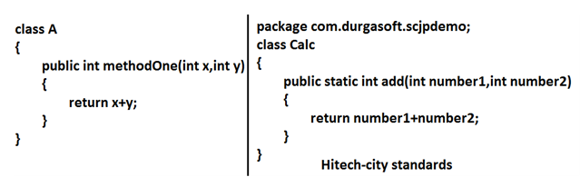
Coding standards for classes:
- Usually class names are nouns.
- Should starts with uppercase letter and if it contains multiple words every inner word should starts with upper case letter.
Example:
Coding standards for interfaces:
- Usually interface names are adjectives.
- Should starts with upper case letter and if it contains multiple words every inner word should starts with upper case letter.
Example:
1. Serializable
2. Runnable
3. Cloneable
these are adjectives
Coding standards for methods:
Usually method names are either verbs or verb-noun combination.
Should starts with lowercase character and if it contains multiple words every inner word should starts with upper case letter.(camel case convention)
Example:
Coding standards for variables:
- Usually variable names are nouns.
- Should starts with lowercase alphabet symbol and if it contains multiple words every inner word should starts with upper case character.(camel case convention)
Example:
length
name
salary
age
mobileNumber
Coding standards for constants:
- Usually constants are nouns.
- Should contain only uppercase characters and if it contains multiple words then these words are separated with underscore symbol.
- Usually we can declare constants by using public static final modifiers.
Example:
MAX_VALUE
MIN_VALUE nouns
NORM_PRIORITY
Java bean coding standards:
A java bean is a simple java class with private properties and public getter and setter methods.
Example:

Syntax for setter method:
1. Method name should be prefixed with set.
2. It should be public.
3. Return type should be void.
4. Compulsory it should take some argument.
Syntax for getter method:
1. The method name should be prefixed with get.
2. It should be public.
3. Return type should not be void.
4. It is always no argument method.
Note: For the boolean properties the getter method can be prefixed with either get or is. But recommended to use is.

Coding standards for listeners:
To register a listener:
Method name should be prefixed with add.
1. public void addMyActionListener(MyActionListener l) (valid)
2. public void registerMyActionListener(MyActionListener l) (invalid)
3. public void addMyActionListener(ActionListener l) (invalid)
To unregister a listener:
The method name should be prefixed with remove.
public void removeMyActionListener(MyActionListener l) (valid)
2. publc void unregisterMyActionListener(MyActionListener l) (invalid)
3. public void removeMyActionListener(ActionListener l) (invalid)
4. public void deleteMyActionListener(MyActionListener l) (invalid)

Various Memory areas present inside JVM
1. Class level binary data includung static variables will be stored in method area.
2. Objects and corresponding instance variables will be stored in Heap area.
3. For every method the JVM will create a Runtime stack all method calls performed by that Thread and corresponding local variables will be stored in that stack.
Every entry in stack is called Stack Frame or Action Record.
4. The instruction which has to execute next will be stored in the corresponding PC Registers.
5. Native method invocations will be stored in native method stacks.

OPERATORS & ASSIGNMENTS
Operator in java is a symbol that is used to perform operations.
Java provides a rich operator environment. An operator is a symbol that tells the computer to perform certain mathematical or logical manipulation. Operators are used in the program to manipulate data and variables. They usually form a part of the mathematical or logical expression.
Note: An operator is a character that represents an action.
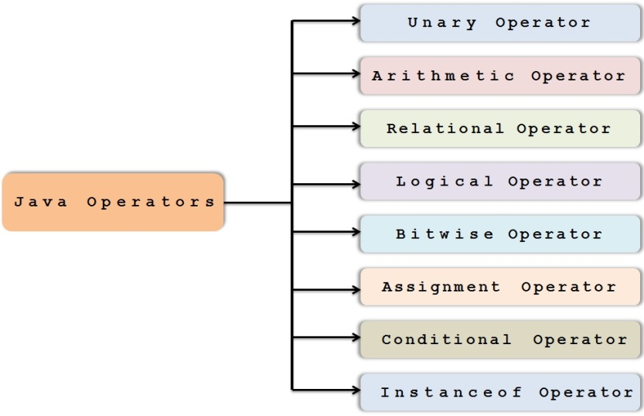

Topics:
1. increment & decrement operators
2. arithmetic operators
3. string concatenation operators
4. Relational operators
5. Equality operators
6. instanceof operators
7. Bitwise operators
8. Short circuit operators
9. type cast operators
10. assignment operator
11. conditional operator
12. new operator
13. [ ] operator
14. Precedence of java operators
15. Evaluation order of java operands
16. new Vs newInstance( )
17. instanceof Vs isInstance( )
18. ClassNotFoundException Vs NoClassDefFoundError

Java Arithmetic Operators
- The Java Arithmetic operators includes operators like Arithmetic Addition, Subtraction, Multiplication, Division and Modulus. All these operators are binary operators, which means they operate on two operands.
- The basic arithmetic operations in Java Programming are addition, subtraction, multiplication, and division.
- Arithmetic Operations are operated on Numeric Data Types as expected.
- Arithmetic Operators can be Overloaded.
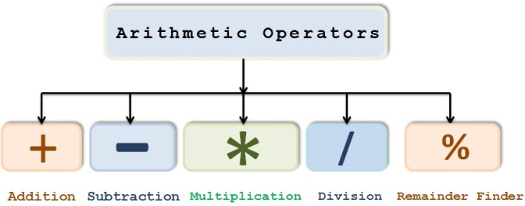
Ex: Assume integer variable A holds 10 and variable B holds 20, then –
Operator | Description | Example
+ (Addition) | Adds values on either side of the operator. | A + B will give 30
- (Subtraction) | Subtracts right-hand operand from left-hand operand. | A - B will give -10
* (Multiplication) | Multiplies values on either side of the operator. | A * B will give 200
/ (Division) | Divides left-hand operand by right-hand operand. | B / A will give 2
% (Modulus) | Divides left-hand operand by right-hand operand and returns remainder. | B % A will give 0
++ (Increment) | Increases the value of operand by 1. | B++ gives 21
-- (Decrement) | Decreases the value of operand by 1. | B-- gives 19

public class Test {

public static void main(String[] args) {

int a = 10;
int b = 20;
int c = 25;
int d = 25;

System.out.println("a + b = " + (a + b));
System.out.println("a - b = " + (a - b));
System.out.println("a * b = " + (a * b));
System.out.println("b / a = " + (b / a));
System.out.println("b % a = " + (b % a));
System.out.println("c % a = " + (c % a));
System.out.println("a++ = " + (a++));
System.out.println("b-- = " + (a--));

// Check the difference in d++ and ++d
System.out.println("d++ = " + (d++));
System.out.println("++d = " + (++d));
}

}

Output
a + b = 30
a - b = -10
a * b = 200
b / a = 2
b % a = 0
c % a = 5
a++ = 10
b-- = 11
d++ = 25
++d = 27
Ex-2:
public class Test {

public static void main(String[] args) {

int answer = 2 + 2;
System.out.println(answer);

answer = answer - 1;
System.out.println(answer);

answer = answer * 2;
System.out.println(answer);

answer = answer / 2;
System.out.println(answer);

answer = answer + 8;
System.out.println(answer);

answer = answer % 7;
System.out.println(answer);
}

}
Output

4
3
6
3
11
4
Ex:
public class Test {

public static void main(String[] args) {

double number1 = 12.5, number2 = 3.5, result;

// Using addition operator
result = number1 + number2;
System.out.println("number1 + number2 = " + result);

// Using subtraction operator
result = number1 - number2;
System.out.println("number1 - number2 = " + result);

// Using multiplication operator
result = number1 * number2;
System.out.println("number1 * number2 = " + result);

// Using division operator
result = number1 / number2;
System.out.println("number1 / number2 = " + result);

// Using remainder operator
result = number1 % number2;
System.out.println("number1 % number2 = " + result);
}

}
NOTE: When we are using division ( / ) operator the result will be completely depend upon the data type it belongs to. For example, if the data type is integer then it will produce the integer value by rounding the value (7 / 3 = 2). If you want correct result then change the data type to float. Don’t get confused, let’s see one more example for better understanding

Java Arithmetic Operators using Float
public class Test {

public static void main(String[] args) {

int a = 25, b = 4;
int integerdiv, modulus;
float floatdiv;

integerdiv = a / b;
modulus = a % b;
floatdiv = (float) a / b;

System.out.format(" Division of two numbers %d, %d is : %d\n", a, b, integerdiv);
System.out.format(" Modulus of two numbers %d, %d is : %d\n", a, b, modulus);

System.out.println(" \n---------Correct Results is--------- ");
System.out.format(" Division of two numbers %d, %d is : %.3f", a, b, floatdiv);
}
}
Java Arithmetic Operators using Oops:
public class ArithmeticOperator {
int addition, subtraction, multiplication, division, modulus;

public int addition(int a, int b)
{
addition = a + b;
return addition;
}

public int subtraction(int a, int b)
{
subtraction = a - b;
return subtraction;
}

public int multiplication(int a, int b)
{
multiplication = a * b;
return multiplication;
}

public int division(int a, int b)
{
division = a / b;
return division;
}

public int modulus(int a, int b)
{
modulus = a % b;
return modulus;

}
}
public class Test {

public static void main(String[] args) {

ArithmeticOperator arith = new ArithmeticOperator();
addition = arith.addition(5, 12);
subtraction = arith.subtraction(12, 4);
multiplication = arith.multiplication(3, 6);
division = arith.division(5, 25);
modulus = arith.modulus(10, 20);

System.out.println("\n Please Enter two integer Value: ");
System.out.println("\n Please Enter two integer Value: ");
System.out.println("\n Please Enter two integer Value: ");
System.out.println("\n Please Enter two integer Value: ");
System.out.println("\n Please Enter two integer Value: ");
}

}
Note: If you declare a method with void keyword then we can’t return any value. If you want to return any value then replace void with data type and add return keyword.
Java Arithmetic Operator Example: Expression
class OperatorExample
{
public static void main(String args[])
{
System.out.println(10*10/5+3-1*4/2);
}
}
Output:
21
Important discussion on Arithmetic Operators:
1. If we apply any Arithmetic operation b/w 2 variables a & b , the result type is always max(int , type of a , type of b).
1. byte + byte=int
2. byte+short=int
3. short+short=int
4. short+long=long
5. double+float=double
6. int+double=double
7. char+char=int
8. char+int=int
9. char+double=double
10. System.out.println('a' + 'b'); // output : 195
11. System.out.println('a' + 1); // output : 98
12. System.out.println('a' + 1.2); // output : 98.2
2. In integral arithmetic (byte , int , short , long) there is no way to represents infinity , if infinity is the result we will get the ArithmeticException / by zero
public class Test {
public static void main(String[] args) {
System.out.println(10 / 0);// // output RE : ArithmeticException / by zero
}
}
3.But in floating point arithmetic(float , double) there is a way represents infinity.
System.out.println(10/0.0); // output : infinity
public class Test {
public static void main(String[] args) {
System.out.println(10 / 0.0);
}
}
For the Float & Double classes contains the following constants:
1. POSITIVE_INFINITY
2. NEGATIVE_INFINITY
Hence , if infinity is the result we won't get any ArithmeticException in floating point arithmetics
Ex :
System.out.println(10/0.0); // output : infinity
System.out.println(-10/0.0); // output : - infinity
Ex:
public class Test {
public static void main(String[] args) {
System.out.println(10 / 0.0); // output : infinity
System.out.println(-10 / 0.0); // output : - infinity
}
}
4. NaN (Not a Number) in integral arithmetic (byte , short , int , long) there is no way to represent undefine the results. Hence the result is undefined we will get ArithmericException in integral arithmetic
System.out.println(0/0); // output RE : ArithmeticException / by zero
public class Test {
public static void main(String[] args) {
System.out.println(0 / 0); // output RE : ArithmeticException / by zero
}
}
But floating point arithmetic (float , double) there is a way to represents undefined the results .
For the Float , Double classes contains a constant NaN , Hence the result is undefined we won't get ArithmeticException in floating point arithmetics .
System.out.println(0.0/0.0); // output : NaN
System.out.println(-0.0/0.0); // output : NaN
Ex:
public class Test {
public static void main(String[] args) {
System.out.println(0.0 / 0.0); // output : NaN
System.out.println(-0.0 / 0.0); // output : NaN
}
}
Note:
For any 'x' value including NaN , the following expressions returns false.
public class Test {
public static void main(String[] args) {
//int x=10;
System.out.println(10 < Float.NaN); // false
System.out.println(10 <= Float.NaN); // false
System.out.println(10 > Float.NaN); // false
System.out.println(10 >= Float.NaN); // false
System.out.println(10 == Float.NaN); // false
System.out.println(Float.NaN == Float.NaN); // false
System.out.println(10 != Float.NaN); // true
System.out.println(Float.NaN != Float.NaN); // true
}
}
ArithmeticException :
1. It is a RuntimeException but not compile time error
2. It occurs only in integral arithmetic but not in floating point arithmetic.
3. The only operations which cause ArithmeticException are : ' / ' and ' % '
First Example: Sum of two numbers
public class AddTwoNumbers {
public static void main(String[] args) {
int num1 = 5, num2 = 15, sum;
sum = num1 + num2;
System.out.println("Sum of these numbers: "+sum);
}
}
Output:
Sum of these numbers: 20
Example: Sum of two numbers using Scanner
The scanner allows us to capture the user input so that we can get the values of both the numbers from user. The program then calculates the sum and displays it.
import java.util.Scanner;
public class AddTwoNumbers2 {
public static void main(String[] args) {
int num1, num2, sum;
Scanner sc = new Scanner(System.in);
System.out.println("Enter First Number: ");
num1 = sc.nextInt();
System.out.println("Enter Second Number: ");
num2 = sc.nextInt();
sc.close();
sum = num1 + num2;
System.out.println("Sum of these numbers: "+sum);
}
}
Output:
Enter First Number:
121
Enter Second Number:
19
Sum of these numbers: 140
Example 1: Program to read two integer and print product of them
import java.util.Scanner;
public class Demo {
public static void main(String[] args) {
/* This reads the input provided by user
* using keyboard
*/
Scanner scan = new Scanner(System.in);
System.out.print("Enter first number: ");
// This method reads the number provided using keyboard
int num1 = scan.nextInt();
System.out.print("Enter second number: ");
int num2 = scan.nextInt();
// Closing Scanner after the use
scan.close();
// Calculating product of two numbers
int product = num1*num2;
// Displaying the multiplication result
System.out.println("Output: "+product);
}
}
Output:
Enter first number: 15
Enter second number: 6
Output: 90
Ex:
import java.util.Scanner;
public class Demo {
public static void main(String[] args) {
/* This reads the input provided by user
* using keyboard
*/
Scanner scan = new Scanner(System.in);
System.out.print("Enter first number: ");
// This method reads the number provided using keyboard
double num1 = scan.nextDouble();
System.out.print("Enter second number: ");
double num2 = scan.nextDouble();
// Closing Scanner after the use
scan.close();
// Calculating product of two numbers
double product = num1*num2;
// Displaying the multiplication result
System.out.println("Output: "+product);
}
}
Output:
Enter first number: 1.5
Enter second number: 2.5
Output: 3.75
String Concatenation operator
1. The only overloaded operator in java is ' + ' operator some times it access arithmetic addition operator & some times it access String concatenation operator.
2. If acts as one argument is String type , then '+' operator acts as concatenation and If both arguments are number type , then operator acts as arithmetic operator
Ex:
class AssignmentConcatination {
public static void main(String[] args){
String firstName = "Pawan";
String lastName = "Kalyan";
String fullName = firstName + lastName;
System.out.println(fullName);
}
}

Ex :
public class Test {
public static void main(String[] args) {
String a = "ashok";
int b = 10, c = 20, d = 30;
System.out.println(a + b + c + d); // output : ashok102030
System.out.println(b + c + d + a); // output : 60ashok
System.out.println(b + c + a + d); // output : 30ashok30
System.out.println(b + a + c + d); // output : 10ashok 2030
}
}
Ex:
public class Test {
public static void main(String[] args) {
String a="ashok";
int b=10 , c=20 , d=30 ;
System.out.println(a+b+c+d); //output : ashok102030
System.out.println(b+c+d+a); //output : 60ashok
System.out.println(b+c+a+d); //output : 30ashok30
System.out.println(b+a+c+d); //output : 10ashok 2030
a=b+c+d ;
System.out.println(a);//incompatible types
b=a+c+d;
System.out.println(b);//incompatible types
a=a+b+c ;
System.out.println(a);//valid
b=b+c+d ;
System.out.println(b);//valid
}
}
Ex:

Ex:
public class Test {
public static void main(String[] args) {
String firstString = "This is";
String secondString = " a concatenated string.";
String thirdString = firstString + secondString;
System.out.println(thirdString); // output will be “This is a concatenated string”
}
}
Relational Operators (< , <= , > , >= )
The equality and relational operators determines the relationship between two operands. It checks if an operand is greater than, less than, equal to, not equal to and so on. Depending on the relationship, it results to either true or false.
Note: Java Relational operators are used to check the equality and for comparison.

Assume variable A holds 10 and variable B holds 20, then –
Operator | Description | Example
== (equal to) | Checks if the values of two operands are equal or not, if yes then condition becomes true. | (A == B) is not true.
!= (not equal to) | Checks if the values of two operands are equal or not, if values are not equal then condition becomes true. | (A != B) is true.
> (greater than) | Checks if the value of left operand is greater than the value of right operand, if yes then condition becomes true. | (A > B) is not true.
< (less than) | Checks if the value of left operand is less than the value of right operand, if yes then condition becomes true. | (A < B) is true.
>= (greater than or equal to) | Checks if the value of left operand is greater than or equal to the value of right operand, if yes then condition becomes true. | (A >= B) is not true.
<= (less than or equal to) | Checks if the value of left operand is less than or equal to the value of right operand, if yes then condition becomes true. | (A <= B) is true.

Note: Equality and relational operators are used in decision making and loops
Ex:
public class Test {
public static void main(String args[]) {
int a = 10;
int b = 20;
System.out.println("a == b = " + (a == b) );
System.out.println("a != b = " + (a != b) );
System.out.println("a > b = " + (a > b) );
System.out.println("a < b = " + (a < b) );
System.out.println("b >= a = " + (b >= a) );
System.out.println("b <= a = " + (b <= a) );
}
}
Output
a == b = false
a != b = true
a > b = false
a < b = true
b >= a = true
b <= a = false
Ex:
public class RelationalOperatorDemo {
public static void main(String args[]) {
int num1 = 10;
int num2 = 50;
if (num1==num2) {
System.out.println("num1 and num2 are equal");
}
else{
System.out.println("num1 and num2 are not equal");
}
if( num1 != num2 ){
System.out.println("num1 and num2 are not equal");
}
else{
System.out.println("num1 and num2 are equal");
}
if( num1 > num2 ){
System.out.println("num1 is greater than num2");
}
else{
System.out.println("num1 is not greater than num2");
}
if( num1 >= num2 ){
System.out.println("num1 is greater than or equal to num2");
}
else{
System.out.println("num1 is less than num2");
}
if( num1 < num2 ){
System.out.println("num1 is less than num2");
}
else{
System.out.println("num1 is not less than num2");
}
if( num1 <= num2){
System.out.println("num1 is less than or equal to num2");
}
else{
System.out.println("num1 is greater than num2");
}
}
}
Output:
num1 and num2 are not equal
num1 and num2 are not equal
num1 is not greater than num2
num1 is less than num2
num1 is less than num2
num1 is less than or equal to num2
Ex:
→ If a number is greater than zero then it is a positive number
→ If a number is less than zero then it is a negative number
→ If a number is equal to zero then it is neither negative nor positive.
Ex:
public class Demo
{
public static void main(String[] args)
{
int number=109;
if(number > 0)
{
System.out.println(number+" is a positive number");
}
else if(number < 0)
{
System.out.println(number+" is a negative number");
}
else
{
System.out.println(number+" is neither positive nor negative");
}
}
}
Output:
109 is a positive number
Example 2: Check whether the input number(entered by user) is positive or negative
import java.util.Scanner;
public class Demo
{
public static void main(String[] args)
{
int number;
Scanner scan = new Scanner(System.in);
System.out.print("Enter the number you want to check:");
number = scan.nextInt();
scan.close();
if(number > 0)
{
System.out.println(number+" is positive number");
}
else if(number < 0)
{
System.out.println(number+" is negative number");
}
else
{
System.out.println(number+" is neither positive nor negative");
}
}
}

Output:
Enter the number you want to check:-12
-12 is negative number
Note:
We can apply relational operators for every primitive type except Boolean.
Ex:
class Test
{
public static void main(String[] args)
{
System.out.println(10 < 10.5); //true
System.out.println('a' > 100.5); //false
System.out.println('b' > 'a'); //true
System.out.println(true > false);//CE : operator > can't be applied to boolean , boolean
}
}

Note: We can't apply relational operators for object types
class Test
{
public static void main(String[] args)
{
System.out.println("veeru" > "veeru");//CE: operator > can't be applied to java.lang.String ,java.lang.String
}
}
Note: Nesting of relational operator is not allowed
Ex:
class Test
{
public static void main(String[] args)
{
System.out.println(10 > 20 > 30);
// System.out.println(true >30);
}
}

