INTERNSHIP PROJECT REPORT
RISK MANAGEMENT AND
SENSITIVITY ANALYSIS
Week 4 Financial Risk Study
Submitted by
Sandeep Singh
Junior Financial Analyst Intern – Virtual | Yuva Internship Portal

CERTIFICATE

This report entitled “Risk Management and Sensitivity Analysis on Tata Motors Limited” is submitted by Sandeep Singh as part of the Week 4 assignment under the Junior Financial Analyst Intern – Virtual programme. The report documents the analytical work performed using Tata Motors’ FY2025-26 Integrated Annual Report and the Week 4 risk-management and sensitivity-analysis financial model.
________________________________________
Sandeep Singh
Junior Financial Analyst Intern – Virtual

CANDIDATE’S DECLARATION

I, Sandeep Singh, declare that this report represents my work prepared for the Week 4 virtual internship assignment on financial risk management and sensitivity analysis. The analysis is based on the supplied Tata Motors FY2025-26 Integrated Annual Report and the accompanying financial model. The scenario outputs are analytical estimates intended for educational and decision-support purposes and should not be interpreted as a guarantee of future market performance.

________________________________________
Sandeep Singh

ACKNOWLEDGEMENT

I would like to express my sincere gratitude to the Yuva Internship Portal and the mentors supporting the Junior Financial Analyst virtual internship for providing a practical environment in which financial risk-management concepts can be translated into a structured financial model.
This Week 4 assignment provided an opportunity to extend valuation work into a more decision-oriented framework. Instead of relying on a single forecast, the exercise required identification of the risks that could change financial outcomes, quantification of those risks through sensitivity analysis, and development of practical mitigation actions.
I also acknowledge the Tata Motors FY2025-26 Integrated Annual Report, which supplied the audited financial baseline, liquidity information, market-risk disclosures, commodity and foreign-exchange risk discussion, debt information and management commentary used in the analysis.
Finally, I am thankful to the academic faculty at Maharaja Ranjit Singh Punjab Technical University for providing the finance and strategic-management foundation required to interpret financial forecasts, capital allocation decisions and valuation sensitivity.

Sandeep Singh

TABLE OF CONTENTS
1. Executive Summary 6
2. Assignment Context and Risk-Management Objective 7
3. Data Sources and Methodology 7
4. FY26 Financial Baseline and Forecast Exposure 8
5. Risk Identification 9
6. Sensitivity-Analysis Framework 10
7. Detailed Sensitivity Results 11–13
8. Range of Outcomes and Financial-Decision Implications 14
9. Risk-Mitigation Strategy 14–15
10. Findings and Conclusion 16
11. Limitations 17
12. Bibliography and Sources 17
13. Annexure: Key Model Outputs 18

1. EXECUTIVE SUMMARY
This Week 4 report extends the valuation work from the preceding assignment into a risk-management and sensitivity-testing framework. The objective is not to produce one new point estimate of value, but to show how financial decision-making changes when the assumptions underlying a forecast move. In an investment-banking context, this matters because a transaction or investment recommendation is exposed to operating risk, financing risk, market risk, execution risk and model risk. A well-structured model therefore needs both a base case and an explicit view of the range of outcomes around that base case.
The analysis is built on Tata Motors’ FY2025-26 Commercial Vehicles financial profile and the existing valuation model. FY26 revenue from operations was ₹83,855 crore, underlying EBITDA was ₹10,314 crore, underlying EBIT was ₹8,538 crore, profit after tax was ₹3,030 crore, operating cash flow was ₹14,981 crore and company-defined free cash flow was ₹12,438 crore. Total debt at year-end was ₹4,817 crore and cash and cash equivalents were ₹6,899 crore. These figures create the starting point for the forecast and for the risk scenarios.
The Week 4 model keeps the prior DCF architecture but makes the core assumptions explicitly stress-testable. The principal variables are annual revenue growth, EBITDA margin, tax rate, depreciation and amortisation as a percentage of revenue, capital expenditure as a percentage of revenue, net working capital as a percentage of revenue, WACC and an interest-rate shock. The model also provides a formula-driven scenario manager with Downside, Base and Upside operating cases and a series of one-way and two-way sensitivity tables.
The base DCF produces an implied value of approximately ₹239.5 per share. Under the modelled downside case, the value falls to approximately ₹191.5 per share, while the upside operating case increases the value to approximately ₹271.4 per share. Relative to the ₹459.1 reference market price used in the model, the DCF values correspond to approximately 58.3% downside, 47.8% downside and 40.9% downside respectively. The message for financial decision-making is therefore clear: even a favourable operating case in the current model does not eliminate valuation risk, while deterioration in growth or margins creates substantial further downside.
The analysis also shows that the discount rate is highly material. A move in scenario WACC from 10.0% to 12.0% reduces implied DCF value from about ₹279.1 to ₹209.9 per share. A 12.5% scenario WACC lowers the modelled value to approximately ₹197.7 per share. Conversely, a lower discount-rate environment increases the present value of future cash flows. This result demonstrates why an analyst should monitor both operating indicators and capital-market conditions when assessing an investment or transaction.
The principal risks identified are commercial-vehicle cyclicality, commodity-price inflation, interest-rate changes, foreign-exchange volatility, geopolitical and supply-chain disruption, and execution risk associated with electrification, alternate powertrains, digital expansion and major strategic investments. Each risk is mapped to a forecast variable and to a stress direction. The recommended response is a combination of operating discipline, hedging, diversified sourcing, liquidity protection, stage-gated capital expenditure and capital-structure flexibility.
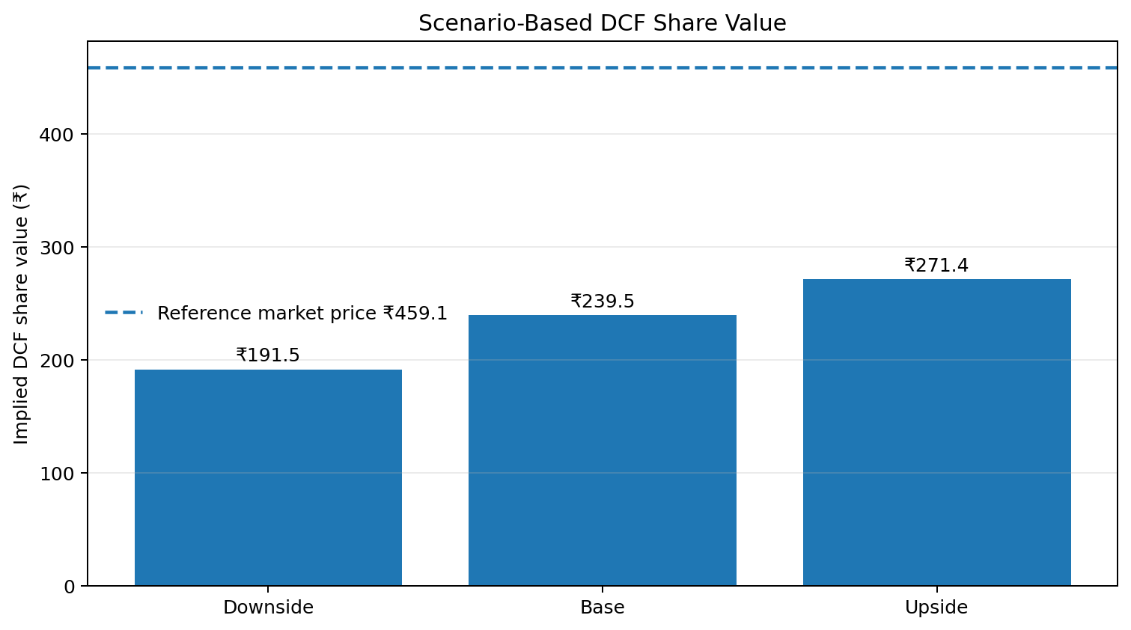
Figure 1. Scenario-based DCF share value: downside, base and upside cases.
.

2. ASSIGNMENT CONTEXT AND RISK-MANAGEMENT OBJECTIVE
The objective of the current task is to understand how uncertainty should be incorporated into financial forecasts and investment decisions. In practical investment banking work, forecasts are not treated as facts. Revenue, margins, working capital, financing costs and capital expenditure are assumptions that can change as market conditions change. Sensitivity analysis converts this uncertainty into measurable ranges and helps senior decision-makers judge whether a transaction, investment or capital allocation plan remains attractive under pressure.
For Tata Motors, the relevant financial scenario is a forward operating and capital-allocation forecast for the Commercial Vehicles business. The scenario begins with FY26 actual results and evaluates how changes in market demand, operating costs, financing conditions and capital intensity affect free cash flow and valuation. This is particularly appropriate because the company operates in a cyclical industrial market and the annual report discusses exposure to commodity prices, foreign exchange, interest rates and supply-chain disruption.
The report is designed around a decision-support principle: every material risk should have a corresponding model variable, a reasonable stress range and a management action. This creates a traceable chain from business risk to financial consequence to mitigation. It also reduces the danger of producing a polished valuation that hides the fragility of its assumptions.

3. DATA SOURCES AND METHODOLOGY
The methodology uses three primary inputs. First, the Tata Motors FY2025-26 Integrated Annual Report provides the audited financial baseline, operating commentary, liquidity data, risk disclosures, debt data and management discussion. Second, the existing Week 3 valuation workbook provides the DCF framework and baseline valuation logic. Third, the Week 4 risk and sensitivity workbook reorganizes those assumptions into an explicit scenario and sensitivity engine.
The methodology follows five steps. Step one is to establish the FY26 actual base. Step two is to identify forecast variables that can change materially. Step three is to define reasonable downside and upside shocks around those variables. Step four is to calculate the resulting effect on revenue, EBITDA, unlevered free cash flow, enterprise value, equity value and implied share price. Step five is to interpret the results from a risk-management perspective and recommend actions that reduce either the probability or the financial impact of the risk.
The Week 4 model uses a base revenue growth assumption of 7.0% and sensitivity cases around that level. The base EBITDA margin is 12.5%, compared with the reported FY26 underlying EBITDA margin of approximately 12.3%. The model applies a 25% tax rate, D&A at 2.3% of revenue, capex at 3.5% of revenue and net working capital at 5.5% of revenue. The DCF uses an 11.0% WACC and a 4.0% terminal growth rate.
The model is formula-driven rather than a collection of manually typed results. The scenario section allows the analyst to select Downside, Base or Upside assumptions, after which the output engine recalculates the forecast and DCF result. In addition, the workbook contains one-way sensitivity tables and two-way matrices for revenue growth versus WACC and EBITDA margin versus WACC, plus targeted capex and interest-rate stress tests.
Model Driver | Base Case | Sensitivity / Stress | Purpose
Revenue growth | 7.0% p.a. | 4.0% to 10.0% | Demand and volume risk
EBITDA margin | 12.5% | 10.5% to 14.5% | Pricing and input-cost risk
WACC | 11.0% | 9.0% to 13.0% | Market and discount-rate risk
Capex / Revenue | 3.5% | 2.5% to 5.0% | Capital-intensity risk
Debt-rate shock | 0.0% | -2.0% to +3.0% | Financing-rate risk

.

4. FY26 FINANCIAL BASELINE AND FORECAST EXPOSURE
FY26 provides a strong but highly specific starting point. Revenue from operations reached ₹83,855 crore. Underlying EBITDA was ₹10,314 crore, implying a 12.3% margin, while underlying EBIT was ₹8,538 crore. Operating cash flow of ₹14,981 crore and free cash flow of ₹12,438 crore indicate substantial cash-generation capacity. Total debt of ₹4,817 crore and cash of ₹6,899 crore imply a comparatively strong liquidity position, although the company also reports broader liquid assets.
From a risk perspective, the most important point is that strong historical cash generation does not guarantee the same future outcome. The business is sensitive to commercial-vehicle volumes, customer financing conditions, infrastructure activity, freight utilization and replacement cycles. The annual report notes that FY26 began relatively subdued before a stronger second half, which is evidence that quarterly or annual averages can hide changes in operating momentum.
The margin base is also a critical exposure. EBITDA margin is not an independent variable in economic terms; it reflects price realization, material costs, manufacturing efficiency, product mix and mix of downstream services. A change of only a few percentage points in the model can create a large difference in DCF value because margin directly affects EBIT and operating cash flow.
Capital intensity is another important forecast exposure. The model assumes capex at 3.5% of revenue. A higher capex ratio reduces free cash flow even when operating profitability is unchanged. This is relevant for commercial-vehicle manufacturers because investments in new platforms, EVs, hydrogen technology, manufacturing upgrades and digital infrastructure can be strategically necessary but may depress near-term cash generation.
FY26A Metric | Value | Role in Risk Model
Revenue from operations | ₹83,855 cr | Forecast starting point
Underlying EBITDA | ₹10,314 cr | Margin sensitivity base
Underlying EBIT | ₹8,538 cr | Operating profit base
Profit after tax | ₹3,030 cr | Earnings reference
Operating cash flow | ₹14,981 cr | Cash-generation reference
Free cash flow | ₹12,438 cr | Liquidity / investment reference
Total debt | ₹4,817 cr | Financing-risk reference
Cash & equivalents | ₹6,899 cr | Liquidity buffer

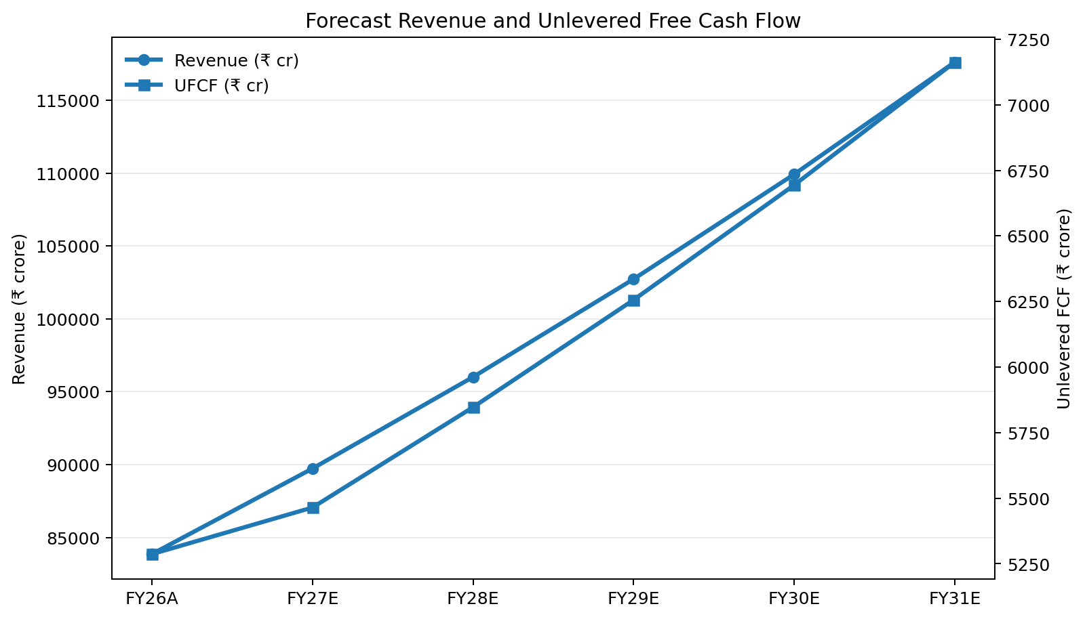
Figure 2. Base-case forecast revenue and unlevered free cash flow, FY26A–FY31E.

5. RISK IDENTIFICATION
Risk | Business Exposure | Model Variable | Stress | Valuation Effect | Primary Control
Commercial-vehicle demand and cyclicality | Volume, pricing, freight activity | Revenue growth | Down | Lower revenue and UFCF | Quarterly forecast refresh; volume and mix monitoring
Commodity and input-cost inflation | Materials, aluminium, copper, etc. | EBITDA margin | Down | Margin compression | Hedging; supplier agreements; pricing discipline
Interest-rate and discount-rate risk | Borrowing cost and required return | WACC | Up | Lower DCF value | Interest-rate hedges; liquidity buffers
Foreign-exchange volatility | Exports and FX-linked assets/liabilities | Growth + margin | Down | Earnings and cash-flow volatility | Forwards, options, exposure matching
Geopolitical / supply-chain disruption | Exports, routes, critical components | Growth + margin | Down | Lower growth and higher costs | Alternate sourcing; route diversification
Technology / EV transition | R&D and capital intensity | Capex / Revenue | Up | Lower near-term FCF | Stage-gated capex; return thresholds

Figure 3 / Table 2. Forecast risk register. Source: Tata Motors FY26 risk disclosures and Week 4 model.
5.1 Commercial-vehicle demand and cyclicality. Commercial-vehicle volumes are linked to infrastructure spending, freight activity, industrial production, financing availability, replacement cycles and customer confidence. If demand slows, revenue growth can fall below the 7.0% base assumption. In the sensitivity model, a lower growth assumption reduces FY31 revenue and unlevered FCF and therefore lowers DCF value.
5.2 Commodity and input-cost risk. The company is exposed to commodities including aluminium, copper, platinum, palladium and other materials used in vehicle production. The annual report notes that Tata Motors uses forward contracts, options, fixed-price arrangements and other risk-management tools. Nevertheless, hedging reduces volatility rather than eliminating the economic risk. In the model, sustained commodity inflation is reflected through a lower EBITDA margin.
5.3 Interest-rate and discount-rate risk. Higher interest rates can affect the business through customer financing, corporate borrowing costs and investor discount rates. In valuation, WACC has an even more direct effect because it changes the present value of all future cash flows and the terminal value. The Week 4 model therefore includes a dedicated interest-rate sensitivity and a WACC stress framework.
5.4 Foreign-exchange risk. International operations and cross-border transactions create exposure to movements in foreign currencies. Currency movements can affect translated revenue, costs, cash flows and the value of imported components. The annual report identifies foreign-exchange risk as a market risk. In the operating model, FX pressure is captured through a combined downside to growth and margin rather than through a stand-alone FX forecasting module.
5.5 Geopolitical and supply-chain disruption. The annual report highlights geopolitical developments and supply-side disruptions, including the impact of West Asia developments on select markets and corridors. Supply disruption can create both volume loss and cost inflation, which means the financial impact may be larger than a pure revenue shock.
5.6 Technology and execution risk. Electrification, hydrogen, connected vehicles and digital services are strategic opportunities, but their financial returns depend on product adoption, infrastructure, technology readiness and capital discipline. If capex rises without sufficient incremental cash flow, the company can create strategic value but destroy near-term free cash flow and valuation.

6. SENSITIVITY-ANALYSIS FRAMEWORK
Week 4 sensitivity analysis converts the above risks into a set of controlled tests. The base case assumes 7.0% annual revenue growth, 12.5% EBITDA margin, 25.0% tax, 2.3% D&A/revenue, 3.5% capex/revenue, 5.5% NWC/revenue, 11.0% WACC and 4.0% terminal growth.
The scenario manager defines Downside at 4.0% revenue growth and 11.5% EBITDA margin, Base at 7.0% growth and 12.5% margin, and Upside at 9.0% growth and 13.0% margin. The selected scenario flows through the forecast and valuation engine, making the model suitable for management discussion and investment-decision review.
Using these operating cases, the model estimates FY31 revenue of approximately ₹1,02,022 crore in the downside case, ₹1,17,611 crore in the base case and ₹1,29,021 crore in the upside case. Corresponding FY31 unlevered FCF is approximately ₹5,599 crore, ₹7,163 crore and ₹8,220 crore.
The resulting enterprise values are approximately ₹68,378 crore in the downside case, ₹86,057 crore in the base case and ₹97,776 crore in the upside case. After the model’s net-cash adjustment, implied share values are approximately ₹191.5, ₹239.5 and ₹271.4. The outcome shows that operating improvements provide upside, but the valuation remains sensitive to both the size and quality of future cash flows.
Metric | Downside | Base | Upside
Revenue FY31E | ₹1,02,022 cr | ₹1,17,611 cr | ₹1,29,021 cr
EBITDA FY31E | ₹11,733 cr | ₹14,701 cr | ₹16,773 cr
UFCF FY31E | ₹5,599 cr | ₹7,163 cr | ₹8,220 cr
Enterprise Value | ₹68,378 cr | ₹86,057 cr | ₹97,776 cr
Equity Value | ₹70,460 cr | ₹88,139 cr | ₹99,858 cr
Implied Share Value | ₹191.5 | ₹239.5 | ₹271.4

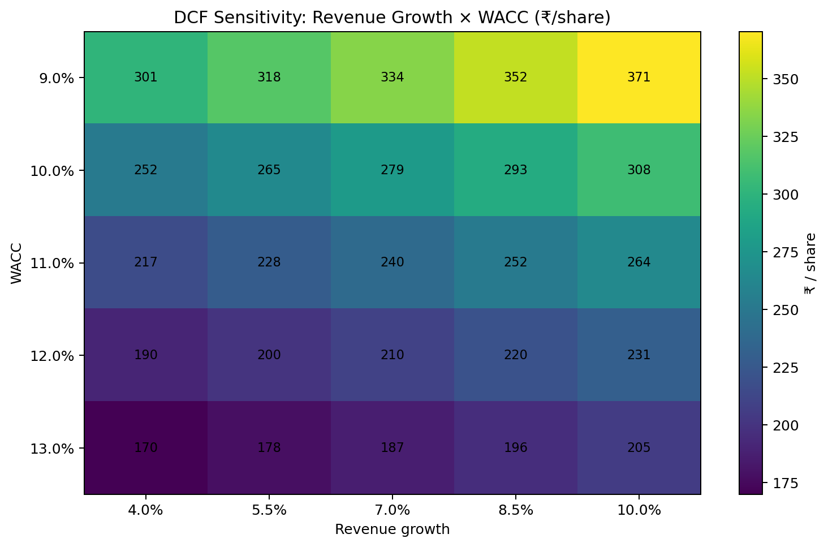
Figure 4. Two-way DCF sensitivity: revenue growth versus WACC.

7. DETAILED SENSITIVITY RESULTS

7.1 Revenue Growth Sensitivity
The one-way revenue-growth sensitivity shows that increasing or decreasing the growth assumption by three percentage points around the base case moves implied share value from approximately ₹216.9 to ₹264.2. The central case remains ₹239.5. This is important because revenue growth affects every year of the explicit forecast and also changes the terminal cash-flow base.

7.2 EBITDA Margin Sensitivity
Margin sensitivity is economically important because it acts directly on operating profit. The model shows a wide range of outcomes as EBITDA margin changes. At lower margins, implied share value falls materially, while higher margins increase cash generation and valuation. The sensitivity demonstrates why product mix, pricing realization, procurement and operating efficiency should be treated as valuation drivers, not just operational KPIs.
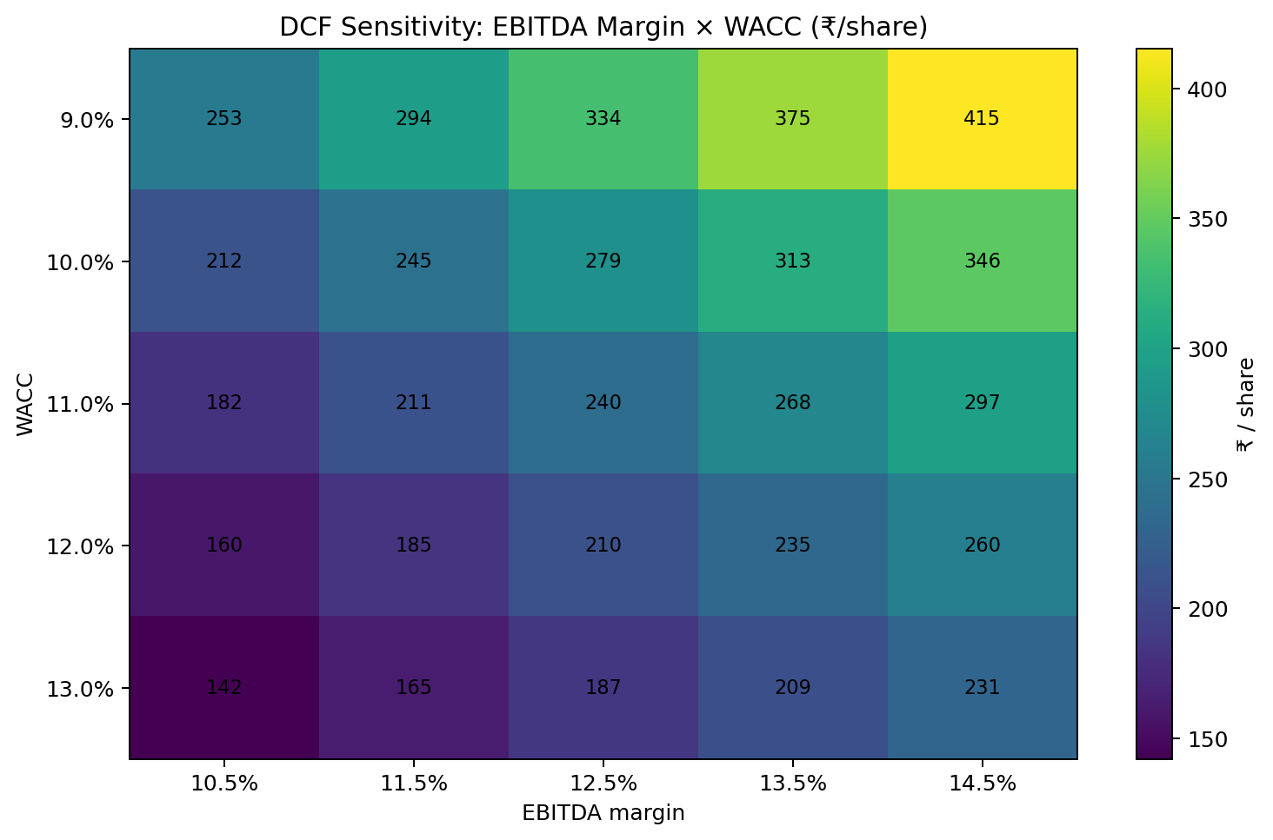
Figure 5. Two-way DCF sensitivity: EBITDA margin versus WACC.

7.3 WACC Sensitivity
WACC is one of the most powerful variables in the model. At 10.0% WACC with a 4.0% terminal growth rate, the model produces approximately ₹277.4 per share. At 11.0%, the value is ₹239.5, and at 12.0% it falls to approximately ₹211.5. The model therefore shows a substantial value range across the WACC band even before operating assumptions are changed.

7. DETAILED SENSITIVITY RESULTS (CONTINUED)

7.4 Revenue Growth × WACC
The two-way sensitivity matrix demonstrates the joint effect of operating growth and discount rate. At 9.0% WACC and 10.0% growth, the implied share value is approximately ₹370.5. At 13.0% WACC and 4.0% growth, it is approximately ₹169.9. This is a wide decision range and illustrates how an investment case can move from relatively resilient to clearly unattractive when macro conditions and operating execution deteriorate together.

7.5 EBITDA Margin × WACC
The EBITDA margin versus WACC table provides a second joint stress test. At 10.5% WACC and a 14.5% margin, the model produces approximately ₹415.4 per share, whereas at 12.0% WACC and an 11.5% margin the value falls to approximately ₹184.7. This confirms that both profitability and discount-rate assumptions deserve high management attention.

7.6 Capex Sensitivity
Capex intensity is tested from 2.5% to 5.0% of revenue. The implied share value declines from approximately ₹277.9 at 2.5% capex/revenue to approximately ₹181.9 at 5.0%. The result highlights the trade-off between strategic investment and near-term cash generation. Management should therefore evaluate major capex projects on expected return on invested capital rather than viewing investment scale itself as a positive.
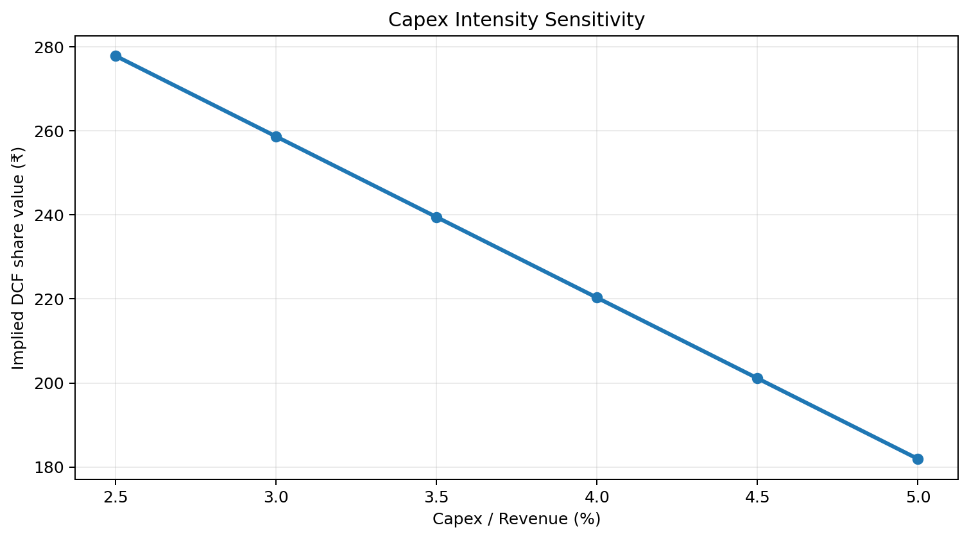
Figure 6. Implied DCF value under alternative capex-to-revenue assumptions.

7. DETAILED SENSITIVITY RESULTS (CONTINUED)

7.7 Interest-Rate Sensitivity
Using the disclosed 8.5% debt coupon as a reference—not as the company’s weighted-average borrowing cost—the model translates debt-rate shocks into a WACC stress. A 2 percentage-point increase in the reference debt rate results in a 12.0% scenario WACC and an implied share value of about ₹209.9. A 2 percentage-point reduction results in a 10.0% scenario WACC and about ₹279.1 per share. The range demonstrates how higher rates can create valuation pressure even if operating forecasts remain unchanged.
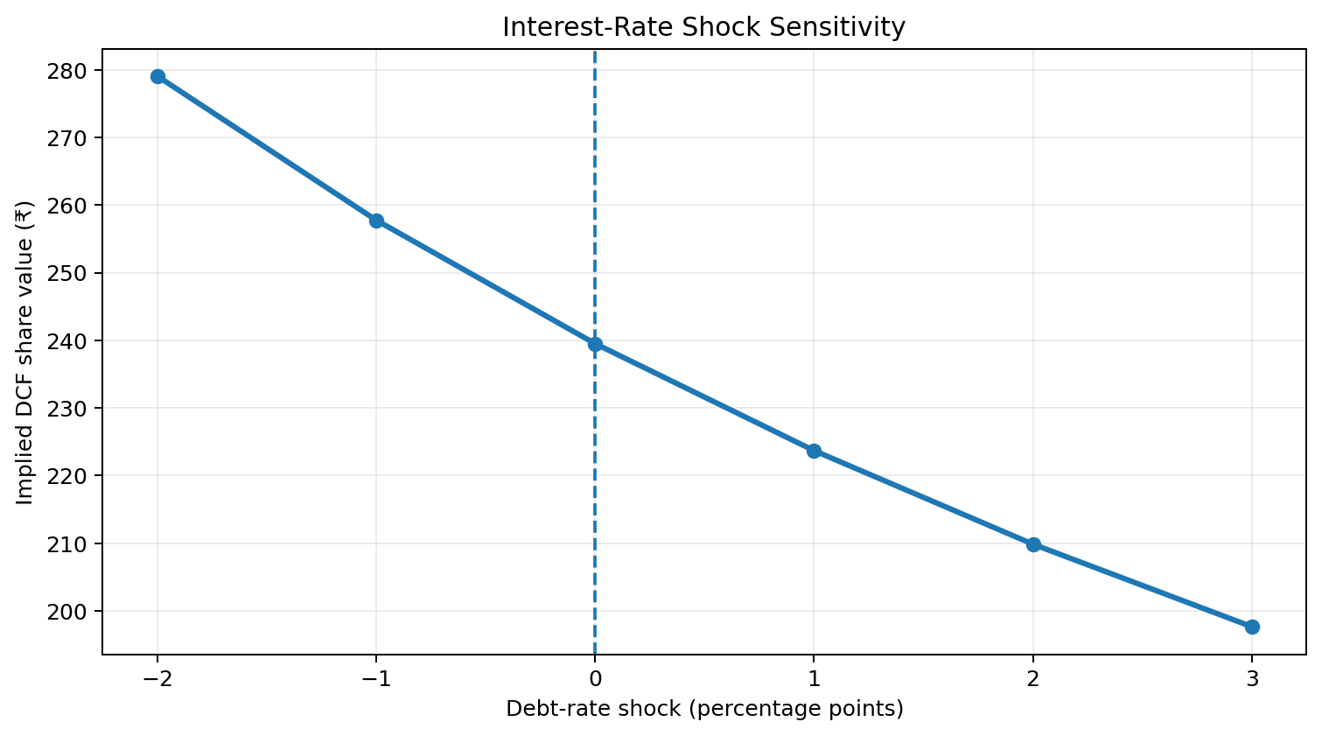
Figure 7. Interest-rate shock sensitivity and implied DCF share value.
Debt-rate shock | Scenario WACC | Implied DCF share value
-2.0% | 10.0% | ₹279.1
-1.0% | 10.5% | ₹257.8
0.0% | 11.0% | ₹239.5
+1.0% | 11.5% | ₹223.7
+2.0% | 12.0% | ₹209.9
+3.0% | 12.5% | ₹197.7

The interest-rate output has two financial-decision implications. First, borrowing costs affect the cash budget and therefore can change the funding mix available for expansion. Second, the market discount rate can move faster than operating earnings, causing valuation to decline before the financial statements reflect the full effect. In an investment-banking context, this is why financing assumptions and market-risk assumptions should be reviewed together.

8. RANGE OF OUTCOMES AND FINANCIAL-DECISION IMPLICATIONS
The purpose of sensitivity analysis is not to select the most attractive number. Its purpose is to understand the shape of the decision. In this case, the model shows a DCF value range of approximately ₹191.5 to ₹271.4 across the core Downside, Base and Upside operating cases. Against the reference market price of ₹459.1, the modelled DCF values remain below the reference price.
The result should not be interpreted as a definitive forecast of share-price direction. It is a statement about model economics. The market can assign a higher multiple than the DCF implies if investors expect stronger growth, higher margins, lower capital intensity, a lower risk premium or strategic benefits that are not captured in the base model.
For an investment banker, the practical lesson is to separate three questions. First, what is the company’s operating plan? Second, how sensitive is the financial model to the plan failing or outperforming? Third, what price or transaction terms provide enough protection against the adverse cases? Sensitivity analysis therefore informs valuation, structuring, due diligence priorities and negotiation strategy.
The downside case is useful as a risk floor for discussion, not as a forecast to be assumed automatically. The upside case is equally useful because it identifies the operational improvement required to create a higher valuation. Comparing the two helps management and investors concentrate on the variables that matter most rather than spreading attention across every line item.
The model also illustrates model risk. A sensitivity table can be mathematically correct while still being economically incomplete. For example, a simple EBITDA-margin shock may capture commodity inflation but not the possibility that higher commodity prices also change customer demand, working capital or competitive pricing. For this reason, the Week 4 model uses both individual sensitivities and joint two-way sensitivities.
Decision Area | Base Case View | Risk Question | Action
Investment | DCF ₹239.5/share | Is margin of safety adequate? | Use scenario range, not single point
Financing | 11.0% WACC | What if rates rise? | Protect liquidity; stagger maturities
Operations | 7.0% growth / 12.5% margin | Can the business defend assumptions? | Track volumes, pricing and margin monthly
Capex | 3.5% of revenue | Are returns sufficient? | Stage-gate investment approvals
Risk management | Multiple hedges and controls | Are exposures changing? | Refresh exposure map quarterly

9. RISK-MITIGATION STRATEGY

9.1 Hedging Strategy
Commodity and FX exposures should continue to be managed through appropriately sized forwards, options and fixed-price contracts. The objective should be to reduce earnings volatility without over-hedging and creating a new basis risk. Hedge effectiveness should be monitored against actual exposure volumes and forecast changes. The annual report states that the company uses forward contracts, options and other hedging mechanisms for foreign exchange and commodity exposures, providing a practical foundation for this recommendation.

9.2 Diversification and Supply-Chain Resilience
Management should maintain multiple qualified suppliers for critical materials and components, use strategic inventory buffers where economically justified and diversify logistics routes. The annual report already describes alternate sourcing and inventory buffers. From a financial perspective, these actions reduce the probability of a severe revenue and margin shock occurring at the same time.

9.3 Capital Restructuring and Liquidity Protection
The strong FY26 cash position provides flexibility, but liquidity should be treated as a strategic risk buffer rather than simply excess cash. Management should preserve access to diversified funding sources, stagger maturities and avoid unnecessary leverage. If external financing costs rise, lower leverage can protect free cash flow and maintain investment capacity.

9.4 Stage-Gated Capex
Technology and expansion projects should be approved in stages, with explicit milestones for demand, cost, launch readiness and expected return. This is particularly relevant to EV, hydrogen, digital and manufacturing programs. Projects that consistently fail return thresholds should be resized or deferred. The capex sensitivity table shows why this control is financially important: higher capex intensity can materially reduce DCF value.

9. RISK-MITIGATION STRATEGY (CONTINUED)

9.5 Operating Risk Dashboard
Management and investors should monitor a compact set of leading indicators: commercial-vehicle volumes, HCV market share, realized price per vehicle, EBITDA margin, commodity-cost indices, international volumes, FX movements, capex/revenue, working-capital intensity and free-cash-flow conversion. These indicators can be linked directly to model assumptions and used to refresh the valuation quarterly.

9.6 Valuation Discipline
Because WACC is highly influential, the DCF should be refreshed whenever market rates, business risk or capital structure changes materially. A static valuation can become misleading even when earnings have not yet changed. Investment decisions should therefore use a range of values and require a margin of safety rather than relying on a single target price.

9.7 Diversification of Funding Sources
From a capital-structure perspective, management can reduce refinancing risk by keeping access to multiple funding channels rather than relying on one source. A balanced combination of internal cash generation, bank facilities and debt-market instruments can provide flexibility across market cycles. The objective is not to maximize debt capacity but to protect the continuity of strategically important investment.

9.8 Investment-Banking Application
For an investment banker advising on capital allocation, a sensitivity model becomes a diligence and negotiation tool. When the downside case shows a large reduction in value from higher WACC or weaker margins, the adviser can recommend stronger covenants, staged funding, contingency liquidity, price protection or lower initial capital deployment. Similarly, if upside value depends on margin expansion, management milestones can be built into the decision framework before committing additional capital.
Figure 8. Cash-flow trajectory used as the operating risk-monitoring baseline.

10. FINDINGS AND CONCLUSION
The Week 4 exercise demonstrates that risk management and valuation are tightly connected. The most important output is not a single DCF value, but the relationship between assumptions and outcomes. Tata Motors enters the analysis with a strong FY26 cash-generation base, improved leverage and clear strategic opportunities. However, commercial-vehicle cyclicality, input-cost inflation, interest-rate changes, FX exposure and execution risk can all affect future cash flow.
The sensitivity model shows that revenue growth, EBITDA margin and WACC are the dominant value drivers. Capex intensity is also important because a higher investment rate directly reduces free cash flow. The two-way sensitivity tables illustrate that risk is non-linear: a moderate deterioration in operating performance combined with a higher discount rate can reduce valuation much more than either shock considered independently.
The recommended financial-management approach is therefore to protect downside while preserving strategic flexibility. Tata Motors should maintain disciplined pricing and procurement, continue appropriate commodity and FX hedging, diversify critical supply sources, protect liquidity, and stage large growth investments around explicit return thresholds. From an investment-banking perspective, these controls improve the quality of the forecast and reduce the chance that an attractive transaction model is built on fragile assumptions.
The final investment implication is one of disciplined scenario-based decision-making. The modelled DCF remains below the reference market price even in the upside operating case. That does not prove that the market is overvalued; it means the current market price requires stronger outcomes than those embedded in the base DCF. Therefore, any capital-allocation or investment decision should be supported by explicit assumptions, monitored against leading indicators and protected by a sufficient margin of safety.

11. LIMITATIONS
The analysis is intentionally sensitivity-driven and should be read as a decision-support model. The scenario ranges are analyst assumptions rather than company guidance. The model uses a simplified net-cash bridge and a scenario WACC mechanism rather than a full market-derived cost-of-capital build. Interest-rate stress uses the disclosed 8.5% reference debt coupon for scenario purposes and should not be interpreted as Tata Motors’ weighted-average borrowing cost.
The FX risk is not forecast through a detailed multi-currency operating model, and commodity risk is represented through EBITDA-margin stress rather than separate price and pass-through equations. The model also does not create a probability-weighted Monte Carlo distribution. Instead, it uses discrete scenarios and deterministic sensitivity tables so that the effect of individual drivers is transparent and easy to communicate.
The exercise therefore prioritizes interpretability and auditability. In a live transaction or investment mandate, the next enhancement would be to connect the sensitivity engine to a more granular operating model, incorporate probability weights, add debt schedules and explicitly model the timing of hedges, capex and working-capital changes.

12. BIBLIOGRAPHY AND SOURCES
No. | Source | Use in Report
1 | Tata Motors Limited, 2nd Integrated Annual Report 2025-26 | Audited FY26 financials, liquidity data, risk disclosures, debt and management commentary
2 | Tata Motors Week 3 Valuation & Investment Model | Base DCF architecture and valuation framework
3 | Tata Motors Week 4 Risk Management & Sensitivity Model | Scenario manager, one-way and two-way sensitivities, risk register and model outputs
4 | Investment Valuation concepts (Damodaran) | Conceptual reference for DCF and valuation sensitivity
.

13. ANNEXURE: KEY MODEL OUTPUTS
Model Area | Key Output | Value
Base DCF | Implied share value | ₹239.5
Scenario DCF | Downside / Base / Upside | ₹191.5 / ₹239.5 / ₹271.4
Revenue × WACC | Selected range | ₹169.9–₹370.5/share across tested corners
EBITDA margin × WACC | Selected range | ₹142.2–₹415.4/share across tested corners
Capex sensitivity | 2.5% to 5.0% revenue | ₹277.9 to ₹181.9/share
Interest-rate sensitivity | -2% to +3% shock | ₹279.1 to ₹197.7/share
FY31E Revenue | Base case | ₹1,17,611 cr
FY31E UFCF | Base case | ₹7,163 cr

