INTERNSHIP PROJECT REPORT

VALUATION ANALYSIS AND
INVESTMENT STRATEGY SIMULATION

Tata Motors Limited – Week 3 Valuation Study

Submitted by
Sandeep Singh
Junior Financial Analyst Intern – Virtual | Yuva Internship Portal

CERTIFICATE

This report entitled “Valuation Analysis and Investment Strategy Simulation on Tata Motors Limited” is submitted by Sandeep Singh as part of the Week 3 valuation assignment under the Junior Financial Analyst Intern – Virtual programme. The report documents the analytical work performed using Tata Motors’ FY2025-26 Integrated Annual Report and the accompanying valuation model.

________________________________________
Sandeep Singh

CANDIDATE’S DECLARATION

I, Sandeep Singh, declared that this report represents my work prepared for the Week 3 virtual internship assignment. The analysis is based on the supplied Tata Motors FY2025-26 Integrated Annual Report and the valuation workbook prepared for this assignment. The valuation outputs are analytical estimates and should not be treated as a guarantee of future market performance.

________________________________________
Sandeep Singh

ACKNOWLEDGEMENT

I would like to express my sincere gratitude to the Yuva Internship Portal and the mentors supporting the Junior Financial Analyst virtual internship for providing a practical environment in which financial valuation concepts can be converted into an integrated investment-analysis workflow. This Week 3 assignment provided an opportunity to move beyond historical statement analysis and construct a decision-oriented valuation framework using discounted cash flow analysis, trading comparables and a precedent transaction cross-check.
I also acknowledge the value of the Tata Motors Integrated Annual Report 2025-26, which provided the audited consolidated financial statement base, management commentary, liquidity information, operating performance indicators and transaction disclosures used in this Week 3 valuation model. The report focuses on valuation methodology, assumptions, sensitivity analysis and investment simulation.
Finally, I am thankful to my academic faculty at Maharaja Ranjit Singh Punjab Technical University for providing the finance and strategic-management foundation required to interpret financial statements, capital allocation choices and valuation outcomes.

TABLE OF CONTENTS

1. Executive Summary ........ 6
2. Introduction and Assignment Context ........ 7
3. Research Methodology and Data Collection ........ 7
4. FY26 Financial Performance Analysis ........ 7
5. Discounted Cash Flow Valuation ........ 9
6. Comparable Company Analysis ........ 11
7. Precedent Transactions Analysis ........ 12
8. Investment Strategy Simulation ........ 13
9. Risk Analysis and Strategic Recommendations ........ 14
10. Findings and Conclusion ........ 15
11. Limitations ........ 16
12. Bibliography and Sources ........ 16
13. Annexure: Key Model Outputs ........ 17

1. EXECUTIVE SUMMARY
FY26 was a structurally important year because the Commercial Vehicles company completed its demerger and operated as an independently listed entity. The annual report highlights revenue from operations of ₹83,855 crore, underlying EBITDA of ₹10,314 crore, underlying EBIT of ₹8,538 crore, profit after tax of ₹3,030 crore and free cash flow of ₹12,438 crore. The company also reported sales volume of 435,227 vehicles and a strong return on capital employed, while continuing to improve its balance sheet. Total debt at year-end was ₹4,817 crore against cash and cash equivalents of ₹6,899 crore, although the report also presents broader liquid assets and a net-cash position that includes lease liabilities and certain investments.
The DCF model uses FY26 as the operating base and projects revenue growth of 7.0% per year, EBITDA margin of 12.5%, tax rate of 25%, D&A at 2.3% of revenue, capital expenditure at 3.5% of revenue and net working capital at 5.5% of revenue. With an 11.0% WACC and 4.0% terminal growth rate, the model generates an enterprise value of approximately ₹86,057 crore and an implied equity value of ₹88,139 crore after a ₹2,082 crore net-cash adjustment. Dividing by 368 crore shares produces a DCF value of approximately ₹239.5 per share. The DCF indicates meaningful downside to the reference market price of ₹459.1 per share used in the model, illustrating that the intrinsic-value case is highly dependent on steady long-run execution and the discount-rate environment.
The trading comparable analysis uses Ashok Leyland and Force Motors as the selected core peer set, with Eicher Motors retained as a reference but excluded from the selected average because its business mix is materially diversified beyond commercial vehicles. FY26 EV/Sales multiples of 2.48x and 2.77x for Ashok Leyland and Force Motors respectively imply a selected peer average of 2.63x. The corresponding EV/EBITDA multiples are 11.6x and 16.78x, giving an average of 14.19x. Applying these to Tata Motors’ FY26 revenue and underlying EBITDA results in a blended trading-comps value of approximately ₹503.6 per share. This market-based approach is therefore materially more supportive of the current share price than the DCF.
The precedent transaction section uses the proposed IVECO acquisition as a cross-check rather than as a valuation input. The model captures the reported €3.8 billion purchase consideration and approximately €13.4 billion of target revenue, producing an illustrative purchase-price-to-sales ratio of about 0.28x. Because the transaction is an equity consideration with a different business mix, financing structure and transaction perimeter, applying this multiple directly to Tata Motors would create a distorted result. Accordingly, the report intentionally excludes the precedent result from the selected target weight, consistent with disciplined investment-banking practice.
The selected valuation target is therefore a 50/50 blend of DCF and trading comparables, producing approximately ₹371.5 per share. Compared with the reference market price of ₹459.1, the base case implies a downside of about 19.1%. The investment simulation shows an illustrative ₹100,000 position translating into an estimated loss of approximately ₹19,071 at the selected target, before transaction costs and taxes. The central conclusion is not that Tata Motors lacks strategic quality; rather, the model suggests that a substantial amount of operational strength and future growth is already recognized in the market valuation. The risk-reward therefore depends on execution catalysts—volume growth, margin expansion, downstream services, electrification and international expansion—being strong enough to justify or exceed the market-implied expectations.

2. INTRODUCTION AND ASSIGNMENT CONTEXT
The Week 3 task is designed to develop practical skills in company valuation and strategic investment recommendation. The stated deliverables require a valuation report supported by an Excel model and explicitly call for multiple techniques, including discounted cash flow analysis, comparable company analysis and precedent transaction analysis. The assignment also requires an investment simulation in which valuation results are converted into an actionable recommendation, with risks, strategy considerations and forecast outcomes. This report is the narrative companion to the valuation workbook and follows a structured internship-report format while maintaining an investment-banking valuation focus.

3. RESEARCH METHODOLOGY AND DATA COLLECTION
The methodology for this report is analytical and descriptive, with the financial model serving as the central quantitative instrument. The data architecture begins with audited FY26 consolidated financial statements and management discussion from Tata Motors’ Integrated Annual Report 2025-26. The annual report provides the FY26 income statement, balance sheet, cash flow statement, selected operating KPIs, liquidity commentary and transaction disclosures. The valuation workbook then converts those inputs into a standardized forecast and valuation framework.
A key quality-control principle in the analysis is traceability. Each major input is identified with a source or page reference in the workbook. The workbook also contains model checks confirming that the balance sheet balances, the DCF bridge reconciles, trading weights sum to 100% and the selected target formula is internally consistent. The report therefore uses the workbook as a transparent calculation engine rather than presenting isolated manually calculated numbers.

4. FY26 FINANCIAL PERFORMANCE ANALYSIS
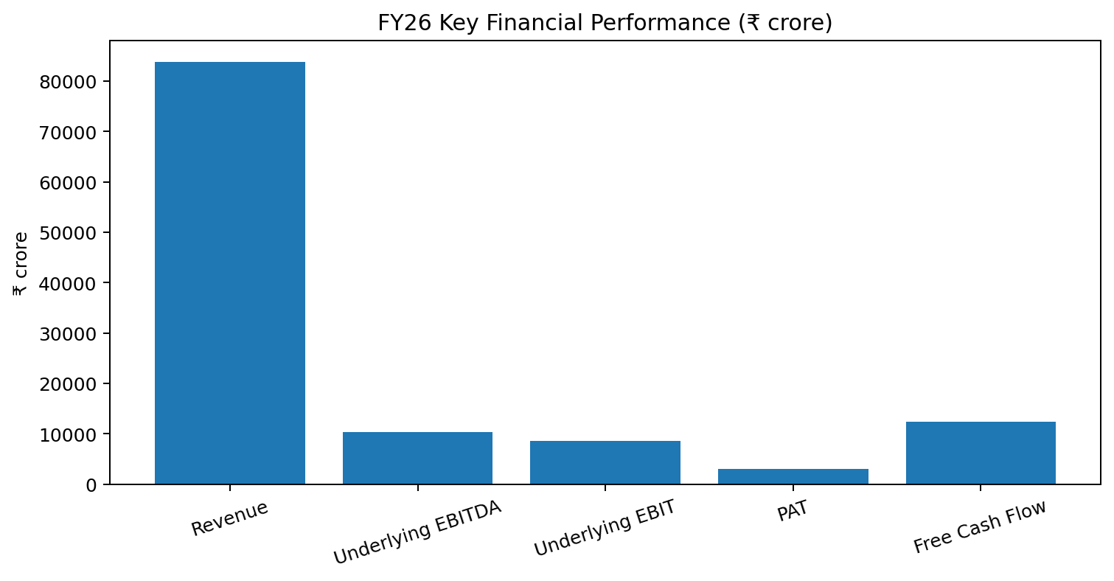
Figure 1. FY26 key financial performance metrics. Source: Tata Motors FY26 Integrated Annual Report; valuation workbook.
FY26 represents a strong operating year for Tata Motors’ Commercial Vehicles business. Revenue from operations reached ₹83,855 crore, representing the highest annual revenue reported by the company in the FY26 report. Underlying EBITDA was ₹10,314 crore and underlying EBIT was ₹8,538 crore. The underlying EBITDA margin was 12.3%, an improvement from the 11.3% level reported for the incomparable nine-month FY25 period. Profit after tax was ₹3,030 crore. These numbers indicate that the company’s growth was accompanied by operating leverage and stronger earnings quality rather than being driven only by volume expansion.
Metric | FY26A | Model / Interpretation
Revenue from operations | ₹83,855 cr | Primary forecast base
Underlying EBITDA | ₹10,314 cr | 12.3% margin; operating base for multiples
Underlying EBIT | ₹8,538 cr | 10.2% underlying EBIT margin
Profit after tax | ₹3,030 cr | Reported consolidated PAT
Operating cash flow | ₹14,981 cr | Strong cash generation
Free cash flow | ₹12,438 cr | Company-defined auto FCF
Total debt | ₹4,817 cr | FY26 year-end borrowings
Cash & equivalents | ₹6,899 cr | Year-end cash balance
Total equity | ₹12,734 cr | Year-end equity
Table 1. FY26 financial baseline used in valuation.
The balance sheet shows improvement in leverage and liquidity. Total debt fell from ₹9,156 crore in the comparable prior column to ₹4,817 crore at FY26, while cash and equivalents increased from ₹1,033 crore to ₹6,899 crore. The company also disclosed liquid assets of ₹13,048 crore when short-term deposits and certain current investments are included. The resulting capital structure provides an important foundation for the Week 3 valuation because lower financial leverage can support greater resilience in cash generation and capital allocation. This matters for valuation because lower leverage can reduce financial distress risk and supports continued investment in new products, digital capabilities and alternate powertrains.
There is also an important analytical warning in the historical series. The annual report explicitly states that the FY25 comparative financial statements cover approximately nine months and are therefore not comparable with the full FY26 year. This makes a naïve FY26-versus-FY25 percentage change potentially misleading. In this report, the prior period is used mainly for contextual comparison, while forecast ratios and valuation assumptions are anchored to the full-year FY26 operating profile. This is a more conservative approach and prevents an artificial growth rate from entering the valuation model.

5. DISCOUNTED CASH FLOW VALUATION
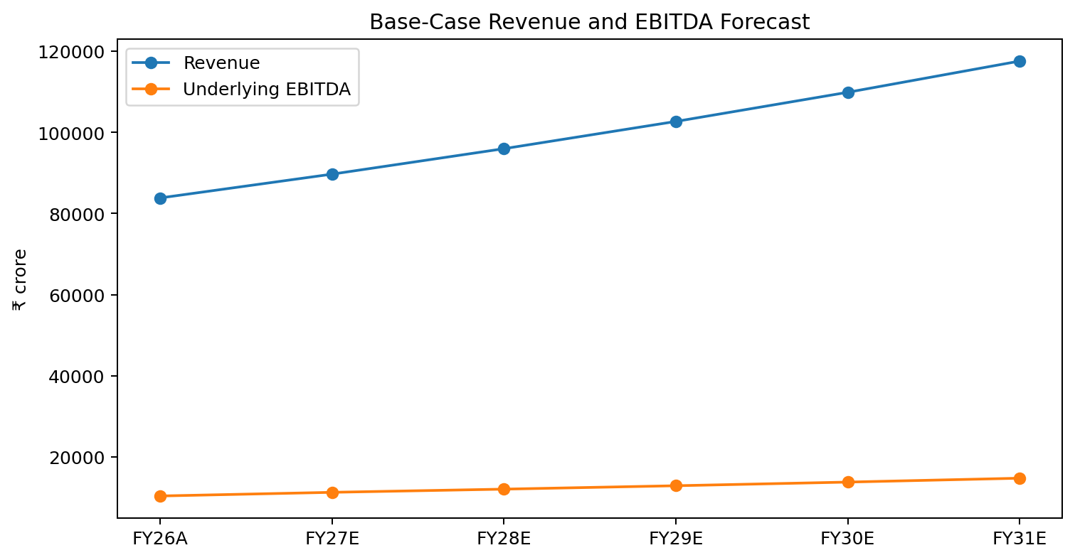
Figure 2. Base-case revenue and underlying EBITDA forecast, FY26A-FY31E.
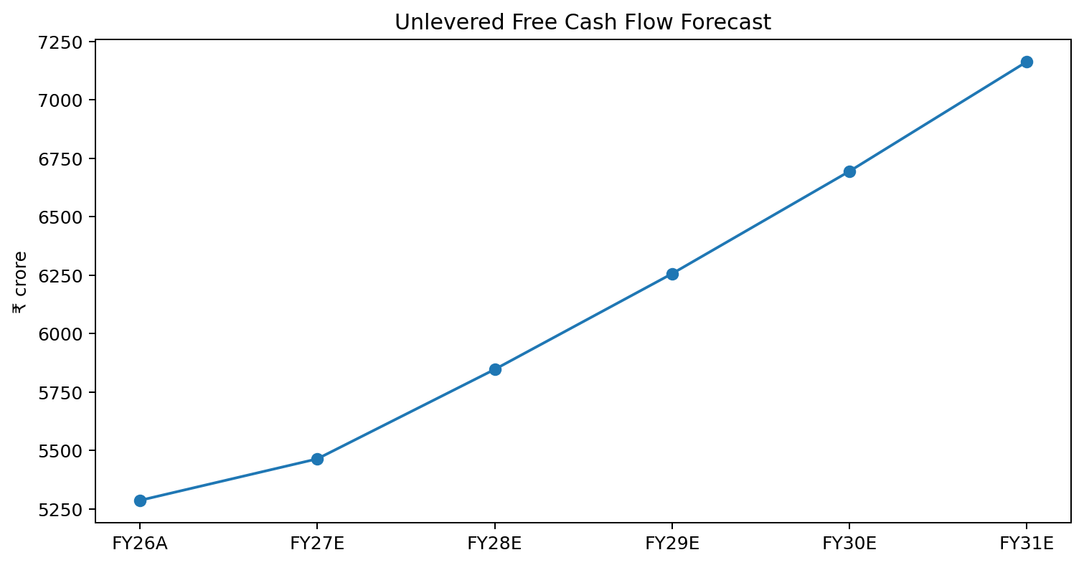
Figure 3. Unlevered free cash flow forecast, FY26A-FY31E.
The discount rate is a central driver of value. The model uses an 11.0% WACC, reflecting the required return for the enterprise under the selected capital structure and risk assumptions. At this rate, the present value of the explicit five-year cash flows is approximately ₹22,903 crore. The terminal value calculated using the Gordon Growth approach is approximately ₹1,06,418 crore, which discounts to approximately ₹63,154 crore. Adding the explicit and terminal present values gives enterprise value of approximately ₹86,057 crore. After adding the model’s ₹2,082 crore net-cash adjustment, implied equity value is approximately ₹88,139 crore.
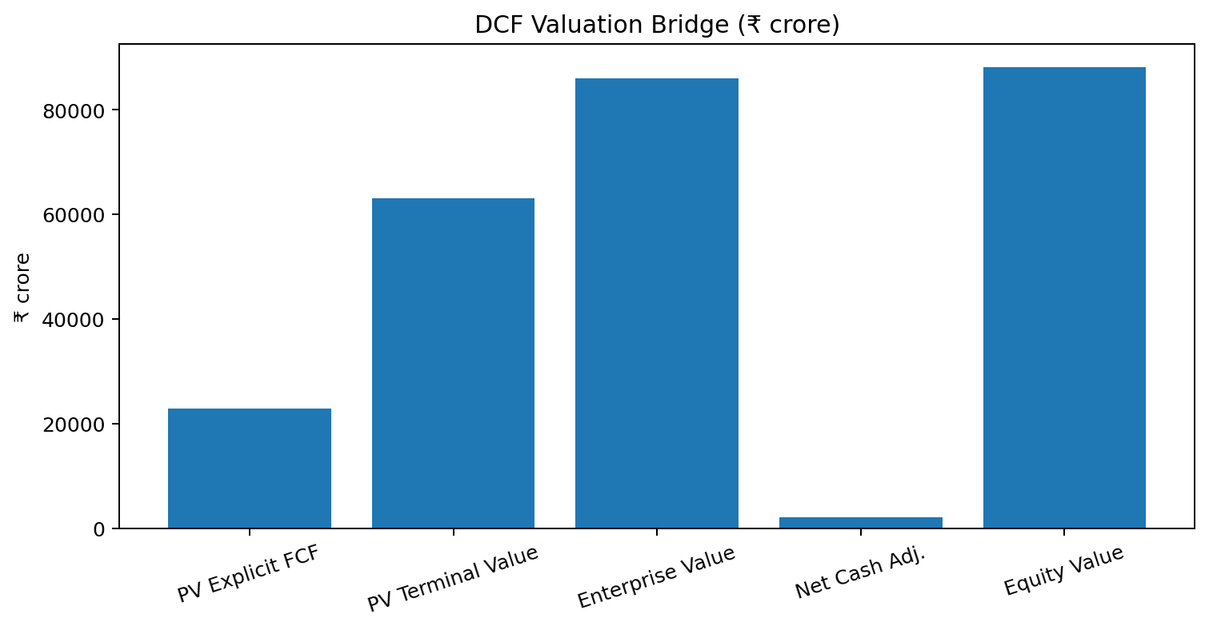
Figure 4. DCF enterprise-to-equity value bridge.
The resulting implied share value is ₹239.5 based on 368 crore shares outstanding. This is about 47.8% below the ₹459.1 reference market price used in the model. The gap should not be interpreted as proof that the market is wrong. Instead, it indicates that the current market price embeds expectations that are stronger than the base-case assumptions, such as higher sustainable growth, stronger margins, lower capital intensity, lower cost of capital, or some combination of these factors. It is precisely because DCF value is sensitive to such assumptions that the model includes a structured sensitivity analysis.
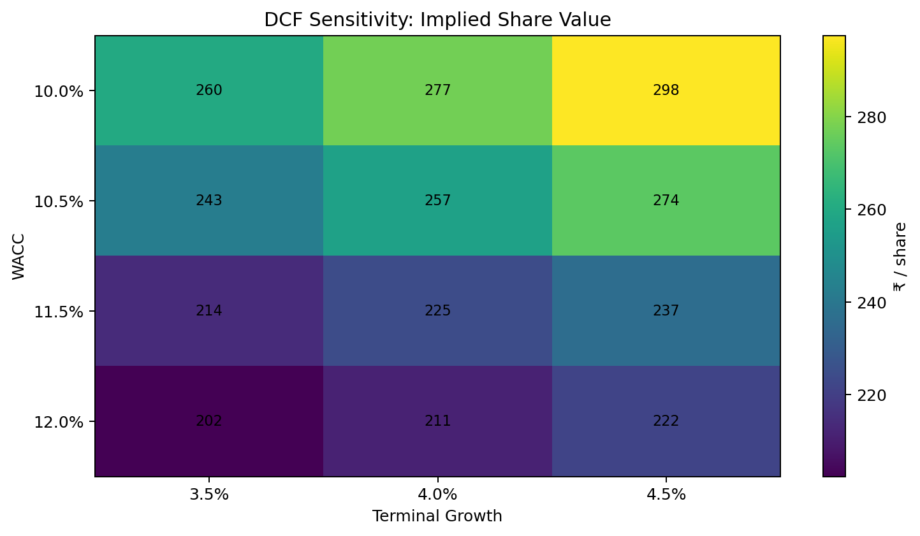
Figure 5. DCF sensitivity to WACC and terminal growth.
The sensitivity table shows DCF share values rising as WACC falls and terminal growth rises. At 10.0% WACC and 4.5% terminal growth, the model produces approximately ₹297.5 per share; at 12.0% WACC and 3.5% terminal growth, the value falls to approximately ₹202.4. This range demonstrates that valuation is not only about the operating forecast. The discount rate and terminal assumptions can shift equity value materially even when near-term revenue and EBITDA projections remain unchanged. In a real investment setting, this is a reason to monitor changes in bond yields, market risk premiums, cost of debt and business-risk perceptions alongside quarterly operating performance.
DCF Item | Value
FY26A Revenue | ₹83,855 cr
FY31E Revenue | ₹1,17,611 cr
FY31E Unlevered FCF | ₹7,163 cr
WACC | 11.0%
Terminal Growth | 4.0%
PV of Explicit FCF | ₹22,903 cr
PV of Terminal Value | ₹63,154 cr
Enterprise Value | ₹86,057 cr
Net Cash Adjustment | ₹2,082 cr
Implied Equity Value | ₹88,139 cr
Implied Share Value | ₹239.5
Table 2. DCF valuation summary.

6. COMPARABLE COMPANY ANALYSIS
Comparable company analysis provides a market-based valuation lens. The peer selection in the workbook is designed around Indian listed companies with meaningful commercial-vehicle exposure. Ashok Leyland and Force Motors are selected as the core peer set because their operating profiles are more directly connected to commercial vehicles. Eicher Motors is included as a market reference but excluded from the selected average because its diversified business, particularly Royal Enfield, leads to much higher valuation multiples and would distort the benchmark for a commercial-vehicle-focused company.
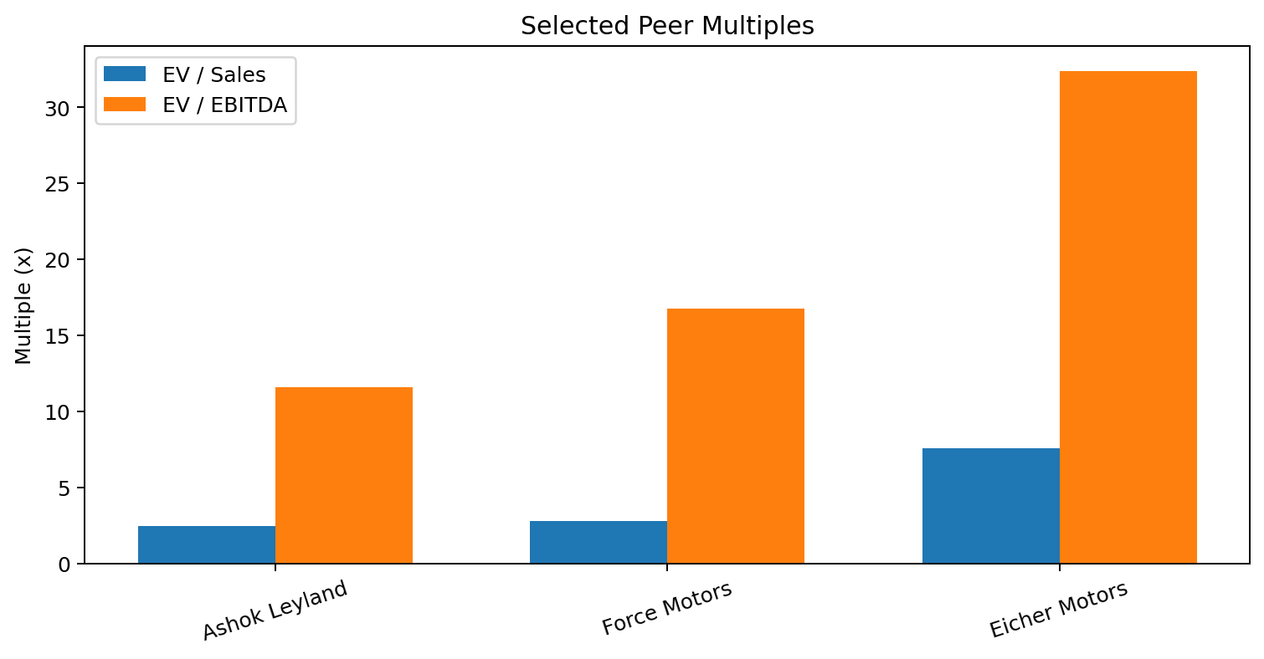
Figure 6. FY26 trading multiples for reference peers.
Peer | EV / Sales | EV / EBITDA | Selection
Ashok Leyland | 2.48x | 11.60x | Selected
Force Motors | 2.77x | 16.78x | Selected
Eicher Motors | 7.57x | 32.40x | Reference only
Selected average | 2.63x | 14.19x | Applied to Tata Motors
Table 3. Comparable company valuation multiples.
Applying the selected EV/Sales average of 2.625x to Tata Motors’ FY26 revenue of ₹83,855 crore produces an implied enterprise value of approximately ₹2,20,119 crore. After the ₹2,082 crore net-cash adjustment, implied equity value is approximately ₹2,22,201 crore, equivalent to about ₹603.8 per share. Applying the selected EV/EBITDA average of 14.19x to FY26 underlying EBITDA of ₹10,314 crore produces an implied enterprise value of approximately ₹1,46,356 crore and an implied share value of about ₹403.4.
The trading-comps method then gives equal weights to the EV/Sales and EV/EBITDA outcomes. The blended selected trading-comps value is approximately ₹503.6 per share. This result is above the reference market price of ₹459.1 and therefore provides an approximately 9.7% implied upside. The difference between the EV/Sales and EV/EBITDA outputs is itself informative. EV/Sales awards value to scale and revenue generation, while EV/EBITDA is more sensitive to profitability. Because Tata Motors’ business is benefiting from margin improvement, the use of both measures reduces dependence on a single profitability assumption.

7. PRECEDENT TRANSACTIONS ANALYSIS
The model captures an illustrative purchase consideration of €3.8 billion against reported target revenue of approximately €13.4 billion, implying a purchase-price-to-sales ratio of approximately 0.28x. When this ratio is mechanically applied to Tata Motors’ FY26 revenue, the resulting implied value is only about ₹64.6 per share. This is clearly inconsistent with the company’s operating fundamentals and the other valuation methods.
Precedent metric | Value | Interpretation
Purchase consideration | €3.8 bn | Reported transaction consideration
Target revenue | €13.4 bn | 2025 revenue cited by Tata Motors
Implied P / Sales | 0.28x | Derived transaction ratio
Illustrative Tata share value | ₹64.6 | Cross-check only; not used in target
Model treatment | Excluded | Transaction perimeter not directly comparable
Table 4. IVECO precedent transaction cross-check.

8. INVESTMENT STRATEGY SIMULATION
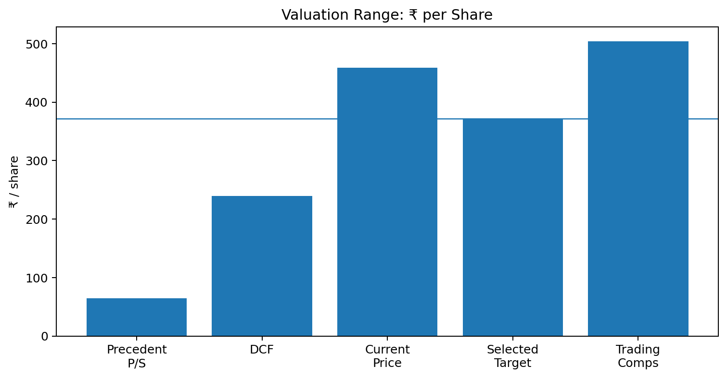
Figure 7. Valuation methods and selected target price.
Method | ₹ / Share | Comment
DCF | 239.5 | Intrinsic value; sensitive to WACC and terminal growth
Trading Comps | 503.6 | Market-based; selected peer set
Precedent P/S | 64.6 | Cross-check only
Current market price | 459.1 | Reference as of 7-Sep-2026
Selected target | 371.5 | 50% DCF + 50% trading comps
Table 5. Valuation summary and target price selection.
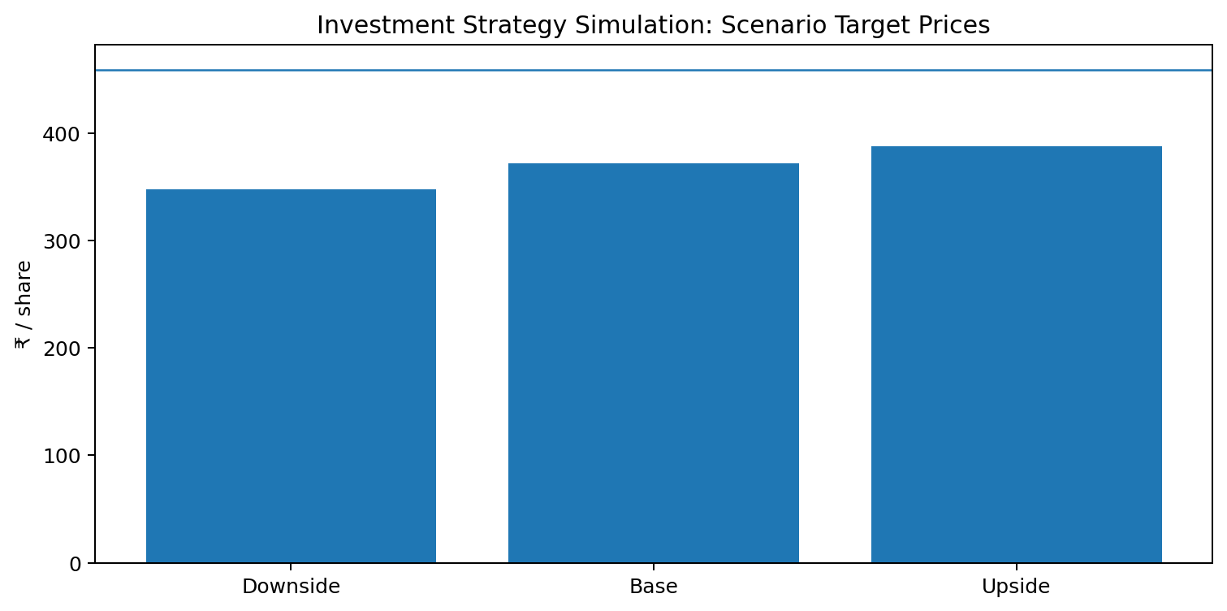
Figure 8. Scenario-based investment target prices.
The scenario simulator produces target prices of approximately ₹347.5 in the downside case, ₹371.5 in the base case and ₹387.5 in the upside case. In each case, the target remains below the current reference price of ₹459.1 because the scenario changes are focused on the DCF assumptions while the trading-comps result is held constant. This construction is useful for showing the directional impact of operating assumptions, but it should not be mistaken for a full probability-weighted valuation tree.
For the illustrative ₹100,000 investment, the simulator assumes an entry price of ₹459.1, which corresponds to approximately 217.8 shares on a fractional-share basis. At the selected target of ₹371.5, the position would be worth approximately ₹80,929, resulting in a modeled loss of about ₹19,071 and a return of approximately -19.1%. This example is deliberately educational rather than a personal investment recommendation. Actual returns depend on market prices, transaction costs, taxation, timing, liquidity, corporate actions and future information that is not reflected in the model.

9. RISK ANALYSIS AND STRATEGIC RECOMMENDATIONS
The investment case is shaped by several categories of risk. First is operating cyclicality. Commercial-vehicle demand is sensitive to infrastructure activity, freight utilization, replacement cycles, financing availability and general economic conditions. FY26 benefited from recovery in the second half, so the base-case model deliberately normalizes future growth rather than projecting a repeat of the strongest quarterly momentum. Investors should monitor monthly volumes, HCV market share and fleet utilization as leading indicators.
Second is commodity and input-cost risk. The annual report identifies exposure to raw materials such as aluminium, copper, platinum and palladium. Higher commodity prices can pressure gross margins, especially if pricing actions lag cost inflation. Tata Motors uses hedging and fixed-price supplier arrangements, but these tools reduce rather than eliminate risk. The investment implication is that the 12.5% sustainable EBITDA margin assumption should be tested against real-world movements in commodity costs and pricing realization each quarter.
Third is geopolitical and international-market risk. The company operates across multiple markets and reported that international business grew strongly in FY26, but the annual report also highlights geopolitical developments affecting some export markets. Currency fluctuations can influence reported results, while disruptions in the Middle East and other corridors can affect logistics, demand and supply chains. Management’s diversification strategy reduces dependence on any single market, but the valuation should still apply an appropriate risk premium to international growth.
Fourth is execution risk linked to electrification, alternate fuels and digital transformation. Battery-electric and hydrogen platforms may create important long-term growth opportunities, but they also require engineering investment, ecosystem infrastructure, product-market fit and disciplined capital deployment. Connected-vehicle services and downstream businesses may improve recurring revenue and customer retention over time, yet the pace of monetization remains uncertain. These opportunities can justify a premium valuation only when they translate into measurable financial outcomes.

Strategic Recommendations
- Maintain a valuation-sensitive investment stance: use ₹371.5 as the central modeled target and require a meaningful margin of safety before treating the stock as an attractive entry.
- Monitor operating catalysts quarterly: domestic CV volumes, HCV market share, EBITDA margin, international growth, aftermarket/services contribution and free cash flow conversion should be the core scorecard.
- Protect margin through disciplined pricing, procurement and hedging. The model’s 12.5% EBITDA margin should be stress-tested against commodity inflation and demand softness rather than treated as a guaranteed run-rate.
- Use capital allocation discipline around electrification, hydrogen, digital services and the IVECO transaction. Strategic expansion should be pursued where expected returns exceed the company’s cost of capital.
- Review the DCF assumptions whenever market rates or business risk change. WACC is a major valuation driver, and a lower or higher cost of capital can move intrinsic value significantly even without changes to near-term earnings.

10. FINDINGS AND CONCLUSION
The Week 3 valuation exercise demonstrates how financial statement analysis can be translated into investment-banking decision support. Tata Motors Commercial Vehicles entered FY26 with strong operational momentum, improved profitability and much stronger liquidity than in earlier periods. Revenue of ₹83,855 crore, underlying EBITDA of ₹10,314 crore, underlying EBIT of ₹8,538 crore and free cash flow of ₹12,438 crore create a robust financial base. The company also strengthened its market position in India while expanding international and technology-led opportunities. These factors support a positive long-term business-quality assessment.
At the same time, valuation introduces a separate question: what price is justified by the expected future cash flows and the market’s view of comparable companies? The DCF produces ₹239.5 per share, highlighting a meaningful gap between intrinsic value under the base-case assumptions and the ₹459.1 reference market price. The trading-comps approach produces ₹503.6 per share, showing that listed-market benchmarks can support a considerably higher valuation. The precedent transaction cross-check is much lower but is not economically comparable enough to include in the selected target. The 50/50 blend of DCF and trading comps therefore produces a central target of ₹371.5 per share.
The central investment conclusion is consequently one of valuation discipline. The business has meaningful catalysts: recovery in commercial-vehicle demand, continued market-share strength, margin improvement, downstream service growth, electrification and international expansion. However, the current price in the model already reflects a substantial portion of those strengths. The base-case blended target implies approximately 19.1% downside, so the report does not identify sufficient margin of safety at the reference price. A stronger investment case would require either a more attractive entry price or operational performance sufficiently above the current model assumptions to raise intrinsic value.

11. LIMITATIONS
- The DCF model is assumption-driven. The 7.0% revenue growth, 12.5% EBITDA margin, 25% tax rate, 3.5% capex-to-revenue, 5.5% NWC-to-revenue, 11.0% WACC and 4.0% terminal growth assumptions are analytical inputs, not guaranteed outcomes or company guidance.
- The FY25 comparison in the annual report covers approximately nine months and is therefore not directly comparable with full-year FY26. This limits the usefulness of simple year-on-year growth calculations and is why FY26 is used as the primary forecast base.
- The trading-comps selection is intentionally narrow. Peer businesses differ in financing activities, product mix, geography, profitability, brand portfolio and growth prospects. The selected average should therefore be interpreted as a market anchor rather than a definitive fair value.
- The IVECO transaction is a cross-check rather than a clean precedent because purchase consideration, target perimeter and strategic synergies differ from the Tata Motors valuation perimeter.
- The market benchmark of ₹459.1 is point-in-time. Share prices move continuously, so the relative upside or downside changes whenever the market price changes.
- The investment simulation is illustrative and uses fractional shares, excludes taxes and transaction costs, and does not represent personalized financial advice.

12. BIBLIOGRAPHY AND SOURCES
No. | Source | Use in Report
1 | Tata Motors Limited, 2nd Integrated Annual Report 2025-26 | Primary audited source; financial statements, MD&A, business profile, liquidity, IVECO disclosures.
2 | Tata Motors FY26 valuation workbook prepared for Week 3 | DCF assumptions, calculations, comparable company multiples, scenario analysis and model checks.
3 | Business Standard, Tata Motors share-price page, as of 7-Sep-2026 | Reference market price and source market capitalization used in the model.
4 | StockAnalysis – Ashok Leyland FY26 ratios | EV/Sales and EV/EBITDA peer inputs.
5 | StockAnalysis – Force Motors FY26 ratios | EV/Sales and EV/EBITDA peer inputs.
6 | StockAnalysis – Eicher Motors FY26 ratios | Reference peer multiples; excluded from selected average due to business diversification.
7 | Damodaran, A. Investment Valuation: Tools and Techniques for Determining the Value of Any Asset | Conceptual reference for valuation methodology.
Primary page references used from the Tata Motors annual report include the FY26 operating profile and business discussion (approximately pp. 213-220), consolidated financial statements (pp. 266-269), liquidity and funding discussion (p. 220), and the disclosed strategic IVECO transaction context in the annual report. The annual report also notes that FY25 comparative P&L and cash-flow figures cover only the period from June 23, 2024 to March 31, 2025 and should not be treated as directly comparable with FY26.

13. ANNEXURE: KEY MODEL OUTPUTS
Model Area | Key Output | Value
DCF | Implied share value | ₹239.5
DCF | Enterprise value | ₹86,057 cr
DCF | Implied equity value | ₹88,139 cr
Trading Comps | Selected value | ₹503.6 / share
Trading Comps | Selected EV/Sales | 2.63x
Trading Comps | Selected EV/EBITDA | 14.19x
Precedent | IVECO P/S cross-check | 0.28x
Precedent | Illustrative share value | ₹64.6
Investment Simulation | Current price | ₹459.1
Investment Simulation | Base target | ₹371.5
Investment Simulation | Base return | -19.1%
Investment Simulation | Illustrative investment | ₹100,000
Investment Simulation | Illustrative profit / (loss) | (₹19,071)
Table 6. Consolidated model output summary.
The accompanying Excel workbook contains the detailed calculation logic, source register, assumption cells, sensitivity table, comparable-company calculations, transaction cross-check and strategy simulation. The Word report is intended to explain and interpret those outputs in a submission-ready narrative format. Where a model number differs from a reported company figure because of methodology—such as the simplified DCF net-cash bridge or the deliberate exclusion of the IVECO precedent from the selected target—the distinction is stated explicitly rather than hidden.

