WEEK 2 PROJECT REPORT
Financial Modeling for Investment Banking
Comprehensive M&A Scenario Analysis:
Tata Motors Acquisition of Iveco Group

Prepared by: Sandeep Singh
Program: MBA 2nd Year
Affiliation: Maharaja Ranjit Singh Punjab Technical University (MRSPTU)
Role: Junior Financial Analyst Intern

1. Executive Summary
Purpose. This report translates the accompanying Excel financial model into an investment-banking style written analysis. The model combines Tata Motors’ FY2025-26 consolidated actuals with a forward operating forecast and a proposed acquisition of Iveco Group.
Starting point. Tata Motors reported FY26 consolidated revenue of ₹83,855 crore, EBITDA margin of 12.3%, profit after tax of ₹3,030 crore, net cash of ₹13,713 crore and free cash flow of ₹12,438 crore. The FY26 annual report also states that the Iveco transaction contemplated an all-cash offer of €14.1 per share, representing approximately €3.8 billion / ₹41,691 crore of equity consideration excluding the Defence business.
Model output. Under the selected Base operating / Base M&A / Balanced financing scenario, the model forecasts pro forma revenue increasing from ₹83,855 crore in FY26A to ₹8,88,679 crore in FY31E, while EBITDA rises to ₹1,05,798 crore and net income to ₹62,821 crore. The modeled revenue CAGR is approximately 60.3%; this very high rate is primarily driven by the modeled inclusion of Iveco’s revenue contribution and therefore should be treated as an educational scenario rather than management guidance.
Metric | FY26A | FY31E | Observation
Revenue (₹ cr) | 83,855 | 888,679 | 60.3% CAGR
EBITDA (₹ cr) | 10,482 | 105,798 | 12.5% → 11.9% margin
Net income (₹ cr) | 3,030 | 62,821 | Strong modeled growth
Ending cash (₹ cr) | 6,899 | 97,660 | Liquidity rebuild after FY27 draw
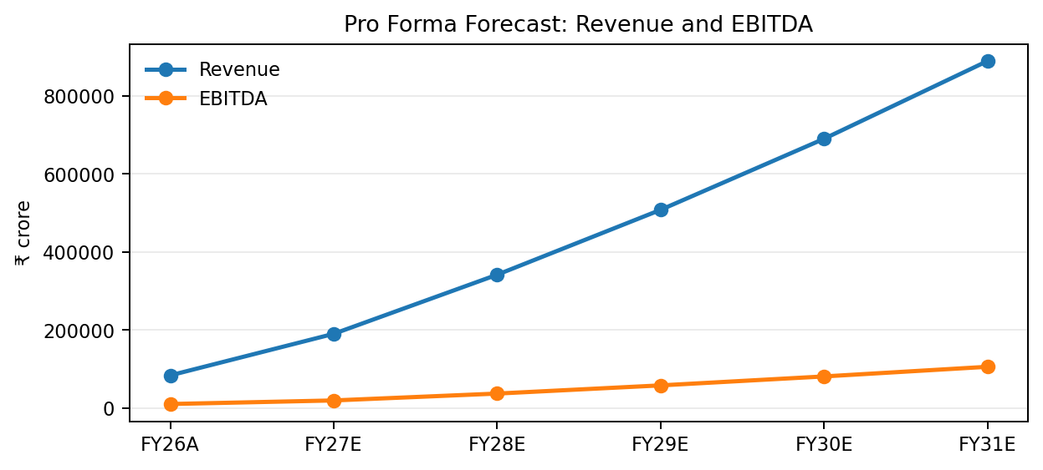
Figure 1. Pro forma revenue and EBITDA trajectory from the financial model.

2. Transaction Context & Strategic Rationale
Transaction context. The Tata Motors FY26 annual report describes the proposed Iveco transaction as a step toward creating a global commercial vehicles group, combining complementary product portfolios and geographies. The disclosed consideration was approximately ₹41,691 crore, excluding Iveco’s Defence business, with completion expected in Q2 FY27 subject to regulatory approvals and other conditions.
Why the transaction matters strategically. The model treats Iveco as a scale-and-geography expansion rather than a pure cost-cutting transaction. Tata Motors already has a strong commercial vehicle franchise in India, while the disclosed transaction offers access to additional European, Latin American and international commercial vehicle markets, manufacturing capabilities and powertrain technologies. This is consistent with the strategic rationale described in the annual report.

1. Global scale and market diversification
The acquisition broadens Tata Motors’ revenue footprint beyond India and reduces reliance on one regional demand cycle.

2. Technology and product portfolio
Iveco contributes light, medium and heavy commercial vehicle platforms and powertrain capabilities that complement Tata Motors’ existing portfolio.

3. Manufacturing and procurement leverage
The financial model assumes procurement and overhead synergies that ramp over time, reflecting a practical integration curve rather than immediate full capture.
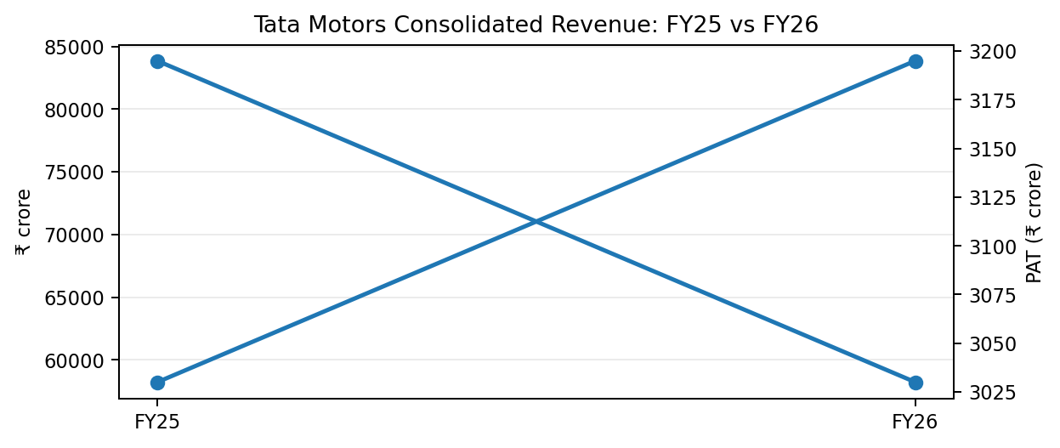
Figure 2. Tata Motors historical revenue and profit after tax from the FY26 annual report.

3. Transaction Mechanics & Financial Assumptions
The model adopts the source-derived purchase consideration and overlays explicitly identified modeling assumptions for financing, operating performance, synergies and integration costs.
Item | Selected Case | Units | Basis
Purchase consideration | 41,691 | ₹ crore | Annual report disclosed; excludes Defence
Cash funding | 4,169 | ₹ crore | Balanced case assumption
Debt funding | 33,353 | ₹ crore | Balanced case assumption
Equity funding | 4,169 | ₹ crore | Balanced case assumption
New debt interest rate | 7.5% | % | Model assumption
Iveco FY25 revenue | 134,000 | ₹ crore | €13.4bn disclosed; ₹/€ conversion assumed
Iveco EBITDA margin | 8.0% | % | Model assumption
Synergy run-rate | 1,500 | ₹ crore | Model assumption
FY27 synergy realization | 25% | % of run-rate | Model assumption
FY27 integration cost | 250 | ₹ crore | One-time model assumption
FY28 integration cost | 100 | ₹ crore | One-time model assumption
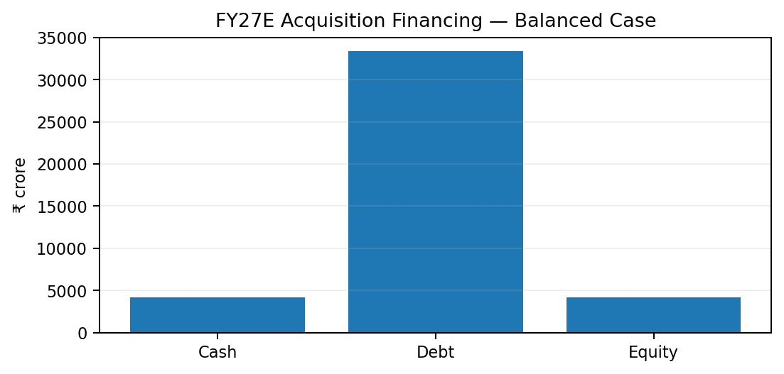
Figure 3. Balanced financing case used in the selected scenario.
Financing interpretation. The balanced structure is deliberately debt-heavy, using approximately 80% debt, 10% cash and 10% equity. This preserves some liquidity while avoiding the maximum dilution associated with an all-equity structure. The major short-term balance-sheet effect appears in FY27E, when cash falls and acquisition debt increases.

4. Pro Forma Financial Modeling & Methodology
The model follows the standard investment banking sequence: establish a historical base, build a standalone forecast, layer in the acquired business, add synergies and integration costs, then reflect financing effects in the combined three-statement model.
1. Standalone forecast: Tata Motors revenue grows at the selected 7.0% operating rate, with EBITDA margin anchored at 12.5% in the selected case.
2. Acquired business contribution: Iveco revenue starts with a 75% FY27 contribution factor because the transaction is expected to close in Q2 FY27, then grows at the selected 3.0% rate.
3. Synergy realization: The model ramps annual synergies from ₹375 crore in FY27 to ₹1,500 crore from FY30, representing procurement and overhead benefits.
4. Financing effects: Debt carries a 7.5% modeled interest rate and is progressively paid down, reducing annual interest expense over the forecast period.
5. Three-statement linkage: Net income, cash generation, debt funding and acquisition outflow feed through the income statement, balance sheet and cash flow statement.

4.1 Pro Forma Income Statement
₹ crore | FY26A | FY27E | FY28E | FY29E | FY30E | FY31E
Revenue | 83,855 | 190,225 | 341,561 | 507,630 | 689,590 | 888,679
EBITDA | 10,482 | 19,631 | 37,234 | 58,182 | 81,110 | 105,798
EBITDA margin | 12.5% | 10.3% | 10.9% | 11.5% | 11.8% | 11.9%
D&A | 1,945 | 5,079 | 8,822 | 12,671 | 16,886 | 21,495
Finance costs | 874 | 3,375 | 2,750 | 2,281 | 1,929 | 1,665
Net income | 3,030 | 9,038 | 20,015 | 33,265 | 47,564 | 62,821
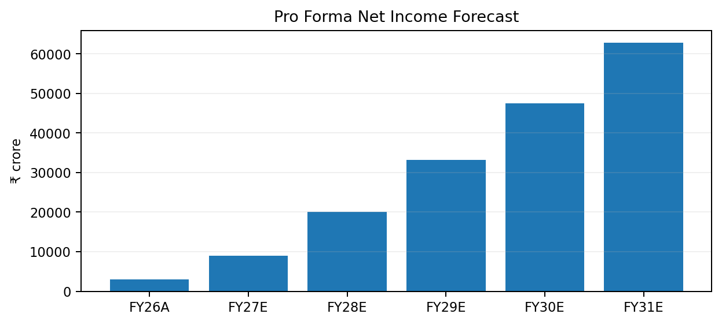
Figure 4. Modeled pro forma net income trajectory.

5. Integrated 3-Statement Model Highlights
The financial model is designed so that transaction funding, operating performance and cash generation interact rather than being treated as isolated schedules.

5.1 Balance Sheet — Key Forecast Lines
₹ crore | FY26A | FY27E | FY28E | FY29E | FY30E | FY31E
PP&E + CWIP + ROU | 12,560 | 14,139 | 17,272 | 22,368 | 29,618 | 39,227
Intangible assets | 3,428 | 5,330 | 8,746 | 13,822 | 20,718 | 29,605
Inventory | 5,448 | 9,511 | 17,078 | 25,382 | 34,480 | 44,434
Trade receivables | 2,721 | 5,707 | 10,247 | 15,229 | 20,688 | 26,660
Cash & equivalents | 6,899 | 2,656 | 16,199 | 35,960 | 62,944 | 97,660
Purchase accounting / goodwill | 0 | 41,691 | 0 | 0 | 0 | 0
Debt | 4,817 | 38,170 | 46,508 | 52,762 | 57,452 | 60,970
Trade payables | 15,704 | 22,827 | 40,987 | 60,916 | 82,751 | 106,642
Equity | 12,734 | 24,133 | 40,145 | 66,757 | 104,809 | 155,065
Balance check | 1,479 | 0 | 0 | 0 | 0 | 0
Model check. The projected balance sheet balances from FY27E onward, with a zero/near-zero balance check. FY26A shows a ₹1,479 crore difference in the simplified model because the workbook begins its forecast with a driver-based balance rather than a fully reconstructed acquisition-date bridge.

5.2 Cash Flow Statement — Key Forecast Lines
₹ crore | FY26A | FY27E | FY28E | FY29E | FY30E | FY31E
Cash flow from operations | 14,981 | 8,391 | 21,163 | 37,927 | 55,942 | 74,866
Capex | -2,103 | -6,658 | -11,955 | -17,767 | -24,136 | -31,104
Acquisition consideration | 0 | -41,691 | 0 | 0 | 0 | 0
Debt funding | 0 | 33,353 | 0 | 0 | 0 | 0
Equity funding | 0 | 4,169 | 0 | 0 | 0 | 0
Dividends | 0 | -1,808 | -4,003 | -6,653 | -9,513 | -12,564
Net change in cash | 6,307 | -4,243 | 13,544 | 19,761 | 26,984 | 34,716
Ending cash | 6,899 | 2,656 | 16,199 | 35,960 | 62,944 | 97,660
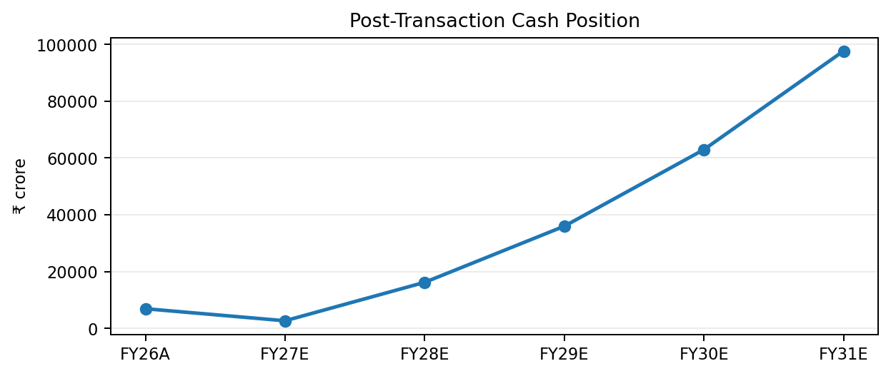
Figure 5. Ending cash recovers after the FY27E acquisition funding draw.

6. M&A Financing, Synergies & Integration Analysis
The acquisition consideration is modeled at ₹41,691 crore. Under the selected Balanced scenario, the transaction is funded with ₹4,169 crore of cash, ₹33,353 crore of debt and ₹4,169 crore of equity. Debt is then amortized through scheduled paydown assumptions, while synergies build as integration progresses.
₹ crore | FY27E | FY28E | FY29E | FY30E | FY31E
Synergies | 375 | 750 | 1,125 | 1,500 | 1,500
Debt balance | 33,353 | 25,015 | 18,761 | 14,071 | 10,553
Interest expense | 2,501 | 1,876 | 1,407 | 1,055 | 791
Iveco revenue contribution | 100,500 | 138,020 | 142,161 | 146,425 | 150,818
Iveco EBITDA | 8,040 | 11,042 | 11,373 | 11,714 | 12,065
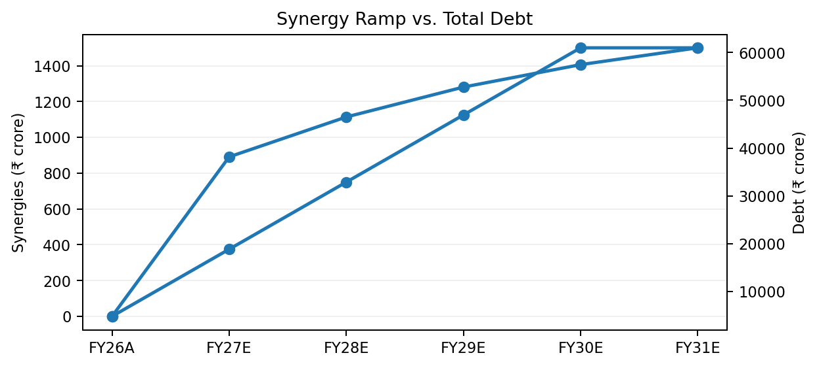
Figure 6. Synergy realization increases while acquisition debt is progressively reduced.
Key implication. The model shows a front-loaded financing impact: the acquisition creates a sharp FY27E increase in debt and a temporary reduction in cash, while the synergy ramp and cash generation subsequently improve liquidity and reduce leverage. Interest expense falls from approximately ₹2,501 crore in FY27E to ₹791 crore by FY31E.

7. Scenario & Sensitivity Analysis
Three financing cases are available in the workbook. The operating and M&A scenario controls also allow the analyst to flex revenue growth, margins, synergy capture, financing mix, debt paydown and integration costs.
Scenario | Cash % | Debt % | Equity % | Interest | Primary trade-off
All Cash | 100% | 0% | 0% | 7.5% | Maximum liquidity draw; minimum leverage
Balanced | 10% | 80% | 10% | 7.5% | Selected base case; moderate liquidity impact
Debt Heavy | 5% | 90% | 5% | 8.0% | Preserves cash but increases leverage / interest
Operating sensitivity. The selected Base case uses 7.0% revenue growth, 12.5% EBITDA margin and 5.5% net working capital as a percentage of revenue. Downside and Upside cases are embedded in the workbook and can be activated through the scenario control panel.
Important interpretation. Because the acquisition introduces a large new revenue base, the output can move materially with the assumed ₹/€ translation, contribution factor and Iveco operating margins. For investment-banking review, these variables should receive the highest diligence focus.

8. Practical Application: Post-Merger Integration (PMI) Reality
1. Regulatory and closing risk: The annual report explicitly states that the transaction remains subject to regulatory approvals and other conditions. Financial close timing therefore remains a critical model variable.
2. Synergy execution: The model assumes gradual synergy realization. Management must translate procurement, overhead and cross-platform opportunities into measurable savings without disrupting vehicle production or service levels.
3. Systems and controls: ERP, reporting, treasury, procurement and working-capital systems require harmonization. A staged integration approach helps preserve operating continuity.
4. Talent retention: Technology, engineering and program-management capabilities are strategic assets. Retaining key teams is essential to preserving the transaction’s expected product and technology benefits.
5. Working capital discipline: The combined group must align customer credit, supplier payment terms, inventory policies and cash controls to prevent the scale-up from consuming more cash than forecast.

9. Conclusion & Recommendation
Conclusion. The modeled Tata Motors–Iveco transaction creates a significant strategic opportunity by adding global commercial-vehicle scale, product breadth and geographic diversification. The base financial model indicates that the combination can generate substantial earnings growth after the initial acquisition funding impact, with synergies rising to ₹1,500 crore and debt balances declining meaningfully through the forecast period.
Recommendation. From a junior financial analyst perspective, the transaction appears strategically compelling but should be evaluated with disciplined attention to purchase price, funding capacity, regulatory timing and synergy delivery. The recommended analytical stance is to proceed subject to completion of approvals and a robust post-merger integration plan, while stress-testing the model under lower Iveco margins, slower synergy capture and higher financing costs.
Model caveat. This workbook is an educational financial model. FY26A figures are source-derived from Tata Motors’ FY2025-26 annual report, while forward assumptions—including Iveco margin, growth, synergy ramp, integration costs, financing mix and ₹/€ conversion—are analyst assumptions and are not Tata Motors guidance.

10. Sources & Analyst Notes
- Tata Motors Limited, 2nd Integrated Annual Report 2025-26 — Consolidated Balance Sheet, Consolidated Statement of Profit and Loss, Consolidated Statement of Cash Flows.
- Tata Motors Limited, Integrated Annual Report 2025-26 — Board’s Report / Iveco Group N.V. transaction disclosures.
- Sandeep Singh, Tata Motors Financial Model — selected Base operating scenario, Base M&A scenario and Balanced financing scenario.
Source-derived reference points include: FY26 revenue ₹83,855 crore; FY26 PAT ₹3,030 crore; FY26 FCF ₹12,438 crore; FY26 total assets ₹52,309 crore; FY26 equity ₹12,734 crore; FY26 total liabilities ₹39,575 crore; cash and cash equivalents ₹6,899 crore; total debt ₹4,817 crore; and proposed Iveco equity consideration of approximately ₹41,691 crore.
The FY25 comparative figures in the annual report are not always directly comparable because the company notes that the FY25 financial period for the demerged Commercial Vehicles entity covers a shorter period. The model therefore uses FY26A as the principal actual starting point.

