**Q1. Prepare the dataset**

Start with baseline_model_nyc_taxi_data.ipynb. Download the March 2024 Green Taxi data. We will use this data to simulate a production usage of a taxi trip duration prediction service.

What is the shape of the downloaded data? How many rows are there?

* 72044
* 78537
* 57457
* 54396

Answer – 57457

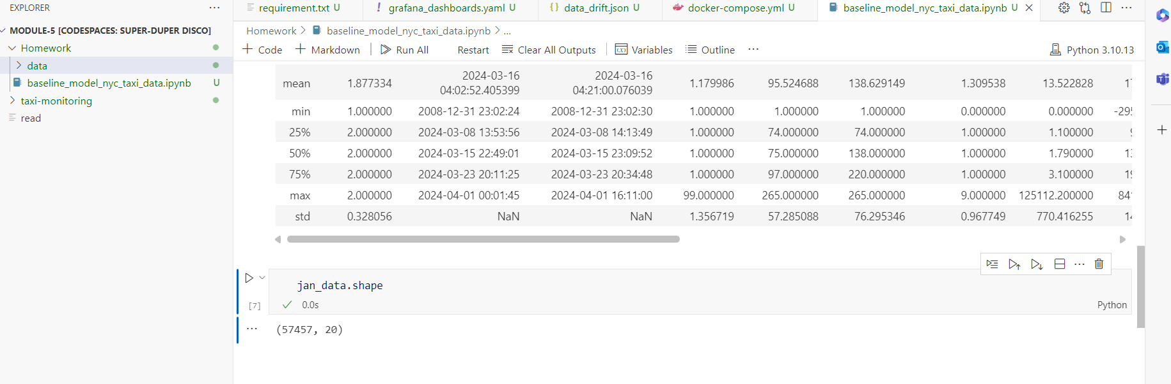

**Q2. Metric**

Let's expand the number of data quality metrics we’d like to monitor! Please add one metric of your choice and a quantile value for the "fare_amount" column (quantile=0.5).

Hint: explore evidently metric ColumnQuantileMetric (from evidently.metrics import ColumnQuantileMetric)

What metric did you choose?

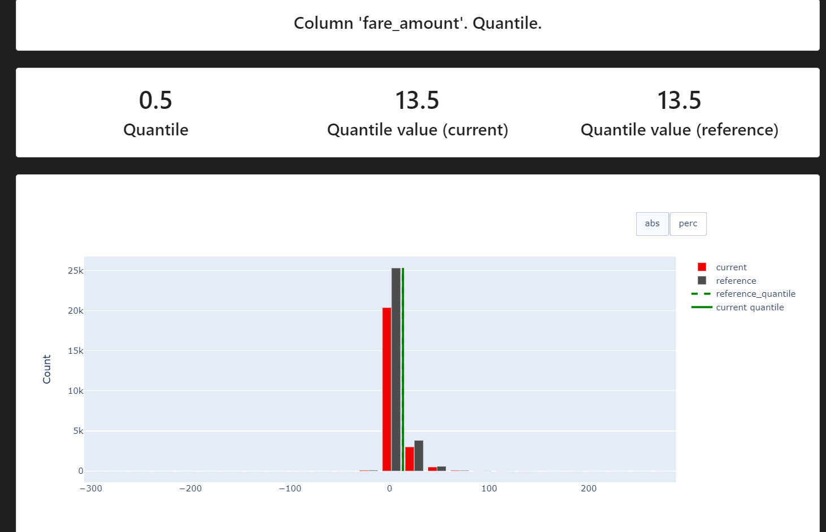

**Q3. Monitoring**

Let’s start monitoring. Run expanded monitoring for a new batch of data (March 2024).

What is the maximum value of metric quantile = 0.5 on the "fare_amount" column during March 2024 (calculated daily)?

* 10
* 12.5
* 14.2
* 14.8

Answer - 14.2

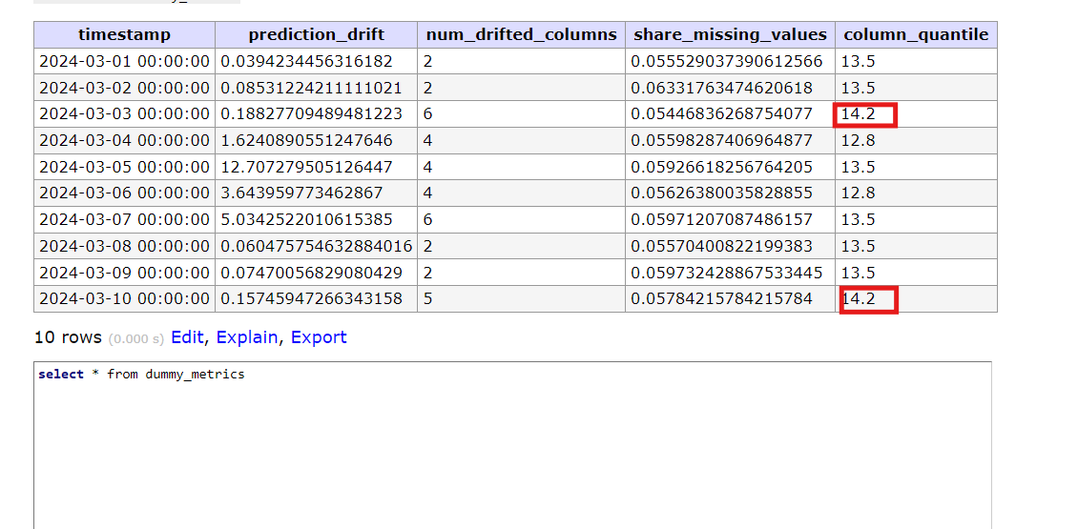

**Q4. Dashboard**

Finally, let’s add panels with new added metrics to the dashboard. After we customize the dashboard let's save a dashboard config, so that we can access it later. Hint: click on “Save dashboard” to access JSON configuration of the dashboard. This configuration should be saved locally.

Where to place a dashboard config file?

* project_folder (05-monitoring)
* project_folder/config (05-monitoring/config)
* project_folder/dashboards (05-monitoring/dashboards)
* project_folder/data (05-monitoring/data)

Answer – Json configuration is under -

project_folder/dashboards

