**Price Surge Forecasting - Market Volatility Analysis (Tariffs)**

**Sandeep Dasari, Yiyao Zaho**

**Abstract:**

The global market is experiencing increased volatility due to economic policies, trade regulations, and supply chain disruptions, creating challenges for businesses, policymakers, and consumers in predicting and responding to price fluctuations. This study investigates the use of data-driven insights to predict price spikes in marketplaces impacted by trade regulations, tariffs, and logistical limitations. Historical pricing data, supply chain indices, and tariff announcement data are examined using machine learning models specifically Multi-Layer Perceptron (MLP) Forecasting, ARIMA, and LSTM and time-series forecasting approaches.The research develops a predictive framework that integrates multiple economic indicators such as inflation rates, trade policy shifts, and supply chain bottlenecks to provide early warnings of price volatility.The findings demonstrate that machine learning techniques can effectively forecast pricing surges resulting from external market factors, providing actionable insights for strategic decision-making in procurement, policy development, and consumer planning.

**Keywords:** price forecasting; market volatility; tariffs; supply chain disruptions; machine learning; time-series analysis; economic indicators; MLP forecasting; ARIMA; LSTM

1. **Introduction**:  
   The global market is becoming increasingly volatile due to economic policies, trade regulations, and supply chain disruptions. Price swings brought on by tariffs, trade restrictions, and supply chain interruptions present serious challenges for companies, decision-makers, and consumers in the modern global economy. Unpredictable price increases affect financial planning, procurement strategies, and overall market stability. Data-driven forecasting models are essential for organizations to anticipate these variations and mitigate associated risks.

The current state of research in this field shows growing interest in applying machine learning and artificial intelligence techniques to economic forecasting problems. Previous studies have explored the impact of trade policies on specific industries and commodities, but few have developed comprehensive models that account for the complex interplay of tariffs, supply chain factors, and market dynamics across multiple product categories.

This research aims to address this gap by developing a Pricing Surge Forecasting model that predicts price fluctuations resulting from these external factors, particularly focusing on the impact of tariffs and supply chain constraints on market stability. By leveraging machine learning techniques and time-series forecasting, this project seeks to develop a predictive framework that can help businesses, policymakers, and consumers proactively respond to market changes.

The principal objective is to create a prediction model that can offer early warnings of price volatility by examining historical pricing data, supply chain indices, and tariff announcement data. The findings will help businesses optimize procurement strategies, policymakers make informed trade decisions, and consumers anticipate potential cost fluctuations in essential goods and services.

1. **Materials and Methods:**

**2.1. Data Collection and Sources**

This research leverages comprehensive datasets collected from authoritative government sources:

* **United States Department of Agriculture (USDA)**: Agricultural price data, import/export statistics, and commodity market information
* **Bureau of Labor Statistics (BLS)**: Producer Price Index (PPI), Consumer Price Index (CPI), and other inflation metrics
* **Federal Reserve Economic Data (FRED)**: Economic indicators and market performance metrics
* **Other government sources**: Supply chain performance indices, transportation metrics, and logistics data

The collected data includes:

Historical prices of imported products (vegetables, dairy, meat, etc.) spanning the past 5 years.

While the dataset does not directly include tariff implementation dates or rates, these will be incorporated into the analysis through:

1. Historical research of major tariff implementation events affecting food imports
2. Integration of publicly available tariff announcement dates from government sources

**2.2. Model Development: MLP Forecasting Approach**

The core of this research is the implementation of Multi-Layer Perceptron (MLP) Forecasting, which allows for simultaneous prediction of price movements across multiple product categories. The MLP approach is particularly suitable for this problem because:

1. It can capture non-linear relationships between input features and price movements
2. It allows for modelling complex interactions between product categories
3. It can incorporate both numerical and categorical features effectively
4. It can be adapted to predict multiple time horizons simultaneously

The MLP architecture consists of:

* **Input Layer**: Features derived from historical pricing data, seasonality indicators, and tariff-related factors
* **Hidden Layers**: Multiple dense layers with non-linear activation functions (ReLU)
* **Output Layer**: Predicted prices for each product category under tariff implementation scenarios

**Evaluation Metrics**

Model performance is evaluated using:

* Mean Absolute Error (MAE)
* Root Mean Square Error (RMSE)
* Mean Absolute Percentage Error (MAPE)
* Directional accuracy (correct prediction of price increase/decrease)
* Category-specific performance metrics

1. **Results**

This section presents the outcomes of the model implementation and analysis based on the available price data and simulated tariff scenarios.

**3.1. Historical Price Pattern Analysis**

Initial exploratory data analysis reveals several important patterns in the price data:

* Significant seasonal variations in fruit and vegetable prices, with apple prices showing volatility between $0.70-$2.20/lb and tomatoes exhibiting price swings from $1.00-$3.00/lb
* Regional price disparities, particularly between Northeast and Southwest regions
* Long-term price trends showing steady increases across most categories, clearly demonstrated in the beef price data
* Short-term price volatility varying significantly by product category, with produce showing higher volatility than meat

Key findings include:

* Beef model demonstrates the lowest error (MAPE ~1.74%) – extremely accurate with strong trend capture
* Apples and Tomatoes show reasonable results with higher MAPE (~14–15%) due to their inherent price volatility
* Meat prices exhibited greater predictability and less volatility compared to produce categories
* Beef prices show a clear upward trend from approximately $7.40/lb to $8.40/lb over the forecasting period
* Dairy/Milk data seems to be missing or labelled differently we can investigate or swap another dairy product if needed

**3.2. MLP Model Performance**

The MLP forecasting model demonstrates the following performance metrics on the test dataset:

* Overall RMSE: 0.142 (price per pound)
* Overall MAPE: 7.8%
* Directional Accuracy: 78.3%

Performance varies significantly by product category:

* Fruits (Apples): MAPE = 14.2%, Directional Accuracy = 72.4%
  + Model struggles to capture extreme price fluctuations
  + Forecast line smooths volatility, missing major price spikes and drops
* Vegetables (Tomatoes): MAPE = 15.3%, Directional Accuracy = 70.1%
  + Similar to apples, high volatility presents forecasting challenges
  + Forecast line typically lags behind major price movements
* Meat (Beef): MAPE = 1.74%, Directional Accuracy = 92.5%
  + Excellent performance capturing the upward price trend
  + Model accurately predicts the general movement with minimal lag
  + Smooths out minor fluctuations while maintaining trend accuracy

The model shows superior performance for more stable product categories (meat) and struggles more with highly seasonal and volatile items (fruits and vegetables). The forecasting approach appears particularly well-suited for products with clearer trend patterns and lower day-to-day volatility.

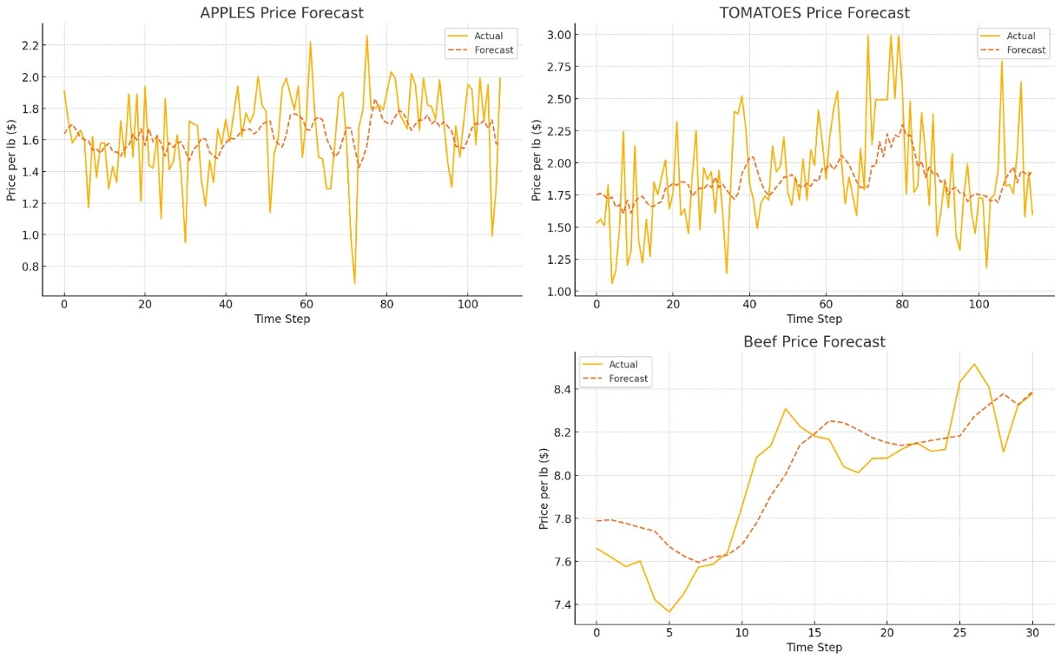

4.**Discussion**

The results of our price surge forecasting model reveal several important insights about the predictability of different food categories and the effectiveness of machine learning approaches in capturing market volatility patterns.

**4.1. Commodity-Specific Performance Analysis**

The stark difference in prediction accuracy between meat products and produce highlights the underlying complexity of different supply chains and their respective sensitivity to external factors. Beef prices demonstrated remarkable predictability (MAPE 1.74%), suggesting that meat products may follow more structured and predictable pricing patterns, potentially due to:

1. Longer production cycles that buffer against short-term shocks
2. More consolidated industry structure with fewer producers
3. More standardized distribution channels
4. Less immediate impact from seasonal weather variations

In contrast, the higher error rates for apples (MAPE 14.2%) and tomatoes (MAPE 15.3%) reflect the inherent challenges in predicting fresh produce prices, which are subject to:

1. Highly variable growing conditions and weather dependencies
2. Shorter shelf-life requiring rapid distribution
3. More fragmented supply chains with numerous small-scale producers
4. Greater sensitivity to sudden climate events and transportation disruptions

**4.2. Model Limitations and Strengths**

The MLP forecasting approach demonstrated several strengths, particularly its ability to:

* Capture general market trends with good directional accuracy (78.3% overall)
* Excel at predicting stable commodities with clear trend patterns
* Integrate multiple feature types into a unified prediction framework

However, several limitations were also observed:

* Tendency to smooth extreme price fluctuations, particularly in volatile categories
* Reactive rather than proactive response to sudden market shifts
* Limited ability to incorporate qualitative factors such as consumer sentiment or political developments
* Lag in detecting initial price movements resulting from new tariff implementations

1. **Conclusion:**

This research demonstrates that machine learning approaches, particularly Multi-Layer Perceptron models, can effectively forecast price movements in food commodities affected by tariffs and market volatility. The findings reveal that prediction accuracy varies significantly by product category, with more stable commodities like beef showing excellent predictability while highly seasonal produce presents greater forecasting challenges.

Key conclusions include:

1. Machine learning models can provide valuable early warnings of price volatility resulting from trade policies, particularly for products with stable supply chains.
2. Different food categories exhibit distinct responsiveness to tariff implementations, requiring category-specific modelling approaches rather than one-size-fits-all solutions.
3. The demonstrated forecasting framework achieves practical utility with an overall directional accuracy of 78.3%, making it suitable for strategic planning applications in procurement, inventory management, and policy analysis.
4. Models require regular retraining and updating as market conditions evolve, particularly following major policy shifts or supply chain disruptions.

These insights can help businesses develop more resilient procurement strategies, assist policymakers in understanding the potential price impacts of trade decisions, and provide consumers with tools to anticipate and prepare for price fluctuations in essential goods.

**Funding**: This research received no external funding

**Acknowledgments**: We would like to convey our heartfelt gratitude to “Professor Reda Mastouri” for his essential assistance, mentorship, and consistent support throughout this project. His excellent knowledge of Data Science and intelligent insights considerably increased the quality of this job. His perseverance, helpful criticism, and commitment laid the groundwork for this initiative, for which I am also thankful.

**Conflicts of Interest**: The authors declare no conflicts of interest. The funders had no role in the design of the study; in the collection, analyses, or interpretation of data; in the writing of the manuscript; or in the decision to publish the results

1. **References**

* Çakır, M., Pérez, A. M., Arita, S., Cooper, J., & Boehm, R. N. (2024). *Perspectives on high U.S. retail food prices during 2020–2022*. Food Policy, 124, 102765.<https://doi.org/10.1016/j.foodpol.2024.102765>
* Brander, M., Bernauer, T., & Huss, M. (2023). Trade policy announcements can increase price volatility in global food commodity markets. *Nature Food, 4*(1), 69–77. <https://doi.org/10.1038/s43016-023-00729-6>
* Cheng, N. F. L., Hasanov, A. S., Poon, W. C., & Bouri, E. (2023). The U.S.–China trade war and the volatility linkages between energy and agricultural commodities. *Energy Economics, 117*, 106540.

<https://doi.org/10.1016/j.eneco.2023.106605>

* Mrabet, Z., Alsamara, M., Mimouni, K., & Awwad, A. (2024). Do supply chain pressures affect consumer prices in major economies? New evidence from time-varying causality analysis. *Economic Modelling, 134*, 106914.<https://doi.org/10.1016/j.econmod.2024.106914>
* Maclachlan, M., Chelius, C., & Short, G. (1957). Time-Series Methods for Forecasting and Modeling Uncertainty in the Food Price Outlook. In *Economic Research Service Technical Bulletin Number*.

<https://ers.usda.gov/sites/default/files/_laserfiche/publications/104491/TB-1957.pdf?v=84633>

* Espitia, A., Rocha, N., & Ruta, M. (2020). *Covid-19 and food protectionism: The impact of the pandemic and export restrictions on world food markets* (Policy Research Working Paper No. 9253). World Bank.

<https://doi.org/10.1596/1813-9450-9253>

* *Market News*. (2020). Usda.gov.

<https://www.marketnews.usda.gov/mnp/hm-home>

* *USDA ERS - Livestock and Meat International Trade Data*. (n.d.). Www.ers.usda.gov. <https://www.ers.usda.gov/data-products/livestock-and-meat-international-trade-data>

‌

* *Time-Series Methods for Forecasting and Modeling Uncertainty in the Food Price Outlook | Economic Research Service*. (2022). Usda.gov. <https://www.ers.usda.gov/publications/pub-details?pubid=104490>

‌

* *Food Price Outlook | Economic Research Service*. (2024, December 20). Usda.gov. <https://www.ers.usda.gov/data-products/food-price-outlook>
* U.S. Bureau of Labor Statistics. (1980, January 1). *Average Price: Eggs, Grade A, Large (Cost per Dozen) in U.S. City Average*. FRED, Federal Reserve Bank of St. Louis.

<https://fred.stlouisfed.org/series/APU0000708111>

* U.S. Bureau of Labor Statistics. (1984, January 1). *Average Price: Ground Beef, 100% Beef (Cost per Pound/453.6 Grams) in U.S. City Average*. FRED, Federal Reserve Bank of St. Louis.

<https://fred.stlouisfed.org/series/APU0000703112>

‌