**Use Cases of Image Capturing App**

**Installation :**

* Run the exe file on the System
* App Installed on System ,by double click on App we can use it.

**Use Cases :**

New File :-

1. First Run the App,then I will got the UI as follows.

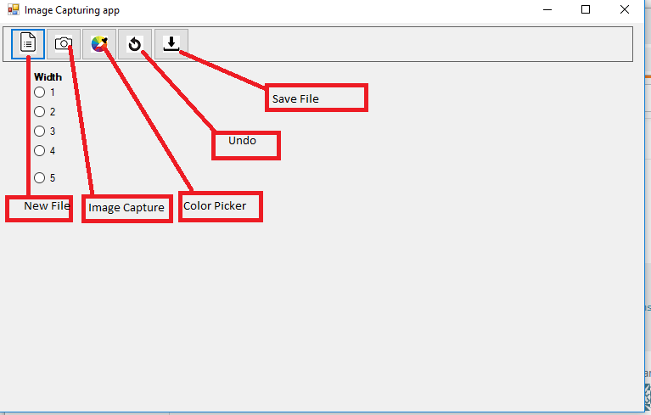

Capture :-

1. When click on New file ,I will get a Selfie camera as follows.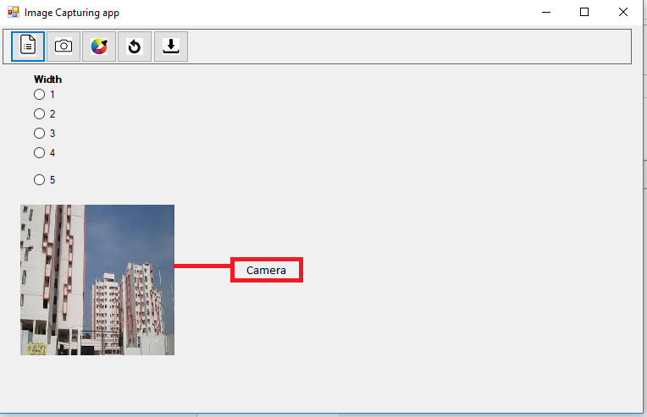

3 . When Click on Image Capture ,that image is captured as follows.

3.1. For Capturing the image I use ‘**AForge’**.Which will activate the camera from our application.

-> VideoCaptureDevice VideoSource = new VideoCaptureDevice (CaptureDevices[0].MonikerString);//camera Name

-> VideoSource.NewFrame += new NewFrameEventHandler(VideoSource_NewFrame);

private void VideoSource_NewFrame(object sender, NewFrameEventArgs eventArgs)

{ pictureBox1.Image = (Bitmap)eventArgs.Frame.Clone();}

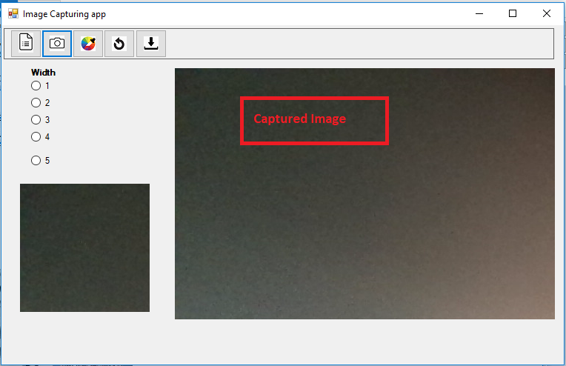

Pick Colour :-

4. When Click on the color Picker, I will got color dialog box from which I will select the desired color and then draw on image.

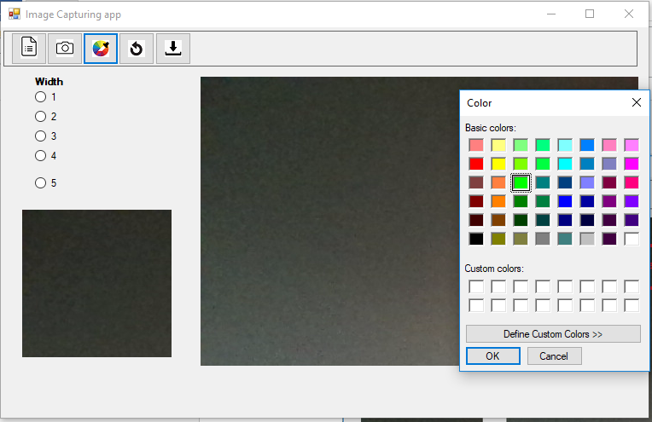

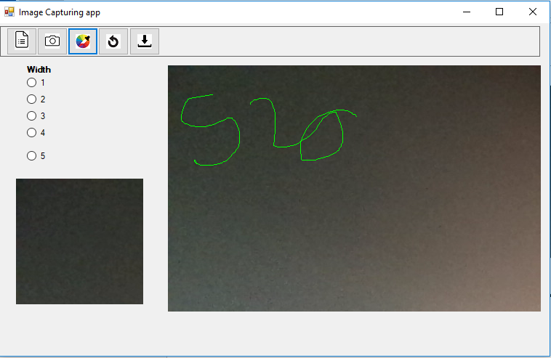

Width :

By Selecting width we can increase or decrease the width of Pencil.

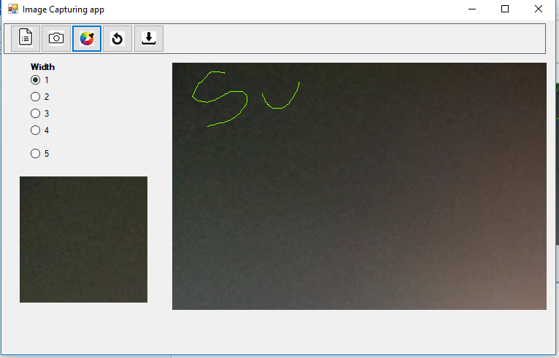

* By selecting the width as ‘5’ ,the width of Pencil increase as follows.

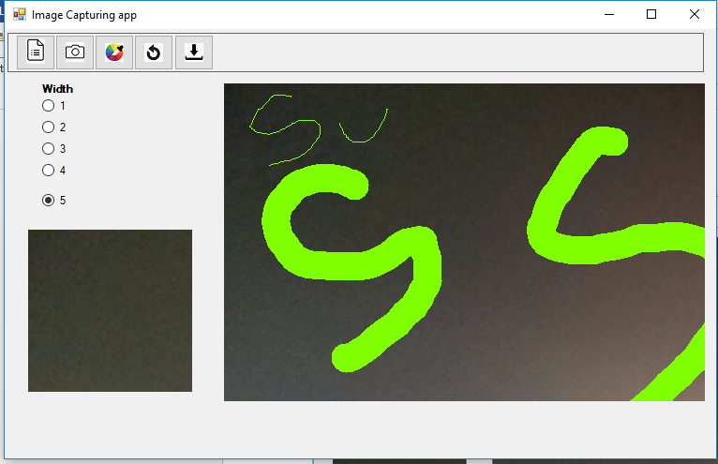

Undo :-

5. When Click on Undo last changes are cleared and shown as follows.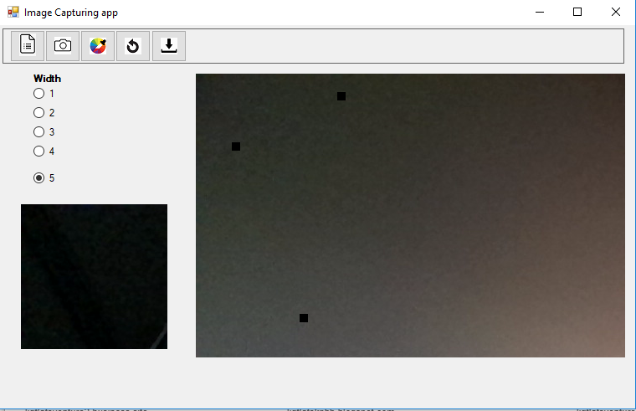

6. When Click on Save ,savefiledialog box will open with with **.jpg** format and ask for File name & Location.

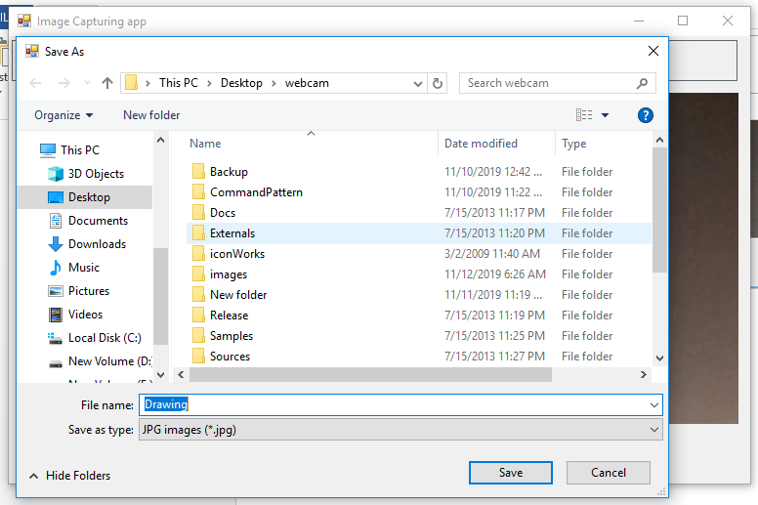

Note:At Present all Last actions cleared at a time.It takes some more time to do R&D on the last 6 actions.

* Actually I have tried multiple ways like ,Capture all the Pencil actions in Stack.
* When click on undo I have pop the top item and again peek the top element of the stack to PictureBox.
* Then in that case all last pencil actions cleared.So I need to do R&D on that it takes more time actually.

1. Select FileLocation & enter File name then click on save button the file will be save in that Particular Location.
2. At the same I will store the image as SVG in selected Location.

* For saving the document as SVG ,I used ‘**Rasterdge**’ dlls.
* This dll has the method name as ‘**ConvertToVectorImages**’ which takes the file and convert it into SVG.
* I have created one folder in ‘**C’** drive as ‘**output**’🡪C:\Output\
* The converting SVG file is saved in that output folder.

🡪public override void ConvertToVectorImages(ContextType targetType,

String directory, String fileName, RelativeType type)

|  |  |  |
| --- | --- | --- |
| **Name** | **Description** | **Valid Value** |
| targetType | The target image format. | ContextType.SVG ContextType.HTML |
| directory | The output file directory. | Any valid file directory on the disk. |
| fileName | The output file name. | Any valid file name. |
| Type | The method to write the output font. | When running on the IIS, the value is RelativeType.ASP; if it is running on the Visual Studio, the value is RelativeType.SVG/RelativeType.HTML. |