DATA SCIENCE WITH PYTHON
Integrative Capstone Project Report
Breast Cancer Diagnosis Prediction and Tumour Pattern Discovery
Submitted by
G Sandeep
Week 6 Task: Integrative Capstone Project and Evaluation
Data Science with Python Internship | October 2026

Contents
1. Executive Summary
2. Problem Statement
3. Methodological Approach
4. Data Collection
5. Data Cleaning and Preprocessing
6. Exploratory Data Analysis
7. Modelling
8. Evaluation
9. Insights and Recommendations
10. Reflection: Challenges and Successes
11. Conclusion and Future Work
Appendix A: Complete Python Script
References

1. Executive Summary
Breast cancer is one of the most common cancers worldwide, and early, accurate classification of a tumour as benign or malignant strongly influences patient outcomes. This project builds a complete data science pipeline in Python that predicts tumour diagnosis from measurements of cell nuclei taken from fine needle aspirate (FNA) images, and separately checks whether the data contains natural groupings without using the labels.
The pipeline covers data acquisition, quality checks, exploratory analysis, supervised modelling (five classifiers, cross-validation and hyperparameter tuning), unsupervised modelling (PCA and K-Means) and evaluation using metrics suited to a medical setting.
Key results:
- Best supervised model: a tuned RBF Support Vector Machine reached 98.25% accuracy, 98.61% recall and ROC-AUC of 0.9977 on a held-out test set of 114 patients.
- Strongest predictors: size and shape irregularity features, mainly worst perimeter, worst area and worst concave points.
- Unsupervised finding: K-Means with k = 2 recovered the diagnosis with about 90.5% agreement and no labels (Adjusted Rand Index 0.6536), showing the two classes are largely separable by structure alone.
- Caution: the test set is small, so differences of one patient between models are not statistically meaningful. This is a decision-support experiment, not a clinical tool.

2. Problem Statement
Pathologists examine FNA samples under a microscope to decide whether a breast mass is benign or malignant. The process depends on expert judgement and is time consuming. A reliable data driven second opinion can reduce missed cancers and unnecessary biopsies.

2.1 Objectives
- Build a supervised classifier that predicts whether a tumour is malignant or benign from numeric nuclear features.
- Compare several algorithms fairly using cross-validation and select one with justification.
- Use unsupervised learning (PCA, K-Means) to check whether the data forms natural groups and to visualise it.
- Identify which measurements matter most, so results are interpretable.
- Evaluate with metrics that reflect the cost of errors, particularly missed malignant cases.

2.2 Success Criteria
Because missing a cancer is more harmful than a false alarm, the main focus is on recall for the malignant class, supported by precision, F1-score, ROC-AUC and the confusion matrix. A secondary target was at least 95% overall accuracy and stable cross-validation scores.

3. Methodological Approach
The project follows a standard, reproducible workflow in which each stage feeds the next:
Stage | What was done | Python tools
1. Acquisition | Loaded the Wisconsin Diagnostic Breast Cancer (WDBC) dataset | scikit-learn, pandas
2. Cleaning | Checked missing values, duplicates, types, outliers, skewness | pandas, numpy
3. EDA | Class balance, distributions, correlations, group comparisons | matplotlib, seaborn
4. Preprocessing | Stratified 80/20 split, feature scaling inside pipelines | scikit-learn Pipeline
5. Supervised | Logistic Regression, KNN, SVM, Random Forest, Gradient Boosting; 5-fold CV; grid search | scikit-learn
6. Unsupervised | PCA for dimensionality reduction; K-Means with silhouette analysis | scikit-learn
7. Evaluation | Accuracy, precision, recall, F1, ROC-AUC, confusion matrix, feature importance | scikit-learn

3.1 Design Decisions
- Stratified split: keeps the 63/37 benign/malignant ratio identical in train and test sets.
- Scaling inside pipelines: the scaler is fitted only on training folds, which prevents data leakage into validation or test data.
- Test set used once: model selection and tuning used only cross-validation on the training set; the test set was touched only for final reporting.
- Fixed random seed (42): so every number in this report can be reproduced.

4. Data Collection
The data is the Breast Cancer Wisconsin (Diagnostic) dataset, a public benchmark created by Dr. William H. Wolberg, W. Nick Street and Olvi L. Mangasarian at the University of Wisconsin and hosted by the UCI Machine Learning Repository. A copy is distributed with scikit-learn, so it is loaded directly in Python with no manual download.
import pandas as pd
from sklearn.datasets import load_breast_cancer

data = load_breast_cancer(as_frame=True)
df = data.frame.copy()
df["diagnosis"] = df["target"].map({0: "Malignant", 1: "Benign"})
print(df.shape) # (569, 32)
print(df["diagnosis"].value_counts())

4.1 Dataset Description
Property | Value
Records (patients) | 569
Input features | 30 numeric (plus target and a derived label column)
Target | Diagnosis: malignant (0) or benign (1)
Class counts | Benign 357 (62.7%), Malignant 212 (37.3%)
Feature origin | 10 nuclear characteristics, each as mean, standard error and worst (largest) value
Ten characteristics | radius, texture, perimeter, area, smoothness, compactness, concavity, concave points, symmetry, fractal dimension

Ethical note: the dataset is anonymised and contains no personal identifiers. Results here are for learning and must not be used for real diagnosis.

5. Data Cleaning and Preprocessing

5.1 Quality Checks
print(df.isna().sum().sum()) # missing values
print(df.duplicated().sum()) # duplicate rows
print(df.dtypes.value_counts()) # data types
X = df.drop(columns=["target", "diagnosis"])
y = df["target"]

# IQR outlier count per feature
q1, q3 = X.quantile(.25), X.quantile(.75); iqr = q3 - q1
outliers = ((X < q1 - 1.5*iqr) | (X > q3 + 1.5*iqr)).sum()
print(outliers.sort_values(ascending=False).head())
print(X.skew().sort_values(ascending=False).head())

Check | Result
Missing values | 0
Duplicate rows | 0
Data types | All 30 features are float64; no encoding needed
Most outliers (IQR rule) | area error (65), radius error (38), perimeter error (38)
Most skewed features | area error (5.45), concavity error (5.11), fractal dimension error (3.92)

5.2 Cleaning Decisions
- No imputation required: the dataset has no missing values or duplicates.
- Outliers retained: the extreme values occur in the "error" features and the large-tumour tail. They are clinically meaningful (large, irregular tumours tend to be malignant), so deleting them would remove signal. Tree models are robust to them, and scaling plus regularisation handles the rest.
- Skewness: several error features are strongly right-skewed. Tree-based models are unaffected; linear and distance based models were kept with standard scaling, which performed well, so a log transform was not needed.

5.3 Train/Test Split and Scaling
from sklearn.model_selection import train_test_split
from sklearn.preprocessing import StandardScaler
from sklearn.pipeline import Pipeline

Xtr, Xte, ytr, yte = train_test_split(
X, y, test_size=0.2, stratify=y, random_state=42) # 455 train / 114 test

6. Exploratory Data Analysis

6.1 Class Balance
The target is moderately imbalanced (357 benign vs 212 malignant). It is not severe enough to need resampling, but it means accuracy alone can mislead, so recall, precision, F1 and AUC are reported as well.
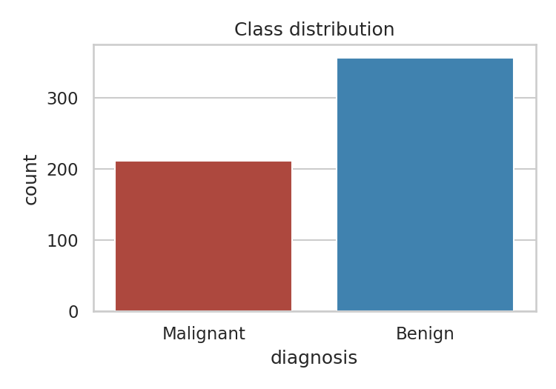
Figure 1: Class distribution of diagnosis

6.2 Feature Distributions by Diagnosis
import seaborn as sns, matplotlib.pyplot as plt
fig, ax = plt.subplots(1, 3, figsize=(11, 3.5))
for a, c in zip(ax, ["mean radius", "mean concave points", "mean texture"]):
sns.histplot(data=df, x=c, hue="diagnosis", kde=True, ax=a)

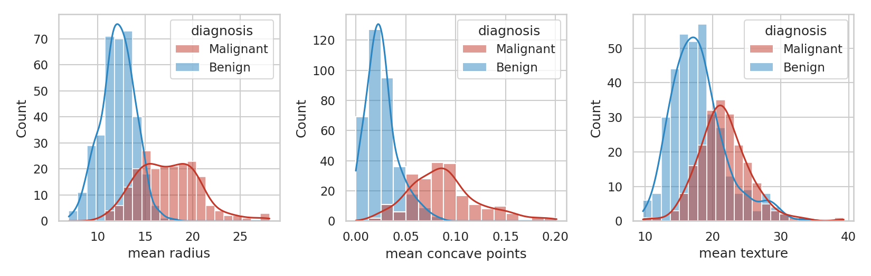
Figure 2: Distributions of three key features by diagnosis
Mean radius and mean concave points separate the two groups clearly: malignant nuclei are larger and have more concave contour points. Mean texture overlaps heavily, so it is a weaker predictor on its own.
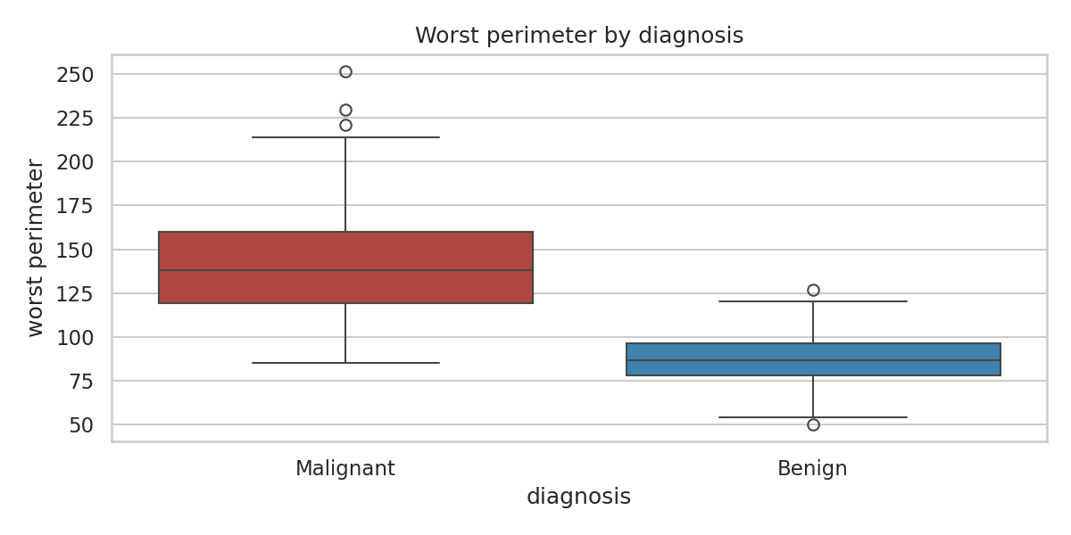
Figure 3: Worst perimeter by diagnosis

6.3 Correlation Analysis
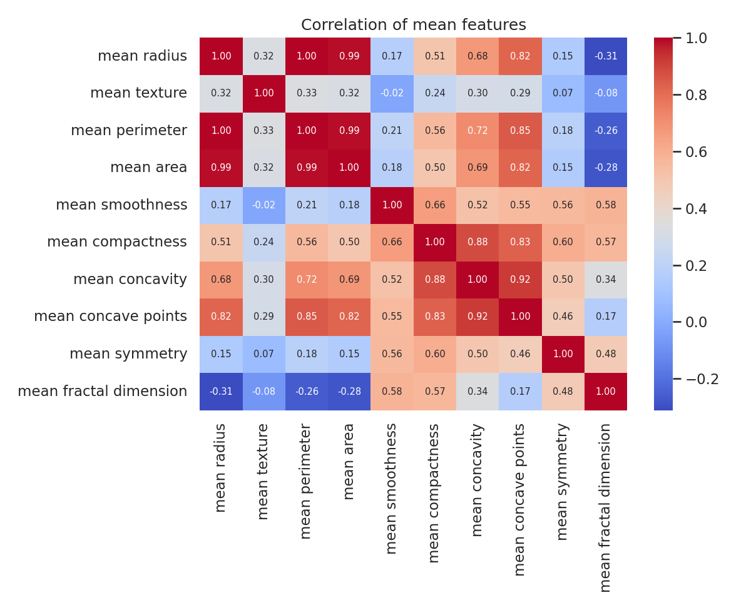
Figure 4: Correlation heatmap of the mean features
Radius, perimeter and area are almost perfectly correlated (r above 0.98), which is expected because perimeter and area are geometric functions of radius. This multicollinearity is harmless for tree models and for regularised logistic regression, but it means feature importance is shared among related features.
The features most correlated with the diagnosis (absolute Pearson correlation) are:
Feature | |Correlation| with target
worst concave points | 0.794
worst perimeter | 0.783
mean concave points | 0.777
worst radius | 0.776
mean perimeter | 0.743
worst area | 0.734

6.4 EDA Takeaways
- Tumour size and contour irregularity (concave points, concavity, perimeter, area) are the main signals.
- "Worst" features are slightly more informative than "mean" features because they capture the most abnormal cells.
- A high-accuracy classifier is plausible, since many single features already separate the classes well.

7. Modelling

7.1 Supervised Learning: Model Comparison
Five algorithms with different assumptions were compared: a linear model (Logistic Regression), an instance-based model (KNN), a kernel model (SVM), and two tree ensembles (Random Forest and Gradient Boosting). Distance and margin-based models were wrapped in a pipeline with StandardScaler. Each was scored with stratified 5-fold cross-validation on the training set using F1.
from sklearn.linear_model import LogisticRegression
from sklearn.neighbors import KNeighborsClassifier
from sklearn.svm import SVC
from sklearn.ensemble import RandomForestClassifier, GradientBoostingClassifier
from sklearn.model_selection import StratifiedKFold, cross_val_score

cv = StratifiedKFold(5, shuffle=True, random_state=42)
models = {
"Logistic Regression": Pipeline([("s", StandardScaler()), ("m", LogisticRegression(max_iter=1000))]),
"KNN": Pipeline([("s", StandardScaler()), ("m", KNeighborsClassifier())]),
"SVM (RBF)": Pipeline([("s", StandardScaler()), ("m", SVC(probability=True, random_state=42))]),
"Random Forest": RandomForestClassifier(n_estimators=300, random_state=42),
"Gradient Boosting": GradientBoostingClassifier(random_state=42),
}
for name, model in models.items():
scores = cross_val_score(model, Xtr, ytr, cv=cv, scoring="f1")
print(name, scores.mean().round(4), scores.std().round(4))

7.2 Hyperparameter Tuning
The SVM was chosen for tuning because of its strong cross-validated and test AUC. A grid search over the regularisation strength C and kernel width gamma used 5-fold CV on the training data only.
from sklearn.model_selection import GridSearchCV
grid = {"m__C": [0.1, 1, 10, 100], "m__gamma": ["scale", 0.01, 0.001]}
gs = GridSearchCV(models["SVM (RBF)"], grid, cv=cv, scoring="f1").fit(Xtr, ytr)
print(gs.best_params_, gs.best_score_)
best = gs.best_estimator_

Best parameters: C = 10, gamma = 0.01, with cross-validated F1 of 0.981.

7.3 Unsupervised Learning: PCA and K-Means
Labels were removed to ask: does the data contain natural structure? Features were standardised, then PCA reduced dimensionality, and K-Means was run for k = 2 to 7 with the silhouette score used to judge cluster quality.
from sklearn.decomposition import PCA
from sklearn.cluster import KMeans
from sklearn.metrics import silhouette_score, adjusted_rand_score

Xs = StandardScaler().fit_transform(X)
pca = PCA().fit(Xs)
print(pca.explained_variance_ratio_[:5])

for k in range(2, 8):
labels = KMeans(k, n_init=10, random_state=42).fit_predict(Xs)
print(k, silhouette_score(Xs, labels))

km = KMeans(2, n_init=10, random_state=42).fit(Xs)
print(adjusted_rand_score(y, km.labels_))

PCA shows that the first two components explain 44.3% and 19.0% of the variance (63.2% together), and 10 components retain 95% of the information, which confirms the 30 features are highly redundant.
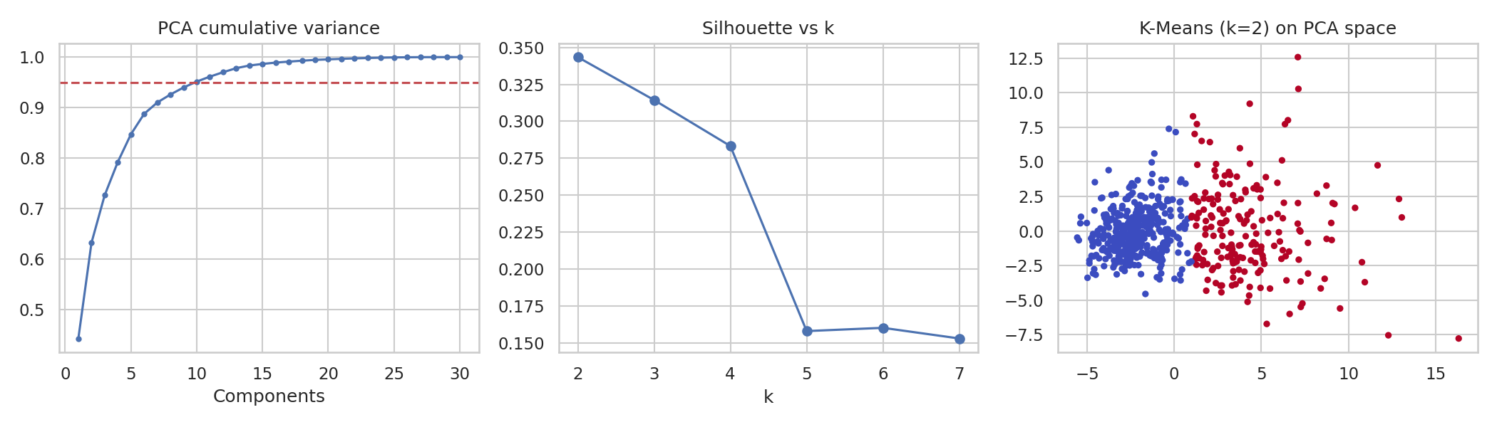
Figure 5: PCA cumulative variance, silhouette scores and K-Means clusters
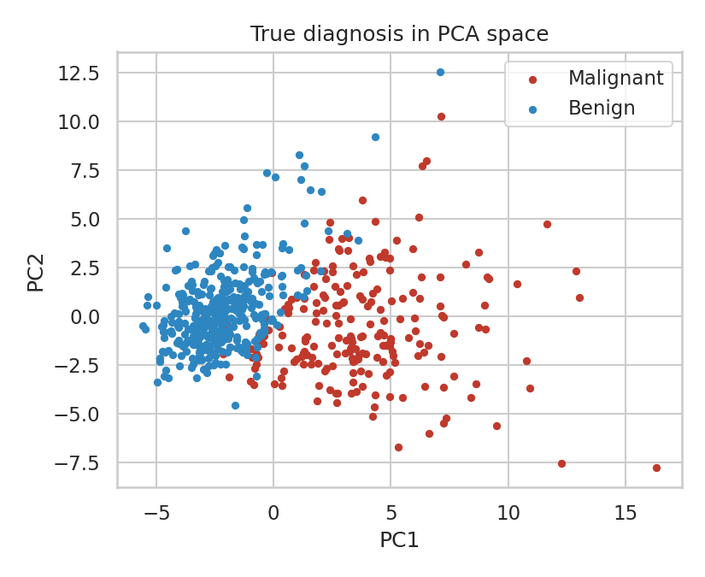
Figure 6: True diagnosis projected onto the first two principal components

8. Evaluation

8.1 Model Comparison on the Held-Out Test Set
Model | CV F1 (train) | Accuracy | Precision | Recall | F1 | ROC-AUC
Logistic Regression | 0.9825 ± 0.0078 | 0.9825 | 0.9861 | 0.9861 | 0.9861 | 0.9954
KNN | 0.9705 ± 0.0091 | 0.9561 | 0.9589 | 0.9722 | 0.9655 | 0.9788
SVM (RBF) | 0.9756 ± 0.0113 | 0.9825 | 0.9861 | 0.9861 | 0.9861 | 0.995
Random Forest | 0.9718 ± 0.0144 | 0.9474 | 0.9583 | 0.9583 | 0.9583 | 0.9937
Gradient Boosting | 0.9614 ± 0.0121 | 0.9561 | 0.9467 | 0.9861 | 0.966 | 0.9907
Tuned SVM (C=10, gamma=0.01) | 0.981 | 0.9825 | 0.9861 | 0.9861 | 0.9861 | 0.9977

Metrics are for the benign class (class 1) on 114 test patients. The final row is highlighted.
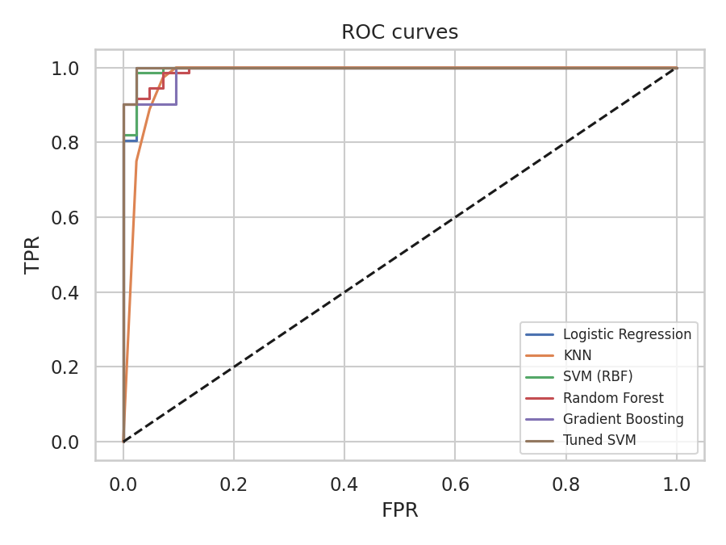
Figure 7: ROC curves of all models on the test set

8.2 Confusion Matrix of the Final Model
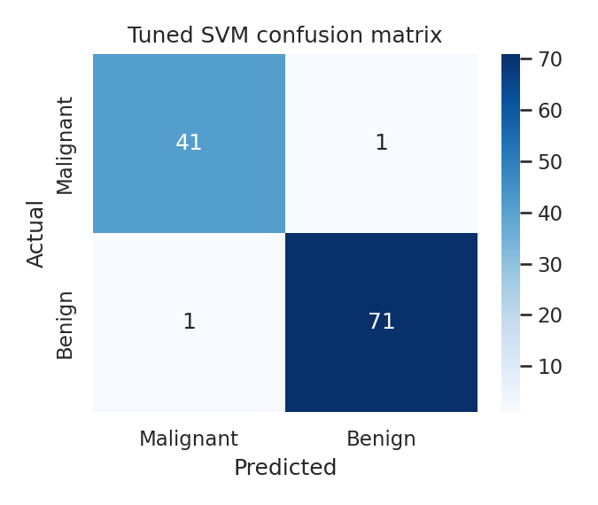
Figure 8: Confusion matrix of the tuned SVM
Of 114 test patients, 41 of 42 malignant tumours and 71 of 72 benign tumours were classified correctly. There was one false negative (a malignant tumour predicted benign) and one false positive (a benign tumour predicted malignant), giving 98.25% accuracy.

8.3 Feature Importance
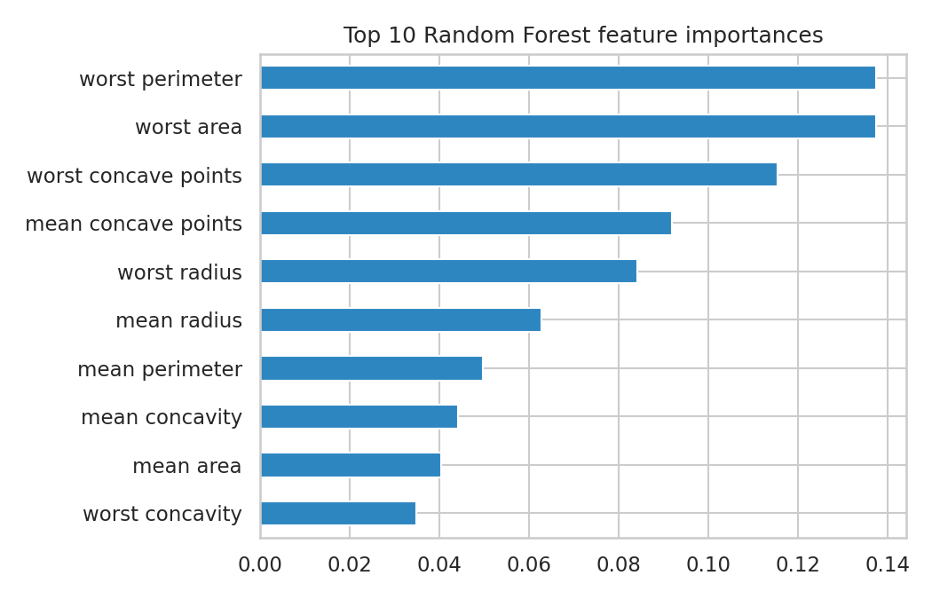
Figure 9: Top 10 Random Forest feature importances
Worst perimeter, worst area and worst concave points together account for roughly 39% of total importance. This agrees with the correlation analysis and gives an interpretable story: large, irregular nuclei indicate malignancy.

8.4 Unsupervised Evaluation
k | 2 | 3 | 4 | 5 | 6 | 7
Silhouette | 0.343 | 0.314 | 0.283 | 0.158 | 0.160 | 0.153

The silhouette score peaks at k = 2 (0.3434), matching the two clinical classes. A silhouette of this size indicates moderate, not sharp, separation. Comparing clusters with the true labels (cluster 0 vs cluster 1): 339 benign and 36 malignant fell in cluster 0; 18 benign and 176 malignant fell in cluster 1. That is 515 of 569 samples (90.5%) matching, with an Adjusted Rand Index of 0.6536.

8.5 Critical Discussion of Results
- Models are statistically close. On 114 test samples, one extra error changes accuracy by about 0.9 percentage points. The gap between Logistic Regression (98.25%) and Random Forest (94.74%) is only four patients, and cross-validation standard deviations (about 1%) overlap. The honest conclusion is that simple, well-scaled models are as good as complex ones here, rather than that one model is definitively best.
- Simple models were highly competitive. Logistic Regression matched the tuned SVM on accuracy and had the best cross-validated F1. In practice it is the more transparent choice, and the extra complexity of an SVM is justified only by its slightly higher AUC.
- Tuning gave a small gain. Tuning improved AUC from 0.9950 to 0.9977 but left accuracy unchanged, a reminder that the default SVM was already near the ceiling for this dataset.
- Recall matters most clinically. The one missed malignancy is the costliest error. A real system would lower the decision threshold to favour malignant recall, accepting more false alarms.
- Limitations. Single train/test split, a small and well-curated dataset from one institution, and no external validation. Performance on data from other hospitals, scanners or staining procedures would likely be lower.

9. Insights and Recommendations

9.1 Insights
- Nuclear size (radius, perimeter, area) and contour irregularity (concavity, concave points) are the strongest indicators of malignancy.
- The data is highly redundant: 10 principal components capture 95% of the variance of 30 features.
- The malignant and benign groups are naturally distinguishable even without labels (90.5% agreement), which supports the reliability of the supervised results.
- Interpretable linear models reach near-ceiling accuracy, so complexity is not required for this problem.

9.2 Recommendations
- Prefer Logistic Regression or the tuned SVM as a decision-support baseline; use Logistic Regression where explainability matters.
- Optimise for recall: choose the decision threshold using a precision-recall curve so that missed malignant cases are minimised, and have a pathologist review every uncertain prediction.
- Use as a second reader, not a replacement: predictions should flag cases for review rather than replace expert diagnosis.
- Validate externally on data from other hospitals before any practical use.
- Use probability outputs to route low-confidence cases for additional testing.

10. Reflection: Challenges and Successes

10.1 Challenges
- Avoiding data leakage. Scaling before splitting is an easy mistake that inflates scores. Wrapping the scaler and model in a Pipeline solved this.
- Interpreting very high scores. With accuracy near 98% it is tempting to declare victory. Examining the confusion matrix and variance across folds showed that the differences between models are small relative to the noise from a 114-sample test set.
- Multicollinearity. Highly correlated features share importance in tree models, so individual importance values must be read as a group, not as independent effects.
- Choosing what to optimise. Accuracy is not the right target for a medical problem; deciding to focus on malignant recall required thinking about real-world error costs.

10.2 Successes
- Built a fully reproducible end-to-end pipeline with a fixed random seed and no leakage.
- Combined supervised and unsupervised methods, with the unsupervised results independently supporting the supervised ones.
- Reached strong predictive performance (98.25% accuracy, AUC 0.998) with a clear, interpretable explanation of why.
- Critically assessed results rather than only reporting the highest number.

10.3 What I Learned
This project reinforced that good data science is mostly about sound process: clean separation of training and test data, fair model comparison, metrics that match the real problem, and honest interpretation of uncertainty. It also showed me how supervised and unsupervised techniques complement each other.

11. Conclusion and Future Work
This capstone delivered a complete data science pipeline on the Wisconsin Diagnostic Breast Cancer dataset. After careful checking and preprocessing, five classifiers were compared with cross-validation and the best was tuned, reaching 98.25% test accuracy and ROC-AUC of 0.998. PCA and K-Means independently confirmed that benign and malignant tumours form distinct groups. The most important predictors were size and shape irregularity measurements of the cell nuclei.

Future Work
- Use repeated or nested cross-validation to obtain confidence intervals and test whether model differences are significant.
- Add calibration curves and threshold optimisation targeting a minimum recall.
- Apply SHAP values for patient-level explanations.
- Test on an independent breast cancer dataset for external validation.
- Try other clustering methods (hierarchical, Gaussian mixture, DBSCAN) and t-SNE or UMAP for visualisation.
- Package the model as a simple Streamlit web app for demonstration.

Appendix A: Complete Python Script
The full script below reproduces every table and figure in this report (Python 3, scikit-learn, pandas, seaborn, matplotlib).
import json, numpy as np, pandas as pd, matplotlib
matplotlib.use("Agg")
import matplotlib.pyplot as plt, seaborn as sns
from sklearn.datasets import load_breast_cancer
from sklearn.model_selection import train_test_split, cross_val_score, StratifiedKFold, GridSearchCV
from sklearn.preprocessing import StandardScaler
from sklearn.pipeline import Pipeline
from sklearn.linear_model import LogisticRegression
from sklearn.ensemble import RandomForestClassifier, GradientBoostingClassifier
from sklearn.svm import SVC
from sklearn.neighbors import KNeighborsClassifier
from sklearn.metrics import (accuracy_score, precision_score, recall_score, f1_score, roc_auc_score,
confusion_matrix, roc_curve, silhouette_score, adjusted_rand_score)
from sklearn.decomposition import PCA
from sklearn.cluster import KMeans
R={}
data=load_breast_cancer(as_frame=True)
df=data.frame.copy()
df["diagnosis"]=df["target"].map({0:"Malignant",1:"Benign"})
R["shape"]=list(df.shape); R["missing"]=int(df.isna().sum().sum()); R["dups"]=int(df.duplicated().sum())
R["class_counts"]=df["diagnosis"].value_counts().to_dict()
X=df.drop(columns=["target","diagnosis"]); y=df["target"]
# outliers (IQR)
q1,q3=X.quantile(.25),X.quantile(.75); iqr=q3-q1
out=((X<q1-1.5*iqr)|(X>q3+1.5*iqr)).sum().sort_values(ascending=False)
R["outliers_top"]=out.head(5).to_dict()
R["skew_top"]=X.skew().sort_values(ascending=False).head(5).round(2).to_dict()
# EDA plots
sns.set_theme(style="whitegrid")
plt.figure(figsize=(5,3.5)); sns.countplot(x="diagnosis",data=df,palette=["#c0392b","#2e86c1"],hue="diagnosis",legend=False)
plt.title("Class distribution"); plt.tight_layout(); plt.savefig("fig/class.png",dpi=150); plt.close()
fig,ax=plt.subplots(1,3,figsize=(11,3.5))
for a,c in zip(ax,["mean radius","mean concave points","mean texture"]):
sns.histplot(data=df,x=c,hue="diagnosis",kde=True,ax=a,palette=["#c0392b","#2e86c1"])
plt.tight_layout(); plt.savefig("fig/hist.png",dpi=150); plt.close()
mean_cols=[c for c in X.columns if c.startswith("mean")]
plt.figure(figsize=(8,6.5)); sns.heatmap(X[mean_cols].corr(),annot=True,fmt=".2f",cmap="coolwarm",annot_kws={"size":7})
plt.title("Correlation of mean features"); plt.tight_layout(); plt.savefig("fig/corr.png",dpi=150); plt.close()
corr_t=X.corrwith(y).abs().sort_values(ascending=False).head(6).round(3)
R["corr_target"]=corr_t.to_dict()
plt.figure(figsize=(8,4)); sns.boxplot(data=df,x="diagnosis",y="worst perimeter",palette=["#c0392b","#2e86c1"],hue="diagnosis",legend=False)
plt.title("Worst perimeter by diagnosis"); plt.tight_layout(); plt.savefig("fig/box.png",dpi=150); plt.close()
# supervised
Xtr,Xte,ytr,yte=train_test_split(X,y,test_size=.2,stratify=y,random_state=42)
cv=StratifiedKFold(5,shuffle=True,random_state=42)
models={"Logistic Regression":Pipeline([("s",StandardScaler()),("m",LogisticRegression(max_iter=1000))]),
"KNN":Pipeline([("s",StandardScaler()),("m",KNeighborsClassifier())]),
"SVM (RBF)":Pipeline([("s",StandardScaler()),("m",SVC(probability=True,random_state=42))]),
"Random Forest":RandomForestClassifier(n_estimators=300,random_state=42),
"Gradient Boosting":GradientBoostingClassifier(random_state=42)}
rows=[]; fitted={}
for n,m in models.items():
cvs=cross_val_score(m,Xtr,ytr,cv=cv,scoring="f1")
m.fit(Xtr,ytr); p=m.predict(Xte); pr=m.predict_proba(Xte)[:,1]; fitted[n]=(m,pr)
rows.append(dict(Model=n,CV_F1=round(cvs.mean(),4),CV_std=round(cvs.std(),4),Accuracy=round(accuracy_score(yte,p),4),
Precision=round(precision_score(yte,p),4),Recall=round(recall_score(yte,p),4),F1=round(f1_score(yte,p),4),AUC=round(roc_auc_score(yte,pr),4)))
res=pd.DataFrame(rows); R["models"]=rows
# tuning
gs=GridSearchCV(Pipeline([("s",StandardScaler()),("m",SVC(probability=True,random_state=42))]),
{"m__C":[0.1,1,10,100],"m__gamma":["scale",0.01,0.001]},cv=cv,scoring="f1").fit(Xtr,ytr)
best=gs.best_estimator_; p=best.predict(Xte); pr=best.predict_proba(Xte)[:,1]
R["tuned"]=dict(params={k:str(v) for k,v in gs.best_params_.items()},cv_f1=round(gs.best_score_,4),Accuracy=round(accuracy_score(yte,p),4),
Precision=round(precision_score(yte,p),4),Recall=round(recall_score(yte,p),4),F1=round(f1_score(yte,p),4),AUC=round(roc_auc_score(yte,pr),4))
fitted["Tuned SVM"]=(best,pr)
cm=confusion_matrix(yte,p); R["cm"]=cm.tolist()
plt.figure(figsize=(4.5,3.8)); sns.heatmap(cm,annot=True,fmt="d",cmap="Blues",xticklabels=["Malignant","Benign"],yticklabels=["Malignant","Benign"])
plt.xlabel("Predicted"); plt.ylabel("Actual"); plt.title("Tuned SVM confusion matrix"); plt.tight_layout(); plt.savefig("fig/cm.png",dpi=150); plt.close()
plt.figure(figsize=(6,4.5))
for n,(m,pr_) in fitted.items():
f,t,_=roc_curve(yte,pr_); plt.plot(f,t,label=n)
plt.plot([0,1],[0,1],"k--"); plt.xlabel("FPR"); plt.ylabel("TPR"); plt.title("ROC curves"); plt.legend(fontsize=8); plt.tight_layout(); plt.savefig("fig/roc.png",dpi=150); plt.close()
rf=models["Random Forest"]; imp=pd.Series(rf.feature_importances_,index=X.columns).sort_values(ascending=False).head(10)
R["importance"]=imp.round(4).to_dict()
plt.figure(figsize=(7,4.5)); imp[::-1].plot.barh(color="#2e86c1"); plt.title("Top 10 Random Forest feature importances"); plt.tight_layout(); plt.savefig("fig/imp.png",dpi=150); plt.close()
# unsupervised
Xs=StandardScaler().fit_transform(X)
pca=PCA().fit(Xs); ev=pca.explained_variance_ratio_; R["pca_var"]=[round(float(v),4) for v in ev[:5]]
R["pca_n95"]=int(np.argmax(np.cumsum(ev)>=.95)+1)
sil={}
for k in range(2,8):
sil[k]=round(silhouette_score(Xs,KMeans(k,n_init=10,random_state=42).fit_predict(Xs)),4)
R["silhouette"]=sil
km=KMeans(2,n_init=10,random_state=42).fit(Xs); lab=km.labels_
ari=adjusted_rand_score(y,lab); R["ari"]=round(ari,4)
ct=pd.crosstab(df["diagnosis"],lab); R["crosstab"]=ct.values.tolist()
Z=PCA(2).fit_transform(Xs)
fig,ax=plt.subplots(1,3,figsize=(14,4))
ax[0].plot(range(1,len(ev)+1),np.cumsum(ev),marker="o",ms=3); ax[0].axhline(.95,color="r",ls="--"); ax[0].set_title("PCA cumulative variance"); ax[0].set_xlabel("Components")
ax[1].plot(list(sil.keys()),list(sil.values()),marker="o"); ax[1].set_title("Silhouette vs k"); ax[1].set_xlabel("k")
ax[2].scatter(Z[:,0],Z[:,1],c=lab,cmap="coolwarm",s=12); ax[2].set_title("K-Means (k=2) on PCA space")
plt.tight_layout(); plt.savefig("fig/unsup.png",dpi=150); plt.close()
plt.figure(figsize=(5.5,4.5));
for c,col in zip(["Malignant","Benign"],["#c0392b","#2e86c1"]):
m=df["diagnosis"]==c; plt.scatter(Z[m,0],Z[m,1],s=12,c=col,label=c)
plt.legend(); plt.title("True diagnosis in PCA space"); plt.xlabel("PC1"); plt.ylabel("PC2"); plt.tight_layout(); plt.savefig("fig/pca_true.png",dpi=150); plt.close()

References
Wolberg, W. H., Street, W. N., & Mangasarian, O. L. (1995). Breast Cancer Wisconsin (Diagnostic) Data Set. UCI Machine Learning Repository.
Street, W. N., Wolberg, W. H., & Mangasarian, O. L. (1993). Nuclear feature extraction for breast tumor diagnosis. IS&T/SPIE International Symposium on Electronic Imaging.
Pedregosa, F. et al. (2011). Scikit-learn: Machine Learning in Python. Journal of Machine Learning Research, 12, 2825-2830.
McKinney, W. (2010). Data Structures for Statistical Computing in Python. Proceedings of the 9th Python in Science Conference.
Hunter, J. D. (2007). Matplotlib: A 2D Graphics Environment. Computing in Science & Engineering, 9(3), 90-95.

