augmentedRCBD

# Details

| Item | Details |
| --- | --- |
| Number of blocks | 4 |
| Number of treatments | 805 |
| Number of check treatments | 5 |
| Number of test treatments | 800 |
| Check treatments | C1, C2, C3, C4, C5 |
| Number of Traits | 4 |
| Traits | PH, FEW, NOF, FYPP |

# ANOVA, Treatment Adjusted

| **Source** | **Df** | **Mean.Sq** | | | | | | | |
| --- | --- | --- | --- | --- | --- | --- | --- | --- | --- |
| **PH** | | **FEW** | | **NOF** | | **FYPP** | |
| Block (ignoring Treatments) | 3 | 3583.16 | ** | 27.32 | ** | 670.83 | ** | 329955.64 | ** |
| Treatment (eliminating Blocks) | 804 | 156.02 | * | 7.91 | ** | 8.73 | ** | 6222.80 | ** |
| Treatment: Check | 4 | 1283.39 | ** | 25.31 | ** | 10.33 | * | 28796.22 | ** |
| Treatment: Test and Test vs. Check | 800 | 150.39 | * | 7.82 | ** | 8.72 | ** | 6109.93 | ** |
| Residuals | 12 | 57.75 |  | 2.10 |  | 2.19 |  | 483.16 |  |

ns P > 0.05; * P <= 0.05; ** P <= 0.01

# ANOVA, Block Adjusted

| **Source** | **Df** | **Mean.Sq** | | | | | | | |
| --- | --- | --- | --- | --- | --- | --- | --- | --- | --- |
| **PH** | | **FEW** | | **NOF** | | **FYPP** | |
| Treatment (ignoring Blocks) | 804 | 169.26 | * | 8.01 | ** | 11.23 | ** | 7453.60 | ** |
| Treatment: Check | 4 | 1283.39 | ** | 25.31 | ** | 10.33 | * | 28796.22 | ** |
| Treatment: Test | 799 | 163.70 | * | 7.91 | ** | 10.84 | ** | 7069.89 | ** |
| Treatment: Test vs. Check | 1 | 157.40 | ns | 20.78 | ** | 325.41 | ** | 228664.18 | ** |
| Block (eliminating Treatments) | 3 | 36.48 | ns | 0.10 | ns | 0.32 | ns | 101.40 | ns |
| Residuals | 12 | 57.75 |  | 2.10 |  | 2.19 |  | 483.16 |  |

ns P > 0.05; * P <= 0.05; ** P <= 0.01

# Standard Errors

| **Comparison** | **FEW** | **FYPP** | **NOF** | **PH** |
| --- | --- | --- | --- | --- |
| A Test Treatment and a Control Treatment | 1.78 | 26.92 | 1.81 | 9.31 |
| Control Treatment Means | 1.03 | 15.54 | 1.05 | 5.37 |
| Two Test Treatments (Different Blocks) | 2.25 | 34.05 | 2.29 | 11.77 |
| Two Test Treatments (Same Block) | 2.05 | 31.09 | 2.09 | 10.75 |

# Critical Difference (5%)

| **Comparison** | **FEW** | **FYPP** | **NOF** | **PH** |
| --- | --- | --- | --- | --- |
| A Test Treatment and a Control Treatment | 3.87 | 58.66 | 3.95 | 20.28 |
| Control Treatment Means | 2.23 | 33.87 | 2.28 | 11.71 |
| Two Test Treatments (Different Blocks) | 4.90 | 74.19 | 5.00 | 25.65 |
| Two Test Treatments (Same Block) | 4.47 | 67.73 | 4.56 | 23.42 |

# Coefficient of Variance

| **Trait** | **CV** |
| --- | --- |
| PH | 6.09 |
| FEW | 7.15 |
| NOF | 8.06 |
| FYPP | 5.92 |

# Overall Adjusted Mean

| **Trait** | **Overall.adjusted.mean** |
| --- | --- |
| PH | 124.73 |
| FEW | 20.28 |
| NOF | 18.29 |
| FYPP | 369.41 |

# Check Statistics

## PH

| **Treatment** | **r** | **Means** | **SE** | **Min** | **Max** |
| --- | --- | --- | --- | --- | --- |
| C1 | 4 | 128.97 | 5.00 | 116.32 | 138.52 |
| C2 | 4 | 127.62 | 4.78 | 115.26 | 137.52 |
| C3 | 4 | 99.75 | 2.48 | 94.26 | 105.29 |
| C4 | 4 | 131.71 | 3.19 | 125.26 | 138.52 |
| C5 | 4 | 149.71 | 1.65 | 146.25 | 154.02 |

## FEW

| **Treatment** | **r** | **Means** | **SE** | **Min** | **Max** |
| --- | --- | --- | --- | --- | --- |
| C1 | 4 | 19.29 | 0.44 | 18.52 | 20.56 |
| C2 | 4 | 20.24 | 0.72 | 18.22 | 21.28 |
| C3 | 4 | 24.07 | 0.57 | 22.51 | 25.28 |
| C4 | 4 | 23.96 | 0.75 | 22.56 | 25.63 |
| C5 | 4 | 18.97 | 0.73 | 17.24 | 20.21 |

## NOF

| **Treatment** | **r** | **Means** | **SE** | **Min** | **Max** |
| --- | --- | --- | --- | --- | --- |
| C1 | 4 | 21.75 | 0.63 | 20.00 | 23.00 |
| C2 | 4 | 20.00 | 0.71 | 18.00 | 21.00 |
| C3 | 4 | 24.25 | 0.85 | 22.00 | 26.00 |
| C4 | 4 | 22.50 | 0.65 | 21.00 | 24.00 |
| C5 | 4 | 23.25 | 0.48 | 22.00 | 24.00 |

## FYPP

| **Treatment** | **r** | **Means** | **SE** | **Min** | **Max** |
| --- | --- | --- | --- | --- | --- |
| C1 | 4 | 381.43 | 10.56 | 362.15 | 410.52 |
| C2 | 4 | 391.20 | 12.43 | 362.57 | 420.53 |
| C3 | 4 | 567.34 | 11.96 | 542.86 | 600.21 |
| C4 | 4 | 522.68 | 4.68 | 512.55 | 532.73 |
| C5 | 4 | 522.30 | 8.80 | 501.48 | 544.16 |

# Descriptive Statistics

| **Trait** | **Count** | **Mean** | **Std.Error** | **Std.Deviation** | **Min** | **Max** | **Skewness** | | **Kurtosis** | |
| --- | --- | --- | --- | --- | --- | --- | --- | --- | --- | --- |
| PH | 805 | 124.73 | 0.47 | 13.20 | 83.38 | 156.89 | -0.08 | ns | 2.66 | * |
| FEW | 805 | 20.28 | 0.10 | 2.81 | 11.43 | 28.36 | 0.47 | ** | 2.82 | ns |
| NOF | 805 | 18.29 | 0.12 | 3.35 | 11.75 | 28.95 | 0.46 | ** | 2.78 | ns |
| FYPP | 805 | 369.41 | 2.99 | 84.97 | 159.08 | 626.01 | 0.63 | ** | 3.00 | ns |

ns P > 0.05; * P <= 0.05; ** P <= 0.01

# Frequency Distribution

## PH

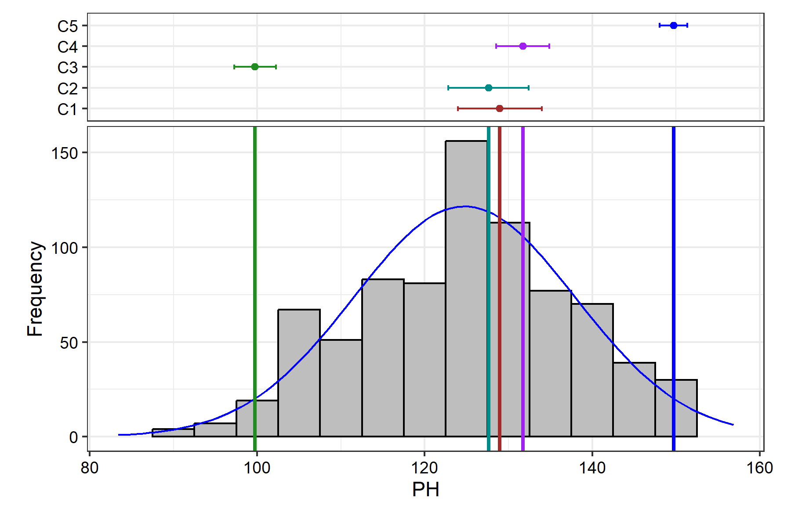

Removed 2 rows containing missing values (`geom_bar()`).

## FEW

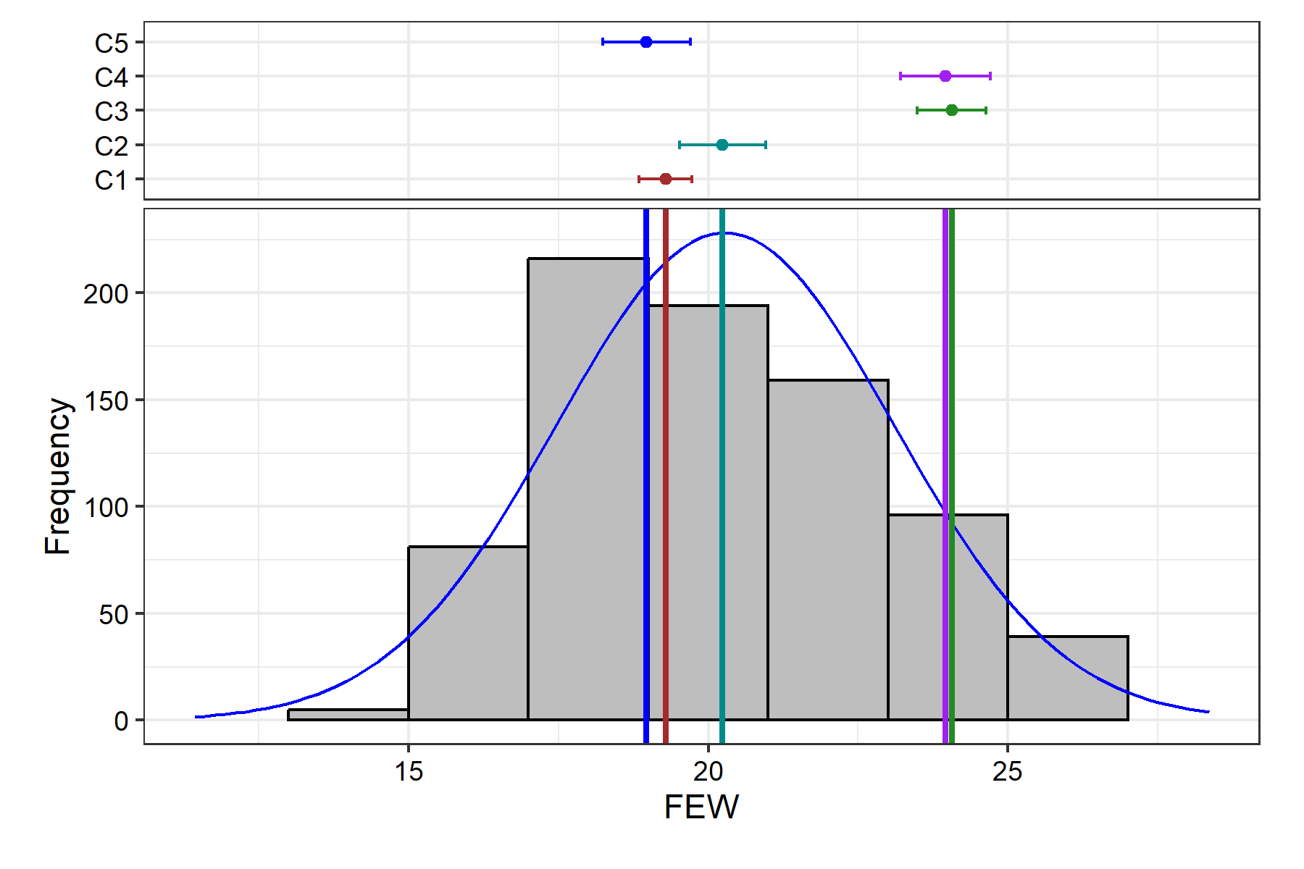

Removed 2 rows containing missing values (`geom_bar()`).

## NOF

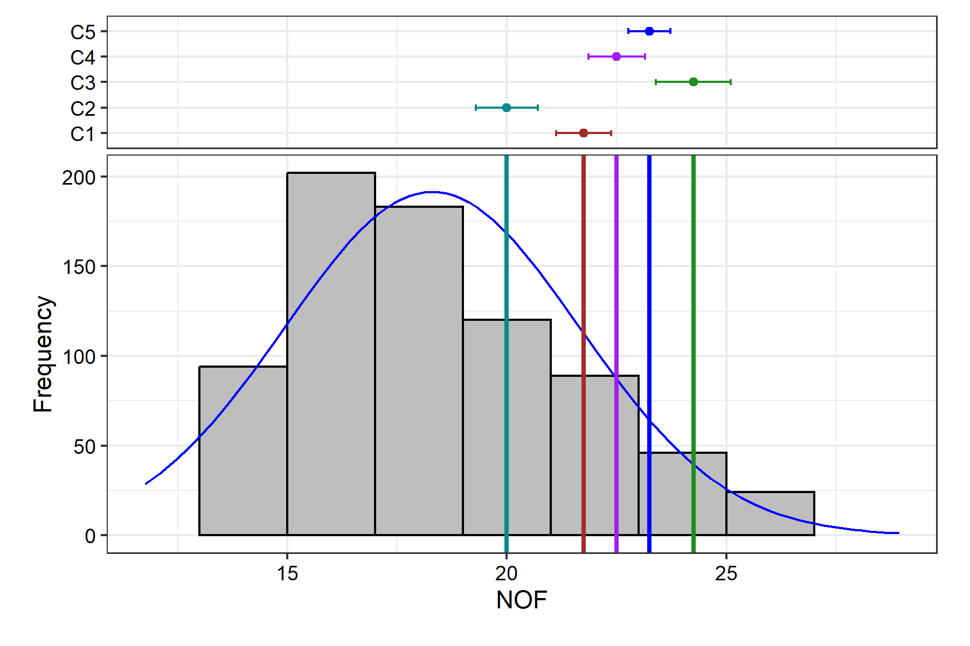

Removed 2 rows containing missing values (`geom_bar()`).

## FYPP

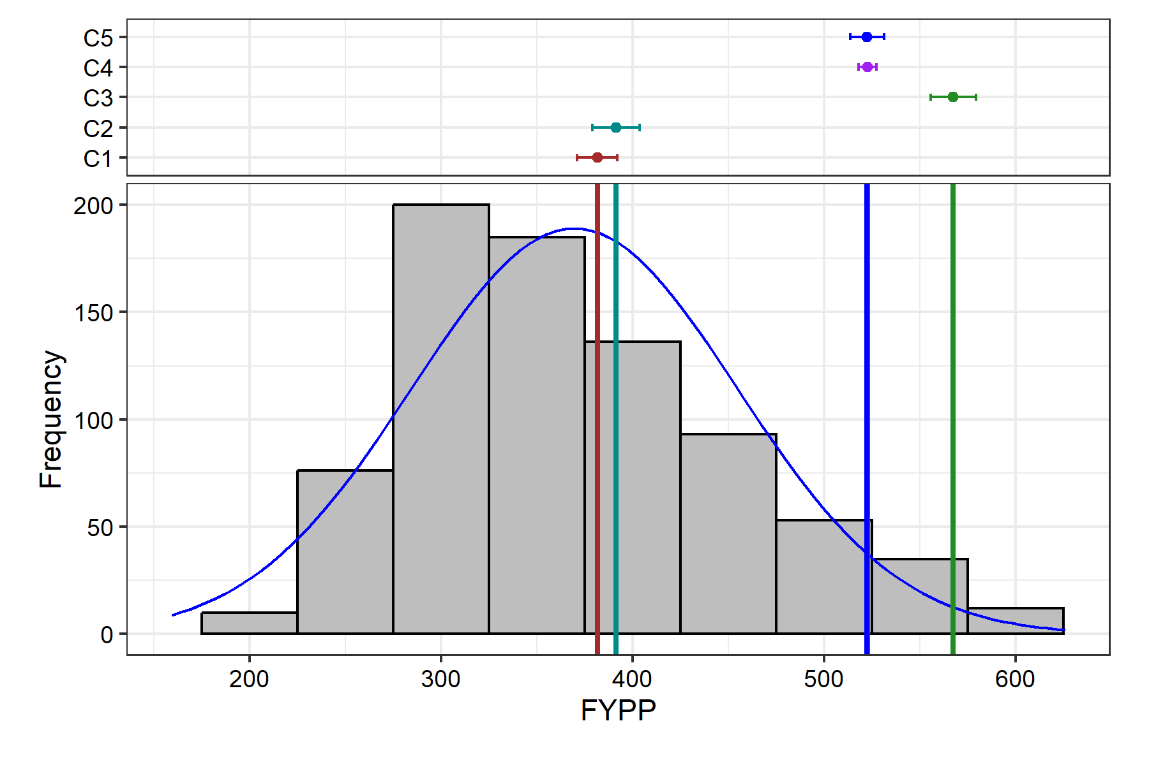

Removed 2 rows containing missing values (`geom_bar()`).

# Genetic Variability Analysis

| **Trait** | **Mean** | **PV** | **GV** | **EV** | **GCV** | **GCV.category** | **PCV** | **PCV.category** | **ECV** | **hBS** | **hBS.category** | **GA** | **GAM** | **GAM.category** |
| --- | --- | --- | --- | --- | --- | --- | --- | --- | --- | --- | --- | --- | --- | --- |
| PH | 124.73 | 163.70 | 105.94 | 57.75 | 8.25 | Low | 10.26 | Medium | 6.09 | 64.72 | High | 17.08 | 13.70 | Medium |
| FEW | 20.28 | 7.91 | 5.80 | 2.10 | 11.88 | Medium | 13.87 | Medium | 7.15 | 73.40 | High | 4.26 | 20.99 | High |
| NOF | 18.29 | 10.84 | 8.65 | 2.19 | 16.08 | Medium | 18.00 | Medium | 8.09 | 79.79 | High | 5.42 | 29.63 | High |
| FYPP | 369.41 | 7069.89 | 6586.73 | 483.16 | 21.97 | High | 22.76 | High | 5.95 | 93.17 | High | 161.61 | 43.75 | High |

# Genetic Variablity Analysis Plots

## Phenotypic and Genotypic Coefficient of Variability

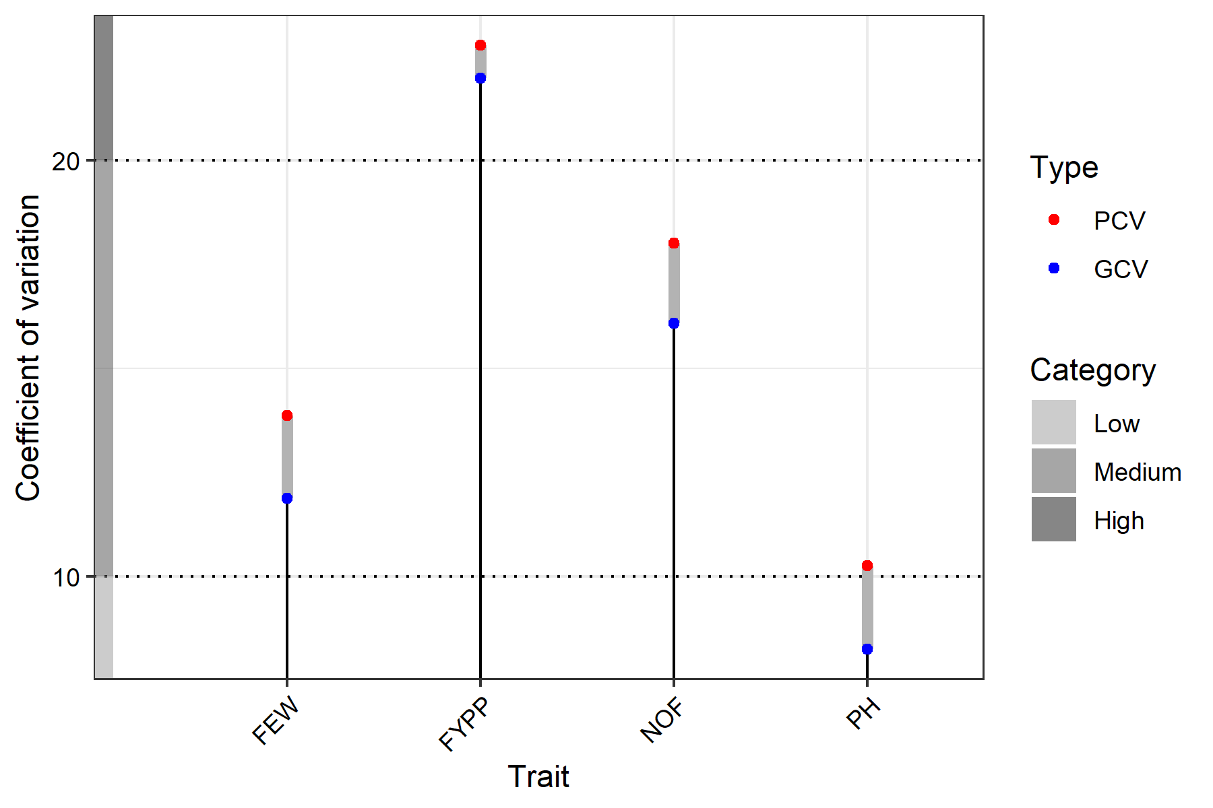

## Broad Sense Heritability

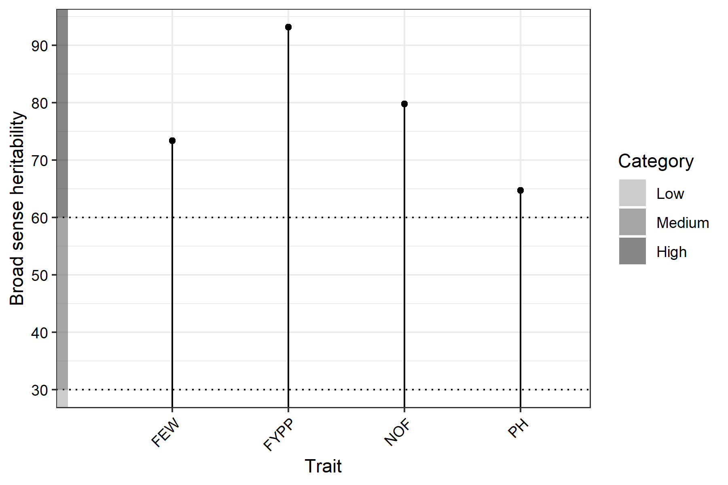

## Genetic Advance Over Mean

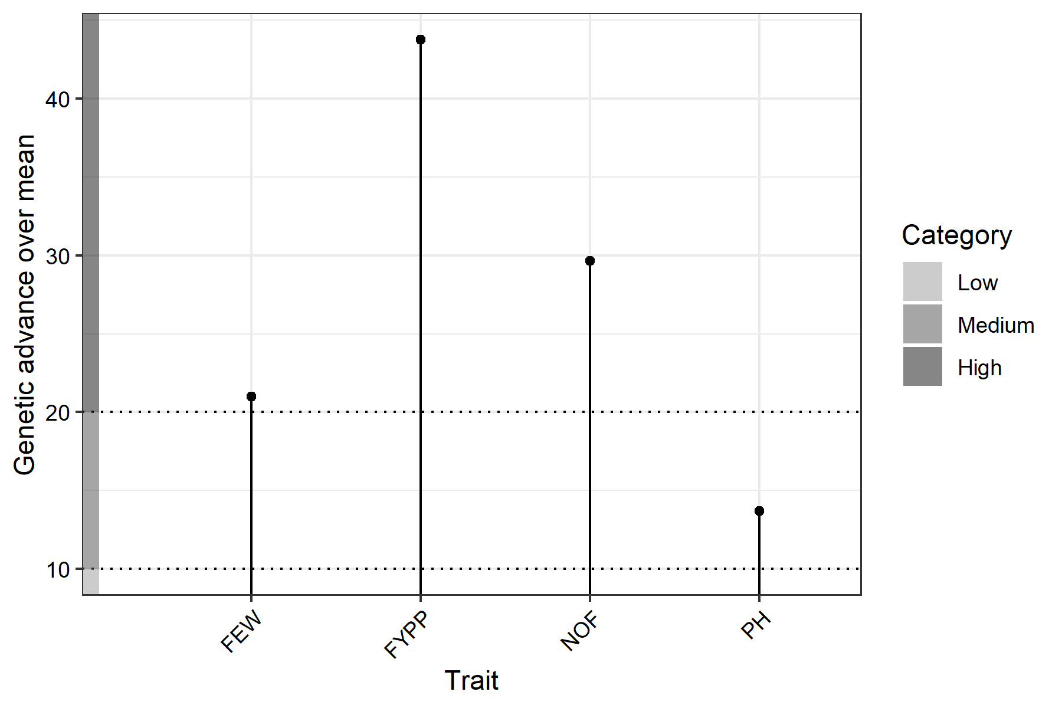

# Adjusted Means

| **Treatment** | **Block** | **FEW** | **FYPP** | **NOF** | **PH** |
| --- | --- | --- | --- | --- | --- |
| C1 |  | 19.29 | 381.43 | 21.75 | 128.97 |
| C2 |  | 20.24 | 391.20 | 20.00 | 127.62 |
| C3 |  | 24.07 | 567.34 | 24.25 | 99.75 |
| C4 |  | 23.96 | 522.68 | 22.50 | 131.71 |
| C5 |  | 18.97 | 522.30 | 23.25 | 149.71 |
| G1 | 1 | 20.01 | 391.08 | 21.95 | 114.95 |
| G10 | 1 | 16.22 | 310.02 | 17.95 | 97.38 |
| G100 | 1 | 16.82 | 315.04 | 17.95 | 127.68 |
| G101 | 1 | 24.79 | 497.32 | 18.95 | 131.40 |
| G102 | 1 | 20.55 | 465.04 | 22.95 | 143.71 |
| G103 | 1 | 19.85 | 430.34 | 20.95 | 127.69 |
| G104 | 1 | 20.25 | 469.99 | 21.95 | 141.40 |
| G105 | 1 | 25.62 | 559.05 | 20.95 | 134.77 |
| G106 | 1 | 21.02 | 446.89 | 19.95 | 124.78 |
| G107 | 1 | 23.24 | 526.22 | 21.95 | 144.80 |
| G108 | 1 | 25.52 | 625.63 | 24.95 | 142.73 |
| G109 | 1 | 19.62 | 326.02 | 15.95 | 111.40 |
| G11 | 1 | 18.22 | 427.08 | 22.95 | 111.50 |
| G110 | 1 | 23.11 | 431.11 | 17.95 | 124.78 |
| G111 | 1 | 28.11 | 581.08 | 20.95 | 141.53 |
| G112 | 1 | 20.55 | 547.05 | 25.95 | 152.42 |
| G113 | 1 | 18.62 | 407.34 | 20.95 | 125.40 |
| G114 | 1 | 22.62 | 534.40 | 22.95 | 127.71 |
| G115 | 1 | 18.62 | 399.04 | 21.95 | 135.40 |
| G116 | 1 | 20.25 | 475.32 | 22.95 | 137.11 |
| G117 | 1 | 21.58 | 577.45 | 25.95 | 149.38 |
| G118 | 1 | 28.31 | 626.01 | 22.95 | 141.39 |
| G119 | 1 | 18.62 | 357.25 | 18.95 | 123.41 |
| G12 | 1 | 20.21 | 485.02 | 23.95 | 147.38 |
| G120 | 1 | 19.20 | 355.63 | 17.95 | 117.41 |
| G121 | 1 | 17.62 | 370.74 | 21.95 | 137.80 |
| G122 | 1 | 20.55 | 477.41 | 23.95 | 143.72 |
| G123 | 1 | 21.25 | 457.12 | 20.95 | 122.40 |
| G124 | 1 | 20.21 | 353.04 | 16.95 | 101.41 |
| G125 | 1 | 18.92 | 410.44 | 20.95 | 135.40 |
| G126 | 1 | 20.55 | 424.08 | 19.95 | 107.41 |
| G127 | 1 | 21.01 | 480.41 | 21.95 | 141.41 |
| G128 | 1 | 26.24 | 538.96 | 20.95 | 141.40 |
| G129 | 1 | 17.25 | 346.28 | 19.95 | 134.77 |
| G13 | 1 | 20.25 | 394.02 | 19.95 | 135.38 |
| G130 | 1 | 18.20 | 421.11 | 21.95 | 141.51 |
| G131 | 1 | 25.20 | 467.58 | 18.95 | 124.69 |
| G132 | 1 | 18.25 | 447.03 | 22.95 | 141.40 |
| G133 | 1 | 14.25 | 310.02 | 19.95 | 125.50 |
| G134 | 1 | 22.20 | 483.63 | 20.95 | 137.67 |
| G135 | 1 | 24.79 | 569.58 | 21.95 | 134.41 |
| G136 | 1 | 18.25 | 312.18 | 15.95 | 111.41 |
| G137 | 1 | 23.24 | 434.01 | 17.95 | 141.40 |
| G138 | 1 | 19.55 | 437.51 | 20.95 | 137.71 |
| G139 | 1 | 22.25 | 451.04 | 18.95 | 124.47 |
| G14 | 1 | 21.25 | 561.11 | 23.95 | 151.41 |
| G140 | 1 | 19.55 | 376.32 | 19.95 | 127.71 |
| G141 | 1 | 18.25 | 330.30 | 16.95 | 107.71 |
| G142 | 1 | 24.55 | 430.05 | 17.95 | 124.38 |
| G143 | 1 | 19.24 | 452.97 | 21.95 | 141.78 |
| G144 | 1 | 20.25 | 427.44 | 19.95 | 127.71 |
| G145 | 1 | 23.51 | 529.39 | 22.95 | 144.51 |
| G146 | 1 | 20.55 | 313.02 | 13.95 | 87.41 |
| G147 | 1 | 19.84 | 363.18 | 18.95 | 127.41 |
| G148 | 1 | 21.19 | 457.74 | 20.95 | 134.41 |
| G149 | 1 | 26.29 | 570.50 | 21.95 | 144.41 |
| G15 | 1 | 17.55 | 355.02 | 19.95 | 127.71 |
| G150 | 1 | 22.20 | 525.39 | 23.95 | 147.41 |
| G151 | 1 | 15.62 | 279.28 | 15.95 | 91.41 |
| G152 | 1 | 18.20 | 320.02 | 16.95 | 111.40 |
| G153 | 1 | 21.01 | 537.24 | 24.95 | 151.41 |
| G154 | 1 | 20.25 | 477.35 | 22.95 | 141.41 |
| G155 | 1 | 23.51 | 491.68 | 19.95 | 114.80 |
| G156 | 1 | 18.95 | 435.01 | 21.95 | 124.71 |
| G157 | 1 | 19.25 | 407.03 | 19.95 | 134.78 |
| G158 | 1 | 17.24 | 289.72 | 15.95 | 104.51 |
| G159 | 1 | 19.65 | 356.77 | 16.95 | 111.51 |
| G16 | 1 | 22.25 | 433.32 | 18.95 | 109.73 |
| G160 | 1 | 21.29 | 435.01 | 20.95 | 127.71 |
| G161 | 1 | 23.19 | 552.34 | 22.95 | 131.73 |
| G162 | 1 | 24.31 | 626.01 | 25.95 | 141.38 |
| G163 | 1 | 26.31 | 624.91 | 23.95 | 144.38 |
| G164 | 1 | 28.20 | 605.17 | 21.95 | 125.68 |
| G165 | 1 | 24.62 | 415.02 | 15.95 | 104.77 |
| G166 | 1 | 20.24 | 357.39 | 17.95 | 124.78 |
| G167 | 1 | 25.61 | 504.95 | 19.95 | 134.41 |
| G168 | 1 | 19.25 | 382.91 | 18.95 | 127.41 |
| G169 | 1 | 20.20 | 318.01 | 15.95 | 101.78 |
| G17 | 1 | 18.25 | 407.30 | 23.95 | 125.51 |
| G170 | 1 | 21.22 | 378.91 | 17.95 | 114.79 |
| G171 | 1 | 22.31 | 456.94 | 20.95 | 135.40 |
| G172 | 1 | 23.57 | 547.97 | 23.95 | 144.41 |
| G173 | 1 | 19.31 | 378.94 | 19.95 | 124.41 |
| G174 | 1 | 18.62 | 430.61 | 23.95 | 141.41 |
| G175 | 1 | 19.84 | 503.28 | 25.95 | 146.73 |
| G176 | 1 | 22.57 | 528.97 | 23.95 | 143.41 |
| G177 | 1 | 20.62 | 407.02 | 19.95 | 122.40 |
| G178 | 1 | 24.20 | 492.32 | 20.95 | 131.71 |
| G179 | 1 | 20.22 | 389.28 | 19.95 | 117.80 |
| G18 | 1 | 22.25 | 577.02 | 25.95 | 152.43 |
| G180 | 1 | 16.34 | 330.36 | 20.95 | 123.73 |
| G181 | 1 | 21.52 | 546.63 | 25.95 | 144.51 |
| G182 | 1 | 20.22 | 431.28 | 21.95 | 151.38 |
| G183 | 1 | 26.31 | 467.34 | 17.95 | 106.41 |
| G184 | 1 | 21.25 | 346.01 | 15.95 | 111.79 |
| G185 | 1 | 21.24 | 366.91 | 17.95 | 131.40 |
| G186 | 1 | 19.85 | 430.39 | 20.95 | 139.37 |
| G187 | 1 | 24.22 | 511.99 | 19.95 | 131.69 |
| G188 | 1 | 18.62 | 430.38 | 21.95 | 141.40 |
| G189 | 1 | 19.55 | 453.31 | 23.95 | 151.47 |
| G19 | 1 | 19.01 | 452.99 | 23.95 | 124.58 |
| G190 | 1 | 21.62 | 159.08 | 19.95 | 111.38 |
| G191 | 1 | 25.62 | 521.91 | 20.95 | 124.70 |
| G192 | 1 | 18.62 | 442.35 | 23.95 | 141.41 |
| G193 | 1 | 17.44 | 315.62 | 17.95 | 111.40 |
| G194 | 1 | 19.62 | 472.98 | 23.95 | 144.38 |
| G195 | 1 | 18.20 | 367.35 | 20.95 | 131.40 |
| G196 | 1 | 16.34 | 377.28 | 21.95 | 133.40 |
| G197 | 1 | 18.20 | 333.30 | 18.95 | 127.71 |
| G198 | 1 | 20.21 | 426.32 | 19.95 | 131.73 |
| G199 | 1 | 21.31 | 485.02 | 22.95 | 144.40 |
| G2 | 1 | 20.35 | 357.02 | 17.95 | 102.03 |
| G20 | 1 | 22.24 | 430.12 | 19.95 | 137.71 |
| G200 | 1 | 22.22 | 552.61 | 24.95 | 141.40 |
| G201 | 2 | 20.06 | 356.45 | 20.35 | 131.89 |
| G202 | 2 | 20.73 | 341.42 | 18.35 | 115.89 |
| G203 | 2 | 19.83 | 342.57 | 19.35 | 135.89 |
| G204 | 2 | 17.46 | 276.16 | 16.35 | 105.89 |
| G205 | 2 | 22.50 | 413.17 | 18.35 | 121.89 |
| G206 | 2 | 19.83 | 426.12 | 21.35 | 139.89 |
| G207 | 2 | 27.45 | 600.43 | 23.35 | 148.89 |
| G208 | 2 | 25.56 | 581.45 | 24.35 | 150.89 |
| G209 | 2 | 15.43 | 397.15 | 26.35 | 155.89 |
| G21 | 1 | 23.60 | 591.68 | 24.95 | 131.47 |
| G210 | 2 | 18.83 | 412.19 | 23.35 | 148.89 |
| G211 | 2 | 20.43 | 470.49 | 24.35 | 145.89 |
| G212 | 2 | 21.47 | 415.49 | 21.35 | 139.89 |
| G213 | 2 | 24.52 | 513.23 | 22.35 | 128.89 |
| G214 | 2 | 18.56 | 335.96 | 18.35 | 145.89 |
| G215 | 2 | 26.52 | 511.45 | 20.35 | 147.89 |
| G216 | 2 | 22.76 | 378.20 | 16.35 | 128.89 |
| G217 | 2 | 20.83 | 346.09 | 18.35 | 139.89 |
| G218 | 2 | 18.82 | 341.10 | 20.35 | 128.89 |
| G219 | 2 | 17.46 | 375.17 | 22.35 | 120.89 |
| G22 | 1 | 17.25 | 326.01 | 17.95 | 101.47 |
| G220 | 2 | 21.43 | 552.17 | 27.35 | 156.89 |
| G221 | 2 | 16.45 | 280.23 | 17.35 | 117.89 |
| G222 | 2 | 18.56 | 375.40 | 20.35 | 132.89 |
| G223 | 2 | 16.55 | 368.12 | 22.35 | 139.89 |
| G224 | 2 | 18.46 | 356.74 | 21.35 | 135.89 |
| G225 | 2 | 21.50 | 400.43 | 20.35 | 128.89 |
| G226 | 2 | 26.52 | 542.58 | 22.35 | 138.89 |
| G227 | 2 | 11.43 | 166.50 | 15.35 | 118.89 |
| G228 | 2 | 21.55 | 378.41 | 19.35 | 148.89 |
| G229 | 2 | 19.52 | 412.48 | 21.35 | 151.89 |
| G23 | 1 | 22.25 | 310.02 | 14.95 | 111.47 |
| G230 | 2 | 17.43 | 288.43 | 18.35 | 106.89 |
| G231 | 2 | 18.73 | 441.49 | 25.35 | 155.89 |
| G232 | 2 | 20.45 | 506.41 | 26.35 | 139.89 |
| G233 | 2 | 21.46 | 422.86 | 21.35 | 148.89 |
| G234 | 2 | 19.83 | 365.17 | 18.35 | 128.89 |
| G235 | 2 | 18.73 | 302.15 | 16.35 | 118.89 |
| G236 | 2 | 24.46 | 413.27 | 17.35 | 121.89 |
| G237 | 2 | 27.46 | 568.10 | 22.35 | 155.89 |
| G238 | 2 | 17.76 | 402.17 | 24.35 | 139.89 |
| G239 | 2 | 18.83 | 367.96 | 22.35 | 131.89 |
| G24 | 1 | 23.25 | 406.91 | 17.95 | 137.38 |
| G240 | 2 | 19.41 | 296.49 | 15.35 | 116.89 |
| G241 | 2 | 20.49 | 318.50 | 17.35 | 128.89 |
| G242 | 2 | 23.76 | 437.11 | 19.35 | 139.89 |
| G243 | 2 | 21.46 | 309.93 | 14.35 | 128.89 |
| G244 | 2 | 24.83 | 498.17 | 21.35 | 135.89 |
| G245 | 2 | 18.46 | 342.11 | 20.35 | 131.89 |
| G246 | 2 | 19.83 | 423.49 | 21.35 | 141.89 |
| G247 | 2 | 19.83 | 441.17 | 22.35 | 135.89 |
| G248 | 2 | 18.52 | 412.17 | 23.35 | 141.89 |
| G249 | 2 | 20.46 | 339.19 | 18.35 | 148.89 |
| G25 | 1 | 18.55 | 385.02 | 21.95 | 151.41 |
| G250 | 2 | 22.47 | 434.77 | 21.35 | 152.89 |
| G251 | 2 | 18.73 | 305.39 | 16.35 | 125.89 |
| G252 | 2 | 20.55 | 322.32 | 17.35 | 131.89 |
| G253 | 2 | 21.92 | 295.16 | 13.35 | 109.89 |
| G254 | 2 | 23.83 | 409.17 | 18.35 | 121.89 |
| G255 | 2 | 22.74 | 378.43 | 18.35 | 131.89 |
| G256 | 2 | 20.77 | 395.54 | 21.35 | 135.89 |
| G257 | 2 | 23.34 | 480.40 | 22.35 | 141.89 |
| G258 | 2 | 18.77 | 415.50 | 24.35 | 145.89 |
| G259 | 2 | 26.52 | 578.19 | 23.35 | 126.89 |
| G26 | 1 | 19.25 | 312.29 | 14.95 | 141.38 |
| G260 | 2 | 27.45 | 545.17 | 21.35 | 131.89 |
| G261 | 2 | 18.46 | 272.42 | 14.35 | 128.89 |
| G262 | 2 | 19.83 | 319.01 | 16.35 | 135.89 |
| G263 | 2 | 20.46 | 342.43 | 18.35 | 110.89 |
| G264 | 2 | 17.83 | 277.96 | 15.35 | 115.89 |
| G265 | 2 | 19.13 | 294.16 | 17.35 | 139.89 |
| G266 | 2 | 16.72 | 318.09 | 21.35 | 148.89 |
| G267 | 2 | 19.83 | 402.58 | 21.35 | 135.89 |
| G268 | 2 | 23.08 | 347.96 | 15.35 | 128.89 |
| G269 | 2 | 16.78 | 315.76 | 20.35 | 139.89 |
| G27 | 1 | 16.22 | 208.95 | 12.95 | 83.38 |
| G270 | 2 | 17.72 | 304.17 | 17.35 | 115.89 |
| G271 | 2 | 21.73 | 323.58 | 16.35 | 128.89 |
| G272 | 2 | 21.06 | 368.09 | 19.35 | 141.89 |
| G273 | 2 | 22.46 | 506.27 | 24.35 | 145.89 |
| G274 | 2 | 16.78 | 267.96 | 16.35 | 118.89 |
| G275 | 2 | 18.16 | 312.02 | 18.35 | 129.89 |
| G276 | 2 | 18.73 | 302.07 | 17.35 | 138.89 |
| G277 | 2 | 17.77 | 338.97 | 21.35 | 128.89 |
| G278 | 2 | 17.03 | 394.06 | 23.35 | 148.89 |
| G279 | 2 | 20.49 | 402.13 | 20.35 | 139.89 |
| G28 | 1 | 24.24 | 425.78 | 17.95 | 111.41 |
| G280 | 2 | 21.46 | 389.11 | 18.35 | 128.89 |
| G281 | 2 | 24.52 | 446.10 | 19.35 | 139.89 |
| G282 | 2 | 20.73 | 422.23 | 20.35 | 145.89 |
| G283 | 2 | 18.45 | 260.96 | 15.35 | 117.89 |
| G284 | 2 | 16.46 | 310.19 | 20.35 | 129.89 |
| G285 | 2 | 22.85 | 511.97 | 23.35 | 145.89 |
| G286 | 2 | 24.04 | 381.79 | 17.35 | 121.89 |
| G287 | 2 | 18.46 | 336.06 | 20.35 | 139.89 |
| G288 | 2 | 20.47 | 279.16 | 13.35 | 110.89 |
| G289 | 2 | 19.83 | 259.12 | 14.35 | 119.89 |
| G29 | 1 | 22.24 | 445.05 | 19.95 | 124.41 |
| G290 | 2 | 23.45 | 375.93 | 16.35 | 128.89 |
| G291 | 2 | 22.46 | 400.20 | 19.35 | 139.89 |
| G292 | 2 | 27.40 | 504.99 | 19.35 | 121.89 |
| G293 | 2 | 20.36 | 413.15 | 22.35 | 145.89 |
| G294 | 2 | 23.45 | 432.13 | 19.35 | 135.89 |
| G295 | 2 | 22.46 | 356.09 | 16.35 | 128.89 |
| G296 | 2 | 24.43 | 341.96 | 15.35 | 117.89 |
| G297 | 2 | 20.36 | 402.17 | 19.35 | 135.89 |
| G298 | 2 | 17.76 | 258.00 | 16.35 | 118.89 |
| G299 | 2 | 22.83 | 302.12 | 13.35 | 113.89 |
| G3 | 1 | 22.25 | 330.12 | 15.95 | 105.40 |
| G30 | 1 | 20.25 | 442.97 | 20.95 | 131.69 |
| G300 | 2 | 19.73 | 399.54 | 20.35 | 144.89 |
| G301 | 2 | 16.46 | 302.18 | 18.35 | 135.89 |
| G302 | 2 | 18.81 | 322.10 | 17.35 | 128.89 |
| G303 | 2 | 15.46 | 222.53 | 15.35 | 110.89 |
| G304 | 2 | 14.56 | 242.54 | 17.35 | 119.89 |
| G305 | 2 | 16.52 | 358.06 | 21.35 | 135.89 |
| G306 | 2 | 19.82 | 268.97 | 14.35 | 115.89 |
| G307 | 2 | 20.46 | 362.04 | 19.35 | 124.89 |
| G308 | 2 | 21.46 | 406.49 | 20.35 | 128.89 |
| G309 | 2 | 18.46 | 372.03 | 20.35 | 135.89 |
| G31 | 1 | 17.01 | 285.12 | 15.95 | 91.41 |
| G310 | 2 | 20.42 | 322.03 | 16.35 | 111.89 |
| G311 | 2 | 16.52 | 317.93 | 21.35 | 124.89 |
| G312 | 2 | 18.83 | 457.06 | 26.35 | 150.89 |
| G313 | 2 | 22.46 | 352.06 | 17.35 | 128.89 |
| G314 | 2 | 23.83 | 562.16 | 25.35 | 149.89 |
| G315 | 2 | 24.83 | 522.10 | 22.35 | 144.89 |
| G316 | 2 | 25.83 | 402.17 | 16.35 | 128.89 |
| G317 | 2 | 18.83 | 366.49 | 21.35 | 145.89 |
| G318 | 2 | 16.83 | 332.17 | 20.35 | 139.89 |
| G319 | 2 | 18.46 | 365.10 | 21.35 | 134.89 |
| G32 | 1 | 15.05 | 273.05 | 17.95 | 111.41 |
| G320 | 2 | 19.46 | 336.45 | 17.35 | 118.89 |
| G321 | 2 | 22.49 | 500.97 | 23.35 | 144.89 |
| G322 | 2 | 18.68 | 366.06 | 20.35 | 135.89 |
| G323 | 2 | 21.79 | 362.07 | 18.35 | 122.89 |
| G324 | 2 | 23.46 | 359.09 | 16.35 | 127.89 |
| G325 | 2 | 20.06 | 376.43 | 20.35 | 135.89 |
| G326 | 2 | 24.46 | 357.94 | 15.35 | 109.89 |
| G327 | 2 | 23.42 | 387.18 | 18.35 | 121.89 |
| G328 | 2 | 18.73 | 302.17 | 16.35 | 129.89 |
| G329 | 2 | 22.76 | 452.20 | 21.35 | 141.89 |
| G33 | 1 | 18.25 | 445.04 | 23.95 | 127.71 |
| G330 | 2 | 21.56 | 322.53 | 16.35 | 128.89 |
| G331 | 2 | 21.25 | 440.19 | 22.35 | 139.89 |
| G332 | 2 | 18.45 | 422.43 | 24.35 | 148.89 |
| G333 | 2 | 16.43 | 302.43 | 18.35 | 119.89 |
| G334 | 2 | 20.96 | 334.99 | 17.35 | 127.89 |
| G335 | 2 | 18.16 | 262.84 | 16.35 | 129.89 |
| G336 | 2 | 26.43 | 469.76 | 19.35 | 118.89 |
| G337 | 2 | 18.83 | 353.54 | 20.35 | 135.89 |
| G338 | 2 | 19.58 | 473.53 | 26.35 | 148.89 |
| G339 | 2 | 17.72 | 332.12 | 20.35 | 138.89 |
| G34 | 1 | 19.27 | 517.12 | 25.95 | 146.40 |
| G340 | 2 | 24.83 | 469.14 | 20.35 | 135.89 |
| G341 | 2 | 25.06 | 332.62 | 14.35 | 118.89 |
| G342 | 2 | 18.46 | 272.07 | 16.35 | 119.89 |
| G343 | 2 | 19.46 | 287.19 | 16.35 | 125.89 |
| G344 | 2 | 21.23 | 312.45 | 16.35 | 109.89 |
| G345 | 2 | 22.43 | 352.33 | 17.35 | 124.89 |
| G346 | 2 | 17.46 | 334.99 | 19.35 | 127.89 |
| G347 | 2 | 23.52 | 436.49 | 20.35 | 139.89 |
| G348 | 2 | 25.82 | 513.74 | 21.35 | 118.89 |
| G349 | 2 | 24.52 | 402.44 | 17.35 | 115.89 |
| G35 | 1 | 17.25 | 415.31 | 22.95 | 131.30 |
| G350 | 2 | 23.45 | 483.43 | 22.35 | 139.89 |
| G351 | 2 | 24.46 | 565.00 | 24.35 | 126.89 |
| G352 | 2 | 18.83 | 314.99 | 18.35 | 121.89 |
| G353 | 2 | 19.87 | 247.59 | 14.35 | 128.89 |
| G354 | 2 | 21.26 | 322.07 | 16.35 | 106.89 |
| G355 | 2 | 24.83 | 436.20 | 18.35 | 124.89 |
| G356 | 2 | 19.06 | 348.69 | 20.35 | 105.89 |
| G357 | 2 | 21.83 | 356.21 | 18.35 | 118.89 |
| G358 | 2 | 23.88 | 511.96 | 22.35 | 129.89 |
| G359 | 2 | 18.83 | 268.41 | 16.35 | 117.89 |
| G36 | 1 | 18.25 | 420.98 | 21.95 | 126.30 |
| G360 | 2 | 26.52 | 532.00 | 21.35 | 135.89 |
| G361 | 2 | 18.76 | 315.76 | 18.35 | 128.89 |
| G362 | 2 | 20.97 | 446.54 | 23.35 | 135.89 |
| G363 | 2 | 21.88 | 365.96 | 18.35 | 127.89 |
| G364 | 2 | 23.52 | 345.00 | 16.35 | 109.89 |
| G365 | 2 | 17.83 | 261.96 | 16.35 | 118.89 |
| G366 | 2 | 18.72 | 312.47 | 18.35 | 128.89 |
| G367 | 2 | 20.42 | 415.00 | 22.35 | 126.89 |
| G368 | 2 | 23.67 | 341.97 | 16.35 | 118.89 |
| G369 | 2 | 22.03 | 352.17 | 17.35 | 105.89 |
| G37 | 1 | 20.21 | 426.01 | 19.95 | 114.43 |
| G370 | 2 | 22.76 | 364.96 | 16.35 | 125.89 |
| G371 | 2 | 19.48 | 296.09 | 15.35 | 129.89 |
| G372 | 2 | 26.73 | 415.17 | 17.35 | 121.89 |
| G373 | 2 | 28.36 | 511.97 | 19.35 | 140.89 |
| G374 | 2 | 19.46 | 313.53 | 16.35 | 109.89 |
| G375 | 2 | 19.72 | 321.97 | 18.35 | 128.89 |
| G376 | 2 | 16.72 | 340.93 | 20.35 | 135.89 |
| G377 | 2 | 18.46 | 345.39 | 18.35 | 117.89 |
| G378 | 2 | 17.46 | 303.43 | 17.35 | 126.89 |
| G379 | 2 | 14.46 | 222.36 | 17.35 | 113.89 |
| G38 | 1 | 16.31 | 307.05 | 17.95 | 125.47 |
| G380 | 2 | 16.72 | 244.07 | 14.35 | 105.89 |
| G381 | 2 | 19.41 | 341.93 | 19.35 | 129.89 |
| G382 | 2 | 16.45 | 414.57 | 26.35 | 149.89 |
| G383 | 2 | 18.46 | 405.49 | 24.35 | 125.89 |
| G384 | 2 | 17.56 | 342.68 | 21.35 | 135.89 |
| G385 | 2 | 23.45 | 602.17 | 27.35 | 148.89 |
| G386 | 2 | 20.46 | 398.97 | 21.35 | 128.89 |
| G387 | 2 | 20.06 | 308.94 | 17.35 | 112.89 |
| G388 | 2 | 24.46 | 456.20 | 20.35 | 113.89 |
| G389 | 2 | 23.46 | 517.96 | 19.35 | 127.89 |
| G39 | 1 | 26.31 | 515.04 | 18.95 | 113.41 |
| G390 | 2 | 19.46 | 318.94 | 16.35 | 129.89 |
| G391 | 2 | 18.83 | 322.07 | 17.35 | 106.89 |
| G392 | 2 | 14.76 | 217.97 | 14.35 | 97.89 |
| G393 | 2 | 17.46 | 278.46 | 16.35 | 95.89 |
| G394 | 2 | 18.83 | 301.07 | 17.35 | 108.89 |
| G395 | 2 | 19.73 | 308.93 | 15.35 | 119.89 |
| G396 | 2 | 17.46 | 309.93 | 17.35 | 111.89 |
| G397 | 2 | 17.88 | 277.43 | 16.35 | 113.89 |
| G398 | 2 | 21.73 | 392.16 | 19.35 | 129.89 |
| G399 | 2 | 22.98 | 354.19 | 17.35 | 131.89 |
| G4 | 1 | 18.62 | 369.88 | 17.95 | 97.41 |
| G40 | 1 | 20.21 | 553.03 | 27.95 | 141.38 |
| G400 | 2 | 17.46 | 342.11 | 21.35 | 130.89 |
| G401 | 3 | 18.14 | 329.47 | 18.95 | 122.63 |
| G402 | 3 | 24.49 | 349.23 | 14.95 | 99.63 |
| G403 | 3 | 21.39 | 369.16 | 17.95 | 102.63 |
| G404 | 3 | 22.64 | 403.52 | 16.95 | 115.63 |
| G405 | 3 | 21.69 | 401.24 | 18.95 | 120.63 |
| G406 | 3 | 19.09 | 487.17 | 26.95 | 143.63 |
| G407 | 3 | 18.42 | 430.59 | 23.95 | 139.63 |
| G408 | 3 | 17.12 | 309.17 | 17.95 | 115.63 |
| G409 | 3 | 21.09 | 385.52 | 18.95 | 121.63 |
| G41 | 1 | 21.25 | 457.44 | 20.95 | 135.73 |
| G410 | 3 | 24.72 | 499.02 | 20.95 | 120.63 |
| G411 | 3 | 21.19 | 258.05 | 12.95 | 111.63 |
| G412 | 3 | 18.39 | 339.03 | 18.95 | 122.63 |
| G413 | 3 | 20.09 | 343.02 | 17.95 | 123.63 |
| G414 | 3 | 21.08 | 463.24 | 22.95 | 129.63 |
| G415 | 3 | 22.12 | 353.80 | 16.95 | 122.63 |
| G416 | 3 | 18.39 | 364.98 | 20.95 | 142.63 |
| G417 | 3 | 24.11 | 399.22 | 15.95 | 111.63 |
| G418 | 3 | 18.42 | 258.99 | 12.95 | 85.63 |
| G419 | 3 | 21.09 | 328.98 | 14.95 | 111.63 |
| G42 | 1 | 24.22 | 587.02 | 24.95 | 143.38 |
| G420 | 3 | 22.12 | 376.58 | 17.95 | 121.63 |
| G421 | 3 | 24.21 | 448.25 | 18.95 | 132.63 |
| G422 | 3 | 20.04 | 329.01 | 16.95 | 125.63 |
| G423 | 3 | 19.71 | 413.01 | 21.95 | 133.63 |
| G424 | 3 | 23.44 | 359.92 | 15.95 | 116.63 |
| G425 | 3 | 18.39 | 257.34 | 14.95 | 122.63 |
| G426 | 3 | 17.09 | 309.16 | 17.95 | 111.63 |
| G427 | 3 | 18.49 | 281.32 | 15.95 | 122.63 |
| G428 | 3 | 18.12 | 306.58 | 17.95 | 133.63 |
| G429 | 3 | 20.12 | 429.17 | 21.95 | 139.63 |
| G43 | 1 | 18.25 | 362.48 | 18.95 | 121.41 |
| G430 | 3 | 22.14 | 412.32 | 18.95 | 113.63 |
| G431 | 3 | 18.49 | 319.29 | 17.95 | 122.63 |
| G432 | 3 | 20.05 | 443.02 | 22.95 | 131.63 |
| G433 | 3 | 23.22 | 375.01 | 16.95 | 124.63 |
| G434 | 3 | 25.69 | 401.24 | 15.95 | 114.63 |
| G435 | 3 | 21.52 | 269.61 | 12.95 | 99.63 |
| G436 | 3 | 20.42 | 353.14 | 17.95 | 118.63 |
| G437 | 3 | 19.12 | 301.14 | 15.95 | 114.63 |
| G438 | 3 | 21.11 | 390.12 | 18.95 | 123.63 |
| G439 | 3 | 23.12 | 398.96 | 17.95 | 124.63 |
| G44 | 1 | 16.24 | 276.02 | 15.95 | 111.40 |
| G440 | 3 | 20.12 | 426.84 | 21.95 | 132.63 |
| G441 | 3 | 17.39 | 252.01 | 14.95 | 111.63 |
| G442 | 3 | 16.15 | 287.98 | 17.95 | 123.63 |
| G443 | 3 | 18.12 | 301.48 | 16.95 | 122.63 |
| G444 | 3 | 16.18 | 343.04 | 21.95 | 138.63 |
| G445 | 3 | 25.49 | 501.15 | 19.95 | 123.63 |
| G446 | 3 | 26.20 | 409.22 | 15.95 | 122.63 |
| G447 | 3 | 22.64 | 396.00 | 17.95 | 125.63 |
| G448 | 3 | 17.12 | 275.02 | 16.95 | 129.63 |
| G449 | 3 | 19.18 | 301.21 | 15.95 | 114.63 |
| G45 | 1 | 18.62 | 457.39 | 22.95 | 141.40 |
| G450 | 3 | 24.82 | 379.65 | 15.95 | 99.63 |
| G451 | 3 | 23.07 | 328.01 | 14.95 | 123.63 |
| G452 | 3 | 18.49 | 229.59 | 12.95 | 99.63 |
| G453 | 3 | 16.11 | 201.15 | 12.95 | 105.63 |
| G454 | 3 | 21.18 | 238.96 | 11.95 | 103.63 |
| G455 | 3 | 24.49 | 402.48 | 16.95 | 125.63 |
| G456 | 3 | 21.49 | 325.01 | 15.95 | 116.63 |
| G457 | 3 | 22.42 | 343.84 | 15.95 | 120.63 |
| G458 | 3 | 17.12 | 323.01 | 19.95 | 139.63 |
| G459 | 3 | 21.09 | 488.02 | 23.95 | 133.63 |
| G46 | 1 | 20.27 | 567.71 | 28.95 | 151.38 |
| G460 | 3 | 17.12 | 311.04 | 16.95 | 124.63 |
| G461 | 3 | 18.39 | 305.49 | 15.95 | 116.63 |
| G462 | 3 | 18.42 | 326.00 | 17.95 | 123.63 |
| G463 | 3 | 22.42 | 348.81 | 15.95 | 125.63 |
| G464 | 3 | 19.49 | 349.01 | 16.95 | 121.63 |
| G465 | 3 | 20.75 | 301.11 | 13.95 | 114.63 |
| G466 | 3 | 22.12 | 343.14 | 15.95 | 112.63 |
| G467 | 3 | 18.39 | 302.61 | 15.95 | 123.63 |
| G468 | 3 | 16.11 | 316.05 | 17.95 | 124.63 |
| G469 | 3 | 17.12 | 311.54 | 16.95 | 129.63 |
| G47 | 1 | 18.25 | 427.96 | 21.95 | 143.38 |
| G470 | 3 | 16.38 | 282.18 | 15.95 | 102.63 |
| G471 | 3 | 18.09 | 311.54 | 17.95 | 106.63 |
| G472 | 3 | 21.09 | 317.25 | 15.95 | 112.63 |
| G473 | 3 | 22.39 | 318.01 | 14.95 | 129.63 |
| G474 | 3 | 18.07 | 331.98 | 17.95 | 115.63 |
| G475 | 3 | 23.07 | 353.02 | 15.95 | 118.63 |
| G476 | 3 | 18.42 | 309.91 | 16.95 | 123.63 |
| G477 | 3 | 21.07 | 322.01 | 14.95 | 122.63 |
| G478 | 3 | 20.42 | 401.22 | 19.95 | 137.63 |
| G479 | 3 | 18.41 | 353.01 | 17.95 | 129.63 |
| G48 | 1 | 20.55 | 445.96 | 20.95 | 124.51 |
| G480 | 3 | 23.11 | 372.01 | 15.95 | 106.63 |
| G481 | 3 | 20.02 | 343.55 | 15.95 | 122.63 |
| G482 | 3 | 22.75 | 426.02 | 17.95 | 128.63 |
| G483 | 3 | 19.42 | 339.74 | 16.95 | 122.63 |
| G484 | 3 | 23.11 | 357.02 | 14.95 | 103.63 |
| G485 | 3 | 16.11 | 240.70 | 13.95 | 122.63 |
| G486 | 3 | 18.12 | 333.61 | 16.95 | 130.63 |
| G487 | 3 | 21.12 | 326.41 | 15.95 | 119.63 |
| G488 | 3 | 18.12 | 301.54 | 16.95 | 122.63 |
| G489 | 3 | 20.08 | 347.21 | 15.95 | 121.63 |
| G49 | 1 | 17.25 | 317.30 | 18.95 | 131.40 |
| G490 | 3 | 21.69 | 403.22 | 17.95 | 115.63 |
| G491 | 3 | 21.42 | 399.01 | 18.95 | 133.63 |
| G492 | 3 | 23.51 | 453.02 | 19.95 | 121.63 |
| G493 | 3 | 18.12 | 244.01 | 13.95 | 112.63 |
| G494 | 3 | 21.12 | 383.48 | 16.95 | 123.63 |
| G495 | 3 | 22.22 | 316.74 | 14.95 | 119.63 |
| G496 | 3 | 19.42 | 325.02 | 15.95 | 105.63 |
| G497 | 3 | 21.12 | 309.22 | 13.95 | 116.63 |
| G498 | 3 | 24.12 | 449.48 | 17.95 | 121.63 |
| G499 | 3 | 17.12 | 306.18 | 16.95 | 111.63 |
| G5 | 1 | 19.85 | 367.29 | 19.95 | 101.80 |
| G50 | 1 | 18.25 | 417.02 | 21.95 | 134.78 |
| G500 | 3 | 27.22 | 426.02 | 14.95 | 120.63 |
| G501 | 3 | 26.11 | 508.22 | 19.95 | 125.63 |
| G502 | 3 | 19.42 | 372.04 | 17.95 | 129.63 |
| G503 | 3 | 18.38 | 301.11 | 16.95 | 132.63 |
| G504 | 3 | 16.39 | 426.59 | 24.95 | 139.63 |
| G505 | 3 | 17.07 | 325.97 | 16.95 | 112.63 |
| G506 | 3 | 21.09 | 319.02 | 15.95 | 106.63 |
| G507 | 3 | 19.42 | 323.21 | 16.95 | 90.63 |
| G508 | 3 | 23.07 | 379.02 | 16.95 | 115.63 |
| G509 | 3 | 20.12 | 386.18 | 18.95 | 123.63 |
| G51 | 1 | 16.31 | 317.81 | 18.95 | 113.40 |
| G510 | 3 | 18.39 | 308.22 | 16.95 | 125.63 |
| G511 | 3 | 20.07 | 349.48 | 17.95 | 133.63 |
| G512 | 3 | 18.43 | 346.97 | 17.95 | 105.63 |
| G513 | 3 | 20.42 | 526.94 | 25.95 | 140.63 |
| G514 | 3 | 24.37 | 421.96 | 17.95 | 123.63 |
| G515 | 3 | 25.55 | 366.00 | 13.95 | 103.63 |
| G516 | 3 | 21.11 | 349.59 | 16.95 | 113.63 |
| G517 | 3 | 22.72 | 414.61 | 18.95 | 120.63 |
| G518 | 3 | 24.43 | 445.51 | 18.95 | 131.63 |
| G519 | 3 | 18.35 | 349.24 | 17.95 | 115.63 |
| G52 | 1 | 18.25 | 319.82 | 17.95 | 122.40 |
| G520 | 3 | 19.12 | 319.48 | 16.95 | 106.63 |
| G521 | 3 | 22.43 | 339.17 | 15.95 | 129.63 |
| G522 | 3 | 19.07 | 421.32 | 21.95 | 132.63 |
| G523 | 3 | 20.01 | 383.62 | 19.95 | 133.63 |
| G524 | 3 | 22.49 | 418.21 | 18.95 | 112.63 |
| G525 | 3 | 18.12 | 298.44 | 16.95 | 125.63 |
| G526 | 3 | 17.49 | 265.73 | 15.95 | 112.63 |
| G527 | 3 | 16.07 | 269.61 | 17.95 | 132.63 |
| G528 | 3 | 17.18 | 259.02 | 15.95 | 120.63 |
| G529 | 3 | 21.09 | 328.15 | 15.95 | 125.63 |
| G53 | 1 | 17.25 | 300.28 | 15.95 | 127.73 |
| G530 | 3 | 20.42 | 371.54 | 18.95 | 131.63 |
| G531 | 3 | 17.39 | 274.98 | 16.95 | 122.63 |
| G532 | 3 | 16.11 | 343.54 | 19.95 | 115.63 |
| G533 | 3 | 23.07 | 275.02 | 11.95 | 113.63 |
| G534 | 3 | 21.11 | 308.08 | 13.95 | 106.63 |
| G535 | 3 | 16.44 | 301.21 | 18.95 | 133.63 |
| G536 | 3 | 21.22 | 369.64 | 17.95 | 122.63 |
| G537 | 3 | 24.09 | 499.19 | 20.95 | 131.63 |
| G538 | 3 | 23.18 | 504.99 | 21.95 | 134.63 |
| G539 | 3 | 18.12 | 279.62 | 15.95 | 99.63 |
| G54 | 1 | 16.28 | 373.30 | 21.95 | 143.41 |
| G540 | 3 | 20.91 | 309.23 | 13.95 | 106.63 |
| G541 | 3 | 18.10 | 314.96 | 17.95 | 115.63 |
| G542 | 3 | 19.39 | 266.01 | 13.95 | 118.63 |
| G543 | 3 | 18.79 | 297.18 | 15.95 | 109.63 |
| G544 | 3 | 22.11 | 322.02 | 14.95 | 125.63 |
| G545 | 3 | 20.01 | 269.01 | 13.95 | 122.63 |
| G546 | 3 | 18.97 | 288.05 | 15.95 | 132.63 |
| G547 | 3 | 21.12 | 342.01 | 16.95 | 112.63 |
| G548 | 3 | 21.42 | 412.82 | 19.95 | 139.63 |
| G549 | 3 | 20.41 | 275.03 | 13.95 | 112.63 |
| G55 | 1 | 18.25 | 313.23 | 15.95 | 118.73 |
| G550 | 3 | 18.12 | 301.44 | 16.95 | 103.63 |
| G551 | 3 | 19.38 | 248.62 | 12.95 | 105.63 |
| G552 | 3 | 16.39 | 267.99 | 16.95 | 118.63 |
| G553 | 3 | 23.18 | 360.16 | 15.95 | 121.63 |
| G554 | 3 | 17.12 | 299.00 | 17.95 | 123.63 |
| G555 | 3 | 25.49 | 439.98 | 16.95 | 125.63 |
| G556 | 3 | 23.40 | 408.32 | 17.95 | 123.63 |
| G557 | 3 | 18.12 | 305.68 | 16.95 | 125.63 |
| G558 | 3 | 19.11 | 346.05 | 18.95 | 122.63 |
| G559 | 3 | 16.64 | 267.81 | 16.95 | 129.63 |
| G56 | 1 | 20.25 | 400.38 | 18.95 | 134.38 |
| G560 | 3 | 18.07 | 225.04 | 12.95 | 107.63 |
| G561 | 3 | 16.08 | 275.49 | 17.95 | 123.63 |
| G562 | 3 | 27.12 | 493.71 | 18.95 | 122.63 |
| G563 | 3 | 19.39 | 319.22 | 16.95 | 125.63 |
| G564 | 3 | 20.49 | 348.01 | 16.95 | 129.63 |
| G565 | 3 | 18.07 | 275.82 | 15.95 | 122.63 |
| G566 | 3 | 19.42 | 319.02 | 16.95 | 132.63 |
| G567 | 3 | 23.11 | 326.70 | 14.95 | 109.63 |
| G568 | 3 | 21.40 | 343.22 | 14.95 | 122.63 |
| G569 | 3 | 23.00 | 428.05 | 18.95 | 133.63 |
| G57 | 1 | 21.21 | 456.39 | 20.95 | 141.51 |
| G570 | 3 | 24.41 | 376.84 | 15.95 | 111.63 |
| G571 | 3 | 20.14 | 279.92 | 12.95 | 99.63 |
| G572 | 3 | 18.07 | 286.08 | 14.95 | 122.63 |
| G573 | 3 | 21.11 | 315.78 | 15.95 | 111.63 |
| G574 | 3 | 20.44 | 476.81 | 23.95 | 147.63 |
| G575 | 3 | 23.07 | 377.01 | 15.95 | 121.63 |
| G576 | 3 | 24.11 | 375.02 | 14.95 | 122.63 |
| G577 | 3 | 19.40 | 273.81 | 12.95 | 112.63 |
| G578 | 3 | 18.12 | 279.58 | 15.95 | 123.63 |
| G579 | 3 | 17.41 | 228.05 | 13.95 | 105.63 |
| G58 | 1 | 22.25 | 506.04 | 21.95 | 137.41 |
| G580 | 3 | 25.18 | 293.54 | 11.95 | 99.63 |
| G581 | 3 | 18.11 | 275.52 | 15.95 | 109.63 |
| G582 | 3 | 16.11 | 227.17 | 11.95 | 100.63 |
| G583 | 3 | 20.34 | 277.04 | 13.95 | 123.63 |
| G584 | 3 | 21.43 | 327.04 | 15.95 | 112.63 |
| G585 | 3 | 27.39 | 327.04 | 14.95 | 120.63 |
| G586 | 3 | 17.09 | 219.16 | 12.95 | 111.63 |
| G587 | 3 | 20.13 | 343.05 | 17.95 | 112.63 |
| G588 | 3 | 16.38 | 246.59 | 15.95 | 123.63 |
| G589 | 3 | 17.41 | 348.15 | 20.95 | 139.63 |
| G59 | 1 | 20.25 | 477.29 | 22.95 | 143.15 |
| G590 | 3 | 21.12 | 277.21 | 13.95 | 122.63 |
| G591 | 3 | 20.33 | 349.05 | 17.95 | 133.63 |
| G592 | 3 | 21.39 | 305.01 | 14.95 | 122.63 |
| G593 | 3 | 23.18 | 358.01 | 14.95 | 105.63 |
| G594 | 3 | 24.38 | 309.82 | 12.95 | 103.63 |
| G595 | 3 | 21.39 | 281.62 | 12.95 | 95.63 |
| G596 | 3 | 26.18 | 443.59 | 16.95 | 107.63 |
| G597 | 3 | 18.39 | 290.22 | 14.95 | 121.63 |
| G598 | 3 | 20.12 | 316.02 | 15.95 | 122.63 |
| G599 | 3 | 17.12 | 326.00 | 17.95 | 133.63 |
| G6 | 1 | 21.35 | 425.99 | 20.95 | 105.46 |
| G60 | 1 | 18.61 | 347.02 | 18.95 | 135.40 |
| G600 | 3 | 16.39 | 246.98 | 13.95 | 105.63 |
| G601 | 4 | 19.27 | 285.02 | 13.75 | 114.34 |
| G602 | 4 | 17.18 | 242.19 | 12.75 | 103.34 |
| G603 | 4 | 16.18 | 285.30 | 16.75 | 124.34 |
| G604 | 4 | 21.23 | 329.09 | 15.75 | 133.34 |
| G605 | 4 | 18.47 | 325.12 | 17.75 | 124.34 |
| G606 | 4 | 21.18 | 282.02 | 12.75 | 111.34 |
| G607 | 4 | 19.27 | 301.61 | 14.75 | 125.34 |
| G608 | 4 | 17.18 | 408.99 | 22.75 | 140.34 |
| G609 | 4 | 19.27 | 246.14 | 11.75 | 109.34 |
| G61 | 1 | 20.62 | 320.18 | 15.95 | 129.44 |
| G610 | 4 | 21.15 | 328.88 | 14.75 | 112.34 |
| G611 | 4 | 22.18 | 324.41 | 14.75 | 127.34 |
| G612 | 4 | 24.21 | 409.32 | 16.75 | 131.34 |
| G613 | 4 | 20.98 | 255.84 | 12.75 | 105.34 |
| G614 | 4 | 26.30 | 346.62 | 13.75 | 97.34 |
| G615 | 4 | 17.84 | 248.99 | 12.75 | 111.34 |
| G616 | 4 | 17.21 | 229.94 | 14.75 | 109.34 |
| G617 | 4 | 18.55 | 248.58 | 13.75 | 119.34 |
| G618 | 4 | 20.21 | 321.92 | 14.75 | 115.34 |
| G619 | 4 | 21.49 | 272.61 | 11.75 | 105.34 |
| G62 | 1 | 22.24 | 417.32 | 17.95 | 127.71 |
| G620 | 4 | 18.58 | 318.88 | 17.75 | 113.34 |
| G621 | 4 | 22.49 | 369.32 | 16.75 | 128.34 |
| G622 | 4 | 16.52 | 342.54 | 15.75 | 124.34 |
| G623 | 4 | 17.38 | 284.99 | 14.75 | 115.34 |
| G624 | 4 | 18.47 | 412.22 | 22.75 | 130.34 |
| G625 | 4 | 20.98 | 263.21 | 12.75 | 107.34 |
| G626 | 4 | 27.21 | 412.72 | 14.75 | 114.34 |
| G627 | 4 | 18.20 | 284.89 | 13.75 | 122.34 |
| G628 | 4 | 21.18 | 324.41 | 14.75 | 104.34 |
| G629 | 4 | 19.49 | 348.88 | 15.75 | 107.34 |
| G63 | 1 | 18.25 | 320.65 | 16.95 | 121.41 |
| G630 | 4 | 20.09 | 267.99 | 13.75 | 120.34 |
| G631 | 4 | 16.47 | 308.58 | 17.75 | 122.34 |
| G632 | 4 | 17.21 | 289.94 | 15.75 | 125.34 |
| G633 | 4 | 24.53 | 439.08 | 16.75 | 127.34 |
| G634 | 4 | 21.48 | 321.41 | 13.75 | 124.34 |
| G635 | 4 | 24.21 | 307.20 | 11.75 | 113.34 |
| G636 | 4 | 16.18 | 274.62 | 15.75 | 105.34 |
| G637 | 4 | 18.16 | 248.38 | 12.75 | 91.34 |
| G638 | 4 | 17.16 | 275.01 | 16.75 | 122.34 |
| G639 | 4 | 23.16 | 416.61 | 16.75 | 131.34 |
| G64 | 1 | 16.88 | 423.02 | 25.95 | 145.40 |
| G640 | 4 | 26.47 | 483.62 | 17.75 | 121.34 |
| G641 | 4 | 21.48 | 308.32 | 14.75 | 127.34 |
| G642 | 4 | 19.18 | 328.77 | 17.75 | 131.34 |
| G643 | 4 | 20.10 | 320.92 | 15.75 | 113.34 |
| G644 | 4 | 14.60 | 242.52 | 15.75 | 118.34 |
| G645 | 4 | 17.58 | 267.38 | 15.75 | 123.34 |
| G646 | 4 | 20.11 | 348.79 | 17.75 | 120.34 |
| G647 | 4 | 18.48 | 328.90 | 16.75 | 125.34 |
| G648 | 4 | 19.20 | 260.62 | 12.75 | 118.34 |
| G649 | 4 | 20.11 | 301.61 | 13.75 | 119.34 |
| G65 | 1 | 17.82 | 307.51 | 15.95 | 121.51 |
| G650 | 4 | 19.20 | 324.62 | 15.75 | 116.34 |
| G651 | 4 | 16.20 | 273.61 | 13.75 | 105.34 |
| G652 | 4 | 20.21 | 343.56 | 15.75 | 113.34 |
| G653 | 4 | 22.20 | 429.97 | 18.75 | 124.34 |
| G654 | 4 | 21.43 | 384.63 | 16.75 | 125.34 |
| G655 | 4 | 19.48 | 342.92 | 17.75 | 124.34 |
| G656 | 4 | 21.31 | 286.68 | 12.75 | 107.34 |
| G657 | 4 | 18.16 | 315.62 | 16.75 | 115.34 |
| G658 | 4 | 20.18 | 374.62 | 17.75 | 127.34 |
| G659 | 4 | 18.21 | 374.55 | 19.75 | 124.34 |
| G66 | 1 | 22.85 | 380.02 | 16.95 | 135.40 |
| G660 | 4 | 20.20 | 281.02 | 13.75 | 108.34 |
| G661 | 4 | 23.27 | 387.42 | 15.75 | 113.34 |
| G662 | 4 | 18.16 | 268.35 | 13.75 | 104.34 |
| G663 | 4 | 19.18 | 358.24 | 17.75 | 122.34 |
| G664 | 4 | 18.16 | 316.88 | 16.75 | 124.34 |
| G665 | 4 | 16.16 | 238.91 | 13.75 | 113.34 |
| G666 | 4 | 21.19 | 395.59 | 17.75 | 125.34 |
| G667 | 4 | 23.20 | 378.62 | 15.75 | 123.34 |
| G668 | 4 | 26.19 | 510.92 | 18.75 | 125.34 |
| G669 | 4 | 18.23 | 278.61 | 13.75 | 104.34 |
| G67 | 1 | 20.85 | 387.25 | 17.95 | 127.71 |
| G670 | 4 | 19.16 | 264.61 | 12.75 | 111.34 |
| G671 | 4 | 21.52 | 318.38 | 13.75 | 105.34 |
| G672 | 4 | 24.21 | 448.38 | 17.75 | 131.34 |
| G673 | 4 | 24.16 | 372.92 | 14.75 | 116.34 |
| G674 | 4 | 19.53 | 241.38 | 11.75 | 109.34 |
| G675 | 4 | 24.21 | 308.56 | 11.75 | 105.34 |
| G676 | 4 | 18.21 | 274.41 | 13.75 | 113.34 |
| G677 | 4 | 23.20 | 416.68 | 16.75 | 124.34 |
| G678 | 4 | 20.13 | 375.05 | 17.75 | 134.34 |
| G679 | 4 | 18.20 | 256.74 | 13.75 | 101.34 |
| G68 | 1 | 22.88 | 376.01 | 15.95 | 135.40 |
| G680 | 4 | 19.80 | 274.42 | 12.75 | 107.34 |
| G681 | 4 | 21.19 | 364.41 | 15.75 | 120.34 |
| G682 | 4 | 18.50 | 373.98 | 18.75 | 124.34 |
| G683 | 4 | 21.24 | 307.57 | 13.75 | 123.34 |
| G684 | 4 | 15.59 | 254.62 | 14.75 | 105.34 |
| G685 | 4 | 18.20 | 341.42 | 17.75 | 114.34 |
| G686 | 4 | 17.63 | 300.81 | 15.75 | 122.34 |
| G687 | 4 | 18.21 | 326.68 | 16.75 | 107.34 |
| G688 | 4 | 17.17 | 324.51 | 17.75 | 125.34 |
| G689 | 4 | 18.21 | 362.54 | 18.75 | 131.34 |
| G69 | 1 | 26.57 | 523.50 | 18.95 | 113.40 |
| G690 | 4 | 21.23 | 307.57 | 13.75 | 104.34 |
| G691 | 4 | 21.58 | 300.78 | 12.75 | 105.34 |
| G692 | 4 | 23.20 | 337.62 | 13.75 | 106.34 |
| G693 | 4 | 24.53 | 374.95 | 14.75 | 107.34 |
| G694 | 4 | 16.49 | 278.52 | 15.75 | 124.34 |
| G695 | 4 | 18.21 | 366.84 | 18.75 | 123.34 |
| G696 | 4 | 27.20 | 398.90 | 13.75 | 105.34 |
| G697 | 4 | 22.31 | 428.38 | 18.75 | 124.34 |
| G698 | 4 | 19.47 | 300.94 | 14.75 | 113.34 |
| G699 | 4 | 21.21 | 348.63 | 15.75 | 107.34 |
| G7 | 1 | 18.55 | 420.12 | 19.95 | 111.40 |
| G70 | 1 | 18.62 | 353.41 | 17.95 | 127.71 |
| G700 | 4 | 20.21 | 348.64 | 16.75 | 134.34 |
| G701 | 4 | 16.50 | 339.01 | 18.75 | 115.34 |
| G702 | 4 | 19.49 | 412.44 | 19.75 | 131.34 |
| G703 | 4 | 22.13 | 345.42 | 14.75 | 126.34 |
| G704 | 4 | 18.21 | 308.59 | 15.75 | 121.34 |
| G705 | 4 | 21.51 | 408.57 | 17.75 | 123.34 |
| G706 | 4 | 20.49 | 301.61 | 15.75 | 96.34 |
| G707 | 4 | 16.47 | 222.54 | 13.75 | 103.34 |
| G708 | 4 | 18.16 | 274.61 | 15.75 | 105.34 |
| G709 | 4 | 19.49 | 321.41 | 16.75 | 121.34 |
| G71 | 1 | 19.51 | 526.50 | 25.95 | 146.71 |
| G710 | 4 | 21.20 | 395.57 | 18.75 | 124.34 |
| G711 | 4 | 16.53 | 275.11 | 16.75 | 125.34 |
| G712 | 4 | 18.16 | 327.88 | 18.75 | 124.34 |
| G713 | 4 | 24.52 | 475.99 | 19.75 | 137.34 |
| G714 | 4 | 16.47 | 276.68 | 17.75 | 113.34 |
| G715 | 4 | 25.18 | 379.90 | 15.75 | 105.34 |
| G716 | 4 | 22.16 | 384.52 | 17.75 | 124.34 |
| G717 | 4 | 15.19 | 225.99 | 13.75 | 111.34 |
| G718 | 4 | 19.16 | 324.52 | 17.75 | 123.34 |
| G719 | 4 | 16.19 | 240.42 | 14.75 | 126.34 |
| G72 | 1 | 16.24 | 433.02 | 24.95 | 151.38 |
| G720 | 4 | 16.16 | 325.99 | 20.75 | 125.34 |
| G721 | 4 | 19.16 | 422.11 | 22.75 | 131.34 |
| G722 | 4 | 24.51 | 378.90 | 15.75 | 107.34 |
| G723 | 4 | 16.16 | 204.51 | 11.75 | 104.34 |
| G724 | 4 | 21.16 | 319.61 | 15.75 | 113.34 |
| G725 | 4 | 21.18 | 558.99 | 26.75 | 145.34 |
| G726 | 4 | 22.18 | 420.62 | 18.75 | 125.34 |
| G727 | 4 | 16.16 | 289.99 | 16.75 | 113.34 |
| G728 | 4 | 20.10 | 324.41 | 14.75 | 114.34 |
| G729 | 4 | 16.18 | 268.91 | 15.75 | 125.34 |
| G73 | 1 | 19.20 | 526.71 | 26.95 | 141.71 |
| G730 | 4 | 16.20 | 224.99 | 12.75 | 107.34 |
| G731 | 4 | 18.16 | 324.91 | 16.75 | 105.34 |
| G732 | 4 | 16.22 | 228.87 | 13.75 | 114.34 |
| G733 | 4 | 20.50 | 496.68 | 24.75 | 144.34 |
| G734 | 4 | 18.48 | 472.99 | 25.75 | 135.34 |
| G735 | 4 | 18.19 | 330.16 | 17.75 | 122.34 |
| G736 | 4 | 20.97 | 324.61 | 14.75 | 115.34 |
| G737 | 4 | 21.31 | 361.44 | 15.75 | 123.34 |
| G738 | 4 | 18.15 | 328.98 | 17.75 | 121.34 |
| G739 | 4 | 17.17 | 327.62 | 19.75 | 131.34 |
| G74 | 1 | 21.21 | 417.05 | 19.95 | 141.38 |
| G740 | 4 | 18.17 | 319.11 | 16.75 | 113.34 |
| G741 | 4 | 16.17 | 238.90 | 13.75 | 101.34 |
| G742 | 4 | 16.96 | 346.61 | 18.75 | 125.34 |
| G743 | 4 | 18.21 | 343.21 | 17.75 | 126.34 |
| G744 | 4 | 20.16 | 400.61 | 18.75 | 131.34 |
| G745 | 4 | 16.47 | 304.93 | 16.75 | 127.34 |
| G746 | 4 | 18.16 | 254.99 | 12.75 | 111.34 |
| G747 | 4 | 16.16 | 274.62 | 15.75 | 125.34 |
| G748 | 4 | 18.16 | 241.41 | 12.75 | 105.34 |
| G749 | 4 | 17.16 | 324.62 | 19.75 | 134.34 |
| G75 | 1 | 22.55 | 431.68 | 17.95 | 135.41 |
| G750 | 4 | 20.27 | 432.39 | 21.75 | 141.34 |
| G751 | 4 | 19.16 | 405.99 | 19.75 | 141.34 |
| G752 | 4 | 16.16 | 274.42 | 15.75 | 122.34 |
| G753 | 4 | 18.20 | 298.58 | 14.75 | 123.34 |
| G754 | 4 | 20.17 | 357.41 | 16.75 | 127.34 |
| G755 | 4 | 16.27 | 238.56 | 12.75 | 101.34 |
| G756 | 4 | 18.17 | 325.99 | 16.75 | 121.34 |
| G757 | 4 | 22.31 | 338.62 | 15.75 | 123.34 |
| G758 | 4 | 18.16 | 315.44 | 16.75 | 125.34 |
| G759 | 4 | 16.19 | 268.03 | 15.75 | 124.34 |
| G76 | 1 | 16.24 | 329.62 | 18.95 | 124.40 |
| G760 | 4 | 18.16 | 325.02 | 17.75 | 131.34 |
| G761 | 4 | 22.16 | 398.90 | 16.75 | 135.34 |
| G762 | 4 | 20.18 | 375.98 | 17.75 | 131.34 |
| G763 | 4 | 18.16 | 348.88 | 12.75 | 113.34 |
| G764 | 4 | 16.53 | 244.61 | 13.75 | 105.34 |
| G765 | 4 | 18.16 | 342.62 | 17.75 | 124.34 |
| G766 | 4 | 25.21 | 346.58 | 12.75 | 113.34 |
| G767 | 4 | 18.16 | 218.91 | 12.75 | 108.34 |
| G768 | 4 | 19.16 | 324.52 | 15.75 | 114.34 |
| G769 | 4 | 16.16 | 307.41 | 19.75 | 131.34 |
| G77 | 1 | 25.35 | 487.33 | 19.95 | 113.38 |
| G770 | 4 | 18.18 | 305.57 | 15.75 | 130.34 |
| G771 | 4 | 19.60 | 318.58 | 16.75 | 125.34 |
| G772 | 4 | 20.17 | 352.51 | 15.75 | 127.34 |
| G773 | 4 | 18.16 | 304.58 | 15.75 | 120.34 |
| G774 | 4 | 17.19 | 287.99 | 15.75 | 131.34 |
| G775 | 4 | 16.16 | 447.62 | 26.75 | 141.34 |
| G776 | 4 | 18.16 | 341.44 | 17.75 | 123.34 |
| G777 | 4 | 21.27 | 445.98 | 19.75 | 125.34 |
| G778 | 4 | 18.19 | 342.54 | 17.75 | 123.34 |
| G779 | 4 | 21.25 | 476.67 | 22.75 | 135.34 |
| G78 | 1 | 22.61 | 532.05 | 22.95 | 127.71 |
| G780 | 4 | 25.18 | 395.99 | 14.75 | 120.34 |
| G781 | 4 | 24.16 | 318.62 | 12.75 | 107.34 |
| G782 | 4 | 18.27 | 275.78 | 13.75 | 115.34 |
| G783 | 4 | 15.17 | 258.22 | 15.75 | 114.34 |
| G784 | 4 | 22.51 | 368.50 | 15.75 | 123.34 |
| G785 | 4 | 25.17 | 531.41 | 20.75 | 135.34 |
| G786 | 4 | 16.20 | 257.42 | 15.75 | 113.34 |
| G787 | 4 | 19.58 | 326.24 | 16.75 | 124.34 |
| G788 | 4 | 19.31 | 418.80 | 20.75 | 135.34 |
| G789 | 4 | 20.97 | 365.64 | 16.75 | 123.34 |
| G79 | 1 | 19.62 | 412.98 | 20.95 | 135.38 |
| G790 | 4 | 23.51 | 465.64 | 18.75 | 123.34 |
| G791 | 4 | 18.21 | 299.00 | 14.75 | 114.34 |
| G792 | 4 | 21.29 | 531.56 | 25.75 | 135.34 |
| G793 | 4 | 22.21 | 308.62 | 13.75 | 107.34 |
| G794 | 4 | 25.27 | 317.44 | 11.75 | 105.34 |
| G795 | 4 | 18.21 | 288.22 | 13.75 | 123.34 |
| G796 | 4 | 22.58 | 405.58 | 16.75 | 125.34 |
| G797 | 4 | 18.18 | 325.51 | 18.75 | 127.34 |
| G798 | 4 | 21.20 | 446.36 | 19.75 | 131.34 |
| G799 | 4 | 19.50 | 387.51 | 18.75 | 136.34 |
| G8 | 1 | 20.22 | 446.99 | 21.95 | 127.80 |
| G80 | 1 | 20.31 | 457.44 | 21.95 | 141.41 |
| G800 | 4 | 20.20 | 315.41 | 15.75 | 115.34 |
| G81 | 1 | 21.34 | 536.30 | 23.95 | 137.71 |
| G82 | 1 | 19.85 | 418.04 | 19.95 | 127.71 |
| G83 | 1 | 21.31 | 541.52 | 23.95 | 143.73 |
| G84 | 1 | 17.25 | 430.35 | 25.95 | 152.40 |
| G85 | 1 | 15.25 | 321.63 | 19.95 | 144.41 |
| G86 | 1 | 26.31 | 576.02 | 20.95 | 141.15 |
| G87 | 1 | 18.22 | 347.01 | 17.95 | 131.40 |
| G88 | 1 | 18.22 | 370.31 | 18.95 | 127.71 |
| G89 | 1 | 19.64 | 312.54 | 15.95 | 114.43 |
| G9 | 1 | 17.25 | 310.99 | 17.95 | 101.38 |
| G90 | 1 | 21.25 | 443.43 | 19.95 | 135.43 |
| G91 | 1 | 16.85 | 289.29 | 15.95 | 95.40 |
| G92 | 1 | 27.25 | 518.98 | 17.95 | 141.41 |
| G93 | 1 | 18.25 | 346.35 | 19.95 | 131.71 |
| G94 | 1 | 18.62 | 462.99 | 23.95 | 151.15 |
| G95 | 1 | 23.25 | 513.25 | 20.95 | 135.40 |
| G96 | 1 | 20.15 | 409.34 | 18.95 | 127.71 |
| G97 | 1 | 19.56 | 347.41 | 16.95 | 124.76 |
| G98 | 1 | 16.57 | 323.28 | 19.95 | 141.41 |
| G99 | 1 | 22.37 | 437.33 | 19.95 | 134.41 |

# Warnings

## Frequency Distribution

#### PH

Removed 2 rows containing missing values (`geom_bar()`).

#### FEW

Removed 2 rows containing missing values (`geom_bar()`).

#### NOF

Removed 2 rows containing missing values (`geom_bar()`).

#### FYPP

Removed 2 rows containing missing values (`geom_bar()`).

# Citation Info

To cite the R package 'augmentedRCBD' in publications use:

Aravind, J., Mukesh Sankar, S., Wankhede, D. P., and Kaur, V. (2023). augmentedRCBD: Analysis

of Augmented Randomised Complete Block Designs. R package version 0.1.6,

https://aravind-j.github.io/augmentedRCBD/https://cran.r-project.org/package=augmentedRCBD.

A BibTeX entry for LaTeX users is

@Manual{,

title = {augmentedRCBD: Analysis of Augmented Randomised Complete Block Designs},

author = {J. Aravind and S. {Mukesh Sankar} and Dhammaprakash Pandhari Wankhede and Vikender Kaur},

year = {2023},

note = {R package version 0.1.6},

note = {https://aravind-j.github.io/augmentedRCBD/},

note = {https://cran.r-project.org/package=augmentedRCBD},

}

This free and open-source software implements academic research by the authors and co-workers. If

you use it, please support the project by citing the package.