A Laboratory Study on the Cyclic Pressures of Untreated and Treated Marine Clay Subgrade Flexible Pavements
B. Satyanarayana
Research Scholar, University College of Engineering
JNTUK Kakinada, Andhra Pradesh, India. satya41@gmail.com
D Koteswara Rao
Professor of Civil Engineering& Director, Faculty Development Centre,
JNTUK Kakinada, Andhra Pradesh, India.
dr.dkrjntuk@gmail.com
Durga Malleswara Rao Kakula
PG Student, Department of Civil Engineering, University College of Engineering,
JNTUK Kakinada, Andhra Pradesh, India.
kdm100676@gmail.com

Abstract - Marine clay is highly compressible soil in nature, available along the coastal corridor and possesses moderate swelling behavior due to the presence of Chlorite, Illite, Kaolinite and Montmorillonite. The natural water content of the marine clay is always greater than its liquid limit. The properties of the marine clay differ significantly in moist and dry conditions. Due to the poor engineering characteristics of these marine clayey soil deposits, several problems occur in the pavement subgrades and also in the building foundations in almost all the countries. Marine clays are fully saturated, soft and sensitive, which possess low density and also low shear strength due to which, they may be consolidated over a period of time. The present study deals with the laboratory experimental investigation on the influence of Ferric Chloride used for improving the strength characteristics of the marine clay treated with an optimum percentage of Silica Fume as subgrade for flexible pavements under cyclic pressures.

Key words— Marine Clay, Silica Fume, Ferric Chloride, Atterberg Limits, Grain Size distribution, Optimum Moisture Content (OMC), Maximum Dry Density (MDD), California Bearing Ratio (CBR), Cyclic Pressures, Deformation.

I. INTRODUCTION
In any developing country, Transportation plays a vital role for the development of the nation. In addition, it consumes significant portion of budgets for the construction &maintenance activities of Pavements. Hence, exploring the cost effective construction methodologies and advanced systems &procedures for maintaining the pavements would help the transportation department at larger extent. Modern pavements expected to ensure high-level safety to the users. Pavements designed based on experimental approach would help in choosing the appropriate soil and pavement parameters. Variations in the thickness of subbase can occur over short distances depending on the geological conditions of the surface soil / natural subgrade. Higher variations in subgrade soil characteristics may cause poor performance of the pavements, which would lead to higher maintenance costs. To minimize the problematic conditions and to improve the characteristics of subgrade materials / soils, few methods have been developed based on the necessity on various situations.
The soil formed in the ocean bed as well as located on shore can be termed as the marine clay. The properties of saturated marine clay may vary considerably from moist to dry state. Marine clay is microcrystalline in nature. It contains clay minerals like Chlorite, Illite, Kaolinite, Montmorillonite and non-clay minerals like quartz and feldspar. Due to uncertainty associated with the performance of marine clay, it imposes great problems in the pavement and foundation designs.
Several remedial measures, like soil replacement, pre-wetting, moisture control and chemical stabilization have been done at various degrees of success. Unfortunately, the limitation of these techniques are questioned their adaptability in all circumstances. Accordingly, several works are being done around the world, to explore more effective and practical treatment methods for any structures laid on marine clay strata. The comprehensive review of literature says that a considerable amount of work, related to the strength characteristics , deformation characteristics and consolidation characteristics has been carried out worldwide almost from the past 50 years. Based on the various contributions, the investigation on marine clay conducted by S. Narasimharao et al.,(1987,1996), Mathew et al., (1997), Investigation on chemical stabilization has been conducted by (Petry and Armstrong, 1989; PrasadaRaju, 2001) revealed that electrolyte like potassium chloride, calcium chloride and ferric chloride may be effectively used in place of conventionally used lime because of their readiness to dissolve in water and supply adequate cations for cation exchange.
Babu T. Jose, A. Sridharan and Benny Mathews Abraham (1988) reported the engineering properties of Cochin marine clays and concluded that these marine clays are characterized by high Atterberg limits and natural water contents. They are moderately sensitive with liquidity indices ranging over 0.46 to 0.87. The grain size distribution shows almost equal fractions of clay and silt size with sand content varying around 20%. The pore water has low salinity which results in marginal changes in properties on washing. Consolidation test results showed a pre-consolidation pressure of up to about 0.5 kg/cm with high compression indices.. These clays have very low un drained shear strength.
Aswanikumar and Mehata (1998) reported by the laboratory investigation that the stabilize granulated blast furnace slag is used in road construction and concluded that the load carrying capacity has been improved on addition of fly ash when lime and cement has been used as admixture.
Narasimha Rao et al., (1996) stated that the permeability (k) values shows an enormous improvement by using lime column technique and the permeability value was improved up to 23times. This shows good promise for improving the soft coastal deposits and the offshore deposits.
Phani Kumar and Radhey Sharma (2004) reported that fly ash can be used as additive in improving the engineering characteristics of soils. They observed that there is decrease in plasticity and hydraulic conductivity and increase in penetration resistance of blends with increase in Fly ash content. Basak and Purkayastha (2009), reported that the engineering characteristics of marine clay collected from Visakhapatnam, India and the physical, chemical and mineralogical properties were presented and the strength, stiffness of the soil matrix were established. e. Improving the strength of soil by stabilization technique was performed by Rajasekhar.G and NarasimhaRao.S (2000) and Supakji N, Sanupong B et.al (2004), Dr. D. Koteswara Rao (2011, 2012) and further, made suitable for construction of foundations over it and also for the flexible pavement sub grades.
Dr. D. Koteswara Rao (2011) studied the efficiency of calcium chloride, potassium chloride, GBFS with marine clay and the test results concluded that load carrying capacity of marine clay foundation bed has been improved.
Dr. D. Koteswara Rao (2012) has also studied the efficiency of lime and rise husk ash treated marine clay and the test results concluded that the ultimate load carrying capacity of the treated marine clay model flexible pavement has been compared with untreated marine clay model flexible pavement.
D. Koteswara Rao and et.al (2013) studied the efficiency of Vitrified Polish Waste for improving the properties of the marine clay and the test results concluded that the treated marine clay can be used as pavement sub grade. Also the author has presented the importance of using industrial by-products (fly ash, steel slag, air cooled slag, Calcium carbide etc.) along with chemicals (Calcium Chloride, Aluminium Chloride, Ferric Chloride etc.) for improving the properties of marine clay as subgrade for flexible pavements.
Chandrakaran et.al (2013), Presented the study on marine clay dredged from coastal areas of Kerala. Attempts were made to utilize these soils as liner material for landfill and filling during reclamation works.
Dr.D. Koteswara Rao (2014), presented the efficiency of steel slag for improving the properties of marine clay to use it as subgrade for foundation beds.
Wong et al., (2014) reported that when marine Clay treated with Calcium chloride-Cement mixture the bearing capacity of the Marine Clay improved greatly. Nor Zurairahetty Mohd Yunus et al.., (2015) presented the efficiency of lime for improving the strength and compressibility behavior of the marine clay (Iskandar Malaysian Region), Int.J.of GEOMATE. DSV Prasad et al., (2016) Reported that the properties of marine clay are improved with addition of various percentages of Quarry dust as an admixture and Ferric chloride as additive and the deformation & load carrying capacity of treated Marine Clay has been increased greatly.
Bijina Blessy T. (2016) presented the effect of chemical and physical combine methods for improving the strength characteristics of the marine clay (IJERT).
Mohammed Ali Mohammed Al-Bared and Amanaton Marto (2017) Presented A review on the geotechnical and engineering characteristics of marine clay and the modern methods viz., Cement grouting, Chemical Additive and Environmental friendly additive are used for improving the properties of marine clay. Among the above three, the authors have presented cement stabilization is the best method for improving the properties of marine clay, (MJFAS).
Dr. D. Koteswara Rao and K. Pradeep (2018), presented the importance of using Phosphogypsum and lime for improving the properties of Kakinada marine clay to suite it as a subgrade for flexible pavements.
Dr.D. Koteswara Rao and Y. Sai Eswar (2018) presented the efficiency of Calcium Carbide and other chemicals for improving the consolidation characteristics of marine clay.
Dr. D. Koteswara Rao and Ch. Ajay Kumar (2018) presented a laboratory investigation on the efficiency of lime and silica fume on improving the properties of the expansive soil for flexible pavements subgrades.

II. OBJECTIVES OF THE STUDY
The objectives of the present experimental study are…
i) To determine the properties of the marine clay.
ii) To evaluate the performance of marine clay when treated with silica fume as an admixture.
iii) To study the effect of Ferric Chloride on improving the properties of marine clay treated with silica fume.
iv) To study the performance of un-treated and treated marine clay as sub grade for flexible pavements under cyclic pressures using model tanks in the laboratory.
III. MATERIALS USED
3.1 Marine Clay
The Marine clay used in this study is obtained from Kakinada Sea Ports Limited at a depth of 0.5m to 1m, Kakinada is located on east coast of India at a latitude of 160 56' North and longitude of 820 15' East.

3.2 Silica Fume
The Silica Fume used in this study is collected from GRR ASSOCIATES, Visakhapatnam, Andhra Pradesh, India.
Table 3.1 Physical Properties of Silica Fume Table 3.2 Chemical Composition of Silica Fume

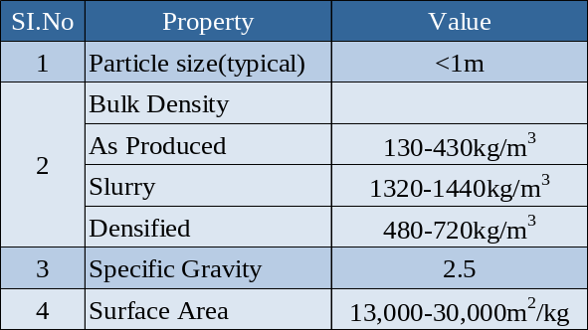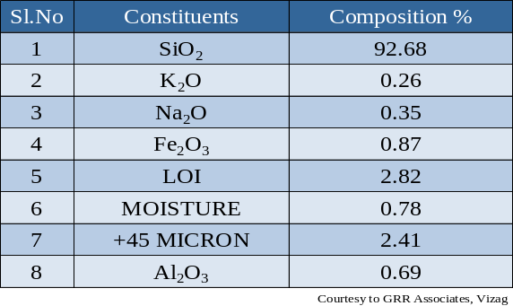

3.3 Geotextile
The geotextile used in this study is Poly Propylene (PP) woven geotextile-GWF-40-220, manufactured by GARWARE –WALL ROPES LTD, Pune, India. The tensile strength of woven Geotextile is 62.00kN/m for warp and 46.00kN/m for weft.
3.4 Aggregates
The size of Road aggregate used in this study is in between 40-20 mm, confirming WBM-III standards was used for the preparation of the base course in the investigation of the modal flexible pavements.
3.5 Gravel
The Gravel used in this study is collected from Surampalem, East Godavari District, Andhra Pradesh, India. The gravel is well-graded gravel and used as sub-base course in all model flexible pavements.

Table 3.3 Properties of the Gravel
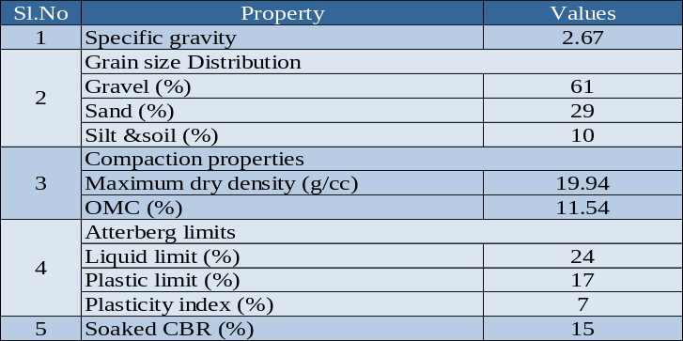

IV. LABORATORY TEST RESULTS
Table 4.1 Characteristics of Marine Clay
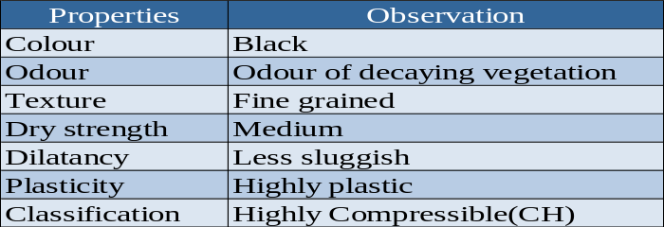

Table 4.2 Physical Properties of Marine clay
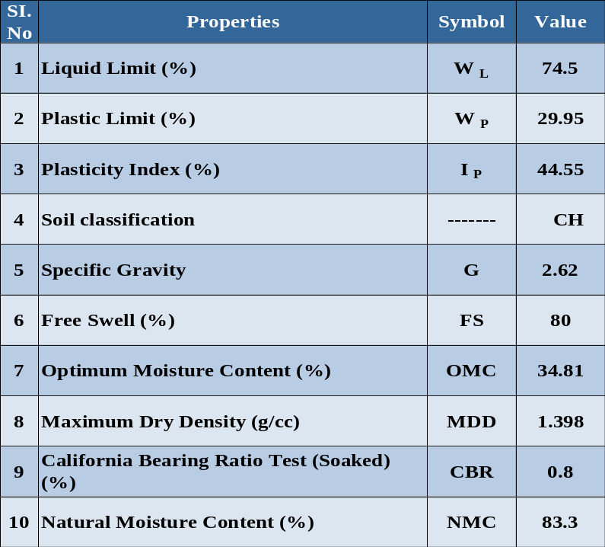

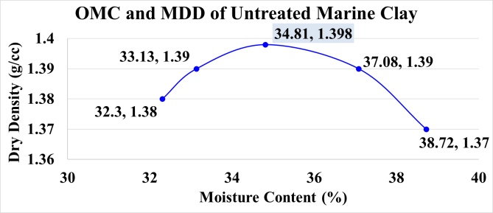
Figure 4.1 OMC and MDD Values of Untreated Marine clay

Optimum Moisture Content (OMC) = 34.81% and Maximum Dry Density (MDD) = 1.398 g/cc

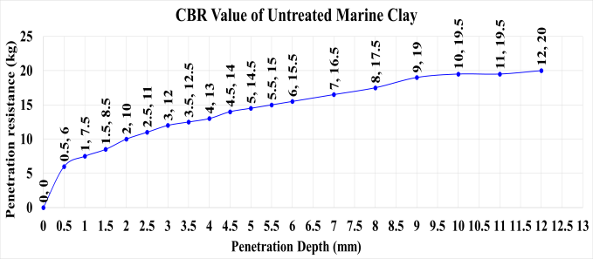
Figure 4.2 CBR Values of Untreated Marine Clay

Table 4.3 OMC and MDD values of Marine Clay & Marine Clay with variation % of Silica fume
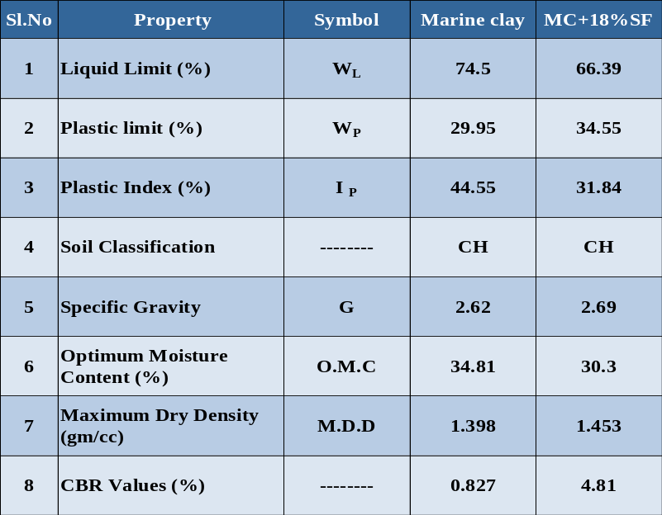

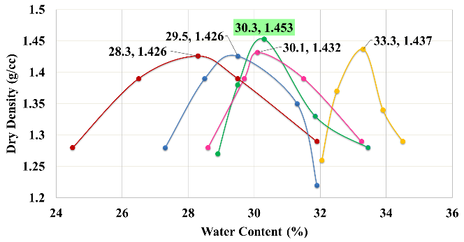
Figure 4.3 OMC and MDD Values of Untreated & Treated Marine Clay with Percentage variations of Silica Fume

Table 4.4: Variation of soaked CBR values with various percentages of Silica Fume
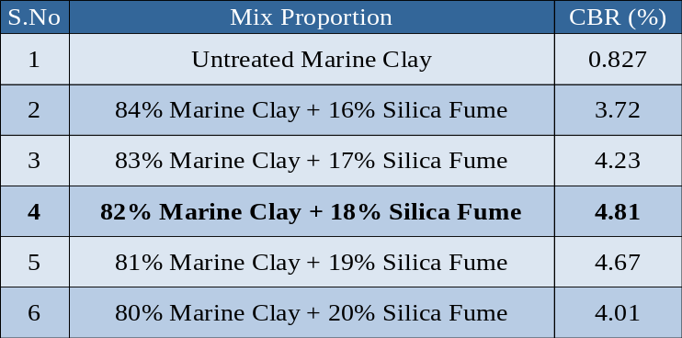

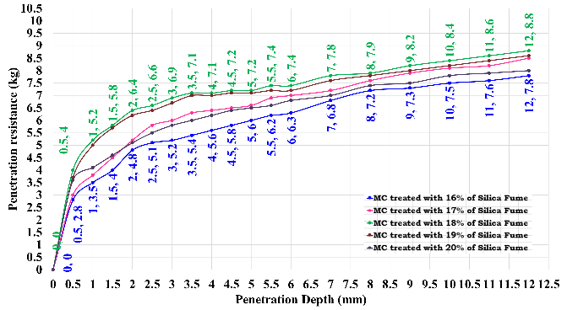
Figure 4.4 CBR of Marine Clay Treated with Percentage Variations of Silica Fume

Discussion-1

As per the IRC 37-2001 & 2012, the subgrade soil should possess the minimum CBR value of 6%. In the present study silica fume treated marine clay has exhibited the CBR value of 4.81% only, which is less as per the IRC codes of practice. As per IRC codes of practice, for achieving the required CBR value of the Silica Fume treated marine clay, an attempt has been taken to improve the CBR value of this treated marine clay with percentage variation of Ferric Chloride to suite it as sub grade for flexible pavements.

Ferric Chloride (FeCl₃)

Commercial grade ferric chloride (consisting of 69% ferric chloride +16% sodium chloride + 15% calcium oxide) was used in this study. The quantity of ferric chloride was varied from 0 to 1.5% by dry weight of soil.

Table 4.5 OMC & MDD values of Marine Clay treated with 18% Silica Fume with Percentage Variations of Ferric Chloride
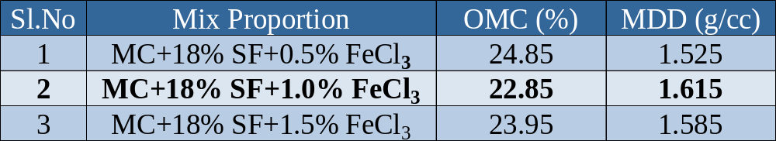

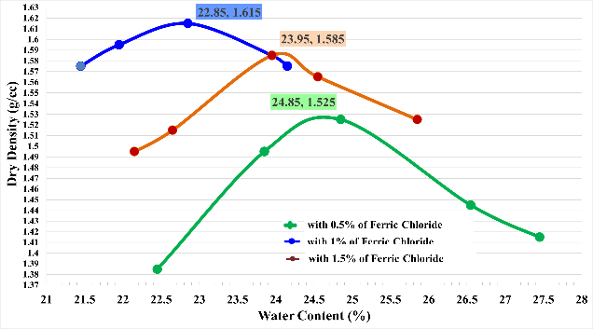
Figure 4.5 Curve showing the OMC & MDD values of Marine Clay treated
with 18% Silica Fume &Percentage Variations of Ferric Chloride

Table 4.6 CBR values of Marine Clay treated with 18% SF with Percentage Variations of Ferric Chloride 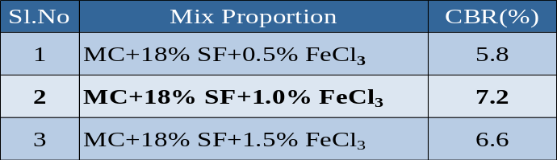

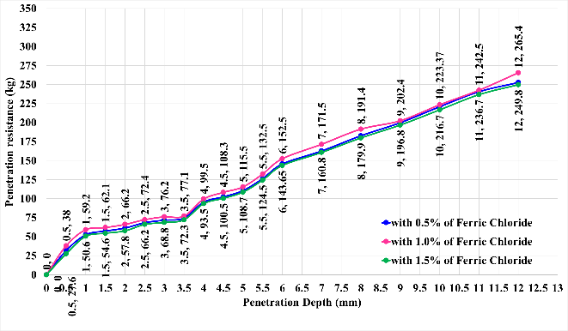
Figure 4.6 CBR values of Marine Clay treated with 18% SF with Percentage Variations of Ferric Chloride

Discussion-2
From the above study, 18% silica fume treated marine clay has exhibited the CBR value of 9.8% on addition of 8% lime as an optimum. Hence this treated marine clay is suitable as subgrade for flexible pavements as per IRC 37-2001, 2012 codes of practice.
Table 4.7 Properties of Treated and Untreated Marine Clay
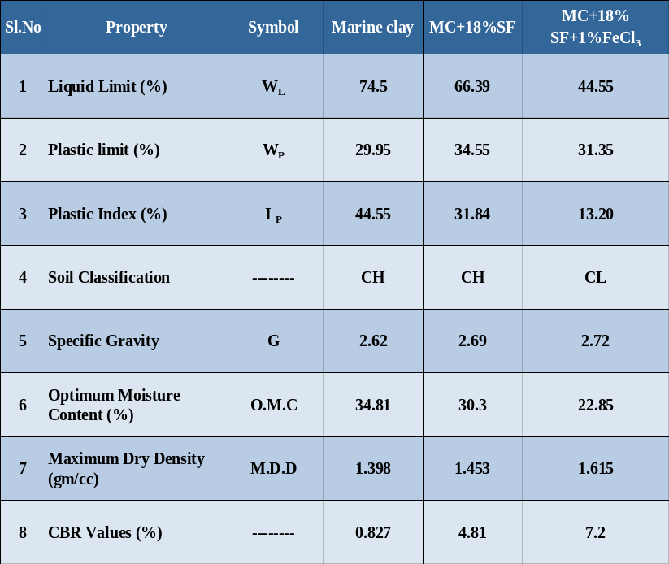

V. CYCLIC PLATE LOAD TEST

Cyclic plate load tests are more significant for determining the ultimate load carrying capacity of the pavements. Cyclic plate load tests were conducted in the laboratory on untreated and treated marine clay subgrade flexible pavements using model tanks.

MODEL TANK
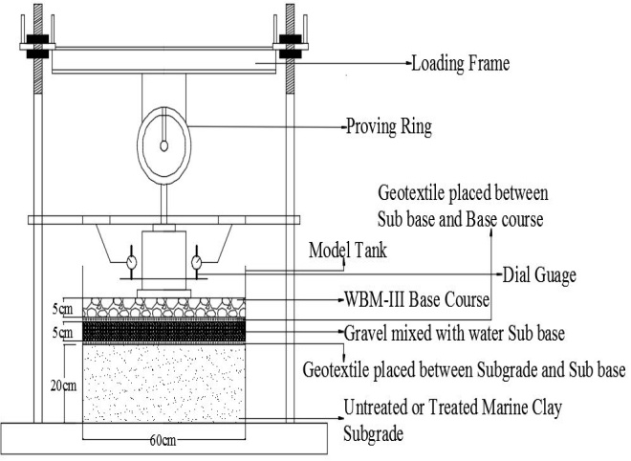
Schematic Diagram of Model Tank

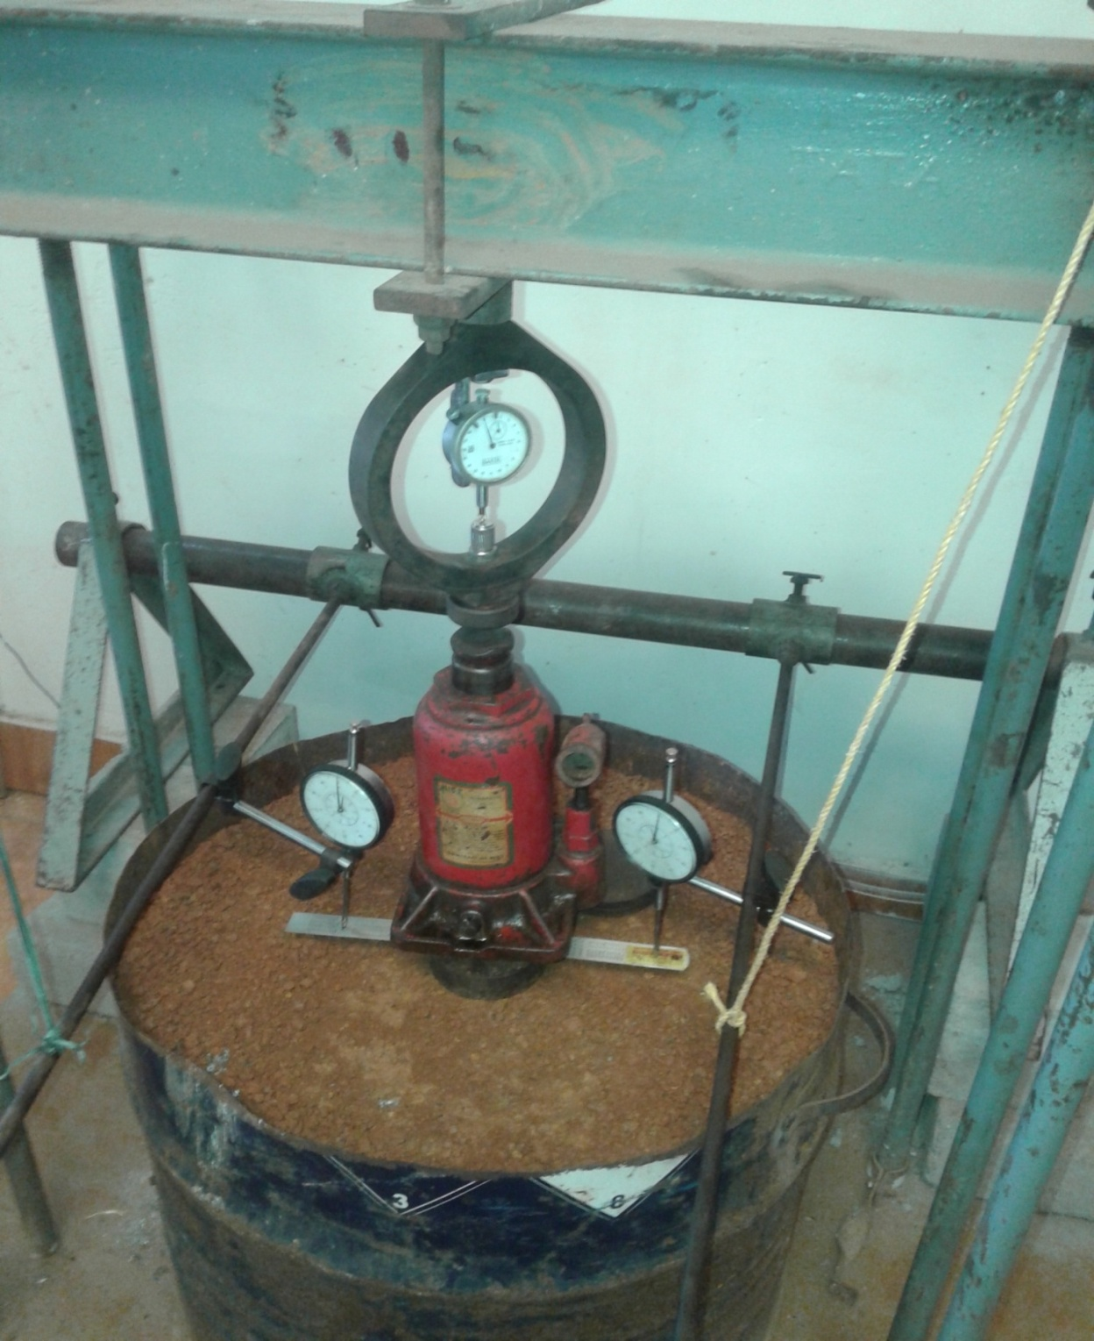
Plate 1 Experimental set up for conducting cyclic plate load test

A circular model tank made of steel with a diameter of 60cm and height of 50 cm is used in this study. In this study a model flexible pavement is prepared with treated and untreated marine clay as subgrade of 20cm thickness over which 5cm thick gravel sub base and 5 cm WBM-III is provided with suitable degree of compaction.

5.1 Test Procedure
A model flexible pavement is prepared in the model tank by providing 3 layers viz. subgrade, sub base, and base course for untreated and treated marine clay flexible pavement conditions.

5.1.1 Preparation of Subgrade
The marine clay passing through 4.75 mm IS Sieve was used and compacted in layers of 2cm thickness at O.M.C to a total compacted thickness of 20cm for untreated and treated marine clay model flexible pavement. For the untreated marine clay, water was mixed directly with the soil corresponding to the OMC of the natural marine clay. For the silica fume treated marine clay the weight of the dry mixes were taken corresponding to the M.D.D of marine clay and marine clay is compacted at O.M.C without any lumps. For further treatments, the required quantity of silica fume was spread on the pulverized soil and mixed thoroughly, until there was uniform mix of silica fume with the soil without any lumps. Further, the required quantity of lime was mixed thoroughly with already mixed soil-silica fume mix at OMC corresponding to the untreated marine clay.

5.1.2 Preparation of Sub Base
On the prepared marine clay subgrade, the gravel mixed with water at OMC was laid in layers of 2.5 cm compacted thickness to a total thickness of 5cm. The sub base layer was compacted to MDD and OMC of gravel.

5.1.3 Preparation of Base Course
On the prepared sub base, two layers of WBM-III each of 2.5 cm compacted thickness, was laid to a total thickness of 5 cm and the gravel used as a binding material the spreading of WBM-III as base course for the model flexible pavement. Prepared Flexible pavement is placed at the center of the loading frame of compression testing machine. A metal plate of 10 cm diameter is placed on the Model flexible pavement through which loading is done. Two dial gauges of least count 0.01mm were arranged to obtain deformations. A hydraulic jack of 5 tone capacity is placed on the metal plate. In Singly reinforced system, a woven geotextile is used as reinforcement and separator between subgrade and sub base course. In case of doubly reinforced flexible pavement first layer is provided as reinforcement and separator between sub grade and sub base for offering more pressures on the reinforcement flexible pavement system. Cyclic plate load was carried out on untreated and treated marine clay model flexible pavements corresponding to tire pressures of, 500kPa, 560kPa, 630kPa, 700kPa, 1000kPa at O.M.C as per IRC codes of practice. Each pressure increment was applied until there is no further change in deformations in between the consecutive cycles. The test is continued until the failure to record the ultimate pressure of untreated and treated flexible pavement.

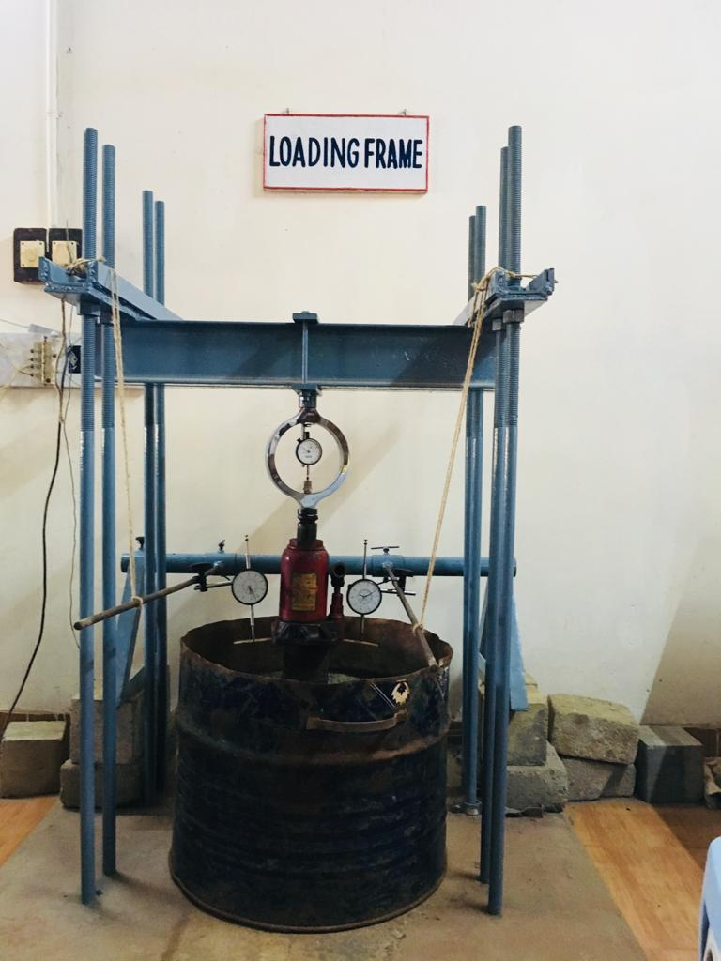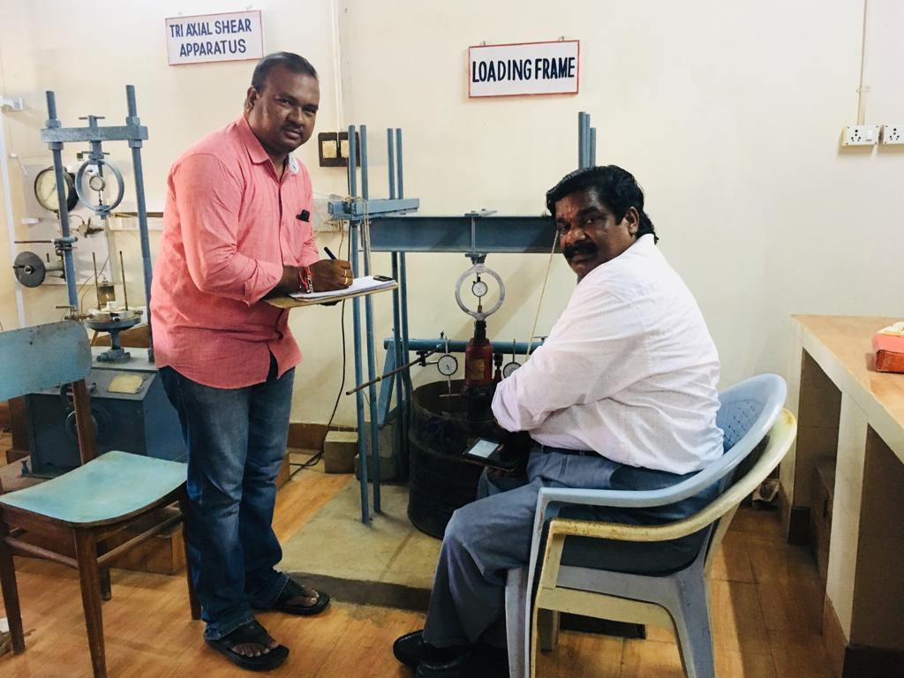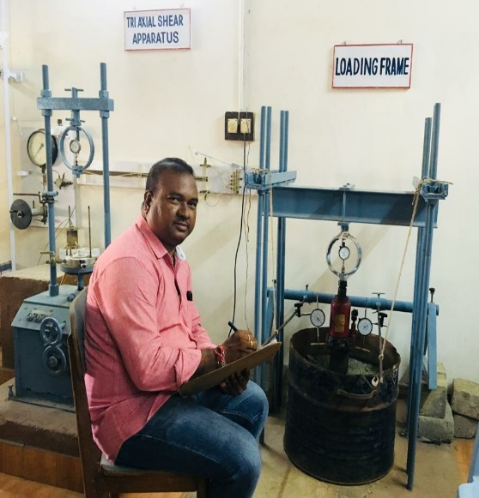
Plate 2 Author is conducting cyclic plate load test
5.2 Plate load test results

a). Table 5.0 and Fig 5.1 Present the load carrying capacity of the marine clay under cyclic pressures. The marine clay has exhibited the load carrying capacity of 71kPa at 3.42mm settlement.

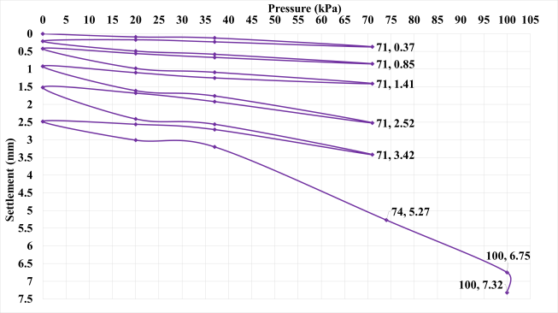
Figure 5.1 Cyclic Plate Load test results of Marine Clay

b). Table 5 and Fig 5.2 Present the load carrying capacity of the untreated marine clay subgrade flexible pavement under cyclic pressures. The untreated marine clay subgrade flexible pavement has exhibited the load carrying capacity of 665kPa at 2.66mm settlement.

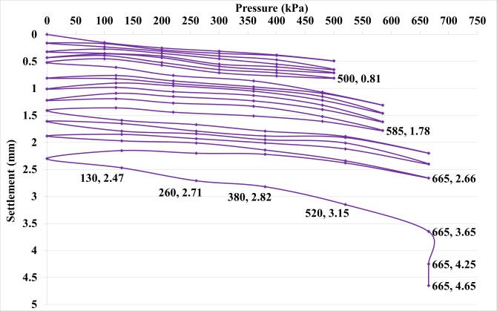
Figure 5.2 Cyclic Plate Load test results of Un-treated Marine Clay subgrade flexible pavement

c). Table 5 and Fig 5.3 present the load carrying capacity of the treated marine clay subgrade flexible pavement under cyclic pressures. The treated marine clay subgrade flexible pavement has exhibited the load carrying capacity of 1000kPa at 2.45mm settlement

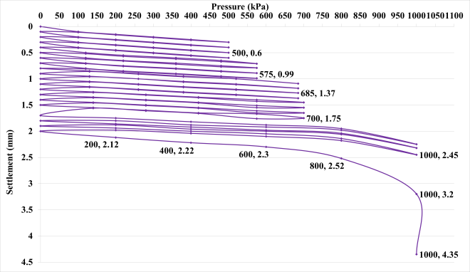
Figure 5.3 Cyclic plate load test results of Treated Marine Clay subgrade flexible pavement

d). Table 5 and Fig 5.4 show the result of geotextile reinforced treated marine clay subgrade flexible pavement, exhibited the ultimate cyclic pressure of 1400kPa at 1.66mm settlement.

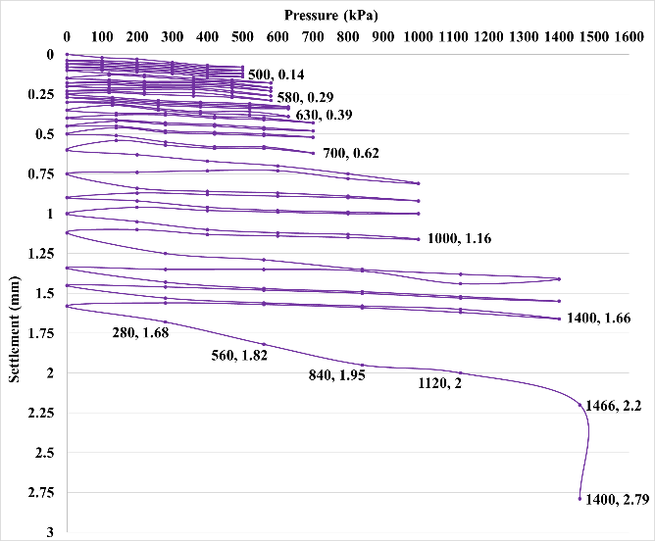
Figure 5.4 Cyclic plate load test results of Treated Marine Clay subgrade flexible pavement reinforced with geotextile
e). Table 5 and Fig 5.5 show the result of doubly reinforced treated marine clay subgrade flexible pavement, exhibited the ultimate cyclic pressure of 2200kPa at 1.54mm settlement. In this experiment the two layers of geotextile has been provided viz. the first layer has been provided subgrade and sub base and the second and provided in between sub base and base course.

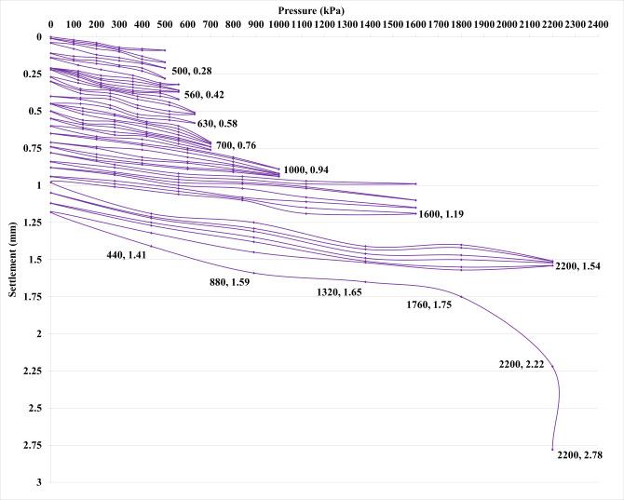
Figure 5.5 Cyclic plate load test results of Treated Marine Clay subgrade flexible pavement reinforced with geo textile

Table 5 Results of Cyclic Plate Load Test of Un-treated and treated Marine Clay Subgrade
Flexible Pavements under cyclic pressures.
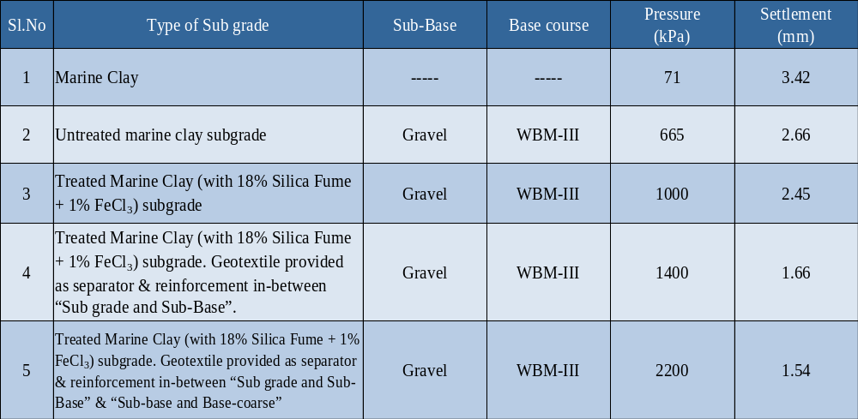

Discussion 3
It has been observed from the laboratory cyclic plate load test results that the Treated Marine Clay subgrade flexible pavement reinforced with double layers of Geotextile provided as separator & reinforcement in-between “Sub grade and Sub-Base” & “Sub-base and Base-coarse” under cyclic pressures are more effective when compared with all other Untreated and treated marine clay subgrade flexible pavement in the present study.

VI. CONCLUSION

- It is noticed from the laboratory test results that the liquid limit of the marine clay has been decreased by 10.89% on addition of 18% silica fume and further the liquid limit of the marine clay treated with silica fume has been decreased by 40.20% with the addition of 1% FeCl3 when compared with untreated marine clay.
- It is observed from the laboratory test results that the plasticity index of the marine clay has been improved by 28.53% on addition of 18% silica fume and further plasticity index of marine clay treated with silica fume has been improved by 70.37% with the addition of 1% FeCl3 when compared with untreated marine clay.
- It is observed from the laboratory test results that the C.B.R. value of the marine clay has been improved by 481.62% on addition of 18% silica fume and further the CBR of the marine clay treated with silica fume has been improved by 770.62% with the addition of 1% FeCl3 when compared with untreated marine clay.
- It is noticed from the laboratory cyclic plate load test results that the ultimate pressure (load carrying capacity) of the treated Marine Clay subgrade flexible pavement provided with doubly reinforcement, has been increased by 230.83% with respect to untreated marine clay subgrade flexible pavements.
- It is also noticed from the laboratory cyclic plate load test results that the total deformations of the treated Marine Clay subgrade flexible pavement reinforced with double layers of Geotextile provided as separator & reinforcement in-between “Sub grade and Sub-Base” & “Sub-base and Base-coarse” has been increased by 72.73% when compared with untreated marine clay subgrade flexible pavements.

REFERENCES

- S. Narasimha Rao and Sankar. N (1987), Compressibility Behaviour of Indian Marine Clays, Docks and Harbours conf., Madras, December 1987.
- BabuT.Jose, A. Sridhran,Benny Mathews Abraham (1988) "A Study of Geotechnical Properties of CochinMarine Clays", MarineGeotechnology,Vol 7. pp. 189-209,1988.
- Rao M.S., Sridharan.A and Chandrakaran.S (1992), Physico chemical effects on the engineering behaviour of Indian marine clays.Proc.ILT Seminar on problems of lowland development, Saga University, Saga japan.265-272.
- G.V.R. PrasadaRaju (2001), Evaluation of Flexible Pavement Performance with Reinforcement and Chemical Stabilization of Expansive Soil Sub-grade, Ph.D. Thesis, Kakathiya university, Warangal, (T.S, India).
- S. Narasimha Rao and Paul K. Mathew (1996), Permeability studies on Marine Clays stabilized with Lime column, International Journal of Offshore and Polar Engieering, Vol.6,No3,sep1996(ISSN 1503-5381).
- Ashwani Kumar and H. S. Mehta (1998), Laboratory Investigations on Use of Stabilized Granulated Blast Furnace Slag in Roads, Indian Highways, December 1998.
- Rajasekharan.G and Narasimha Rao.S (2000), Strength Characteristics of Lime treated Marine Clay, Journal of Ground Improvement, Vol.3, pp-127-136.
- J.Chu, Myint Win Bo, M.F.Chang and V.Choa(2002) Consolidation characteristics and Permeability properties of Singapore Marine Clay. Journal of Geotechnical and Geo environmental Engineering, Vol.128, No.9, Sep., 2002, pp.724-7323.
- Supakij N, Sanupong B et al (2004), "Strength Development of Soft Marine Clay Stabilized with Cement and Fly Ash", Kasetsart J. (Nat.Sci.) 38:539-552.
- C.N.V Satyanaraya reddy et al (2008) presented a case study in marine clay related to the heaving of the ground due to the shear displacement of marine clay, IGC-2008, Bangalore, pp: 614-616.
- Basack and Purkayastha (2009)"Engineering properties of marine clays from the eastern coast of India." Journal of Engineering and Technology Research Vol.1 (6), pp.109-114, September, Shridharan 2009.
- Koteswara Rao. D et al., (2011), The effect of reinforcement on GBFS and lime treated marine clay for foundation soil beds IJEST, Vol.3, No.3. March., 2011.
- Koteswara Rao. D et al., (2012), A Laboratory study on the stabilization of marine clay using saw dust and lime, IJESAT, July 2012.
- Dr. D. Koteswara Rao (2013), presented the affect of vitrified polish waste on improving the properties of marine clay, IJEIT, Vol-2, Issue -11, May 2013.
- Dr. D. Koteswara Rao (2014), presented the affect of steel slag for improving the properties of marine clay for foundation beds, 2nd International Conference,Trivandrum, IMMM,2014, vol.2,pp 267-273, Issue -11, 17th -19th December2014.
- Nor Zurairahetty Mohd Yunus et al (2015), presented performance of lime treatd marine clay on strength and compressibility characteristics, Int. J. of GEOMATE, June (2015). Vol.08, No.2 (SI.No.16), pp: 1232-1238.
- Bijina Blessy T. (2016) presented the effect of chemical and physical combine methods for improving the strength characteristics of the marine clay (IJERT), vol.5, issue. 08, August 2018.
- Mohammed Ali Mohammed Al-Bared and Amanaton Marto (2017) Presented A review on the geotechnical and engineering characteristics of marine clay and the modern methods, MJFAS, vol.13, No.4, 2017, pp: 826-832.
- Dr. D. Koteswara Rao and Y. SaiEswar (2018), presented the efficiency of Calcium Carbide and other chemicals for improving the consolidation characteristics of marine clay, IJTIMES, vol.4, issue. 08, August 2018.
- Dr. D. Koteswara Rao and Ch. Ajaykumar (2018), presented a laboratory investigation on the efficiency of expansive soil treated with silica fume and lime as subgrade for flexible pavements, IJTIMES, vol. 4, issue.08, August 2018.
- Dr. D. Koteswara Rao and K.Pradeep (2018), presented improving the properties of marine clay using phosphogypsum and lime as subgrade for flexible pavements, IJTIMES, vol.4, Issume. 08, August 2018.
- IS: 2720 part- 4 (1975): Grain size analysis.
- IS: 2720 part- 5 (1970): Determination of Liquid limit and Plastic limit.
- IS: 2720 part- 6 (1972): Determination of Shrinkage limit.
- IS: 2720 part- 6 (1974): Determination of Dry density and Optimum moisture content.
- IS: 2720 Part-10 (1973): Determination of Unconfined compressive strength.
- IS: 2720 Part-16 (1979): Determination of California bearing ratio.
- IS: 2720 part-40 (1977): Determination of Free Swell Index.

AUTHORS BIOGRAPHIE
Author 1:
B. Satyanarayana, Research Scholar, Department of Civil Engineering, University College of Engineering, JNTUK Kakinada, East Godavari District-533003, Andhra Pradesh, India
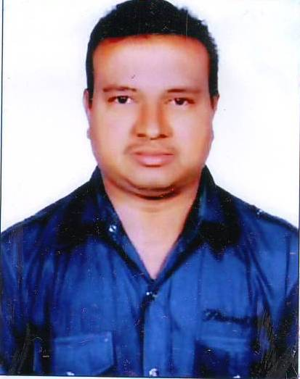
B. Satyanarayana
Research Scholar
University College of Engineering
JNTUK Kakinada, Andhra Pradesh, INDIA.

Author 2:
Dr. D Koteswara Rao is working as a Professor of Civil Engineering & Director, Faculty Development Centre, Jawaharlal Nehru Technological University Kakinada. He is a “Triple Hat-Trick Best Teacher Awardee” from the Department of Civil Engineering, University College of Engineering, JNTUK Kakinada. He was awarded the “University Meritorious teacher award -2013” by the University authorities and also received the National Best Teacher award-2013. Recently he was awarded “the State Best Teacher Award-2017” by the Government of Andhra Pradesh, India. He has published 41 research and review papers in various International& national journals and conferences. He has guided about 50 post graduate projects and four research scholars are working under his guidance. He is a leading consulting member in the fields of Surveying, Transportation and Geotechnical Engineering.


Dr. D. Koteswara Rao
Professor of Civil Engineering & Director
Faculty Development Centre
JNTUK Kakinada, Andhra Pradesh, INDIA.

Author 3:
Kakula Durga Malleswara Rao, P.G student, Geo- Technical Engineering Division, Department of Civil Engineering, University College of Engineering, JNTUK Kakinada, East Godavari District-533003, Andhra Pradesh, India.


Kakula Durga Malleswara Rao
Post Graduate Student
University College of Engineering
JNTUK Kakinada, Andhra Pradesh, INDIA.

