Social Networking Cloud - Resource Sharing Model in OPNET
Emilin Shyni C
Department of Computer Science and engineering
KCG College Of Technology, Chennai,Tamil Nadu, India
emilin@kcgcollege.com

Roopa V
Department of Information Technology
Sri Krishna College of Technology, Coimbatore,Tamil Nadu, India
rooparam81@gmail.com

Abstract - The “on-demand” services that the “Cloud” offers comes along with storage and security constraints. This paper subjects to focus on these challenges lying ahead of Cloud Technologies by suggesting shared storage resource model through trust enabled system. The other part of the paper deals with the impact on usage of current social networking systems and its related mobile applications. The resource sharing is modeled using Sales force and Apex programming. OPNET simulator tool is used to visualize the storage scenarios implemented based on user- trustee relationship. The authentication is also focused by generating the random key each time before enabling the system. Online survey is open for suggestions and the results obtained are analyzed to study impact of social systems among people. The design using Sales force and Apex programming proves to be an apt application of the concept, integrating “Social” aspect of the technology to improve the Trust of the “Cloud” users. The combination of Genetic and Ant Colony algorithm proves that the matched pairs suggested for storage is more. The simulation results from OPNET give the related network characteristics. The survey results prove that the usage of social networking is creating a darker impact to suggest ‘usage with purpose’. The demo of social site is on the internet and can be accessed by the users of sales force. The survey taken is also available online and leaves room for future discussions along with the growing technology.

Keywords- Authentication, Cloud, Data Storage, Security

1. INTRODUCTION
The objective of the project is to provide a focus on the growing social networking applications and architect a cloud model addressing the storage and security constraints. This paper proposes a demo of the social networking process using trust- based approach for shared data storage using Sales-force programming in cloud[13].
1.1 Cloud – Data – Storage Sharing
The storage of all data from social networking is moving towards the Cloud Storage. These options is chosen by almost all the social sites as cloud provides vast storage options as well as provide effective means when data is to be shared. Resource sharing is an important aspect of cloud. SaaS, PaaS and IaaS and other services are provided by the cloud with this concept as its base. Similar concept of resource in this case, Storage in cloud is chosen[10].
1.2 Social Networks- Survey
Social networking knowingly or unknowing has a darker side too. Social networking can tremendously affect the public policy and may a lot of changes [7]. It also becomes a destructive threat to government and it is an advance form of hacking. Social networking site uses are vulnerable to security attacks such as hacking identity theft and viruses. Social networking posts cannot be fully deleted as it is being spread all over. Unauthorized sharing of social networking exposed artist to loss of intellectual property and loss of time.

II.RELATED WORK

The following section deals with the literature survey covering topics including cloud storage and resource sharing models, SN(social networking), impacts of usage of SN, various survey relating to the same.

The usage of the social system is increasing in rapid manner. Content sharing [6] is the basis of all any online social system. These data from the point of creation is used in sharing, discussion / forums, modifications etc. The social system is referred to as a Jungle in ecosystem. The honeycomb of social media was constructed with major focus on 2 major aspects : social media functionality and implications of the functionality. The conclusion was based on 4C’s→ Cognize, Curate, Congruity and Chase.

Using facebook, flickr communities are formed based on matching of the user profiles. They [4] formed (LSBN- Location Based Social Networking) has a similar community interest. Inter-node is implicit functionality representation i.e, grouping based on family members or colleague group whereas intra-node features the groups based on characteristics i.e, an user is a follower of certain group. M2 Clustering and HM2 clustering are compared. In M2 (Multi-Mode & Multi-Attribute ) algorithm, feature selection is based on multiple datasets. In HM2( Hierarchical Multi-Mode& Multi-attribute) approach, the average linkage is used rather than single and complete linkage mainly due to accuracy. Hence with this these social systems are prone to be vulnerable. The study pattern becomes complex if the user has chosen for any basic privacy options.

Tagging [5] takes place only when the users share few resources including pictures, songs, books etc. Flickr, last.fm, a Nobii systems are extensively used as tagging is of major usage on these sites. Hence the data collected from each sharing leads to social classification concept of data folksonomies. Thus homophily among friends was deeply analyzed for different social systems. The link prediction results was based on users’ nationality, spoken language, purchases, library systems. Homophily prediction becomes difficult as 30-35% users remain non-participant in these social activities but friendship prediction still remains.
The [2] a brief survey on focus on dark side of using facebook. The topics included managing inappropriate or annoying content, being tethered to Facebook, perceived lack of privacy and control, social comparison and jealousy, and relationship tension. The results was [12]obtained from people of mixed age groups. Though light side of using facebook as a form of socializing these rear side are to be focused as it had a behavioral impact on humans and also the stress and emotions of people was altered because of this. The study [3] focused on the growing usage of social sites and apps and suggested that a third party perspective for interpretation is needed. With the enormous size of the cloud data centers and the large number of nodes supporting any cloud offering, hardware and software failures become an unavoidable reality, for which a robust monitoring system must be in place to allow the cloud services to actively react to failures and the node failures. The content of a page, photo uploads being shared should all be monitored as there is demand to stop the inappropriate content as social sites are the main medium of communication these days. [1] The load balancing on increasing workload and creation of the VM instances is on the study to meet the requirements of the end user. The hypercube model is been proposed so as to balance the compute nodes that are distributed to balance the load. The VM instances [9] are migrated in a centralized manner so as to track the usage of the computing nodes. But the future model is to have a de-centralized approach for load balancing as it can be even more scalable and much efficient to share the data across in a trust based approach. The overall energy [8] consumption and the balancing of load needs a trust based model for balancing the work. The work load is been split across random, rapidly increasing and decreasing. There has also been models on optimal memory allocation[7] process which is on a global phenomenon of allocating dynamic memory. This memory is based on VM instances on demand and also is carried on a consolidated centralized server. This model is also dependent on a dedicated disk so as to monitor the VM instances and memory allocation instead a trust based de centralized system will be even more effective on these implementation. [15]The adaptive model to dispatch of tasks in the virtual machine (VM) adds up to the deployment of CSP and hence the end user is also given the access controls to enable or disable the trust of their circle thus minimizing the security risks by the provider. The dark side of social networking has been the successful finding that daily instances are being proven.

III. Proposed Architecture

The proposed system is based on cloud storage system, involving the social networking by sharing the data and storage. This system provides lot of storage spaces but the utilization of the space must be monitored. So to optimize the full storage system we can group people among them and split up the storage area so that it will be more sufficient for them and the storage space will also not be wasted. And more than that all the users will be connected to the cloud based system.
Thus in the implemented system there will be lots of users for the storage to be utilized and all the users will be connected through the cloud system just like how server connects to the entire system. This enables the user to connect to the central storage system. The users will have direct access to the storage system so that it gives them lots of storage spaces to the user in cloud and the user to be more connected to each other in some way or another. The implementation of the system is by giving a new component trust enabling system. This pairs the people whoever is using and pairs the storage space within the user. In the beginning it shares data to every person whoever is given access to cloud.
3.1 Resource Sharing Cloud SN Model
The overall improvisation in the proposed architecture model thus involves:
- The trust based approach is being proposed as with resource and data sharing is with trustee. This approach is preferred than the ranking process as with the complexity of ranking is addressed.
- This approach helps in over all expansion of the sharing approach among trustee friends. Scalability measures are thus handled.
- The Genetic Algorithm along with consideration of Ant Colony Optimization is to be implemented. The search of storage space is modeled by combining these algorithms.
- The overall design is done using SALESFORCE and APEX Programming the recent approach in Cloud. The modeling of social network for trust enabled social system is implemented.
- Survey on “BE SOCIAL - OR- NO SOCIAL” is carried on the recent Scenarios of social networking. The topics focused are analyzed.
3.2 Proposed Architecture
The architecture as shown in Figure 1 diagram depicts the distinct modules:The primary role and the function of each layer and the sub-components in each of the layer are explained below:
The External / User layer signifies the different users in the real world scenario. It is used to represent the users of the system in interaction with the system to consume various services provided including data storage. The services also include the interactions among different users, option to choose the privacy options and restrictions, control of visibility to other users, data upload and deletions. Hence the model or architecture addresses the enhanced Security need for protecting the system. The next layer is the social networking layer where the social network sites and applications available are focussed The various social site includes facebook, twitter, and other mobile messengers like whatsapp, hike, line, facebook messenger, gmail, google plus etc. Facebook is chosen where the friend requests and acceptance to the same plays a vital role.

The Cloud based is the term referring to all the social networking systems available where the data storage is supported by cloud. This region is of focus because the data sharing process is on this layer. The concept of resource sharing is important where in the utilization of storage with today’s need of growing data. The user selects a group of trustee and enables the trustee with enhanced privacy options to store the trustee data the user space. In individual internet users everyone are connected to one single cloud based storage. This enables the user to get connected with one another from one place to another. In cloud computing the main advantage is sharing of data and spreading it with the parent or neighboring persons is considered as the main pros of cloud computing.

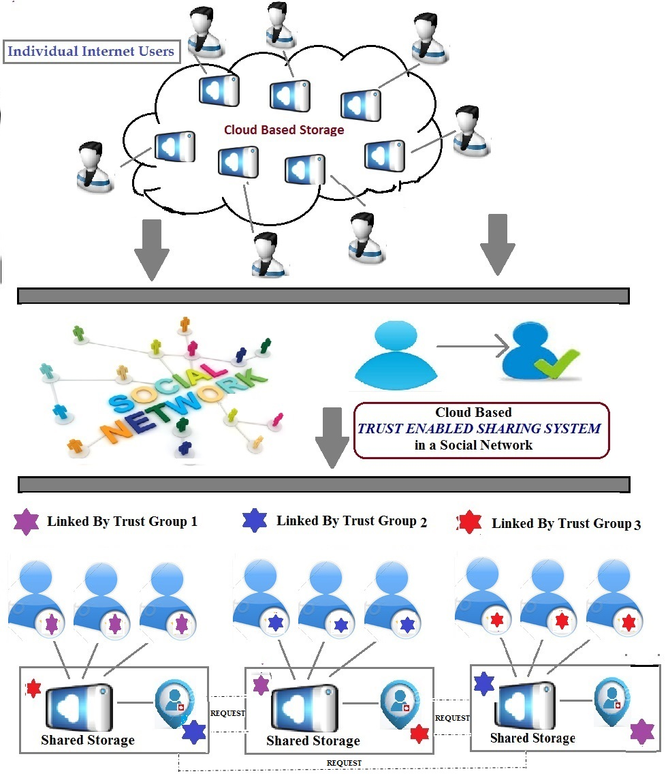
Trust Enabled System
External/ User Layer
Social Networking Layer

Figure 1. Proposed System architecture
3.3 Data Sharing Visualization Scenarios
Opnet is used in this implementation as a data sharing visualization tool. The data flow and the overall setup of the cloud based social network with trust enabled sharing system is explained in this architecture as shown in Figure 2. This includes user, friends, trustee among friends and interactions with other friends in the social network such that the genetic origin and optimized space is searched by ant-colony.

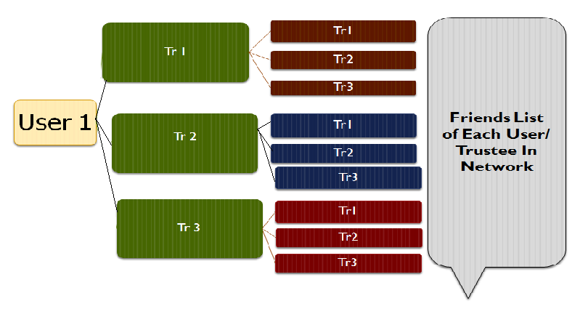

Figure 2.Trust Enabled SN Resource Sharing Model

IV. SYSTEM IMPLEMENTATION
The system implementation describes elaborately the various modules being implemented. The overall execution of these modules is explained and the various supporting tools and mechanisms for the successful implementation is also explained.

4.1 Formation of Demo Social Network
Salesforce is known for customer relationship management is expanded into commercial application of social networking through acquisition as in Figure 3. Salesforce is chosen and using the Apex Programming, the webpage, the demo of the social network is been built. The page consists of the user login, list of friends, option for choosing the trustee and removing the trustee from the given friend’s list. This is advantageous than using Seattle Clearing House model as this Resource sharing system is trust based.
4.2.Authentication Among User And Trustee
The security aspect of data sharing must always play a vital role in the trust enabled system. Security aspect is governed through- out the working process. The first level is that the user to select the trustee among the friend’s list. If the trustee is selected then approval must be sent by the trustee. Hence a random security key is generated among the user and trustee such that the authentication process is being implemented. The second level of security level approach is when the trustee has a set of trustee among his particular’s friends list as shown in Figure 3

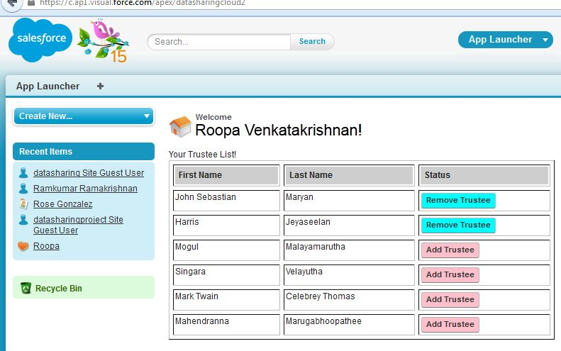
Figure 3. Trustee Page of the Demo SN System

4.3. Data Sharing Visualization using OPNET
OPNET is performance based software which enables the current performance establishing a trustee grid, a way of authenticating the person with the information.
Scenario 1: The social cloud involves about 5-10 users. Each user can add upto 3 trustee friends so that data storage can occur between these 3 trustees in the user 1 storage space. Likewise for other users also. Each user can have 3 trustee friends. The normal flow of data is that user has a separate server and the data flow is from user to the respective server.
Scenario 2: (Storage Space For Trustee) The user 1 has 3 trustee and these trustee friends can have their own trustee friends of 3 each. If one of them need storage then they can send request to user 1 (since he is on the trustee list of user 1) to ask for storage space for their trustee. The request can be accepted or denied based on the storage space available. From Figure 2, the scenarios are being implemented with the data flow such that trustee sends data and is stored in the corresponding user space.
Scenario 3: If unknown friends send request then it will be denied and no storage of data in the server.
4.4. Genetic -Ant Colony Algorithm
Ant colony optimization is a way of finding the storage space and how to use it With an ACO algorithm, the shortest path in a graph, between two points A and B, is built from a combination of several paths.. Ants search for the needed storage and gene pair is selected according to the trustee relationship that the user is involved. It is more flexible and becomes an easy technology to be used.
Search for storage space using Genetic- Ant Colony Algorithm
Consider a social network = S
Let number of relations = R
Let the users and trustee relations = (u, t_{i})
t_{i}{ i=1,2,3….n}
Available nodes for each trustee and users = user → N(Node)
Trustee → t₁,t_{2,}t_{3….….}t_{i}
Friends of Trustee → e_{1,} e_{2,} e_{3…..}e_{i}
where the path of individual node in need of storage is searched by Genetic Ant Colony Algorithm.
Suppose, e₃ is in search of storage, where the path travelled is between nodes e_{i}→n_{i}→N
{i= 1,2,3…n} depending on path of number of trustee and friends of trustee created.
Similar paths can be created using the same if scalable, the nodes can be created and the path is traced by this algorithm.
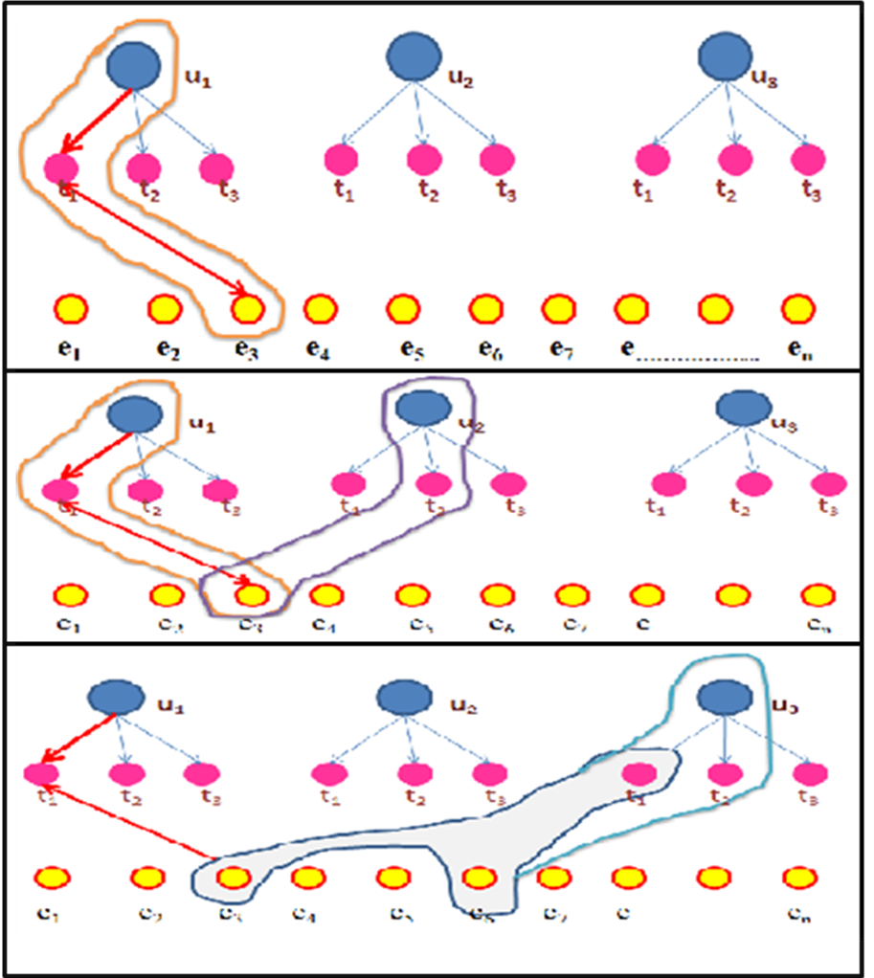

Figure 4.Genetic ACO Algorithm Implementation
4.5. Survey Analysis on Being social or Not
Social networking is a very fast developing way of sharing things and sharing the happening in the world. Social networking can tremendously affect the public policy and may a lot of changes. The survey focus as in Figure 6 was mainly on the present impact of the usage and un-usage of social networking sites and applications in the mobile phones. The participants of the survey was adults ranged in age from 20- 55. All the participants were regular users of the social sites and its mobile apps. As report says that on an average usage of the social sites is about 42 minutes a day. Facebook is still on the top of it and number of users surpasses by 1 billion registered accounts. The theme of the survey was hence alarming the facts on the usage of social networks and concentrating on the emotional, social and stress factors of the usage.

V. RESULT AND ANALYSIS
The results from the implementation of the modules are shown in this section. Here the various sections include Online Survey results for analyzing the impact of Social Networks and resource sharing obtained by implementing trust enabled social system.
5.1 Survey Results
There were responses to this survey and results obtained suggests that though the social media was invented for necessity and formal exchange of information, an aspect of distraction and lack of focus as in Figure 5(a) is that the usage has become more frequent. It shows the sharing among friends may be controlled but among friends of friends may have some privacy issues and exchange of the personal information may lead to lack of privacy in Figure 5(b). From Figure 5(c) though daily facts are that news and other happenings around is been is been updated only by the daily news feed happening.

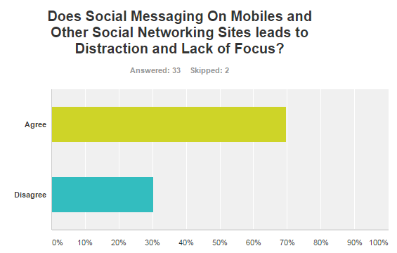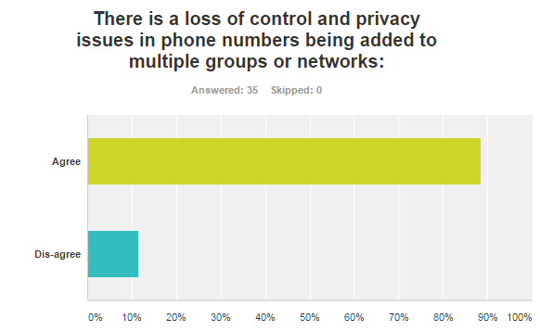

Figure 5(a). Result for Distraction & Lack of Focus Figure 5(b). Result for Control & Privacy Issues

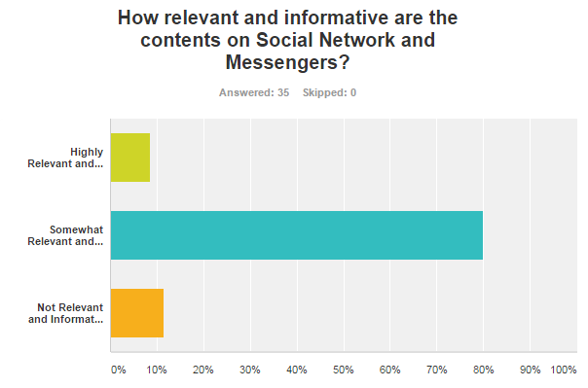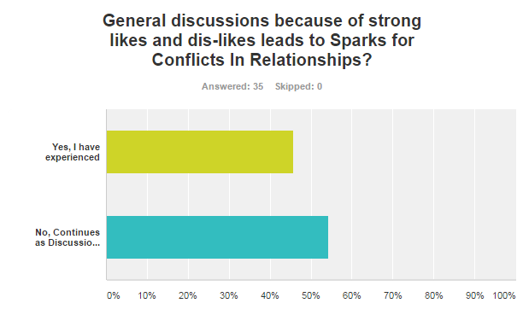

Figure 5(c). Content Relevace & Information Figure 5(d). Conflicts in Relationship

The social media acts as a platform for open discussions among the groups. These group discussions may be among some followers of a particular community. When those are being open for discussion, these may lead to some unnecessary lead for conflicts in relationships in Figure 5(d). This may be open in forum and may leave room for emotional trauma and created unwanted stress in the relationship. Constant tweets and updates are sometimes felt stressful and annoying as in Figure 5(e).

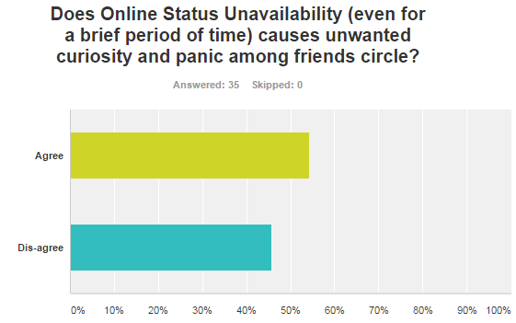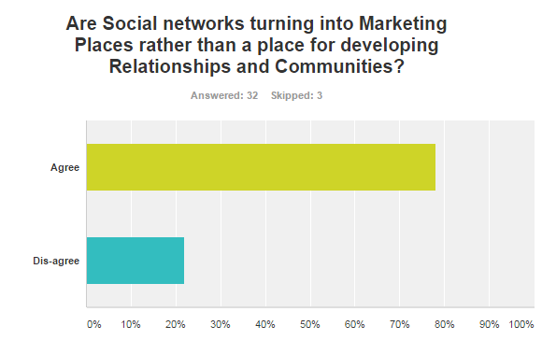

Figure 5(e). Results for Panic & Unwanted Curiosity Figure 5(f). Results for SN as Marketing Platform

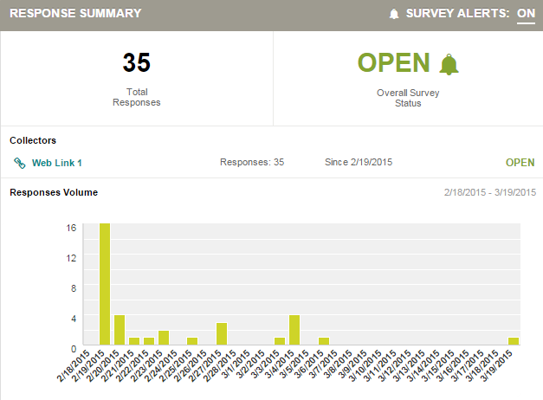

Figure 6. Open Survey Results

The fact being that even the unknown group of friends also participates in this fact. The marketing online and shopping online has given the options for the users to directly choose the products on one’s typical interest Figure 5(f).

5.2 Opnet Simulation Results
Through the simulation scenarios implemented, the above results were obtained and comparison of various networking aspects while the data flow is being monitored is based on the equations (1.1, 1.2) where the delay, traffic, packet flows was calculated. The graph in Figure 7(a) is the overall implementation of the data flow and the traffic of each scenario is calculated. The other scenarios suggest normal traffic. The graph in Figure 7(b), shows the throughput calculated for all the scenarios. Here the user- trustee flow has the maximum and minimal if the non-trustee nodes are involved.

Number Of Received Packets
Traffic Received = -------------------------------------------- [1.1]
Number of Sent Packets

Number of Packets delivered* Packet size * 8
Throughput = --------------------------------------------------------------- [1.2]
Total duration of Simulation

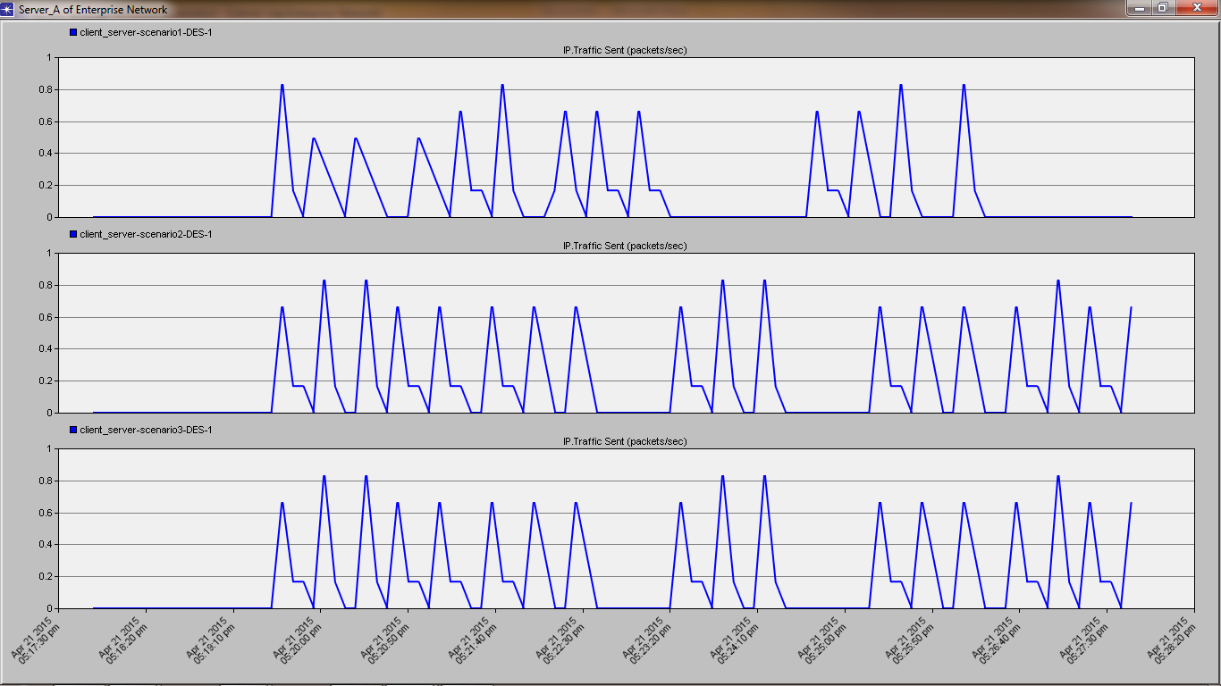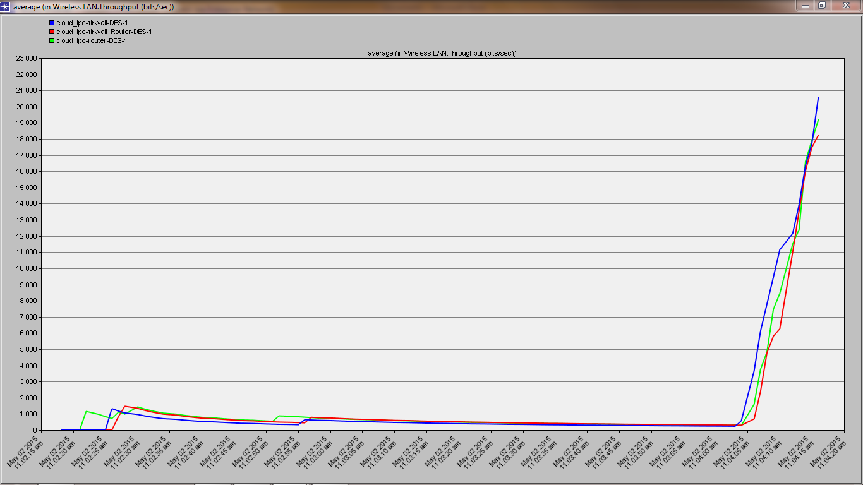
Figure 7(a). Traffic Sent/ Received Scenarios Figure 7(b). Throughput comparison Scenarios

Hence with the Genetic ACO combination as shown in Figure 8, the trustee nodes are identified and a trust enabled social network is thus formed and a formation of Resource Sharing environment is created.

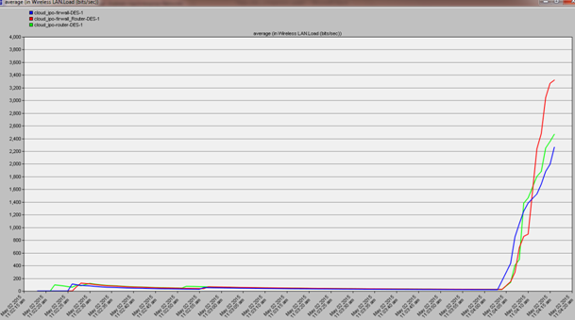
Matched Pairs
Genetic & ACO
Genetic
Matching Algorithm
Figure 8. Comparison of Algorithms

VI. CONCLUSION
This paper proposes the necessity to utilize the storage space more efficiently in the social network supported by cloud. The trust based approach is chosen over other implementations as granting of request can be made in a secured manner. Salesforce CRM model is user-friendly approach & the future would be the development of Salesforce1 Mobile App, that are more productive from anywhere in the world and stay connected to customers and teammates, focusing on customer success. OPNET simulation tool is used for data storage visualization as it deals with control over both network and application performance management. Genetic- Ant Colony combined Algorithm is preferred over other heuristic search optimization algorithms and the reasons are validated. The survey on the growing social sites is to alarm the facts on usage with purpose without being affected emotionally with focus on Usage with Purpose. Connected to both the right information and their colleagues, sales teams are working smarter and seeing dramatic improvements in performance. The future enhancement of this paper includes twitter features and the other social media features.
References
[1]. Michael Pantazoglou, Gavriil Tzortzakis, and Alex Delis ,”Decentralized and Energy-Efficient Workload Management in Enterprise Clouds IEEE Transactions on Cloud computing, Vol. X, No. Y, Month 201x
[2]. Jesse Fox , Jennifer J. Moreland, " The dark side of social networking sites: An exploration of the relational and psychological stressors associated with Facebook use and affordances", Elsevier 2014.
[3]. Yichuan Jiang, Senior Member, IEEE, and J. C. Jiang," Understanding Social Networks From a Multiagent Perspective", IEEE 2014.
[4]. Zhu Wang, Daqing Zhang, Xingshe Zhou, Dingqi Yang, Zhiyong Yu, and Zhiwen Yu, “Discovering and Profiling Overlapping Communities in Location-Based Social Networks,” , IEEE 2014.
[5]. Luca Maria Aiello, Alain Barrat, Rossano Schifanella, Ciro Cattuto, Benjamin Markines And Filippo Menczer, “Friendship Prediction and Homophily in Social Media”, ACM 2012.
[6]. Jan H. Kietzmann *, Kristopher Hermkens, Ian P. McCarthy, Bruno S. Silvestre, "Social media? Get serious! Understanding the functional building blocks of social media", Elsevier 2011.
[7]. Lori M. Kaufman, Bruce Potter "Monitoring Cloud Computing by Layer, Part 1 & 2" ieee computer and reliability societies 1540-7993/@ieee march/april 2011.
[8].Luca Ferretti, Michele Colajanni, and Mirco Marchetti,"Distributed, Concurrent, and Independent Access to Encrypted Cloud Databases", ieee transactions on parallel and distributed systems, vol. 25, no. 2, february 2014.
[9]. Joseph Idziorek, Mark F. Tannian, and Doug Jacobson, "The Insecurity of Cloud Utility Models", Published by the IEEE C omputer Societ y 1520-9202/13/ © 2013 IEEE.
[10].Khaled Salah, Jose M. Alcaraz Calero, Sherali Zeadally ,Sameera Al-Mulla and Mohammed Alzaabi, "Using Cloud Computing to Implement a Security Overlay Network", Copublished by the IEEE Computer and Reliability Societies 1540-7993/13/ © 2013 IEEE.
[11].Vijay Varadharajan & Udaya Tupakula, “Security as a Service Model for Cloud Environment”, ieee transactions on network and service management, vol. 11, no. 1, march 2014.
[12]. John Harauz., et all, Data Security in the World of Cloud Computing JULY/AUGUST 2009 , 1540- 7993/09/$26.00 © 2009 IEEE COPublished by the IEEE Computer and reliabilty services.
[13]. Dan Gonzales, Member, IEEE, Jeremy M. Kaplan, Evan Saltzman, Zev Winkelman, and Dulani Woods ,”Cloud-Trust—a Security Assessment Model for Infrastructure as a Service (IaaS) Clouds” 2168-7161 2015 IEEE. Translations and content mining are permitted for academic research only.
[14]. Wei-Zhe Zhang, Member, IEEE, Hu-Cheng Xie, and Ching-Hsien Hsu, Senior Member ,”Automatic Memory Control of Multiple Virtual Machines on a Consolidated Server IEEE, transactions on cloud computing, Vol. 5, no. 1, January-March 2017
[15]. Lan Wang and Erol Gelenbe , Fellow ,”Adaptive Dispatching of Tasks in the Cloud” IEEE Transactions on cloud computing, Vol. 6, No. 1, January-March 2018

