Copyright Warranty and Authorization Form

Title of the Paper:

Paper Id-No.: 96

DECLARATION
I/We Mr.Thongchai Sengsri and Prof.M.Radhakrishna the author/authors of the research paper/article entitled A Design for Highly Interactive Automated Instructional System authorize you to
Publish the above mentioned paper/article in the proceeding of ICRMR 2018.
It is herein agreed that:
- I/We will not publish his/her above said contribution anywhere else without the prior written permission of the publisher unless it has been changed substantially.
- I/ We declare and warrants that his/her/their contribution is original, except for such excerpts from copyrighted works as may be included with the permission of the copyright holder and author thereof, that it contains no libelous statements, and does not infringe on any copyright, trademark, patent, statutory right, or propriety right of others. The Author signs for and accepts responsibility for releasing this material on behalf of any and all co-authors.
- The Author also warrants that he or she has the right to enter into this Agreement, the Article contains no libelous or unlawful statements, contains no instructions that may cause harm or injury and does not violate the copyright or trademark, or infringes on the rights or the privacy of others; and that all statements in the Article asserted as facts are either true or are based upon reasonable research.
- I/We agree to indemnify the organizer ICRMR against all claims and expenses arising from any breach of warranty from me/us in this agreement.
1st Author’s Signature 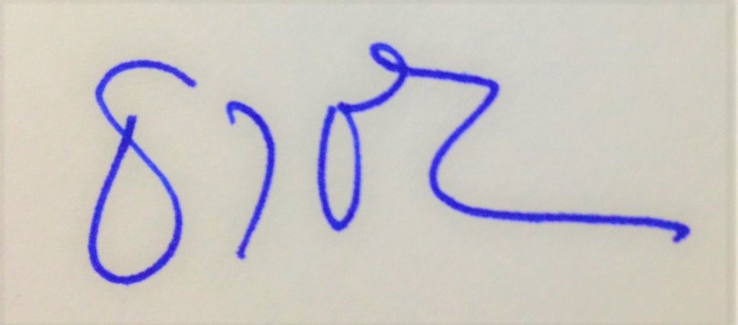 | 2nd Author’s Signature
Author’s Name: Thongchai Sengsri | Author’s Name: Maringanti Radhakrishna
Address  117/11 M.5 Banklong, Muang, Phitsanulok,65000  THAILAND | Address
Date: 10/10/18
Mobile: +669 1843 9978

