Efficient Bandwidth Allocation for on-Demand Multimedia Advertisements using
Mobile Agents
Roopa G M
Department of Computer Science and Engineering
Bapuji Institute of Engineering and Technology,Davangere-577004, Karnataka, INDIA.
Email- roopa.rgm@bietdvg.edu
Nirmala C R
Department of Computer Science and Engineering
Bapuji Institute of Engineering and Technology,Davangere-577004, Karnataka, INDIA.
Email- crn@bietdvg.edu

Abstract- The current advanced technologies/high-speed communication network services have lead to a huge popularity in accessing the on-demand multimedia-services. Such services has given rise to series of competitive scenarios among major segments like data-providers, software companies, hardware-manufacturers, network-operators and ad-campaigns. The huge growth in on-demand ad-services from the user ratings/views/downloads/requests and many monitoring agencies there are many challenges/drawbacks for providing such services . The major issues with traditional on-demand services are, on-demand servers require high-bandwidth to serve every client-request, timing restrictions with delay in transmitting the multimedia component within specified time before losing significance, ad-insertion techniques adopted which keep varying depending upon the channel used (demand, online, linear-broadcast) and finally the network traffic. In-order to overcome the challenges, a multi Mobile-Agent paradigm is proposed to provide an efficient on-demand multimedia ad-services by applying the dynamic-bandwidth allocation algorithm, which allocates/de-allocates higher bandwidth for high-priority video-components. By employing Mobile Agent paradigm, the results show a huge reduction on the central server-load, efficient bandwidth resource usage, dynamically allocates high bandwidth for higher-priority multimedia components and reduces the network traffic by adopting asynchronous-communication mode. The proposed mobile agent paradigm with dynamic-bandwidth allocation schemes shows better performance when compared to the conventional scheme used for on-demand multimedia services.

Keywords – e-Advertising ,Dynamic bandwidth allocation, On-Demand Multimedia, Quality-of-Service, Popular video advertisement, Video-on-Demand.

I. Introduction
The major goal of the emerging broadband networks is to provide a high-speed transmission of a wide range of QoS [7,9]. Serving such multimedia services has become the major issues for most of the broadcasting network in terms of network traffic and thus an efficient transmission mechanism is necessary for the existing network operators to meet the Quality-of-Service constraints[8,11,16].
The advancement in the video-technology has provided the time/place where the current users choose to watch the content without any delay. This results in a need for a new advertising opportunity to effectively reach huge users than ever. Currently, Video-on-Demand services is gaining popularity as a very important application in the entertainment domain [5,3]. A Video-on-Demand system is designed with following three networks-configurations: Networked, Distributed and Centralized. In a networked configured architecture, a set of video servers is distributed over the network and individual video-server controls/manages a subset of videos[13,15] , which is responsible for serving only a small number of clients-requests. In a distributed configured architecture , there exists a single central-server that stores all the videos and small servers located near the edges of the network, which stores the high demand videos[14,17]. In a centralized configured architecture, there is a single central server which stores all the videos and process, satisfies the requests of all the clients[18].
Recently, data-driven network approaches have attracted a lot of attention to solve VoD delivery problems in peer-to-peer based network[1,12].Although a number of companies carried out various Video-on-Demand trails and it is observed that the web users are very huge receptive to the idea if video-on-demand. Such companies are still making an attempt for providing high QoS with high cost. Thus, it is necessary to improve the efficiency which is a critical factor for Video-on-Demand services. Finally, strategies that can make the existing network more efficient and reduces the need for additional network cost, which may be enough to help Video-on-Demand companies succeed when they are currently failing[6,10].
One such strategy proposed improves the efficiency by optimizing the usage of network resources, efficiently allocating/de-allocating the network bandwidth and provides high quality of services with low cost is by adopting the Mobile Agent Paradigm. Mobile agent paradigm supports an autonomous programming concept which performs the task on behalf of the users . It helps the user to make the right decision based on the current status of the environment it migrates by applying its knowledge-base. This mobile agent code is independent of the platform and can execute on any remote host in a heterogeneous networks [2,4].
In this work, we make use of Multi Mobile Agent framework for on-demand multimedia services which is expected to be scalable, centralized and gives a robust layout for providing the services asynchronously and autonomously for user request. Here, an efficient-bandwidth allocation algorithm is applied to allocate high bandwidth for higher priority videos . The major advantages of using Agent technology are (i) Assigning the priority to videos are a dynamic entity , which depends upon two factors the number of users requesting for a particular video and the number of download/viewed count. (ii) dynamic allocation / de-allocation of the bandwidth for higher priority videos by efficiently utilizing the network resources (iii) reduces the load on the central server by adopting the server-side ad-insertion followed by avoiding the ad-blockers threat and extends to provide a better viewing experience. (iv) reduces the network traffic by asynchronously establishing the communication connection to process the user request (v) reduces the video rejection ratio (vi) Finally, uses the proxy server concept to determine the number of repetitions in the user request and reduces the delay in serving the user request.

II. system overview
In a typical centralized Mobile Agent on-demand system, the video management server is placed at the head end (includes all the video content) and uses a proxy server to cache the current requested-content. The goal of this system is to maximize the bandwidth utilization to process every on-demand request. Figure 1, shows the system architecture and the set of modules involved in providing efficient on-demand services.
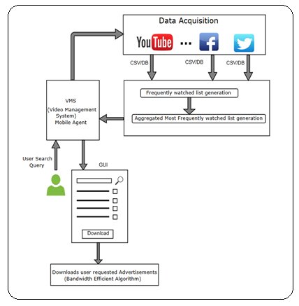
Figure 1: System Architecture

System Description –
The user makes a request for downloading the on-demand video advertisements by entering the search keyword in the GUI provided.
- At the background, the VMS with mobile agent collects the statistical data from social media websites like YouTube (can be extended to FaceBook and Twitter ) related to the user request using the particular APIs. The statistical data collected has the following fields like number of views/downloads/likes/dislikes/comments/ratings/thumbnails etc. as shown in Figure 2. The retrieved list is in the JSON format which is converted into CSV file.
- Initially, the corresponding code-samples for YouTube APIs which includes YouTube Data-API, YouTube Analytics-API and YouTube Live streaming-API needs to be downloaded from the YouTube Developers-sites . This website provides a specified path to access the git repository.
- In order to run the YouTube APIs, Google-API library credentials have to be created using Google account to login to the console of Google Developer’s website. This gives the option to access the set of YouTube APIs for a particular application.
- The Java code calls the API’s search.list( ) method which enables to search for YouTube videos, channels and playlists which match the user specific criteria.
- The set of properties associated with each response are snippet, content-details, player, statistics and status. Statistical data which are in the JSON representation will be retrieved.
- An online JSON-to-CSV converter is triggered for conversion and for further processing. The Static agent in the Aggregator VMS performs the first stage sorting of the CSV file by triggering VB macros shown in Figure 3, to arrange the list in the descending order. At the end of this stage the videos are categorized into most frequently and least frequently requested/viewed/downloaded list.
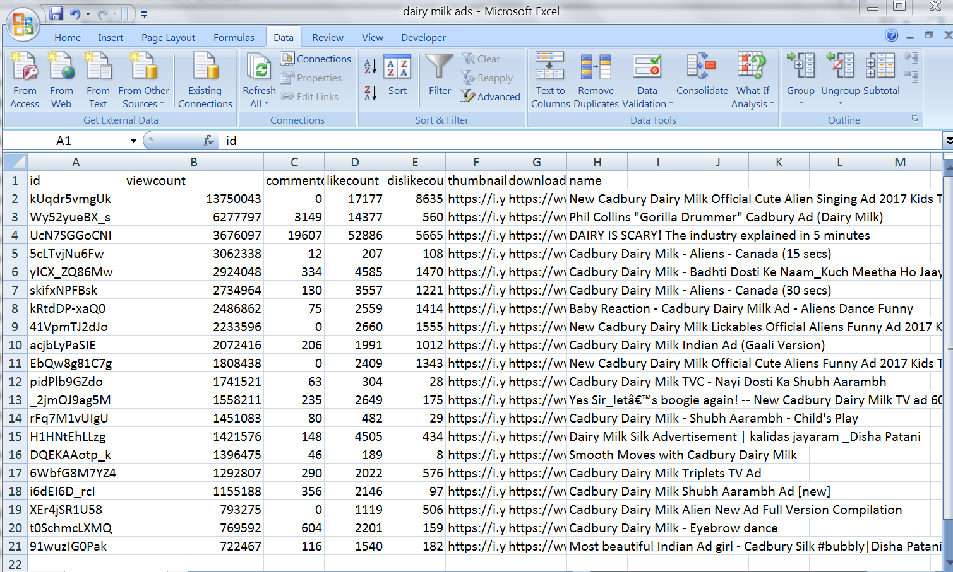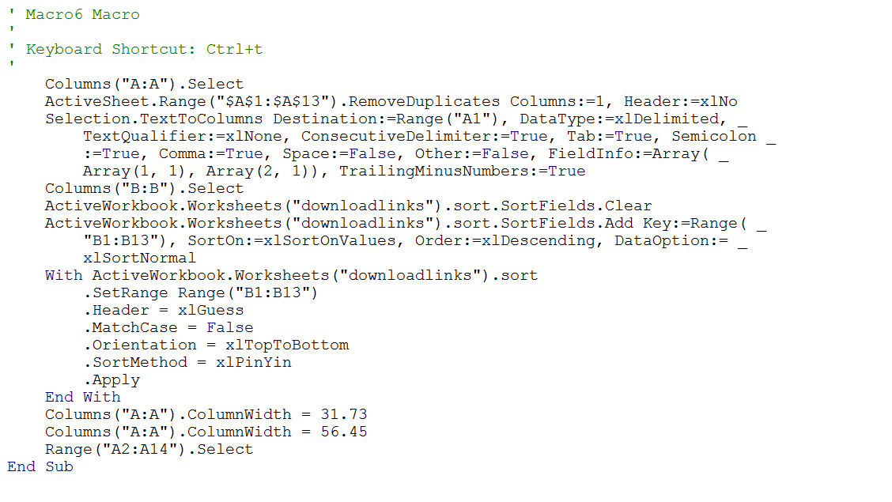
Figure 2: The retrieved list in JSON format and converted to CSV file. Figure 3: VB-Macro for sorting the statistical data list

- For user entered search query, the most frequently requested /viewed/downloaded video list is populated and returned by the static agent for the user as shown in Figure 4 , to construct the download links to the videos. Once the random selection is made by the user as shown in Figure 5, the construct download list is push by the mobile agents to create the download_links.csv file which includes the download-url , view-count and name-description of the search-keyword.
- On the construction of the download-links.csv file is created as shown in Figure 6, the static agent in the aggregator module performs the second stage sorting to rearrange the list by applying triggering the VB macro in descending order by considering the key factor as view/download count.

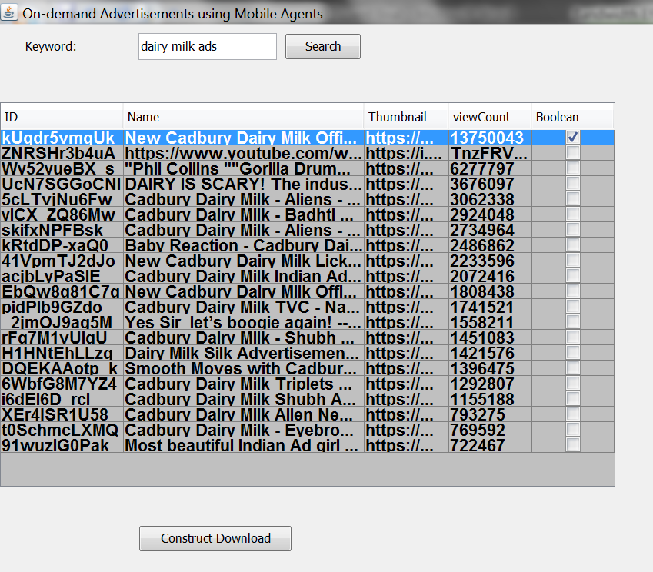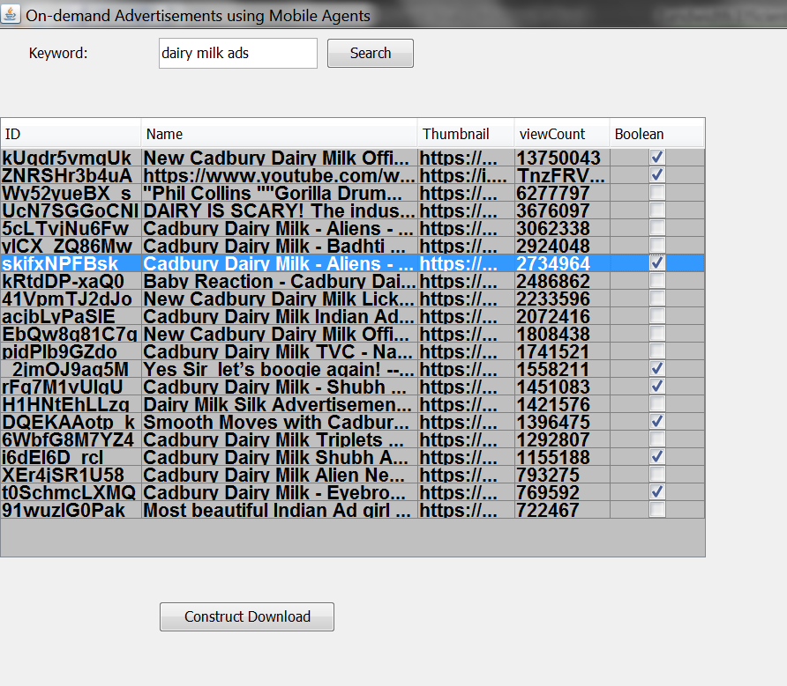
Figure 4: User requests for on-Demand-Video download. Figure 5: User Random selection made for download request.
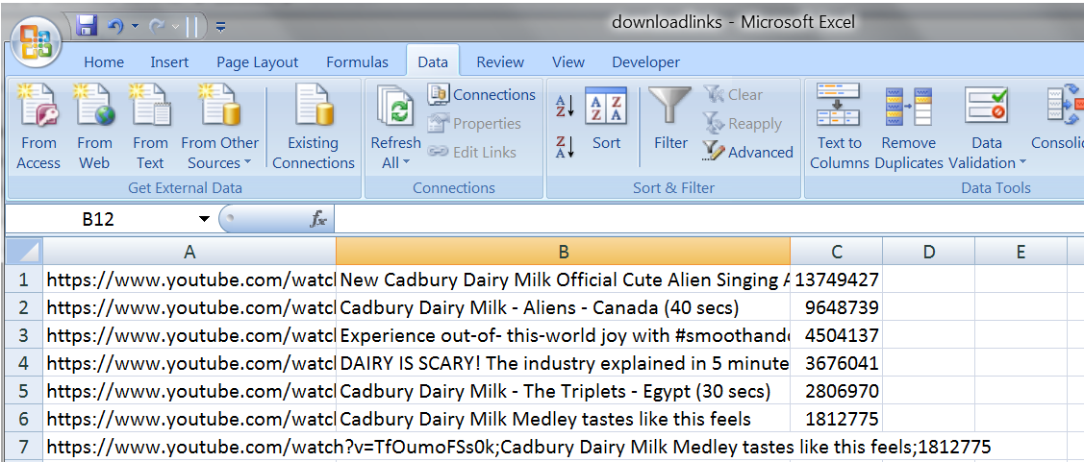
Figure 6: Construction of the download_link.csv file
- Next, the VMS Static agent applies the bandwidth allocation algorithm to dynamically allocate /de-allocate high bandwidth for higher priority videos. And extends to create concurrent mobile agents based on the number of requests made by the user at any given time to track the individual video requests. The proposed algorithm is given below :

- MOBILE AGENT BASED EFFICIENT BANDWIDTH ALLOCATION ALGORITHM (MAEBA)
The MAEBA algorithm is implemented on the central video management server in the aggregator VMS , which controls the server actions for the user requests it receives. Depending upon the priority assigned to each request , the bandwidth is allocated and the user specific videos-ads are downloaded. The task of allocating/de-allocating the bandwidth dynamically tom the video advertisement segments is carried out by the mobile agents.
- Requesting-Segment :
INPUT:
V | : | Total number of videos
R | : | User request for fetching the videos
S | : | Array of Video segment fetched for user request
TTL | : | Available time for processing the user request
Vmax | : | Size of each video segment.
Vb macro | : | For sorting the initial video segment
Ads.csv | : | User statistical data collected from the social media websites
PROCESSING:
For the user search keyword ,the statistical data collected from the social media sites (Ads.csv) are scheduled by mobile agents and then it sorts the list in descending order by considering the number of requests/view-count/downloaded as the key factor. This list is categorized into most and least frequently viewed list (sortlist.csv). To achieve this the static agent in VMS triggers Vb macro file.
OUTPUT:
The most frequently requested/viewed/downloaded array of video advertisement segments are fetched and displayed to the user for selecting the set of video advertisement segments to download and are then added to construct download list (download_link.csv).
- Sending-Segment :
INPUT:
R | : | Request for creating link structure
TTL | : | Available time for processing the link structure
Vb macro | : | For re-sorting the array of fetched video segment list
select.csv | : | Array of randomly selected video ad-segments for download
PROCESSING:
Re-sorting the array of randomly selected video advertisement segments from the select.csv file is carried out by the static agent by triggering running the vb macro which is then added to the construct download list into down-list.csv file.
OUTPUT:
Adding the randomly selected video advertisement segments to down-list.csv file which is arranged in the descending order. Next, allocation /de-allocation of bandwidth is applied for higher priority video advertisement segments which are ready for downloading
Algorithm: Mobile Agent Based Efficient Bandwidth Allocation Algorithm
The following parameters used in the algorithm:
R_{i} | : | Video request at given time t
N | : | Total number of video advertisement segments requested
V | : | An array used to store all the videos into the VMS
S | : | An array used to track the set of videos being served
BW | : | Available bandwidth
bw( i , t ) | : | Allocated bandwidth for high priority video i at any time instance t.
free-ch | : | Free channels available at any given time
total-ch | : | Total number of channels available
The code segment describes the set of mobile agent actions performed to allocate the bandwidth for popular and average videos segments:
- When a new-request R_{i} arrives at given time t₁
If ( none of the other requests are currently served) then
Assign all the channels to this new request R_{i}

else
identify the popularity of the request R_{i} with the other request being
served R_{S}
if ( the popularity of the R_{i} > the request being served R_{S}) then
de-allocate the assigned channels from R_{S}
allocate the channels to R_{i}
else ( reject the new request )
end if
end if
- When a current-request R_{C} (popular) is complete at given time t₂ :
If( currently there are other requests that needs to be served) then
If (check if request R_{C} is assigned single channel) then
Identify any other request R_{O} with assigned channels >1
Assign the free-channels to the other request R_{O}
else if ( R_{C} is assigned more than one channel )
as the request R_{C} is complete ,
allocate the channels for next set of request that are not complete
end if
else if ( currently there are no other request that needs to be served)
mark all available channels as free and wait for the new request
end if
- Mobile agents assign the task of downloading the video advertisement segments to vget Download Manager to download the user demanded advertisements based on dynamic allocation of the bandwidth and finally leads to the efficient distribution and utilization of bandwidth.

III. Experiment setup
To carry out the simulations, YouTube site has been crawled for extracting the user statistical data for the given search query. To deploy and perform the functionality of on-demand multimedia services, the experimental setup is done in CS&E labs of the Research Centre. Here, each host is configured with JDK1.5, Aglet Software Development Kit 2.0.2 and MySQL for the purpose of storing. Computing systems with similar-configuration of Intel Core i3/i5 , 8GB-RAM connected through a 10/100/1000Mbps LAN with the Internet Access 25/22 Mbps BSNL Broadband.

IV. Results and discussion
The performance of mobile agent based on-demand advertising was simulated by making an assumption that the user requests randomly arrive during the peak time. The performance evaluation parameters considered are higher bandwidth allocation for high priority videos, the delay in downloading the video advertisement segments , number of video advertisement segments served , number of video advertisement segments requested, the video rejection ratio, bandwidth utilization , the waiting time for popular /average video advertisement segments, the throughput rate , processing time for user request.
Number of video segments displayed : | 100
Number of video segments requested : | 60
Maximum/Minimum available bandwidth: | 25/22 Mbps BSNL Broadband
Number of popular video segments : | 20
Number of non-popular video segments : | 40

Various graphs are plotted for various parameters defined for the proposed model and the existing approach.
- The graph in Figure 7, shows the downloading time required for the number of video segments requested. Consider, for example, to download 20 video-advertisements of varying ad-record size the mobile agent paradigm takes around 80 seconds as it executes each request in parallel and adopts asynchronous communication model. Whereas the client/server model takes around 150 seconds due to its sequential/synchronous downloading process. Next, we have also considered the downloading time from the proxy server if the request has repeated and the downloading time lies in between the two approaches. Time complexity is reduced in case of mobile agent paradigm due to its parallel processing of video requests and it varies based on space complexity of selected video-advertisements.
- The graph in Figure 8, shows the downloading time for popular and average video advertisement segments . Here, it is observed that the downloading time for popular video advertisement segments is less when compared to that of the average video advertisement segments. As the proposed work adopts the dynamic bandwidth allocation technique by allocating more number of channels for high priority video advertisement segments. Thus the high priority video advertisement segments are processed first by adjusting/de-allocating the channels allocated for the average video advertisement segments.
For example, consider the user requests for 50 video advertisement which includes 30 popular video advertisement segments and the remaining are non-popular video segments . For the above user request, the available bandwidth is initially divided into 50 channels. Based on the construction of link structure, the dynamic bandwidth allocation algorithm allocates more channels for popular video advertisement segments than the non-popular video advertisement segments. Here , the channels allocate to the non-popular video ad-segments can either be de-allocated or the downloading process is kept as pause. Hence , the downloading time for popular video advertisement segments is 50 sec and that for the non-popular video advertisement segments is 100 sec .
Time complexity naturally reduces due to maximum bandwidth allocation a prioritized parallel download towards popular video advertisements.
- The graph in Figure 9, shows the number of video advertisement segments served by both the approaches. Based on the type of the request segment , the number of video advertisement segments served can vary for both the approaches. First, if there arrives a new request, then the number of videos served by the Mobile agent model is high because higher priority videos are processed with less time restrictions and higher bandwidth (channels). It continues to re-allocate the bandwidth assigned to high priority videos back to the average video advertisement segments. Second, if there arrives a repeated request, then the proxy server processes the request and serves the request by reducing the load on the central server. Thus the number of video segment served by Proxy server is high. Whereas in case of client/server model the available bandwidth is equally divided based on the number of requests to be processed. Here, in this case the number of video advertisement segments served is less due to the in-efficient utilization of bandwidth and timely restrictions.
- The graph in Figure 10, shows the waiting time for processing the popular requests and average requests. Initially maximum bandwidth is allocated if there exists a single request ,but as the number of request segment increases the priority for each videos is check and more bandwidth is assigned to high priority videos than the average video advertisement segments. The bandwidth allocation for average videos still decreases as the number of request segment increases. Thus the waiting time is huge in case of an average video request when compared to that of the popular video request.
- The graph in Figure 11, shows the average bandwidth (channels) allocated for popular and average video advertisement segments . The mobile agent based efficient bandwidth allocation technique allocates more bandwidth (channels ) for popular video advertisement segments than for the average video advertisement segments. Every user request is processed with efficient utilization of bandwidth.
- The graph in Figure 12, shows the number of video advertisement segments rejected. The number of video advertisement segments rejected is less in the proposed approach when compared to that of the existing model. The video advertisement segments rejection happens for the following reasons like, when the requested video segment is not present in the PS/VMS ,when there are no free channels to process the request, due to server overloading some of the request may be rejected and the timely restrictions for download.
- The graph in Figure 13, shows that for a given set of video advertisement segments the number of user request served and rejected for the proposed mobile agent based on-demand advertisement system. Here, we have made an assumption that the maximum number of video advertisement segments is processed and satisfied during the peak time. From the graph it is observed that, there is continuous request from the users in the video advertisement segments during the peak time. Next, for such continuous user request maximum numbers of requests are served by adopting the mobile agent paradigm and dynamic bandwidth allocation algorithm. Here, more bandwidth (channels) is allocated for popular video advertisements by the mobile agents for individual video advertisement segments and once the particular video segment is downloaded the bandwidth (channels) is de-allocated and allocated to the next video segment. Thus ,maximum numbers of video requests are served and this in-turn reduces the number of videos segments rejected.
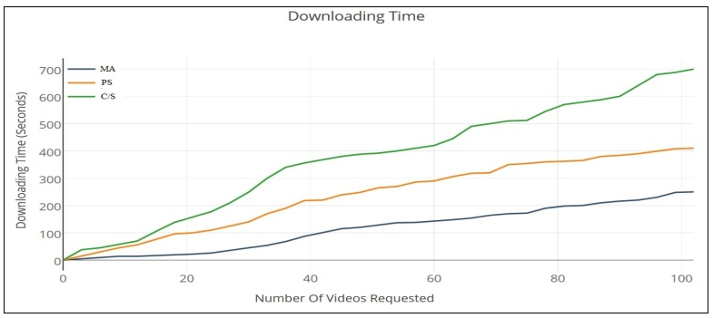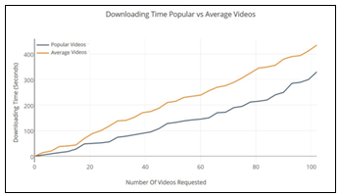
Figure 7: Downloading time for requested Video ad-segments Figure 8: The downloading time for Popular/Average Videos-ads
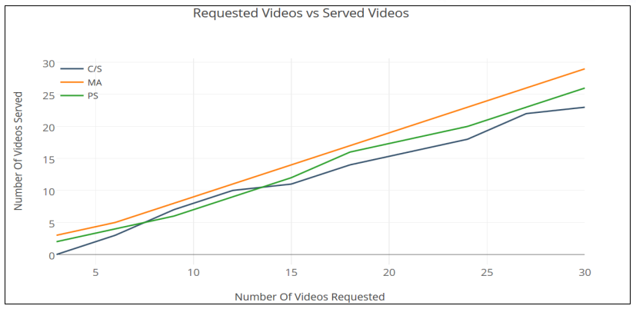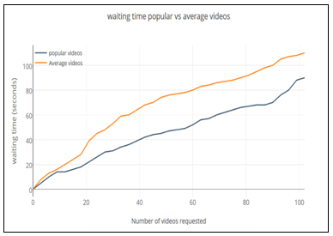
Figure 9: Number of video-segments served Figure 10: Waiting time for popular video ad-segments
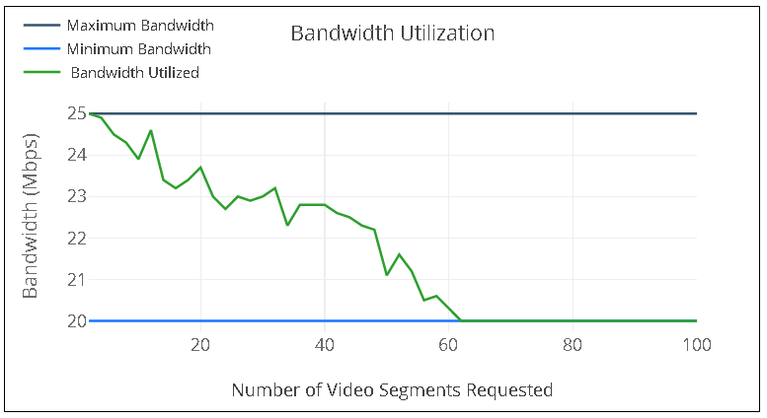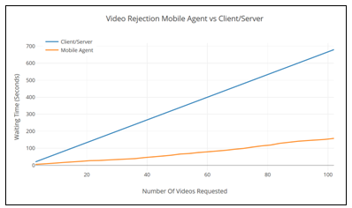
Figure 11:Bandwidth utilization for the requested video segments Figure 12: Video ad-segments rejected for both the approaches.
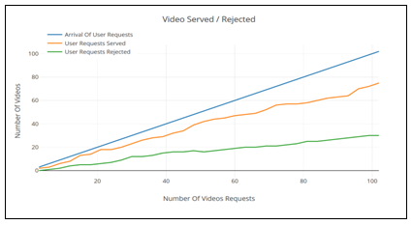
Figure 13: Number of Videos served and rejected for the continuous request arrival.

V. conclusion
For the successful deployment of large scale video-on-demand services , it is necessary to target/attracts a huge number customers . This can be achieved by providing a high Quality-of-Service to the user request , which in-turn generates a huge revenue from these services by reducing the cost of video delivery and the profits for the on-demand service providers. In this work , an attempt is made to adopt the Multi Mobile Agent paradigm for providing the on-demand video advertisement services by allocating/de-allocating the higher bandwidth (channels ) for high priority video advertisement segments (popular video advertisements) . This results in the efficient utilization of the available bandwidth, serving the popular video advertisements with high Quality-of-Service , reduces the load on the central Video-Management-Server by using server-side ad-insertion technique, reduces the network traffic by asynchronously establishing the communication connection to process the user request, reduces the number of video rejections and finally uses the proxy server concept to determine the number of repetitions in the user request and reduces the delay in serving the user request. The comparison results show that the proposed mobile agent paradigm over performs when compared to that of the conventional scheme used for providing the on-demand multimedia services.

VI. future scope
- Key factors considered for retrieving the user specific search keyword can be extended to like/dislike count, positive/negative comments and user rating/scores.
- Extracting current statistical data to create the popular advertisements-list can be extended to Twitter, Facebook, Linkedin, and other social media websites.
- The Search process can be extended with multiple filters to download the current statistical data based on different categories to reduce the search space. It can still be extended to retrieve the historical data by providing the date/time filters.

ACKNOWLEDGEMENTS:
I take this opportunity to express my deep-regard and profound gratitude to my Research Supervisor Dr. Nirmala C R for her continuous encouragement , exemplary guidance, valuable-feedback throughout the completion of this research work. I am thankful to my Research Centre for providing the necessary technical infrastructure for the successful accomplishment of this task. I also extend my sincere gratitude to all my colleagues and friends who helped me in carrying out my research work.

REFERENCES

- Eni Triningsih and Yoanes Bandung “Bandwidth Allocation-Aware Scheduling Algorithm for Video-on-Demand Application Over Digital Learning Network”. International conference on ICT for Smart Society, Surabaya, 20-21 July 2016 ISBN: 978-1-5090-1620-4..
- Adhi Rizal and Yones Bandung “Passive Available Bandwidth Estimation Based on Collision probability and Node State Synchronization in Wireless Network”, Institut Teknologi Bandung,2016.
- Shilpa Shashikant Chaudhari and Rajeashekar C Biradar, “Collision probability based available bandwidth estimation in Mobile Adhoc Networks”, in Applications of Digital Information and Web Technologies (ICADIWT),2014 pp 244-249.
- Wen Boyin and Xing Ruman, “Design of Video-on-Demand system Based on Streaming Media Technology”, in Fifth International on Computational and Information Science (ICCIS),2013 pp,1349 – 1351.
- H S Guruprasad and Dr. H D Maheshappa “ Efficient Resource Allocation in a Distributed VoD using Agent Technology” (IACSIT) International Journal of Engineering and Technology Vol. No. 5, December 2009. ISSN: 1793-8236.
- King-Man Ho, Wing-Fai Poon, Kwok-Tung Lo, “Video-on-Demand Systems with Cooperative clients in Multicast Environment”, IEEE Transactions on circuits and systems for video technology, Vol-19, No.3 March 2009.
- H S Guruprasad and Dr. H D Maheshappa “Dynamic Load Sharing Policy in Distributed VoD using agents” IJCSNS International Journal of Computer Science and Network Security, Volume-.8 No.10, October 2008.
- H S Guruprasad and Dr. H D Maheshappa “Dynamic Load Balancing Architecture for Distributed VoD using Agent Technology” International Journal of Computer Science & Security (IJCSS),November 2008- Volume (2) : Issue 5,pp 13-22.
- Ashok Kumar, H S Guru Prasad, H D Maheshappa, Ganesan, “Mobile Agent Based Efficient Channel Allocation For VoD”, IASTED International Conference on Communication Systems & Applications [CSA 2006] 3rd -5th July, 2006, Banff, CANADA.
- Mohammed A. M. Ibrahim, “Distributed Network Management with Secured Mobile Agent support” International Conference on Hybrid Information Technology (ICHIT06),2006.
- Santosh Kulkarni , “Bandwidth Efficient Video-on-demand Algorithm (BEVA)” Telstra Research Labs, Clayton, VIC 3168, Australia. 0-7803-7661-7/03/©2003 IEEE.
- Meng Guo and Mostafa H. Ammar and Ellen W. Zegura, “Selecting among Replicated Batching Video-on-Demand Servers”, Proceedings of the 12th International Workshop on Network and Operating System Support for Digital Audio and Video, pp 155-163, 2002.
- Hai Liu, Nirwan Ansari, and Yun Q. Shi “On-line Dynamic Bandwidth allocation for VBR Video Transmission” 2001 IEEE.
- S S Manvi and P Venkataram, “Mobile Agent based online Bandwidth allocation Scheme in Multimedia Communications”, IEEE GLOBECOM 2001 Conference USA.
- Sridhar Ramesh, Injong Rhee and Katherine Guo “Multicast with Cache (Mcache): An Adaptive Zero-Delay Video-on-Demand Service”, IEEE Transactions on Circuit and Systems for Video Technology, 11(3), pp 440-456, March 2001.
- Derek Eager, Mary Vernon and John Zahorjan “Bandwidth Skimming: A Technique for Cost-Effective Video-on-Demand, In Proceedings of SPIE Conference on Multimedia Computing and Networking 2000, San Jose, California, January 2000.
- H S Guruprasad and Dr. H D Maheshappa “Dynamic Load Balancing Architecture for Distributed VoD using Agent Technology” International Journal of Computer Science & Security (IJCSS), Volume (2) : Issue 5).
- D N Sujatha , Rajesh K V, Girish K , Venugopal K R and L M Patnaik “ Efficient Channel Allocation Based on Priority of the Video in VoD Systems. Microprocessor Application Laboratory, Indian Institute of Science, Bangalore.

