Copyright Warranty and Authorization Form

Title of the Paper: DETECTION OF NOSIY BLOOD IMAGES INDICATING PRODROMAL DISEASES

Paper Id-No.: 22

DECLARATION
I/We SOHNI MUNEER, TARIQ JAMEEL SAIFULLAH KHANZADA AND SAMIULLAH JATOI the Author/authors of the research paper/article entitled DETECTION OF NOSIY BLOOD IMAGES INDICATING PRODROMAL DISEASES authorize you to
Publish the above mentioned paper/article in the proceeding of ICRMR 2018.
It is herein agreed that:
- I/We will not publish his/her above said contribution anywhere else without the prior written permission of the publisher unless it has been changed substantially.
- I/ We declare and warrants that his/her/their contribution is original, except for such excerpts from copyrighted works as may be included with the permission of the copyright holder and author thereof, that it contains no libelous statements, and does not infringe on any copyright, trademark, patent, statutory right, or propriety right of others. The Author signs for and accepts responsibility for releasing this material on behalf of any and all co-authors.
- The Author also warrants that he or she has the right to enter into this Agreement, the Article contains no libelous or unlawful statements, contains no instructions that may cause harm or injury and does not violate the copyright or trademark, or infringes on the rights or the privacy of others; and that all statements in the Article asserted as facts are either true or are based upon reasonable research.
- I/We agree to indemnify the organizer ICRMR against all claims and expenses arising from any breach of warranty from me/us in this agreement.
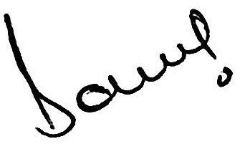
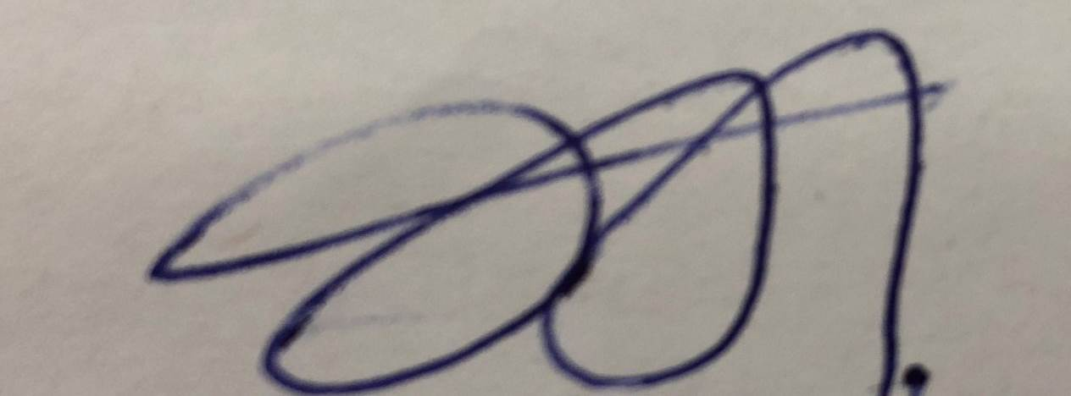
1st Author’s Signature 2nd Author’s Signature
Author’s Name: SOHNI MUNEER Author’s Name: Tariq Jameel Saifullah Khanzada
Address: H-20 Salmaa Garden, Hussainabad, Hyderabad Address: Computer System Depart IICT
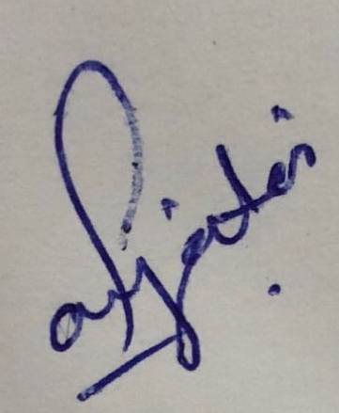
3st Author’s Signature
Author’s Name: Samiullah Jatoi
Address: B-14 Phase 2, Qasimabad Hyderabad

Date: 09-OCT-2018
Mobile: +92-334-0276758

