The Mycovirus Database - An E-Bank for Mycoviral Genomes
Wajeeha Shamsi
Atta-ur -Rahman School of Applied Biosciences (ASAB)
National University of Sciences and Technology (NUST), H-12, Islamabad 44000, Pakistan
Email- wshamsi.phdabs10asab@asab.nust.edu.pk
Atif Jamal
Crop Disease Research Institute (CDRI)
National Agricultural Research Centre (NARC), Islamabad 45500, Pakistan
Email- atif75j@gmail.com

Nasar Virk
Atta-ur -Rahman School of Applied Biosciences (ASAB)
National University of Sciences and Technology (NUST), H-12, Islamabad 44000, Pakistan
Email- nasarvirk@asab.nust.edu.pk

Muhammad Faraz Bhatti*
Atta-ur -Rahman School of Applied Biosciences (ASAB)
National University of Sciences and Technology (NUST), H-12, Islamabad 44000, Pakistan
Email- mfbhatti@asab.nust.edu.pk

(* Author to whom correspondence is addressed)

Abstract- The Mycovirus Database (MVDB) is a unique repository for submission of genomes of reported and unclassified mycoviral families. This database to date contains the genomic sequences of 336 mycoviruses. Newly identified genomic sequences can also be submitted to this database through user friendly interface. It also provides facility of downloading the information. This database is flexible and allows the addition of different tools including external links to analytical tools: BLAST, CLUSTALW and MAFFT to perform different analysis. More information can be further integrated in the website. The beta version of this database is now available at www.mycovirusdb.com.

Keywords – Mycovirus, database, genomes

I. Introduction
The viruses of fungi that have been reported in all important taxa of fungi symbolize a significant division of virology. These are grouped into double-stranded RNA (dsRNA), single-stranded RNA (positive and negative sense), and single-stranded DNA (ssDNA) based on their genome. At present the linear dsRNA is classified into seven families, namely Chrysoviridae, Partitiviridae, Megabirnaviridae, Totiviridae, Quadriviridae, Reoviridae, and one genus Botybirnavirus. There are six families of +ssRNA mycoviruses, namely Alphaflexiviridae, Barnaviride, Endornaviridae, Gammaflexiviridae, Hypoviridae, Narnaviridae, and a proposed family Fusariviridae. The proposed family for linear –ssRNA mycoviruses is Mycomononegaviridae. The circular ssDNA mycoviruses is in the family Mycodnaviridae (Sato et al., 2018, Xie et. al. 2014; Liu et al. 2014; Ghabrial et. al. 2009; Zhang et al. 2014; and Ghabrial et al. 2015).

II. Database
A total of 71,628 authenticated viral and viroid genome segments, excluding influenza virus, are deposited in INSDC databases (Brister et al., 2015). At present 8100 complete viral genomes are deposited in National Center for Biotechnology Information (NCBI) Reference Sequence database (data taken on 25th September, 2018 from https://www.ncbi.nlm.nih.gov/genomes/GenomesGroup.cgi?taxid=10239). The mycovirus database (Fig. 1) contains nucleotide sequences of all the families of fungal viruses which are summarized in the “MYCOV” table present in the underlying database.


- Home page of mycovirus database (URL: www.mycovirusdb.com)
Out of 336 mycoviruses, 246 viruses belong to the dsRNA genome (these included 27 viruses from the family Chrysoviridae, 49 from Endornaviridae 4 from Megabirnaviridae, 107 from Partitiviridae, 7 from Mycoreoviridae, 45 from Totiviridae, 1 from Quadriviridae and 6 botybirnaviruses), 50 viruses belong to the +ssRNA genome (alphaflexiviruses 3, narnaviruses 24, barnavirus and gammaflexivirus 1 each, 15 hypoviruses and 6 fusariviruses). 1 member representing -ssRNA genome (Mycomononegavirus), 1 member of Mycodnaviridae and 40 unclassified viruses (2 having ssDNA genome, 35 having dsRNA genome and 3 with ssRNA genome) (Figure 2).

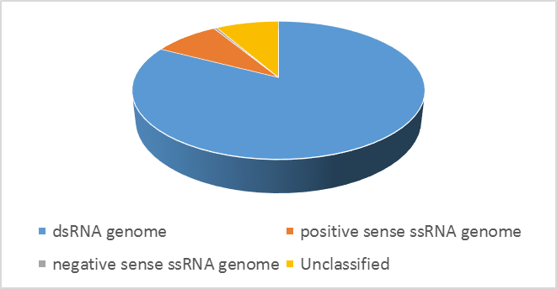
Figure 2.Data representing different families of mycoviruses based on genome in MVDB.
The viral genome sequences can be visualized by following the sequences tab at the top of the home page. By selecting the desired family from the dropdown menu at the “Sequences” page and clicking the “Go” button, all the viruses in that family would be displayed (Fig. 3).
A unique ID is assigned to all the viruses. The sequences could be submitted to the existing database by hitting the “Submit Sequence” tab (Fig. 4) or by clicking on the “+ Create” tab on the “Sequences” page (Fig. 5).



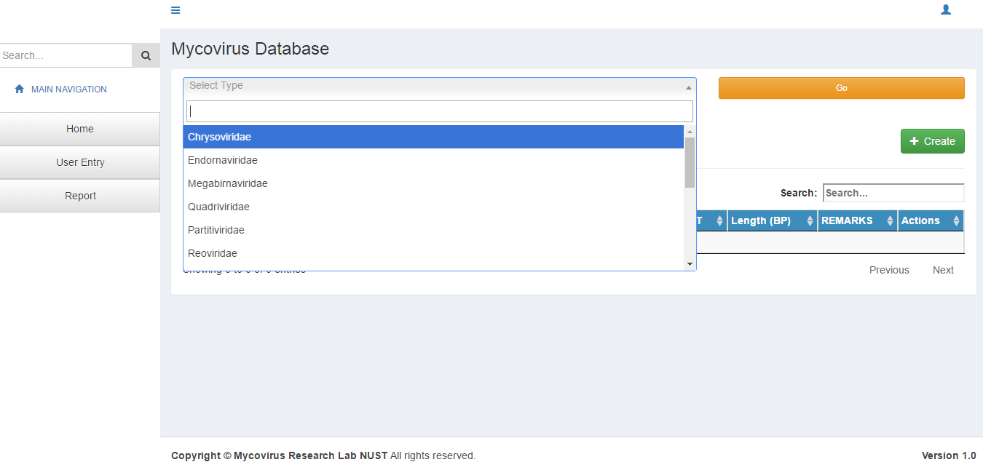
Figure 3.Information about the viruses can be obtained by clicking on the “Sequences” tab.
While submitting a new sequence, no fields could be left empty in the sequence submission form. The FASTA sequences can be seen by clicking on the “file Action” button at the right side of the rows (Fig. 6). The information in the database could be downloaded by clicking on any of the tabs located at the top of the tables. The FASTA sequences could be downloaded by clicking on the “Download” tab at the top right side of the table (Fig. 7).
III. Database Structure
The Mycovirus Application is a web application developed on PHP, AJAX and Jquery on top of a mySQL database. Both technologies are based upon Open Source free to use license. The underlying database has three tables: one for user registration, one for the virus classification and another one for virus information. PHP is available at http://www.php.net. MySQL is available free from http://www.mysql.com. All data have been taken from the NCBI’s Nucleotide and Genome sites at the following two URLs.
https://www.ncbi.nlm.nih.gov/genomes/GenomesGroup.cgi?taxid=10239&sort=taxonomy# and https://www.ncbi.nlm.nih.gov/nucleotide.

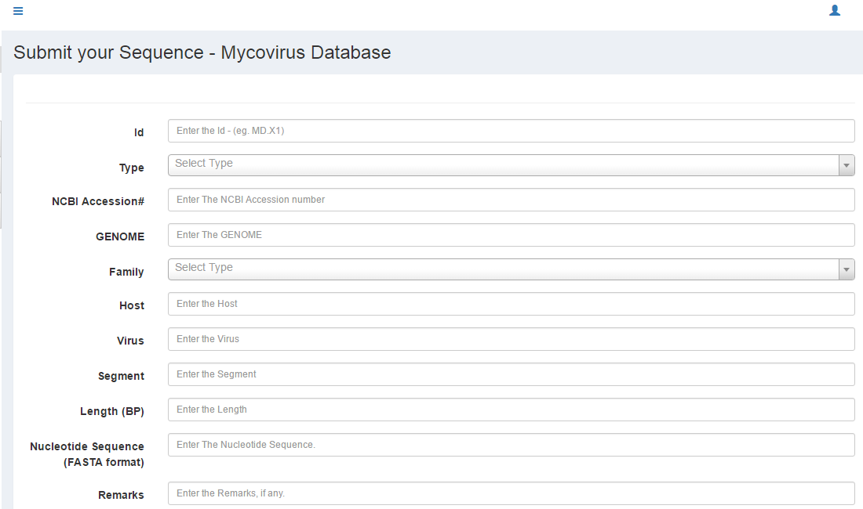

Figure 4.Submission of sequence in the mycovirus database by hitting “Submit Sequence” tab

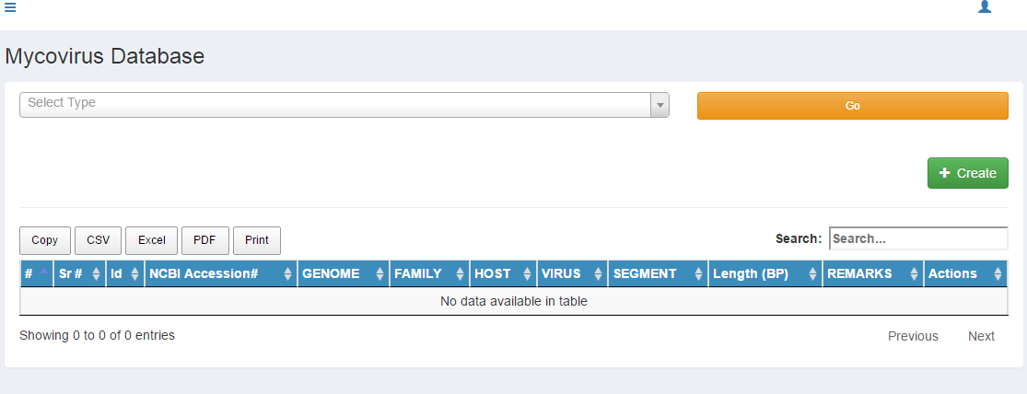

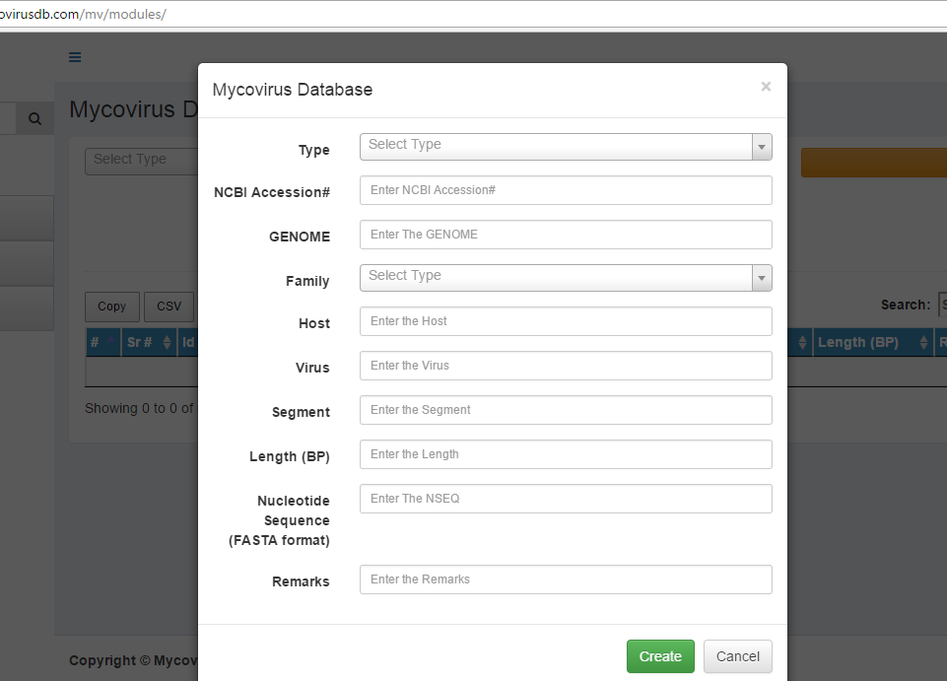
Figure 5.Submission of sequence in the mycovirus database by hitting “+ Create” tab on “Sequences” page.

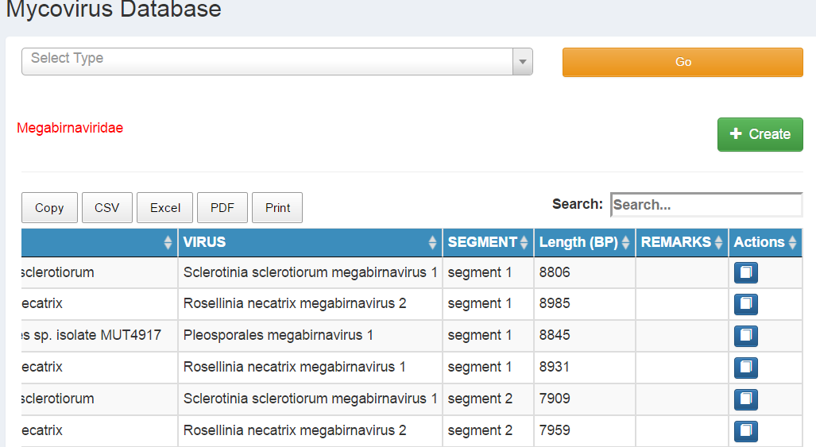

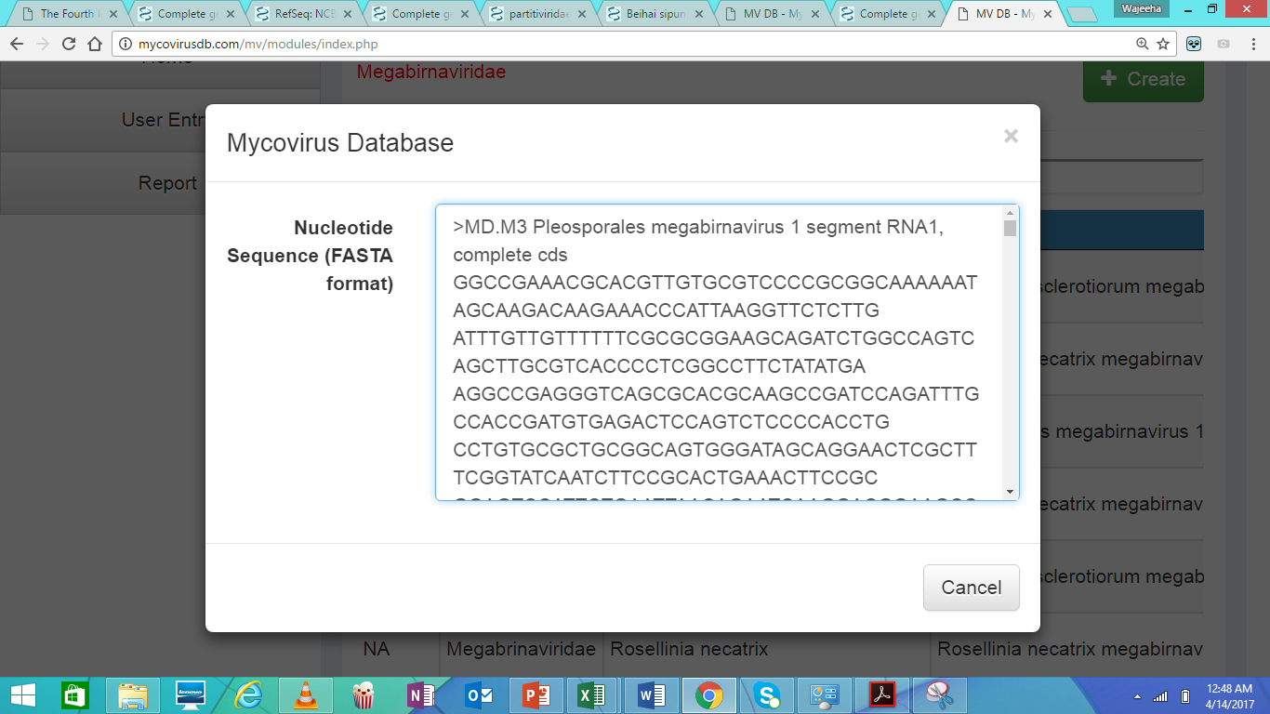
Figure 6.The sequence (in FASTA format) can be seen by using “Action” button.

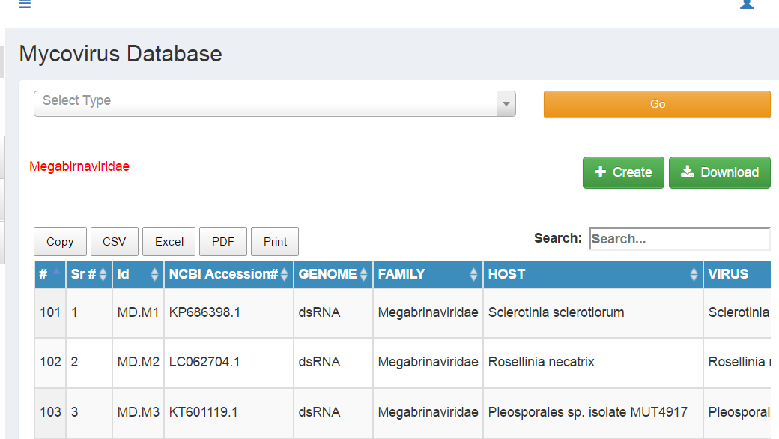
Figure 7.The information can be downloaded by following any of the tabs “Copy, CSV, Excel, PDF and Print”.

IV.CONCLUSION
The Mycovirus Database is the first and exclusive online database for mycoviruses. It has a user friendly interface. The database could be useful to perform different sequence related analysis of mycoviral genomes.
In future this database could be improved by incorporating additional features by including categories (proteins, genes involved in silencing, UTRs, Internal Ribsomal Entry Sites) and articles. The database could be interlinked to other renowned databases like Protein Data Bank (PDB), UniProt, Swiss-Prot and FungiDB. Moreover different analytical tools can be integrated in the website making and the sequences in the database can be linked to the respective hosts and their relationship can be further studied.

REFERENCES

- Brister JR, Ako-Adjei D, Bao Y, Blinkova O. “NCBI viral genomes resource”. Nucleic Acids Res ;43(Database issue): D571-7. 2015.
- Liu L, Xie J, Cheng J, Fu Y, Li, G, Yi X and Jiang D. “Fungal negative-stranded RNA virus that is related to Bornaviruses and Nyaviruses.” Proceedings of the National Academy of Sciences, vol. 111, pp. 12205–12210. 2014
- Xie J, Jiang D. “New insights into mycoviruses and exploration for the biological control of crop fungal diseases”. Annu. Rev. Phytopathol., vol. 52, pp. 45–68. 2014
- Ghabrial SA and Suzuki N. “Viruses of plant pathogenic fungi”. Annu. Rev. Phytopathol., vol. 47, pp. 353–384. 2009
- Ghabrial, S.A.; Castón, J.R.; Jiang, D.; Nibert, M.L.; Suzuki, N. “50-plus years of fungal viruses”. Virology, vol. 479–480, pp. 356–368. 2015
- Sato, Y., Casto´n, J. R. and Suzuki, N. “The biological attributes, genome architecture and packaging of diverse multi-component fungal viruses”. Current Opinion in Virology, vol. 33, pp. 55–65. 2018
- Zhang, R.; Liu, S.; Chiba, S.; Kondo, H.; Kanematsu, S.; Suzuki, N. “A novel single-stranded RNA virus isolated from a phytopathogenic filamentous fungus, Rosellinia necatrix, with similarity to hypo-like viruses”. Front. Microbiol., 5, e360. 2014.

