Virtual Bidding Strategy using Game Theory for Power Supply Market
Saurabh Kumar
Department of Electrical Engineering
Institute of Engineering & Technology, Lucknow, Uttar Pradesh, India
er.saurabhkumarthakur@gmail.com
Bharti Dwivedi
Department of Electrical Engineering
Institute of Engineering & Technology, Lucknow, Uttar Pradesh, India
bharti.dwivedi@ietlucknow.ac.in

Abstract- The future of bidding strategy in electricity supply power system needs well established controllable and stable technologies. The financial risk is very high with the real-time market wherein the participants do not have the option to change their decisions once taken. In order to circumvent such risks appropriate bidding strategy needs to be adopted. The Strategy built on sound mathematical framework may ensure an efficient and robust bidding operation of the systems. In this paper economic load dispatch based on particle swarm optimization technique on the matrix laboratory software platform is applied to obtain the marginal cost of three generators catering to three different constant loads at a time individually. Market clearing price is obtained for all the twenty-seven bidding combinations by a virtual bidding strategy. A comparison of the costs is carried out for the three loading conditions individually. The technical and logical conclusions are reported through game theory matrix. Generalized sets of equations are finally developed using game theory to identify the overall best response set for each generator through virtual bidding strategy.

Keywords – Power supply market, PSO based economic load dispatch, Virtual bidding strategy, Game theory

I. Introduction
The competitive power system market has need restructuring and deregulation in bidding strategic to achieve optimal efficiency in generation and consumption, an economic pricing strategy plays an important role [1]. The Genco does thus have to compete against each other in bidding sport market in order to procure a sizable profit and economics for their generators in this uncertain market environment [2]. This effort has been oriented to obtain corresponding revenues that truly reflect the use of strategic and provide economic indications for upcoming investments in the power market, because energy storage and management perspective in power market is a challenging issue [3], [4]. Among the many trading mechanisms in a competitive power market, the PoolCo model can be considered as one of the mechanisms to implement straightforward [5]. In this environment, for optimal decision-making each generating unit decides its bidding strategy for price and generation quantity to sell, and the market sets the market clearing price of the power transacted [5], [6]. The two main approaches followed for pricing in the power market are: First is the classical “marginal pricing” where nodal prices represent the cost of the last MW to be supplied. Second is the “pay-as-bid” pricing where forward bilateral contracts are negotiated [7], [8].
In some papers, matrix games have been used for bidding strategies are discretized, like “high,” or “low,” or “medium”, revenue matrices are created by enumerating all possible combinations of strategies, to incorporate self-scheduling in the method. Searching for exact bidding equilibrium region is a necessary objective for market participants, because equilibrium shows long-term bidding strategies for profit, monitoring and corrective measures [9], [10], [11]. The four things to consider describing a game: First, the player, second, the game rule, third, the outcomes and fourth, the payoffs and the utility functions of the players. A game can be two types either cooperative or non-cooperative. Where the players collaborate to achieve a common goal called a cooperative game and where the players act on their own called non-cooperative game. Also, a game can be either of imperfect or perfect information and simultaneous or sequential [11], [12].
For each participant, bidding strategies ideally should be selected to maximize its profit. Game theory is a natural platform to model such an environment [9], [13]. The game theory is better-expected way to establish a significant analytical as well as the conceptual framework with a set of mathematical method in the construction and design of the future smart grid in the power system [14], [15]. From several years, game theory has been adopted in a wide number of disciplines ranging from economics and politics to psychology [6], [9], [13]. Most recently, game theory is trying to use in deregulated electricity power system industries, because the conventional economic modelling approach presented some shortcomings and limited ability to model all the intrinsic characteristics of electricity markets, its major objective to provide better market efficiency by maximize the profit of power producers and also reduce electricity price to the final consumer via introducing competition [16], [17]. This competitive environment enables power market participants to seek to maximize the profit via pricing theirs strategically with the help of game theory strategical methods to attained Nash equilibrium with a pareto optimal solution in deregulated power system [9], [11], [17]. Game theory is a tool for rational decision making in conflict situations. It has long been commonly used in economics, the social sciences and biology to model decision making situations where the outcomes are contingent upon the interacting strategies of two or more agents with conflicting, or at best, self- interested motives [18], [19], [20]. It is expected that suppliers bid with linear marginal price functions without capacity limits to determine the pricing strategy using game theory. In a deregulated environment, game theory is also used in to simulate the decision-making process for defining offered prices [20], [21].

II. Proposed Formulations

Economic Load Dispatch –
The fuel cost function of a generator is represented with a second-order polynomial, mostly used in control problems and power system operation, 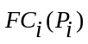 is the fuel cost of i^{th} unit in 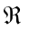 where is the power output of i^{th} generating unit in MW [22].
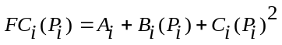 (1)
For n number of generating units, the system total fuel cost function is defined as
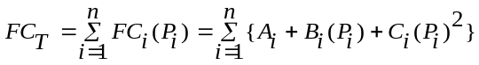 (2)
Where,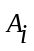,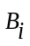, and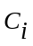are non-negative cost coefficient constants of the i^{th} generator in, /MW, /MW² respectively.
The constraints considered here are as follows [23]
- Constraint of Power Balance: is the generation in MW of i^{th} unit and 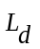is the load demand. Then,
Then,
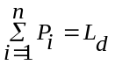 (3)
- Inequality Constraints of Generation Limit: The maximum generation amount of the generator is predefined and the output power of any generator should not exceed its operating range of rating.
If P_{i (min)} is the maximal generation in MW of i^{th} unit. Then,
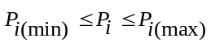 (4)
The real power generation is obtained for each GENCO by solving equation (2) with constraints considered here from equation (3) and (4).

2.2. Pricing –
The prime objective of GENCOs is to maximize the profit by selecting an optimal bidding strategy while satisfying the load demand under economic load dispatch constraints. In this study, it is assumed that the market clearing price of the generating system is the marginal costs of scheduled at base generators for meeting the next hour MW of generation individually [9], [10], [24]. Thus, 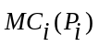 is the marginal cost of i^{th} unit in /MW with power output 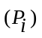 in MW. The expression for marginal cost is given by equation (5) [6], [10].
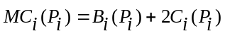 (5)
In order to evolve efficient optimal bidding strategies of GENCOs, it is essential to estimate the marginal cost for each participating generator accurately. It is envisaged that the GENCOs can set their bidding marginal costs slightly lower or higher than their respective marginal costs [9], [10], [11]. Thus combinations of different bidding strategies of generators get created reflecting their incremental costs for further analysis and interpretation.

2.3. Bidding Strategy with Game Theory –
The bidding for the next MW of generation by a unit should be such that its marginal cost equals the market clearing cost [9], [10], [24]. For all the possible sets of bidding strategies, the marginal costs are evaluated. The base case of all three generators for each set is considered to be the market clearing price for all set. The underlying reason for the above is that if the cost of generation of one additional MW of a generator is higher than the overall lowest marginal cost, then that generator will be selling the power at loss and vice a versa. The bidding strategies applied in this paper is shown in Table 1. This exercise created a combination of strategies revealing the contributions of all the three generators in terms of revenue.
Table -1 Bidding Strategies
Bidding Strategy | Cost
Low (O) | 80% of the marginal cost of unit
Base (X) | Marginal cost of unit
High (1) | 20% of the marginal cost of unit

A game includes three key elements: players, actions, and payoffs function. The functions of these three elements and their description will be explained in the following [25]:
1. A set of players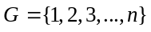is a finite set of , indexed by.
2. A set of actions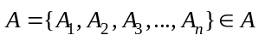available to each player to determines their possible strategies.
3. A payoff functions 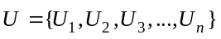 represent preferences of each players and shows what receive at the end of the game.
Best response in a game is defined as 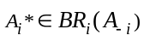
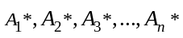is pure strategy Nash equilibrium for player, if for each player i, 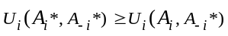.
Where, 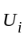is player i action of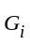; 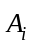is action of one player; 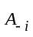is action of rest all players.

2.4 Logic Formulation for Three Generators –
An overall generalized set of logic is developed by game theory matrix to give the best response in terms of identification of the most profitable strategic combinations.
Let the Set of Players be 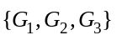
Sets of Actions of 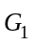, 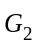 and 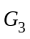 are: 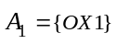, 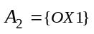and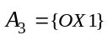 respectively.
Set of Outcomes, 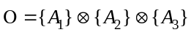={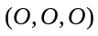, 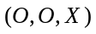…………………...…..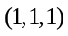} (27 combinations)
Utility payoffs of 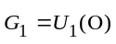, 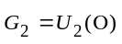and 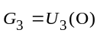
Payoff of i^{th} player in game theory is represented by 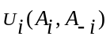
Where, is the utility payoff of i^{th} player; is action of i^{th} player; is the action of the rest of the players.
Best response in a game is defined as
Thus, overall revenue in best response of 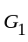on bidding strategy of low = 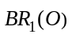= Mostly loss
And, overall revenue in best response of on bidding strategy of base =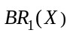= Mixed (profit/loss)
Also, overall revenue in best response of on bidding strategy of high =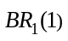= Mostly profit
Simalary, overall revenue in best response of 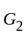on bidding strategy of low = 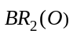= Mostly loss
And, overall revenue in best response of on bidding strategy of base =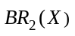= Mixed (profit/loss)
Also, overall revenue in best response of on bidding strategy of high =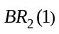= Mostly profit
Simalary, overall revenue in best response of 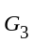on bidding strategy of low = 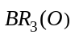= Mostly loss
And, overall revenue in best response of on bidding strategy of base =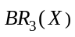= Mixed (profit/loss)
Also, overall revenue in best response of on bidding strategy of high =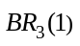= Mostly profit

III. Simulation and Result
The Matrix Laboratory software simulation of particle swarm optimization based economic load dispatch for three different constant loads by three generators was carried out separately. The three generators data are given in Table-2.
Table -2 Data of three Generator [23]
Generator | P_{max} | P_{min} | c | b | a
G1 | 600 | 150 | 0.00156 | 7.92 | 561
G2 | 400 | 100 | 0.00194 | 7.85 | 310
G3 | 200 | 50 | 0.00482 | 7.97 | 78

The three strategies low, base and high were applied on all the three generators individually to evolve 3³ =27 sets of the combinations for each load. The costs for all the sets were evaluated for the three loads of 485MW, 585MW, and 685MW as shown in Table3 , Table 4 and Table 5 respectively.
Table -3 Simulation result of optimal bidding strategy with scheduled load of 485MW

S.No | Strategies |  |  | Generation  485(MW) |  |  | Marginal Cost of Generator  (/MW) |  |  | Marginal Cost - Market Clearing Price  (/MW)
S.No | 1 | 2 | 3 | P1 | P2 | P3 | MC1 | MC2 | MC3 | R1 | R2 | R3
1 | O | O | O | 222 | 196 | 67 | 6.890 | 6.888 | 6.892 | -1.722 | -1.722 | -1.723
2 | O | O | X | 231 | 204 | 50 | 6.912 | 6.913 | 8.452 | -1.700 | -1.697 | -0.163
3 | O | O | 1 | 231 | 204 | 50 | 6.912 | 6.913 | 10.142 | -1.700 | -1.697 | 1.527
4 | O | X | O | 295 | 100 | 90 | 7.072 | 8.238 | 7.070 | -1.540 | -0.372 | -1.545
5 | O | X | X | 335 | 100 | 50 | 7.172 | 8.238 | 8.452 | -1.440 | -0.372 | -0.163
6 | O | X | 1 | 335 | 100 | 50 | 7.172 | 8.238 | 10.142 | -1.440 | -0.372 | 1.527
7 | O | 1 | O | 295 | 100 | 50 | 7.072 | 9.885 | 7.070 | -1.540 | 1.275 | -1.545
8 | O | 1 | X | 335 | 100 | 50 | 7.172 | 9.885 | 8.452 | -1.440 | 1.275 | -0.163
9 | O | 1 | 1 | 335 | 100 | 50 | 7.172 | 9.885 | 10.142 | -1.440 | 1.275 | 1.527
10 | X | O | O | 150 | 248 | 87 | 8.388 | 7.049 | 7.046 | -0.224 | -1.561 | -1.569
11 | X | O | X | 150 | 285 | 50 | 8.388 | 7.164 | 8.452 | -0.224 | -1.446 | -0.163
12 | X | O | 1 | 150 | 285 | 50 | 8.076 | 7.164 | 10.142 | -0.536 | -1.446 | 1.527
13 | X | X | O | 150 | 135 | 200 | 8.388 | 8.373 | 7.918 | -0.224 | -0.237 | -0.697
14 | X | X | X | 222 | 196 | 67 | 8.612 | 8.610 | 8.615 | 0 | 0 | 0
15 | X | X | 1 | 231 | 204 | 50 | 8.640 | 8.641 | 10.142 | 0.028 | 0.031 | 1.527
16 | X | 1 | O | 185 | 100 | 200 | 8.497 | 9.885 | 7.918 | -0.115 | 1.275 | -0.697
17 | X | 1 | X | 295 | 100 | 90 | 8.840 | 9.885 | 8.837 | 0.228 | 1.275 | 0.222
18 | X | 1 | 1 | 335 | 100 | 50 | 8.965 | 9.885 | 10.142 | 0.353 | 1.275 | 1.527
19 | 1 | O | O | 150 | 248 | 87 | 10.065 | 7.049 | 7.046 | 1.453 | -1.561 | -1.569
20 | 1 | O | X | 150 | 285 | 50 | 10.065 | 7.164 | 8.452 | 1.453 | -1.446 | -0.163
21 | 1 | O | 1 | 150 | 285 | 50 | 10.065 | 7.164 | 10.142 | 1.453 | -1.446 | 1.527
22 | 1 | X | O | 150 | 135 | 200 | 10.065 | 8.373 | 7.918 | 1.453 | -0.237 | -0.697
23 | 1 | X | X | 150 | 248 | 87 | 10.065 | 8.812 | 8.808 | 1.453 | 0.202 | 0.193
24 | 1 | X | 1 | 150 | 285 | 50 | 10.065 | 8.955 | 10.142 | 1.453 | 0.345 | 1.527
25 | 1 | 1 | O | 150 | 135 | 200 | 10.065 | 10.048 | 7.918 | 1.453 | 1.438 | -0.697
26 | 1 | 1 | X | 150 | 135 | 200 | 10.065 | 10.048 | 9.898 | 1.453 | 1.438 | 1.283
27 | 1 | 1 | 1 | 222 | 196 | 67 | 10.335 | 10.332 | 10.339 | 1.723 | 1.722 | 1.724

Table -4 Simulation result of optimal bidding strategy with scheduled load of 585MW

S.No | Strategies |  |  | Generation  (MW) |  |  | Marginal Cost of Generator  (/MW) |  |  | Marginal Cost - Market Clearing Price  (/MW)
S.No | 1 | 2 | 3 | P1 | P2 | P3 | MC1 | MC2 | MC3 | R1 | R2 | R3
1 | O | O | O | 269 | 234 | 82 | 7.007 | 7.006 | 7.008 | -1.751 | -1.753 | -1.752
2 | O | O | X | 287 | 248 | 50 | 7.052 | 7.049 | 8.452 | -1.706 | -1.710 | -0.308
3 | O | O | 1 | 287 | 248 | 50 | 7.052 | 7.049 | 10.142 | -1.706 | -1.710 | 1.382
4 | O | X | O | 370 | 100 | 115 | 7.259 | 8.238 | 7.262 | -1.499 | -0.521 | -1.498
5 | O | X | X | 435 | 100 | 50 | 7.421 | 8.238 | 8.452 | -1.337 | -0.521 | -0.308
6 | O | X | 1 | 435 | 100 | 50 | 7.421 | 8.238 | 10.142 | -1.337 | -0.521 | 1.382
7 | O | 1 | O | 370 | 100 | 115 | 7.259 | 9.885 | 7.262 | -1.499 | 1.125 | -1.498
8 | O | 1 | X | 435 | 100 | 50 | 7.421 | 9.885 | 8.452 | -1.337 | 1.125 | -0.308
9 | O | 1 | 1 | 435 | 100 | 50 | 7.421 | 9.885 | 10.142 | -1.337 | 1.125 | 1.382
10 | X | O | O | 150 | 319 | 116 | 8.388 | 7.269 | 7.271 | -0.370 | -1.490 | -1.489
11 | X | O | X | 150 | 385 | 50 | 8.388 | 7.475 | 8.452 | -0.370 | -1.284 | -0.308
12 | X | O | 1 | 150 | 385 | 50 | 8.388 | 7.475 | 10.142 | -0.370 | -1.284 | 1.382
13 | X | X | O | 203 | 182 | 200 | 8.554 | 8.554 | 7.918 | -0.204 | -0.205 | -0.842
14 | X | X | X | 269 | 234 | 82 | 8.758 | 8.759 | 8.760 | 0 | 0 | 0
15 | X | X | 1 | 269 | 248 | 50 | 8.813 | 8.814 | 10.142 | 0.055 | 0.055 | 1.382
16 | X | 1 | O | 285 | 100 | 200 | 8.809 | 9.885 | 7.918 | 0.051 | 1.126 | -0.842
17 | X | 1 | B | 370 | 100 | 115 | 9.075 | 9.885 | 9.075 | 0.317 | 1.126 | 0.315
18 | X | 1 | 1 | 435 | 100 | 50 | 9.277 | 9.885 | 10.142 | 0.519 | 1.126 | 1.382
19 | 1 | O | O | 150 | 319 | 116 | 10.065 | 7.271 | 7.267 | 1.307 | -1.488 | -1.493
20 | 1 | O | X | 150 | 385 | 50 | 10.065 | 7.475 | 8.452 | 1.307 | -1.284 | -0.308
21 | 1 | O | 1 | 150 | 385 | 50 | 10.065 | 7.475 | 10.142 | 1.307 | -1.284 | 1.382
22 | 1 | X | O | 150 | 235 | 200 | 10.065 | 8.761 | 7.916 | 1.307 | 0.002 | -0.844
23 | 1 | X | X | 150 | 318 | 117 | 10.065 | 9.085 | 9.094 | 1.307 | 0.326 | 0.334
24 | 1 | X | 1 | 150 | 385 | 50 | 10.065 | 9.343 | 10.142 | 1.307 | 0.584 | 1.382
25 | 1 | 1 | O | 203 | 182 | 200 | 10.265 | 10.265 | 7.918 | 1.507 | 1.506 | -0.842
26 | 1 | 1 | X | 203 | 182 | 200 | 10.265 | 10.265 | 9.898 | 1.507 | 1.506 | 1.138
27 | 1 | 1 | 1 | 269 | 234 | 81.8 | 10.510 | 10.510 | 10.510 | 1.752 | 1.751 | 1.750

Table -5 Simulation result of optimal bidding strategy with scheduled load of 685MW

S.No | Strategies |  |  | Generation  685 (MW) |  |  | Marginal Cost of Generator  (/MW) |  |  | Marginal Cost - Market Clearing Price  (/MW)
S.No | 1 | 2 | 3 | P1 | P2 | P3 | MC1 | MC2 | MC3 | R1 | R2 | R3
1 | O | O | O | 316 | 272 | 97 | 7.124 | 7.124 | 7.124 | -1.781 | -1.781 | -1.781
2 | O | O | X | 342 | 293 | 50 | 7.189 | 7.189 | 8.452 | -1.716 | -1.716 | -0.453
3 | O | O | 1 | 342 | 293 | 50 | 7.189 | 7.189 | 10.142 | -1.716 | -1.716 | 1.237
4 | O | X | O | 446 | 100 | 139 | 7.449 | 8.238 | 7.447 | -1.456 | -0.667 | -1.458
5 | O | X | X | 535 | 100 | 50 | 7.671 | 8.238 | 8.452 | -1.234 | -0.667 | -0.453
6 | O | X | 1 | 535 | 100 | 50 | 7.671 | 8.238 | 10.142 | -1.234 | -0.667 | 1.237
7 | O | 1 | O | 446 | 100 | 139 | 7.449 | 9.885 | 7.447 | -1.456 | 0.980 | -1.458
8 | O | 1 | X | 535 | 100 | 50 | 7.671 | 9.885 | 8.452 | -1.234 | 0.980 | -0.453
9 | O | 1 | 1 | 535 | 100 | 50 | 7.671 | 9.885 | 10.142 | -1.234 | 0.980 | 1.237
10 | X | O | O | 150 | 400 | 135 | 8.388 | 7.521 | 7.417 | -0.517 | -1.384 | -1.488
11 | X | O | X | 219 | 400 | 66 | 8.603 | 7.521 | 8.606 | -0.302 | -1.384 | -0.299
12 | X | O | 1 | 235 | 400 | 50 | 8.653 | 7.521 | 10.142 | -0.252 | -1.384 | 1.237
13 | X | X | O | 259 | 226 | 200 | 8.728 | 8.726 | 7.918 | -0.177 | -0.179 | -0.987
14 | X | X | X | 316 | 272 | 97 | 8.905 | 8.905 | 8.905 | 0 | 0 | 0
15 | X | X | 1 | 342 | 293 | 50 | 8.987 | 8.986 | 10.142 | 0.081 | 0.081 | 1.237
16 | X | 1 | O | 385 | 100 | 200 | 9.121 | 9.885 | 7.918 | 0.216 | 0.980 | -0.987
17 | X | 1 | X | 446 | 100 | 139 | 9.311 | 9.885 | 9.309 | 0.406 | 0.980 | 0.404
18 | X | 1 | 1 | 535 | 100 | 50 | 9.589 | 9.885 | 10.142 | 0.684 | 0.980 | 1.237
19 | 1 | O | O | 150 | 400 | 135 | 10.065 | 7.521 | 7.417 | 1.160 | -1.384 | -1.488
20 | 1 | O | X | 150 | 400 | 135 | 10.065 | 7.521 | 9.271 | 1.160 | -1.384 | 0.366
21 | 1 | O | 1 | 219 | 400 | 66 | 10.323 | 7.521 | 10.327 | 1.418 | -1.384 | 1.422
22 | 1 | X | O | 150 | 335 | 200 | 10.065 | 9.149 | 7.918 | 1.160 | 0.244 | -0.987
23 | 1 | X | X | 150 | 390 | 145 | 10.065 | 9.363 | 9.367 | 1.160 | 0.458 | 0.462
24 | 1 | X | 1 | 219 | 400 | 66 | 10.323 | 9.402 | 10.327 | 1.418 | 0.497 | 1.422
25 | 1 | 1 | O | 259 | 226 | 200 | 10.473 | 10.472 | 7.918 | 1.568 | 1.567 | -0.987
26 | 1 | 1 | X | 259 | 226 | 200 | 10.473 | 10.472 | 9.898 | 1.568 | 1.567 | 0.993
27 | 1 | 1 | 1 | 316 | 272 | 97 | 10.687 | 10.686 | 10.686 | 1.782 | 1.781 | 1.781

The zero values in the above tables indicate that the corresponding generator would run on marginal cost with no profit, no loss. However, with negative values, it is considered that it would run in loss. While with positive values, it would run in profit.
On the basis of the above study for three different loads, the Matrix Laboratory software simulation output data shown Table 3, Table 4 and Table 5 are plotted in Figure 1, Figure 2 and Figure 3 respectively.
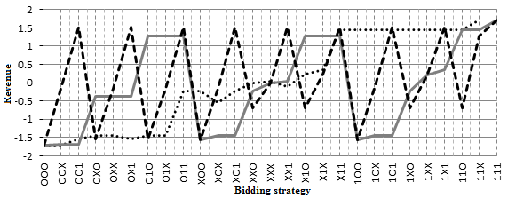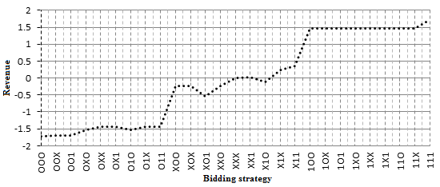
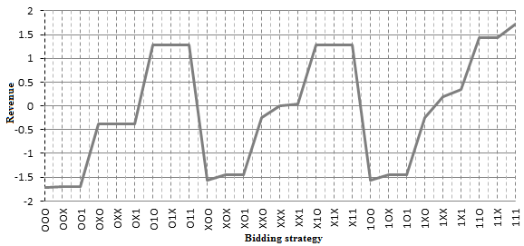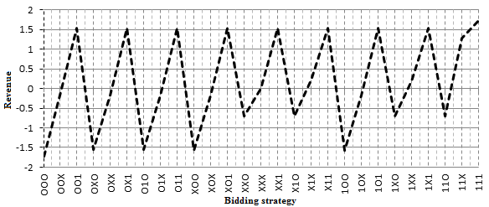
- Revenue graph of strategies: 485MW- (a) G1, G2 and G3 (b) G1 (c) G2 (d) G3
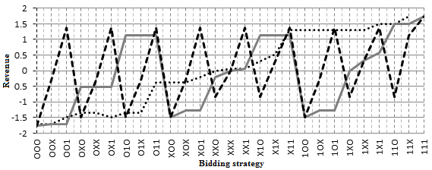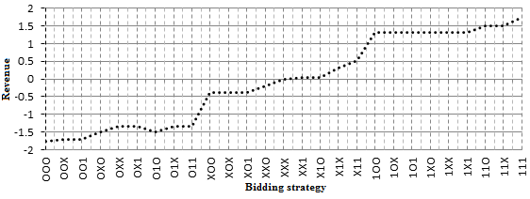
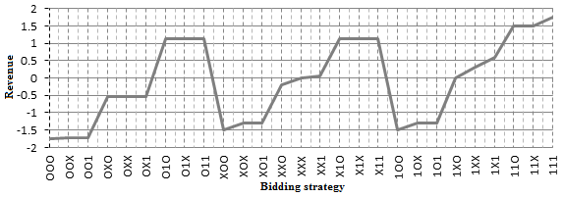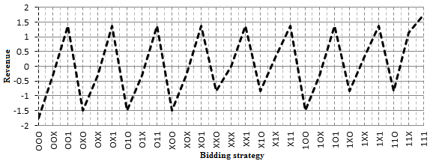
- Revenue graph of strategies: 585MW- (a) G1, G2 and G3 (b) G1 (c) G2 (d) G3
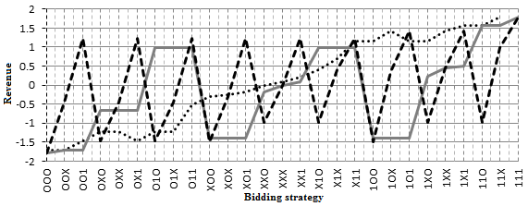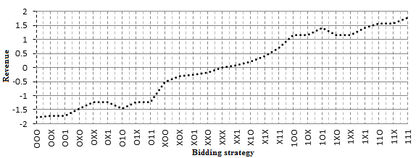
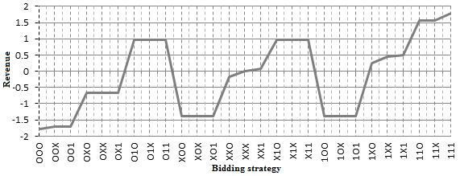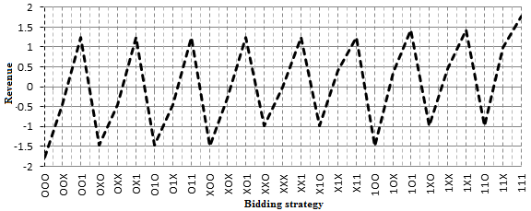
- Revenue graph of strategies: 685MW- (a) G1, G2 and G3 (b) G1 (c) G2 (d) G3
The performance analysis of the application of various bidding strategies applied on the three generators is getting revealed against each of the 27 sets in the form of corresponding revenue impact regions. In above graph the round dotted lines show the revenue impact of G1, the solid lines show the revenue impact of G2, the dash lines show the revenue impact of G3 for all the three designated loads.

IV. Result Analysis
The notation 'P', 'L' and 'N' are assigned to the conditions of ‘Profit’, 'Loss' and ‘No loss- no gain' respectively. Now, if the three generators are considered to be the three players in the power market, then in the matrix strategic environment of 27 possibilities, the similar 24 combinations remain the same for each load. This is shown with the help shadowed combination blocks in the combinatorial strategic matrix given in Table 6.
Table -6 Game Theory Strategic Matrix: Strategies Independent of load variations
Matrix for three Generator |  | G3
 |  | 1 |  |  | X |  |  | O
 |  | G2
 |  | 1 | X | O | 1 | X | O | 1 | X | O
G1  (485MW) | 1 | PPP | PPP | PLP | PPP | PPP | PLL | PPL | PLL | PLL
G1  (485MW) | X | PPP | PPP | LLP | PPP | NNN | LLL | LPL | LLL | LLL
G1  (485MW) | O | LPP | LLP | LLP | LPL | LLL | LLL | LPL | LLL | LLL
G2  (585MW) | 1 | PPP | PPP | PLP | PPP | PPP | PLP | PPL | PPL | PLL
G2  (585MW) | X | PPP | PPP | LLP | PPP | NNN | LLL | PPL | LLL | LLL
G2  (585MW) | O | LPP | LLP | LLP | LPL | LLL | LLL | LPL | LLL | LLL
G3  (685MW) | 1 | PPP | PPP | PLP | PPP | PPP | PLP | PPL | PPL | PLL
G3  (685MW) | X | PPP | PPP | LLP | PPP | NNN | LLL | PPL | LLL | LLL
G3  (685MW) | O | LPP | LLP | LLP | LPL | LLL | LLL | LPL | LLL | LLL
The matrix was investigated to reveal the highest profit giving combinations. It was found that there were 7 similar strategic combinations that give highest profit for all the loads. This is depicted by shadowed strategic combination blocks in Table 7.

Table -7 Game Theory Strategic Matrix: Highest Profit Trend
Matrix for three Generator |  | G3
 |  | 1 |  |  | X |  |  | O
 |  | G2
 |  | 1 | X | O | 1 | X | O | 1 | X | O
G1  (485MW) | 1 | PPP | PPP | PLP | PPP | PPP | PLL | PPL | PLL | PLL
G1  (485MW) | X | PPP | PPP | LLP | PPP | NNN | LLL | LPL | LLL | LLL
G1  (485MW) | O | LPP | LLP | LLP | LPL | LLL | LLL | LPL | LLL | LLL
G2  (585MW) | 1 | PPP | PPP | PLP | PPP | PPP | PLP | PPL | PPL | PLL
G2  (585MW) | X | PPP | PPP | LLP | PPP | NNN | LLL | PPL | LLL | LLL
G2  (585MW) | O | LPP | LLP | LLP | LPL | LLL | LLL | LPL | LLL | LLL
G3  (685MW) | 1 | PPP | PPP | PLP | PPP | PPP | PLP | PPL | PPL | PLL
G3  (685MW) | X | PPP | PPP | LLP | PPP | NNN | LLL | PPL | LLL | LLL
G3  (685MW) | O | LPP | LLP | LLP | LPL | LLL | LLL | LPL | LLL | LLL
The matrix was investigated to reveal the highest loss giving combinations. It was found that there were 7 similar strategic combinations that give highest loss for all the loads. This is depicted by shadowed strategic combination blocks in Table 8.
Table -8 Game Theory Strategic Matrix: Highest Loss Trend
Matrix for three Generator |  | G3
 |  | 1 |  |  | X |  |  | O
 |  | G2
 |  | 1 | X | O | 1 | X | O | 1 | X | O
G1  (485MW) | 1 | PPP | PPP | PLP | PPP | PPP | PLL | PPL | PLL | PLL
G1  (485MW) | X | PPP | PPP | LLP | PPP | NNN | LLL | LPL | LLL | LLL
G1  (485MW) | O | LPP | LLP | LLP | LPL | LLL | LLL | LPL | LLL | LLL
G2  (585MW) | 1 | PPP | PPP | PLP | PPP | PPP | PLP | PPL | PPL | PLL
G2  (585MW) | X | PPP | PPP | LLP | PPP | NNN | LLL | PPL | LLL | LLL
G2  (585MW) | O | LPP | LLP | LLP | LPL | LLL | LLL | LPL | LLL | LLL
G3  (685MW) | 1 | PPP | PPP | PLP | PPP | PPP | PLP | PPL | PPL | PLL
G3  (685MW) | X | PPP | PPP | LLP | PPP | NNN | LLL | PPL | LLL | LLL
G3  (685MW) | O | LPP | LLP | LLP | LPL | LLL | LLL | LPL | LLL | LLL
The matrix was further investigated to reveal that there exist 12 similar strategic combinations giving mixed combinations. This is depicted by shadowed strategic combination blocks in Table 9.
Table -9 Game Theory Strategic Matrix: Mixed (Profit/Loss) Trend
Matrix for three Generator |  | G3
 |  | 1 |  |  | X |  |  | O
 |  | G2
 |  | 1 | X | O | 1 | X | O | 1 | X | O
G1  (485MW) | 1 | PPP | PPP | PLP | PPP | PPP | PLL | PPL | PLL | PLL
G1  (485MW) | X | PPP | PPP | LLP | PPP | NNN | LLL | LPL | LLL | LLL
G1  (485MW) | O | LPP | LLP | LLP | LPL | LLL | LLL | LPL | LLL | LLL
G2  (585MW) | 1 | PPP | PPP | PLP | PPP | PPP | PLP | PPL | PPL | PLL
G2  (585MW) | X | PPP | PPP | LLP | PPP | NNN | LLL | PPL | LLL | LLL
G2  (585MW) | O | LPP | LLP | LLP | LPL | LLL | LLL | LPL | LLL | LLL
G3  (685MW) | 1 | PPP | PPP | PLP | PPP | PPP | PLP | PPL | PPL | PLL
G3  (685MW) | X | PPP | PPP | LLP | PPP | NNN | LLL | PPL | LLL | LLL
G3  (685MW) | O | LPP | LLP | LLP | LPL | LLL | LLL | LPL | LLL | LLL
The results given in Table 6 to Table 9 are found to be in consonance with the proposed game theory based logic narrated in section 2.4 in order to obtain the best response.

V. Conclusions
In the competitive power market, bidding is done on real-time basis. Imperfect information in conventional bidding strategies may cause serve loss to companies. The behaviour and performance of three Gencos are considered in this paper, and are analysed in an electricity power market. Firstly, the economic load dispatch is obtained by particle swarm optimization using Matrix Laboratory software for various virtual bidding scenarios. Next, the impacts of exact revenue regions making profit / loss are identified for all possible bidding combinations. The proposed approach is based on cost comparison of each of the virtual bidding strategies to obtain the profit / loss thereof . Game theory is then deployed through which the Gencos may visualize precisely the profit / loss and hence predetermine the revenue regions of operation by selecting befitting bidding strategy for attaining their best response. This may assist them in avoiding bad bidding strategy decisions in real-time bidding market and save them from making loss.

REFERENCES

- A. C. Nunez, G. Gutierrez and E. Gil, "Strategic generation bidding and scheduling under price uncertainty," IEEE Latin America Transactions, vol. 16, no. 5, pp. 1445-1453, 2018.
- S. Bhattacharjee and S. B. Raha, "Double auction bidding based economics for a microgrid model," Innovations in Power and Advanced Computing Technologies, Vellore, 2017, pp. 1-6.
- S. Kumar, R. Kumar and N. Singh, "Comparative analysis of battery with paper battery for renewable energy storage," International Conference on Challenges in Sustainable Development from Energy & Environment Perspective, Gorakhpur, India, 2017, pp. 222-229.
- S. Kumar, R. Singh, D. Singh, R. Prasad and T. Yadav, "Electronics-waste Management," International Journal of Environmental Engineering and Management, vol. 4, no. 4, pp. 389-396, 2013.
- P. F. Penner, "Electric utility restructuring," A Guide to the Competitive Era. Vienna, VA, Public Utilities Reports, Inc., 1997.
- R. W. Ferrero, J. F. Rivera, and S. M. Shahidehpour, “Application of games with incomplete information for pricing electricity in deregulated power pools,” IEEE Trans. Power Systems, vol. 13, no. 1, pp. 184–189, 1998.
- Y. Ren and F. Galiana, “Pay-as-Bid versus marginal pricing—Part I: Strategic generator offers,” IEEE Trans. Power Syst., vol. 19, no. 4, pp. 1777–1783, 2004.
- F. Stacke and P. Cuervo, "A Combined Pool/Bilateral/Reserve Electricity Market Operating Under Pay-as-Bid Pricing," IEEE Transactions on Power Systems, vol. 23, no. 4, pp. 1601-1610, 2008.
- R. W. Ferrero, S. M. Shahidehpour and V. C. Ramesh, "Transaction analysis in deregulated power systems using game theory," IEEE Transactions on Power Systems, vol.12 no. 3, pp. 1340-1347, 1997.
- Z. Wang, K. L. Lo, "Game theory application and strategic bidding in electricity supply market," World Journal of Engineering and Technology, vol. 4 no. 1, pp. 72-81, 2016.
- D. H. Kiran B and S. Kumari, "A hybrid game theoretic approach to generator bidding in energy and ancillary service markets," International Journal of Renewable Energy Research, vol. 7 no. 1 pp. 68-79, 2017.
- S. de la Torre, J. Contreras and A. J. Conejo, "Finding multiperiod nash equilibria in pool-based electricity markets," IEEE Transactions on Power Systems, vol. 19, no. 1, pp. 643-651, 2004.
- G. Owen, "Game theory," Third ed, Academic Press, 1995.
- W. Tushar, C. Yuen, D. B. Smith and H. V. Poor, "Price discrimination for energy trading in smart grid: A game theoretic approach," IEEE Transactions on Smart Grid, vol. 8, no. 4, pp. 1790-1801, 2017.
- N. Yaagoubi and H. T. Mouftah, "Energy trading in the smart grid: A distributed game-theoretic approach," Canadian Journal of Electrical and Computer Engineering, vol. 40, no. 2, pp. 57-65, 2017.
- R. Debnath, D. Kumar and D. K. Mohanta, "Effective demand side management (DSM) strategies for the deregulated market envioronments," Conference on Emerging Devices and Smart Systems, Tiruchengode, 2017, pp. 110-115.
- S. Bahrami, V. W. S. Wong and J. Huang, "Demand response for data centers in deregulated markets: A matching game approach," 2017 IEEE International Conference on Smart Grid Communications, Dresden, 2017, pp. 344-350.
- O. Perez Barrios, G. De Ita Luna and L. M. Polanco Balcazar, "Design of an efficient algorithm to find pure Nash equilibria on strategic games," IEEE Latin America Transactions, vol. 14, no. 1, pp. 320-324, 2016.
- Y. Yang, Y. Zhang, F. Li and H. Chen, "Computing all nash equilibria of multiplayer games in electricity markets by solving polynomial equations," IEEE Transactions on Power Systems, vol. 27, no. 1, pp. 81-91, 2012.
- G. C. Lazaroiu, V. Dumbrava, M. Costoiu and M. Roscia, "Game theory and competitive aspects in electricity markets," IEEE International Conference on Environment and Electrical Engineering and IEEE Industrial and Commercial Power Systems Europe, Milan, 2017, pp. 1-6.
- H. Song, C. Liu, J. Lawarree and R. W. Dahlgren, "Optimal electricity supply bidding by Markov decision process," IEEE Transactions on Power Systems, vol. 15, no. 2, pp. 618-624, 2000.
- S. Tiwari, B. Dwivedi and M.P Dave, "Economic load dispatch using particle swarm optimization," 1st Edition, Germany, Lap Lambert Academic Publishing, 2017.
- A. J. Wood, B. F. Wollenberg and G. B. Sheble, "Power generation, operation and control," 3rd Edition, New York, John Wiley & Sons, 2014.
- L. Yang, F. Wen, F. F. Wu, Y. Ni and J. Qiu, "Development of bidding strategies in electricity markets using possibility theory," International Conference on Power System Technology, Kunming, China, 2002, pp. 182-187.
- N. Yildira, E. Tacer, "Game Theory Approach to Solve Economic Dispatch Problem", International Journal of Trade Economics and Finance, vol. 6, no. 4, pp. 230, 2015.

