PERFORMANCE OF LATERITE BLOCK WITH AGE
Biju Mathew
Department of Civil Engineering
Vimal jyothi engineering college, chemperi kannur, Kerala, India
bijupmathews@vjec.ac.in
C. Freeda Christy
School of Civil Engineering
Karunya Institute of science and Technology, Coimbatore, Tamilnadu , India
freeda@karunya.edu
Benny Joseph
Department of Civil Engineering
Vimal Jyothi engineering college, chemperi kannur , Kerala , India
bennyjpsephs@vjec.ac.in

Abstract- Laterite is available as rock type and is commonly available in the tropical climate. This can be easily being cut into brick type or any desired shape. This is commonly used as building stone for foundation plinth and superstructure work for ordinary building up to three stories as load bearing walls. The main aim of this investigation is to study the strength of laterite block with age after excavating from the laterite quarry. For this study, fresh laterite excavated from the field, 30 days, 90 days, six months and one year under normal exposed atmospheric condition. The study reveals that, with the increases in age the compressive strength increases. About 50 % increases in strength during first ninety days.

Keywords – Laterite, compressive strength

I. Introduction

Laterite has been used in building construction for thousands years and approximately 30% of the world’s present population lives in laterite. Laterite blocks of different size are used for masonry for load bearing and partisan wall for housing construction in western Gaht of India, Because of easy availability; laterite has the advantage of requiring no specialized skilled labour for its production The ease of cutting and shaping of laterite and hardening with age due atmospheric exposure makes its use different and versatile in building applications. The invent of machines for quarrying laterite result large scale production of laterite. The laterite masonry was evaluated based on the performance of the engineering properties on fresh, 30 days, 90 days, six months and one year after natural atmospheric drying. The result shows that laterite from Malabar region is week during the initial period and gain strength with the age. It was recommended to use laterite as load bearing masonry in house construction after 30 days of quarrying. The plastering can be recommended after six months.

II. Laterite Block

Laterite
Laterite is a soil and rock type is available in hot and wet tropical area. The main constituents of laterite are iron and aluminum and are of rusty-red coloration, because of high iron oxide content. They develop by intensive and prolonged weathering of the underlying parent rock. Tropical weathering is a prolonged process of chemical weathering which produces a wide variety in the thickness, grade, chemistry and ore mineralogy of the resulting soils.

Historically, laterite was cut into brick-like shapes and used in monument-building. After 1000 CE, construction at Angkor Wat and other Southeast Asian sites changed to rectangular temple enclosures made of laterite, brick and stone. Since the mid-1970s, some trial sections of bituminous-surfaced, low-volume roads have used laterite in place of stone as a base course. Thick laterite layers are porous and slightly permeable, so the layers can function as aquifers in rural areas. Locally available laterites have been used in an acid solution, followed by precipitation to remove phosphorus and heavy metals at sewage-treatment facilities.
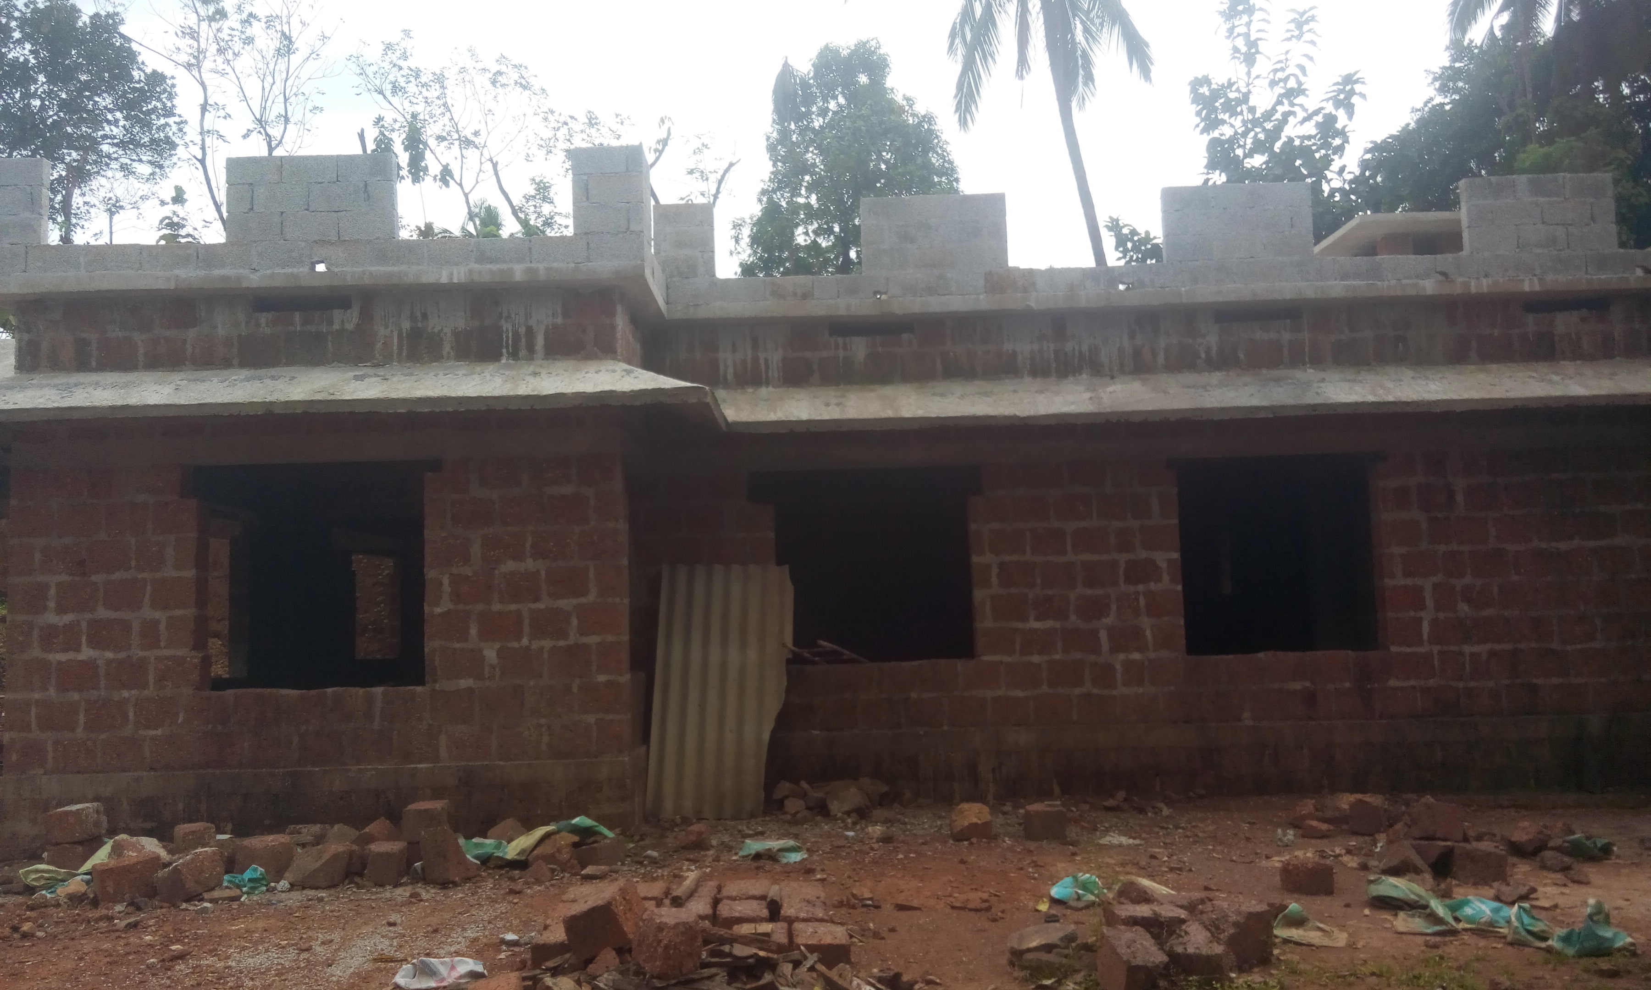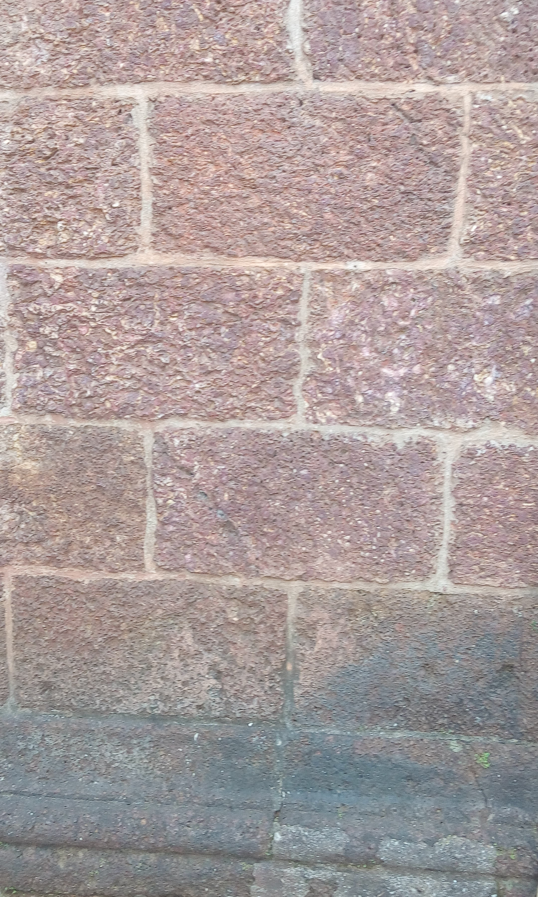

Fig 1 Use of laterite

Quarrying of laterite stone

The laterite was quarrying by manually with axe in the past century. With the introduction of Machines, the quarrying made easy. The selection of laterite cutting machines and power depends upon the area and changes from location to location .India using mobile rotary saw machine which consists of following steps:
- Removal of top soil and leveling the surface,
- Marking lines on leveled horizontal bed of laterite depending upon the width and length ,
- Moving cutters through these lines up to desired depth of stone
- Removing the stone from the site
- Transporting the stone the different

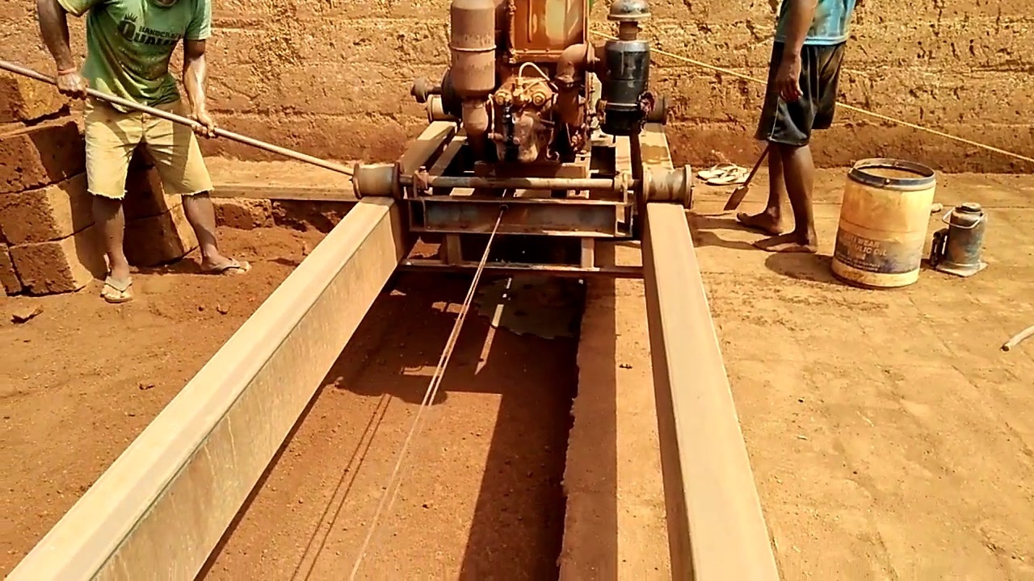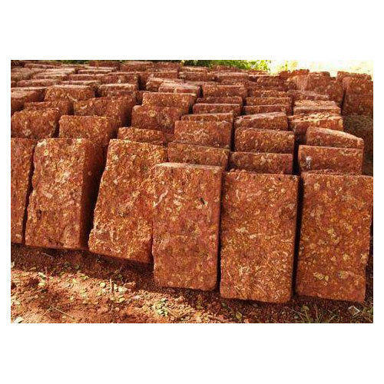

Fig 1 laterite block quarrying

  - Engineering Properties of laterite stone

Experimental investigation of laterite from four active quarries of Malabar region in kannur district of Kerala, India were undertaken at Vimal jyothi Engineering college to determine compressive strength. The various size of laterite was available out of which, the Standard size laterite of 350 x 200 x200 mm was used for this study. The laterite sample was collected from Chemperi , Ulikkal , kelakam and koothuparmba , approximately 40 km apart from each other. Table 1 to 4 shows the typical physical properties of laterite, while Fig.2 shows the variations in compressive strength of laterite under different conditions tested. The results of research studies on Malabar laterite reported from other locations of Malabar region are summarized
Table 1: Compressive strength of Laterite from Chemperi
Sl No | Location | Days | Compressive strength in N/mm2
1 | Chemperi | 0 | 4.45
2 | Chemperi | 30 | 9.00
3 | Chemperi | 90 | 12
4 | Chemperi | 180 | 14
5 | Chemperi | 360 | 17

Table 2: Compressive strength of Laterite from Ullikkal
Sl No | Location | Days | Compressive strength in N/mm2
1 | Ulikkal | 0 | 4.78
2 | Ulikkal | 30 | 9.80
3 | Ulikkal | 90 | 11.50
4 | Ulikkal | 180 | 14.80
5 | Ulikkal | 360 | 16.20

Table 3: Compressive strength of Laterite from Kelakam
Sl No | Location | Days | Compressive strength in N/mm2
1 | Kelakam | 0 | 3.62
2 | Kelakam | 30 | 8.10
3 | Kelakam | 90 | 12.10
4 | Kelakam | 180 | 14.70
5 | Kelakam | 360 | 16.80

Table 4: Compressive strength of Laterite from koothupramba
Sl No | Location | Days | Compressive strength in N/mm2
1 | Koothuparamba | 0 | 3.08
2 | Koothuparamba | 30 | 7.50
3 | Koothuparamba | 90 | 11.20
4 | Koothuparamba | 180 | 13.70
5 | Koothuparamba | 360 | 16.10

The laterite block from different locations shows the increases in strength with increases in age under atmospheric drying. About 50 % increase in compressive strength with 30 days atmospheric drying. The colour of laterite as reddish at the time of quarrying slowly changes to reddish brown with atmospheric exposure.
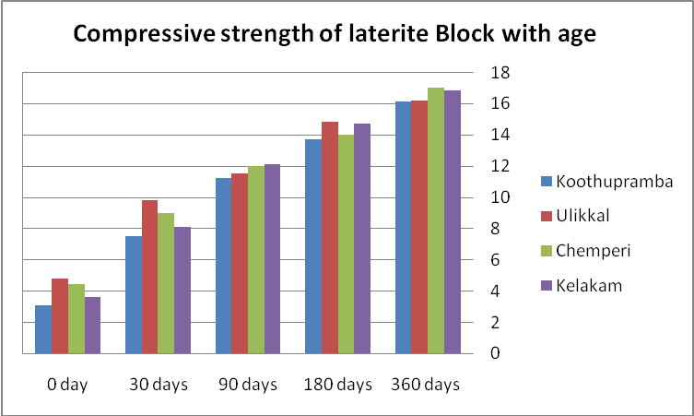
Fig 2 : Compressive strength of laterite block with age

In case of laterite masonry exposed to atmosphere gain more strength with the increases with the age . The laterite masonry covered with cement plaster shows not much increase the compressive strength. This may be due to, when exposed to atmosphere the chemical reaction taken place between aluminum oxide in the presence of air. Due to this strength increases with the age.

III.CONCLUSION

The experimental result shows that laterite from Malabar region is week during the initial period and gain strength with the age under normal atmospheric drying. It was recommended to use laterite as load bearing masonry in house construction after 30 days of quarrying. The plastering can be recommended after six months as the laterite gain sufficient strength.
The effect of laterite block for sub grade and highway work with the age to be studied.

REFERENCES
- S.K. Jain, P.G. Patil, N.J. Thakor. Engineering properties of laterite stone scrap blocks.
- Agricultural Engineering International: CIGR Journal. Vol.13, No.3, 2011.
- K Kasthurba, A & R Reddy, Krishna & Reddy, Venkat. (2015). Use of Laterite as a Sustainable Building Material in Developing Countries. International Journal of Earth Sciences and Engineering. 07. 1251-1258.
- https://en.wikipedia.org/wiki/Laterite
- IS 1121-2 (1974): Methods of Test for Determination of Strength Properties of

