Integration of Solar Photovoltaic with Heavy Duty Gas turbine based Generator for Power Quality Conditioning using DVR
Ravi Dharavath
School of Electrical Engineering
Vellore Institute of Technology, Vellore, Tamilnadu, India
Email- rv.dharavath@gmail.com
I. Jacob Raglend
School of Electrical Engineering
Vellore Institute of Technology, Vellore, Tamilnadu, India
Email- jacobraglend.i@vit.ac.in

Abstract- The renewable source integration in the distribution system motive is providing smoothening and continues power supply. The power quality severity arises in the distribution due to variation in supply and non-linearity of the loads makes causes the voltage imbalance. The renewable energy photovoltaic penetration in the distribution affects the system voltage. This voltage interruptions problem can be overcome with dynamic voltage restorer. The dynamic voltage restorer alone is not sufficient to overcome the voltage related issue. The one of the way is to provide continues and quality of power supply is the integration of solar photovoltaic, heavy duty gas turbine based generator with dynamic voltage restorer. The novel integration of the proposed system is to provide reliable and secure power supply. The solar photovoltaic power is extracted using radial basis function neural network based maximum power tracking method for predicting the intermittent nature power. The heavy duty gas turbine generator is integrated with solar photovoltaic through the AC to DC converter. The performance of the system is simulated using MATLAB-Simulink software under dynamic irradiances and different loading condition. As per IEEE-519 standard, the total harmonic distortion of load performance maintain within the limit.
Keywords – Heavy Duty Gas Turbine Generator (HDGT), Solar Photovoltaic, Boost Converter, Voltage Source Converter, radial basis function neural network (RBFN) based maximum power point tracking( MPPT).

I. Introduction
Nowadays many methods are investigation is made on the solar photovoltaic systems for achieving the maximum power, and advance research is going on efficient utilization of solar photovoltaic system. The authors in [1-2] have been reviewed 31 kinds of maximum power point tracking technique (MPPT). The intelligent techniques used to track the maximum power efficiently from the solar photovoltaic system. The author [3-4] has been explaining the fuzzy based MPPT method to improve the tracking efficiency. But the solar photovoltaic nature is intermittent and it cannot be predictable. The artificial neural network based radial basis function network is analyzed with the MPPT for predicting the future. The solar photovoltaic system is implemented in various applications in the present scenario such as rooftop, stand alone, grid connected, power quality conditioning and in smart grid systems etc [5-6]. The solar photovoltaic grid connected in the distribution system is playing the major role in providing continues and the peak power supply during the day time. But the problem is intermittent in nature and it may not provide sufficient power for longer time due to cloud formation, for limited specification.
The more research has been investigated on integration of renewable energy sources for supporting power supply continuously to the load. The integration of solar PV, wind, diesel generator and the storage technology has been investigated for obtaining continues power supply [7]. But the diesel generator causes the environment pollution and life span is also less. The wind generation again intermittent and it cannot be support under abnormal condition of environment. The battery storage may not support for longer time. These problems can be overcome by using heavy duty gas turbine based generator. The heavy duty gas turbine based generation is clean and efficient power source [8]. The solar photovoltaic with heavy duty gas turbine generator will work efficiently and it can supply the load demand within an instant. But the dynamic variation in the solar photovoltaic and sudden switching of large size load in the distribution causes power quality problem. The sensitive load may damage due to voltage interruption. These problems can be overcome with the customer power devices. The dynamic voltage restorer (DVR), DSTATCOM and UPQC are called as customer power devices. Among these devices DVR is most effective device to solve voltage related issues in the distribution systems [9].

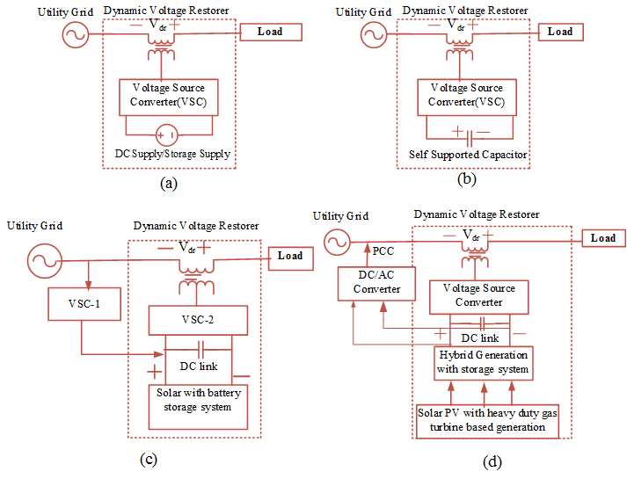
Figure 1. Dynamic voltage restorer
The DVR with different configuration and with solar photovoltaic is shown in the Fig.1. The Fig.1 (a) shows the basic DVR configuration and it requires the separate dc source. In the Fig.1 (b) represent the self-supported DVR and it does not require the separate supply [10-11]. In the steady state, the active power need not be required in the self-supported DVR due to injected voltage in orthogonal with line current. The self-supported DVR is protecting the within the limited period and it may not be support for longer time. This can be overcome using separate source or storage supply as shown in the Fig.1(c). The separate source is cost expensive and it useful only for compensating the voltage sag. It cannot be supply the necessary load demand. One way to overcome the voltage related issue and for providing reliable power at the load end is obtain by integration of solar photovoltaic, HDGT generator with DVR. There is no external supply required for the DVR as shown in the Fig.1 (d).
In this paper, the next section deals with proposed system modules and integration. In the third section described the control strategies and fourth section is discussed the system performance with Simulink results. The system performance is studied with the solar photovoltaic under various irradiance and temperature. The DVR is operated under different condition of the load. The complete description is explained in the following sections.

II. INTEGRATION OF SOLAR PV, HDGT WITH DVR
The integration of solar photovoltaic, heavy duty gas turbine with DVR is represented in the figure 2. The major modules of the system are solar photovoltaic, boost converter, heavy duty gas turbine generator, voltage source converter, dynamic voltage restorer. The solar photovoltaic power is integrated with the grid using voltage source converter. The boost converter can be placed in between the solar PV and dc link for stepping up the solar voltage. The heavy duty gas turbine generator is integrated with dc link through the uncontrolled rectifier. The each module has been explains in the following section in detail.
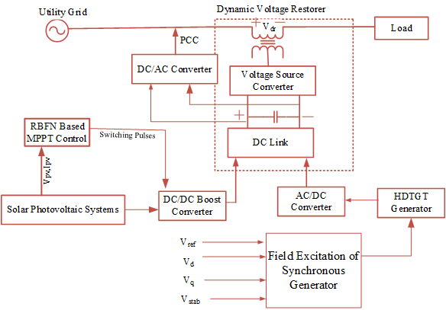
Figure 2. Solar PV, HDGT generator integration with DVR

Solar Photovoltaic
The solar photovoltaic system is made of PV cell arranged in series and parallel form is called PV array. It will work on the principle of photo electric effect. The mono crystalline behavior of solar PV array is considered for the simulation.
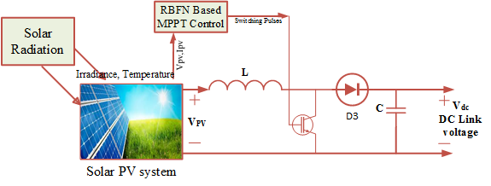
Figure 3. Solar photovoltaic systems
The solar PV array is model using the following equation 1 and 2 [12]
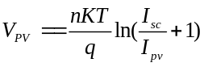 (1)
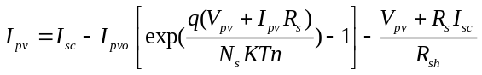 (2)
where Ipv, – solar PV current (A), Vpv – PV voltage (V), T- reference PV cell temperature, K- Boltzmann constant. The solar photovoltaic with boost converter is used to obtain the dc link voltage as shown in the Fig.3. The boost converter switching pulses is generated using the radial basis function neural network (RBFNN) based MPPT tracking method.

2.2. Heavy duty gas turbines based Generator
The heavy duty gas turbine dynamic model [13] based synchronous generator is shown in the Fig.4. The mechanical power to synchronous generator is provided with the heavy duty gas turbine. It will stabilize the dc link with quick response and it will support the peak load demand. The field regulator regulates the output power of the generator and it fed to dc link trough the AC-DC converter. In Fig.5 LVG stands for low value gate, V_{max} and V_{min} is maximum and minimum valve position respectively, Vref is rated voltage of stator terminal (pu), V_{d}, V_{q} are the terminal voltage (pu), V_{stab} stabilized voltage of power system. V_{f} is the field voltage (pu) of synchronous machine block. T₁ = 10 sec, T₂ = 0.1sec andT₃ = 3sec are time constant of valve, fuel system and combustor delay, K_{t} =1 and K_{r} = 0.04 are the gain of the turbine and fuel system respectively, D_{turb} = 0.03 is turbine constant P_{mech} is the turbine output power [14].

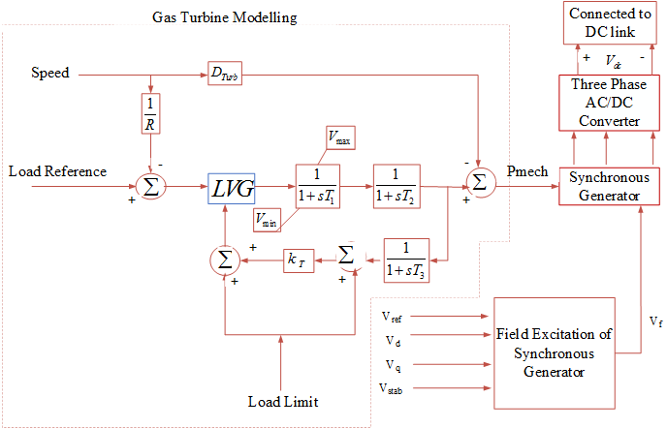
Figure 4 Heavy duty gas turbine based generator

III. CONTROL METHODOLOGY
The mainly control methodology of proposed system categorized into three ways. In the first stage, the solar photovoltaic system is extracted using RBFNN. In the second stage the dc link power is integrated with the utility grid using grid synchronization controller. In the third stage the DVR controller is used to compensate the voltage sag. Each controller has been explained in the following section in detail.

3.1 Radial basis function nueral network(RBFNN)
The radial basis function neural network is used to get the smoothening power from the intermittent nature of solar PV systems within the instant. The RBFNN is fast convergence in generating the switching pulses based on the training algorithm. RBFN is in two type of training such as supervised and unsupervised training. Mainly RBFNN contains input, output and hidden layer [15-16]. The RBFNN layout is shown in the figure 5. The MPPT function is analyzed with the unsupervised learning and then weights are updated based on the targeted output.
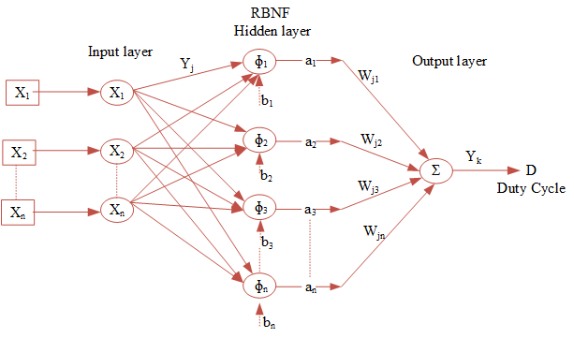
Figure 5 Radial basis function network
In the input layer, at the node the net input and output variables are defined using equations 7 and 8.
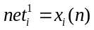 (3)
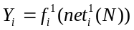 (4)
Where i= 1, 2, 3……n, xi (n) are the input variables, Yi is the output at the input node. In the hidden layer, the performance of each node is computed using Gaussian function. At the hidden layer, the net input and output computed as follows
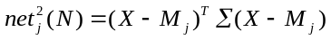 (5)
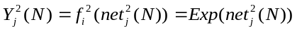 (6)
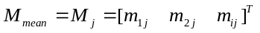 (7)
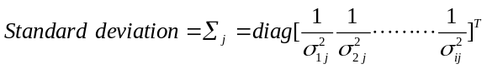 (8)
Here j=1, 2, 3 …

3.2 Inverter Control strategies
The grid synchronization unit is represented in Fig.6. The synchronization unit contains mainly three main modules. The first module is phase locked loop (PLL) and measuring unit is used to trace grid voltage, frequency. The voltage signal synchronizes the reference quantity with use of the internal oscillator. The second module regulates the voltage through the PI (Proportional+ integral) controller. The third module is used to regulate the current with the instantaneous quantity through the PI controller. And further it is transformed to three vector quantity using inverse park transformation. The switching function is implemented with hysteresis current controller.
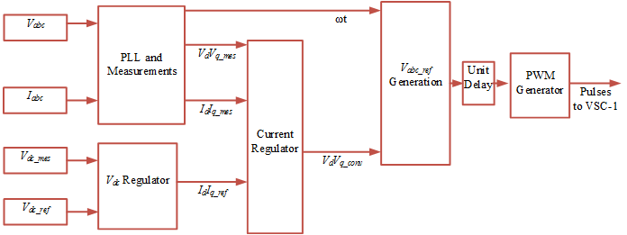
Figure 6 Control strategies of voltage source converter

3.3 DVR convertercontrol strategies
The dynamic voltage restores control strategy is shown in Fig.7. the DVR switching function regulated through the PI controller using through the Clark and Park transformation. PLL is a unit vector generation it will synchronize the voltage with measured quantity. The measured three phase voltage Vabc is transformed into Vdqo and the voltage is regulated with reference voltage using PI controller.
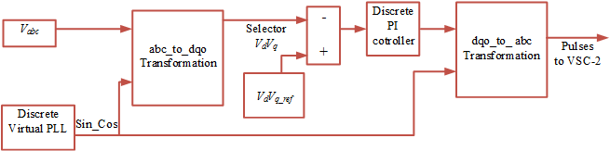
Figure 7 Control strategy of DVR

IV. SIMULINK RESULTS
The integration of solar photovoltaic, HDGT generator with DVR system performance is simulated under dynamic source and load conditions. The specification of the solar photovoltaic system is shown in the table1. The 100kW solar photovoltaic is simulated under dynamic irradiance and temperature condition as shown in Fig.8.
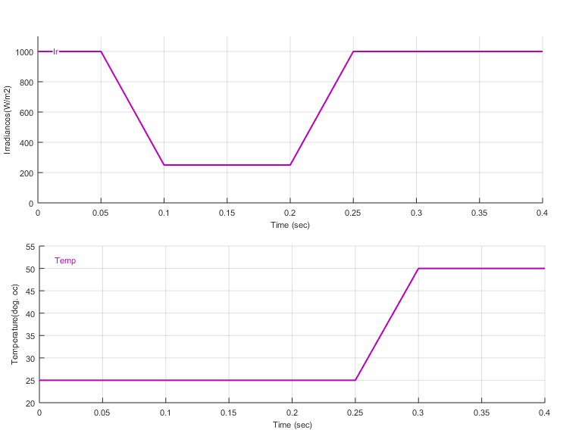
Figure 8 Solar irradiances, Temperature
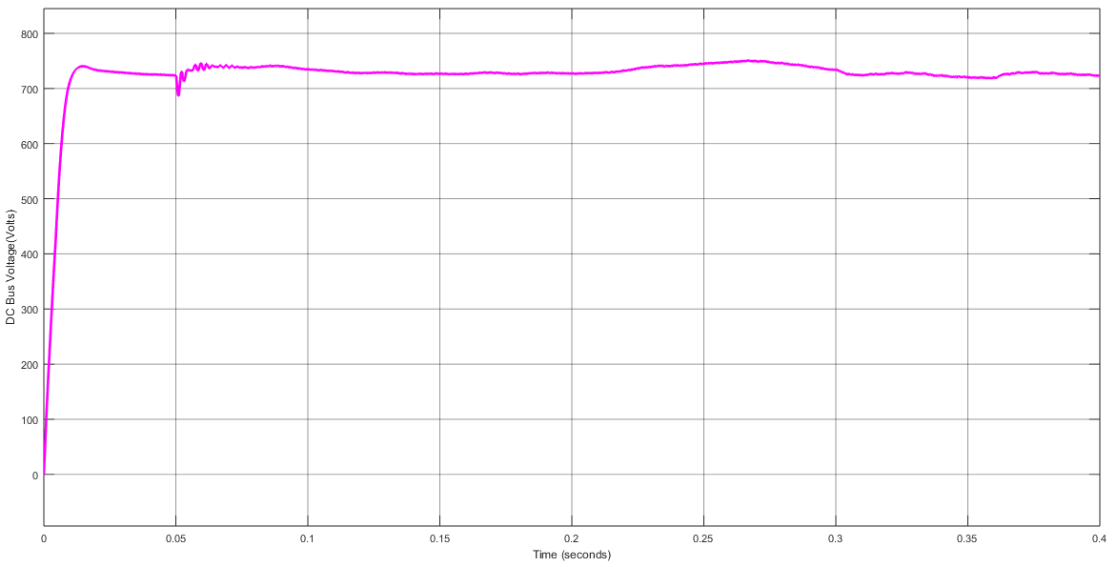
Figure 9 DC link voltages
. At 25oC temperature, the irradiance vary from 1000W/m2 to 250W/m2 during the time at t=0.05Sec to 0.1 Sec. The corresponding change in dc link voltage is visualized in Fig.9. The heavy duty gas turbines are making the dc link voltage is constant even the irradiance and temperature vary during the interval t=0.2sec to t=0.3sec.
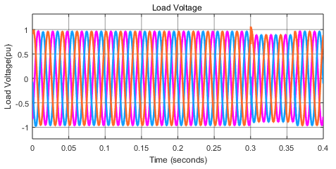
Figure 10 Load voltages
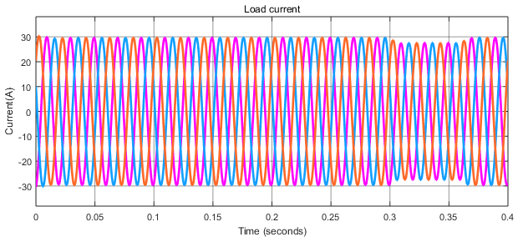
Figure 11 Load current

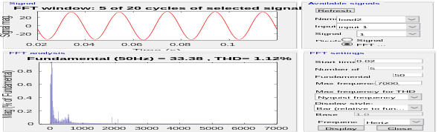  Figure 12 THD of load voltages | 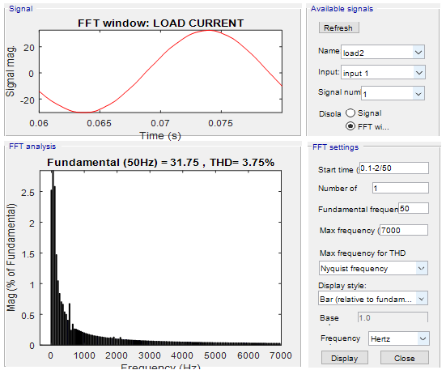  Figure 13 THD of load current
Table 1 the specifications of the solar photovoltaic system
S.No. | Name of the Parameter | Rating
 | Solar parallel strings | 02
 | Solar series connected module per string | 08
 | Solar PV array open circuit voltage | 37.3V
 | Solar PV short circuit current | 8.66A
 | Maximum voltage at MPP | 30.7V
 | Maximum current at MPP | 8.15A
 | Capacitor at solar PV | 212.33µF
 | Boost converter switching frequency | 5kHz
 | Boost inductor | 2mH
 | Boost capacitor | 35.211µF
 | Inverter DC link voltage | 720V
The sag is created during the interval t=0.3sec to t=0.35sec. During this interval the load voltage is balanced with the help of DVR as shown in the Fig.10 and Fig.11. The total harmonic distortion of the load is maintained within the limit as per IEEE-519 standard, which is shown in the Fig.12 and Fig.13. The load voltage and current are stabilized during the entire simulation profile even under dynamic variation in the solar photovoltaic and loads.

V. CONCLUSION
The radial basis function neural network is efficiently used for getting the maximum power from the solar photovoltaic systems. The heavy duty gas turbine output is regulated with field excitation system and is integrated with the DC link through the AC-DC converter. The integration of solar photovoltaic with heavy duty gas turbine is used to maintain the constant voltage at DC link. The integrated system stabilizes the load and is simulated under dynamic source and load condition. The sensitive load is protected with DVR by maintaining the balanced voltages at the load point. As per IEEE-519 standards, the load voltage and current THD is obtain within the limit.

REFERENCES
- Verma D, Nema S, Shandilya AM, Dash SK. “Maximum power point tracking (MPPT) techniques: Recapitulation in solar photovoltaic systems”, Renewable and Sustainable Energy Reviews, vol: 54, pp: 1018-34, 2016 Feb 29.
- Saravanan S, Babu NR. “Maximum power point tracking algorithms for .photovoltaic system–A review”, Renewable and Sustainable Energy Reviews, vol: 57, pp: 192-204, 2016 May 31.
- El Khateb, Ahmad, Nasrudin Abd Rahim, Jeyraj Selvaraj, and Mohammad Nasir Uddin. "Fuzzy-logic-controller-based SEPIC converter for maximum power point tracking." IEEE Transactions on Industry Applications 50, no. 4 (2014): 2349-2358.
- Kumar, Nishant, Ikhlaq Hussain, Bhim Singh, and Bijaya Ketan Panigrahi. "Implementation of Multilayer Fifth-Order Generalized Integrator-Based Adaptive Control for Grid-Tied Solar PV Energy Conversion System." IEEE Transactions on Industrial Informatics 14, no. 7 (2018).
- Singh, Bhim, Priyank Shah, and Ikhlaq Hussain. "ISOGI-Q Based Control Algorithm for a Single Stage Grid Tied SPV System." IEEE Transactions on Industry Applications 54, no. 2 (2018): 1136-1145.
- Mishra, Sukumar, Deepak Pullaguram, Srikanta Achary Buragappu, and Deepak Ramasubramanian. "Single-phase synchronverter for a grid-connected roof top photovoltaic system." IET Renewable Power Generation 10, no. 8 (2016): 1187-1194.
- Kant, Krishan, Chinmay Jain, and Bhim Singh. "A Hybrid Diesel-WindPV-Based Energy Generation System With Brushless Generators." IEEE Transactions on Industrial Informatics 13, no. 4 (2017): 1714-1722.
- Kim, Dong-Joon, Young-Hwan Moon, Bum-Sun Choi, Heon-Su Ryu, and Hae-Kon Nam. "Impact of a Heavy-Duty Gas Turbine Operating under Temperature Control on System Stability." IEEE Transactions on Power Systems (2017).
- Kanjiya, P., Singh, B., & Chandra, A. “SRF theory revisited to control self supported dynamic voltage restorer (DVR) for unbalanced and nonlinear loads”, In Industry Applications Society Annual Meeting (IAS), IEEE, pp: 1-8, 2011, October.
- Ghosh, A., Jindal, A. K., & Joshi, A. “Design of a capacitor-supported dynamic voltage restorer (DVR) for unbalanced and distorted loads”, IEEE transactions on power delivery, 19(1), pp: 405-413.
- Mallick, Nirmalya, and Vivekananda Mukherjee. "Self-tuned fuzzy-proportional–integral compensated zero/minimum active power algorithm based dynamic voltage restorer." IET Generation, Transmission & Distribution, vol.12, no. 11, pp: 2778-2787, 2018.
- Villalva MG, Gazoli JR, RuppertFilho E. “Comprehensive approach to modeling and simulation of photovoltaic arrays”, IEEE Transactions on power electronics, vol.24(5), pp:1198-208, 2009.
- S. Member, F. M. Hughes, S. K. Yee, and J. V Milanovic, ‘Overview and Comparative Analysis of Gas Turbine Models for System Stability Studies’, IEEE Transactions on Power Systems , vol. 23, no. 1, pp. 108–118, 2008.
- M. Reza, B. Tavakoli, B. Vahidi, S. Member, and W. Gawlik, "An Educational Guide to Extract the Parameters of Heavy Duty Gas Turbines Model in Dynamic Studies Based on Operational Data", IEEE Transactions on Power Systems , vol. 24, no. 3, pp. 1366–1374, 2009.
- Mellit, A., & Kalogirou, S. A. (2008). "Artificial intelligence techniques for photovoltaic applications: A review", Progress in energy and combustion science, 34(5), pp: 574-632.
- Reddy, D., & Ramasamy, ‘S. "Design of RBFN Controller Based Boost Type Vienna Rectifier for Grid-Tied Wind Energy Conversion System", IEEE Access, 6, pp: 3167-3175.

