A Study on the Automatically Allocating DHCP Additional Service IPs Using SDN/NFV Technology
So-Ki Jung
Infra Innovation Team
SKbroadband Seoul City, Republic of Korea
Email- mkgg0107@naver.com

Abstract- The present study examines a method that uses SDN/NFV technology software defined networking and network functions virtualization technology to automatically allocate internet protocol addresses by selectively providing dynamic host configuration protocol options for each additional service using container software structures in home network devices and their controllers.

Keywords – SDN, NFV, Controller, Container, DHCP

I. Introduction
As we enter the fourth industrial revolution, the number of things connected to the internet is increasing geometrically. Gartner said that by 2020, the number of devices connected to the internet will exceed 5 billion and that society will transform into an ultra-connected state where data from various things and people can be accessed anytime, anywhere (1). In addition, over-the-top high quality video content and the introduction of new capabilities have caused an increase in customer traffic and demand for various additional services. Therefore, as the diversity of services increases, so does the amount of network equipment and incompatibility between heterogeneous equipment. Therefore, an internet protocol (IP) pool must be added to provide the additional services to customer devices. Software is required to provide an option value that allocates IPs to customer devices. Additionally, the network management burden is increased because of the need to change the settings of the network equipment and devices for each customer device. In this study, these issues are overcome by performing software virtualization using software defined networking(SDN) and network functions virtualization (NFV) and by making network management more efficient so that the IP pool can be provided selectively. Collaborative technology development was performed with the SK Telecom NW Technology Institute’s Broadband Technology Lab to introduce software virtualization, and a patent was applied for. This research was part of the governmental R&D project on 10Gb internet commercialization, conducted by the Ministry of Science and ICT. Chapter 2 of this paper describes the dynamic host configuration protocol (DHCP) options for providing wired/wireless communications additional service IPs. Chapter 3 describes experiments that introduce the SDN/NFV technology. Finally, Chapter 4 presents this paper’s conclusions and future research directions.

Ⅱ. Method of Providing Wired/Wireless Additional Service IPs
Wired/wireless communications services include those that provide ultra-high-speed internet, IP television (IPTV), wired/wireless telephony, and Wi-Fi. Currently, the number of services providing home internet of things (IoT) services is increasing. However, there are cases where some customers want only IPTV service rather than a variety of services. Communication companies have released products that provide only IPTV services to meet this demand. These additional services use the same network structure and equipment as existing products. Thus, from the perspective of the communication companies, such product services are often undesirable. Fig. 1 shows a network diagram with different methods of wired/wireless communication service provision per the customer’s environment. In the figure, (1) represents a customer who uses ultra-high-speed internet, IPTV, phone, Wi-Fi, etc., together, whereas (2) requests only IPTV. This study examines the automatic allocation of IPs for additional virtualized services for customers who request them. The wired/wireless communication service is provided through a DHCP server, which provides IPs to customer devices.
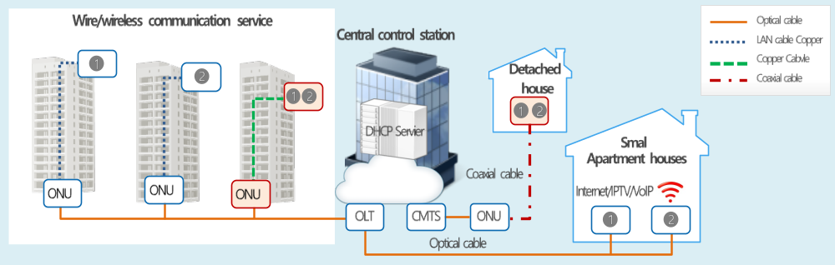
- Fig. 1. Wired/wireless communications service network diagram

DHCP is a protocol that dynamically sets network configuration parameters for performing transport control protocol (TCP)/IP communications, such as the IP address of a customer’s device (5). If a customer requests a wired/wireless communication service, IPs are allocated via DHCP to devices such as PCs and routers to perform initial communications. Currently, the DHCP server sends a discover packet to the customer’s device and checks the option field of the packet message to allocate an IP address that matches the device’s requirements. The option field provides the customer database (DB) and requested product service. To allocate IPs, software features must be developed to satisfy the requirements according to the DHCP options for each network device. Table 1 shows the packet messages sent between DHCP and the customer device for allocating an IP. Four stages of messages are sent and received, based on the device’s identifying media access layer (MAC) address key value.
TABLE 1. DHCP message’s ethernet and IP address (5)
DHCP Message | Destination MAC | Source MAC | Destination IP | Source IP
DHCP Discover | FF:FF:FF:FF:FF:FF | DHCP Client(PC) | 255.255.255.255 | 0.0.0.0
DHCP Offer | FF:FF:FF:FF:FF:FF | DHCP Server | 255.255.255.255 | DHCP Server
DHCP Request | FF:FF:FF:FF:FF:FF | DHCP Client(PC) | 255.255.255.255 | 0.0.0.0
DHCP Ack | FF:FF:FF:FF:FF:FF | DHCP Server | 255.255.255.255 | DHCP Server

The IP source receives an allocation based on the communication protocol between the DHCP server and the device. As shown in the content in Fig. 2 red box, the additional service option value is added to the discover message, and the allocation is made differently for each client. The DHCP option in the red box must receive an additional service IP allocation corresponding to the requested service. The DHCP discover packet is transmitted to the server, as shown in Table 1. The DHCP server allocates an IP to the device suitable for its requirements, and the additional service is provided. A service that only specifies a certain model must be provided for devices providing the additional service DHCP option for independent IPTV service, as in (2) of Fig. 1. If the model is lack or if a spare occurs, there is no way to use it. Additionally, if there is a different setting on the optical network unit (ONU) port to which the customer device from Fig. 1 connects, the DHCP sends a message with a non-matching option value. Thus, a service differing from the one the customer requested could be sent. Therefore, because of the characteristics of additional services having their service type classified based on the IP address, if a new additional service is added, new changes must be made to the network equipment or device software providing the corresponding DHCP option. Additionally, the extra service means that the network equipment and device settings must be changed for each device through which a customer has a subscription. Thus, the network management burden is continually increased. To resolve this issue, a solution must be found to apply software-based virtualization to the customer devices.

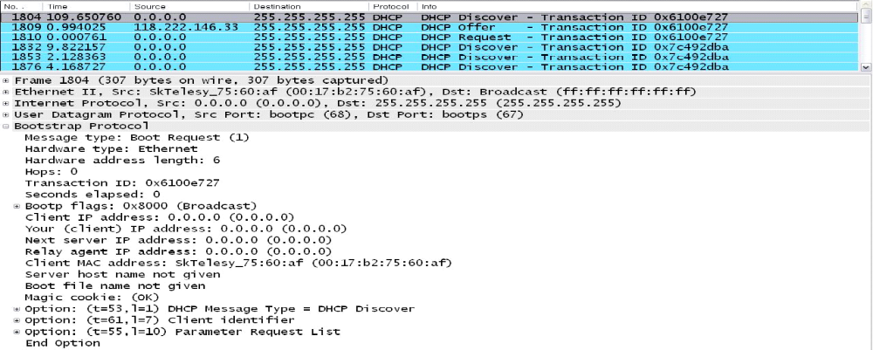
- Fig. 2. Option field in DHCP Discover

Fig. 3 shows the DHCP server and network configuration, which allocates IPs to customer devices. To allocate IPs to devices, the devices, network equipment, DHCP server, and customer DB management equipment are connected so that service can be provided. The DHCP server supplies and manages IP addresses and client setting parameters. When it receives a request to provide an IP from a new host, it checks a given IP address and its lease period, allocating it as applicable. In the existing DHCP environment, the additional service option is added by the network equipment that receives the DHCP discover message sent by the device. The DHCP server receiving this value compares the discover message’s option field value with the customer DB and allocates an IP address for the additional service to which the customer is subscribed. To allocate IP addresses that support additional services to devices in the existing DHCP environment, software must be developed for the DHCP option requirements of each device or network equipment.
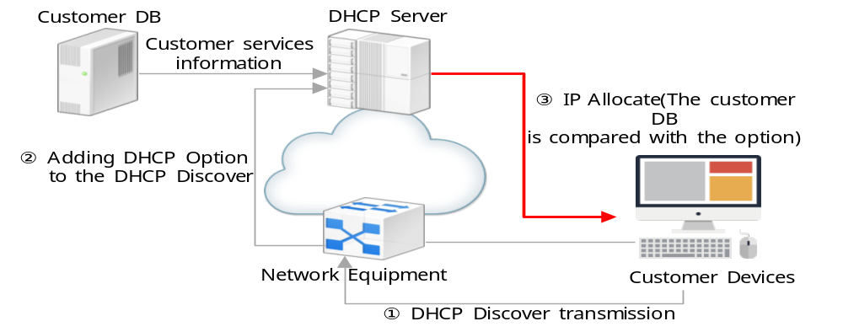
- Fig. 3. DHCP option operation in subscriber equipment ONU structure
The next chapter presents a technology that allocates additional service IPs using the SDN/NFV method to overcome this problem.

Ⅲ. Introducing SDN/NFV Technology

Owing to the diversification of customer services, network environments are transforming from closed hardware configurations to SDN/NFV technology-based open interfaces and software methods (3). This chapter introduces the software-based virtualization technology, SDN/NFV, to minimize hardware factors and to make it possible to selectively allocate IPs to match customers’ additional service requests. SDN/NFV technology improves network features and software protocol programming so that complex network structures dependent upon equipment manufacturers can be implemented in more dynamic network environments (3). This allows features to be added easily without replacing network equipment via remote automated software-based controls, so that hardware investments and operating costs can be reduced (3). The definition of SDN/NFV is as follows. SDN is a technology that separates network equipment control and packet transmission and sets up various kinds of network controls, paths, etc., using software via an open interface (i.e., application programming interface (API)) (2,3). NFV performs virtualization to separate the network equipment into a universal server and performs control management via software (2). Fig. 4 and Table 2 show the method of introducing SDN/NFV concepts to various heterogeneous network equipment and using an open API to virtualize devices and transform them into a software customized technology. In Fig. 4, the two SDN/NFV technologies operate in a mutually complementary configuration so they can perform virtualization, impossible with existing network equipment (2).
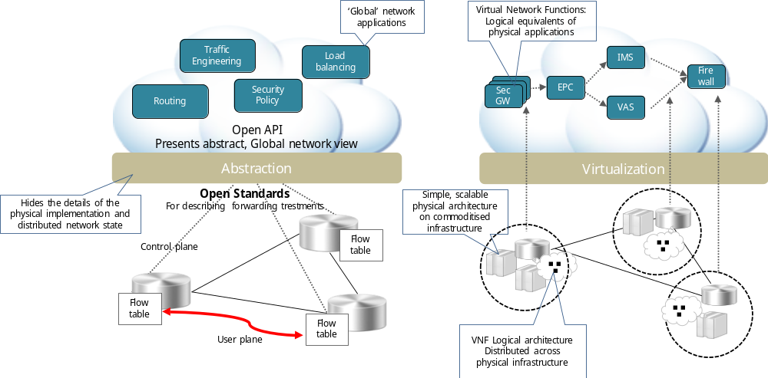
- Fig. 4. Comparison of SDN’s abstraction and NFV’s virtualization concepts (2)
TABLE 2. Technical comparison of SDN and NFV (2)
Category | SDN | NFV
Features | Makes heterogeneous network equipment compatible, separates data functions and control functions, provides centralized method and open interface (API) | Network virtualization Separates hardware from software
Protocol | Openflow, I2RS, NETCONF, XMPP, ALTO, etc. | -
Applications | Cloud orchestration networking support | Middle box service functions such as service gateway, CDN, DPI, firewall, vEPC, etc.
Standardization | ONF, IETF, ITU-T and various others | ETSI ISG NFV

The SDN/NFV model can be divided into cloud network and transmission network components (3). Currently, cloud networks using software-based technologies are changing more dynamically (3). Transmission network area is a technology that is gradually expanding through security such as scalability and stability (3). The SDN/NFV method installs a central controller and organizes its basic software structure by putting a docker on a Linux base and modularizing each network function into the form of a software structure container on the device.
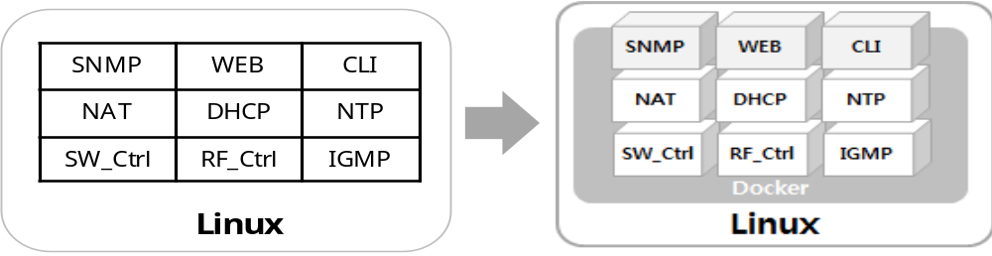
Fig. 5. Changes in NFV-based device’s software structure

Fig. 5 shows the modularization of Linux-based NFV device software. If an existing DHCP container exists in the open source docker, IP addresses for additional services can be allocated to devices through the DHCP container that is received from the controller equipment. The control equipment’s operation method selects the specific options values that support each feature according to the DHCP options during the stage in which the customer’s additional services are confirmed, based on the identification information received from the device. The IP addresses for additional services are allocated from the server. Before the IP checking stage, device identification information is received during a device session. The docker is created based on the open source code of a Linux application program container to more quickly automate and share the network and file system information (4). Docker containers are created in a modularized capsule image form. They include only the basic operating system items, and they are organized as application programs that are made elaborately beforehand (4).

Ⅳ. SDN/NFV-based Additional Service Setup

In SDN/NFV, the control equipment plays an important role in allowing the DHCP IP options to be provided selectively for each additional service.
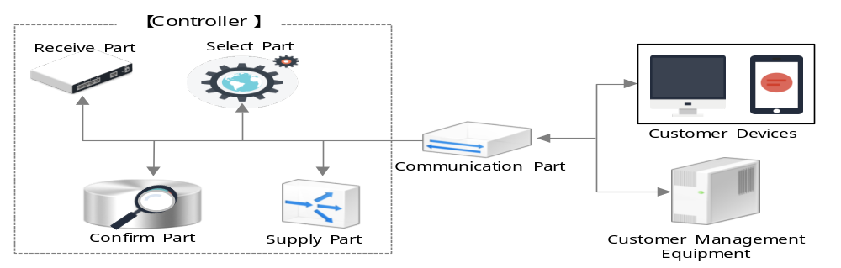
Fig. 6. Controller composition

The controller equipment in Fig. 6 is composed of software and hardware modules that include receive, confirm, select, and supply parts. The receive part receives the device MAC identification information. The confirm part confirms the additional services to which the customer device is subscribed. It checks the subscriber management equipment’s DB with the device identification MAC address to confirm the additional services. The select part selects the container of the specific option that supports the additional service to which the device is subscribed from among multiple DHCP containers to support each function according to the DHCP options. When the customer device’s DHCP container selection is complete, the supply part supplies the selected container to the device so that the additional service IP address for the received customer device can be allocated by the DHCP server. The communication part includes an antennae system, radio frequency transmitter–receiver, amplifier, codec, chipset, and circuitry (e.g., memory). The software module in Fig. 6 controls the computations in the controller equipment and is loaded in the customer device equipment’s internal memory. The control equipment supports each function per the DHCP option used for checking additional services that the customer device is subscribed to, based on the identification information received from the device. If the receipt of the DHCP container from the control equipment is confirmed, the unique option value, set by the DHCP option based on the received DHCP container, is transmitted to the server. The DHCP server allocates the IP address that matches the unique option value to the customer device. The virtualization-based additional services providing environment includes the devices, DHCP server, control equipment, and subscription management equipment. The devices are the home network devices of the SDN/NFV foundation, which requests IP address allocation so they can use the additional services. They can be PCs or routers, and they include all equipment that can be allocated an IP address in a DHCP environment. The DHCP server processes IP addresses for the devices and manages the IP address pool and the client setting parameters. When a request is received from a new DHCP client host, it processes the allocation of an IP address by replying with a specific IP and the address’ lease period. The control equipment provides DHCP options for supporting additional services requested by devices. It can provide DHCP options for devices by transmitting DHCP containers, managed according to DHCP options. Here, the DHCP containers are located within the docker in a Linux environment, the device operating system, and can be understood as a series of processes that perform functions that match each DHCP option. The control equipment can be implemented as network equipment or a server. A variety of software can be installed, allowing the network load balancing mechanism or service equipment to operate on the internet or another network. Thus, it can be implemented as a computerized system. The subscriber management equipment is the DB that manages additional service subscription information for each customer device. It manages additional service subscription information by matching the MAC address device identification information and the additional service to which the device is subscribed.

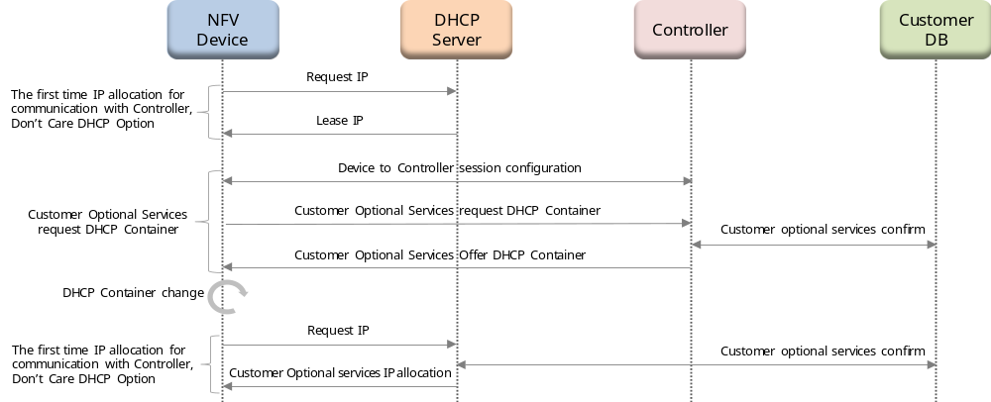
- Fig. 7. NFV device’s additional service customer DHCP container acquisition process

Figure 7 shows the workflow for an NFV device being allocated an additional service IP. The NFV device is allocated an IP address from the DHCP server to form a session with the controller. It forms a session to access the control equipment based on the allocated IP address. Currently, the IP address allocated by the DHCP server is unrelated to the additional service and acts only as a basic IP address for communication with the control equipment. The equipment receives the NFV device’s MAC address from a request to the DHCP container received from the NFV device via a device session. If the controller receives a device identification MAC address, it confirms the additional server subscription by the NFV device, based on the MAC address. If the DHCP container is implemented to receive allocation via the process in Fig. 7, an IP suitable to the services to which the customer subscribed can be allocated, regardless of whether the network equipment has DHCP options. This improves network application management efficiency.

Ⅴ. Conclusion

With the advent of the fourth industrial revolution and society’s transformation into an ultra-immersive, ultra-intelligent, ultra-connected state, network equipment and devices are becoming more diverse as the demand for services increases. Therefore, customers’ additional service needs are increasing throughout the wired/wireless communications sector. This study focused on operating IP networks more efficiently by introducing a software virtualization-based technology for allocating IPs used by customer devices and additional services. In the existing additional service IP allocation method, the network equipment and device’s software settings were changed based on the DHCP option values and the device identification MAC address. Thus, when the number of customers subscribing to additional services increased, there was an increase in the network operation burden and investment cost (e.g., equipment). Therefore, this study on additional wired/wireless services aimed to allocate new and various additional service IP addresses to devices by providing DHCP options in virtualized containers using SDN/NFV technology. Virtualized containers consist of Linux docker-based software virtualization and a controller. By implementing software features, such as network equipment and device containers, it was possible to seamlessly support customer’s additional services without any separate changes in settings. As such, this method could overcome the incompatibility between various equipment and devices, and it could improve IP pool resource efficiency and compatibility between heterogeneous devices. The network is converted from a hardware methodology to a software methodology. Our software virtualization used SDN/NFV-based technology to improve customer device services and improved the network operating system. It also improved the efficiency of network operations management and equipment purchases when the demand for additional services increased. SDN/NFV-based network solutions are being developed, but more standardization between service provider companies and equipment development companies is required to expand into the area of transmission networks. In the future, SDN/NFV and Wi-Fi access points must be virtualized with the commercialization of 5G networks for network efficiency and reductions in investment costs.

Acknowledgment

This paper was prepared by the SK Broadband Consortium as part of the "2018 10Giga Internet Commercialization Project," which is a joint project of the Ministry of Science and ICT and the National Information Society Agency (NIA).

References

- Mike J. Walker, “2017 Hype Cycles Highlight Enterprise and Ecosystem Digital Disruptions: A Gartner Trend Insight Report ,”2017 Gartner, Inc. pp. 1–67, 21 July. 2017.
- SDN/NFV Forum, “Understanding SDN and NFV Through Open Source and Open Standards,” pp.27-465. 26 May. 2017.
- I. S. Jacobs and C. P. Bean, “Integrated SDN/NFV management and orchestration architecture for dynamic deployment of virtual SDN control instances for virtual tenant networks,” Journal of optical communication and networking, vol.X, NO.X, pp. 271–350, Nov. 2015.
- Bernstein, D. “Containers and cloud: From lxc to docker to kubernetes.” IEEE Cloud Computing, 1.3, pp. 81-84, 2014
- Netmanias, NMC consulting group, “Understanding the Detailed Operations of DHCP,” Technical Paper, pp.1-8, Feb. 2011
- Y. Yorozu, M. Hirano, K. Oka, and Y. Tagawa, “Electron spectroscopy studies on magneto-optical media and plastic substrate interface,” IEEE Transl. J. Magn. Japan, vol. 2, pp. 740–741, Aug. 1987 [Digests 9th Annual Conf. Magnetics Japan, p. 301, 1982].

