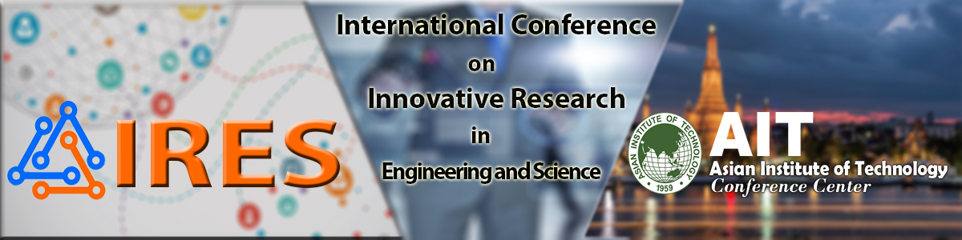
 |  | PARTICIPANT DETAILS
 | Conference Name: | International Conference on Innovative Research in Engineering and Science (IRES 2017)
 | Conference Venue: | Asian Institute of Technology Conference Center
 |  | Pathum Thani, Thailand
 | Conference Dates: | June 16-17, 2017
 | Paper Title:
 | Paper ID:
 | Easychair ID :
 | College / Organization:

Address for Communication:

Contact No:

Email-id:

Author’s Details
S.No. | Name | Complete Postal Address | Mobile No. | Email ID
1st Author
2nd Author
3rd Author
4th Author
5th Author

Registration Details- SCOPUS/Thomson Reuter Indexed Journals

Category | Early Bird Registration | Late Registration
Authors - USD/INR/Thai Baht
Student / Research Scholar (Full Time) (Upto 8 pages) | $220/Rs. 13,500/THB 7,000 | $250/Rs. 15,000/THB 7,500
Academician/ Industry (Upto 8 pages) | $250/Rs. 15,500/THB 8,000 | $280/Rs. 17,000/THB 8,500
Extra pages (per page) | $15/Rs. 700/THB 350 | $10/Rs. 700/THB 350
Delegates - - USD/INR/Thai Baht
Student / Research Scholar (Full Time) | $90/Rs. 5,500/THB 3,000 | $100/Rs. 6,000/THB 3,500
Academician/ Industry | $120/Rs. 6,000/THB 3,200 | $130/Rs. 7,000/THB 4,000

Registration Details- DOI Indexed Journals
Category | Early Bird Registration | Late Registration
Authors - USD/INR/Thai Baht
Student / Research Scholar (Full Time) (Upto 8 pages) | $150/Rs. 9,000/THB 4,500 | $170/Rs. 10,000/THB 5,000
Academician/ Industry (Upto 8 pages) | $170/Rs. 10,500/THB 5,200 | $200/Rs. 12,000/THB 6,000
Extra pages (per page) | $10/Rs. 200/THB 100 | $10/Rs. 200/THB 100
Delegates - - USD/INR/Thai Baht
Student / Research Scholar (Full Time) | $90/Rs. 5,500/THB 3,000 | $100/Rs. 6,000/THB 3,500
Academician/ Industry | $120/Rs. 6,000/THB 3,200 | $130/Rs. 7,000/THB 4,000

Note:

- The registration fee will cover for 2 days high tea-breaks, 2 days lunches and with all conference materials.
- Student authors /Research Scholars/Faculty members have to submit a scanned copy of proof(i.e. ID card Copy) should send along with the registration form to avail the discounts.
- Please ensure that Author’s name, easychair paper ID and address of communication should be clearly mentioned in the fund Transfer Application.

Payment Instructions
The mode of payment is as follows:
​You can pay through payumoney online using below link online:​

https://www.payumoney.com/paybypayumoney/#/9C696A2A2F70C8380F12759BEFDFEB85

​​OR​
Through Direct Deposit from any Bank to our bank account with following details:
Account Details
Bank Name | Punjab and Sind Bank
Branch address | Indirapuram, Ghaziabad, 201014
Branch Code | 000883
Account Name | Geeta Rani
Account Number | 08831000010696
Account Type | SB
IFSC Code | PSIB0000883 (5th character is zero)

Email Id | scesm2017@gmail.com
Download Paper format: http://iresconf.org/uploads/downloads/paper-Format.doc
Download Copyright Form: http://iresconf.org/uploads/downloads/IRES_Copyright_Form.doc

Note:

After Registration, Please Send the Transaction Details (such as Scanned Copy of Transaction Slip or payumoney success transaction mail), Filled-in Registration form, Camera Ready Paper(both doc and pdf format) and filled copyright form by Email to ires2017@gmail.com. Please save your above files with your paper ID & send .zip file with in one week from Acceptance Notification date.

Place:

Date:

Signature

(Full Name)

